

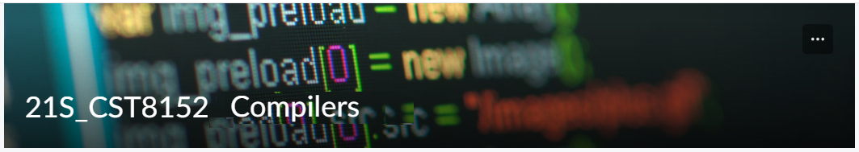

MODEL TASK FOR ASSIGNMENT 2.1 – KRAIT

[Quoc Thang Tran] - Id: [041009239]

- Note: This task is part of the Assignment 2 from Compilers Course. Any problem, contact your lab professor.

PART 1: RE – Regular Expression (1.5 mark)

Lexeme Classes: Define the classes to be used in your regular expression:

Answer:
• L = [A-Za-z] (Letters)
• D = [0-9] (Digits)
• U = _ (Underscore)
• M = ( (MID delimitator)
• Q = “ (SL delimitator)
• H = # (SL comment)
• E = \n (End of Line)
• P = . (Period)
• O = [^LDUMQHEP] (Other chars)

Define the RE to be used for: variables, literals and keywords:

Answer:

* Variables: (L|U)[L|D|U]*

* MID: (L|U)[L|D|U]*M

* SL: Q(^Q)*Q

* IL: D+(^DP)

* DL: D+PD+(^D)

* Keywords: False, True, and, or, not, continue, break, pass, if, elif, else, for, while, global, in, return, def

* Comment: H[^E]*E

PART 2: TD – Transition Diagram (1.5 marks)

Activity: Starting from the previous lexeme classes and obeying the RE, it is possible to define the automata for your language:

Answer (draw / copy image of the automata):
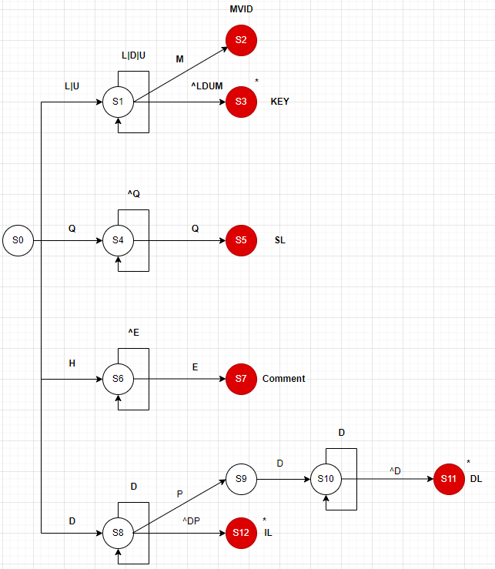

PART 3: TT – Transition Table (2 marks)

Activity: Now, it is possible to define the TT for these lexemes:

Answer (Transition Table):
Input |  |  |  | Output
State | 0 | 1 | 2 |  | 3 | 4 | 5 | 6 | 7 | 8 | Type
 | L(A-Za-z) | D(0-9) | U(_) |  | M(() | Q(“) | H(#) | E(\n) | P(.) | O(^LDUMQHE) | -
0 | 1 | 8 | 1 |  | ES | 4 | 6 | ES | ES | ES | NOAS[0]
1 | 1 | 1 | 1 |  | 2 | 3 | 3 | 3 | 3 | 3 | NOAS[1]
2 | FS | FS | FS |  | FS | FS | FS | FS | FS | FS | ASNR(MID)[2]
3 | FS | FS | FS |  | FS | FS | FS | FS | FS | FS | ASWR(KEY)[3]
4 | 4 | 4 | 4 |  | 4 | 5 | 4 | 4 | 4 | 4 | NOAS[4]
5 | FS | FS | FS |  | FS | FS | FS | FS | FS | FS | ASNR(SL)[5]
6 | 6 | 6 | 6 |  | 6 | 6 | 6 | 7 | 6 | 6 | NOAS[6]
7 | FS | FS | FS |  | FS | FS | FS | FS | FS | FS | ASNR(Comment)[7]
8 | 12 | 8 | 12 |  | 12 | 12 | 12 | 12 | 9 | 12 | NOAS[8]
9 | ES | 10 | ES |  | ES | ES | ES | ES | ES | ES | NOAS[9]
10 | 11 | 10 | 11 |  | 11 | 11 | 11 | 11 | 11 | 11 | NOAS[10]
11 | FS | FS | FS |  | FS | FS | FS | FS | FS | FS | ASWR(DL)[11]
12 | FS | FS | FS |  | FS | FS | FS | FS | FS | FS | ASWR(IL)[12]

Update: Oct 2nd 2022.

Adapted from resources developed by Prof. Svillen Ranev (Algonquin College, 2019)

