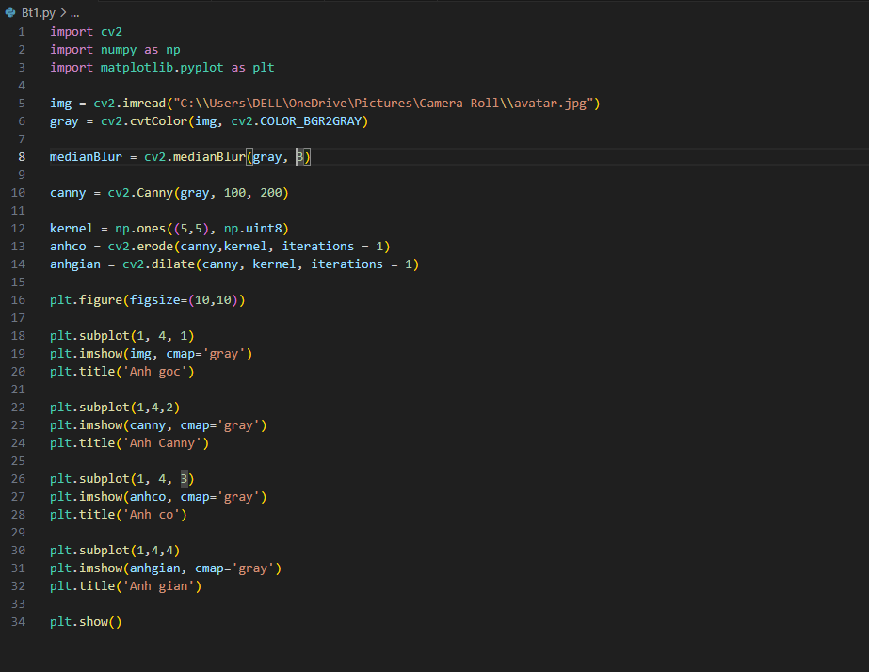Bài 1

