Version 1.1

Revision History

|  |  |  |  |
| --- | --- | --- | --- |
| **Date** | **Version** | **Description** | **Author** |
| 09/11/2022 | 1.0 | Initial version | Vo Duy Truong |
| 30/11/2022 | 1.1 | Update | Vo Duy Truong |
|  |  |  |  |
|  |  |  |  |

Table of Contents

1. Use-case Model 4

2. Use-case Specifications 4

2.1 Use-case: Sign up 4

2.2 Use-case: Sign In 5

2.3 Use-case: Search username 5

2.4 Use-case: Watch video 6

2.5 Use-case: Upload video 6

2.6 Use-case: Follow another user 6

2.7 Use-case: Edit profile 7

2.8 Use-case: Sign out 7

2.9 Use-case: Record video 7

# Use-case Model

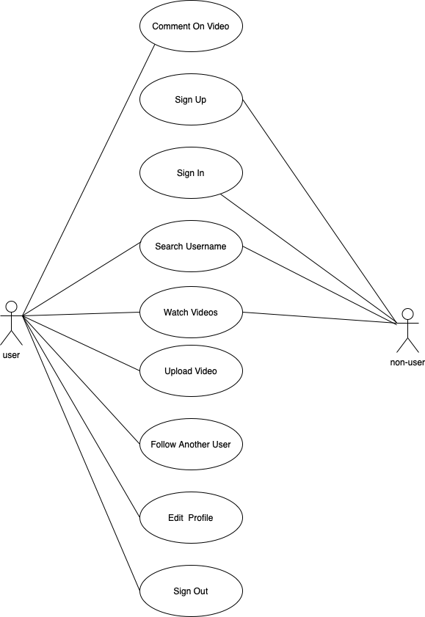

# Use-case Specifications

## Use-case: Sign up

|  |  |
| --- | --- |
| Use case Name | Sign up |
| Brief description | This use case describes how the user create an account. |
| Actors | Non-user |
| Basic Flow | 1. At the homescreen, the user clicks on profile button. 2. System displays screen to choose sign up or sign in. 3. The user clicks on sign up button. 4. System displays screen to choose sign up via email or phone number 5. The user enter email or phone number 6. System sends OTP or link to verify. |
| Alternative Flows | **Alternative flow 1: User enter existed phone number or email**   1. From #5 of the basic flow, user enters another term 2. Continue step #6 in the basic flow   **Alternative flow 2: Verifying OTP or link failed**   1. From #5 of the basic flow, user try signing up again! 2. Continue step #6 |
| Pre-conditions | User goes to homescreen in Short Video Application. |
| Post-conditions | The user successfully creates a new account and go back homescreen. |

## Use-case: Sign In

|  |  |
| --- | --- |
| Use case Name | Sign in |
| Brief description | This use case describes how the user sign in the app |
| Actors | Non-user |
| Basic Flow | 1. At the homescreen, the user clicks on profile button. 2. System displays screen to choose sign up or sign in. 3. The user clicks on sign in button. 4. System displays screen to choose sign in via email or phone number 5. The user enter email or phone number 6. System sends OTP or link to verify. |
| Alternative Flows | **Alternative flow 1: User enter the new phone number or email**   1. From #5 of the basic flow, user enters another term 2. Continue step #6 in the basic flow   **Alternative flow 2: Verifying OTP or link failed**   1. From #5 of the basic flow, user try signing up again! 2. Continue step #6 |
| Pre-conditions | User goes to homescreen in Short Video Application. |
| Post-conditions | The user successfully sign in and go back homescreen. |

## Use-case: Search username

|  |  |
| --- | --- |
| Use case Name | Search username |
| Brief description | This use case describes how the user search another user with username |
| Actors | Non-user, user |
| Basic Flow | 1. At the homescreen, the user clicks on search button. 2. System displays screen with an edittext to enter an username. 3. The user enters the username to search. 4. System displays hint all usernames involved. 5. The user clicks on an username 6. System navigates to the relevant profile. |
| Alternative Flows | None |
| Pre-conditions | User goes to homescreen in Short Video Application. |
| Post-conditions | System displays the profile |

## Use-case: Watch video

|  |  |
| --- | --- |
| Use case Name | Watch video |
| Brief description | This use case describes how the user watchs video |
| Actors | Non-user, user |
| Basic Flow | 1. At the homescreen, the user can watch videos. |
| Alternative Flows | None |
| Pre-conditions | User goes to homescreen in Short Video Application. |
| Post-conditions | System displays videos |

## Use-case: Upload video

|  |  |
| --- | --- |
| Use case Name | Upload video |
| Brief description | This use case describes how the user upload a video. |
| Actors | User |
| Basic Flow | 1. At the homescreen, the user clicks on Add button. 2. System displays Camera screen. 3. The user clicks on upload video button. 4. System displays local video files. 5. The user chooses an video. 6. System displays description screen. 7. The user enters description for the chosen video. 8. The user clicks on upload button at description screen. |
| Alternative Flows | **Alternative flow 1: User chooses the video with duration greater than 15 seconds and resolution greater than 720p.**   1. From #5 of the basic flow, user choose another video 2. Continue step #6 in the basic flow   **Alternative flow 2: Connection is unstable**   1. The user click back button to move to Camera screen. 2. Continue step #3 in the basic flow |
| Pre-conditions | User must sign up/sign in and then goes to homescreen in Short Video Application. |
| Post-conditions | The user successfully upload a new video into server, add to “my video” and go back homescreen. |

## Use-case: Follow another user

|  |  |
| --- | --- |
| Use case Name | Follow another user |
| Brief description | This use case describes how the user can follow another user |
| Actors | User |
| Basic Flow | **Basic flow 1: Follow from video**   1. At the homescreen, the user clicks on icon “+” to follow the owner of video   **Basic flow 2: Follow from profile**   1. At each video, the user can click on username to go to profile or use serach username. 2. At profile screen, the user clicks on button “follow” to follow. |
| Alternative Flows | None |
| Pre-conditions | User must sign up/sign in and then goes to a profile of an user. |
| Post-conditions | The user successfully follow another user whose username add to following list. The user followed receives an notification. |

## Use-case: Edit profile

|  |  |
| --- | --- |
| Use case Name | Edit profile |
| Brief description | This use case describes how the user can edit their profile |
| Actors | User |
| Basic Flow | 1. At the homescreen, the user clicks on profile button. 2. System displays profile screen 3. The user clicks on watch profile button. 4. System displays user’s information. 5. The user clicks on edit profile button. 6. System allows the user to edit infromation. 7. The user clicks on apply. |
| Alternative Flows | None |
| Pre-conditions | User must sign up/sign in and then goes to homescreen in Short Video Application. |
| Post-conditions | The user successfully edit their profile and the update information will be displayed. |

## Use-case: Sign out

|  |  |
| --- | --- |
| Use case Name | Sign out |
| Brief description | This use case describes how the user can sign out their account |
| Actors | User |
| Basic Flow | 1. At the homescreen, the user clicks on profile button. 2. System displays profile screen 3. The user clicks on more button. 4. System displays sign out button. 5. The user clicks on sign out button. |
| Alternative Flows | None |
| Pre-conditions | User must sign up/sign in and then goes to homescreen in Short Video Application. |
| Post-conditions | The user successfully sign out their account go back to homescreen. |

## Use-case: Record video

|  |  |
| --- | --- |
| Use case Name | Record video |
| Brief description | This use case describes how the user can record their own video |
| Actors | User |
| Basic Flow | 1. At the homescreen, the user clicks on “+” button. 2. System displays camera screen 3. The user can click on flip button if they want to flip flip camera. 4. The user start recording by clicking on start record button. 5. If the user want to pause, click on pause button. 6. If the user want to stop, click on stop record button. 7. After stopping record, if system will display description screen to enter the description of video. 8. The user clicks on post button. Then, system will return camera screen and post video. |
| Alternative Flows | None |
| Pre-conditions | User must sign up/sign in and then goes to homescreen in Short Video Application. |
| Post-conditions | The user successfully record their own video and this video will be in their album. |