Version <1.0>

Revision History

|  |  |  |  |
| --- | --- | --- | --- |
| **Date** | **Version** | **Description** | **Author** |
| <14/12/2022> | <1.0> | Initial version | Vo Duy Truong |
|  |  |  |  |
|  |  |  |  |
|  |  |  |  |

Table of Contents

1. HomeScreen 4

2. SearchScreen 4

3. ProfileScreem 5

4. InboxScreen 6

# HomeScreen

- This is our application’s main screen. This screen covers almost main functions of this appliction such as watch video, search account, reaction, comments, etc.

The biggest space in this screen is used for showed video.

The defaul showed videos are videos of whose you following. You can change to the option that show videos are accordant to you.

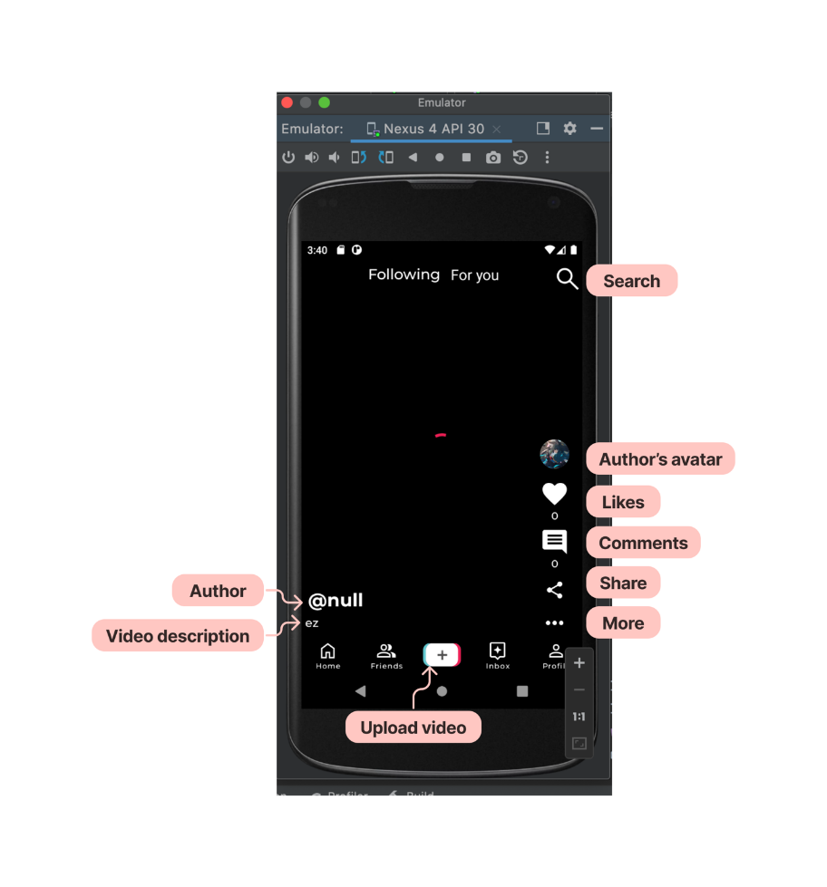

# SearchScreen

- If you click on the icon Search in HomeScreen, the screen will change to this. You can search the account that you want to see video and details.

# ProfileScreem

- If you click on username in SearchScreen or on video at HomeScreen, their profile page will appeared like this.

- If you click on profile button at HomeScreen, your profile will be showed.

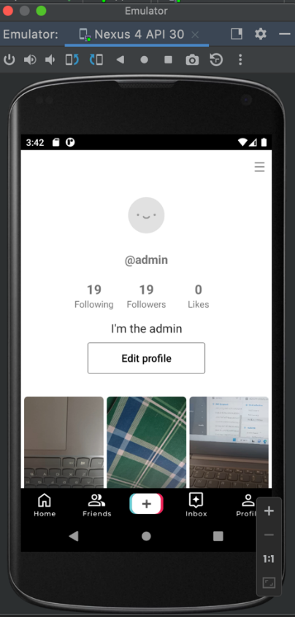

# InboxScreen

- If you click on inbox button, this screen will be showed.

