**MINISTRY OF EDUCATION AND TRAINING**

**HCMC UNIVERSITY OF TECHNOLOGY AND EDUCATION**

**FACULTY FOR HIGH-QUALITY TRAINING**



Mid-Term Project

Student Management System

Course: Windows Programming

Period: 7 - 10

Lecturer: Le Vinh Thinh

|  |  |
| --- | --- |
| **NAME** | **STUDENT’S ID** |
| Le Minh Thang | 18110048 |

*HCMC May, 2021  
Last update: May 18, 2021*

**SCORE**

|  |  |  |  |
| --- | --- | --- | --- |
| Criteria | Content | Presentation | Total |
| Point |  |  |  |

**REMARKS OF TEACHERS**

………………………………………………………………………………………………………………………………………………………………….

…………………………………………………………………………………………………………………………………………………………………

…………………………………………………………………………………………………………………………………………………………………

…………………………………………………………………………………………………………………………………………………………………

…………………………………………………………………………………………………………………………………………………………………

Ho Chi Minh City, May 18th, 2021

Teacher’s score

(Signature and full name)

**Le Vinh Thinh**

**THANK YOU**

In order to successfully complete this topic and this report, we would like to extend our sincere thanks to the lecturer, Le Vinh Thinh, who directly supported us throughout the process of making the topic. We thank the teacher for giving advice from his practical experience to guide me in the right direction with the requirements of the selected topic, always answer questions and give suggestions and corrections. time to help me overcome our shortcomings and complete it well as well as on schedule.

We also would like to express our sincere thanks to the teachers in the

High Quality Education Department in general and the Information Technology industry in particular for their dedicated knowledge to help me have a foundation to make. This topic has created conditions for me to learn and perform well on the topic. Along with that, I would like to thank our classmates for providing useful information and knowledge to help me improve our topic.

With limited knowledge and many other limitations in terms of technical and experience in implementing a software project. Therefore, in the process of creating a topic with shortcomings is inevitable, we look forward to receiving valuable comments from the teachers to make our knowledge more complete and We can do even better next time.

We sincerely thank you.

At the end, we would like to wish all of you teachers, ladies and gentlemen, always having abundant health and more success in the career of growing people. Once again we sincerely thanks.

**SUBJECT DESCRIPTION OF THE SUBJECTS OF DATA BASIS MANAGEMENT**

Implementing student: **Le Minh Thang** ID’s student: **18110048**

**Tasks of the topic:** Building Student Management System to ensure the following functions:

1. Manage student’s information.

2. Manage course’s information.

3. Manage score’s information.

4. Show result’s information.

5. Human Resources information

**TABLE OF CONTENTS**

*All images which are presented in this report are listed here.*

|  |
| --- |
| **table 1. Image list** |
|  |

|  |  |  |
| --- | --- | --- |
| Figure | Caption | Page |
| 1 | Class Diagram | 8 |
| 2 | Database | 8 |
| 3 | Login Form | 10 |
| 4 | Register Form | 10 |
| 5 | Main Form | 11 |
| 6 | Add New Student Form | 12 |
| 7 | Student List Form | 13 |
| 8 | Statics Form | 13 |
| 9 | Edit/Remove Student Form | 14 |
| 10 | Manage Student Form | 14 |
| 11 | Print Form | 15 |
| 12 | Add Course Form | 15 |
| 13 | Remove Course Form | 16 |
| 14 | Edit Course Form | 16 |
| 15 | Manage Courses Form | 16 |
| 16 | Print Course Form | 17 |
| 17 | Add Score Form | 18 |
| 18 | Remove Score Form | 18 |
| 19 | Manage Score Form | 19 |
| 20 | Average Scores Form | 19 |
| 21 | Print Form | 20 |
| 22 | Average results by Scores Form | 20 |
| 23 | Statics Results Form | 21 |
| 24 | Human Resource | 21 |
| 25 | Add Contact Form | 22 |
| 26 | Edit Contact Form | 23 |
| 27 | Select Contact Form | 24 |
| 28 | Contact Full List Form | 24 |

**i.General**

**1. FUNCTIONS OF THE TOPIC**

* **FUNCTIONAL REQUIREMENTS**
* Register

+ The user will register or sign up.

+ To register have to provide information ID, first name, last name, username, password, picture to register.

* Sign up

+ Input/ Output: Detail and confirm of registration status and a student number and password will be generated for the the user.

+ Processing: All details will be checked and will notify if an error occurs.

* Login

+ Input: Enter the username and password provided.

+ Output: User will be able to use the features of software.

* There are 4 main functions:
* Student

+ Add New Student

+ Student List

+ Statics

+ Edit/Remove Student

+ Manage Student

+ Print

* Course

+ Add Course

+ Remove Course

+ Edit Course

+ Manage Course

+ Print

* Score

+ Add Score

+ Remove Score

+ Manage Score

+ Average Score By Course

+ Print

* Result

+ Average Results by Score

+ Statics Result

**iI.COntent**

**1. DATABASE DESIGN**

### Class Diagram

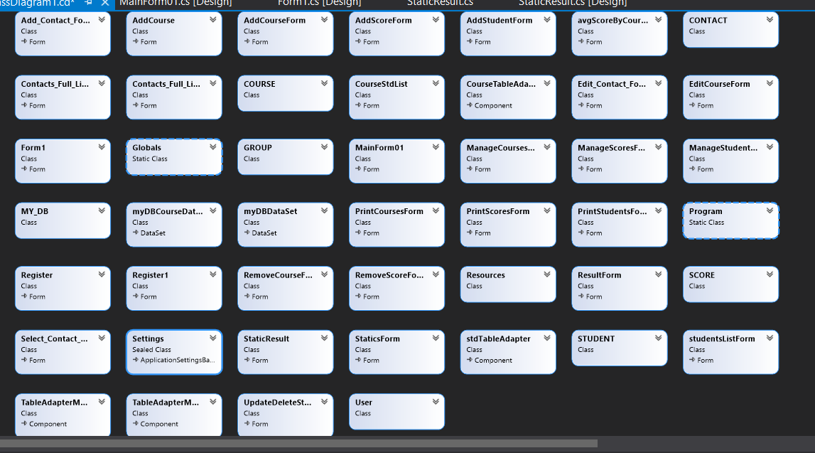

Figure 1. Class Diagram

### Database Diagram

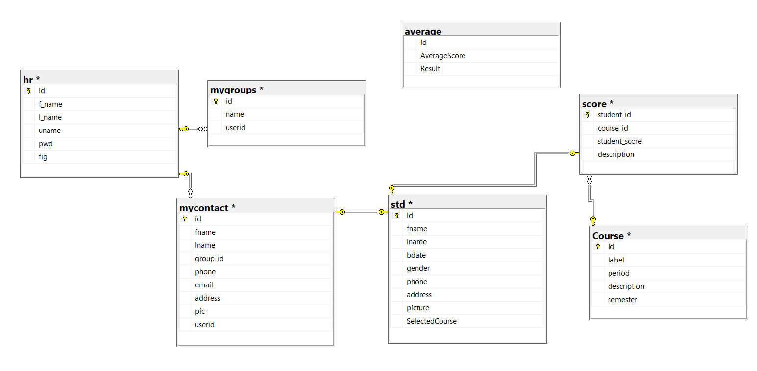

Figure 2. Databases Diagram

|  |  |  |
| --- | --- | --- |
| **No** | **Table’s name** | **Purpose** |
| 1 | std | Store student’s information into system. |
| 2 | Course | Store course’s information of student. |
| 3 | score | Store score’s information of courses that student participate in. |
| 4 | mygroups | Store teachers ’s courses that teachers responsible for them. (If human resources is Teacher) |
| 5 | mycontact | Store Student that teacher responsible(If human resources is Teacher) |
| 6 | hr | Store account when user register and login into system |
| 7 | average | Store average scores of each course |

**iII.Design the theme**

1. **Login Form**

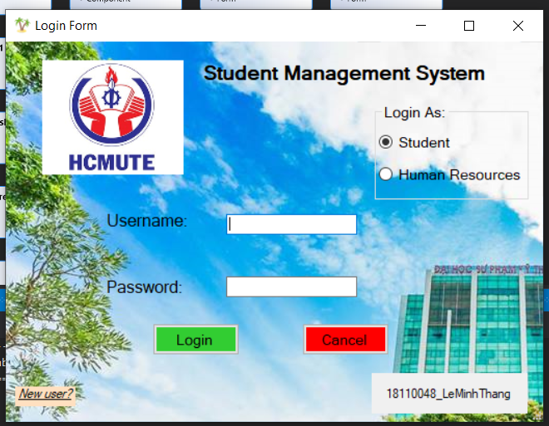

Figure 3. Login Form

1. **Register Form**

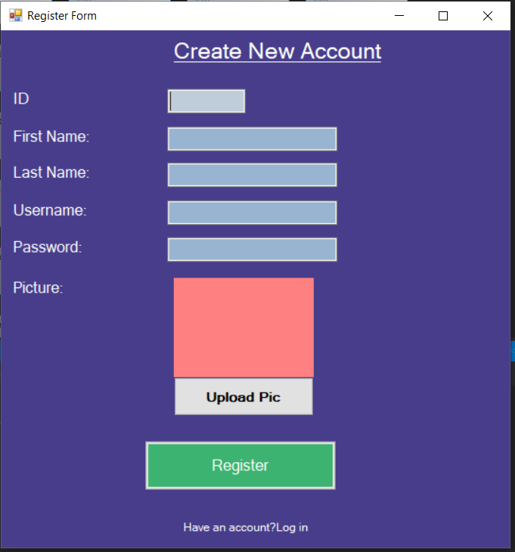

Figure 4. Register Form

1. **Main Form**

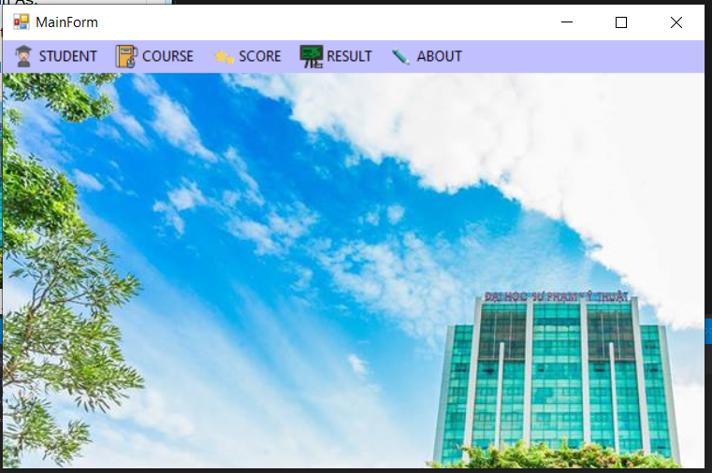

Figure 5. Main Form

1. **Function Form**

* **Student:**

+ Add New Student Form

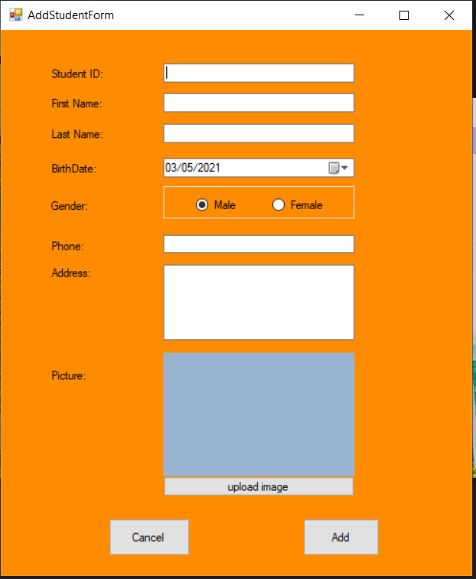

Figure . Add New Student Form

+ Student List Form

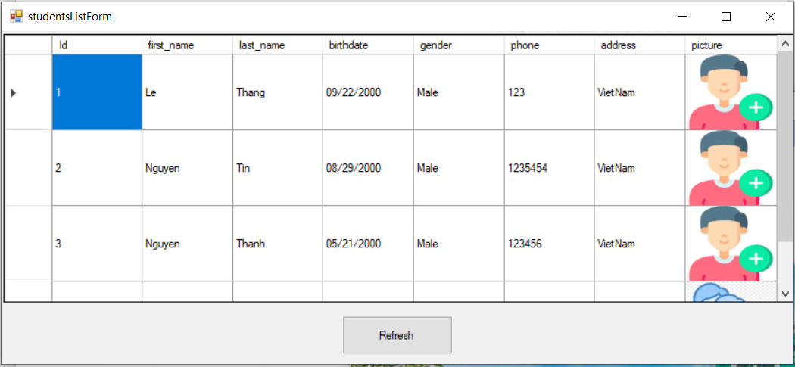

Figure . Student List Form

+ Statics Form

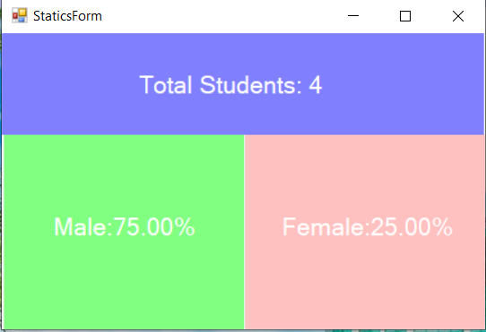

Figure . Statics Form

+ Edit/Remove Student Form

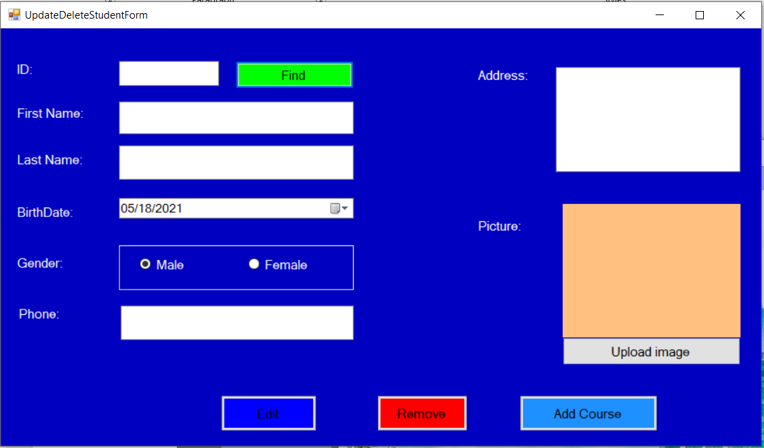

Figure . Edit/Remove Student Form

+ Manage Student Form

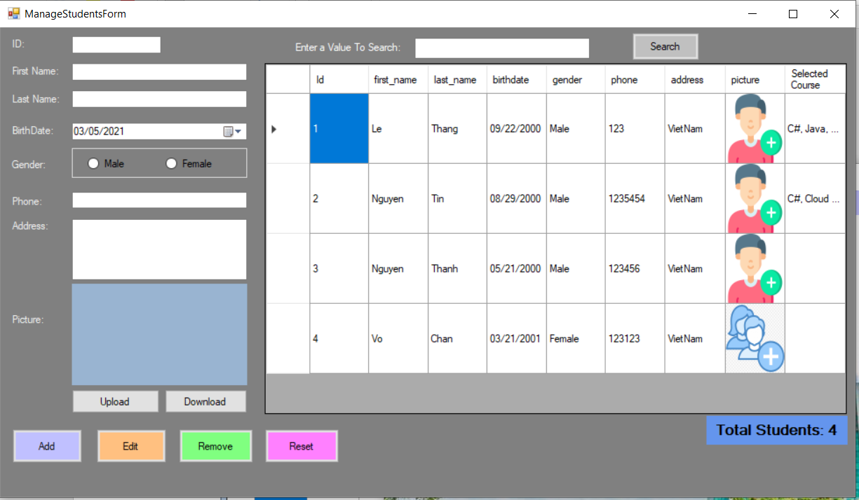

Figure . Manage Student Form

+ Print Form

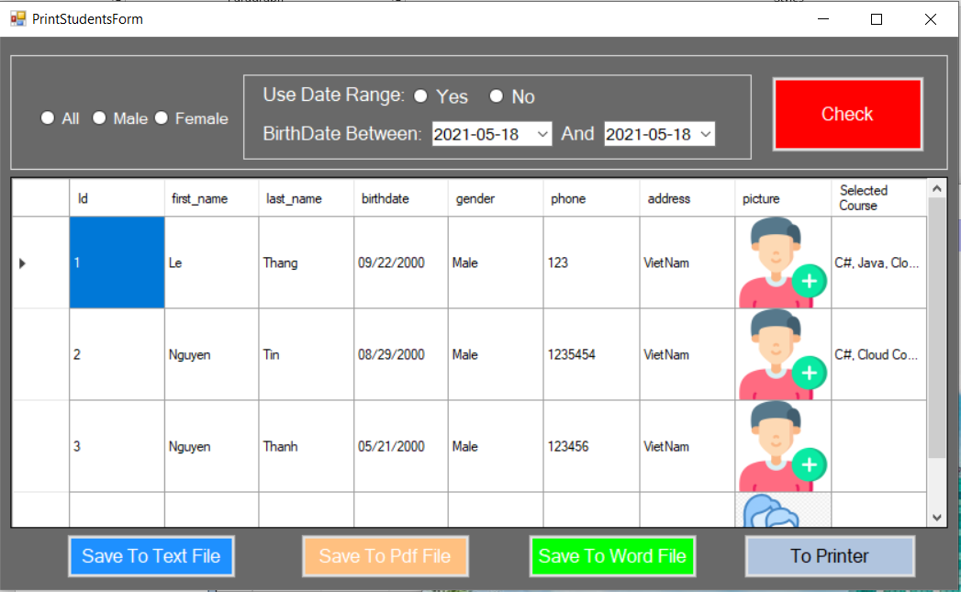

Figure . Print Form

* **Course:**

+ Add Course Form

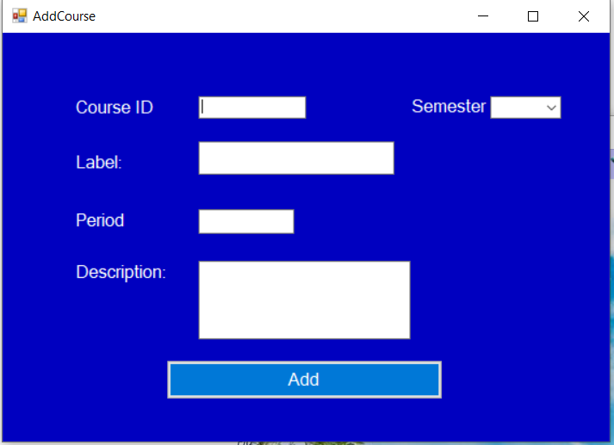

Figure . Add Course Form

+ Remove Course Form

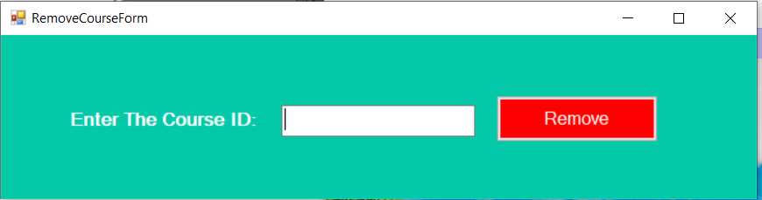

Figure . Remove Course Form

+ Edit Course Form

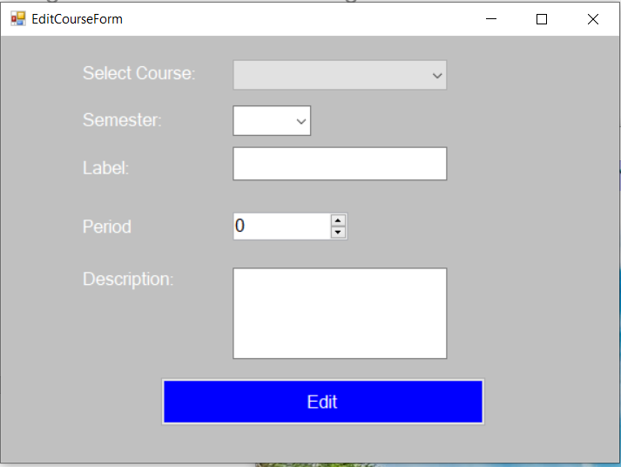

Figure . Edit Course Form

+ Manage Courses Form

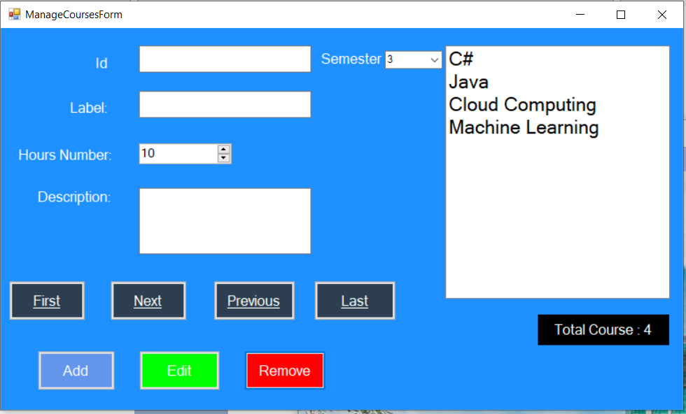

Figure . Manage Courses Form

+ Print Course Form

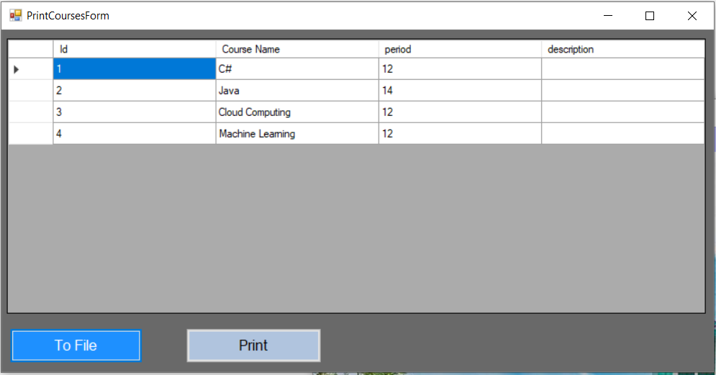

Figure . Print Course Form

* **Score:**

+ Add Score Form

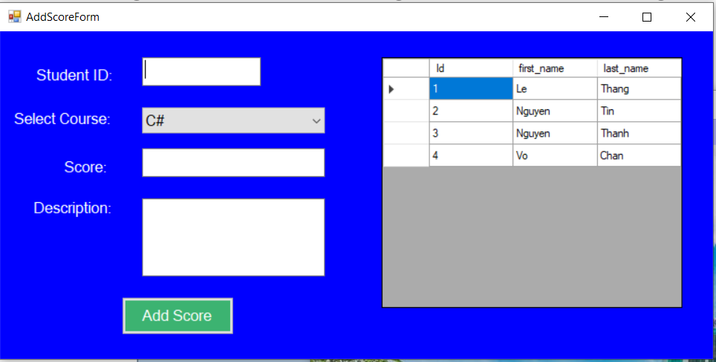

Figure . Add Score Form

+ Remove Score Form

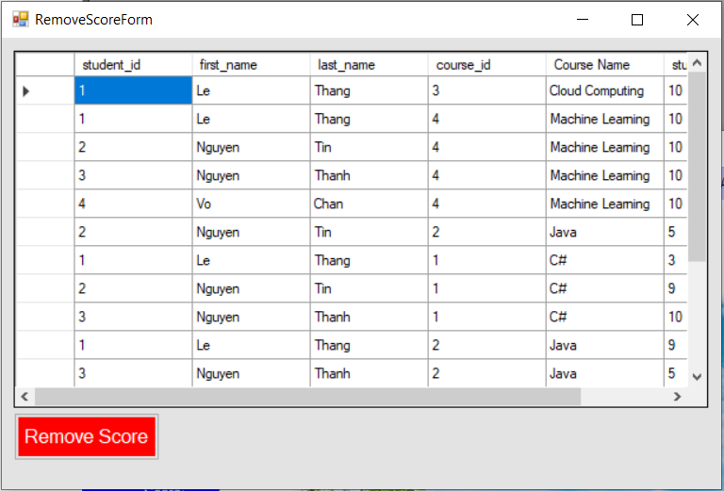

Figure . Remove Score Form

+ Manage Score Form

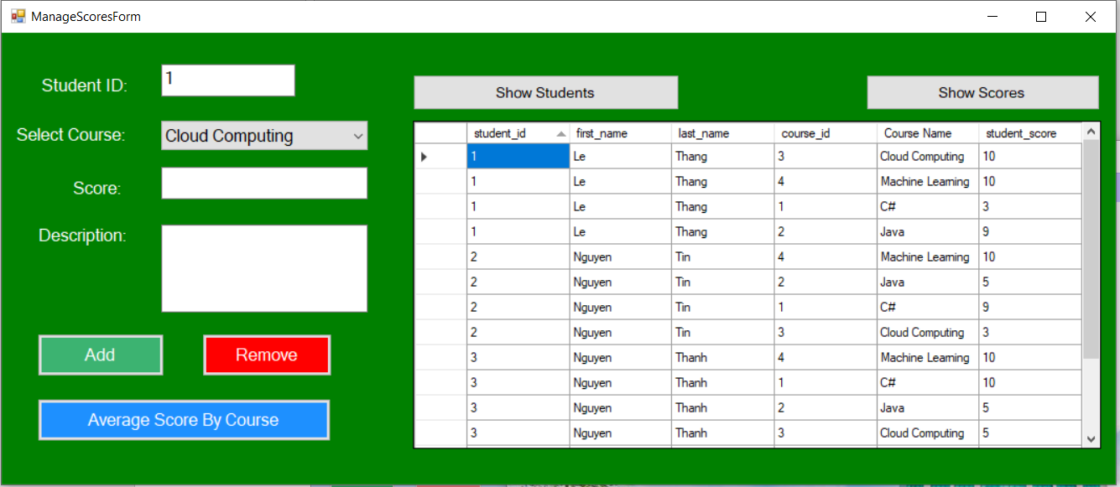

Figure . Manage Score Form

+ Average Scores Form

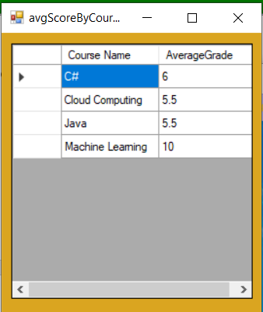

Figure . Average Scores Form

+ Print Form

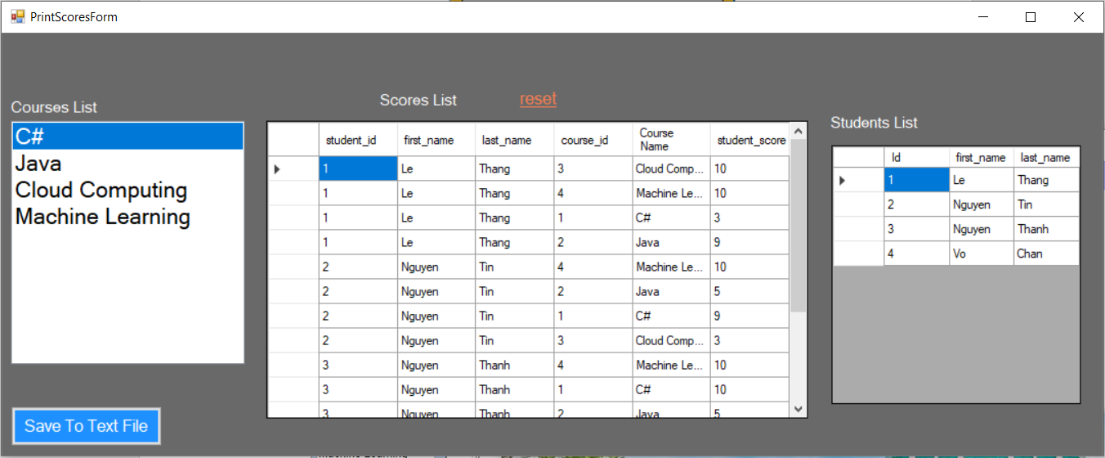

Figure . Print Form

* **Result:**

+ Average results by Scores Form

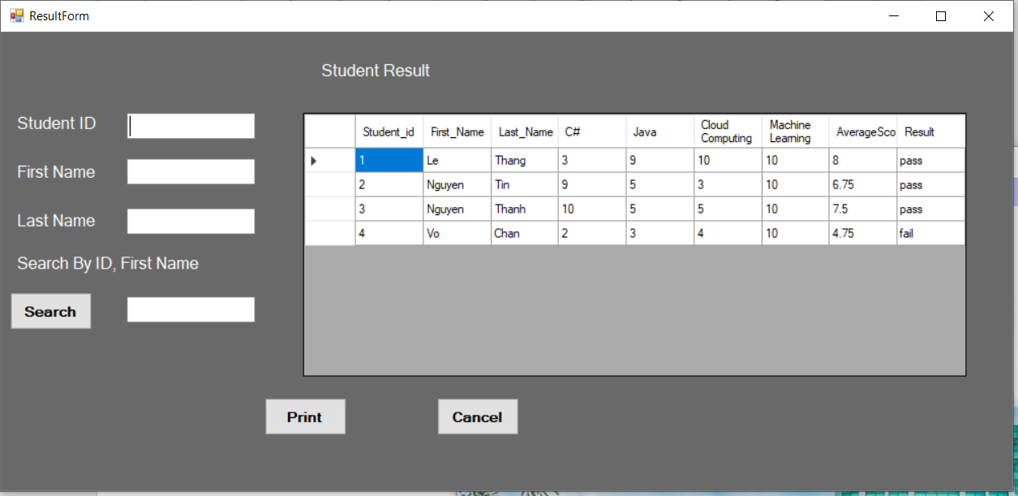

Figure . Average results by Scores Form

+ Statics Results Form

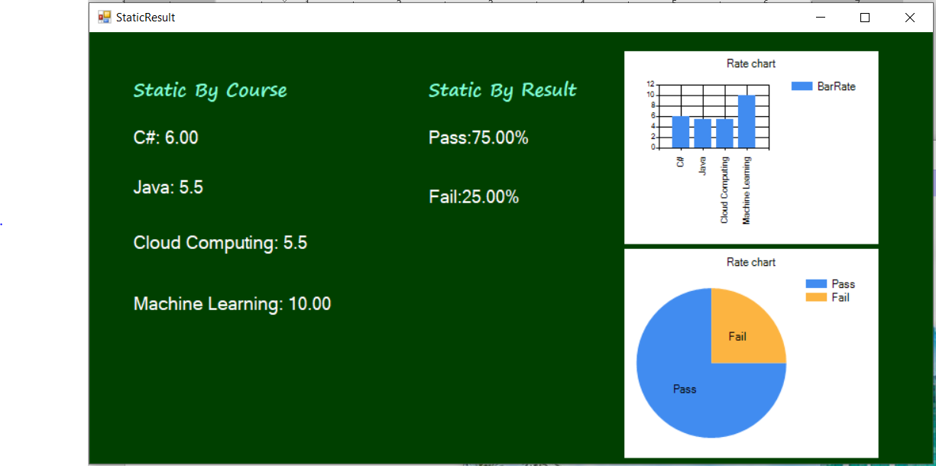

Figure . Statics Results Form

* **Human Resource**

**+** MainForm Human resources

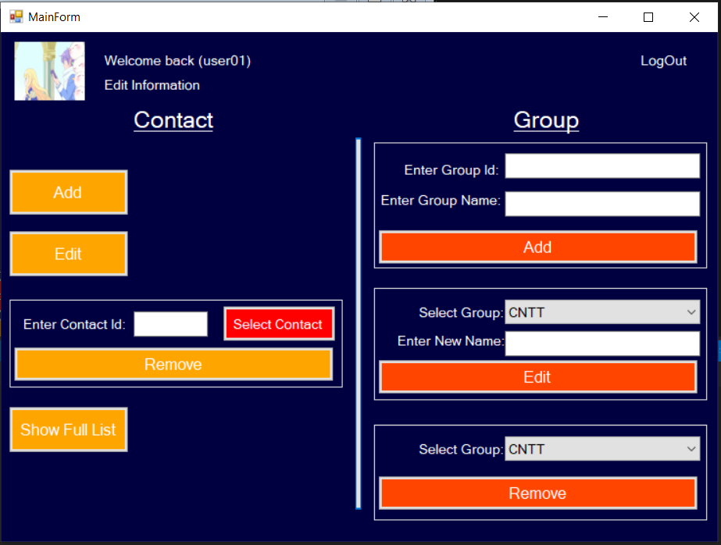

Figure . Human Form

+ Add Contact Form

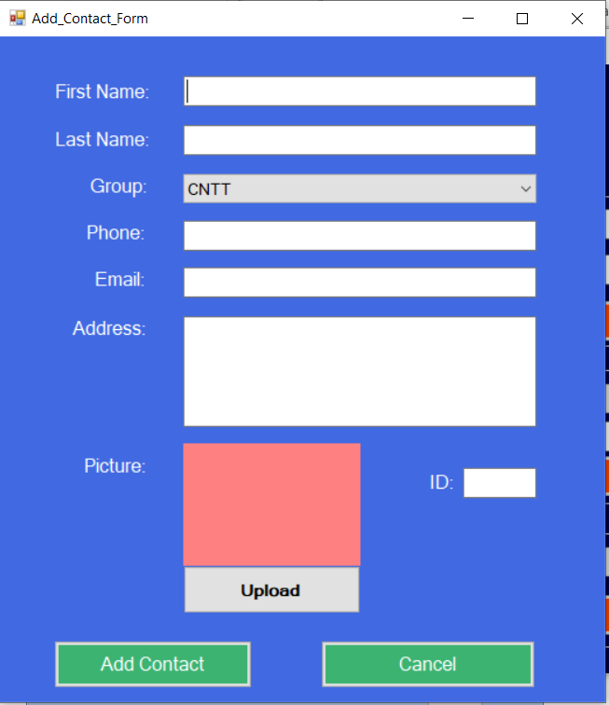

Figure . Add Contact Form

+ Edit Contact Form

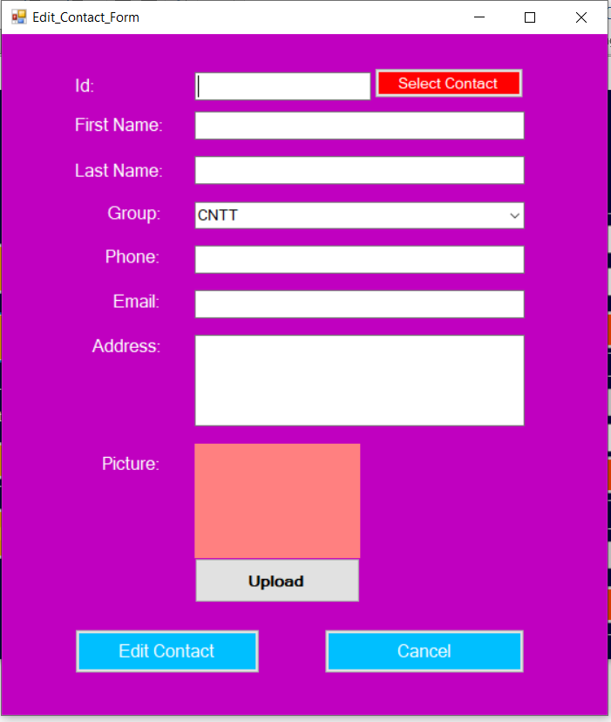

Figure . Edit Contact Form

+ Select Contact Form

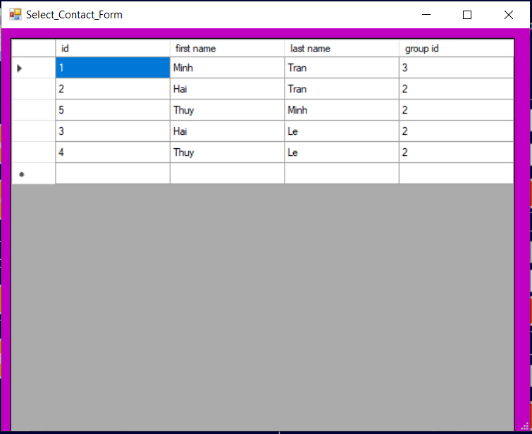

Figure . Select Contact Form

+ Contact Full List Form

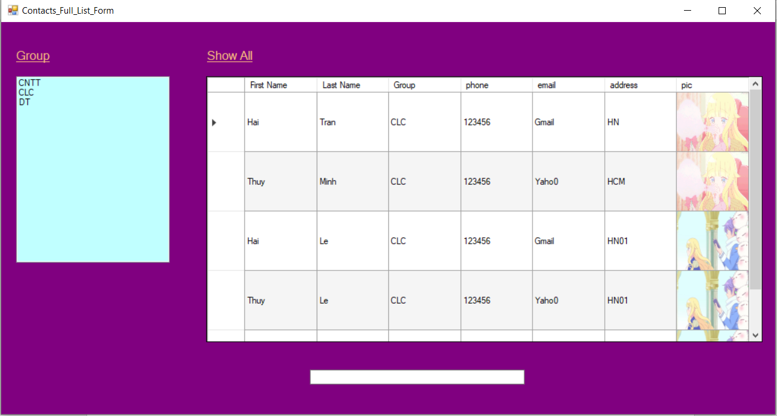

Figure . Contact Full List Form