**Adaptive Optimization, 2019**

**Ant Colony Optimization (H.W. 6)**

**Due: 2019. June. 11 (Tuesday)**

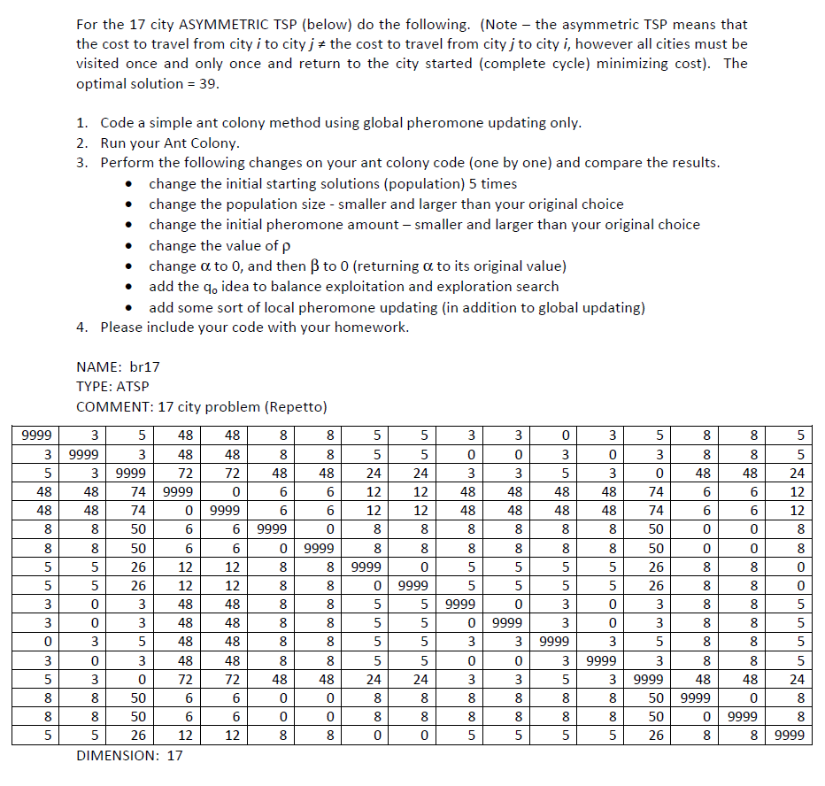

|  |
| --- |
| NAME: br17 |
|  | TYPE: ATSP |
|  | COMMENT: 17 city problem (Repetto) |
|  | DIMENSION: 17 |
|  | EDGE_WEIGHT_TYPE: EXPLICIT |
|  | EDGE_WEIGHT_FORMAT: FULL_MATRIX |
|  | EDGE_WEIGHT_SECTION |
|  | 9999 3 5 48 48 8 8 5 5 3 3 0 3 5 8 8 |
|  | 5 |
|  | 3 9999 3 48 48 8 8 5 5 0 0 3 0 3 8 8 |
|  | 5 |
|  | 5 3 9999 72 72 48 48 24 24 3 3 5 3 0 48 48 |
|  | 24 |
|  | 48 48 74 9999 0 6 6 12 12 48 48 48 48 74 6 6 |
|  | 12 |
|  | 48 48 74 0 9999 6 6 12 12 48 48 48 48 74 6 6 |
|  | 12 |
|  | 8 8 50 6 6 9999 0 8 8 8 8 8 8 50 0 0 |
|  | 8 |
|  | 8 8 50 6 6 0 9999 8 8 8 8 8 8 50 0 0 |
|  | 8 |
|  | 5 5 26 12 12 8 8 9999 0 5 5 5 5 26 8 8 |
|  | 0 |
|  | 5 5 26 12 12 8 8 0 9999 5 5 5 5 26 8 8 |
|  | 0 |
|  | 3 0 3 48 48 8 8 5 5 9999 0 3 0 3 8 8 |
|  | 5 |
|  | 3 0 3 48 48 8 8 5 5 0 9999 3 0 3 8 8 |
|  | 5 |
|  | 0 3 5 48 48 8 8 5 5 3 3 9999 3 5 8 8 |
|  | 5 |
|  | 3 0 3 48 48 8 8 5 5 0 0 3 9999 3 8 8 |
|  | 5 |
|  | 5 3 0 72 72 48 48 24 24 3 3 5 3 9999 48 48 |
|  | 24 |
|  | 8 8 50 6 6 0 0 8 8 8 8 8 8 50 9999 0 |
|  | 8 |
|  | 8 8 50 6 6 0 0 8 8 8 8 8 8 50 0 9999 |
|  | 8 |
|  | 5 5 26 12 12 8 8 0 0 5 5 5 5 26 8 8 |
|  | 9999 |
|  | EOF |