# HTTP (Hypertext Transfer Protocol)

Before http 2.0

HTTP is a TC/IP based communication protocol

## Uniform Resource Identifiers

Uniform Resource Identifiers (URI) are simply formatted, case-insensitive string containing name, location, etc. to identify a resource, for example, a website, a web service, etc. A general syntax of URI used for HTTP is as follows:

URI = "http:" "//" host [ ":" port ] [ abs_path [ "?" query ]]

Here if the **port** is empty or not given, port 80 is assumed for HTTP and an empty **abs_path** is equivalent to an **abs_path** of "/". The characters other than those in the **reserved** and **unsafe** sets are equivalent to their ""%" HEX HEX" encoding.

**Example**

The following three URIs are equivalent:

http://abc.com:80/~smith/home.html

http://ABC.com/%7Esmith/home.html

http://ABC.com:/%7esmith/home.html

## Request Method

The request **method** indicates the method to be performed on the resource identified by the given **Request-URI**. The method is case-sensitive and should always be mentioned in uppercase. The following table lists all the supported methods in HTTP/1.1.

|  |  |
| --- | --- |
| **S.N.** | **Method and Description** |
| 1 | **GET**  The GET method is used to retrieve information from the given server using a given URI. Requests using GET should only retrieve data and should have no other effect on the data. |
| 2 | **HEAD**  Same as GET, but it transfers the status line and the header section only. |
| 3 | **POST**  A POST request is used to send data to the server, for example, customer information, file upload, etc. using HTML forms. |
| 4 | **PUT**  Replaces all the current representations of the target resource with the uploaded content. |
| 5 | **DELETE**  Removes all the current representations of the target resource given by URI. |
| 6 | **CONNECT**  Establishes a tunnel to the server identified by a given URI. |
| 7 | **OPTIONS**  Describe the communication options for the target resource. |
| 8 | **TRACE**  Performs a message loop back test along with the path to the target resource. |

<https://assertible.com/blog/7-http-methods-every-web-developer-should-know-and-how-to-test-them>

<https://www.tutorialspoint.com/http/http_methods.htm>

<https://www.tutorialspoint.com/http/http_requests.htm>

<https://www.tutorialspoint.com/http/http_status_codes.htm>

# Session & cookie

# HTTP cheat sheats

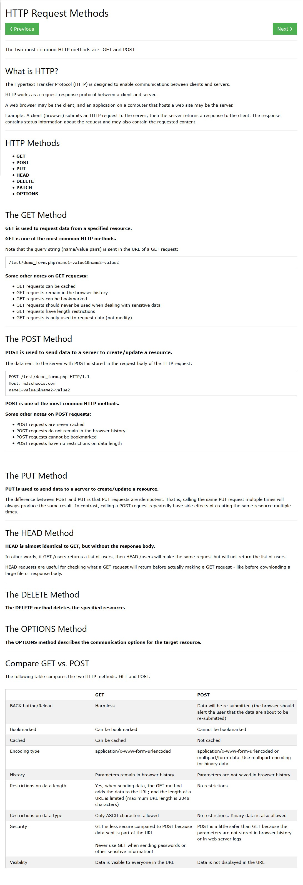

<https://www.w3schools.com/tags/ref_httpmethods.asp>