# External App in SharePoint Online

Video: http://youtu.be/zEBZ_G4RrYY?hd=1

Link : [https://yourname.sharepoint.com/sites/Coke/**_layouts/15/appregnew.aspx**](https://yourname.sharepoint.com/sites/Coke/_layouts/15/appregnew.aspx)

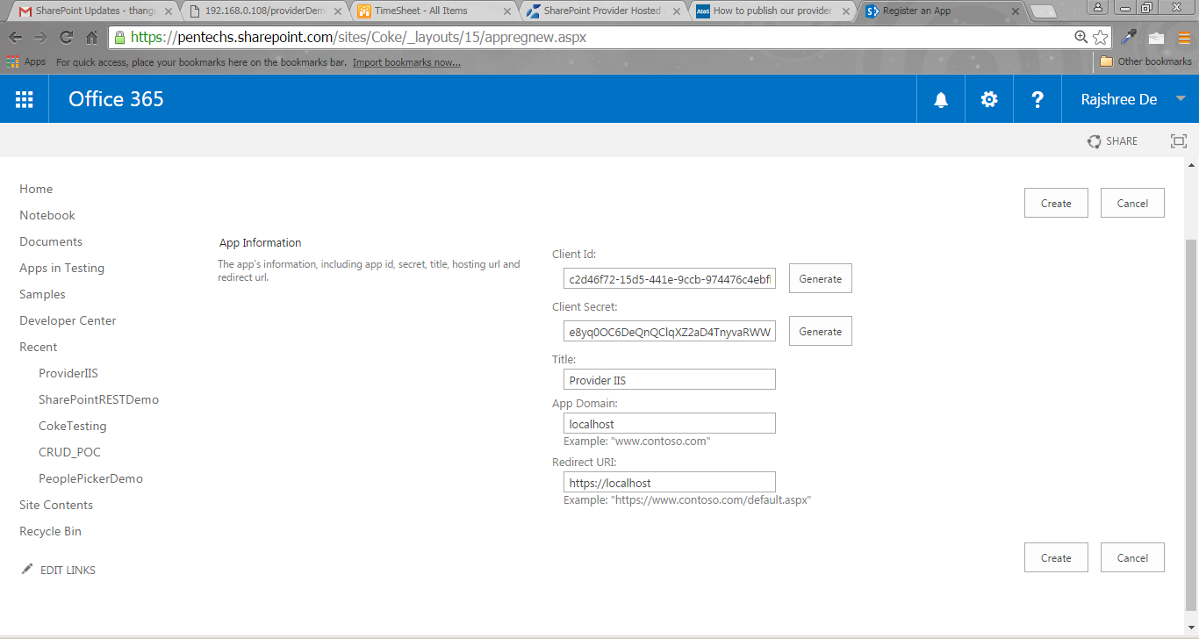

The app identifier has been successfully created.

|  |  |
| --- | --- |
| Client Id: | c2d46f72-15d5-441e-9ccb-974476c4ebfb |
| Client Secret: | e8yq0OC6DeQnQClqXZ2aD4TnyvaRWWhkqr/Um/+VRkk= |
| Title: | Provider IIS |
| App Domain: | localhost |
| Redirect URI: | https://localhost |

Save the new ClientID and Secret in notepad.

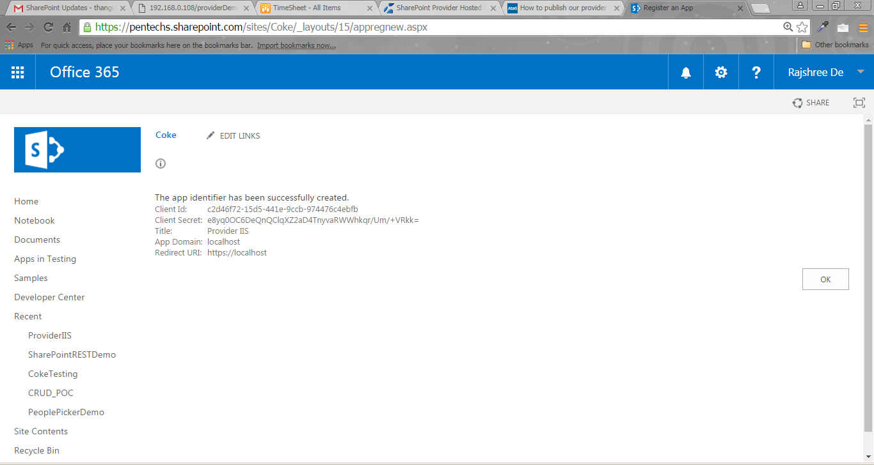

Paste the URL of your Application in AppManifest.xml. Example https://192.168.0.108/welcome/chromewelcome.html

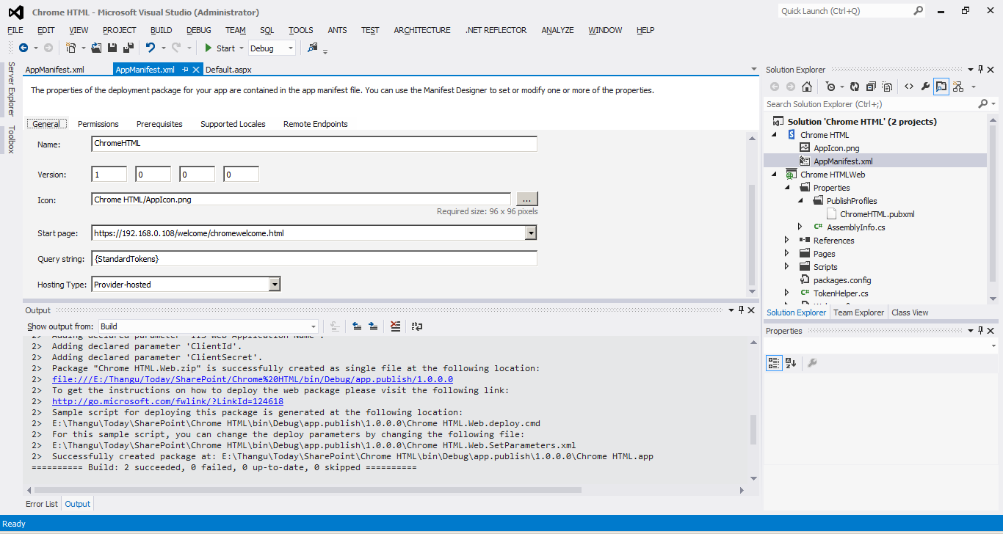

Paste the Client ID in the Code Portion of AppManifest.xml

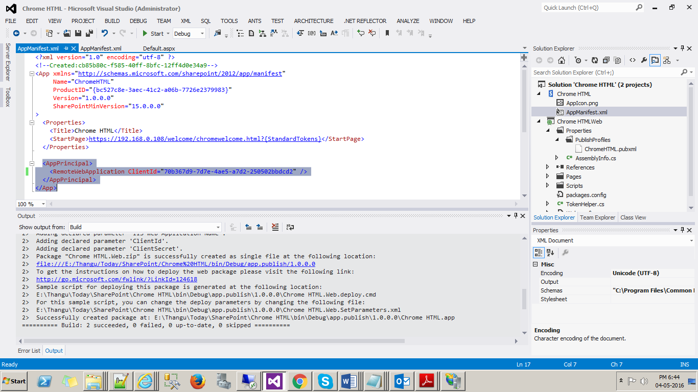

Publish the SharePoint App. Ignore the Web Portion of the Provider Hosted App.

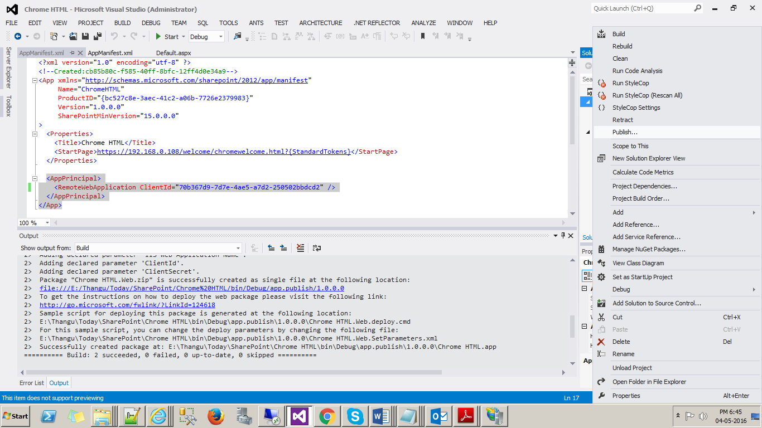

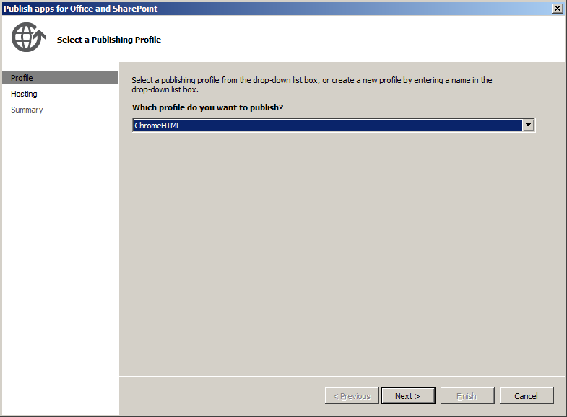

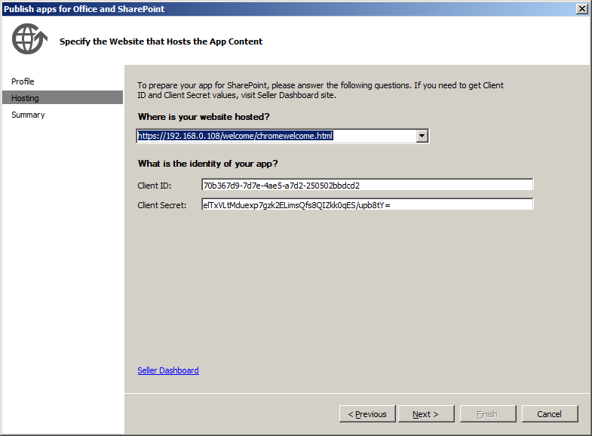

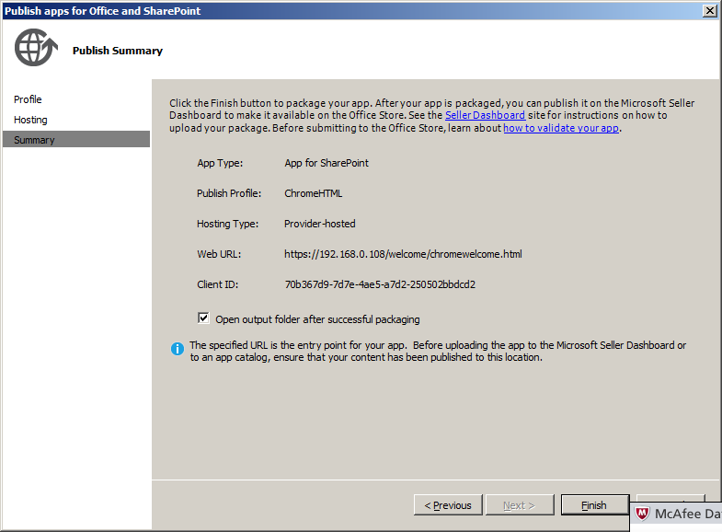

Upload the App in the SharePoint Online Site

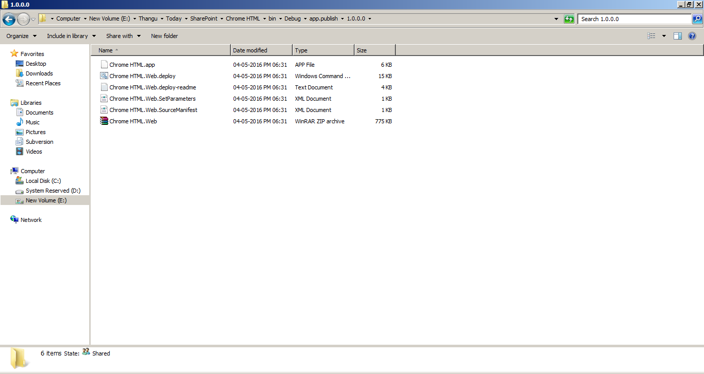

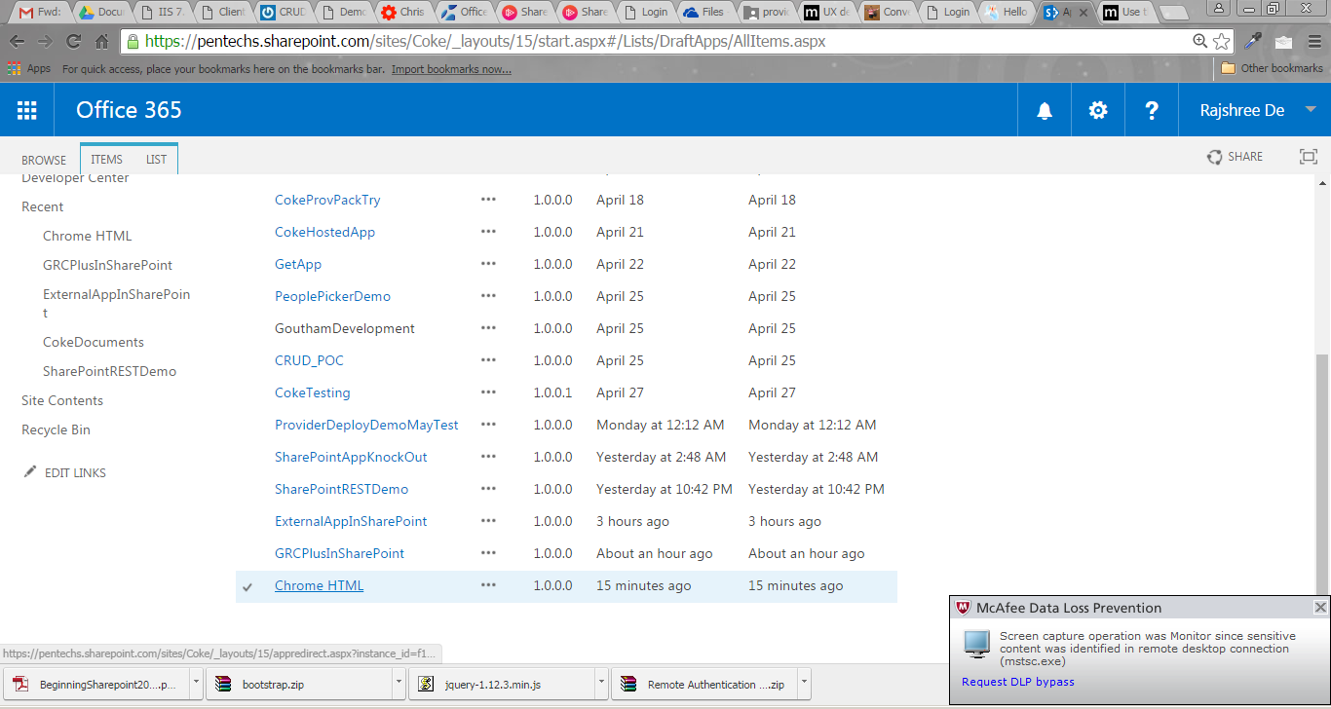

Click the app

# References

http://www.slideshare.net/SPSNewJersey/sharepoint-2013-and-existing-web-applications