Buoc 1:

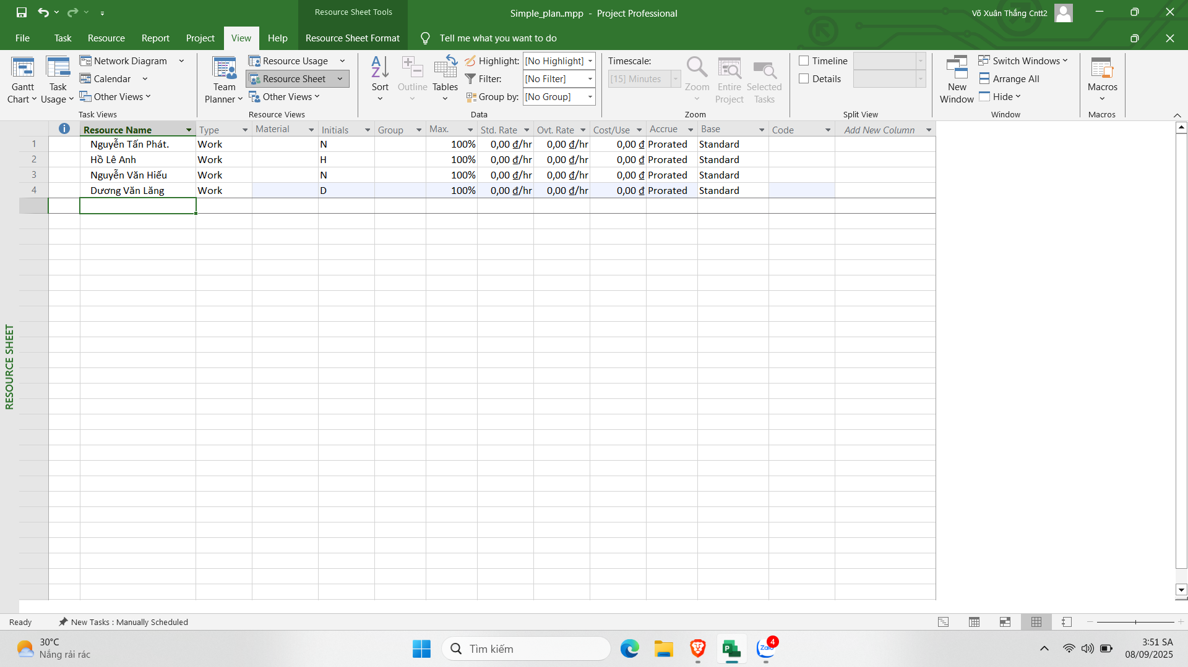

Buoc 2:

Bước 3

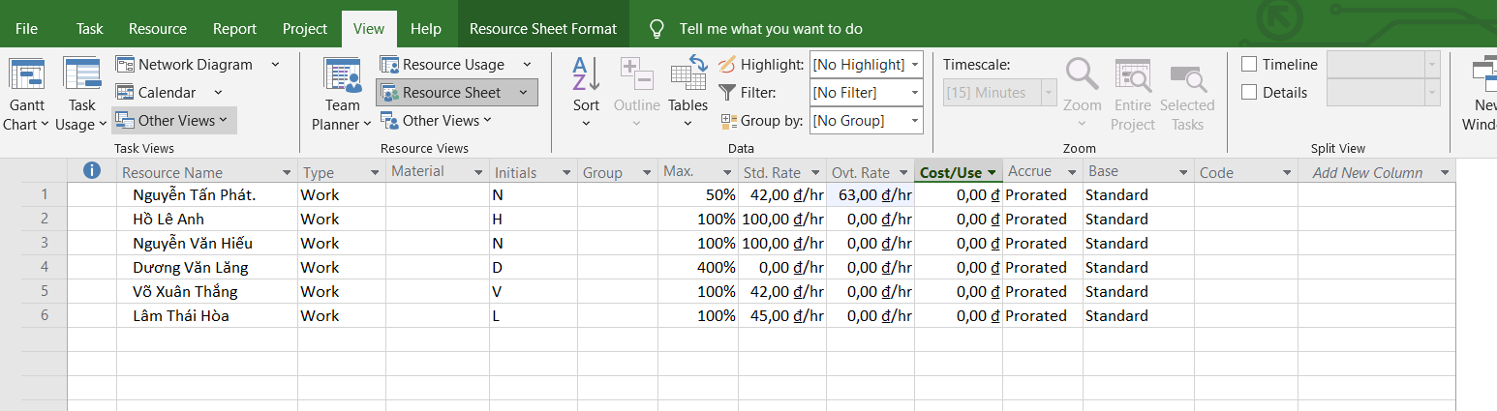

Bước 4

Bước 5

Bước 6

II. Phân tài nguyên cho công việc

Bước 1

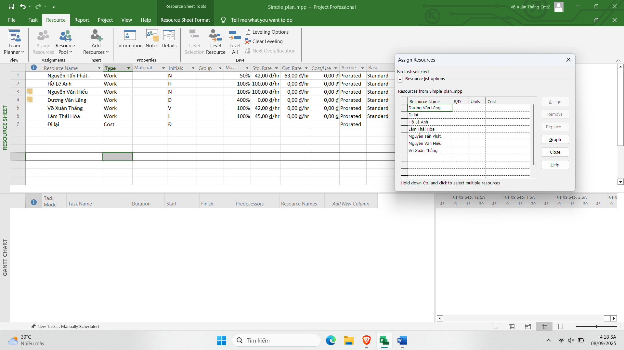

Bước 2

Bước

Bước

Bước

Bước

Bước

Bước