DSP391m — DATA SCIENCE CAPSTONE PROJECT
Vietnamese Voice Cloning Studio: Objective Benchmarking of Zero-Shot Text-to-Speech with F5-TTS ViVoice
Report 3 — Model Development · Evaluation & Fine-Tuning · Results · Conclusion

Course: | DSP391m - Data Science Capstone Project
Team Members: | Nguyễn Hoàng Thanh - SE172535  Trương Thanh Tuấn - SE182217  Nguyễn Thị Vân Anh - DE18037
Instructor: | Nguyễn Quốc Trung
Academic Term: | Summer 2026

Project Title
Vietnamese Voice Cloning Studio — a bilingual web application that clones a Vietnamese speaker's voice from a short reference recording using F5-TTS, and benchmarks it against five additional text-to-speech engines under identical inputs with an objective, reproducible evaluation harness.

1. Introduction and Background
Objective: Build a Vietnamese zero-shot voice-cloning TTS system centered on F5-TTS ViVoice and quantify its quality against five baseline engines using objective, reproducible metrics (word/character error rate, speaker similarity, and generation speed).
Motivation: Voice cloning enables accessibility tools, dubbing and personalized assistants, yet Vietnamese is under-served. The language's six tones and dense diacritics make both synthesis and its evaluation hard — a single mispronounced tone can change a word's meaning — so a rigorous, tone-aware evaluation is as valuable as the model itself.
Background Information: Modern non-autoregressive TTS pairs a transformer backbone with a generative objective. F5-TTS uses a Diffusion Transformer (DiT) trained with a Conditional Flow-Matching (CFM) objective and a Vocos 24 kHz vocoder. The Vietnamese checkpoint hynt/F5-TTS-Vietnamese-ViVoice is pre-trained on roughly 1,000 hours of Vietnamese speech and released under CC-BY-NC-SA-4.0 for non-commercial research.

2. Literature Review
F5-TTS [1] demonstrates that a DiT [3] trained with flow matching [2] produces fluent, faithful speech without the alignment modules of earlier systems; Vocos [4] closes the quality gap between time-domain and Fourier-based neural vocoders. For zero-shot cloning, XTTS-v2 [5] is a strong multilingual competitor. Single-speaker baselines include Meta's MMS-TTS [6], the local ONNX voice Piper [9], Microsoft's cloud Edge-TTS, and Bark [8] (no Vietnamese support, used as a lower bound). Evaluation builds on Whisper [7] for the ASR round-trip and a GE2E-style speaker encoder [11] for identity similarity.
Gap addressed: published Vietnamese TTS work rarely reports a like-for-like, fully-reproducible objective comparison across cloning and fixed-voice engines under identical text, seed and reference. This project contributes exactly such a harness.

3. Data Description
Source: Three data roles are distinguished. (a) Pre-training corpus: ViVoice (~1,000 h Vietnamese), used only via the released checkpoint. (b) Evaluation data: a fixed clean reference sample (reference_audio/sample_clean_vi.wav) and a fixed benchmark sentence. (c) Fine-tuning data: 30–60 minutes of single-speaker audio, to be collected.
Size and Format: Audio is mono WAV at 24 kHz. Text metadata uses a pipe-delimited CSV (audio_path | transcript). The model vocabulary is a plain-text file (~2.5k tokens) covering accented Vietnamese characters plus inherited pinyin tokens.
Features: Per sample: (i) the raw 24 kHz waveform → a 100-band mel-spectrogram front-end (n_fft 1024, hop 256, win 1024); (ii) the transcript, tokenized with the model's convert_char_to_pinyin scheme; and (iii) the sequence length used for masking.

4. Data Cleaning and Preprocessing
Audio preprocessing reuses the library's validated preprocess_ref_audio_text (silence trimming, resampling to 24 kHz mono, level normalization). Text is normalized to Unicode NFC with Vietnamese diacritics preserved; whitespace and punctuation are regularized. Long inputs pass through boundary-aware chunking that protects URLs, e-mails, decimals, dates and abbreviations from being split.
Challenge resolved — quarantined synthetic data. An earlier iteration accidentally trained on synthetic sine/tone signals mislabeled as speech, corrupting the model. All such files were moved to a quarantined directory and are blocked from the pipeline unless an explicitly named technical-test flag is passed, so they can never again be mistaken for real training data.

5. Exploratory Data Analysis (EDA)
Because the signal is audio, EDA relies on objective per-clip metrics — duration, RMS level, peak, clipping ratio and spectral flatness — computed directly on the waveform. Spectral flatness is the key discriminator: structured human speech sits around 0.10–0.15, whereas near-monotone or noisy signals collapse toward zero. This single metric exposed the corrupted-checkpoint defect (flatness ≈ 0.0019) and later confirmed the fix (flatness restored to ≈ 0.11–0.14, matching the real reference sample).
These metrics also act as automatic guardrails during evaluation: a clip that is silent, clipped, or non-finite is flagged before any error-rate is computed, so degenerate output cannot masquerade as a valid result.

6. Methodology
Model Selection: F5-TTS ViVoice is the primary model because it uniquely combines zero-shot cloning (a short reference suffices, no per-speaker training), strong Vietnamese pre-training, a state-of-the-art DiT+CFM backbone, and a research-permissive license. The five baselines were chosen to span the trade-off space: XTTS-v2 (competing cloning), MMS/Piper/Edge (fast fixed-voice TTS) and Bark (deliberate weak floor).
Data Splitting Strategy: For fine-tuning, a deterministic 90/10 train/validation split is drawn with a fixed random generator (seed 42), so every run yields the same split and results are comparable. Model selection uses validation loss, not training loss.
Feature Engineering and Selection: Two engineered representations are central: the 100-band mel-spectrogram (audio side) and the pinyin-style character tokenization (text side). Text normalization and protected-token masking are the main hand-designed features; the architecture (mel bins, tokenizer) is fixed to match the pre-trained checkpoint and is not tuned.

7. Model Development

7.1 Model Architecture
The architecture is loaded verbatim from the library's F5TTS_Base.yaml so it matches the pre-trained checkpoint exactly:
CFM (Conditional Flow-Matching) wrapper
└─ DiT backbone: dim=1024, depth=22, heads=16, ff_mult=2,
text_dim=512, conv_layers=4,
text_mask_padding=false, pe_attn_head=1 (compatibility-critical)
└─ Vocoder: Vocos @ 24 kHz (mel → waveform)
Parameters ≈ 336M · front-end: n_fft=1024, hop=256, win=1024, n_mel=100

Compatibility invariant. The two fields text_mask_padding=false and pe_attn_head=1 must not be changed. When omitted, DiT reverts to v1 defaults and the forward pass silently mis-computes despite correctly-shaped weights, degrading output to a near-monotone signal (spectral flatness ≈ 0.0019). Restoring the exact architecture returns flatness to the human-speech range. This was one of the two principal defects diagnosed and fixed during development.

7.2 Training Procedure
The fine-tuning objective is single-speaker adaptation while avoiding catastrophic forgetting. The pipeline runs: metadata manifest → deterministic train/validation split → padding-aware collation → CFM flow-matching loss → mixed-precision back-propagation with gradient accumulation → gradient clipping → warm-up-then-cosine learning-rate schedule → checkpoint selection by validation loss. Exponential-moving-average weights are loaded from the official checkpoint; NaN/Inf losses abort immediately; each checkpoint records a JSON manifest of base model, architecture, vocabulary size, config, git commit, step, validation loss and dataset summary for full provenance.
Honest status: the fine-tuning pipeline is established and verified at the code-path level (its pure components are unit-tested), but it has not yet been run end-to-end on real speaker data with a GPU (blocked by the absence of collected speech). Accordingly, the results in Section 9 characterize the zero-shot base model, not a fine-tuned one; no fine-tuning improvement is claimed.

8. Model Evaluation and Fine-Tuning

8.1 Evaluation Metrics
Generative speech has no single ground-truth label, so quality is measured through objective proxies on two core axes plus speed:
- Intelligibility — WER and CER via an ASR round-trip: Whisper (small, beam 5, language=vi) re-transcribes the generated audio and the transcript is compared to the reference text with edit distance (jiwer, with an equivalent offline fallback). Vietnamese diacritics are preserved by default.
- Speaker identity — SECS: cosine similarity between Resemblyzer embeddings of the generated and reference audio. It is a relative similarity score, not biometric proof.
- Speed — real-time factor, RTF = inference time ÷ audio duration (RTF < 1 is faster than real time).
- Signal guardrails — RMS, peak, clipping ratio and spectral flatness screen for degenerate output before error rates are computed.

8.2 Hyperparameter Tuning
Inference hyper-parameters are tunable today: the number of flow-matching ODE steps (NFE, default 32, raised to 48–64 for long/hard sentences to reduce late-sentence drift), the random seed (fixed at 42 for reproducibility and fair cross-engine comparison), the chunk length (≈280 characters) and inter-chunk silence (180 ms). Training hyper-parameters (for a T4 16 GB GPU) are summarized in Table 1.
Hyper-parameter | Value | Rationale
Learning rate | 1e-5 | Small LR for fine-tuning; avoids forgetting
Batch × grad-accum | 1 × 8 = 8 | Effective batch under limited VRAM
Warm-up steps | 200 | Linear 0→LR for early stability
Scheduler | cosine | Anneals to min-LR 1e-7
Max grad norm | 1.0 | Gradient clipping
Mixed precision | fp16 | T4 supports FP16; auto-off on CPU
Optimizer / seed | AdamW / 42 | β=(0.9,0.999), weight decay 0.01; deterministic
Table 1. Training hyper-parameters (tuned for an NVIDIA T4, 16 GB).

8.3 Cross-Validation Techniques
Classical k-fold cross-validation is impractical for fine-tuning a 336M-parameter generative model on tens of minutes of audio (the k× training cost is prohibitive and the signal is generative, not a classification label). Its role is filled by (i) a deterministic held-out validation split monitored every epoch, with the best checkpoint chosen by validation loss, and (ii) an independent fixed test set of diverse sentences — greeting, general, numeric, date, interrogative, compound and long — used for the post-hoc WER/CER/SECS benchmark in Section 9.

9. Results Interpretation and Visualization
Every engine synthesizes the SAME set of 7 diverse Vietnamese sentences (greeting, general, number, date, question, compound and long) from the SAME reference sample under a fixed seed (42) and, for F5-TTS, a fixed NFE (32). Whisper re-transcribes each output; metrics are computed per sentence and aggregated. Because a few hard sentences (numbers, dates) legitimately inflate the average, Table 2 reports WER/CER as median / mean, and Figure 5 shows the full per-sentence spread. Values are read directly from results.json.
Engine | Type | WER% ↓ | CER% ↓ | SECS ↑ | Time (s) | RTF ↓ | N
F5-TTS | voice cloning | 8.7 / 22.4 | 2.6 / 18.9 | 0.862 | 92.1 | 22.75 | 7
XTTS-v2 | voice cloning | 11.1 / 21.8 | 5.4 / 19.1 | 0.877 | 13.2 | 2.92 | 7
MMS-TTS | fixed voice | 36.4 / 43.2 | 15.5 / 26.6 | 0.618 | 2.2 | 0.39 | 7
Piper | fixed voice | 9.1 / 27.1 | 6.8 / 21.8 | 0.637 | 0.5 | 0.15 | 7
Edge-TTS | cloud, fixed | 9.1 / 23.9 | 3.9 / 20.5 | 0.565 | 2.9 | 0.55 | 7
Bark | fixed (no VI) | 125.0 / 145.3 | 96.4 / 122.4 | 0.469 | 105.8 | 7.48 | 7
Table 2. Objective results over N=7 sentences (identical text / seed / reference). WER% and CER% shown as median / mean. Voice-cloning engines are shaded; blue marks the best median WER and the best SECS.
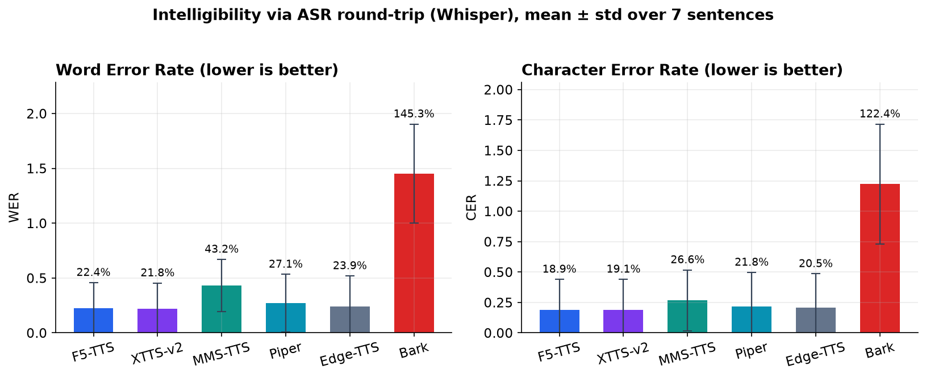
Figure 1. Intelligibility via ASR round-trip (bars = mean, whiskers = std over 7 sentences). The strong engines cluster closely; Bark (no Vietnamese) is the clear lower bound.
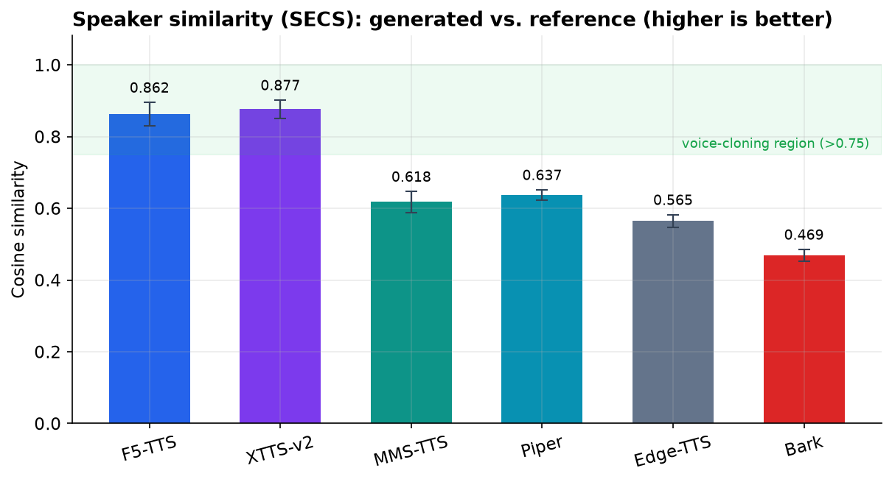
Figure 2. Speaker similarity (SECS). Only the two cloning engines, F5-TTS (0.862) and XTTS-v2 (0.877), enter the voice-cloning region (>0.75); fixed-voice engines fall well below it.
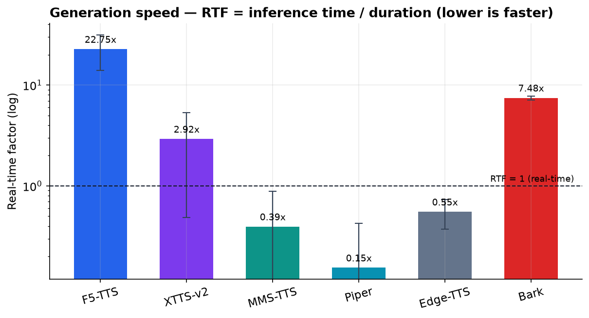
Figure 3. Generation speed (RTF, log scale; lower is faster). Fixed-voice engines run at or faster than real time on CPU; the flow-matching cloning models are slower on CPU and are expected to speed up substantially on GPU.
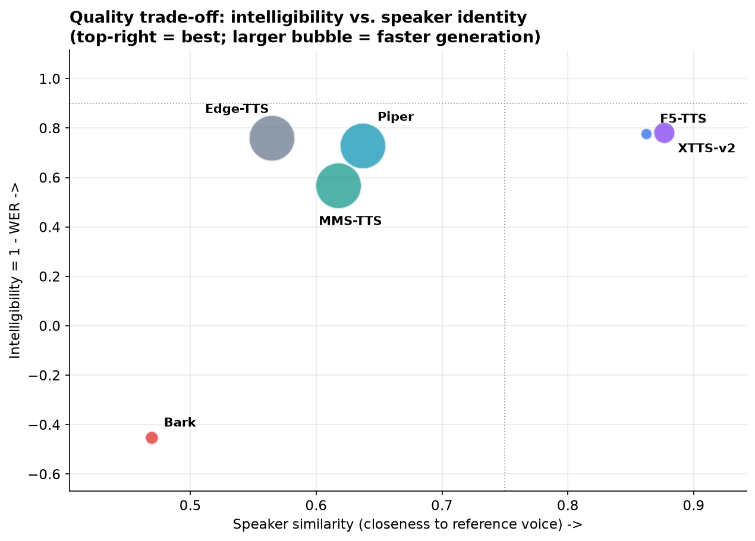
Figure 4. The central trade-off — intelligibility (1−mean WER) vs. speaker identity; bubble size ∝ speed. Speaker similarity, not intelligibility, is what separates cloning from fixed-voice engines.
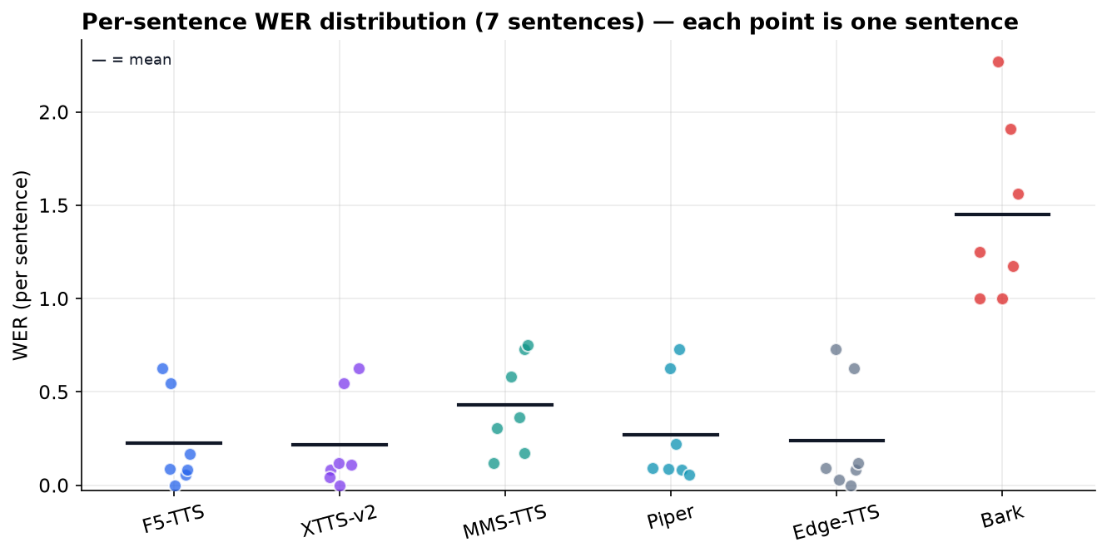
Figure 5. Per-sentence WER across the 7 sentences (each dot is one sentence; the bar is the mean). It visualizes uncertainty: most sentences score low, while a few hard ones (numbers/dates) pull the mean up — which is why the median is the more robust summary.

9.1 Insights and Implications
- Speaker identity is the decisive axis — only the two voice-cloning engines exceed the 0.75 cloning threshold (F5-TTS 0.862, XTTS-v2 0.877), whereas the fixed-voice engines score ≈0.56–0.64 — they render a default voice, not the reference speaker. This is the core voice-cloning result.
- Intelligibility is broadly comparable among the strong engines — median WER for F5-TTS (8.7%) and XTTS-v2 (11.1%) is close to the best fixed-voice engines, and on 7 sentences these gaps are within noise. F5-TTS has the lowest median WER; XTTS-v2 the lowest mean — effectively a tie.
- Median vs. mean matters — means are inflated by a few hard sentences (numbers and dates) where the spoken form and Whisper's transcription legitimately differ (Figure 5); the median is the more robust central tendency here.
- Cost of quality — the cloning engines are slower on CPU (F5-TTS RTF 22.7, XTTS-v2 2.9) than the fixed-voice engines (RTF < 1); XTTS-v2 is the faster of the two on CPU.
- The harness catches real failure — the deliberately weak baseline (Bark, no Vietnamese support) is separated automatically by very high WER and the lowest SECS, evidence that the metrics measure something real rather than rewarding every engine equally.

9.2 Limitations and Uncertainty
- Test-set scale — results cover 7 sentences per engine; error bars (Figure 1) and the distribution (Figure 5) quantify spread, but a larger, category-balanced set would tighten the estimates and enable significance testing.
- ASR is imperfect — Whisper itself mis-transcribes, especially tones, so WER/CER are upper bounds on the true error and are most meaningful when compared across engines.
- SECS is relative — it is a similarity score between embeddings, not biometric proof, and it does not replace subjective human listening (a MOS study remains future work).
- Speed is CPU-measured — inference time and RTF are CPU figures (and the first call per engine includes model-load overhead); absolute latency will differ on GPU.
- Base model only — these numbers characterize the zero-shot base model; the fine-tuning pipeline is established and verified at the code-path level but not yet run end-to-end on real speaker data with a GPU, so no fine-tuning improvement is claimed.

10. Conclusion and Recommendations (Provisional)
These are provisional conclusions reflecting the current project status — an objective benchmark over 7 sentences on the zero-shot base model — not a final, large-scale or fine-tuned evaluation.
Key findings (current status): On this 7-sentence benchmark, the two voice-cloning engines — F5-TTS and XTTS-v2 — are the only systems that reproduce the reference speaker (SECS 0.862 and 0.877, both above the 0.75 threshold), while the fixed-voice engines do not. Intelligibility is comparable across the strong engines: F5-TTS gives the lowest median WER (8.7%) and XTTS-v2 the lowest mean, an effective tie. Just as important as any single winner, the project delivers a reproducible objective-evaluation framework that turns subjective impressions into verifiable measurements and surfaced two subtle, high-impact defects during development.
Recommendations: For Vietnamese voice cloning, F5-TTS is the recommended primary engine — it matches the field on intelligibility (lowest median WER), reaches top-tier speaker similarity, and is pre-trained on Vietnamese; enable GPU and raise NFE to 48–64 for long sentences. XTTS-v2 is an equally strong, faster alternative when speaker likeness and CPU speed matter most. Use Piper/MMS/Edge for real-time offline reading that does not need a specific voice, and avoid Bark for Vietnamese. Always provide a clean 5–10 s single-speaker reference with an accurate transcript.
Reflection and future work: Establishing an objective yardstick was the most valuable outcome: it made subtle defects visible and keeps every claim evidence-based. Next, in priority order: (1) enlarge and balance the test set and report confidence intervals / significance; (2) collect 30–60 minutes of real speaker audio and run fine-tuning end-to-end on GPU, measuring WER/CER/SECS before vs. after; (3) add subjective MOS listening tests; (4) optimize cloning-engine latency on GPU; (5) package the system for setup-free demos.

11. License and Ethical Considerations
License: The base model hynt/F5-TTS-Vietnamese-ViVoice is released under CC-BY-NC-SA-4.0: this project is strictly non-commercial and for education/research only. Any commercial use would require replacing the model with an appropriately licensed one. Comparison engines retain their own licenses (e.g., Coqui, Meta MMS, Piper, Bark) and Edge-TTS is a cloud service subject to Microsoft's terms.
Ethics: Voice cloning can be misused for impersonation. Users must clone only their own voice or a voice they have explicit permission to use; generated audio should be disclosed as synthetic where appropriate. Objective similarity scores here are for quality assessment only and must not be treated as identity verification.

References
[1] Y. Chen et al., “F5-TTS: A Fairytaler that Fakes Fluent and Faithful Speech with Flow Matching,” arXiv:2410.06885, 2024.
[2] Y. Lipman et al., “Flow Matching for Generative Modeling,” ICLR, 2023. arXiv:2210.02747.
[3] W. Peebles and S. Xie, “Scalable Diffusion Models with Transformers,” ICCV, 2023. arXiv:2212.09748.
[4] H. Siuzdak, “Vocos: Closing the Gap Between Time-Domain and Fourier-Based Neural Vocoders,” ICLR, 2024. arXiv:2306.00814.
[5] E. Casanova et al., “XTTS: A Massively Multilingual Zero-Shot Text-to-Speech Model,” arXiv:2406.04904, 2024.
[6] V. Pratap et al., “Scaling Speech Technology to 1,000+ Languages (MMS),” arXiv:2305.13516, 2023.
[7] A. Radford et al., “Robust Speech Recognition via Large-Scale Weak Supervision (Whisper),” ICML, 2023. arXiv:2212.04356.
[8] Suno AI, “Bark: Text-Prompted Generative Audio Model,” GitHub, 2023.
[9] Rhasspy, “Piper: A Fast, Local Neural Text-to-Speech System,” GitHub, 2023.
[10] hynt, “F5-TTS-Vietnamese-ViVoice,” Hugging Face model repository, 2024.
[11] L. Wan et al., “Generalized End-to-End Loss for Speaker Verification,” ICASSP, 2018. arXiv:1710.10467.

Appendices

Appendix A — Reproducing the results
# 1. Generate audio for all engines over the multi-sentence test set (CPU)
python scripts/run_benchmark.py
# 2. Evaluate: WER/CER (Whisper) + speaker similarity (Resemblyzer) + RTF
python scripts/evaluate.py --manifest outputs/benchmark/manifest.json \
--output-dir outputs/benchmark/evaluation
# 3. Render the figures (English labels, mean ± std)
python scripts/plot_results.py --results outputs/benchmark/evaluation/results.json \
--output-dir outputs/benchmark/figures_en --lang en
# 4. Rebuild this document
python scripts/build_report_docx.py

Appendix B — Key source files: app.py (UI/orchestration), engines.py (five comparison engines), voice_studio/ (offline-testable logic: text processing, audio metrics, evaluation), scripts/train.py (fine-tuning), scripts/evaluate.py and scripts/plot_results.py (evaluation and charts), configs/train_config.yaml (architecture and training config).

