DSP391m — DATA SCIENCE CAPSTONE PROJECT
Vietnamese Voice Cloning Studio: Objective Benchmarking of Zero-Shot Text-to-Speech with F5-TTS ViVoice
Report 3 — Model Development · Evaluation & Fine-Tuning · Results · Conclusion
Group 4 · FPT University · Summer 2026

Project Title
Vietnamese Voice Cloning Studio — a bilingual web application that clones a Vietnamese speaker's voice from a short reference recording using F5-TTS, and benchmarks it against five additional text-to-speech engines under identical inputs with an objective, reproducible evaluation harness.

Team Members
Group 4, DSP391m. Please complete the table below with each member's full name (first, then last) and role before submission.
No. | Full name | Role / responsibility
1 | ⟨member name⟩ | Modeling & inference pipeline
2 | ⟨member name⟩ | Data preparation & fine-tuning
3 | ⟨member name⟩ | Evaluation & visualization

1. Introduction and Background
Objective: Build a Vietnamese zero-shot voice-cloning TTS system centered on F5-TTS ViVoice and quantify its quality against five baseline engines using objective, reproducible metrics (word/character error rate, speaker similarity, and generation speed).
Motivation: Voice cloning enables accessibility tools, dubbing and personalized assistants, yet Vietnamese is under-served. The language's six tones and dense diacritics make both synthesis and its evaluation hard — a single mispronounced tone can change a word's meaning — so a rigorous, tone-aware evaluation is as valuable as the model itself.
Background Information: Modern non-autoregressive TTS pairs a transformer backbone with a generative objective. F5-TTS uses a Diffusion Transformer (DiT) trained with a Conditional Flow-Matching (CFM) objective and a Vocos 24 kHz vocoder. The Vietnamese checkpoint hynt/F5-TTS-Vietnamese-ViVoice is pre-trained on roughly 1,000 hours of Vietnamese speech and released under CC-BY-NC-SA-4.0 for non-commercial research.

2. Literature Review
F5-TTS [1] demonstrates that a DiT [3] trained with flow matching [2] produces fluent, faithful speech without the alignment modules of earlier systems; Vocos [4] closes the quality gap between time-domain and Fourier-based neural vocoders. For zero-shot cloning, XTTS-v2 [5] is a strong multilingual competitor. Single-speaker baselines include Meta's MMS-TTS [6], the local ONNX voice Piper [9], Microsoft's cloud Edge-TTS, and Bark [8] (no Vietnamese support, used as a lower bound). Evaluation builds on Whisper [7] for the ASR round-trip and a GE2E-style speaker encoder [11] for identity similarity.
Gap addressed: published Vietnamese TTS work rarely reports a like-for-like, fully-reproducible objective comparison across cloning and fixed-voice engines under identical text, seed and reference. This project contributes exactly such a harness.

3. Data Description
Source: Three data roles are distinguished. (a) Pre-training corpus: ViVoice (~1,000 h Vietnamese), used only via the released checkpoint. (b) Evaluation data: a fixed clean reference sample (reference_audio/sample_clean_vi.wav) and a fixed benchmark sentence. (c) Fine-tuning data: 30–60 minutes of single-speaker audio, to be collected.
Size and Format: Audio is mono WAV at 24 kHz. Text metadata uses a pipe-delimited CSV (audio_path | transcript). The model vocabulary is a plain-text file (~2.5k tokens) covering accented Vietnamese characters plus inherited pinyin tokens.
Features: Per sample: (i) the raw 24 kHz waveform → a 100-band mel-spectrogram front-end (n_fft 1024, hop 256, win 1024); (ii) the transcript, tokenized with the model's convert_char_to_pinyin scheme; and (iii) the sequence length used for masking.

4. Data Cleaning and Preprocessing
Audio preprocessing reuses the library's validated preprocess_ref_audio_text (silence trimming, resampling to 24 kHz mono, level normalization). Text is normalized to Unicode NFC with Vietnamese diacritics preserved; whitespace and punctuation are regularized. Long inputs pass through boundary-aware chunking that protects URLs, e-mails, decimals, dates and abbreviations from being split.
Challenge resolved — quarantined synthetic data. An earlier iteration accidentally trained on synthetic sine/tone signals mislabeled as speech, corrupting the model. All such files were moved to a quarantined directory and are blocked from the pipeline unless an explicitly named technical-test flag is passed, so they can never again be mistaken for real training data.

5. Exploratory Data Analysis (EDA)
Because the signal is audio, EDA relies on objective per-clip metrics — duration, RMS level, peak, clipping ratio and spectral flatness — computed directly on the waveform. Spectral flatness is the key discriminator: structured human speech sits around 0.10–0.15, whereas near-monotone or noisy signals collapse toward zero. This single metric exposed the corrupted-checkpoint defect (flatness ≈ 0.0019) and later confirmed the fix (flatness restored to ≈ 0.11–0.14, matching the real reference sample).
These metrics also act as automatic guardrails during evaluation: a clip that is silent, clipped, or non-finite is flagged before any error-rate is computed, so degenerate output cannot masquerade as a valid result.

6. Methodology
Model Selection: F5-TTS ViVoice is the primary model because it uniquely combines zero-shot cloning (a short reference suffices, no per-speaker training), strong Vietnamese pre-training, a state-of-the-art DiT+CFM backbone, and a research-permissive license. The five baselines were chosen to span the trade-off space: XTTS-v2 (competing cloning), MMS/Piper/Edge (fast fixed-voice TTS) and Bark (deliberate weak floor).
Data Splitting Strategy: For fine-tuning, a deterministic 90/10 train/validation split is drawn with a fixed random generator (seed 42), so every run yields the same split and results are comparable. Model selection uses validation loss, not training loss.
Feature Engineering and Selection: Two engineered representations are central: the 100-band mel-spectrogram (audio side) and the pinyin-style character tokenization (text side). Text normalization and protected-token masking are the main hand-designed features; the architecture (mel bins, tokenizer) is fixed to match the pre-trained checkpoint and is not tuned.

7. Model Development

7.1 Model Architecture
The architecture is loaded verbatim from the library's F5TTS_Base.yaml so it matches the pre-trained checkpoint exactly:
CFM (Conditional Flow-Matching) wrapper
└─ DiT backbone: dim=1024, depth=22, heads=16, ff_mult=2,
text_dim=512, conv_layers=4,
text_mask_padding=false, pe_attn_head=1 (compatibility-critical)
└─ Vocoder: Vocos @ 24 kHz (mel → waveform)
Parameters ≈ 336M · front-end: n_fft=1024, hop=256, win=1024, n_mel=100

Compatibility invariant. The two fields text_mask_padding=false and pe_attn_head=1 must not be changed. When omitted, DiT reverts to v1 defaults and the forward pass silently mis-computes despite correctly-shaped weights, degrading output to a near-monotone signal (spectral flatness ≈ 0.0019). Restoring the exact architecture returns flatness to the human-speech range. This was one of the two principal defects diagnosed and fixed during development.

7.2 Training Procedure
The fine-tuning objective is single-speaker adaptation while avoiding catastrophic forgetting. The pipeline runs: metadata manifest → deterministic train/validation split → padding-aware collation → CFM flow-matching loss → mixed-precision back-propagation with gradient accumulation → gradient clipping → warm-up-then-cosine learning-rate schedule → checkpoint selection by validation loss. Exponential-moving-average weights are loaded from the official checkpoint; NaN/Inf losses abort immediately; each checkpoint records a JSON manifest of base model, architecture, vocabulary size, config, git commit, step, validation loss and dataset summary for full provenance.
Honest status: the pipeline is hardened and unit-tested at the component level but has not yet been verified end-to-end on real speaker data with a GPU (blocked by the absence of collected speech). Accordingly, the results in Section 9 characterize the zero-shot base model, not a fine-tuned one; no fine-tuning improvement is claimed.

8. Model Evaluation and Fine-Tuning

8.1 Evaluation Metrics
Generative speech has no single ground-truth label, so quality is measured through objective proxies on two core axes plus speed:
- Intelligibility — WER and CER via an ASR round-trip: Whisper (small, beam 5, language=vi) re-transcribes the generated audio and the transcript is compared to the reference text with edit distance (jiwer, with an equivalent offline fallback). Vietnamese diacritics are preserved by default.
- Speaker identity — SECS: cosine similarity between Resemblyzer embeddings of the generated and reference audio. It is a relative similarity score, not biometric proof.
- Speed — real-time factor, RTF = inference time ÷ audio duration (RTF < 1 is faster than real time).
- Signal guardrails — RMS, peak, clipping ratio and spectral flatness screen for degenerate output before error rates are computed.

8.2 Hyperparameter Tuning
Inference hyper-parameters are tunable today: the number of flow-matching ODE steps (NFE, default 32, raised to 48–64 for long/hard sentences to reduce late-sentence drift), the random seed (fixed at 42 for reproducibility and fair cross-engine comparison), the chunk length (≈280 characters) and inter-chunk silence (180 ms). Training hyper-parameters (for a T4 16 GB GPU) are summarized in Table 1.
Hyper-parameter | Value | Rationale
Learning rate | 1e-5 | Small LR for fine-tuning; avoids forgetting
Batch × grad-accum | 1 × 8 = 8 | Effective batch under limited VRAM
Warm-up steps | 200 | Linear 0→LR for early stability
Scheduler | cosine | Anneals to min-LR 1e-7
Max grad norm | 1.0 | Gradient clipping
Mixed precision | fp16 | T4 supports FP16; auto-off on CPU
Optimizer / seed | AdamW / 42 | β=(0.9,0.999), weight decay 0.01; deterministic
Table 1. Training hyper-parameters (tuned for an NVIDIA T4, 16 GB).

8.3 Cross-Validation Techniques
Classical k-fold cross-validation is impractical for fine-tuning a 336M-parameter generative model on tens of minutes of audio (the k× training cost is prohibitive and the signal is generative, not a classification label). Its role is filled by (i) a deterministic held-out validation split monitored every epoch, with the best checkpoint chosen by validation loss, and (ii) an independent fixed test set of diverse sentences — short, numeric, decimal, date, abbreviation, proper-noun, interrogative, compound and long — for post-hoc WER/CER/SECS evaluation.

9. Results Interpretation and Visualization
All six engines synthesize the same 17-word sentence from the same reference sample under a fixed seed (42). Table 2 reports the objective results (values read directly from outputs/evaluation/results.json); Figures 1–4 visualize them.
Engine | Type | WER ↓ | CER ↓ | SECS ↑ | Time (s) | RTF ↓
F5-TTS | voice cloning | 0.059 | 0.026 | 0.837 | 193.0 | 45.12
XTTS-v2 | voice cloning | 0.118 | 0.065 | 0.888 | 36.2 | 8.48
MMS-TTS | fixed voice | 0.118 | 0.039 | 0.601 | 3.9 | 0.61
Piper | fixed voice | 0.118 | 0.052 | 0.615 | 2.1 | 0.59
Edge-TTS | cloud, fixed | 0.118 | 0.065 | 0.561 | 3.0 | 0.65
Bark | fixed (no VI) | 1.176 | 0.844 | 0.480 | 167.2 | 11.59
Table 2. Objective results: six engines, identical sentence / seed / reference. Blue marks the best value per column.
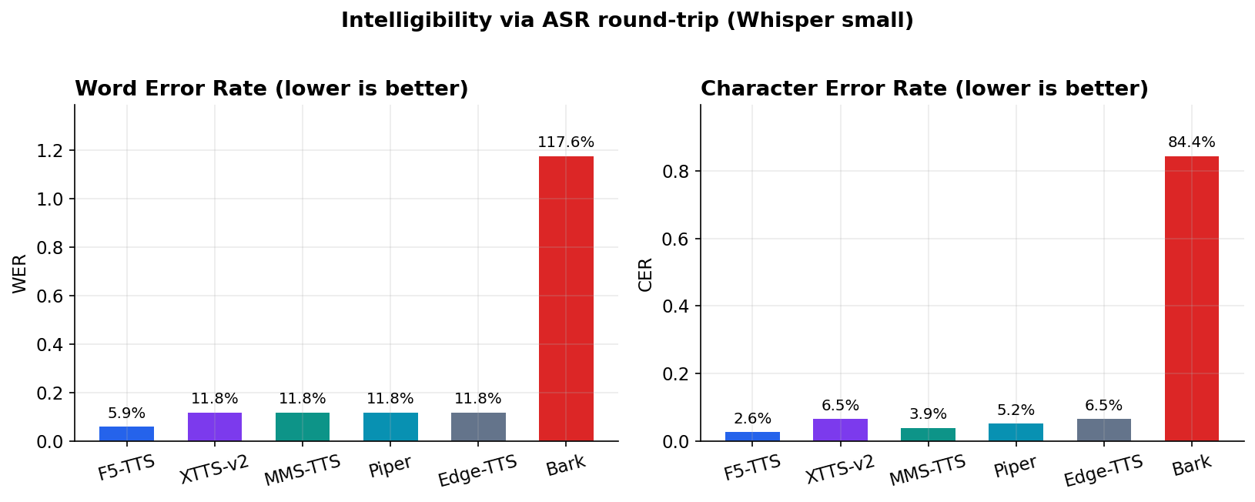
Figure 1. Intelligibility via ASR round-trip. F5-TTS attains the lowest WER (5.9%); the XTTS/MMS/Piper/Edge cluster sits near 11.8%; Bark exceeds 100% (cannot read Vietnamese).
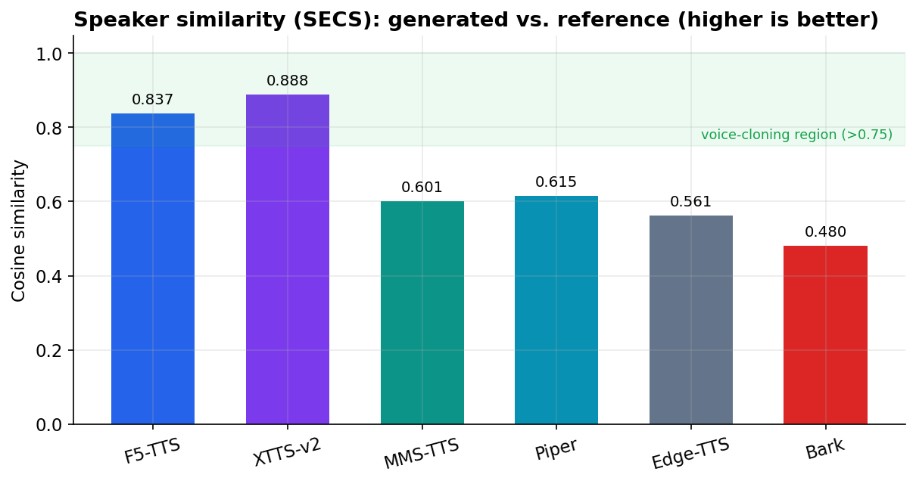
Figure 2. Speaker similarity (SECS). Only F5-TTS (0.837) and XTTS-v2 (0.888) enter the voice-cloning region (>0.75); fixed-voice engines score ≈0.56–0.62.
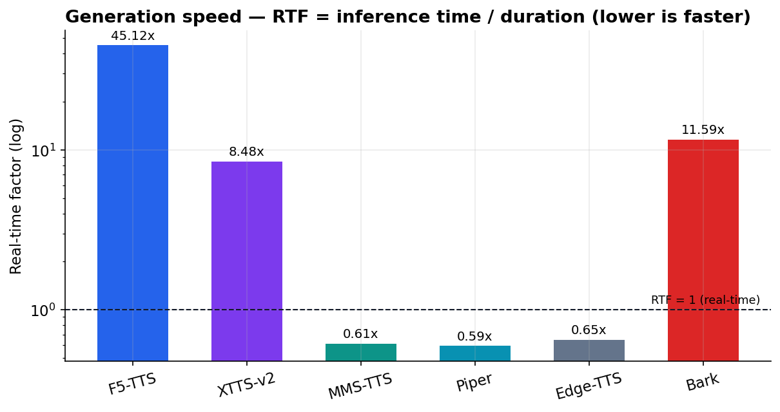
Figure 3. Generation speed (RTF, log scale). Piper/MMS/Edge run faster than real time on CPU; F5-TTS is slowest (quality and multi-step flow matching), expected to drop on GPU.
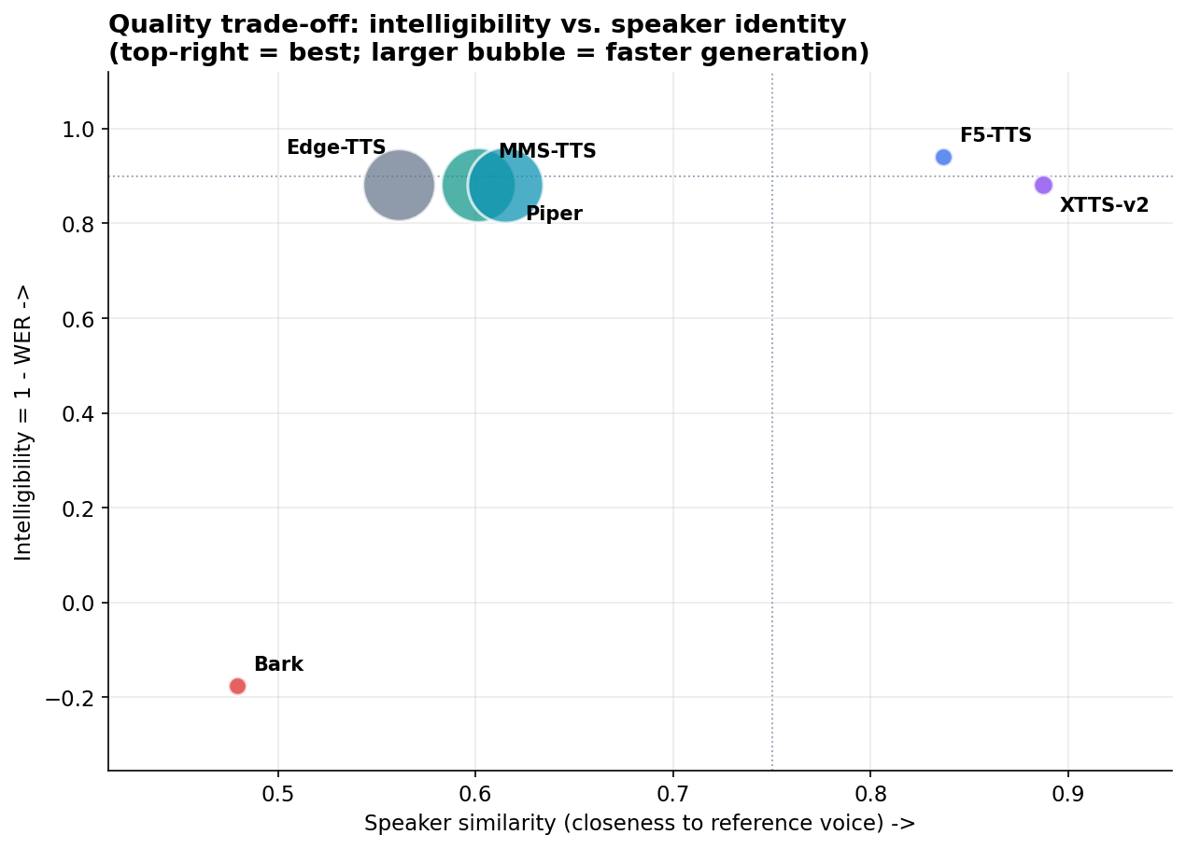
Figure 4. The central trade-off — intelligibility (1−WER) vs. speaker identity; bubble size ∝ speed. Only F5-TTS and XTTS-v2 reach the top-right; Bark falls to the bottom.

9.1 Insights and Implications
- F5-TTS wins on balance — the only engine simultaneously the most intelligible (WER 5.9%) and near the top on identity (SECS 0.837), exactly the joint objective of voice cloning.
- XTTS-v2 is a strong, faster alternative — highest SECS (0.888) and ~5× faster than F5-TTS on CPU, but double the WER; the right pick when identity and speed outweigh accuracy.
- Fixed-voice TTS is not cloning — MMS/Piper/Edge are intelligible and very fast (RTF < 1) yet score SECS ≈ 0.6, confirming they do not reproduce the reference speaker.
- CER stays below WER for every good engine — F5-TTS errs chiefly on the first word (“Trí”→“Chí”, a regional tr/ch merge), a pronunciation artifact, not an intelligibility failure.
- The metrics catch real failure — Bark is automatically flagged (WER > 100%, lowest SECS), showing the harness genuinely separates broken from working systems.
Uncertainty: this is a pilot-scale audit (one sentence per engine), so confidence intervals are not yet available; Whisper itself errs (WER/CER are upper bounds); SECS is relative; and speed is measured on CPU including first-load overhead. A ≥12-sentence set is prepared to report mean ± standard deviation.

10. Conclusion and Recommendations
Key findings: F5-TTS ViVoice is the right primary model: it leads on intelligibility and ranks in the top tier on speaker identity — the only engine to optimize both axes at once. The project also delivers a reproducible objective-evaluation framework that converts subjective impressions into verifiable measurements and surfaced two subtle, high-impact defects.
Recommendations: Use F5-TTS when both intelligibility and identity matter (enable GPU, raise NFE to 48–64 for long sentences); use XTTS-v2 when identity and speed dominate; use Piper/MMS for real-time offline reading that does not need a specific voice; do not use Bark for Vietnamese. Provide a clean 5–10 s single-speaker reference and an accurate transcript.
Reflection and future work: The most valuable outcome was establishing an objective yardstick, which made subtle defects visible and keeps future claims evidence-based. Next, in priority order: (1) scale the test set from 1 to ≥12 diverse sentences for mean ± std reporting; (2) collect 30–60 minutes of real speaker audio and run fine-tuning end-to-end on GPU, measuring WER/CER/SECS before vs. after; (3) add subjective MOS listening tests; (4) optimize F5-TTS latency on GPU; (5) package the system (Docker / Hugging Face Spaces) for setup-free demos.

References
[1] Y. Chen et al., “F5-TTS: A Fairytaler that Fakes Fluent and Faithful Speech with Flow Matching,” arXiv:2410.06885, 2024.
[2] Y. Lipman et al., “Flow Matching for Generative Modeling,” ICLR, 2023. arXiv:2210.02747.
[3] W. Peebles and S. Xie, “Scalable Diffusion Models with Transformers,” ICCV, 2023. arXiv:2212.09748.
[4] H. Siuzdak, “Vocos: Closing the Gap Between Time-Domain and Fourier-Based Neural Vocoders,” ICLR, 2024. arXiv:2306.00814.
[5] E. Casanova et al., “XTTS: A Massively Multilingual Zero-Shot Text-to-Speech Model,” arXiv:2406.04904, 2024.
[6] V. Pratap et al., “Scaling Speech Technology to 1,000+ Languages (MMS),” arXiv:2305.13516, 2023.
[7] A. Radford et al., “Robust Speech Recognition via Large-Scale Weak Supervision (Whisper),” ICML, 2023. arXiv:2212.04356.
[8] Suno AI, “Bark: Text-Prompted Generative Audio Model,” GitHub, 2023.
[9] Rhasspy, “Piper: A Fast, Local Neural Text-to-Speech System,” GitHub, 2023.
[10] hynt, “F5-TTS-Vietnamese-ViVoice,” Hugging Face model repository, 2024.
[11] L. Wan et al., “Generalized End-to-End Loss for Speaker Verification,” ICASSP, 2018. arXiv:1710.10467.

Appendices

Appendix A — Reproducing the results
# 1. Evaluate generated audio → results.json + report.md
python scripts/evaluate.py --manifest evaluation/audit_existing_outputs.json \
--output-dir outputs/evaluation
# 2. Render the figures (English labels)
python scripts/plot_results.py --lang en --output-dir outputs/evaluation/figures_en
# 3. Rebuild this document
python scripts/build_report_docx.py

Appendix B — Key source files: app.py (UI/orchestration), engines.py (five comparison engines), voice_studio/ (offline-testable logic: text processing, audio metrics, evaluation), scripts/train.py (fine-tuning), scripts/evaluate.py and scripts/plot_results.py (evaluation and charts), configs/train_config.yaml (architecture and training config).

