Bài tập cơ bản

Bài 1:

Code:

#include<iostream>

using namespace std;

int main(){

int hangchuc, hangdv, i;

cout<<"Nhap vao so nguyen 2 chu so: ";

cin>>i;

if(i>9&i<100){

hangdv= i%10;

hangchuc= i/10;

if(hangdv\*hangchuc == 2\*(hangdv+hangchuc)){

cout<<"So "<<i<<" thoa yeu cau de bai";

}else{

cout<<"So "<<i<<" khong thoa yeu cau de bai";

}

}

else{

cout<<"Hay nhap lai";

return 0;

}

return 0;

}

Chạy:

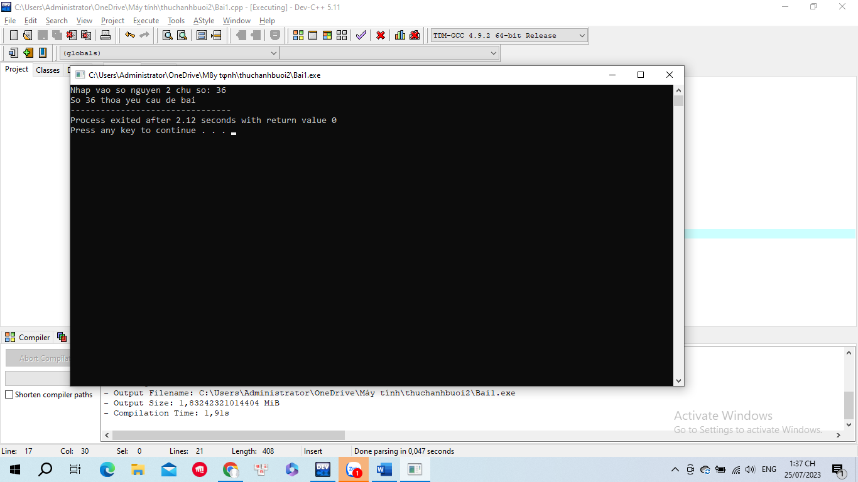

Bài 2:

Code:

#include <iostream>

#include <math.h>

using namespace std;

bool nguyento(int n)

{

if(n<2) return false;

int sq = sqrt(n);

for(int i=2;i <=sq ;i++){

if(n % i == 0){

return false;

}

}

return true;

}

int main()

{

int n;

cout<<"Nhap n: ";

cin>>n;

for(int i=1;i<n;i++){

if(nguyento(i) == true)

cout<<" "<<i;

}

return 0;

}

Chạy:

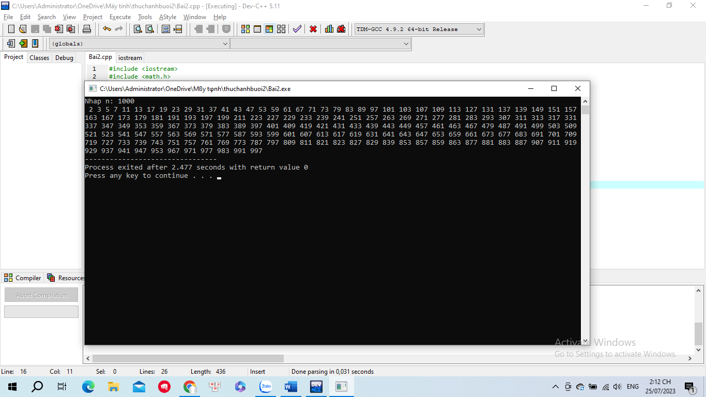

Bài 4:

Code:

#include <iostream>

using namespace std;

int main(){

int n, tmp;

cout<<"Nhap n: ";

cin>>n;

int res= 0;

while(n>0){

tmp= n % 10;

res= res\* 10 + tmp;

n = n / 10;

}

cout<<"So dao la: "<<res;

}

Chạy:

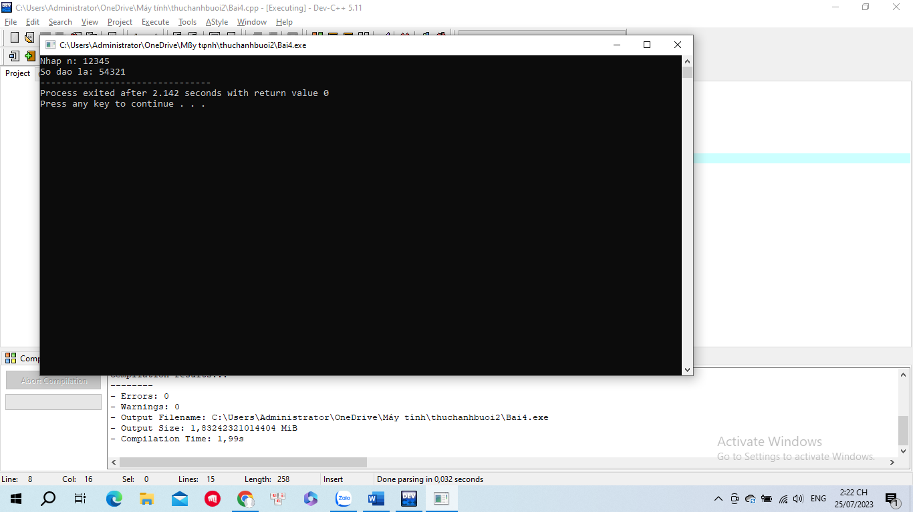

Bài 5:

Chạy:

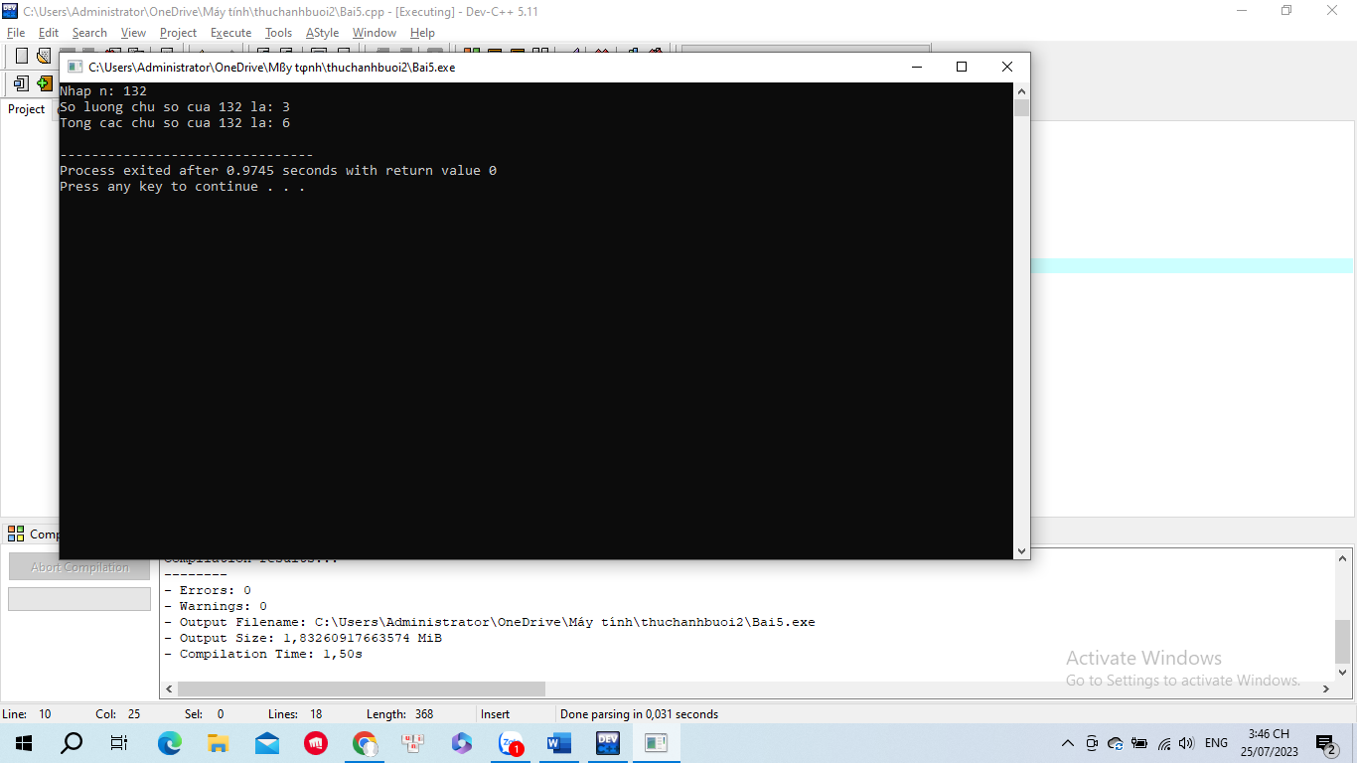

Code:

#include<iostream>

using namespace std;

int main(){

int n;

cout <<"Nhap n: "; cin >> n;

int dem =0;

int tong =0;

int tmp= n;

while (tmp>0){

int x = tmp %10;

tong +=x;

dem++;

tmp /=10;

}

cout << "So luong chu so cua " << n << " la: " <<dem<< endl;

cout << "Tong cac chu so cua " << n << " la: " <<tong << endl;

return 0;

}

Bài 9:

Code:

#include<iostream>

using namespace std;

int main() {

int km;

float total1,total2,total3;

cout << "Nhap so km: ";

cin >> km;

total2 = 15.000+13.500 \* (km-1);

total3 = 15.000 + 13.500 \* 4 + 11.000 \* (km - 5);

total1 = total3 \* (90 / 100);

if (km == 1)

cout << "Ban can tra: 15.000" << endl;

else if ((km>=2)&&(km<=5))

cout<<"Ban can tra: 15.000+13.500\*"<<(km-1)<<" = "<<total2<<endl;

else

{

if (km > 12) {

cout << "Ban can tra: 15.000+13.500\*4+11.000\*" << (km - 5) << " = " << total3 << endl;

}

else

cout << "So tien ban tra: 15.000+13.500\*4+11.000\*" << (km - 5) << " = " << total3 << endl;

}

return 0;}

Chạy:

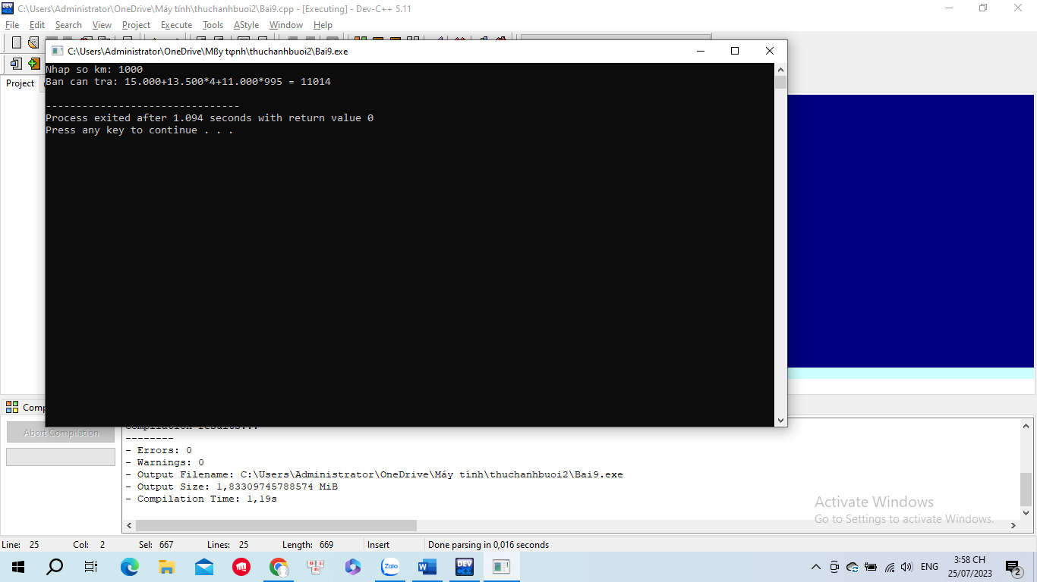

Bài 8:

Chạy:

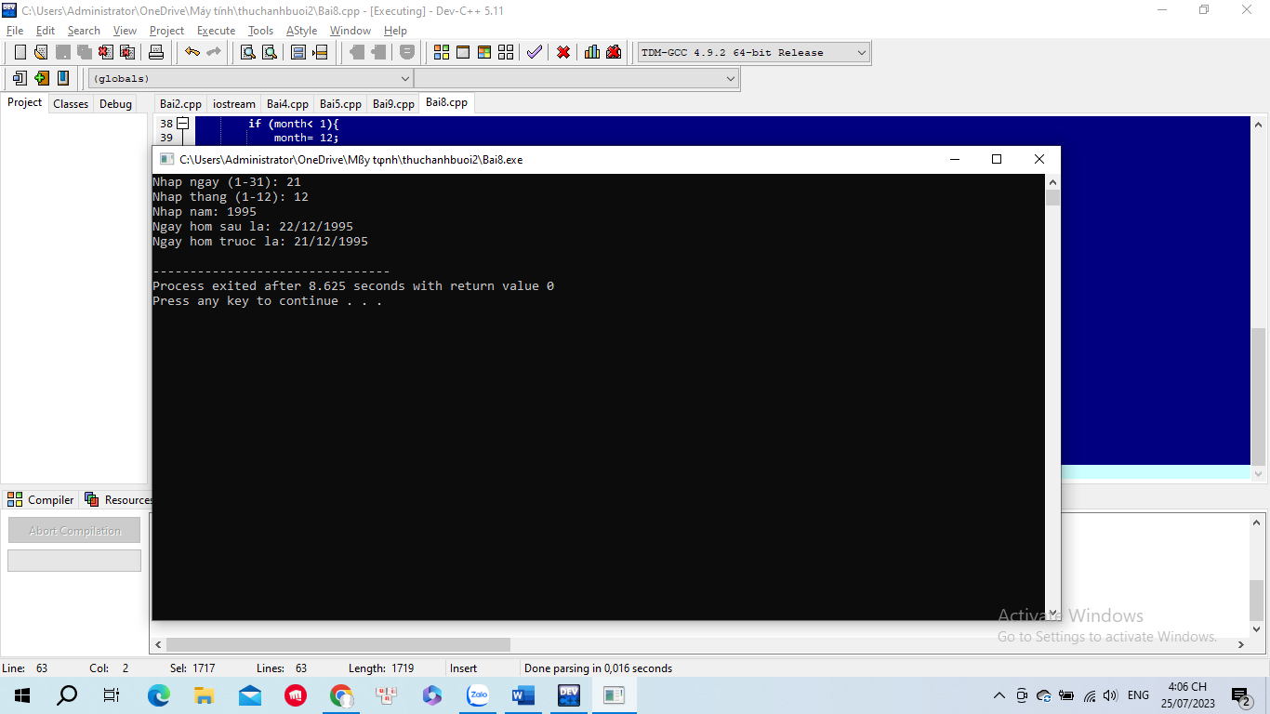

Code:

#include <iostream>

using namespace std;

bool isValidDate(int day, int month, int year){

if (year<0||month<1||month>12||day<1){

return false;

}

int daysInMonth[]= {0, 31, 28, 31, 30, 31, 30, 31, 31, 30, 31, 30, 31};

if ((year%4 == 0&&year%100 != 0)||year%400 == 0){

daysInMonth[2]= 29;

}

return day<= daysInMonth[month];

}

void findNextDay(int &day, int &month, int &year){

int daysInMonth[]= {0, 31, 28, 31, 30, 31, 30, 31, 31, 30, 31, 30, 31};

if ((year%4 == 0&&year%100 != 0)||year%400 == 0){

daysInMonth[2]= 29;

}

day++;

if (day> daysInMonth[month]){

day= 1;

month++;

if (month> 12){

month= 1;

year++;

}

}

}

void findPreviousDay(int &day, int &month, int &year){

int daysInMonth[]= {0, 31, 28, 31, 30, 31, 30, 31, 31, 30, 31, 30, 31};

if ((year % 4 == 0 && year % 100 != 0) || year % 400 == 0){

daysInMonth[2]= 29;

}

day--;

if (day< 1){

month--;

if (month< 1){

month= 12;

year--;

}

day= daysInMonth[month];

}

}

int main() {

int day, month, year;

cout<<"Nhap ngay (1-31): ";

cin>>day;

cout<<"Nhap thang (1-12): ";

cin>>month;

cout<<"Nhap nam: ";

cin>>year;

if (isValidDate(day, month, year)){

findNextDay(day, month, year);

cout<<"Ngay hom sau la: "<<day<<"/"<<month << "/"<<year<<endl;

findPreviousDay(day, month, year);

cout<<"Ngay hom truoc la: "<<day<<"/"<<month<<"/"<<year<<endl;

} else{

cout<<"Ngay thang nam khong hop ly"<<endl;

}

return 0;

}

Bài 10:

Chạy:

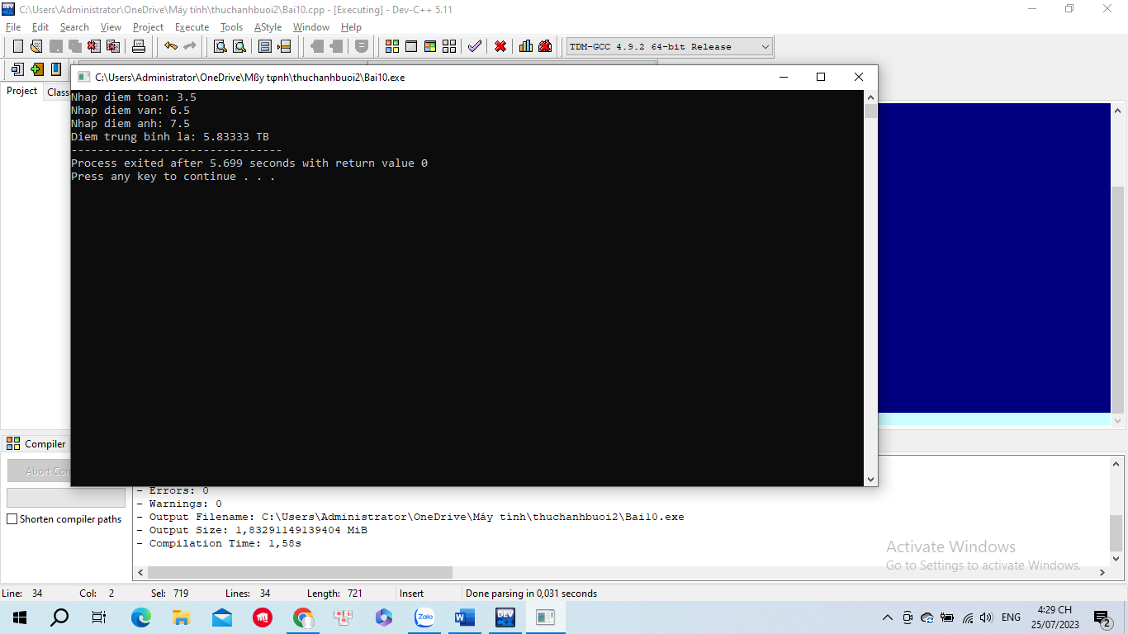

Code:

#include <iostream>

using namespace std;

int main()

{

float diemT;

float diemV;

float diemA;

float dtb;

cout<<"Nhap diem toan: ";

cin>>diemT;

cout<<"Nhap diem van: ";

cin>>diemV;

cout<<"Nhap diem anh: ";

cin>>diemA;

dtb = (diemT + diemV + diemA) / 3;

cout<<"Diem trung binh la: "<<dtb;

if (dtb < 3.0){

cout<<" KEM";

}else if ((3.0 <= dtb)&&(dtb < 5.0)){

cout<<" YEU";

}else if ((5.0 <= dtb)&&(dtb < 6.5)){

cout<<" TB";

}else if ((6.5 <= dtb)&&(dtb < 8.0)){

cout<<" KHA";

}else if ((8.0 <= dtb)&&(dtb < 9.0)){

cout<<" GIOI";

}else{

cout<<" XUAT SAC";

}

return 0;

}

Bài 3:

Chạy:

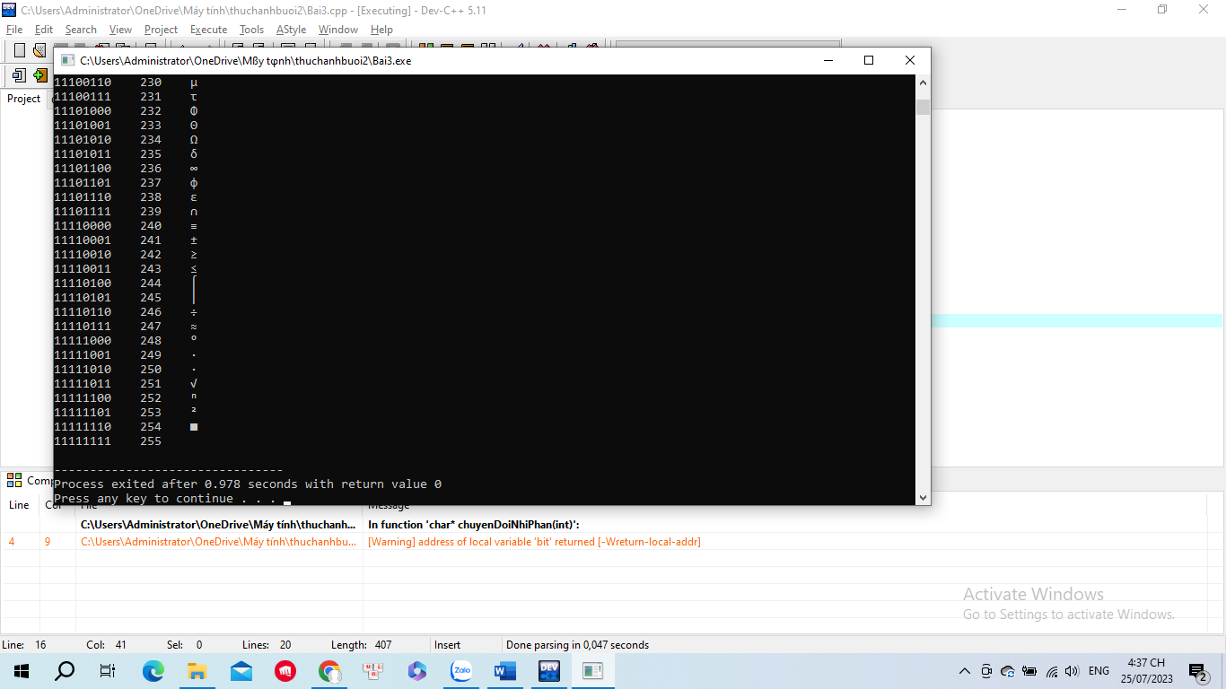

Code:

#include <iostream>

using namespace std;

char \*chuyenDoiNhiPhan(int n){

char bit[50] = "00000000";

int i = 7;

while(n > 0){

bit[i] = (n%2)+48;

i--;

n = n/2;

}

return bit;

}

int main(){

int i;

for(i = 0; i <= 255; i++){

char \*bit = chuyenDoiNhiPhan(i);

\*(bit+8) = 0;

printf("%s %d %c\n",bit, i, i);

}

}

Bài 7:

Chạy:

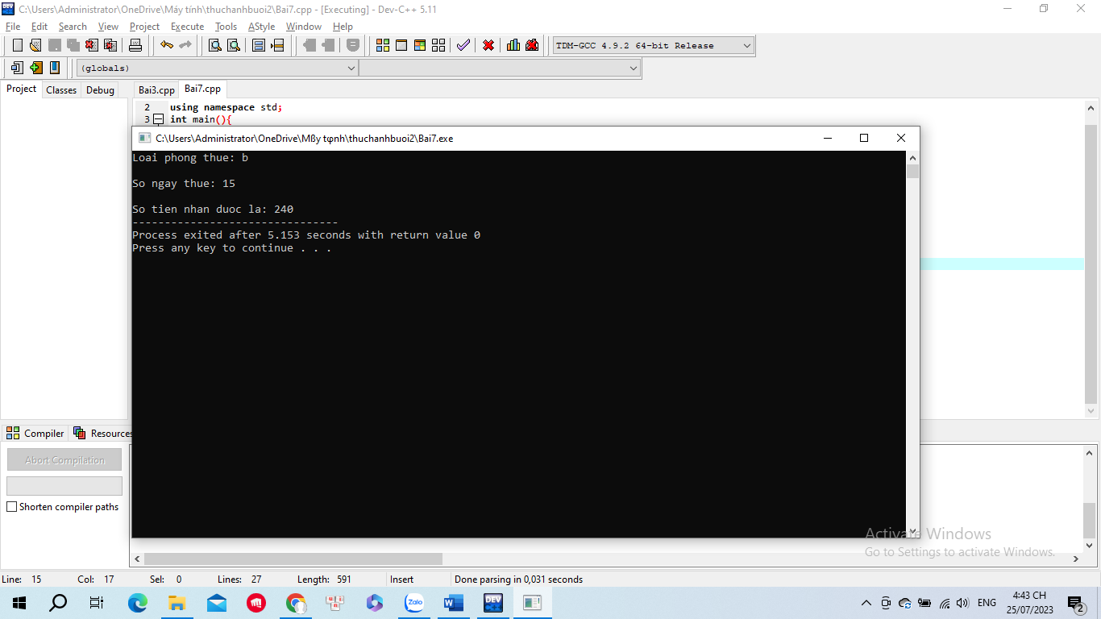

Code:

#include <iostream>

using namespace std;

int main(){

int x;

char c;

do{

cout<<"Loai phong thue: ";

cin>>c;

}while(c!='a'&&c!='b'&&c!='c');

do{

cout<<"\nSo ngay thue: ";

cin>>x;

}while(x<1);

float A=250.000,B=200.000,C=150.000;

float A1=0.1,B1=0.08,C1=0.08;

float sotien;

if(x<=12&&x>=1){

sotien = (c=='a') ? (A\*x):((c=='b') ? (B \* x):(C \* x));

}else{

sotien=(c=='a') ? (A\*A1\*x):((c=='b') ? (B\*B1\*x):(C\*C1\*x));

}

cout<<"\nSo tien nhan duoc la: "<<sotien;

return 0;

}

Bài 6:

Chạy:

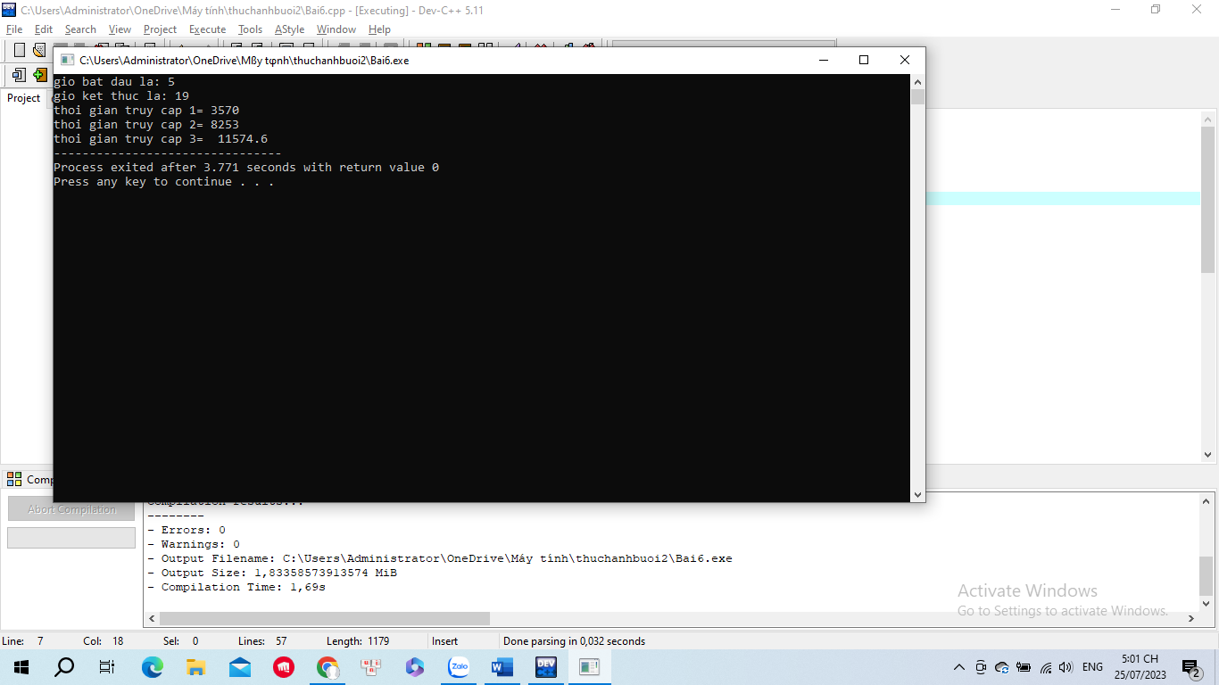

Code:

#include<iostream>

using namespace std;

int main(){

long start,end;

long tien1,tien2,tien3;

long accesstime;

float tong=0;

cout<<"gio bat dau la: ";

cin>>start;

cout<<"gio ket thuc la: ";

cin>>end;

if((start>=0)&&(end<=24)){

if((start>0)&&(end<=7)){

tien1=300;

tong=(end-start)\*tien1;

if((end-start)<7){

tong=tong-(tong\*0.15);

}

cout<<"thoi gian truy cap 1= "<<tong<<endl;

}

else if(end>7){

tien1=300;

tong=(end-start)\*tien1;

if((end-start)>7){

tong=tong-(tong\*0.15);

}

cout<<"thoi gian truy cap 1= "<<tong<<endl;

}

if((end>7)&&(end<=17)){

tien2=400;

tong=tong+((end-start)\*tien2);

if((end-start)>6){

tong=tong-(tong\*0.1);

}

cout<<"thoi gian truy cap 2= "<<tong<<endl;

}

else if(end>=17){

tien2=400;

tong=tong+((end-start)\*tien2);

if((end-start)>6){

tong=tong-(tong\*0.1);

}

cout<<"thoi gian truy cap 2= "<<tong<<endl;

}

if((end>17)&&(end<=24)){

tien3=350;

tong=tong+((end-start)\*tien3);

if((end-start)>4){

tong=tong-(tong\*0.12);

}

cout<<"thoi gian truy cap 3= "<<tong;

}

}

return 0;

}