**Grid-bots: How they really work & how to make money with them**

Grid-bot trading is something I heard about a couple of years ago but never really tested until mid-2021. I’ve seen so many people claiming that grid-bots are providing steady gains with minimal effort. My gut reaction was to call BS but I decided to try it anyway and want to share my learning via this post.

I’ll try to quickly explain what grid-bots are, talk about my own experiences with them, explain some problems I’ve observed with grid-bots and offer my view on how best to use grid-bots for semi-automated trading. As always, these are just my opinions, not financial advice.

# What is grid-trading / what are grid-bots?

Grid-trading is where you set a series of buy/sell orders within a price range, and a grid-bot is a programming tool to help you manage this process. As price moves up (or down) to a level, it will buy (or sell) a set quantity of a coin. The logic is that as price moves up (or down), you’ll be slowly selling (or buying) more coins at higher (or lower) prices. Obviously, this would be quite tedious to do manually, so grid-bots do all the order-setting/execution and profit-tracking for you. To start a grid-bot on most platforms, you’ll select the coin-pair, price-range, choose the number of grid-levels in your range, and the coin quantity to buy/sell per level. The grid-bot handles everything from there, except for stopping the process.

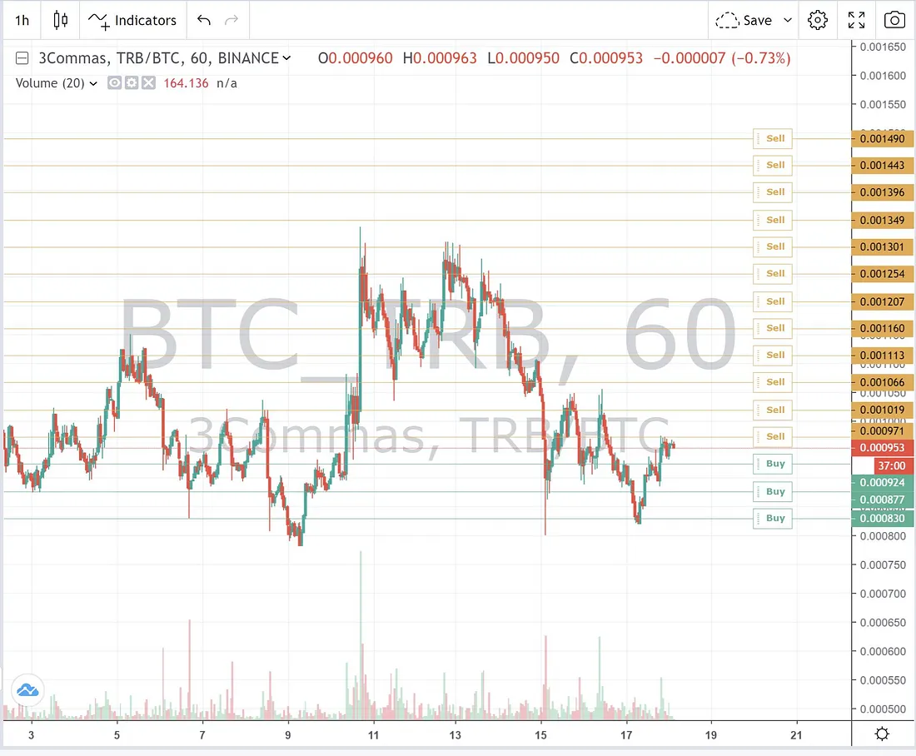

The grid-trading approach has some advantages — automated execution of a LOT of trades, less focus on entries/exits, profit-tracking and funds management by the trade platform, etc. Grid-bots also tend to use limit-orders and can increase your overall trading volume, so you may get lower fees.

Quite a few trading platforms and exchanges offer grid-bots. Off-head I remember a few…(my faves) Pionex, 3commas, Bitsgap and (others) BingX, Altrady, Kucoin, Huobi

My experience testing out grid-bots

I started experimenting with grid-bots in mid-2021. I chose 3commas over Pionex, because I thought 3commas had more coins to choose from, given that it links to a few different exchanges. I could also use other 3commas features in conjunction with the grid-bots to hedge my grid-bot exposure. Finally, Pionex functions like its own exchange, technically, and I didn’t want to open yet another exchange account.

I set up 30–40 grid-bots over a 6–8 week period, using some spare Binance and FTX sub-accounts. These bots proceeded to earn 0.5–2% a day when I had them running. This got me excited. I’m all about trading automation and was looking for a way to make money in a sideways market. With things working so well I decided to try this out with 2–4x leverage using Binance futures. Well, we all know what happened next. I proceeded to make 3–5% a day! I cracked the code!!

Of course I added a couple more leveraged grid-bots to the account, because why not? Well…things then went from good to bad almost overnight. I lost everything in the sub-account and was left wondering what the hell happened. It turned out that 3commas had an issue — at the time — with their futures grid-bots. Somehow, when price moved up above my grid-range, I was still in a leveraged short position, which caused my account to be liquidated. 3Commas tech support basically told me that I should always be careful when using leverage/futures, as if I did anything wrong and it wasn’t 100% their fault. Thanks for nothing and the losses.

Price went up. I was long, yet I still got liquidated. If price goes above your grid, the bot should sell all your coins and you should end up holding only the quote currency (ex: if trading ETH-USD, you’ll sell all your ETH and be holding 100% USD). I expected to log into my 3commas account, see some hefty gains and maybe cry a little over missed profits, but not a blown account. SMH. That experience really made me question 3commas, their grid-bots and grid-trading in general. I started looking at the numbers in detail to see if there were any other hidden problems. More on this below…

Note: 3commas has since made drastic improvements to their grid-bot portal (e.g., showing you realized and unrealized profits, adding stop-losses on both sides of the grid-range, showing you how much funds you have available while creating your bots, etc. A YouTuber made a video a few months ago and detailed some of these improvements — link.

My main issues with grid-bots

Based on the math, my impression is that grid-bots make very little money in sideways markets. You hear the opposite claim everywhere (i.e., that grid-bots are perfect for sideways markets), but I haven’t seen detailed reviews looking at account values while running grid-bots only in sideways markets. Usually people are discussing these bots during a bull-run. The bots tend to highlight realized gains, but not the changing unrealized gains/losses over time (note: this vid/platform is a refreshing exception — link)

When you step back to look at the math, things makes perfect sense. If you buy the same number of coins at fixed levels across a price-range, then your average buy price is the midpoint of the range. If price drops and you start to sell the same quantity of coins at the same levels, then your average sell price is what? Yep, the midpoint of the range. You can’t buy X at Y, then sell the same X at Y and make money. You must buy low then sell high to make profit. Most of the grids in a grid-bot will be buying and selling the same levels, which isn’t profitable.

Here’s a more detailed example…Say you have a grid-bot with 10 levels (i.e., price going from $1.10 to $2.00) and a buy/sell quantity per level of 20 coins. You’ll spend $270 in buys on the way down and make $288 in sells on the way up. You only make 7% ($18/$270) on a 82% increase in price. Please note that the total profit from all that buying and selling is the same as simply buying and selling the top & bottom grid-levels (i.e., ($2 — $1.10) x 20 coins = $18).

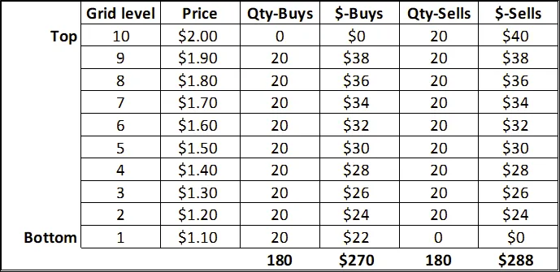

If you start the grid-bot below your grid-range, at say $1, and price runs up to $2.05, you’ll sell your 180 coins at an average price of $1.60, which is close to the middle of the range, instead of closer to $2.00. You’re effectively selling early. If price then drops back to $1, the grid-bot will buy all of those coins back and generate an unrealized loss of $72. You’ll be holding coins at an average buy price of $1.50 vs. the market price of $1.00. It’s not an ideal way to trade, at all.

Main takeaway — the only time you’re making money is when prices go up, and even then, you’re making less than you would simply holding the coins. It’s like reverse dollar-cost averaging as you exit on the way up.

With my test bots, I realized that I was mainly making money from the rise in price and that the trading platform wasn’t showing me the value of my position at any point. The reported gains were always positive, which created the illusion of consistent profit-making. I understand that platforms may be getting better about showing the unrealized gains/losses, which is the responsible thing to do.

Extra: I found a YouTuber that compared the gains from a buy & hold approach to a grid-bot using a custom strategy developed for Tradingview. This really highlights my points above. These links will start you at the specific sections in each video — Vid1, Vid2

What grid-bots are actually good for

Grid-bots are simply a tool. You can use them to do two things. Either you’re scaling out of a position at set intervals or you’re scaling into a position at set intervals. Scaling out is for up-trending markets and exits. Scaling in is for down-trending markets and accumulation.

Scaling out (exiting)

Set up your grid-bots at a relative low point and then exit at levels far above your entry. Your lowest grid level should be far above your average entry price. Your target exit levels will be the bottom/top of your grid-levels. The key here is to treat this like an actual trade, not a “set it and forget it” fantasy. Ideally, you start your bot near a support level (horizontal > diagonal or dynamic) and set your grid/exit-levels at or slightly above the “high” point of your trading range (or around a resistance level). This approach works in both sideways and up-trending markets. Some opportunities are possible in down-trending markets if price moves to a major support-level or if you are trading a coin that increases in value as price drops (ex: Bear-USD on FTX).

Scaling in (accumulation)

If you have a coin that you want to hold long-term and price is declining, you can set up a grid-bot with wide grid-levels that will buy as the price drops. This is probably the easiest way to automate coin accumulation. The only downside is that if price pumps randomly, the bot will sell some of the coins you accumulated. With the current bear market and potential for a global recession, this strategy is something I’m doing for a few high-potential projects.

My preferred strategies for grid-bots

A. Sideways market: Avoid the common mistake of simply buying and selling throughout the range. If a range goes from 0% (bottom) to 100% (top), you want to start your bot when price is in the lower end of the range (ex: 0–25%), and you want to set your grids to exit in the higher end of the range (ex: 70–120%). I’d also advise using a stop-loss below the grid, based on technical analysis. The upside with this approach is better ROI, but the downside is more active management. You have to start/stop the bot at the right time and may have to restart things if your stop-loss gets hit, but you don’t need to sit in front of your computer all day. Here’s an example of a sideways market trade using the recent price action of Bitcoin.

Snapshot depicting sideways price action and a grid-bot trading strategy

<https://www.tradingview.com/x/zIpod17V/>

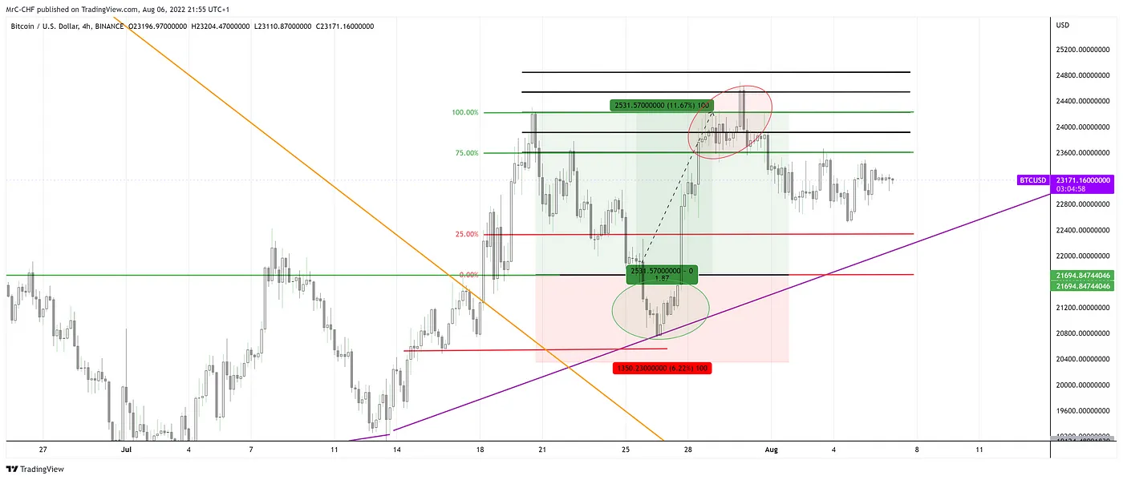

Explanation: In early/mid-June BTC was dumping hard. Between June 16–18th, BTC tried to find support but was rejected at $22.5k before dipping to ~$18k, where it found some support. This was an opportunity to play a range, imho. BTC had been doing this for months, so it made sense that it would range for a while before either dipping again or breaking out. $20k was also a somewhat significant support/resistance area in the past.

You could assume a 0–100% range from $18k to $22.5k, and if price dropped within the 0–25% of that trading-range, you would start a grid-bot. You would have set your grid-levels between 70–120% of the trading-range by aligning the mid-point of your grid levels to the high of $22.5k then having the bottom of your grid levels around the 70–75% level of the trading-range. You would also have set a stop-loss below the trading-range, ideally based on recent price action. For this BTC move, an 8.5% stop-loss at/below the 25% level of the trading-range would have been fine, since it was giving a 1.5–2x a reward-to-risk ratio. In this case, you would have entered in the first week of July (first green circle) and shut down the bot by July 8–9th (first red circle) with a decent profit. If you didn’t, then price would have dropped again, down to ~$19k (2nd green circle), before running up to $24k (2nd red circle). At this point, you should have stopped the grid-bot, since all your coins would have been sold anyway.

B. Up-trending market (short/mid-term trade): Similar to the sideways market example above, you start your bot when price is at a low point in the trend. Maybe price comes back down to a prior resistance level or is near dynamic support, like a valid moving average. You set your exit grids further up, perhaps based on a resistance level or near the high-end of an up-trending channel. Here’s an example using the same BTC price action right after the sideways market example above.

Snapshot depicting an up-trending price and a grid-bot trading strategy

<https://www.tradingview.com/x/qOz1OSv2/>

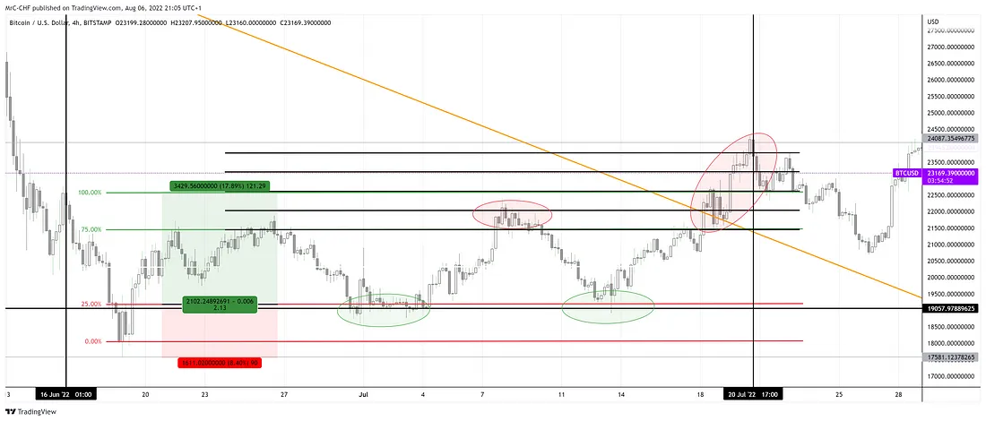

Explanation: After price ran up to $24k, it broke a multi-month down-trend (orange line), so one could have anticipated more bullish movement and started looking for up-trend opportunities. $21.6–22k was the last resistance zone, so this (green line) could become support going forward. You could have used that level ($21.6k) as the 0% point for your new trading range, with the high of the range (100% mark) at the most recent high ($24k). You would have bought your coins and started the grid-bot around $22k, while setting a stop-loss around $20.5k, which was a prior support level (red line) and still allowed a 1.5–2x reward/risk ratio. After entry, price dropped to about $20.8k, so it didn’t reach the stop-loss. Price then moved back up to $23.6–24.5k, where you should have stopped the bot. At this point, price seems to be ranging again, so one could be looking to set a new trading-range, probably $22.8–25k.

Conversely, instead of stopping the bot, you could move your grid-levels further up to the $22.8–25k range and adjusting your stop-loss to a higher position.

C. Up-trending market (long-term trade): Instead of targeting a near-term high to exit your coins, you can long-term HODL a coin but use a grid for some opportunistic sales at a much higher price. For instance, BTC is trading around $20–23k right now. Instead of simply buying & holding some BTC you could set up a grid bot with grids ranging from $38- 68k. The bot will buy up all the BTC, at current price, and be ready to sell at your target levels.

D. Down-trending market (scaling out): Most grid-bots are inherently long, but you can use the same approach as above (option B) for an up-trending market. However, you’ll have to buy tokens that are inherently short, like the Bear-USD token on FTX that simulates a 3x-short on BTC. In a down-trending market (for BTC), this token will have a bullish chart.

E. Down-trending market (scaling in): If you have a coin that you want to get into slowly via dollar-cost-averaging, a grid-bot is a perfect tool for this. You start a grid-bot with levels below the current price. An example, say you’re short-term bearish but long-term bullish on bitcoin. You could set up a grid-bot with levels from $20k down to $10k, hoping to accumulate if BTC drops further. If BTC drops to $10k, you could stop the bot or even move the grid levels up to your long-term bullish targets. One major benefit to this strategy is that once the grid-bot is started, your capital is tied up in limit orders.

Grid-bot best practices

1. Start small: Test things out on your preferred platform using just one bot. See how gains from the bot correlate with changes in the account’s actual value. This way you know if/how the grid-bot is actually generating profits.

2. Set grid-levels manually: Some platforms offer algorithms to set your grid levels. In my experience, most of these assume money is made simply buying and selling in sideways markets, which is false. You should also ignore the advice to have many, tight grid-levels. Just set up the grids yourself and keep it simple.

3. Focus on the charts & your account value: If your trading platform doesn’t show both realized and unrealized profits, then you should probably ignore the stats they offer and just track your positions using Tradingview and your overall account value. Remember that the key is to start/stop your bots at the right time/level, just like normal trading, so watch the charts.

4. Diversify your bets: You don’t want all your money in one coin or all your bots/trades to be correlated. For example, if you have several grid-bots, all with Defi tokens trading Coin/USD, then you’re essentially making the same bet several different ways. You get a little diversification with this approach, but a better approach is to hold different types of coins (mix of Defi, Gaming, Layer 1/2), coins of different quality (large caps, mid-caps and shit-coins), and even different quote pairs (coin/BTC, coin/USD, coin/ETH).

5. Focus on high-value coins: Remember that grid-bots will hold a 100% coin position if the price drops below your grid-levels. If you don’t use a stop-loss, then you’ll definitely be a bag-holder, so make sure it’s something you’re willing to hold. This is one reason I like trading ETH/BTC because I’m happy hodl-ing both.

6. Learn to use stop-losses: Trading is risk management, so I’ve learned to use stop-losses. Learn how to read market structure in the price charts and how to place conservative stops with wide gaps.

7. Consider a dynamic stop-loss: A static stop-loss will close your grid-bot if it gets hit. It can be annoying if price moves back up and you’re setting up the same grid-bot again. Or worse, you miss the re-start/entry opportunity. An alternative I’ve used in the past is to “hedge” my grid-bot exposure with a conditional short trade. I use the 3commas platform, and you can link to a futures/margin account to enable shorting. You can also use their smart-trade feature to set a conditional entry, where price needs to drop to a certain level for it to trigger, that will open a short-trade of equal size to the long exposure of your grid-bot (ex: if your bot will hold a max of 100 coins, then you set up a short for 100 coins). 100 coins short + 100 coins long = a net cash position. You can either close the short-trade manually, to get back long, or you can select a stop-loss level for the short-trade that will close the short and leave you in a long position. Obviously, if the short-trade stop gets hit then you’ll have to manually create another conditional short, but it’s a safeguard in case you’re busy or away.

Another alternative of this is to use a 3commas DCA-bot linked to a horizontal line+alert on Tradingview. With this in place, a short-trade can be opened every time price drops and closes below the line. You’ can still set stop-loss to that trade, but you don’t have to reset the short-trade. The alert & DCA-bot is ready to hedge your position repeatedly. I’m not going to walk-through the full setup of this now, but it’s a very useful approach.

Okay, this has been a very long post, so I’ll end it here. Below are some additional resources that I’ve found on grid-bots.

Good luck with your trading!

Useful links

(Pionex affiliated) https://youtu.be/9je590xJEEo

(from Bitsgap) https://youtu.be/3RtHtyeH1AU

(from 3commas) https://3commas.io/blog/step-by-step-instruction-to-grid-bot

(TradingParrot) https://www.youtube.com/watch?v=eV947alnJFw

08:45 — talks about how profits change in a down-trending market

13:00 — talks about gains from grid-bot vs a simple buy&hold strategy

Other links

https://coincodecap.com/grid-trading

<https://phemex.com/academy/what-is-grid-trading>

# How to Generate 159% per year of Semi-Passive Income with Grid Bots

There are many methods to generate wealth in the crypto industry: 1) buy & hold, 2) bot trading, and 3) active trading (day trading). There are also ways to use your existing crypto capital to generate passive income through staking, yield farming, peer-to-peer lending, etc.

Today, we will take a deep look into bot trading, specifically grid bots. These bots are unique because, unlike active trading or day trading, grid bots generate returns while being semi-passive.

Here is an example of one of my active grid bots that is short-selling STEPN ($GMT). Over the course of the last 192 days of activity, I have nearly doubled my money. Yearly, it averages 159%… not bad for being somewhat inactive.

Figure 1. Grid Bot Short Selling $GMT for the past 192 days

In no way do I want to mislead you all…I don’t always win. Some of my bots are currently losing. Overall, I’ve made 5.35% in the last 30 days versus a baseline of 2.38% for the entire crypto market (with a buy&hold strategy). I take more risks and I tend to get more returns. This strategy has been optimized within the last year such that I sacrifice returns to obtain a more stable income. In the last 365 days, I have generated a return of 26.9%…however with a buy&hold I would have made 29.8%. I had to learn (and am still learning each day) from mistakes to start beating the market. Although I am proud of this outcome, my current strategy can outperform even that, which I will share with you all today.

Figure 2. Overall Grid Bot Portfolio return in last 30 days

What is a Grid Bot?

A grid bot is designed to buy and sell an asset when the price of that asset crosses a specific price. In the case of a grid bot that is designed for a bull (upward trending) market, a trigger is set when the price of the asset crosses a grid while moving up and a portion of the asset is sold. On the other hand, if the price crosses a grid during a bear (downward trending) market, a portion of US currency is used to buy the asset. The idea is to continuously keep creating profitable pairs of trades by buying low and selling high. Grid bots are especially good when an asset keeps oscillating sideways without real gains or losses. The weakness is when an asset skyrockets and never comes back down because you end up selling early and have a high opportunity cost. Similarly, if the price of an asset goes down and never comes back up, you end up buying high and never having the chance to sell back. It’s like trying to grab a falling knife. However risk-heavy it seems, it is, in my experience, less stressful than day trading to generate income, and for certain assets it makes a lot of sense to use.

Pick a Portfolio of Assets

First, you have to chose a specific crypto asset which I categorize them in two categories: 1) long-term bull (cryptocurrencies that will do better and gain value over the next decade, roughly 1% of crypto on the market) and 2) long-term bear (crypto with bad economics that are likely to keep losing value until people forget about them, about 99% of the crypto in circulation).

To help yourself pick a portfolio, feel free to use my referral code to join Cyrator, a group of crypto analysts such as myself who are constantly reviewing crypto projects. At the time of this writing (July 22nd, 2023), I am long on: 1) ETH, 2) GMX, 3) BTC, 4) PYR, 5) GNS, 6) APEX. As well, I am short on: 1) SAND, 2) GMT, 3) MANA, 4) AUDIO, 5) CHZ. Note, this portfolio is highly time sensitive, so you should do your own research and pick assets based on what you believe. I have written extensively about analyzing crypto assets based on tokenomics to help you pick the right projects. Feel free to reach out on Twitter to discuss more time-sensitive information.

Picking a Direction — Bull or Bear

Once you have chosen your assets, you must decide if you want your grid bot to be active for weeks, months, or even years–the direction will depend on it. Next, you pick whether it will be a downward or upward trend for that asset over that time period. This is a critical decision that involves macroeconomics (market trend), fundamental analysis (economic evaluation of the project), and technical analysis (trading activity of the project)… sorry I wish it was simpler. I will write more blog posts about this topic and create YouTube videos as well to explain more visually (stay tuned).

In absence of real knowledge, I’d recommend taking a look at the greed/fear index. If you see greed is high (in the green), then pick a downward trend, and if instead the needle is deep on the red (fear side), then pick an upward trend (basically do the opposite of what the market does). This is by no means financial advice and is not always a good predictive indicator, but it is better than shooting in the dark.

Fear & Greed Index

When greed is extreme, assets are often over evaluated and will eventually come back down to a fair price or even get under valued.

Pick a Range

At this point, you will need a better understanding of technical analysis. The trick is to pick a range where you believe the crypto assets will be oscillating within (the high and low price that the assets may reach over the next week or few months). This decision depends on how much capital you can allocate and how much risk you want to absorb.

In the case of STEPN, I believe the tokenomics of the project are flawed and that the downward trend will continue until the project becomes forgotten. This is why I picked a downward trend with a range between $0.5 and $0.1. The range is large, yes, but my bot has been active for the past 192 days. If I were to pick a tighter range, the price could move out of the set range and I’d have to choose to keep it active (in the case that it returns in the active range), or close it with risk of impermanent loss. Since I am patient and comfortable with capital and risk, I picked a wide range, but the bot still managed to generate 1178 trades over this time frame (that’s an average of 6 trades per day that I can be passively observing/sleeping).

STEPN Price Chart

From a purely technical point of view, this chart looks like it will reverse soon and $GMT should return to $0.50 eventually or even more. This analysis, however, would be missing an understanding of this project’s fundamental flaws in regards to tokenomics. I believe it will keep going down indefinitely and that the team will eventually move on to a new, more exciting project.

How Many Grids?

Choosing the number of grids necessary for this selected project is just as important as the market evaluation. If the grids are set too sparse, the grid bot will not trigger often enough and you will lose potential yield. On the contrary, if the grids are set too tight, the increase in profit per trade may be too low…remember, transaction fees still apply.

Since I often pick a wide range for my bots, I simultaneously chose a larger number of grids to trigger the right amount of trades.

Sparse and Dense Grid Setting

How Much Capital to Allocate

One of the last parameters to choose is how much capital to allocate. I tend to choose between 5x to 20x leverage on my bots, so I usually don’t allocate large amounts of capital due to the high leverage. I prefer to keep more USDT to prevent liquidation when the market moves in the wrong direction for an extended period of time. Ultimately, the amount to allocate highly depends on how much you can afford and are willing to lose. As with all investments in crypto, there are high risks.

Binance: Grid Bot Settings Screen

Simultaneous Long & Shorts

In order to maximize returns for the grid bot, you would need to pick 1 direction for the movement of the currency, however that is more risky. In my case, I am always looking for ways to reduce risk and increase profits. To do that, I “SHORT” poorly designed crypto assets, and I “LONG” projects that I believe will keep performing better and better at every bull run (BTC, ETH, etc.). This way, over time, my bots that are short and my bots that are long end up winning. By balancing out my portfolio in such a manner, the risk of liquidation is a lot smaller, even with high leverage. By performing long and short simultaneously, my portfolio appears to not be gaining returns, but in reality the bots are accumulating tokens on one side, and taking profits on the other regardless of the direction of the market. Overtime, the actual profits start accumulating and I take vastly less risk to produce about 5% a month (at the time of this writing).

Conclusion

I realize that the content of this post does not entirely provide all the information needed to start earning income with grid bots. The reason I wrote it without providing all the information is that some of that information is highly time sensitive and would represent financial advice which is a regulated activity. So, instead, I would recommend anyone that wants to understand this topic fully to spend enough time trying first with money that can be lost without any financial impact. Feel free to reach out on Twitter to discuss, and let me know if you’d like to see a video guide where I go step by step in creating a portfolio from scratch. However, please do realize that if I do this, it will only be as a teaching activity and should not be construed as financial advice, and I take no responsibility if the performances are not as plentiful as one would hope. The markets behave in a way that is like a casino to a certain extent. Over a long-time period things can work out well, but there are occasional black swan events that can truly affect performance in a way that cannot be predicted.

If you are you curious to understand more about tokenomics, crypto trading, and other topics of relation to crypto-currencies, feel free to subscribe and join my various social media channels:

Cyrator

Twitter

Medium

Instagram

TikTok

YouTube

Special thanks to my intern + editor Jackson.

Also, feel free to check out my own crypto startup, Fanance, where you can earn income by following content creators.