521H0218_PhanThanhDat

TICKET VENDING MACHINE

2.

**- Functional requirements:**

+ Select the languages

+ Chosse Destinition

+ Chosse Pick up point

+ Payment by card or digital wallet

+ Cancel Transaction

+ Invoice

**- Non-functional requirements:**

+ The system is always active

+ The system is convenience and speed.

+ QR code should be valid in 30 second.

+ Ticket issuance time is no more than 5s.

+ Have a password for buying ticket

1. Use Case Modelling

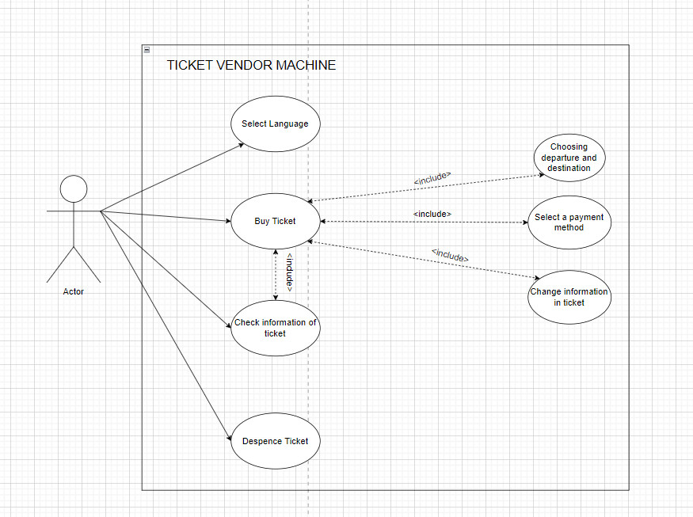

1. Activity Diagram

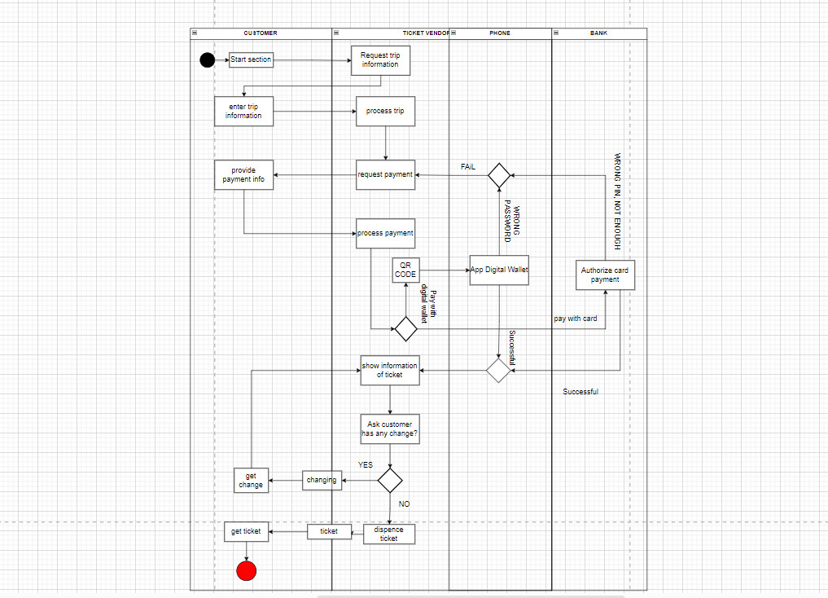

5.

- Sequence Diagram

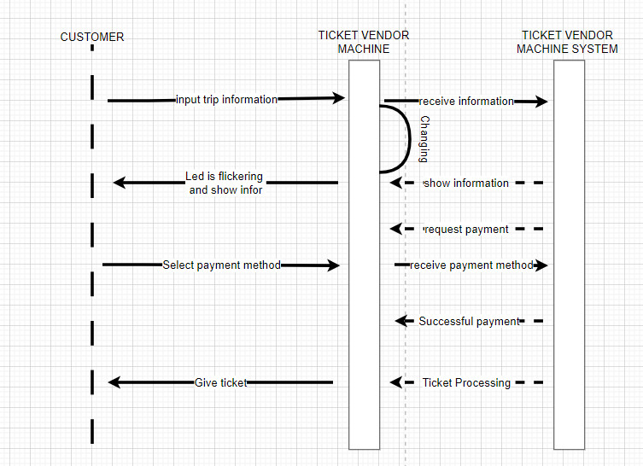

-State Chart Diagram

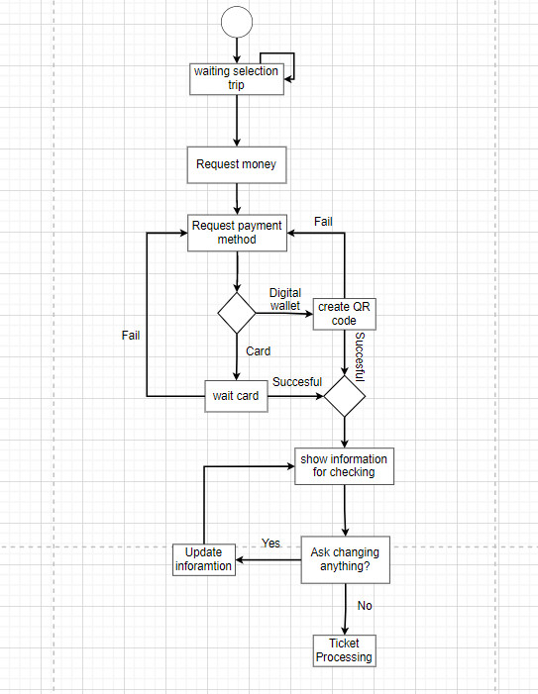

- Class Diagram

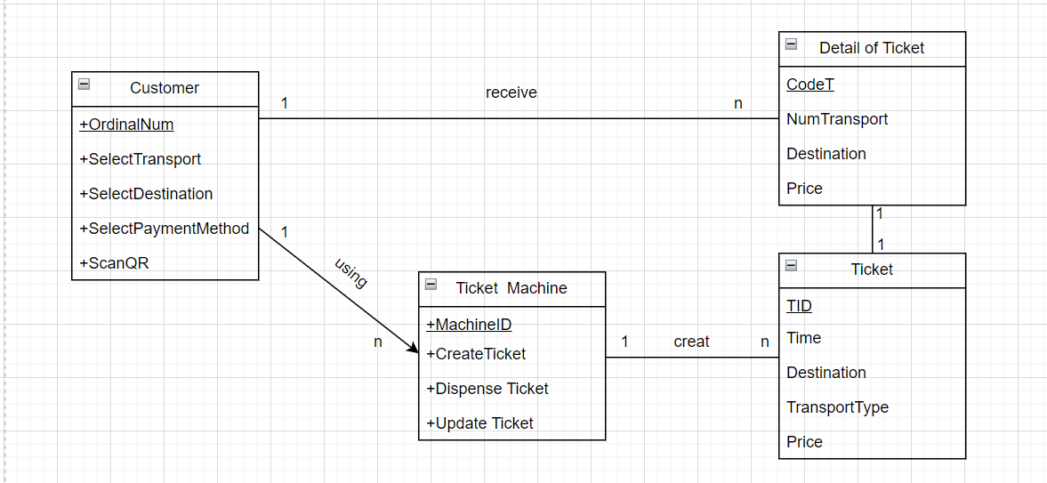

6.

Standby screen interface

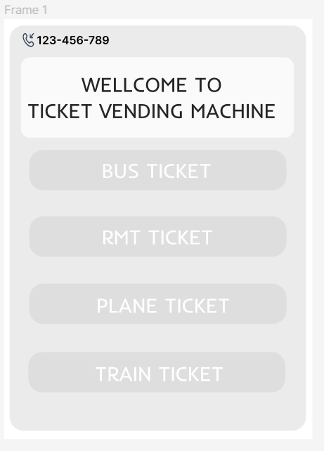

Bus ticket purchase screen interface

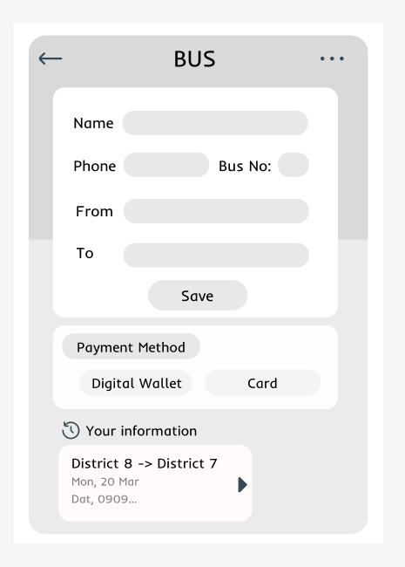

Digital wallet payment interface

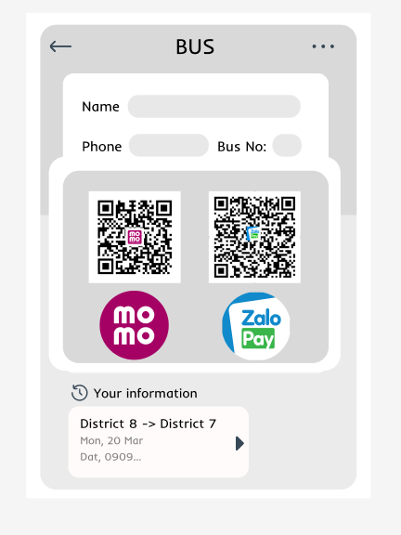

Card payment interface

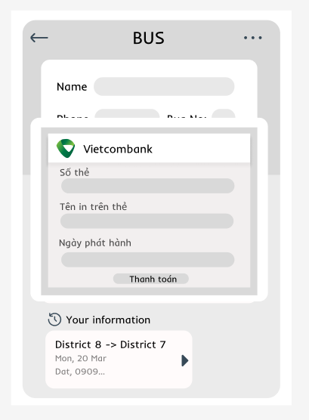

Ticket printing interface

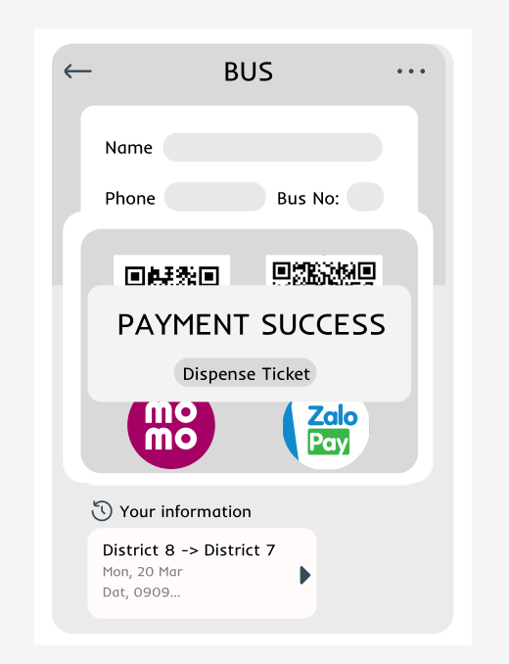

7.

-Deployment Diagram

