Ex 1 :

Resource Sheet

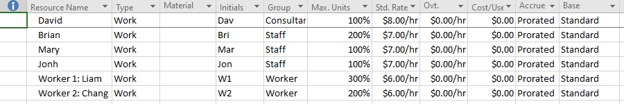

Gantt Chart 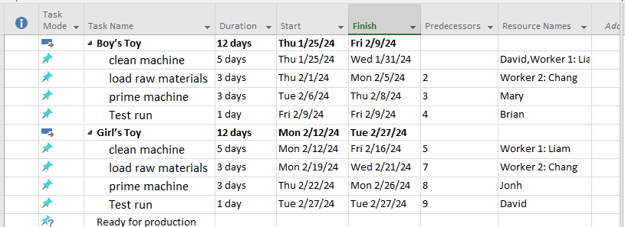

Ex2

Resource Sheet

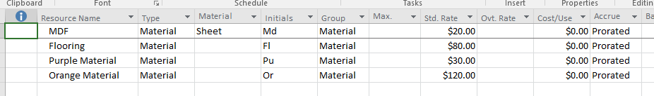

Gantt Chart

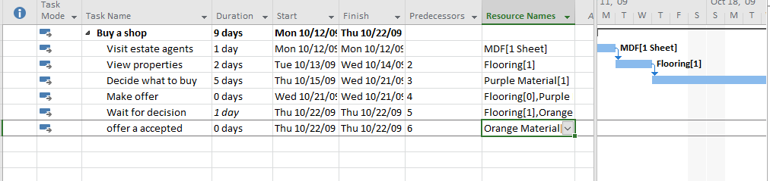

Ex3

Resource Sheet

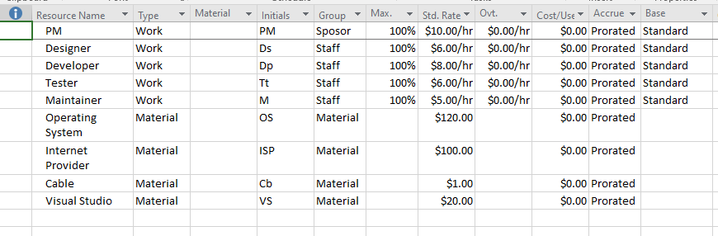

Gantt Chart

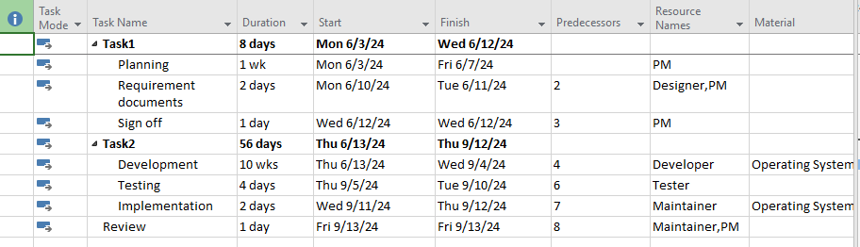

Ex4

Resource Sheet

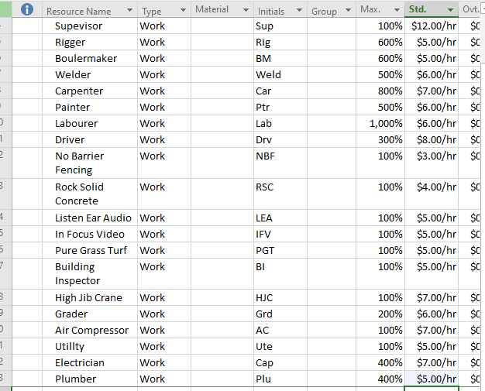

Gantt Chart

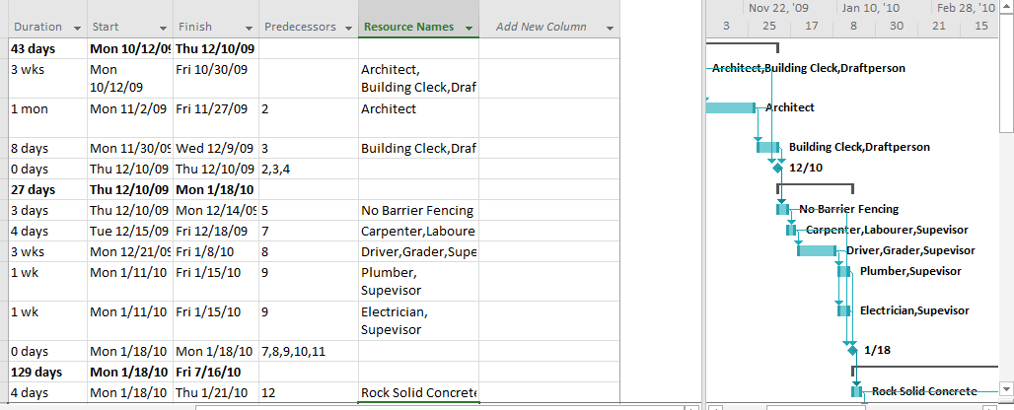

Ex3

Resource Sheet

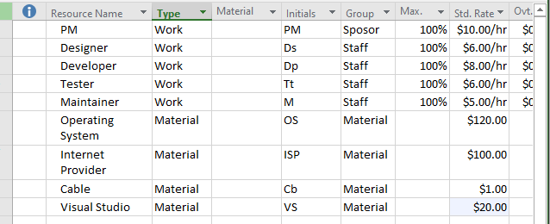

Gantt Chart

