**Họ và tên :** ĐẶNG THANH HUY

**MSSV**:20530352 **Chapter 6:**

**EX1:**

Flower flowers like flowers.

L = V, N, ART, P

i = 1 to 4

SEQ(1,1) = PROB(flower/V)* PROB(V/O) = 0.05 * 0 = 0

SEQ(2,1) = PROB(flower/N)* PROB(N/O) = 0.063 * 0.29 = 0.01827

t = 2 to 4

i = 1 to 4

SEQ(1,2) = SEQ(2,1)* PROB(V/N)* PROB(flowers/V) = 0.01827 * 0.35 * 0.05

= 3.19725 * 10-4

SEQ(2,2) = SEQ(2,1)* PROB(N/N)* PROB(flowers/N) = 0.01827*0.13* 0.063 = 1.496313 * 10-4

t = 3 to 4

i = 1 to 4

SEQ(1,3) = max j=1,4 (SEQ(1,2)* PROB(V/V), SEQ(2,2)* PROB(V/N))*

PROB(like/V) = max(3.19725 * 10-4 * 0, 1.496313 * 10-4 * 0.35) * 0.1 =

5.2370955 * 10-6

SEQ(2,3) = max j=1,4 (SEQ(1,2)* PROB(N/V), SEQ(2,2)* PROB(N/N)*

PROB(like/N) = max(3.19725 * 10-4 * 0.43, 1.496313 * 10-4 * 0.13) * 0.012 =

1.649781 * 10-6

SEQ(4,3) = max j=1,4 (SEQ(1,2)*

PROB(P/V),SEQ(2,2)*PROB(P/N))*PROB(like/P)

= max(3.19725 * 10-4 * 0, 1.496313 * 10-4 * 0.26) * 0.068 = 2.645481384 *

10-6

t = 4

i = 1 to 4

SEQ(1,4) = SEQ(2,3)* PROB(V/N) * PROB(flower/V) = 1.649781 * 10-6 * 0.43

* 0.05 = 3.54702915 * 10-8

SEQ(2,4) = max j=1,4 (SEQ(1,3)* PROB(N/V), SEQ(2,3)* PROB(N/N),

SEQ(4,3)*PROB(N/P)) * PROB(flower/N) = max(5.2370955 * 10-6 * 0.35,

1.649781 * 10-6 * 0.13, 2.645481384 * 10-6 * 0.26) * 0.063 = 1.154779558 * 10-7

**Transition network:**

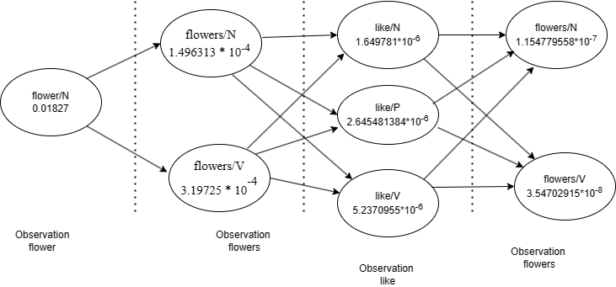

**EX2:**

Initialization Step:

SEQSUM(1,1) = PROB(the|V) * PROB(V) = 0 * 0 = 0

SEQSUM(1,2) = PROB(the|N) * PROB(N) = 0.29 * 0 = 0

SEQSUM(1,3) = PROB(the|P) * PROB(P) = 0 * 0 = 0

SEQSUM(1,4) = PROB(the|ART) * PROB(ART) = 0.71 * 0.99 = 0.7029

Computing the Forward Probabilities:

t = 2 (a)

i = 1: SEQSUM(2,1) = (PROB(V|V) * SEQSUM(1,1) + PROB(V|N) * SEQSUM(1,2) +

PROB(V|P) * SEQSUM(1,3) + PROB(V|ART) * SEQSUM(1,4)) * PROB(a|V)

= 0 * 0 + 0.43 * 0 + 0 * 0 + 0 * 0.7029 * 0

= 0

i = 2: SEQSUM(2,2) = (PROB(N|V) * SEQSUM(1,1) + PROB(N|N) * SEQSUM(1,2) +

PROB(N|P) * SEQSUM(1,3) + PROB(N|ART) * SEQSUM(1,4)) * PROB(a|N)

= 0.35 * 0 + 0.13 * 0 + 0.26 * 0 + 1 * 0.7029 * 0.005

= 0.0035145

i = 3: SEQSUM(2,3) = (PROB(P|V) * SEQSUM(1,1) + PROB(P|N) * SEQSUM(1,2) +

PROB(P|P) * SEQSUM(1,3) + PROB(P|ART) * SEQSUM(1,4)) * PROB(a|P)

= 0 * 0 + 0.44 * 0 + 0 * 0 + 0 * 0.7029 * 0

= 0

i = 4: SEQSUM(2,4) = (PROB(ART|V) * SEQSUM(1,1) + PROB(ART|N) * SEQSUM(1,2)

+ PROB(ART|P) * SEQSUM(1,3) + PROB(ART|ART) * SEQSUM(1,4)) * PROB(a|ART)

= 0.65 * 0 + 0 * 0 + 0.74 * 0 + 0 * 0.7029 * 0.995

= 0

t = 3 (flies)

i = 1: SEQSUM(3,1) = (PROB(V|V) * SEQSUM(2,1) + PROB(V|N) * SEQSUM(2,2) +

PROB(V|P) * SEQSUM(2,3) + PROB(V|ART) * SEQSUM(2,4)) * PROB(flies|V)

= 0 * 0 + 0.43 * 0.0035145 + 0 * 0 + 0 * 0 * 0.52

= 0.0007858422

i = 2: SEQSUM(3,2) = (PROB(N|V) * SEQSUM(2,1) + PROB(N|N) * SEQSUM(2,2) +

PROB(N|P) * SEQSUM(2,3) + PROB(N|ART) * SEQSUM(2,4)) * PROB(flies|N)

= 0.35 * 0 + 0.13 * 0.0035145 + 0.26 * 0 + 1 * 0 * 0.48

= 0.0002193048

i = 3: SEQSUM(3,3) = (PROB(P|V) * SEQSUM(2,1) + PROB(P|N) * SEQSUM(2,2) +

PROB(P|P) * SEQSUM(2,3) + PROB(P|ART) * SEQSUM(2,4)) * PROB(flies|P)

= 0 * 0 + 0.44 * 0.0035145 + 0 * 0 + 0 * 0 * 0

= 0

i = 4: SEQSUM(3,4) = (PROB(ART|V) * SEQSUM(2,1) + PROB(ART|N) * SEQSUM(2,2)

+ PROB(ART|P) * SEQSUM(2,3) + PROB(ART|ART) * SEQSUM(2,4)) *

PROB(flies|ART)

= 0.65 * 0 + 0 * 0.0035145 + 0.74 * 0 + 0 * 0 * 0

= 0

t = 4 (like)

i = 1: SEQSUM(4,1) = (PROB(V|V) * SEQSUM(3,1) + PROB(V|N) * SEQSUM(3,2) +

PROB(V|P) * SEQSUM(3,3) + PROB(V|ART) * SEQSUM(3,4)) * PROB(like|V)

= 0 * 0.0007858422 + 0.43 * 0.0002193048 + 0 * 0 + 0 * 0 * 0.49

= 04620752136

i = 2: SEQSUM(4,2) = (PROB(N|V) * SEQSUM(3,1) + PROB(N|N) * SEQSUM(3,2) +

PROB(N|P) * SEQSUM(3,3) + PROB(N|ART) * SEQSUM(3,4)) * PROB(like|N)

= 0.35 * 0.0007858422 + 0.13 * 0.0002193048 + 0.26 * 0 + 1 * 0 * 0.16

= 04856870304

i = 3: SEQSUM(4,3) = (PROB(P|V) * SEQSUM(3,1) + PROB(P|N) * SEQSUM(3,2) +

PROB(P|P) * SEQSUM(3,3) + PROB(P|ART) * SEQSUM(3,4)) * PROB(like|P)

= 0 * 0.0007858422 + 0.44 * 0.0002193048 + 0 * 0 + 0 * 0 * 0.34

= 03280799808

i = 4: SEQSUM(4,4) = (PROB(ART|V) * SEQSUM(3,1) + PROB(ART|N) * SEQSUM(3,2)

+ PROB(ART|P) * SEQSUM(3,3) + PROB(ART|ART) * SEQSUM(3,4)) *

PROB(like|ART)

= 0.65 * 0.0007858422 + 0 * 0.0002193048 + 0.74 * 0 + 0 * 0 * 0

= 0

t = 5 (flowers)

i = 1: SEQSUM(5,1) = (PROB(V|V) * SEQSUM(4,1) + PROB(V|N) * SEQSUM(4,2) +

PROB(V|P) * SEQSUM(4,3) + PROB(V|ART) * SEQSUM(4,4)) * PROB(flowers|V)

= 0 * 04620752136 + 0.43 * 04856870304 + 0 * 03280799808 + 0 * 0 * 0.22

= 004594599308

i = 2: SEQSUM(5,2) = (PROB(N|V) * SEQSUM(4,1) + PROB(N|N) * SEQSUM(4,2) +

PROB(N|P) * SEQSUM(4,3) + PROB(N|ART) * SEQSUM(4,4)) * PROB(flowers|N)

= 0.35 * 04620752136 + 0.13 * 04856870304 + 0.26 * 03280799808 + 1 * 0 * 0.78

= 02419298184

i = 3: SEQSUM(5,3) = (PROB(P|V) * SEQSUM(4,1) + PROB(P|N) * SEQSUM(4,2) +

PROB(P|P) * SEQSUM(4,3) + PROB(P|ART) * SEQSUM(4,4)) * PROB(flowers|P)

= 0 * 04620752136 + 0.44 * 04856870304 + 0 * 03280799808 + 0 * 0 * 0

= 0

i = 4: SEQSUM(5,4) = (PROB(ART|V) * SEQSUM(4,1) + PROB(ART|N) * SEQSUM(4,2)

+ PROB(ART|P) * SEQSUM(4,3) + PROB(ART|ART) * SEQSUM(4,4)) *

PROB(flowers|ART)

= 0.65 * 04620752136 + 0 * 04856870304 + 0.74 * 03280799808 + 0 * 0 * 0

= 0

Computing the Lexical Probabilities:

Normalization at t = 1:

PROB(the|V) = SEQSUM(1,1) / SEQSUM(1,1) + SEQSUM(1,2) + SEQSUM(1,3) +

SEQSUM(1,4)

= 0 / 0.7029

= 0

PROB(the|N) = SEQSUM(1,2) / SEQSUM(1,1) + SEQSUM(1,2) + SEQSUM(1,3) +

SEQSUM(1,4)

= 0 / 0.7029

= 0

PROB(the|P) = SEQSUM(1,3) / SEQSUM(1,1) + SEQSUM(1,2) + SEQSUM(1,3) +

SEQSUM(1,4)

= 0 / 0.7029

= 0

PROB(the|ART) = SEQSUM(1,4) / SEQSUM(1,1) + SEQSUM(1,2) + SEQSUM(1,3) +

SEQSUM(1,4)

= 0.7029 / 0.7029

= 1

Normalization at t = 2:

PROB(a|V) = SEQSUM(2,1) / SEQSUM(2,1) + SEQSUM(2,2) + SEQSUM(2,3) +

SEQSUM(2,4)

= 0 / 0.0035145

= 0

PROB(a|N) = SEQSUM(2,2) / SEQSUM(2,1) + SEQSUM(2,2) + SEQSUM(2,3) +

SEQSUM(2,4)

= 0.0035145 / 0.0035145

= 1

PROB(a|P) = SEQSUM(2,3) / SEQSUM(2,1) + SEQSUM(2,2) + SEQSUM(2,3) +

SEQSUM(2,4)

= 0 / 0.0035145

= 0

PROB(a|ART) = SEQSUM(2,4) / SEQSUM(2,1) + SEQSUM(2,2) + SEQSUM(2,3) +

SEQSUM(2,4)

= 0 / 0.0035145

= 0

Normalization at t = 3:

PROB(flies|V) = SEQSUM(3,1) / SEQSUM(3,1) + SEQSUM(3,2) + SEQSUM(3,3) +

SEQSUM(3,4)

= 0.0007858422 / 0.001005147

= 0.7818181818

PROB(flies|N) = SEQSUM(3,2) / SEQSUM(3,1) + SEQSUM(3,2) + SEQSUM(3,3) +

SEQSUM(3,4)

= 0.0002193048 / 0.001005147

= 0.2181818182

PROB(flies|P) = SEQSUM(3,3) / SEQSUM(3,1) + SEQSUM(3,2) + SEQSUM(3,3) +

SEQSUM(3,4)

= 0 / 0.001005147

= 0

PROB(flies|ART) = SEQSUM(3,4) / SEQSUM(3,1) + SEQSUM(3,2) + SEQSUM(3,3) +

SEQSUM(3,4)

= 0 / 0.001005147

= 0

Normalization at t = 4:

PROB(like|V) = SEQSUM(4,1) / SEQSUM(4,1) + SEQSUM(4,2) + SEQSUM(4,3) +

SEQSUM(4,4)

= 04620752136 / 0.0001275842225

= 0.3621726923

PROB(like|N) = SEQSUM(4,2) / SEQSUM(4,1) + SEQSUM(4,2) + SEQSUM(4,3) +

SEQSUM(4,4)

= 04856870304 / 0.0001275842225

= 0.3806795393

PROB(like|P) = SEQSUM(4,3) / SEQSUM(4,1) + SEQSUM(4,2) + SEQSUM(4,3) +

SEQSUM(4,4)

= 03280799808 / 0.0001275842225

= 0.2571477683

PROB(like|ART) = SEQSUM(4,4) / SEQSUM(4,1) + SEQSUM(4,2) + SEQSUM(4,3) +

SEQSUM(4,4)

= 0 / 0.0001275842225

= 0

Normalization at t = 5:

PROB(flowers|V) = SEQSUM(5,1) / SEQSUM(5,1) + SEQSUM(5,2) + SEQSUM(5,3) +

SEQSUM(5,4)

= 004594599308 / 02878758115

= 0.1596035208

PROB(flowers|N) = SEQSUM(5,2) / SEQSUM(5,1) + SEQSUM(5,2) + SEQSUM(5,3) +

SEQSUM(5,4)

= 02419298184 / 02878758115

= 0.8403964791

PROB(flowers|P) = SEQSUM(5,3) / SEQSUM(5,1) + SEQSUM(5,2) + SEQSUM(5,3) +

SEQSUM(5,4)

= 0 / 02878758115

= 0

PROB(flowers|ART) = SEQSUM(5,4) / SEQSUM(5,1) + SEQSUM(5,2) + SEQSUM(5,3)

+ SEQSUM(5,4)

= 0 / 02878758115

= 0

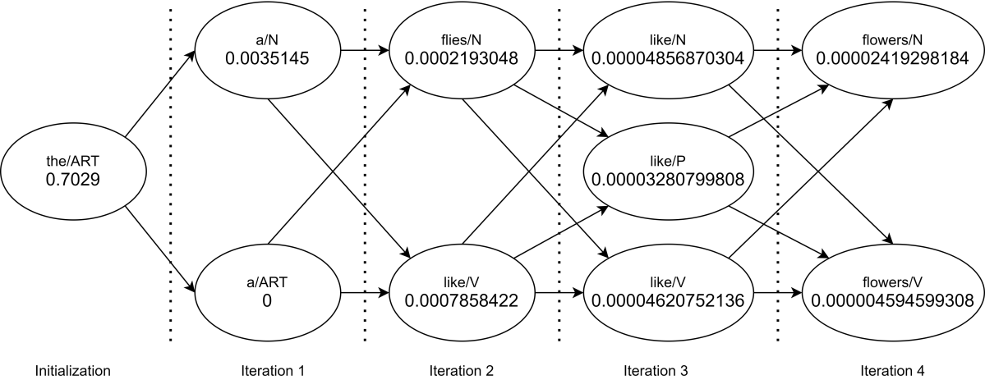

**Chapter 7:**

**Ex1:**

1. "A man stopped at every truck stop."

This sentence is ambiguous due to its possible syntactic structures. It can be interpreted in two main ways:

1. The man stopped at every truck stop he encountered.

Paraphrase: The man halted at each truck stop along his journey.

1. There was a man at each truck stop who stopped.

Paraphrase: At each truck stop, there was a man who came to a halt.

b) "Several people ate the pizza."

This sentence is ambiguous due to its possible word senses. It can be interpreted in two main ways:

1.Different groups of people consumed the pizza separately.

Paraphrase: Multiple groups of individuals had pizza.

2.A group of people together consumed the pizza.

Paraphrase: A number of people shared in eating the pizza.

c) "We saw her duck."

This sentence is ambiguous due to a combination of syntactic structures and word senses. It can be interpreted in two main ways:

1.We observed the duck belonging to her.

Paraphrase: We witnessed the duck that belongs to her.

2.We observed her perform the action of ducking.

Paraphrase: We witnessed her ducking (bending down quickly).

**EX2:**

1. George ate a pizza at every road stop.

Ambiguity: The sentence could mean either that George ate one distinct pizza at each road stop, or he ate portions of the same pizza across multiple road stops.

**Quasi-Logical Forms:**

Distinct Pizzas Interpretation:

∀s(s in RoadStops→∃p(p in Pizzas∧EAT(George,p,s)))

This interpretation suggests that for each road stop s, there is a different pizza p that George ate.

Same Pizza, Multiple Stops Interpretation:

∃p(p in Pizzas∧∀s(s in RoadStops→EAT(George,p,s)))

This form suggests that there is one pizza p that George ate across all road stops.

1. Several employees from every company bought a pizza.

Ambiguity: This sentence could mean either that a group of employees from each company collectively purchased one pizza, or each employee from every company purchased a separate pizza.

**Quasi-Logical Forms:**

Collective Purchase Interpretation:

∀c(c in Companies→∃e(e in Employees of c∧∃p(p in Pizzas∧BUY(e,p))))

This interpretation means that for each company c, there is a group of employees e who collectively buy at least one pizza p.

Individual Purchase Interpretation:

∀c(c in Companies→∀e(e in Employees of c→∃p(p in Pizzas∧BUY(e,p))))

This form implies that every employee e from each company c buys their own individual pizza p.

1. We saw John in the park by the beach.

Ambiguity: The sentence might mean that John was seen in a park located next to the beach, or it might mean that John was seen at both the park and also independently by the beach.

**Quasi-Logical Forms:**

Park Adjacent to the Beach Interpretation:

SEE(We,John,IN(Park adjacent to Beach))

This implies that the park where John was seen is next to the beach.

Separate Locations Interpretation:

SEE(We,John,IN(Park)∧IN(Beach))

This interpretation suggests that John was seen both in the park and, separately, at the beach.

**Chapter 8:**

**EX1:**

(λx(Px)A)simplifies to PA

((λx(xA))(λy(Qy))) simplifies to QA

((λx((λy(Py))x))A) simplifies to PA

**EX2:**

**Syntactic Analysis:**

NP1 (The man)

VP (gave the apple to Bill)

V (gave)

NP2 (the apple)

PP (to Bill)

P (to)

NP3 (Bill)

**Lexical Entries:**

man: λm (MAN m1)

apple: λa (APPLE a1)

Bill: λb (NAME b1 “Bill”)

gave: λx λy λz (PAST (GIVE x y z)) - where x is the giver, y is the thing given, and z is

the receiver.

to: λt (TO t1)

**Semantic Interpretation:**

NP1:

the: λP λx (THE x (P x))

man: λm1 (MAN m1)

SEM(NP1) = (λP λx (THE x (P)x))) (λm1 (MAN m1)) = λm1 (THE m1 (MAN

m1))

NP2:

the: λP λx (THE x (P x))

apple: λa1 (APPLE a1)

SEM(NP2) = (λP λx (THE x (Px))) (λa1 (APPLE a1)) = λa1 (THE a1 (APPLE

a1))

PP:

to: λt (TO t1)

Bill: λb1 (NAME b1 “Bill”)

SEM(PP) = λt (TO t1) (λb1 (NAME b1 “Bill”)) = TO (NAME “Bill”)

VP:

gave: λx λy λz (PAST (GIVE x y z))

NP2: λa1 (THE a1 (APPLE a1))

PP: TO (NAME “Bill”)

SEM(VP) = λx λy λz ( (TO (NAME “Bill”)) PAST (GIVE x y z)) (λa1 (THE a1

(APPLE a1))) (NAME “Bill”) = λx ( (TO (NAME “Bill”)) PAST (GIVE x (λa1

(THE a1 (APPLE a1))) (NAME “Bill”)))

S:

NP1: λm1 (THE m1 (MAN m1))

VP: λx (PAST (GIVE x (λa1 (THE a1 (APPLE a1))) )TO (NAME “Bill”))

SEM(S) = λx ( (TO (NAME “Bill”)) PAST (GIVE x (λa1 (THE a1 (APPLE a1))) )

(NAME “Bill”) (λm1 (THE m1 (MAN m1))) = (TO (NAME “Bill”)) PAST (GIVE

λm1 (THE m1 (MAN m1)) (λa1 (THE a1 (APPLE a1))) (NAME “Bill”))

**EX3:**

I use python to draw .

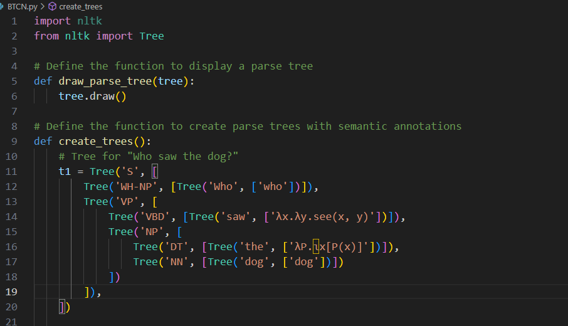

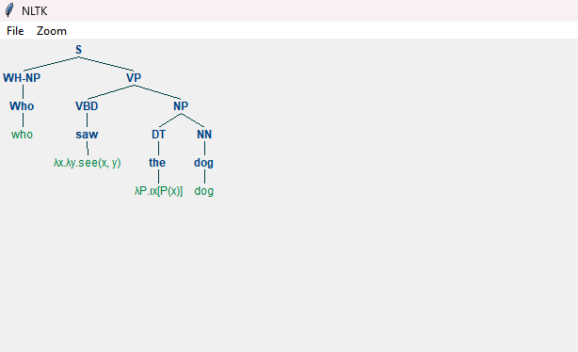

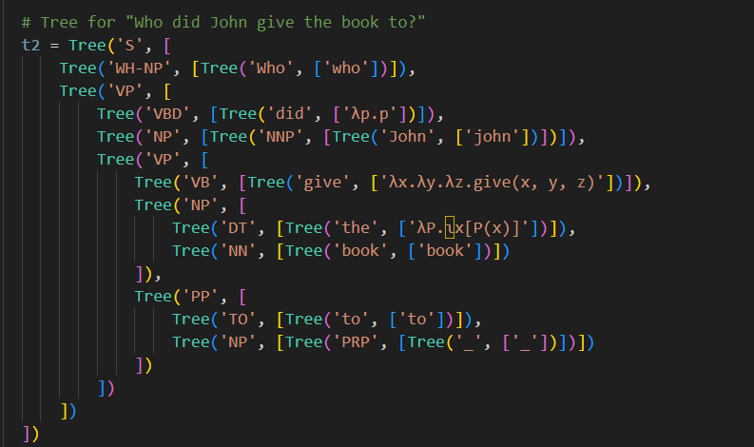

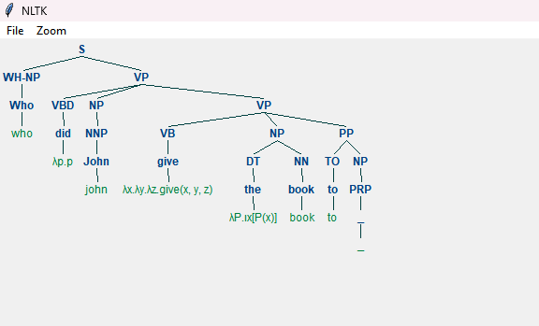

**Chapter 9 :**

**EX1:**

- For "bridge/STRUCTURE1":

- Count (the/bridge/STRUCTURE1) = 5500

- Count (suspension/bridge/STRUCTURE1) = 200

- Count (bridge/STRUCTURE1) = 5651

- Count (construction/bridge/ STRUCTURE1) = 1

- Count (the) in the corpus = 500,000

- Count (suspension) in the corpus = 2000

- Count (construction) in the corpus = 1000

- For "bridge/DENTAL-DEV37":

- Count (the/bridge/DENTAL-DEV37) = 180

- Count (suspension/bridge/DENTAL-DEV37) = 1

- Count (bridge/DENTAL-DEV37) = 194

- Count (construction/bridge/DENTAL-DEV37) = presumed low 0.1 due to it being rare

- STRUCTURE1:

Cn(the/bridge/STRUCTURE1)=107*5500/5651*500000≈1.94

Cn(suspension/bridge/STRUCTURE1)107× 200/5651×2000≈17.7

Cn(construction/bridge/STRUCTURE1)=107× 1/5651×1000≈1.8

- DENTAL-DEV37:

Cn(the/bridge/DENTAL-DEV37)=107× 180/194×500000≈1.84

Cn(suspension/bridge/DENTAL-DEV37)=107× 1/194×2000≈2.6

Cn(construction/bridge/DENTAL-DEV37)=107× 0.1/194×1000≈0.005

**EX2:**

The given grammar is enough to appropriately interpret these sentences.

Extend the lexicon and sense hierarchy:

route (N AGR 3s SEM ROUTE1)

route (N AGR 3s SEM ROUTE2)

book (N AGR 3s SEM BOOK2)

gave (V SUBCAT _np VFORM past SUBJ ?subj OBJ? SEM (& (GIVES1 *) (AGENT * ? subj)

(THEME * ?semobj)))

knows (V SUBCAT _np VFORM pres SUBJ ? subj OBJ? SEM (& (KNOWS1 *) (AGENT * ?subj)

(THEME * ?semobj)))

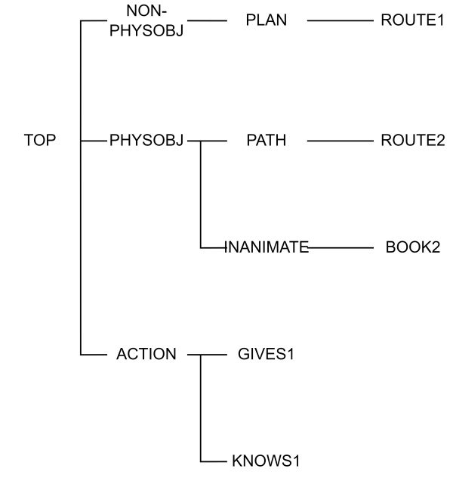

Extend the selectional restrictions:

(AGENT GIVES1 PERSON)

(THEME GIVES1 PHYSOBJ)

(AGENT KNOWS1 PERSON)

(THEME KNOWS1 NON-PHYSOBJ || PHYSOBJ)