Real-World Steel Frame Optimization Using a Hybrid Leader Selection-Based Multi-Objective Flow Direction Algorithm
Truong V.H.¹, Samir Khatira¹, Thanh Cuong-Le^{1,*}
¹Center for Engineering Application & Technology Solutions, Ho Chi Minh City Open University, Ho Chi Minh City, Viet Nam.
*Correspondence author: Thanh Cuong-Le, E-Mail: cuong.lt@ou.edu.vn

ABSTRACT
This paper presents a novel Multi-Objective Flow Direction Algorithm (MOFDA) for complex engineering optimization problems. The key innovation is a hybrid leader selection mechanism, which replaces the conventional roulette wheel selection and significantly enhances convergence and diversity in identifying Pareto-optimal solutions. The proposed MOFDA is rigorously evaluated on 31 standard benchmark problems and 11 constrained engineering design cases - including truss optimization, welded beam design, and a large-scale steel frame structure - to assess its accuracy, stability, and solution diversity comprehensively. Comparative studies with state-of-the-art multi-objective algorithms such as MOMVO, MOMSA, MSSA, and MOGNDO further highlight the strong performance of MOFDA. In addition, MOFDA is integrated into a MATLAB–SAP2000 framework and applied to the real-world structural optimization of the Dong Bai ferry terminal steel frame in Vietnam. The results show that MOFDA consistently achieves competitive or superior outcomes on benchmark functions, delivers substantial weight reduction, and improves structural efficiency in engineering applications. These findings demonstrate both the proposed approach's technical novelty and practical effectiveness.
Keywords: metaheuristics, multi-objective optimization, indicators, flow direction algorithm.
  - Introduction
Generally, MOO is a specific type of problem in optimization where the aim is to optimize many objectives concurrently, which frequently have competing goals. This problem type is encountered in several domains of daily life, including mathematics, engineering, social studies, economics, agriculture, aviation, automobiles, and numerous others [1]. MOO problems do not have a single global optimum by their nature. Alternatively, they consist of a collection of optimal trade-off solutions, known as the Pareto set, in the space of decisions and related trade-off goals, known as the Pareto front, in the space of objectives [1, 2]. It is the primary challenge of MOO problems in improving all available objectives simultaneously [3].
Metaheuristic optimization algorithms have been proven effective in identifying optimal solutions to nonlinear and difficult MOO situations in recent years, to handle the challenges of MOO problems. The findings show that metaheuristic algorithms can yield very accurate solutions in a reasonable time when used to solve complicated optimization problems. Metaheuristic algorithms provide several advantages over analytical techniques, including ease of implementation, a simple framework, good accuracy, and reasonable execution time [4]. In other words, these approaches provide superior efficiency and use fewer computer resources than those relying on derivatives [5]. A jungle of efficient metaheuristic techniques has been developed to address the complexities inherent in MOO. Rajwar et al. state that more than 500 metaheuristic algorithms have been developed until 2023, with 350 introduced in the past decade [6].
Numerous advanced metaheuristic algorithms have been proposed to improve solution quality and diversity. Recent notable methods include Multi-objective Multi-Verse Optimization (MOMVO) [7], Multi-objective Material Generation Algorithm (MOMGA) [8], Multi-objective Ant Lion Optimizer (MOALO) [9], Multi-objective Generalized Normal Distribution Optimization (MOGNDO) [4], Multi-objective Mantis Search Algorithm (MOMSA) [3], Multi-objective Beetle Antennae Search (MOBAS) [10], Multi-objective Trader algorithm (MOTR) [11], Multi-objective Salp Swarm Algorithm (MSSA) [12]. In addition, several emerging algorithms - such as the Multi-Objective Stochastic Paint Optimizer (MOSPO) [13], the Multi-Objective African Vulture Optimization Algorithm (MOAVOA) [14], and the Multi-Objective Arithmetic Optimization Algorithm (MOAOA) [15] - have attracted growing attention for their innovative mechanisms and firm performance on benchmark tests. The No Free Lunch (NFL) theorem of optimization posits that the wide variety of metaheuristics is the underlying cause for the lack of an algorithm that can effectively solve all types of problems [16]. This work is motivated to propose a novel advanced optimizer since the suggested algorithm may outperform other algorithms on some issues that have not been solved so far.
In response to these challenges, this study introduces a novel MOO approach, named MOFDA, to solve MOO problems by extending the original FDA [5]. To enhance the FDA's framework for handling MOO problems, two advanced mechanisms, i.e., an external repository (or archive controller) and a newly proposed hybrid leader selection strategy, are employed. The archive controller helps to determine the suitable solution for inclusion in a repository based on a well-defined decision-making procedure. The core innovation of this work is the hybrid leader selection mechanism, which combines grid-based density estimation and local diversity metrics to select leaders for guiding the search process, thereby balancing exploration and exploitation more effectively than conventional methods.
In addition, rigorously validating MOFDA was done through extensive testing across 31 case studies of unconstrained mathematical MOO benchmark problems and 11 constrained engineering design challenges. The mathematical MOO benchmarks consist of ZDT1-4, ZDT6, DTLZ1-6 collected from the test suite of Zitzler et al. [17] and Deb et al. [18]; then, MMF1, 2, 4, 5, 7, 8, 10-15 from CEC2020 and UF1-UF7 from CEC09. The engineering MOO problems consist of eight real truss design problems collected from Ref. [19] and three other constrained MOO problems, i.e., SRN, OSY, and Welded Beam problems, chosen from Refs. [3, 4].
MOFDA's performance is competitive and superior to other leading MOO algorithms, including MOMVO, MOGNDO, MSSA, and MOMSA. The selected algorithms for this comparison are recognized as state-of-the-art, each having demonstrated excellence in previous studies. These algorithms cover a broad spectrum of metaheuristic approaches, including physics-inspired, probabilistic, and swarm intelligence methods, and have demonstrated effectiveness on benchmark suites and real-world engineering applications. Particularly, the MOGNDO algorithm [4], introduced by Khodadadi et al. in 2024, has been rigorously tested and proven to outperform prominent algorithms like Multi-Objective Particle Swarm Optimization (MOPSO) [20], Multi-Objective Grey Wolf Optimizer (MOGWO) [21], and Multi-Objective Harris Hawks Optimization (MOHHO) [22]. Similarly, the MOMSA algorithm, proposed by Jameel and Abouhawwash in 2024, has shown its strength through extensive comparisons with MOPSO, MSSA [12], MOMVO [7], and the Multi-Objective Evolutionary Algorithm based on Decomposition (MOEA/D) [23]. In light of these results, MOFDA emerges as a highly effective and robust solution in MOO, offering significant advancements over existing algorithms.
In addition, several recently developed algorithms, such as the Multi-Objective Stochastic Paint Optimizer (MOSPO) [13], Multi-Objective African Vulture Optimization Algorithm (MOAVOA) [14], and Multi-Objective Arithmetic Optimization Algorithm (MOAOA) [15] - have also demonstrated promising performance on various challenging optimization problems. While these emerging methods were not included in the present comparative analysis, incorporating them into future benchmarking studies could provide a broader perspective on the relative strengths and weaknesses of MOFDA in the rapidly evolving field of MOO.
Besides, this research also employs three widely recognized indicators to evaluate the proposed MOFDA algorithm’s performance compared to the other advanced algorithms. They are Generational Distance ($GD$) proposed by Veldhuizen in 1998 [24], Inverted Generational Distance ($IGD$) introduced by Knowles, J. D., et al. in 2006 [25] and Spacing-to-Extent ($STE$) developed by Tejani et al. in 2019 [19, 26]. In which, $IGD$ and $GD$ are applied to measure the quality of the accuracy and convergence. And $STE$ is utilized for examining the distribution (coverage) rate of Pareto optimal solutions obtained by algorithms.
Moreover, a significant highlight of this study is the real-world application of the proposed MOFDA algorithm to optimize the steel frame structure of the Dong Bai ferry terminal in Vietnam. This case study demonstrates MOFDA’s ability to achieve substantial weight reductions and enhance structural stability, confirming its effectiveness for complex engineering challenges. This practical contribution is enabled by integrating MOFDA with a hybrid MATLAB–SAP2000 framework, where MATLAB manages the optimization process and communicates directly with SAP2000 to conduct high-precision finite element analyses. The automated two-way data exchange allows for rigorous structural performance and code compliance evaluation for each candidate solution. Overall, this approach showcases that MOFDA, combined with the automated workflow, can significantly improve weight efficiency and structural safety while fully satisfying engineering constraints.
The paper’s remainder is structured as follows: Section 2 presents the general definitions related to MOO problems. Section 3 then illustrates the proposed MOFDA method. Sections 4 is organized to introduces the selected MOO benchmark problems as well as the engineering design problems used in this study. Section 5 presents the main results and discussion of the proposed approach. Section 6 highlights the practical application of MOFDA to the optimization of a real-world steel frame structure. Finally, Section 7 concludes the paper and outlines directions for future research.
  - Prelimilaries
    - MOO Definitions
In contrast to conventional optimization, which aims to improve only one objective function, the MOO is designed to solve challenges with many conflicting objectives. A single optimum solution is not the goal of MOO; instead, it seeks to identify a range of solutions that achieve an equilibrium between these multiple opposing objectives. The added complexity requires evaluating various solutions to determine the best trade-offs among the objectives. In mathematical terms, MOO is often framed as a minimization problem with MOO functions, as illustrated below [27]:
Optimize | $F\left(x\right)=\left\{f_{1}\left(x\right),f_{2}\left(x\right),…,f_{j}\left(x\right)\right\}, j=1, 2,…,D$ | (1)
Subject | $\begin{matrix}g_{k}\left(x\right)≥0, k=1, 2,.., K \\ h_{l\left(x\right)}=0, l=1, 2,…, L \\ L_{i}≤x_{i}≤U_{i}, i=1, 2,…,M\end{matrix}$ | (2)
where $D,L$, $K$ and $M$ are the number of objective functions, equality constraints, inequality constraints and variables; $L_{i}$ and $U_{i}$ stands for the $i^{th}$ variable's lower and upper bounds, respectively. And $x$ is the vector of solutions $x=\left[x_{1}, x_{2}, …,x_{M}\right]$.

    - Pareto Concepts
A set of solutions that reflect variable degrees of optimality across the various objectives is typically used to represent the "optimum" of MOO. It challenges the traditional concept of optimality, necessitating a revised definition tailored to accommodate the trade-offs between competing objectives. The definition of "optimum" in MOO, introduced by Edgeworth (1881) [28] and subsequently developed by Pareto (1896) [29], is known as "Pareto optimality" and is defined as follows.
- Definition 1 (Pareto Dominance): Vector $x$ dominates $y$ (denoted by $x≺y$) if and only if: $∀i∈\left\{1,2,…,M\right\}:f_{i}\left(x\right)≤f_{i}\left(y\right)$ and $∃j∈\left\{1,2,…,M\right\}: f_{i}\left(x\right)<f_{i}\left(y\right)$.
- Definition 2 (Pareto Optimality): In the absence of a dominant solution $y$, vector $x$ is considered a non-dominated solution, also known as a Pareto solution. The collection of Pareto solutions is a representation of the Pareto set ($PS$), which is defined as $PS=\left\{x∈X|∄y∈X, y≺x\right\}$ by definition.
- Definition 3 (Pareto Front -$PF$): The image of $PS$ in the objective space is referred to as the objective function, and its definition is as follows: $PF=\left\{F\left(x\right)|x∈PS\right\}$.
    - Performance Indicators
In MOO, evaluating the quality of an approximate $PF$ is essential, especially under a limited computational budget. To this end, performance indicators serve as scalar metrics that provide objective, quantitative assessments of the solution sets generated by different algorithms. Riquelme et al. [30] classify the metrics into three categories:
(1) Cardinality Metrics: which measure the number of solutions;
(2) Accuracy Metrics: which assess how close the solutions are to the $PF$;
(3) Diversity Metrics: these look at the spread and distribution of solutions. Spread refers to the range of values covered, while distribution refers to the relative distances between solutions.
In addition, these indicators are also divided into unary (requiring only one solution set) and binary (requiring two solution sets for comparison). A comprehensive discussion on the strengths and limitations of these indicators can be found in [30].
To comprehensively assess the effectiveness of the proposed MOFDA algorithm and its counterparts (MOMVO, MSSA, MOMSA, and MOGNDO), this study adopts three widely accepted unary indicators: Inverted Generational Distance ($IGD$), Generational Distance ($GD$), and Spacing-to-Extent ($STE$). Each of these provides insights into different aspects of the algorithm’s behavior:
      - Generation Distance
The Generational Distance ($GD$), proposed by Veldhuizen in 1998 [24], quantifies the average proximity of the obtained $PF$ to the true front. It captures the convergence accuracy of an algorithm by calculating the Euclidean distance between each obtained solution and its closest point on the true $PF$:
$$GD={\left(\frac{1}{n_{PF}}\sum_{i=1}^{n_{PF}}{d_{i}^{2}}\right)}^{\frac{1}{2}}$$ | (17)
where $n_{PF}$ is the total number of nondominated solution vectors, and $d_{i}$ is the Euclidean distance between the objective space and the nearest true Pareto optimal solution.
A $GD$ value of zero signifies perfect convergence. However, $GD$ is known to favor sparse approximations, since it does not penalize an algorithm for missing regions of the front, as long as a few points are very close to the true $PF$. Consequently, it can sometimes misrepresent the overall quality when the solution lacks diversity [31].
      - Inverted Generation Distance
To overcome $GD$’s shortcomings, the $IGD$ was introduced by Knowles, J. D., et al. in 2006 [25]. $IGD$ evaluates how well the true $PF$ is represented by the obtained solution set by computing the average distance from each point on the reference front to its closest point in the approximation [32]:
$IGD=\frac{\sqrt{\sum_{i=1}^{n}{d_{i}^{2}}}}{n_{PF}}$ | (18)
This metric is widely considered more reliable than $GD$ for practical assessments, as it requires the algorithm to produce a diverse and well-distributed set of solutions across the true front [32]. A lower IGD indicates better convergence and coverage.
      - Spacing-to-Extend ($STE$)
The $STE$ indicator, developed by Tejani et al. in 2019 [19, 26], measures the distribution uniformity of solutions concerning their spread across objectives. It is defined as the ratio between the variance in spacing and the range (extent) of the solutions:
$$STE=\frac{\frac{1}{n_{PF}-1}{\sum_{i=1}^{n_{PF}}{\left(d_{i}-\overline{d}\right)}}^{2}}{\sum_{i=1}^{n_{obj}}{\left|f_{i}^{max}-f_{i}^{min}\right|}}$$ | (19)
where $\overline{d}$ is the mean value of all $d_{i}$, $n_{obj}$ is the objective number, $f_{i}^{min}$ and $f_{i}^{max}$ are the minimum and maximum values of the objective function at $i^{th}$, respectively. A lower $STE$ value suggests that the solutions are more uniformly distributed, ensuring a good representation of the $PF$ from both a convergence and diversity perspective.
  - Proposed Multi-Objective Flow Direction Algorithm
    - Flow Direction Algorithm
The FDA algorithm, which is a physics-based algorithm, was introduced by Karami et al. in 2021 [5]. It stimulates the formation of runoff that flows toward the drainage basin's outlet along the land's slope. The FDA uses the D8 method, created by O'Callaghan and Mark in 1984 [33], to simulate the runoff behaviour. This method sends the flow to the lowest cell in the eight next to it (Jenson & Domingue, 1988) [34]. In the FDA algorithm, each flow has its position, $X\left(i\right)$, and height (fitness), $F_{X}\left(i\right)$. And each flow is surrounded by $β$ neighbor positions, $X_{nei}\left(j\right)$, and heights (objective function’s fitness), $F_{X_{nei}}\left(j\right)$. The neighbors’ positions are calculated by [5]:

$$X_{nei}\left(j\right)=X\left(i\right)+randn×Δ$$ | (3)
where $randn$ is a random value with a normal distribution, and $Δ$ stands for the neighbourhood radius, which controls the range of searching space. This radius is found using the formula below [5]:
$$Δ=\left(rand×X_{rand}-rand×X\left(i\right)\right)×\left\|X_{leader}-X\left(i\right)\right\|×W$$ | (4)
in which $rand$ is a random number with uniform distribution, $X_{rand}$ is a random position, $W$ is a nonlinear weight. In Eq. (4), the first term presents the movement of the flow $X\left(i\right)$ to random position $X_{rand}$. The second one means that flow $X\left(i\right)$ runs closer to the flow leader $X_{leader}$. The $W$ in third term, that promises the escape from the local optimal in FDA, is found as follows:
$$W={\left(1-\frac{iter}{Max_{iter}}\right)}^{2×randn}×\left(\overline{rand}×\frac{iter}{Max_{iter}}\right)×\overline{rand}$$ | (5)
As mentioned, the flow goes at a velocity of $V$ toward the neighbour based on the equation below:
$$V=randn×S_{0}$$ | (6)
where $S_{0}$ is the slope between the current flow position and its neighbouring position. The following relation determines it:
$$S_{0}=\frac{F_{X}\left(i\right)-{F_{X}}_{nei}^{leader}}{\left\|X\left(i\right)-X_{nei}^{leader}\right\|}$$ | (7)
where $F_{X}(i)$ and $F_{X_{nei}}\left(j\right)$ represents the fitness of the flow $X\left(i\right)$ and the neighbour $X_{nei}(j)$, respectively. The new position of the flow is defined as:
$$X_{new}\left(i\right)=X\left(i\right)+V×\frac{X\left(i\right)-X_{nei}\left(j\right)}{\left\|X\left(i\right)-X_{nei}\left(j\right)\right\|}$$ | (8)
where $X_{new}(i)$ is the flow’s new position. In case there is no non-dominated neighbour to the current flow, the FDA algorithm accepts an alternative random selection, as follows:
if $F_{X}\left(r\right)≺F_{X}\left(i\right): X_{new}\left(i\right)=X\left(i\right)+randn×\left(X\left(r\right)-X\left(i\right)\right)$ | (9)
else $X_{new}\left(i\right)=X\left(i\right)+2randn×\left(X_{leader}-X\left(i\right)\right)$ | (10)
Where, $F_{X}(r)$ is a fitness of a random flow, $X(r)$, that dominates to the current flow, $X\left(i\right)$.
    - Multi-Objective Flow Direction Algorithm
As mentioned, two advanced mechanisms, an external repository or archive and a leader selection strategy, are implemented to improve the FDA's framework for managing MOO problems. They enable identifying the most suitable extant position solutions from the archive to serve as leaders for the search operation.
      - External Repository
The external repository's primary objective (an Archive) is maintaining a chronological record of the nondominated vectors identified during the search process. The external repository consists of two essential elements: (1) the archive controller and (2) the grid mechanism.
- The Archive Controller
The primary role of the archive controller is to determine the suitability of a solution for inclusion in the repository based on a well-defined decision-making procedure, as follows: (1) If the external archive is empty, then the current solution is accepted; (2) The new solution is automatically discarded if an individual in the external archive dominates it; (3) Alternately, any members in the archive that are dominated by the new solution are replaced by the current solution. This archive has a maximal capacity, which is crucial to acknowledge. The adaptive grid mechanism is initiated as soon as the limitation is exceeded.
- The Adaptive Grid Mechanism
As mentioned above, the adaptive grid method is activated if the repository reaches its maximal capacity. The primary function of the grid mechanism is to preserve the variety of solutions present in the archive to the greatest extent feasible. This mechanism divides the objective space into many regions, or hypercubes, corresponding to the number of objective functions. If a newly proposed solution exceeds the current borders of the grid, the grid is adapted to include this solution. If the answer is already present in the grid, it is assigned to the region with the lowest number of solutions.
The adaptive grid’s primary advantage lies in its lower computational cost than niching, except when it needs frequent updates, which can equalize the computational demands. The method efficiently and uniformly distributes the maximum possible number of hypercubes across the objective space. However, it requires problem-specific information, such as the number of grid subdivisions, to function effectively.
- Flowchart of MOFDA | 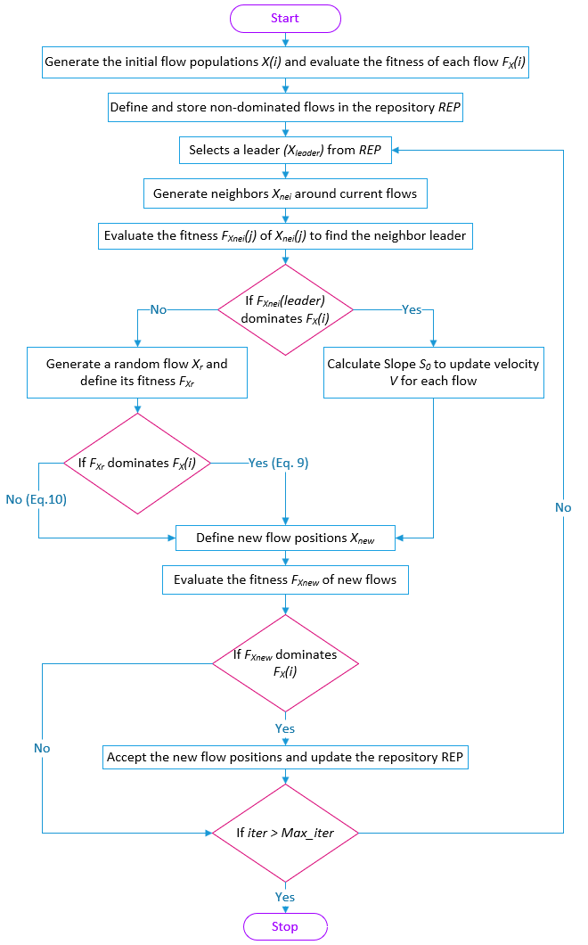
      - Leader Selection Method (Hybrid Strategy)
Selecting a leader is crucial in guiding the search toward promising regions of the solution space in MOO. The leader serves as a temporary reference point that influences the movement of other individuals. However, due to Pareto optimality, comparing solutions directly becomes non-trivial, as no single solution is strictly “better” than the others across all objectives. A variant of the MOFDA algorithm [35] proposed by Khodadadi et al., a classical roulette-wheel-based strategy was used to select a leader from the non-dominated individuals stored in the external archive. This method prioritized solutions located in sparsely populated hypercubes, with the probability of choosing solution $i$ given by:
$$P_{i}=\frac{c}{N_{i}}$$ | (11)
where $N_{i}$​ denotes the number of solutions in the $i^{th}$ hypercube, and $c$ is a constant greater than one. Although this mechanism encouraged exploration by favoring less crowded areas, it relied heavily on randomness, which could lead to unstable search behavior, especially in problems with complex $PF$.
- Pseudo-code of MOFDA
Input: Initialize the flow population $X\left(i\right)$ and evaluate the fitness of each flow $F_{X}\left(i\right)$
Define and store non-dominated flows in the repository $REP$
Generate hypercubes and define locations of flows in these hypercubes
Output: The set Pareto Front for optimal fitness ${PF}_{X}$ and its corresponding solutions $X_{PF}$
for ($iter$ < Max iterations)
Selects a leader from non-dominated flows by the hybrid strategy
Update the linear weight $W$ by Eq. (5)
Generate $β$ neighborhoods $X_{nei}\left(j\right)$ around each flow by Eqs. (3)-(5)
Evaluate neighbor flows $F_{X_{nei}}\left(j\right)$ to find the leader of the neighbour $X_{nei}^{leader}$ and $F_{X_{nei}}^{leader}$
if $F_{X_{nei}}^{leader}$ dominates $F_{X}\left(i\right)$
Calculate slope $S_{0}$ from $X\left(i\right)$ to the neighbour $X_{nei}^{leader}$ by Eq. (7)
Update velocity $V$ of each flow by Eq. (6)
Define new flows $X_{new}$ by Eq. (8)
else
Generate a random flow $X_{r}$ and their fitness $F_{X_{r}}$
if $F_{X_{r}}$ dominates $F_{X}\left(i\right)$
Define new flows $X_{new}$ by Eq. (9)
else
Define new flows $X_{new}$ by Eq. (9)
end if
end if
Evaluate the fitness of new flows $F_{X_{new}}$
if $F_{X_{new}}$ dominates $F_{X}\left(i\right)$
Accept the new flow positions and update the repository $REP$
end if
end for
Therefore, this study proposes a hybrid strategy combining grid positioning and local density awareness to improve leader selection stability and convergence behavior. Specifically, each candidate in the archive is evaluated using a scoring formula that balances exploration and exploitation:
$$s_{i}={GI}_{i}+\frac{ε_{i}}{1+{DE}_{i}}$$ | (12)
where: $GI_{i}$ refers to the hypercube index associated with the solution; $DE_{i}$ is computed based on the number of individuals sharing the same grid cell; and $ε_{i}∈[0,1]$ is a small random value to maintain diversity and reduce deterministic selection bias. The leader is then selected as the individual with the lowest score, ensuring preference toward solutions located in less crowded yet structurally promising regions of the search space.
This refined selection mechanism differs from earlier approaches by introducing a controlled randomness that avoids overexploitation while maintaining diversity. By reducing the risk of premature convergence and enhancing leader stability, the hybrid strategy contributes to more robust convergence and improved spread of the final Pareto front, particularly in high-dimensional and irregular optimization landscapes. Finally, the flowchart showing the detailed steps of the MOFDA process is presented in Fig. 1.
  - Experimental Setup
    - Unconstrained Multi-Objective Tests
- Unconstrained benchmarks.
No. | Problems | No. of objectives $(M)$ | No. of variables $\left(D\right)$ | Range | Ref.
 | ZDT1-3 | 2 | 30 | $x_{i}∈\left[0,1\right]$ | [17]
 | ZDT4 | 2 | 10 | $\begin{matrix}x_{1}∈\left[0,1\right]\end{matrix}$ & $x_{i}∈\left[-10,10\right]$, $i=2,…,n$ | [17]
 | ZDT6 | 2 | 30 | $x_{i}∈\left[0,1\right]$ | [17]
 | DTLZ1 | 3 | 7 | $x_{i}∈\left[0,1\right]$ | [18]
 | DTLZ2-6 | 3 | 12 | $x_{i}∈\left[0,1\right]$ | [18]
 | MMF1 | 2 | 2 | $\begin{matrix}x_{1}∈\left[1,3\right]\end{matrix}$ & $x_{2}∈\left[-1,1\right]$ | [36]
 | MMF2 | 2 | 2 | $\begin{matrix}x_{1}∈\left[0,1\right]\end{matrix}$&$\begin{matrix}x_{2}∈\left[0,2\right]\end{matrix}$ | [36]
 | MMF4 | 2 | 2 | $\begin{matrix}x_{1}∈\left[-1,1\right]\end{matrix}$&$\begin{matrix}x_{2}∈\left[0,2\right]\end{matrix}$ | [36]
 | MMF5 | 2 | 2 | $\begin{matrix}x_{1}∈\left[1,3\right]\end{matrix}$&$\begin{matrix}x_{2}∈\left[-1,3\right]\end{matrix}$ | [36]
 | MMF7 | 2 | 2 | $\begin{matrix}x_{1}∈\left[1,3\right]\end{matrix}$&$\begin{matrix}x_{2}∈\left[-1,1\right]\end{matrix}$ | [36]
 | MMF8 | 2 | 2 | $\begin{matrix}x_{1}∈\left[-3.1416,3.1416\right]\end{matrix}$&$\begin{matrix}x_{2}∈\left[0,9\right]\end{matrix}$ | [36]
 | MMF10,11 | 2 | 2 | $$\begin{matrix}x_{i}∈\left[0.1,1.1\right]\end{matrix}$$ | [36]
 | MMF12 | 2 | 2 | $$\begin{matrix}x_{i}∈\left[0,1\right]\end{matrix}$$ | [36]
 | MMF13 | 2 | 3 | $$\begin{matrix}x_{i}∈\left[0.1,1.1\right]\end{matrix}$$ | [36]
 | MMF14,15 | 3 | 3 | $\begin{matrix}x_{i}∈\left[0,1\right]\end{matrix}$ | [36]
 | UF1,2,4-7 | 2 | 30 | $\begin{matrix}x_{1}∈\left[0,1\right]\end{matrix}$ & $x_{i}∈\left[-2,2\right]$, $i=2,…,n$ | [37]
 | UF3 | 2 | 30 | $$\begin{matrix}x_{i}∈\left[0,1\right]\end{matrix}$$ | [37]
The performance of the MOFDA algorithm is first assessed across a range of 31 unconstrained MOO benchmarks, as follows: ZDT1-4, ZDT6, DTLZ1-6 collected from the test suite of Zitzler et al. [17] and Deb et al. [18]; then, MMF1,2,4,5,7,8,10-15 from CEC2020 [36] and UF1-UF7 from CEC09.
    - Constrained Engineering Problems
The subsequent challenge examination consists of eight real truss problems collected from Ref. [19] and three other constrained MOO problems, i.e., SRN, OSY, and Welded Beam problems, chosen from Refs. [3, 4].
      - Truss Problems
This study initially considers eight different MOO truss sizing optimization challenges, namely the 10-bar, 25-bar, 37-bar, 60-bar, 72-bar, 120-bar, 200-bar, and 942-bar trusses as outlined in Ref. [19]. For consistency, the tests on these truss problems utilize the same units as those employed in Ref. [19]. The objective functions for these problems are to minimize structural mass and compliance with constraints based on allowable stress, as below:
Minimize $F\left(f_{1}\left(x\right),f_{2}\left(x\right)\right)=\left\{\begin{matrix}f_{1}\left(x\right)=\sum_{j=1}^{N}{ρx_{j}L_{j}} \\ f_{2}\left(x\right)=u^{T}F\end{matrix}\right.$  Subjected to $σ_{max}-σ_{a}≤0$ | (13)
where $f_{1}$ is the objective function of the structural mass and $f_{2}$ is for compliance; $N$ stands for the number of bars in the truss, $ρ$, $x_{j}$ and $L_{j}$ is the density, cross-section, and length of the bar $j^{th}$, respectively; $σ_{max}$ is the maximum stress of the truss’s bars and $σ_{a}$ is the allowable stress. In addition, the results of the displacements, $u$, loading vectors, $F$, and stress are computed from finite element analysis.
a) 10-bar truss | b) 25-bar truss
c) 37-bar truss |  | d) 60-bar truss
        - Truss structures

In these problems, the cross-section variables $,x_{j},$ of each bar are key geometric parameter. They affects both the structural mass and the stress on each bar. The bar’s diameter is not directly considered, it can be derived from the cross-sectional area if needed. s
In addition, whole truss problems discussed in this section are consistently defined regarding material properties and allowable stress limits. The modulus of elasticity, density, and allowable stress are 200 GPa, 7850 kg/m³, and 400 MPa, respectively. In addition, this study considers the size of the truss’s bars as discrete variables. The truss structures for the 10-bar, 25-bar, 37-bar, 60-bar, 72-bar, 120-bar, 200-bar, and 942-bar trusses are illustrated in Fig. 2. The 10-bar, 37-bar, 60-bar, and 200-bar trusses are 2D (plane) trusses, while the 25-bar, 72-bar, 120-bar, and 942-bar trusses depicted in Fig. 2 are 3D (space) trusses.
e) 72-bar truss
f) 120-bar truss
g) 200-bar truss | h) 942-bar truss
Fig. 2. (continue)
Design variables are organized into groups for some tests, resulting in a potential mismatch between the number of design variables and truss members. The number of variables for the 10-bar, 25-bar, 37-bar, 60-bar, 72-bar, 120-bar, 200-bar, and 942-bar tests is represented by 10, 8, 15, 25, 16, 7, 29, and 59, respectively.
      - SRN Problem
The next constrained engineering challenge is a MOO test proposed by Srinivas and Deb [38] as follows:
Minimise${F\left(f_{1}\left(x\right),f_{2}\left(x\right)\right)=\left\{\begin{matrix}f_{1}\left(x\right)=2+{\left(x_{1}-2\right)}^{2}+{\left(x_{2}-1\right)}^{2} \\ f_{2}\left(x\right)=9x_{1}-{\left(x_{2}-x_{1}\right)}^{2}\end{matrix}\right.}$  Where $\left\{\begin{matrix}g_{1}\left(x\right)=x_{1}^{2}+x_{2}^{2}-255 \\ g_{2}\left(x\right)=x_{1}-3x_{2}+10\end{matrix}\right.$  And $\left\{\begin{matrix}\begin{matrix}-20≤x_{1}≤20 \\ -20≤x_{2}≤20\end{matrix}\end{matrix}\right.$  In which $\begin{matrix}\left\{\begin{matrix}q=6000×\left(14+\frac{x_{2}}{2}\right) \\ \begin{matrix}D=\sqrt{\frac{x_{2}^{2}}{4}+\frac{x_{1}+x_{3}^{2}}{4}} \\ J=2×\left(x_{1}+x_{2}\sqrt{2}×\left(\frac{x_{2}}{12}+\frac{{\left(x_{1}+x_{3}\right)}^{2}}{4}\right)\right) \\ \begin{matrix}α=\frac{6000}{\sqrt{2}×x_{1}×x_{2}} \\ β=Q×\frac{D}{J}\end{matrix} \end{matrix}\end{matrix}\right.\end{matrix}$ | (14)
      - Welded Beam
Another well-known MOO real engineering problem is the test of the Welded Beam suggested by Ray and Liew [39], see Fig. 3. The objectives in this matter are to reduce both the cost of manufacturing ($f_{1}$) and the deflections ($f_{2}$) of a welded beam. For this problem, four design variables are the weld thickness ($x_{1}$), the clamping bar length ($x_{2}$), the bar height ($x_{3}$), and the bar thickness ($x_{4}$).
Minimize: $F\left(f_{1}\left(x\right),f_{2}\left(x\right)\right){=\left\{\begin{matrix}f_{1}\left(x\right)=1.10471×x_{1}^{2}×x_{2}+0.04811×x_{3}×x_{4}×\left(14+x_{2}\right) \\ f_{2}\left(x\right)=\frac{65856000}{{30.10}^{6}×x_{4}×x_{3}^{3}}\end{matrix}\right.}$  Where: $\left\{\begin{matrix}g_{1}\left(x\right)=τ-13600 \\ g_{2}\left(x\right)=σ-30000 \\ \begin{matrix}g_{3}\left(x\right)=x_{1}-x_{4} \\ g_{4}\left(x\right)=6000-P\end{matrix}\end{matrix}\right.$  And: $\left\{\begin{matrix}\begin{matrix}0.125≤x_{1}≤5 \\ 0.1≤x_{2},x_{3}≤10\end{matrix} \\ \begin{matrix}0.125≤x_{4}≤5\end{matrix}\end{matrix}\right.$  In which: $\begin{matrix}\left\{\begin{matrix}q=6000×\left(14+\frac{x_{2}}{2}\right) \\ \begin{matrix}D=\sqrt{\frac{x_{2}^{2}}{4}+\frac{x_{1}+x_{3}^{2}}{4}} \\ J=2×\left(x_{1}+x_{2}\sqrt{2}×\left(\frac{x_{2}}{12}+\frac{{\left(x_{1}+x_{3}\right)}^{2}}{4}\right)\right) \\ \begin{matrix}α=\frac{6000}{\sqrt{2}×x_{1}×x_{2}} \\ β=Q×\frac{D}{J}\end{matrix} \end{matrix}\end{matrix}\right.\end{matrix}$ | (15)
        - Structure of welded beam [39].
      - OSY test
Osyczka and Kundu [40] proposed five distinct regions for the OSY test issue. There are also six constraints and six design variables to consider below:
Minimise $F\left(f_{1},f_{2}\right){=\left\{\begin{matrix}f_{1}\left(x\right)=\sum_{i=1}^{6}{x_{i}^{2}} \\ f_{2}\left(x\right)=25{\left(x_{1}-2\right)}^{2}+{\left(x_{2}-1\right)}^{2}+{\left(x_{3}-1\right)}^{2}{\left(x_{4}-4\right)}^{2}+{\left(x_{5}-1\right)}^{2}\end{matrix}\right.}$  Where$\left\{\begin{matrix}g_{1}\left(x\right)=2-x_{1}-x_{2} \\ g_{2}\left(x\right)=x_{1}+x_{2}-6 \\ \begin{matrix}g_{3}\left(x\right)=x_{2}-x_{1}-2 \\ g_{4}\left(x\right)=x_{1}-{3x}_{2}-2 \\ \begin{matrix}g_{5}\left(x\right)=x_{4}+{\left(x_{3}-3\right)}^{2}-4 \\ g_{6}\left(x\right)=4-x_{6}-{\left(x_{5}-3\right)}^{3}\end{matrix}\end{matrix}\end{matrix}\right.$  And$\left\{\begin{matrix}\begin{matrix}0≤x_{1}≤10 \\ 0≤x_{2}≤10 \\ 1≤x_{3}≤5\end{matrix} \\ \begin{matrix}0≤x_{4}≤6 \\ 1≤x_{5}≤5 \\ 0≤x_{6}≤10\end{matrix}\end{matrix}\right.$ | (16)
  - Evaluations and Discussions
To rigorously evaluate the effectiveness of the proposed MOFDA algorithm, this study conducts a comprehensive performance comparison across 41 distinct benchmark problems, utilizing three widely accepted performance indicators. These evaluations benchmark MOFDA against four prominent multi-objective optimization (MOO) algorithms: MOMVO, MSSA, MOMSA, and MOGNDO. The first comparator, MOMVO [7], is a well-established optimizer inspired by multiverse theory. MOMVO enhances convergence and solution diversity by simulating parallel universes, enabling robust exploration of complex landscapes. The second method, MSSA [12], mimics the collective foraging behavior of marine organisms. Through virtual "slaps" that steer agents in the decision space, MSSA facilitates adaptive navigation toward the Pareto front. MOMSA [3], the third method, is inspired by the aggressive hunting and cannibalistic strategies of praying mantises. It integrates these biologically inspired mechanisms into its exploration-exploitation balance. Lastly, MOGNDO [4] extends the GNDO framework by incorporating a two-phase search strategy—exploitation guided by probabilistic modeling around elite agents, and exploration through random trio-based perturbation.
All algorithms were evaluated under identical experimental conditions to ensure fair and reproducible comparison. Each was initialized with a population size of 100, and the external archive (repository) was capped at 200 solutions. An adaptive grid with a fixed resolution of 10 divisions was used across all methods to maintain diversity. Every algorithm was executed over 500 iterations, repeated for 30 independent runs to obtain statistically robust results.
As Derrac et al. [41] recommended, this study goes beyond reporting Mean and Standard Deviation values. It adopts five statistical keys (SKs) for a more complete performance portrait:
(1) Best – the most optimal result achieved across all runs.
(2) Worst – the least favorable result observed.
(3) Mean – the arithmetic average, reflecting the central tendency of outcomes.
(4) Standard Deviation (SD) – a measure of variability; lower SD implies greater consistency and reliability.
(5) Mode – the most frequently occurring value; highlights trial repeatability.
These statistical descriptors collectively provide a balanced evaluation, capturing not only the peak capabilities of each algorithm but also their reliability and robustness under uncertainty. Such a detailed analysis framework ensures that conclusions drawn about MOFDA’s performance are quantitatively grounded and statistically defensible.
    - Unconstrained MOO benchmarks
      - ZDT Tests
To assess the effectiveness of the proposed MOFDA algorithm, a comprehensive comparison is conducted against four established MOO methods, e.g., MOMVO, MSSA, MOMSA, and MOGNDO. The test suite includes five well-known benchmark problems from the ZDT family, namely ZDT1 to ZDT4 and ZDT6 (as outlined in Table 1), which encompass a range of Pareto front characteristics such as convexity, discontinuity, and multimodality. In addition, Table 2 presents the detailed statistical analysis across the five algorithms, focusing on three primary indicators: $IGD$, $GD$ and $STE$. MOFDA consistently outperforms the other methods across several benchmark problems. In ZDT1, MOFDA achieves the best scores in all three indicators. The Best values of $IGD$ (8.2155E–5), $GD$ (9.853E–5), and $STE$ (1.337E–3) are the lowest among all competitors, indicating excellent convergence and distribution. This trend is reinforced in ZDT2, where MOFDA again achieves the lowest Best values of $IGD$ (1.920E–4), $GD$ (1.584E–4), and $STE$ (2.090E–3), clearly surpassing MOMVO, MOMSA, MSSA, and MOGNDO in all metrics. The $PF$ plots in Fig. 4 further illustrate this observation, where MOFDA’s solutions closely align with the true $PF$ curve. $GD$boxplots in Fig. 5 confirm that MOFDA achieves not only low central tendency values but also reduced spread, suggesting robustness against stochastic variation across multiple runs.
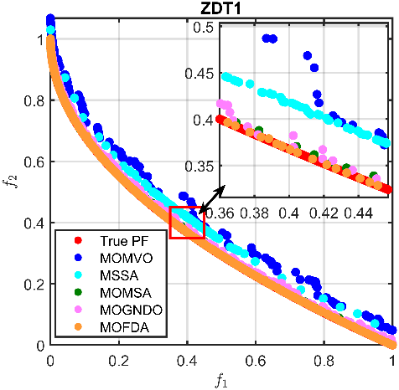 | 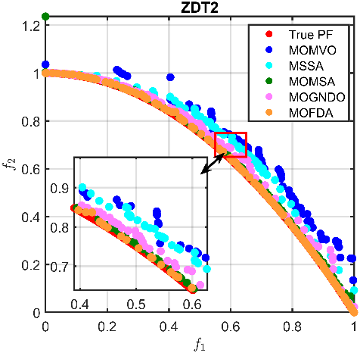 |  | 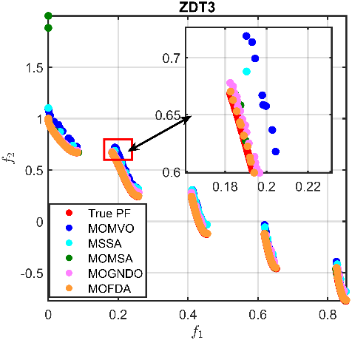
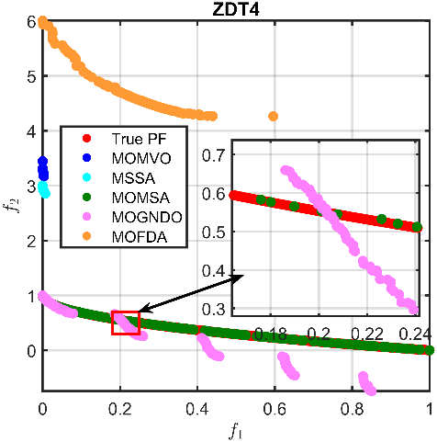 |  | 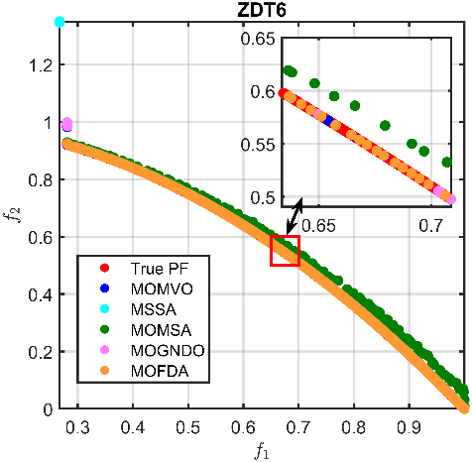
        - $PF$ Comparison Across ZDT Problems
For the more challenging ZDT3 problem, which features a fragmented $PF$, MOFDA continues to demonstrate superior convergence behavior. It obtains the lowest Best $IGD$ (1.229E–4) and $GD$ (1.011E–4), reflecting substantial precision in convergence and uniformity, even under fragmented front conditions. While the fragmented nature of the $PF$ in ZDT3 poses challenges for many algorithms, MOFDA remains resilient and maintains its ability to distribute solutions effectively across fragmented regions of the front, as depicted in Fig. 4.
However, for ZDT4 - a multi-modal problem - MOFDA demonstrates a relative decline in performance. MOMSA outperforms MOFDA, achieving the best scores in all three indicators. This outcome suggests that MOMSA's mechanisms are better suited for escaping local optima in highly rugged landscapes. Nevertheless, MOFDA remains competitive, with stable performance and no significant outliers. Finally, for ZDT6, MOFDA again outperforms the other methods across most indicators. It records the lowest Best $GD$ (6.7275E–5), Mean $IGD$ (1.611E–4), and Mode $STE$ (1.528E–3). These results highlight MOFDA’s flexibility in dealing with disconnected and non-uniform $PF$.
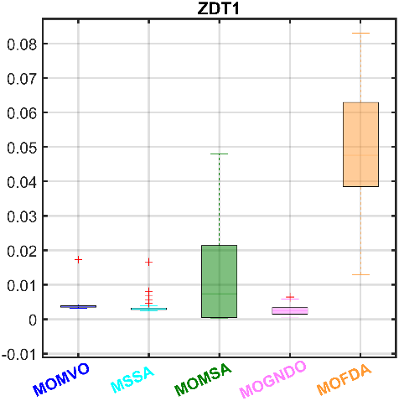 | 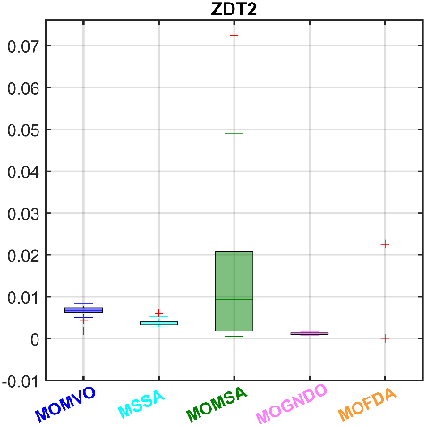 |  | 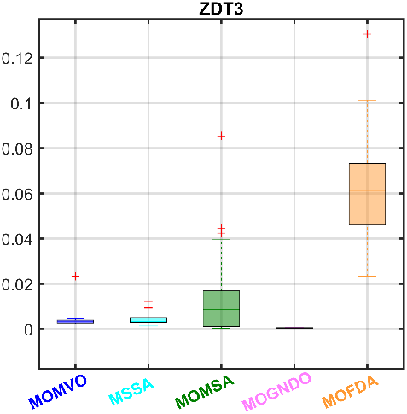
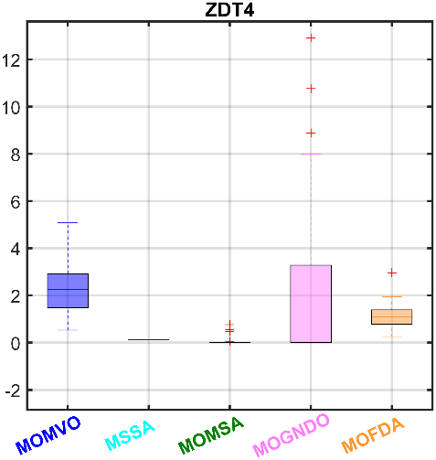 |  | 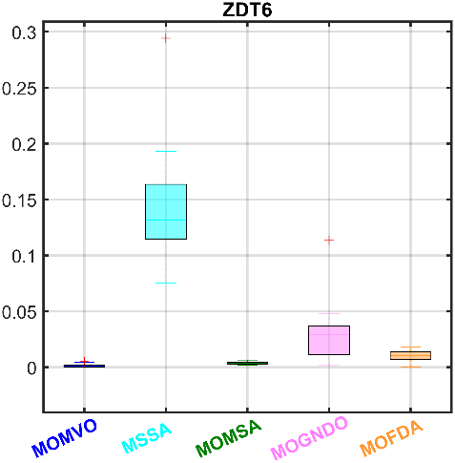
        - $GD$ Boxplot of ZDT Problems
      - DTLZ Tests
The DTLZ suite offers complex and diverse problems for evaluating multi-objective optimizers, especially in tri-objective scenarios. As reported in Table 3 and illustrated in Figs. 6 and 7, the MOFDA algorithm consistently delivers strong and often superior performance across these benchmarks.
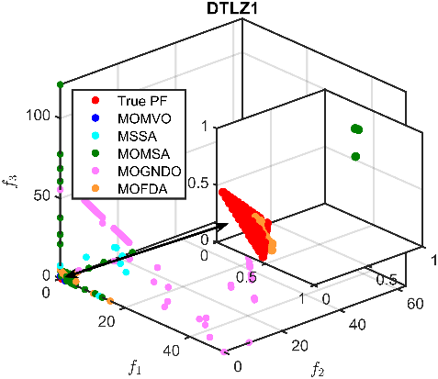 | 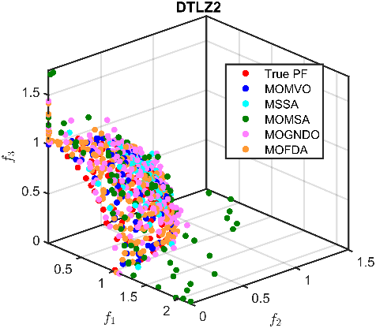 | 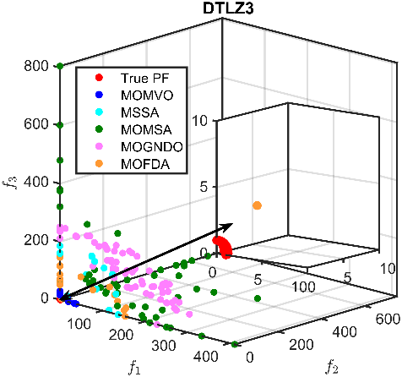
        - $PF$ Comparison Across DLTS Problems.

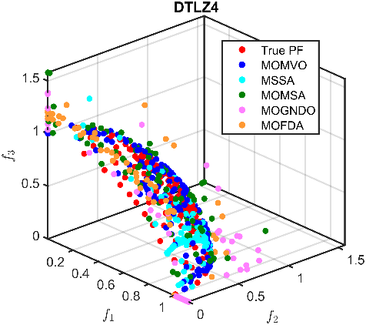 | 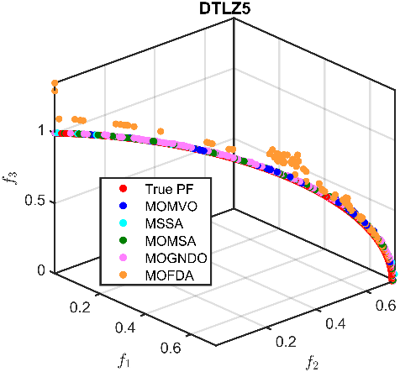 | 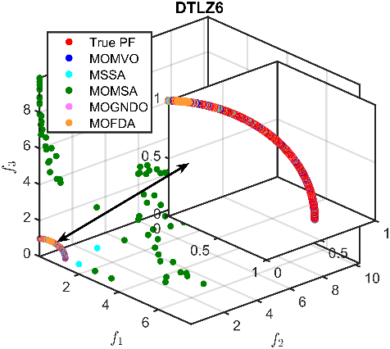
Fig. 6. (continued)
One of the most notable observations is that MOFDA achieves the Best $IGD$ values in 4 out of 6 test problems (DTLZ1, DTLZ2, DTLZ3, and DTLZ6), demonstrating not only its convergence capability but also its robustness across problems with different $PF$ characteristics. These results are visually corroborated in Fig. 6, where MOFDA’s solutions most closely align with the true $PF$, and in Fig. 7, where the boxplots show MOFDA’s distributions to be tightly clustered and favorably positioned.
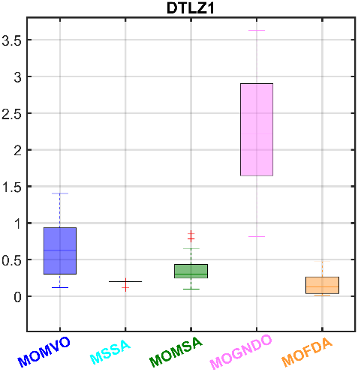 | 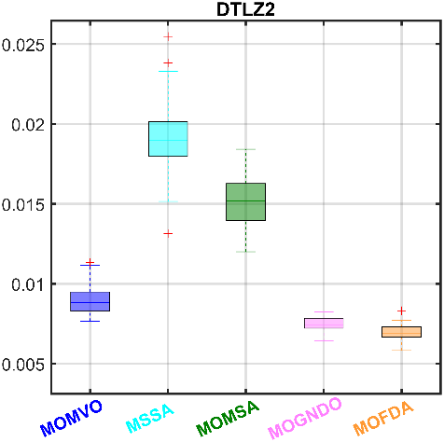 | 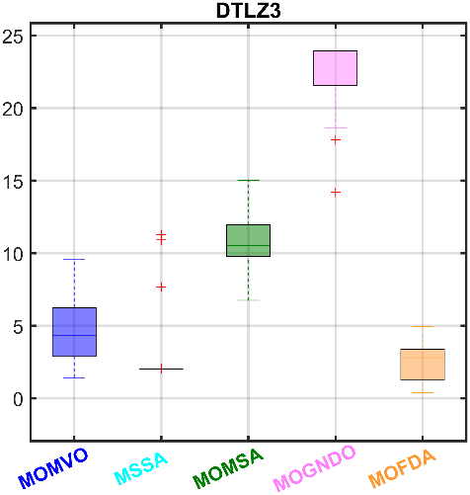
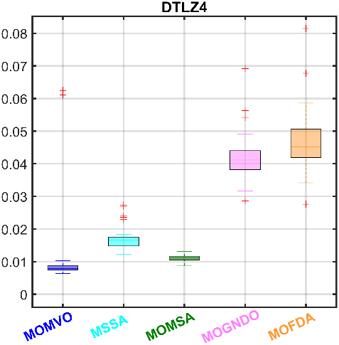 | 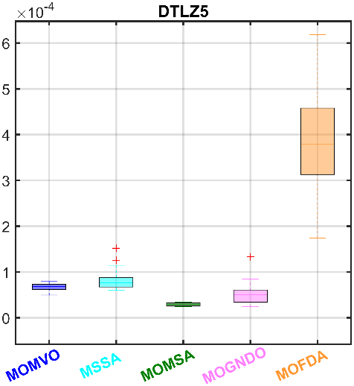 | 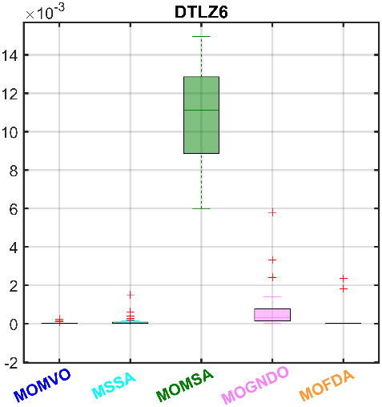
        - $IGD$ Boxplots of DTLZ benchmarks.
Additionally, even in cases where MOFDA is not the absolute best in $GD$, the differences are slight, suggesting that it still provides solutions that are very close to the true $PF$. The Mean and Mode values highlight MOFDA’s strength by consistently producing high-quality results in multiple runs. Its low $SD$ values across tests indicate reliable and stable behavior, even in challenging, multi-modal DTLZ problems. These outcomes affirm MOFDA’s ability to effectively handle complex MOO problems, offering a robust balance between convergence, accuracy, and diversity.
      - UF Tests
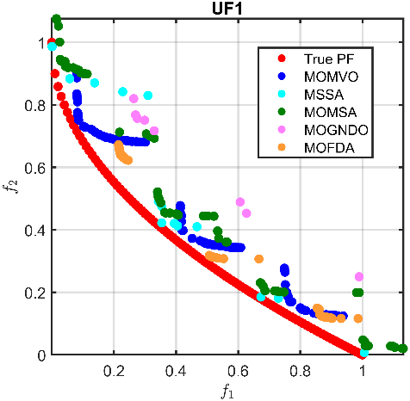 | 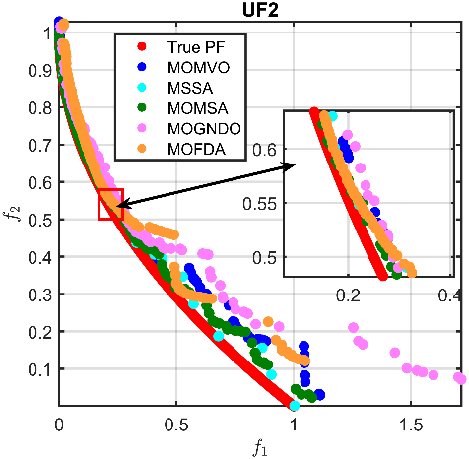 | 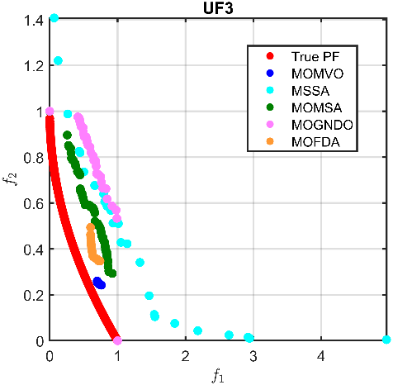
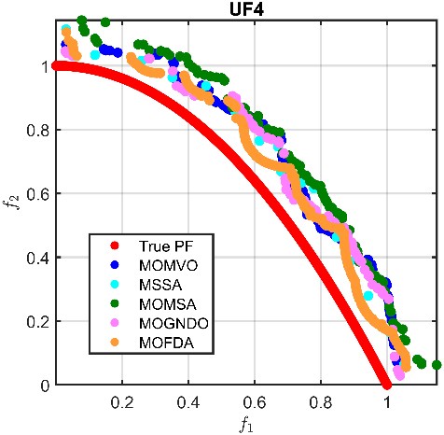 | 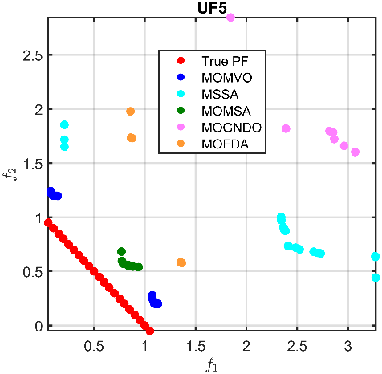 | 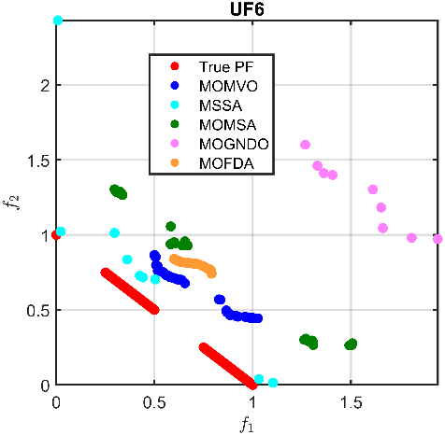
        - $PF$ Comparison Across UF Problems.
To further examine the robustness and adaptability of the proposed MOFDA algorithm, a comprehensive evaluation was conducted on the UF benchmark set from CEC-2009, comprising seven diverse test problems (UF1 to UF7). These problems are well known for presenting challenges such as multimodality, deception, non-separability, and variable $PF$ geometries, thereby providing a rigorous testing ground for MOO. |  | 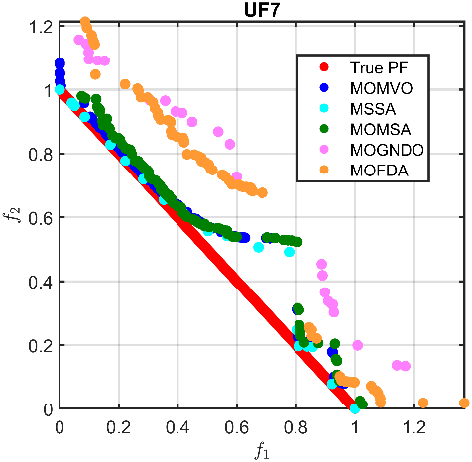  Fig. 8. (continued)
For instance, in UF1, although MOFDA shows reasonable performance, it does not lead in any of the three key metrics ($IGD$, $GD$, $STE$). Similarly, on UF2, UF3, and UF5-7, algorithms like MOMVO or MSSA often show slightly better convergence or spread characteristics. The only exception is UF4, where MOFDA demonstrates a leading position. It achieves the lowest Best $IGD$ (2.256E–3), $GD$ (5.589E–3), and the lowest Worst $STE$ (4.075E–3), suggesting superior convergence and solution diversity. This advantage is also reflected visually in Fig. 8, where MOFDA's Pareto front is well aligned with the true front, and in Fig. 9, where the boxplots reveal more stable performance with lower variance.
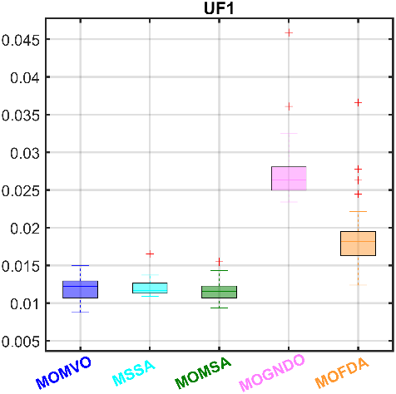 | 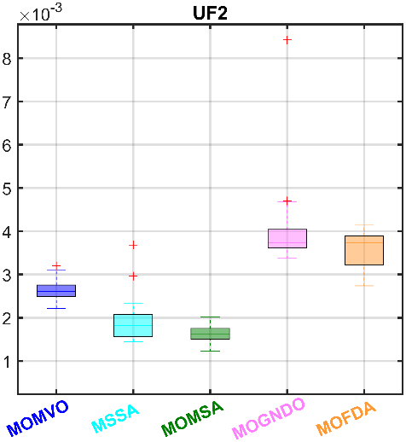 | 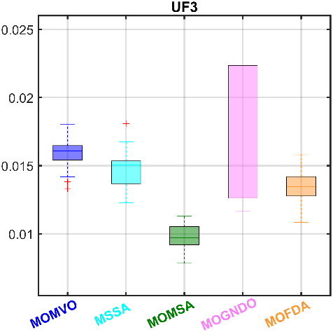
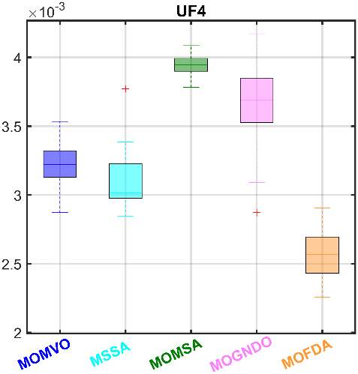 | 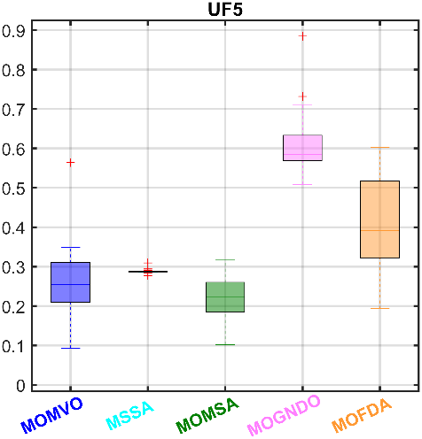 | 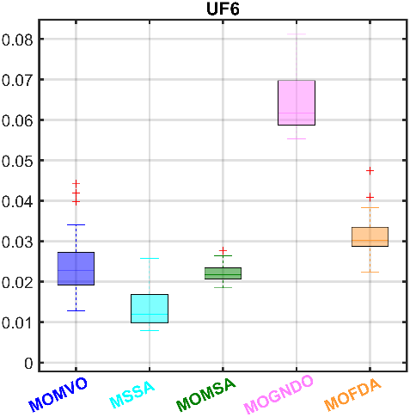
        - $IGD$ Boxplots of UF benchmarks.
The overall comparison is presented in Table 4, while Figs. 8 and 9, it is clear that MOFDA performs competitively but not dominantly across the UF suite. In most cases, it achieves results that are either close to or on par with the leading methods, rather than surpassing them outright. It demonstrates its robustness, though not necessarily superiority, across the board. |  | 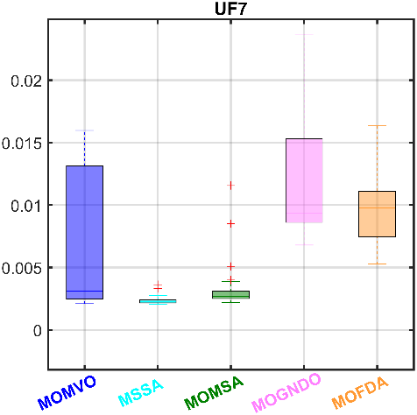  Fig. 9. (continued)
      - MMF Tests
The fourth evaluation in this research focuses on the MMF benchmark suite from the CEC-2020 competition, which is specifically designed to challenge algorithms with multi-modal Pareto sets, deceptive search landscapes, and complex constraint structures. The complete statistical results across 12 MMF tests are summarized in Table 5, while Figs. 10 and 11 offer visual insights into $PF$ quality and distribution spread.
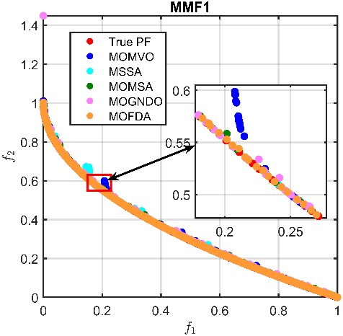 | 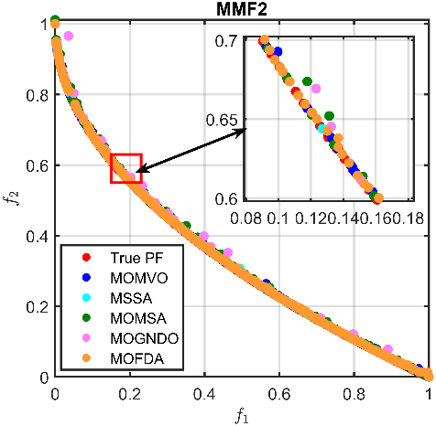 | 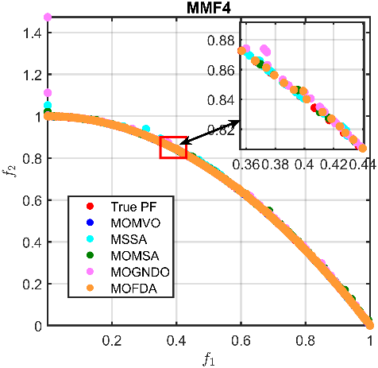
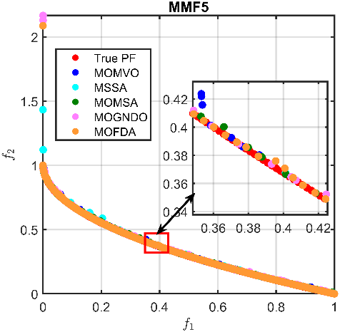 | 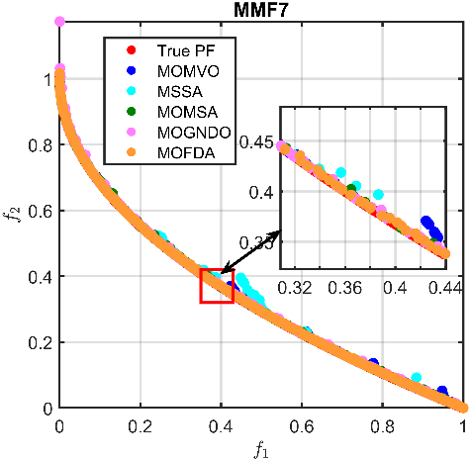 | 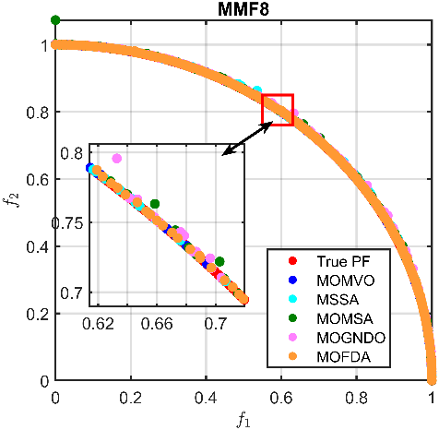
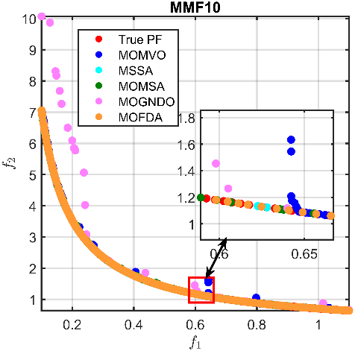 | 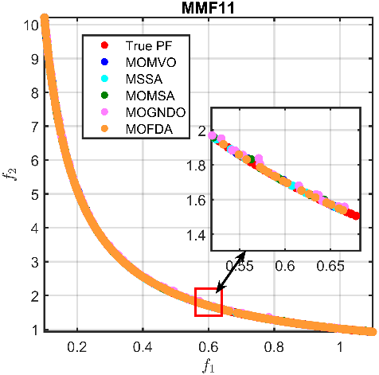 | 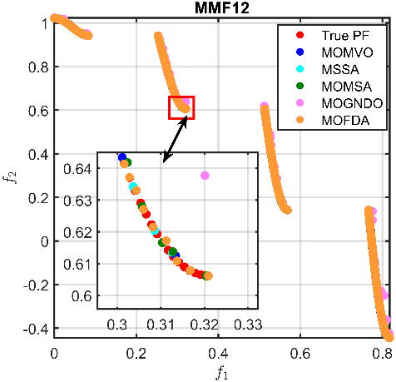
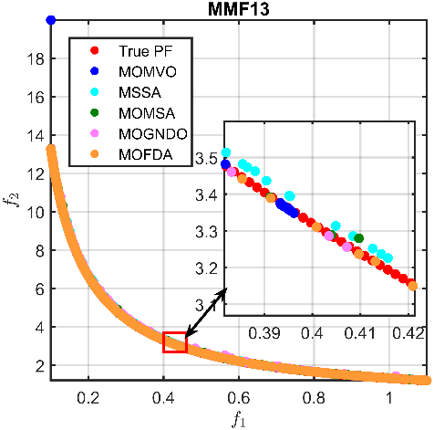 | 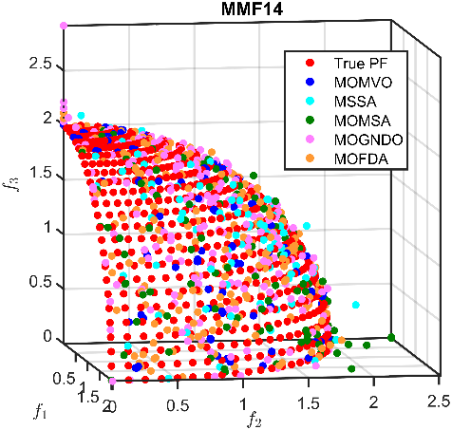 | 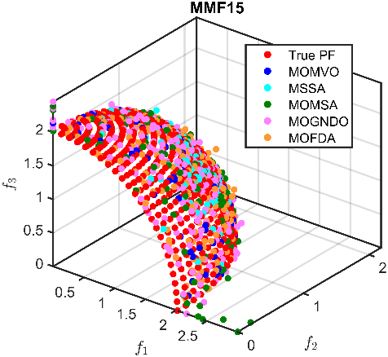
        - $PF$ Comparison Across MMF Benchmarks.
A standout finding from this evaluation is the clear dominance of the proposed MOFDA algorithm. It is evidenced by its 100% Best $IGD$ across all MMF problems (highlighted in bold in Table 5), underscoring its superior convergence to the true $PF$. Such consistency across a wide range of MMF instances - both 2D and 3D - highlights the algorithm's robustness in tackling deceptive and multi-modal problems.
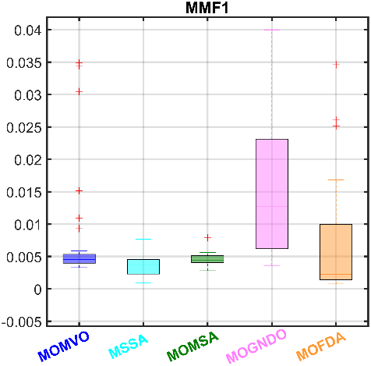 | 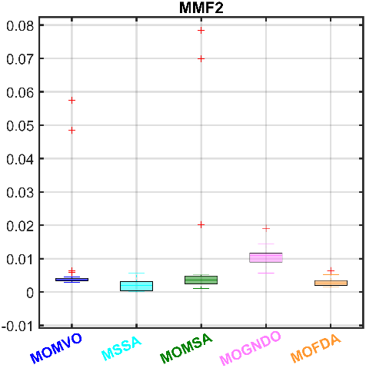 | 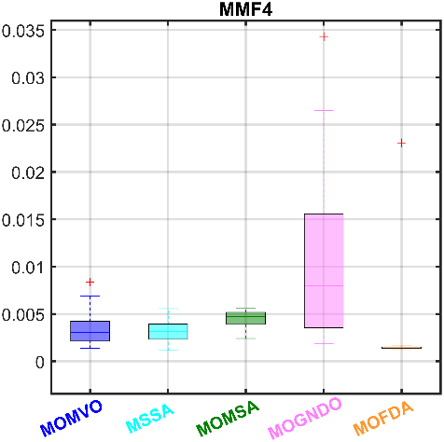
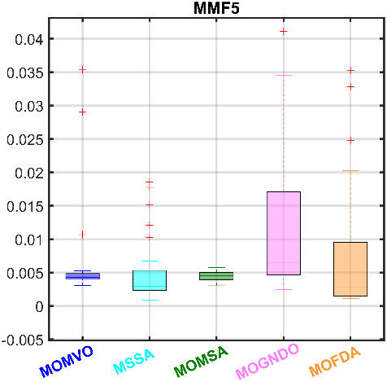 | 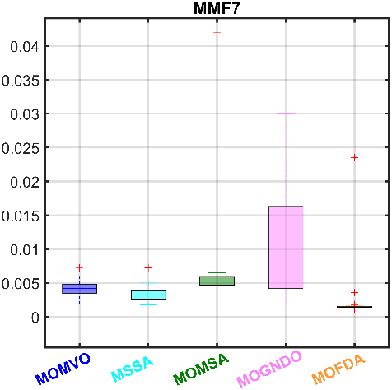 | 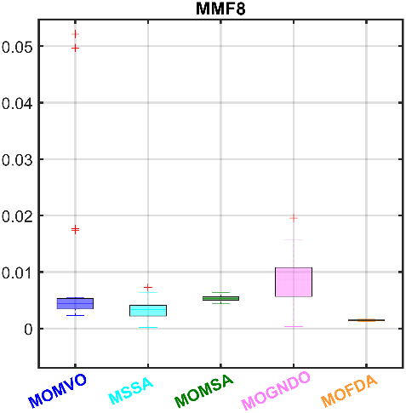
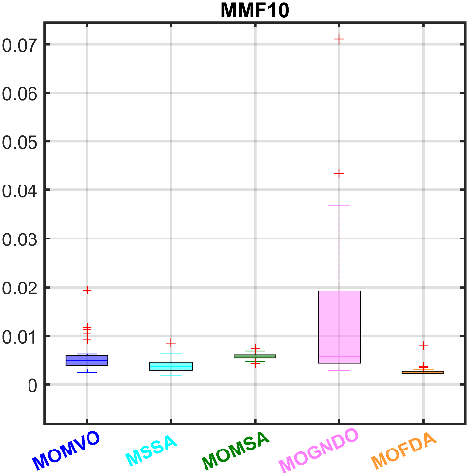 | 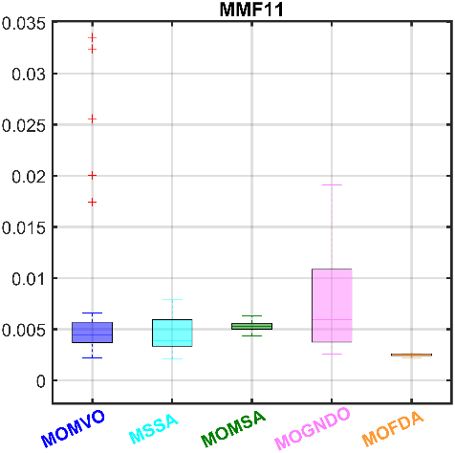 | 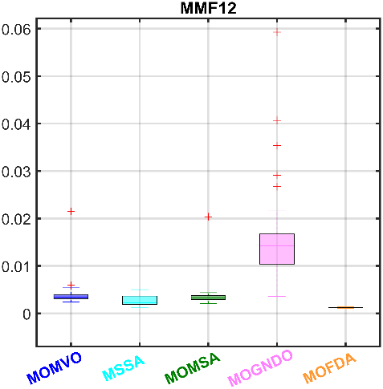
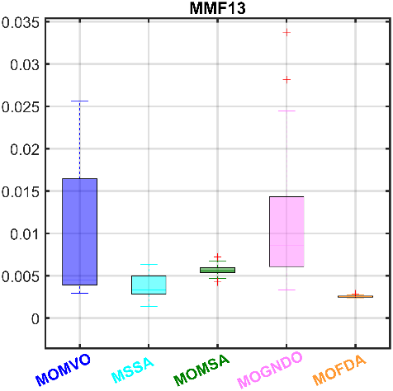 | 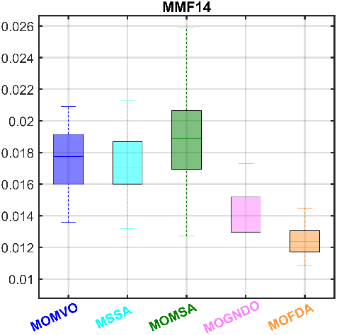 | 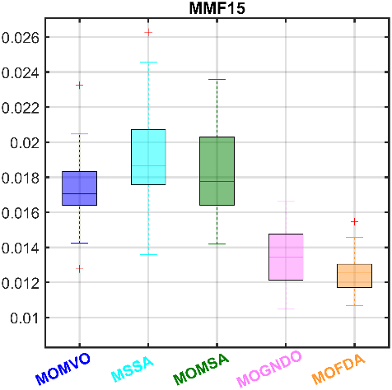
        - $STE$ Boxplots of MMF benchmarks.
Beyond $IGD$, MOFDA also achieves leading results in $GD$ and $STE$ on the majority of problems, reflecting not only its precision in approaching the true $PF$ but also its ability to maintain a well-distributed set of non-dominated solutions. These aspects are crucial for solving practical MOO problems, where closeness and diversity are necessary for decision-making. Fig. 10 further supports this conclusion through graphical alignment: the $PF$ produced by MOFDA consistently align very closely with the true $PF$, confirming both convergence and coverage. Fig. 11 provides additional insight, showing that MOFDA’s $STE$ values are generally the lowest and most stable across all test problems. This reflects superior solution spread and spacing uniformity, key factors in reliable decision-space representation.
    - Evaluation of Constraint Handling in Engineering Optimization
This section focuses on a range of constrained engineering design problems, including the SRN, OSY, Welded Beam, and eight truss optimization problems (i.e., truss of 10, 25, 37, 60, 72, 120, 200, and 942 bars). Managing constraints is essential to ensure that solutions are optimal, feasible, and applicable to real-world designs. Various penalty methods, such as annealing, dynamic, static, co-evolutionary, adaptive, and the death penalty, can be utilized for this purpose [42]. This study adopts a penalty-based approach, specifically the death penalty method. Under this strategy, any solution violating constraints is considered infeasible and assigned a poor fitness value. It ensures that infeasible solutions are excluded from the optimization process without requiring algorithm-specific adjustments. Formally, the constraint violation for a candidate solution $X$ is calculated as follows [43]:
$$P\left(X\right){=\sum_{j=1}^{m}{\max\left(0,g_{j}\left(X\right)\right)}+\sum_{k=1}^{n}{h_{n}\left(X\right)}}$$ | (26)
where $g_{j}\left(X\right)≤0$ are inequality constraints and $h_{n}\left(X\right)=0$ are equality constraints. If $P\left(X\right)>0$, the solution is penalized and discarded from selection. This method is computationally simple, broadly compatible, and requires no tuning of penalty parameters. The fitness is then defined as:
$$G\left(f\left(X\right),P\left(X\right)\right){=F\left(f\left(X\right)\right)+α∙P\left(X\right)}$$ | (26)
where $F\left(f\left(X\right)\right)$ is the original objective function, and $α$ is a penalty coefficient.
The performance evaluation is presented through $PF$ (Fig. 12), $GD$ boxplots (Fig. 13), and indicator summaries (Table 6). The results show that MOFDA consistently produces non-dominated solutions closely aligned with the true $PF$, demonstrating superior convergence and diversity. For example, in small-scale problems such as the 10-bar and 25-bar trusses, MOFDA achieves the lowest Best $IGD$ (e.g., 1.971E+1 for the 10-bar) and $GD$ (8.488E+0), indicating a strong convergence to the true $PF$. Additionally, it maintains excellent diversity, as seen from the compact spread ($STE$ = 2.215E–3). In addition, for medium-scale designs, such as the 60-bar and 72-bar truss problems, MOFDA remains highly competitive. For instance, in the 72-bar case, it achieves the smallest Best $IGD$ = 3.620E+1 and Best $STE$ = 1.506E–3, highlighting its ability to manage increased variable dimensionality and constraint density without significant loss of accuracy or diversity.
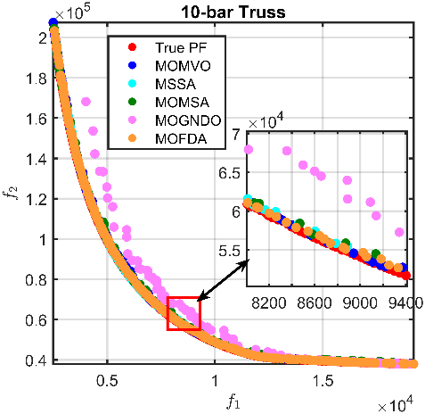 | 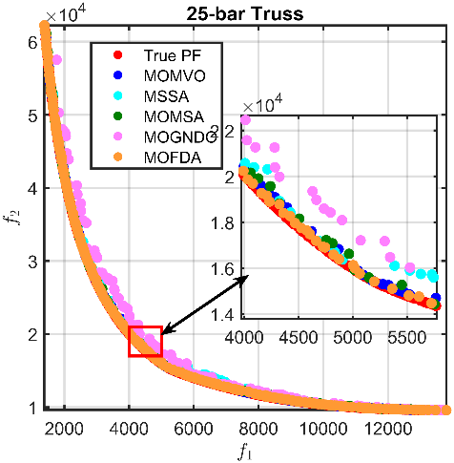 | 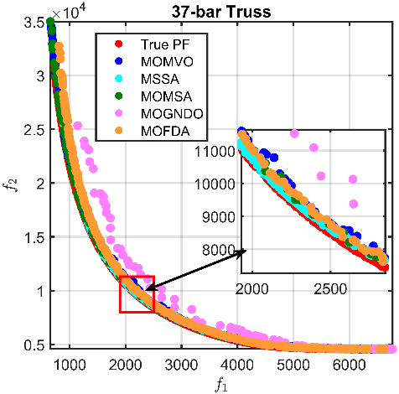
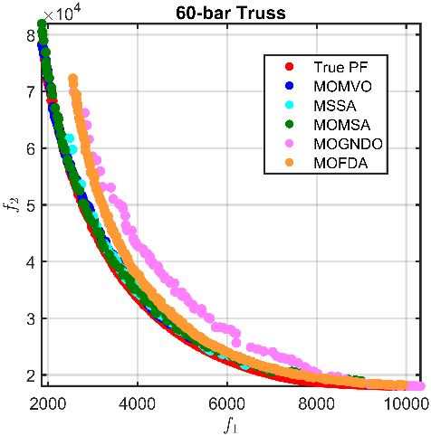 | 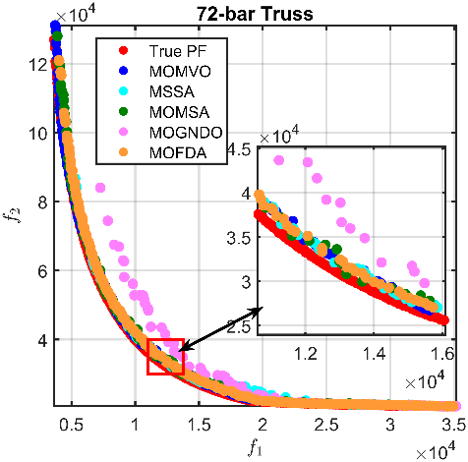 | 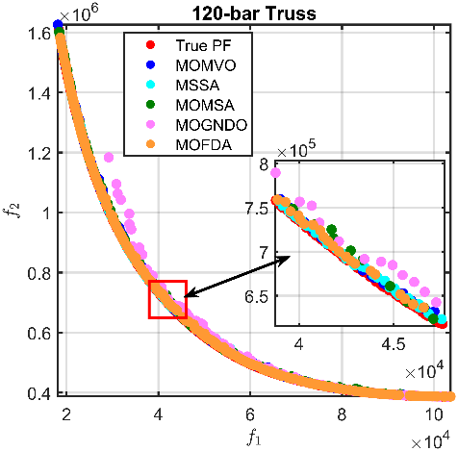
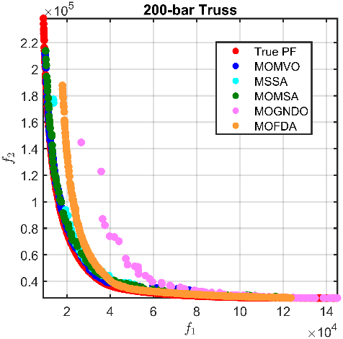 | 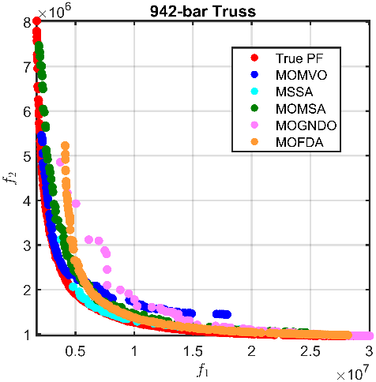 | 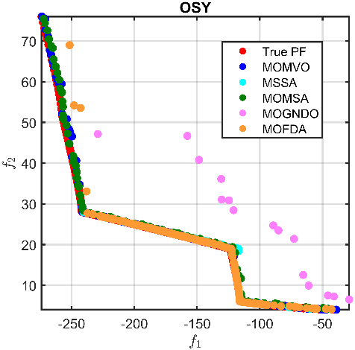
- $PF$ Comparison Across Engineering Problems. | 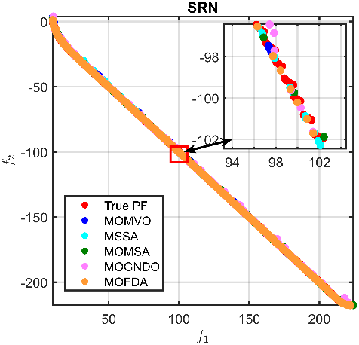 | 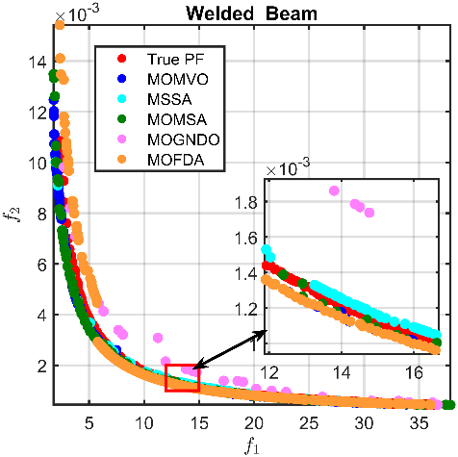
When applied to large-scale truss problems, particularly the 200-bar and 942-bar cases, MOFDA still demonstrates remarkable scalability. Particularly, in the 942-bar problem, it still obtains the Best $IGD$ (5.306E+4), $GD$ (2.629E+4), and $STE$ (1.820E–3). Besides, the proposed MOFDA also delivers excellent results on classical constrained problems. In the Welded Beam problem, it surpasses all others with $IGD$ = 4.665E–3, $GD$ = 2.724E–3, and $STE$ = 1.738E–3. In the SRN problem, although the $IGD$ is on par with other methods, MOFDA achieves the lowest $STE$ = 1.164E–3, confirming its ability to maintain a diverse and high-quality front even under nonlinear equality constraints.
In addition to outperforming others on average, MOFDA also demonstrates greater stability across multiple independent runs. As illustrated in the $GD$ boxplots (Fig. 13), MOFDA’s solutions tend to cluster tightly around low median values, indicating less variance and greater robustness to stochastic variation—an essential trait for real-world application in engineering design.
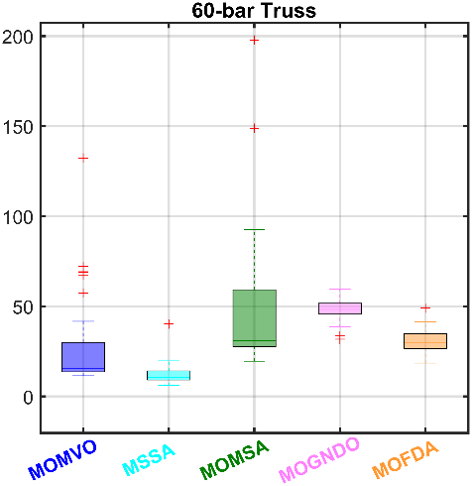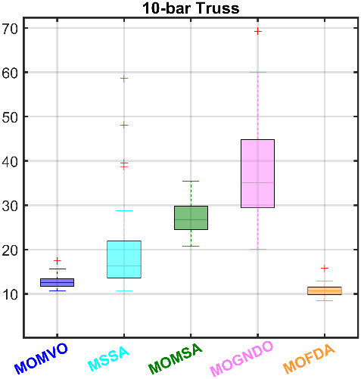 | 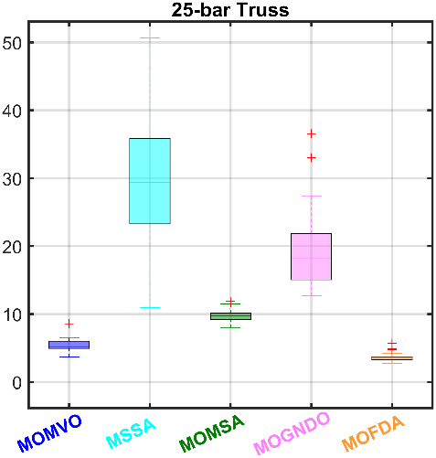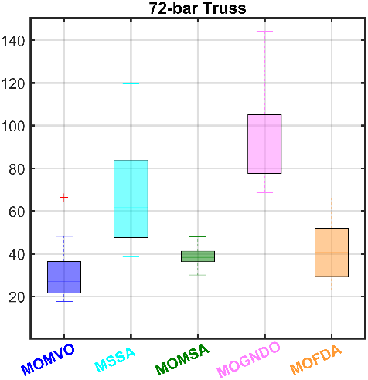 | 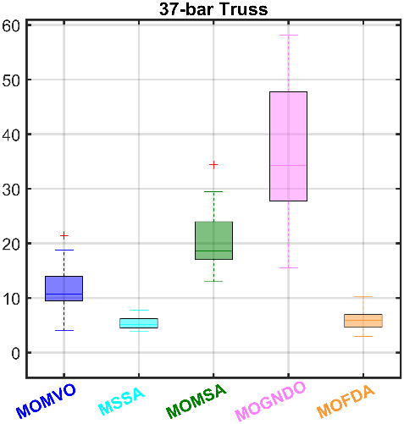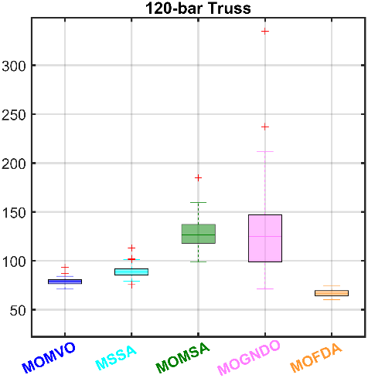
        - $GD$ Boxplots of Engineering Problems.
In summary, the results confirm that MOFDA is competitive and remarkably reliable, scalable, and diverse in its solution quality. It consistently delivers feasible, high-performing Pareto-optimal solutions across a wide range of constrained multi-objective problems, outperforming several state-of-the-art alternatives in accuracy and stability.

- Indicator-Based comparison for ZDT problems.
Tests | SKs | $IGD$ |  |  |  |  | $GD$ |  |  |  |  | $STE$
 |  | MOMVO | MSSA | MOMSA | MOGNDO | MOFDA | MOMVO | MSSA | MOMSA | MOGNDO | MOFDA | MOMVO | MSSA | MOMSA | MOGNDO | MOFDA
ZDT1 | (1) | 1.527E-3 | 1.315E-3 | 2.041E-4 | 2.941E-4 | 8.215E-5 | 3.173E-3 | 2.394E-3 | 3.464E-4 | 5.937E-4 | 9.853E-5 | 2.732E-3 | 2.262E-3 | 2.138E-3 | 2.254E-3 | 1.337E-3
 | (2) | 1.907E-3 | 6.286E-3 | 2.916E-4 | 1.563E-3 | 2.164E-2 | 1.729E-2 | 1.663E-2 | 4.805E-2 | 6.496E-3 | 1.707E-2 | 4.392E-2 | 4.934E-3 | 3.293E-2 | 1.016E-2 | 2.888E-3
 | (3) | 1.730E-3 | 1.854E-3 | 2.449E-4 | 7.622E-4 | 4.491E-3 | 4.167E-3 | 3.857E-3 | 1.310E-2 | 2.791E-3 | 6.711E-3 | 4.524E-3 | 3.575E-3 | 8.380E-3 | 4.919E-3 | 1.696E-3
 | (4) | 1.100E-4 | 1.033E-3 | 2.443E-5 | 3.612E-4 | 4.373E-3 | 2.496E-3 | 2.731E-3 | 1.474E-2 | 1.767E-3 | 4.753E-3 | 7.449E-3 | 6.916E-4 | 9.195E-3 | 1.755E-3 | 3.021E-4
 | (5) | 1.527E-3 | 1.315E-3 | 2.041E-4 | 2.941E-4 | 8.215E-5 | 3.173E-3 | 2.394E-3 | 3.464E-4 | 5.937E-4 | 9.853E-5 | 2.732E-3 | 2.262E-3 | 2.138E-3 | 2.254E-3 | 1.337E-3
ZDT2 | (1) | 2.163E-3 | 1.319E-3 | 2.333E-4 | 6.147E-4 | 1.920E-4 | 1.815E-3 | 2.805E-3 | 5.242E-4 | 7.914E-4 | 1.584E-4 | 3.039E-3 | 2.561E-3 | 1.926E-3 | 4.849E-3 | 2.090E-3
 | (2) | 2.317E-2 | 3.074E-3 | 3.515E-4 | 1.088E-3 | 7.853E-3 | 8.395E-3 | 6.081E-3 | 7.252E-2 | 1.674E-3 | 1.885E-2 | 3.463E-1 | 7.598E-3 | 4.749E-2 | 8.423E-3 | 1.601E-2
 | (3) | 4.187E-3 | 1.722E-3 | 2.916E-4 | 8.162E-4 | 3.245E-3 | 6.659E-3 | 3.771E-3 | 1.515E-2 | 1.186E-3 | 7.972E-3 | 2.402E-2 | 4.061E-3 | 8.823E-3 | 6.899E-3 | 3.906E-3
 | (4) | 5.257E-3 | 4.010E-4 | 3.250E-5 | 1.220E-4 | 3.016E-3 | 1.240E-3 | 6.923E-4 | 1.717E-2 | 2.241E-4 | 7.402E-3 | 7.003E-2 | 1.255E-3 | 1.099E-2 | 8.998E-4 | 2.486E-3
 | (5) | 2.163E-3 | 1.319E-3 | 2.333E-4 | 6.147E-4 | 1.920E-4 | 1.815E-3 | 2.805E-3 | 5.242E-4 | 7.914E-4 | 1.584E-4 | 3.039E-3 | 2.561E-3 | 1.926E-3 | 4.849E-3 | 2.090E-3
ZDT3 | (1) | 1.368E-3 | 1.730E-3 | 2.085E-4 | 4.854E-4 | 1.229E-4 | 2.226E-3 | 1.332E-3 | 2.991E-4 | 3.151E-4 | 1.011E-4 | 2.363E-3 | 1.132E-3 | 1.603E-3 | 2.953E-3 | 1.166E-3
 | (2) | 2.707E-3 | 8.784E-3 | 3.270E-4 | 1.050E-3 | 9.064E-3 | 2.339E-2 | 2.318E-2 | 8.543E-2 | 6.897E-4 | 1.014E-2 | 4.392E-2 | 4.938E-3 | 3.891E-2 | 5.219E-3 | 1.005E-2
 | (3) | 2.102E-3 | 3.101E-3 | 2.637E-4 | 7.067E-4 | 2.810E-3 | 3.922E-3 | 4.946E-3 | 1.458E-2 | 4.998E-4 | 2.591E-3 | 4.570E-3 | 2.561E-3 | 7.009E-3 | 3.838E-3 | 2.919E-3
 | (4) | 3.067E-4 | 1.596E-3 | 2.721E-5 | 1.404E-4 | 2.843E-3 | 3.736E-3 | 4.221E-3 | 1.891E-2 | 9.849E-5 | 2.955E-3 | 7.448E-3 | 1.011E-3 | 8.871E-3 | 6.075E-4 | 1.844E-3
 | (5) | 1.368E-3 | 1.730E-3 | 2.085E-4 | 4.854E-4 | 1.229E-4 | 2.226E-3 | 1.332E-3 | 2.991E-4 | 3.151E-4 | 1.011E-4 | 2.363E-3 | 1.132E-3 | 1.603E-3 | 2.953E-3 | 1.166E-3
ZDT4 | (1) | 9.182E-2 | 8.206E-2 | 1.798E-4 | 2.753E-2 | 1.247E-1 | 5.316E-1 | 1.347E-1 | 9.679E-5 | 4.808E-4 | 2.573E-1 | 2.050E-2 | 1.995E-3 | 1.595E-4 | 1.754E-2 | 2.095E-3
 | (2) | 9.044E-1 | 8.316E-2 | 2.792E-4 | 8.957E-1 | 8.109E-1 | 5.075E+0 | 1.373E-1 | 7.642E-1 | 1.825E+1 | 2.963E+0 | 1.118E-1 | 5.970E-3 | 7.203E-2 | 1.491E+10 | 7.783E-2
 | (3) | 3.316E-1 | 8.237E-2 | 2.177E-4 | 2.903E-1 | 3.633E-1 | 2.273E+0 | 1.359E-1 | 6.135E-2 | 6.295E+0 | 1.127E+0 | 5.096E-2 | 3.491E-3 | 8.190E-3 | 7.441E+8 | 1.562E-2
 | (4) | 1.811E-1 | 3.113E-4 | 2.366E-5 | 2.774E-1 | 1.623E-1 | 1.136E+0 | 6.082E-4 | 1.853E-1 | 6.072E+0 | 5.868E-1 | 2.439E-2 | 9.180E-4 | 1.721E-2 | 2.887E+9 | 1.698E-2
 | (5) | 9.182E-2 | 8.206E-2 | 1.798E-4 | 2.753E-2 | 1.247E-1 | 5.316E-1 | 1.347E-1 | 9.679E-5 | 4.808E-4 | 2.573E-1 | 2.050E-2 | 1.995E-3 | 1.595E-4 | 1.754E-2 | 2.095E-3
ZDT6 | (1) | 5.438E-4 | 2.994E-2 | 5.426E-4 | 9.594E-4 | 6.727E-5 | 3.961E-5 | 7.554E-2 | 1.768E-3 | 1.456E-3 | 2.349E-5 | 5.964E-3 | 9.186E-4 | 3.369E-3 | 6.095E-3 | 1.528E-3
 | (2) | 3.850E-3 | 7.286E-2 | 1.968E-3 | 1.631E-2 | 8.759E-5 | 5.014E-3 | 2.943E-1 | 6.465E-3 | 1.134E-1 | 5.490E-4 | 3.475E-2 | 4.673E-1 | 5.674E-3 | 9.734E-2 | 3.510E-3
 | (3) | 1.186E-3 | 3.495E-2 | 1.099E-3 | 7.559E-3 | 7.374E-5 | 1.341E-3 | 1.414E-1 | 3.680E-3 | 2.748E-2 | 1.611E-4 | 1.667E-2 | 1.258E-1 | 4.503E-3 | 2.551E-2 | 1.961E-3
 | (4) | 7.298E-4 | 1.116E-2 | 3.390E-4 | 3.902E-3 | 4.117E-6 | 1.414E-3 | 4.135E-2 | 1.136E-3 | 2.209E-2 | 2.039E-4 | 7.140E-3 | 1.095E-1 | 6.366E-4 | 1.965E-2 | 6.255E-4
 | (5) | 5.438E-4 | 2.999E-2 | 5.426E-4 | 9.594E-4 | 6.727E-5 | 3.961E-5 | 7.554E-2 | 1.768E-3 | 1.456E-3 | 2.349E-5 | 5.964E-3 | 9.186E-4 | 3.369E-3 | 6.095E-3 | 1.528E-3

- Indicator-Based comparison for DTLZ problems.
Tests | SKs | $IGD$ |  |  |  |  | $GD$ |  |  |  |  | $STE$
 |  | MOMVO | MSSA | MOMSA | MOGNDO | MOFDA | MOMVO | MSSA | MOMSA | MOGNDO | MOFDA | MOMVO | MSSA | MOMSA | MOGNDO | MOFDA
DTLZ1 | (1) | 1.189E-1 | 1.150E-1 | 9.876E-2 | 8.164E-1 | 1.743E-2 | 2.928E-1 | 8.869E-1 | 1.941E-1 | 3.281E+0 | 1.748E-1 | 3.217E-3 | 1.992E-6 | 3.389E-3 | 1.612E-2 | 8.316E-4
 | (2) | 1.403E+0 | 2.013E-1 | 8.513E-1 | 3.626E+0 | 4.720E-1 | 4.084E+0 | 2.506E+0 | 1.165E+1 | 8.084E+0 | 4.215E+0 | 1.632E-1 | 1.391E-2 | 3.908E-2 | 5.346E-2 | 8.072E-2
 | (3) | 6.444E-1 | 1.818E-1 | 3.581E-1 | 2.240E+0 | 1.712E-1 | 2.135E+0 | 1.247E+0 | 7.037E+0 | 4.735E+0 | 1.901E+0 | 4.936E-2 | 1.057E-3 | 1.575E-2 | 2.690E-2 | 4.383E-2
 | (4) | 3.749E-1 | 3.396E-2 | 1.887E-1 | 7.394E-1 | 1.412E-1 | 1.129E+0 | 3.605E-1 | 2.888E+0 | 1.419E+0 | 1.064E+0 | 3.669E-2 | 2.739E-3 | 9.323E-3 | 9.048E-3 | 1.967E-2
 | (5) | 1.189E-1 | 1.150E-1 | 9.876E-2 | 8.164E-1 | 1.743E-2 | 2.928E-1 | 8.869E-1 | 1.941E-1 | 3.281E+0 | 1.748E-1 | 3.217E-3 | 1.992E-6 | 3.389E-3 | 1.612E-2 | 8.316E-4
DTLZ2 | (1) | 7.664E-3 | 1.314E-2 | 1.200E-2 | 6.415E-3 | 5.820E-3 | 3.804E-3 | 3.391E-3 | 2.519E-2 | 5.816E-3 | 5.102E-3 | 1.417E-2 | 1.222E-2 | 1.246E-2 | 9.284E-3 | 1.055E-2
 | (2) | 1.134E-2 | 2.548E-2 | 1.842E-2 | 8.242E-3 | 8.315E-3 | 5.641E-3 | 5.787E-3 | 6.709E-2 | 4.086E-2 | 7.300E-3 | 1.877E-2 | 2.654E-2 | 3.068E-2 | 1.977E-2 | 1.733E-2
 | (3) | 9.029E-3 | 1.913E-2 | 1.508E-2 | 7.462E-3 | 6.959E-3 | 4.423E-3 | 4.209E-3 | 4.706E-2 | 1.223E-2 | 6.048E-3 | 1.665E-2 | 1.924E-2 | 1.988E-2 | 1.432E-2 | 1.288E-2
 | (4) | 1.012E-3 | 2.648E-3 | 1.540E-3 | 4.532E-4 | 5.239E-4 | 4.039E-4 | 5.312E-4 | 1.003E-2 | 6.750E-3 | 5.572E-4 | 1.241E-3 | 3.794E-3 | 4.109E-3 | 2.572E-3 | 1.329E-3
 | (5) | 7.664E-3 | 1.314E-2 | 1.200E-2 | 6.415E-3 | 5.820E-3 | 3.804E-3 | 3.391E-3 | 2.519E-2 | 5.816E-3 | 5.102E-3 | 1.417E-2 | 1.222E-2 | 1.246E-2 | 9.284E-3 | 1.055E-2
DTLZ3 | (1) | 1.434E+0 | 2.024E+0 | 6.752E+0 | 1.419E+1 | 3.987E-1 | 3.520E+0 | 1.021E+1 | 3.833E+1 | 1.754E+1 | 1.029E+1 | 4.527E-3 | 1.490E-5 | 6.924E-3 | 1.516E-2 | 6.831E-3
 | (2) | 9.602E+0 | 1.128E+1 | 1.501E+1 | 2.395E+1 | 4.940E+0 | 1.703E+1 | 1.304E+1 | 6.628E+1 | 3.052E+1 | 2.951E+1 | 9.542E-2 | 1.765E-2 | 3.228E-2 | 4.004E-2 | 1.563E-1
 | (3) | 4.569E+0 | 2.818E+0 | 1.070E+1 | 2.233E+1 | 2.546E+0 | 1.003E+1 | 1.134E+1 | 4.627E+1 | 1.880E+1 | 1.976E+1 | 3.591E-2 | 2.815E-3 | 1.551E-2 | 2.575E-2 | 6.029E-2
 | (4) | 2.111E+0 | 2.477E+0 | 2.169E+0 | 2.380E+0 | 1.250E+0 | 3.778E+0 | 7.555E-1 | 5.584E+0 | 2.965E+0 | 4.537E+0 | 2.588E-2 | 5.195E-3 | 6.247E-3 | 5.858E-3 | 2.697E-2
 | (5) | 1.434E+0 | 2.024E+0 | 6.752E+0 | 1.419E+1 | 3.987E-1 | 3.520E+0 | 1.021E+1 | 3.833E+1 | 1.754E+1 | 1.029E+1 | 4.527E-3 | 1.490E-5 | 6.924E-3 | 1.516E-2 | 6.831E-3
DTLZ4 | (1) | 6.314E-3 | 1.217E-2 | 8.838E-3 | 2.861E-2 | 2.759E-2 | 3.577E-3 | 3.351E-3 | 1.599E-2 | 8.739E-3 | 2.901E-3 | 4.539E-3 | 1.288E-2 | 1.342E-2 | 1.074E-2 | 1.034E-2
 | (2) | 6.250E-2 | 2.735E-2 | 1.305E-2 | 6.917E-2 | 8.150E-2 | 5.319E-3 | 1.269E-2 | 4.079E-2 | 1.142E-1 | 1.154E-1 | 1.991E-2 | 2.758E-2 | 2.387E-2 | 5.238E-2 | 9.074E-2
 | (3) | 1.505E-2 | 1.717E-2 | 1.104E-2 | 4.190E-2 | 4.720E-2 | 4.336E-3 | 5.559E-3 | 2.547E-2 | 3.053E-2 | 3.182E-2 | 1.560E-2 | 1.805E-2 | 1.893E-2 | 2.764E-2 | 3.233E-2
 | (4) | 1.867E-2 | 3.900E-3 | 9.421E-4 | 8.040E-3 | 1.027E-2 | 3.580E-4 | 2.123E-3 | 7.509E-3 | 2.024E-2 | 2.363E-2 | 3.926E-3 | 3.131E-3 | 2.660E-3 | 1.090E-2 | 1.764E-2
 | (5) | 6.314E-3 | 1.217E-2 | 8.838E-3 | 2.861E-2 | 2.759E-2 | 3.577E-3 | 3.351E-3 | 1.599E-2 | 8.739E-3 | 2.901E-3 | 4.539E-3 | 1.288E-2 | 1.342E-2 | 1.074E-2 | 1.034E-2
DTLZ5 | (1) | 4.955E-5 | 6.074E-5 | 2.396E-5 | 2.394E-5 | 1.737E-4 | 1.787E-4 | 8.599E-5 | 3.527E-4 | 2.673E-4 | 3.786E-3 | 2.358E-3 | 1.768E-3 | 3.390E-3 | 3.275E-3 | 4.193E-3
 | (2) | 8.032E-5 | 1.521E-4 | 3.449E-5 | 1.332E-4 | 6.180E-4 | 3.943E-4 | 1.125E-3 | 4.474E-2 | 5.528E-3 | 1.885E-2 | 5.754E-3 | 7.369E-3 | 2.143E-2 | 1.334E-2 | 1.887E-2
 | (3) | 6.786E-5 | 8.408E-5 | 2.924E-5 | 5.206E-5 | 3.897E-4 | 2.899E-4 | 3.600E-4 | 1.290E-2 | 1.404E-3 | 1.056E-2 | 3.569E-3 | 4.088E-3 | 8.193E-3 | 5.512E-3 | 8.716E-3
 | (4) | 7.697E-6 | 2.445E-5 | 3.191E-6 | 2.245E-5 | 1.088E-4 | 5.971E-5 | 2.560E-4 | 1.445E-2 | 1.179E-3 | 3.611E-3 | 7.261E-4 | 1.342E-3 | 5.405E-3 | 2.016E-3 | 3.548E-3
 | (5) | 4.955E-5 | 6.074E-5 | 2.396E-5 | 2.394E-5 | 1.737E-4 | 1.787E-4 | 8.599E-5 | 3.527E-4 | 2.673E-4 | 3.786E-3 | 2.358E-3 | 1.768E-3 | 3.390E-3 | 3.275E-3 | 4.193E-3
DTLZ6 | (1) | 1.485E-5 | 2.477E-5 | 6.003E-3 | 3.155E-5 | 1.025E-5 | 7.041E-7 | 7.622E-7 | 4.850E-1 | 5.355E-7 | 6.167E-7 | 2.305E-3 | 1.595E-3 | 1.038E-2 | 5.263E-3 | 1.505E-3
 | (2) | 2.416E-4 | 1.506E-3 | 1.495E-2 | 5.799E-3 | 2.355E-3 | 5.108E-2 | 1.853E-1 | 7.192E-1 | 5.376E-1 | 7.443E-2 | 5.183E-2 | 3.687E-2 | 2.310E-2 | 4.082E-1 | 3.301E-2
 | (3) | 4.116E-5 | 1.388E-4 | 1.067E-2 | 8.127E-4 | 1.519E-4 | 5.919E-3 | 2.903E-2 | 6.349E-1 | 6.613E-2 | 4.866E-3 | 8.949E-3 | 8.038E-3 | 1.756E-2 | 6.001E-2 | 4.029E-3
 | (4) | 4.613E-5 | 2.897E-4 | 2.510E-3 | 1.241E-3 | 5.308E-4 | 1.222E-2 | 4.680E-2 | 5.691E-2 | 1.557E-1 | 1.852E-2 | 1.240E-2 | 7.153E-3 | 3.045E-3 | 8.259E-2 | 7.303E-3
 | (5) | 1.485E-5 | 2.477E-5 | 6.003E-3 | 1.410E-3 | 1.025E-5 | 7.041E-7 | 7.622E-7 | 4.850E-1 | 5.355E-7 | 6.167E-7 | 2.305E-3 | 1.595E-3 | 1.038E-2 | 5.263E-3 | 1.505E-3

- Indicator-Based comparison for UF problems.
Tests | SKs | $IGD$ |  |  |  |  | $GD$ |  |  |  |  | $STE$
 |  | MOMVO | MSSA | MOMSA | MOGNDO | MOFDA | MOMVO | MSSA | MOMSA | MOGNDO | MOFDA | MOMVO | MSSA | MOMSA | MOGNDO | MOFDA
UF1 | (1) | 8.762E-3 | 1.091E-2 | 9.352E-3 | 2.342E-2 | 1.240E-2 | 3.547E-4 | 2.649E-3 | 4.845E-3 | 4.520E-2 | 8.962E-3 | 2.414E-4 | 2.870E-6 | 6.470E-4 | 1.043E-2 | 3.542E-3
 | (2) | 1.496E-2 | 1.655E-2 | 1.550E-2 | 4.591E-2 | 3.663E-2 | 4.564E-2 | 4.021E-2 | 3.299E-2 | 2.824E-1 | 1.494E-1 | 3.393E-3 | 2.744E-3 | 1.942E-2 | 1.435E-1 | 3.656E-2
 | (3) | 1.207E-2 | 1.202E-2 | 1.168E-2 | 2.755E-2 | 1.903E-2 | 4.615E-3 | 7.707E-3 | 1.239E-2 | 7.803E-2 | 3.126E-2 | 1.465E-3 | 1.072E-3 | 4.178E-3 | 3.737E-2 | 1.044E-2
 | (4) | 1.481E-3 | 1.122E-3 | 1.331E-3 | 4.504E-3 | 4.739E-3 | 8.619E-3 | 6.670E-3 | 6.595E-3 | 4.112E-2 | 2.714E-2 | 8.149E-4 | 7.430E-4 | 4.233E-3 | 3.630E-2 | 7.564E-3
 | (5) | 8.762E-3 | 1.091E-2 | 9.352E-3 | 2.342E-2 | 1.240E-2 | 3.547E-4 | 2.649E-3 | 4.845E-3 | 4.520E-2 | 8.962E-3 | 2.414E-4 | 2.870E-6 | 6.470E-4 | 1.043E-2 | 3.542E-3
UF2 | (1) | 2.216E-3 | 1.443E-3 | 1.224E-3 | 3.373E-3 | 2.738E-3 | 2.553E-3 | 1.254E-3 | 2.854E-3 | 1.036E-3 | 3.438E-3 | 2.390E-3 | 1.201E-3 | 3.337E-3 | 5.404E-3 | 2.329E-3
 | (2) | 3.200E-3 | 3.680E-3 | 2.013E-3 | 8.424E-3 | 4.139E-3 | 7.470E-3 | 1.643E-2 | 1.359E-2 | 4.905E-2 | 1.327E-2 | 4.653E-3 | 5.474E-3 | 5.983E-3 | 2.443E-2 | 1.474E-2
 | (3) | 2.647E-3 | 1.930E-3 | 1.612E-3 | 4.015E-3 | 3.605E-3 | 4.429E-3 | 3.040E-3 | 6.418E-3 | 2.080E-2 | 5.721E-3 | 3.253E-3 | 3.154E-3 | 4.450E-3 | 1.175E-2 | 4.846E-3
 | (4) | 2.382E-4 | 4.833E-4 | 1.807E-4 | 9.173E-4 | 3.879E-4 | 1.291E-3 | 3.041E-3 | 2.506E-3 | 1.136E-2 | 1.932E-3 | 6.306E-4 | 1.117E-3 | 5.368E-4 | 5.203E-3 | 2.724E-3
 | (5) | 2.216E-3 | 1.443E-3 | 1.224E-3 | 3.373E-3 | 2.738E-3 | 2.553E-3 | 1.254E-3 | 2.854E-3 | 1.036E-3 | 3.438E-3 | 2.390E-3 | 1.201E-3 | 3.337E-3 | 5.404E-3 | 2.329E-3
UF3 | (1) | 1.333E-2 | 1.228E-2 | 7.835E-3 | 1.168E-2 | 1.083E-2 | 2.217E-2 | 6.876E-2 | 2.669E-2 | 0.000E+0 | 2.515E-2 | 2.663E-3 | 1.070E-3 | 1.701E-3 | 0.000E+0 | 2.667E-3
 | (2) | 1.802E-2 | 1.808E-2 | 1.131E-2 | 2.236E-2 | 1.580E-2 | 1.203E-1 | 1.215E-1 | 5.544E-2 | 3.720E-2 | 1.439E-1 | 3.098E-2 | 4.631E-3 | 2.519E-2 | 1.507E-2 | 2.617E-2
 | (3) | 1.592E-2 | 1.468E-2 | 9.793E-3 | 1.803E-2 | 1.334E-2 | 4.390E-2 | 9.541E-2 | 3.796E-2 | 6.957E-3 | 5.814E-2 | 5.320E-3 | 2.211E-3 | 1.027E-2 | 3.406E-3 | 9.953E-3
 | (4) | 1.076E-3 | 1.292E-3 | 9.453E-4 | 4.827E-3 | 1.244E-3 | 1.811E-2 | 1.633E-2 | 6.608E-3 | 8.763E-3 | 3.428E-2 | 5.563E-3 | 7.282E-4 | 8.018E-3 | 4.232E-3 | 5.805E-3
 | (5) | 1.333E-2 | 1.228E-2 | 7.835E-3 | 2.236E-2 | 1.083E-2 | 2.217E-2 | 6.876E-2 | 2.669E-2 | 0.000E+0 | 2.515E-2 | 2.663E-3 | 1.070E-3 | 1.701E-3 | 0.000E+0 | 2.667E-3
UF4 | (1) | 2.871E-3 | 2.844E-3 | 3.782E-3 | 2.871E-3 | 2.256E-3 | 6.821E-3 | 6.343E-3 | 1.298E-2 | 8.599E-3 | 5.589E-3 | 2.146E-3 | 2.091E-6 | 3.375E-3 | 2.642E-3 | 1.512E-3
 | (2) | 3.534E-3 | 3.771E-3 | 4.085E-3 | 4.172E-3 | 2.906E-3 | 8.653E-3 | 8.517E-3 | 1.399E-2 | 2.037E-2 | 6.789E-3 | 4.256E-3 | 5.731E-3 | 5.405E-3 | 1.920E-2 | 4.075E-3
 | (3) | 3.220E-3 | 3.095E-3 | 3.944E-3 | 3.641E-3 | 2.570E-3 | 7.733E-3 | 7.061E-3 | 1.348E-2 | 1.312E-2 | 6.227E-3 | 2.863E-3 | 1.374E-3 | 4.309E-3 | 5.406E-3 | 2.116E-3
 | (4) | 1.526E-4 | 1.938E-4 | 8.067E-5 | 3.009E-4 | 1.653E-4 | 5.030E-4 | 5.813E-4 | 2.884E-4 | 2.330E-3 | 3.902E-4 | 5.000E-4 | 1.728E-3 | 4.742E-4 | 3.055E-3 | 5.535E-4
 | (5) | 2.871E-3 | 2.844E-3 | 3.782E-3 | 2.871E-3 | 2.256E-3 | 6.821E-3 | 6.343E-3 | 1.298E-2 | 8.599E-3 | 5.589E-3 | 2.146E-3 | 2.091E-6 | 3.375E-3 | 2.642E-3 | 1.512E-3
UF5 | (1) | 9.325E-2 | 2.773E-1 | 1.021E-1 | 5.088E-1 | 1.935E-1 | 3.407E-2 | 1.185E-1 | 2.978E-2 | 6.909E-1 | 1.080E-1 | 1.095E-3 | 9.596E-6 | 2.379E-3 | 2.820E-2 | 3.577E-3
 | (2) | 5.641E-1 | 3.094E-1 | 3.166E-1 | 8.846E-1 | 6.029E-1 | 4.049E-1 | 1.599E-1 | 3.290E-1 | 1.796E+0 | 5.572E-1 | 7.637E-2 | 1.518E-3 | 5.523E-2 | 2.238E-1 | 6.117E-2
 | (3) | 2.543E-1 | 2.882E-1 | 2.192E-1 | 6.061E-1 | 4.097E-1 | 1.629E-1 | 1.394E-1 | 1.366E-1 | 1.043E+0 | 3.078E-1 | 1.535E-2 | 3.448E-4 | 1.272E-2 | 7.584E-2 | 1.883E-2
 | (4) | 9.256E-2 | 4.942E-3 | 5.311E-2 | 7.632E-2 | 1.164E-1 | 8.685E-2 | 9.600E-3 | 5.597E-2 | 2.270E-1 | 1.061E-1 | 1.697E-2 | 3.878E-4 | 1.216E-2 | 4.458E-2 | 1.426E-2
 | (5) | 9.325E-2 | 2.773E-1 | 1.021E-1 | 5.088E-1 | 1.935E-1 | 3.407E-2 | 1.185E-1 | 2.978E-2 | 6.909E-1 | 1.080E-1 | 1.095E-3 | 9.596E-6 | 2.379E-3 | 2.820E-2 | 3.577E-3
UF6 | (1) | 1.283E-2 | 7.864E-3 | 1.844E-2 | 5.537E-2 | 2.241E-2 | 5.628E-3 | 2.131E-2 | 4.322E-2 | 3.860E-1 | 3.800E-2 | 2.690E-3 | 1.125E-5 | 2.998E-4 | 1.129E-2 | 2.363E-3
 | (2) | 4.417E-2 | 2.579E-2 | 2.760E-2 | 8.115E-2 | 4.739E-2 | 1.024E-1 | 6.681E-2 | 1.950E-1 | 1.300E+0 | 2.769E-1 | 6.799E-2 | 2.072E-3 | 3.188E-2 | 7.275E+10 | 9.768E-2
 | (3) | 2.487E-2 | 1.338E-2 | 2.199E-2 | 6.413E-2 | 3.184E-2 | 4.225E-2 | 3.908E-2 | 7.046E-2 | 6.334E-1 | 1.174E-1 | 1.775E-2 | 6.996E-4 | 5.812E-3 | 2.986E+9 | 2.157E-2
 | (4) | 8.316E-3 | 4.924E-3 | 2.148E-3 | 7.215E-3 | 5.234E-3 | 1.898E-2 | 1.120E-2 | 3.962E-2 | 2.086E-1 | 6.935E-2 | 1.663E-2 | 6.529E-4 | 7.768E-3 | 1.353E+10 | 2.240E-2
 | (5) | 1.283E-2 | 7.864E-3 | 1.844E-2 | 5.537E-2 | 2.241E-2 | 5.628E-3 | 2.131E-2 | 4.322E-2 | 3.860E-1 | 3.800E-2 | 2.690E-3 | 1.125E-5 | 2.998E-4 | 1.129E-2 | 2.363E-3
UF7 | (1) | 2.097E-3 | 2.055E-3 | 2.186E-3 | 6.791E-3 | 5.267E-3 | 1.792E-4 | 2.841E-3 | 3.548E-3 | 4.171E-2 | 1.397E-2 | 5.667E-4 | 1.970E-4 | 1.636E-3 | 1.304E-2 | 2.281E-3
 | (2) | 1.597E-2 | 3.624E-3 | 1.157E-2 | 2.369E-2 | 1.634E-2 | 9.871E-3 | 1.773E-2 | 2.189E-2 | 1.202E-1 | 8.857E-2 | 8.496E-3 | 1.183E-2 | 3.361E-2 | 1.968E-1 | 7.274E-2
 | (3) | 6.405E-3 | 2.360E-3 | 3.350E-3 | 1.201E-2 | 9.545E-3 | 2.559E-3 | 5.470E-3 | 8.250E-3 | 6.557E-2 | 3.515E-2 | 2.455E-3 | 2.203E-3 | 6.646E-3 | 5.547E-2 | 1.127E-2
 | (4) | 5.405E-3 | 3.543E-4 | 1.962E-3 | 4.956E-3 | 2.764E-3 | 2.022E-3 | 3.269E-3 | 4.387E-3 | 1.854E-2 | 2.077E-2 | 1.446E-3 | 2.147E-3 | 6.111E-3 | 4.601E-2 | 1.308E-2
 | (5) | 2.097E-3 | 2.055E-3 | 2.186E-3 | 6.791E-3 | 5.267E-3 | 1.792E-4 | 2.841E-3 | 3.548E-3 | 4.171E-2 | 1.397E-2 | 5.667E-4 | 1.970E-4 | 1.636E-3 | 1.304E-2 | 2.281E-3

- Indicator-Based comparison for MMF problems.
Tests | SKs | $IGD$ |  |  |  |  | $GD$ |  |  |  |  | $STE$
 |  | MOMVO | MSSA | MOMSA | MOGNDO | MOFDA | MOMVO | MSSA | MOMSA | MOGNDO | MOFDA | MOMVO | MSSA | MOMSA | MOGNDO | MOFDA
MMF1 | (1) | 6.720E-4 | 1.325E-3 | 2.912E-4 | 3.045E-4 | 1.293E-4 | 3.374E-4 | 3.295E-4 | 4.539E-4 | 3.643E-4 | 2.329E-4 | 3.285E-3 | 8.919E-4 | 2.803E-3 | 3.618E-3 | 7.545E-4
 | (2) | 1.126E-3 | 2.120E-3 | 4.174E-4 | 3.781E-3 | 1.454E-4 | 9.339E-3 | 8.947E-3 | 1.846E-2 | 1.873E-2 | 1.414E-2 | 3.487E-2 | 7.681E-3 | 7.866E-3 | 3.994E-2 | 3.461E-2
 | (3) | 8.664E-4 | 1.580E-3 | 3.445E-4 | 1.022E-3 | 1.357E-4 | 1.496E-3 | 1.931E-3 | 1.305E-3 | 6.646E-3 | 2.481E-3 | 7.986E-3 | 3.499E-3 | 4.553E-3 | 1.482E-2 | 6.802E-3
 | (4) | 1.035E-4 | 1.930E-4 | 3.193E-5 | 1.078E-3 | 4.413E-6 | 2.470E-3 | 1.831E-3 | 3.274E-3 | 5.830E-3 | 3.256E-3 | 8.943E-3 | 1.603E-3 | 9.369E-4 | 9.383E-3 | 8.751E-3
 | (5) | 6.720E-4 | 1.325E-3 | 2.912E-4 | 3.045E-4 | 1.293E-4 | 3.374E-4 | 3.295E-4 | 4.539E-4 | 3.643E-4 | 2.329E-4 | 3.285E-3 | 8.919E-4 | 2.803E-3 | 3.618E-3 | 7.545E-4
MMF2 | (1) | 3.599E-4 | 1.176E-3 | 3.488E-4 | 1.569E-3 | 1.615E-4 | 2.330E-4 | 1.695E-4 | 4.377E-4 | 3.217E-4 | 2.457E-4 | 2.882E-3 | 5.813E-5 | 1.075E-3 | 5.685E-3 | 1.436E-3
 | (2) | 5.750E-4 | 2.200E-3 | 4.835E-4 | 5.052E-3 | 1.664E-3 | 4.284E-2 | 1.846E-1 | 1.592E-1 | 2.475E-3 | 5.752E-4 | 5.743E-2 | 5.755E-3 | 7.844E-2 | 1.912E-2 | 6.421E-3
 | (3) | 4.500E-4 | 1.465E-3 | 3.994E-4 | 2.603E-3 | 5.627E-4 | 3.369E-3 | 1.539E-2 | 3.380E-2 | 8.455E-4 | 3.939E-4 | 7.191E-3 | 1.960E-3 | 8.585E-3 | 1.084E-2 | 2.895E-3
 | (4) | 6.264E-5 | 2.261E-4 | 2.990E-5 | 7.688E-4 | 3.722E-4 | 9.368E-3 | 4.581E-2 | 3.951E-2 | 4.847E-4 | 8.217E-5 | 1.253E-2 | 1.670E-3 | 1.817E-2 | 2.539E-3 | 1.141E-3
 | (5) | 3.599E-4 | 1.176E-3 | 3.488E-4 | 1.569E-3 | 1.615E-4 | 2.330E-4 | 1.695E-4 | 4.377E-4 | 3.217E-4 | 2.457E-4 | 2.882E-3 | 5.813E-5 | 1.075E-3 | 5.685E-3 | 1.436E-3
MMF4 | (1) | 1.161E-3 | 1.167E-3 | 2.801E-4 | 2.500E-4 | 1.259E-4 | 2.505E-4 | 2.529E-4 | 4.933E-4 | 3.587E-4 | 3.254E-4 | 1.378E-3 | 1.131E-3 | 2.552E-3 | 1.835E-3 | 1.226E-3
 | (2) | 2.251E-3 | 2.113E-3 | 3.983E-4 | 4.620E-4 | 1.592E-4 | 5.197E-3 | 3.441E-2 | 2.771E-2 | 2.430E-2 | 6.471E-3 | 8.370E-3 | 5.562E-3 | 4.867E-2 | 3.432E-2 | 2.308E-2
 | (3) | 1.592E-3 | 1.455E-3 | 3.280E-4 | 3.585E-4 | 1.404E-4 | 5.980E-4 | 6.661E-3 | 4.470E-3 | 6.096E-3 | 5.506E-4 | 3.478E-3 | 3.169E-3 | 8.088E-3 | 1.042E-2 | 2.140E-3
 | (4) | 2.766E-4 | 2.273E-4 | 3.329E-5 | 5.298E-5 | 9.168E-6 | 9.174E-4 | 9.366E-3 | 7.226E-3 | 6.247E-3 | 1.119E-3 | 1.745E-3 | 1.153E-3 | 1.099E-2 | 8.097E-3 | 3.957E-3
 | (5) | 1.161E-3 | 1.167E-3 | 2.801E-4 | 2.500E-4 | 1.259E-4 | 2.505E-4 | 2.529E-4 | 4.933E-4 | 3.587E-4 | 3.254E-4 | 1.378E-3 | 1.131E-3 | 2.552E-3 | 1.835E-3 | 1.226E-3
MMF5 | (1) | 5.423E-4 | 1.194E-3 | 3.002E-4 | 2.849E-4 | 1.260E-4 | 1.579E-4 | 7.998E-4 | 3.075E-4 | 2.947E-4 | 1.906E-4 | 3.085E-3 | 8.365E-4 | 2.402E-3 | 2.445E-3 | 1.133E-3
 | (2) | 9.606E-4 | 1.871E-3 | 4.470E-4 | 2.003E-3 | 1.428E-4 | 9.676E-3 | 4.634E-2 | 2.584E-2 | 1.486E-2 | 2.030E-2 | 3.542E-2 | 1.855E-2 | 5.570E-3 | 4.109E-2 | 3.522E-2
 | (3) | 7.289E-4 | 1.511E-3 | 3.498E-4 | 5.916E-4 | 1.345E-4 | 9.042E-4 | 1.498E-2 | 1.749E-3 | 3.538E-3 | 3.791E-3 | 6.351E-3 | 5.024E-3 | 4.521E-3 | 1.162E-2 | 7.415E-3
 | (4) | 8.524E-5 | 1.691E-4 | 3.674E-5 | 3.922E-4 | 3.684E-6 | 2.032E-3 | 1.149E-2 | 5.187E-3 | 3.766E-3 | 5.126E-3 | 7.200E-3 | 4.800E-3 | 7.553E-4 | 1.038E-2 | 9.509E-3
 | (5) | 5.423E-4 | 1.194E-3 | 3.002E-4 | 2.849E-4 | 1.260E-4 | 1.579E-4 | 7.998E-4 | 3.075E-4 | 2.947E-4 | 1.906E-4 | 3.085E-3 | 8.365E-4 | 2.402E-3 | 2.445E-3 | 1.133E-3
MMF7 | (1) | 9.044E-4 | 1.190E-3 | 2.968E-4 | 2.566E-4 | 1.306E-4 | 1.840E-4 | 3.616E-4 | 2.945E-4 | 2.625E-4 | 1.743E-4 | 1.949E-3 | 1.770E-3 | 3.118E-3 | 1.858E-3 | 1.108E-3
 | (2) | 1.626E-3 | 1.899E-3 | 4.308E-4 | 1.171E-3 | 1.496E-4 | 1.252E-3 | 1.643E-3 | 5.243E-4 | 2.097E-2 | 4.970E-3 | 7.197E-3 | 7.227E-3 | 5.744E-3 | 3.011E-2 | 2.352E-2
 | (3) | 1.159E-3 | 1.480E-3 | 3.473E-4 | 4.140E-4 | 1.396E-4 | 4.845E-4 | 8.282E-4 | 3.734E-4 | 4.181E-3 | 3.975E-4 | 4.209E-3 | 3.388E-3 | 4.485E-3 | 1.077E-2 | 2.265E-3
 | (4) | 1.579E-4 | 2.186E-4 | 4.011E-5 | 2.074E-4 | 5.131E-6 | 2.477E-4 | 3.145E-4 | 4.924E-5 | 5.167E-3 | 8.696E-4 | 1.161E-3 | 1.140E-3 | 6.766E-4 | 8.580E-3 | 4.035E-3
 | (5) | 9.044E-4 | 1.190E-3 | 2.968E-4 | 2.566E-4 | 1.306E-4 | 1.840E-4 | 3.616E-4 | 2.945E-4 | 2.625E-4 | 1.743E-4 | 1.949E-3 | 1.770E-3 | 3.118E-3 | 1.858E-3 | 1.108E-3
MMF8 | (1) | 7.085E-4 | 8.496E-4 | 2.818E-4 | 2.946E-4 | 1.369E-4 | 1.300E-4 | 1.968E-4 | 4.634E-4 | 2.747E-4 | 2.801E-4 | 2.298E-3 | 1.618E-4 | 6.035E-4 | 3.659E-4 | 1.227E-3
 | (2) | 1.153E-3 | 2.292E-3 | 4.507E-4 | 1.412E-3 | 1.516E-4 | 2.740E-2 | 5.721E-1 | 2.762E-1 | 9.428E-1 | 3.424E-4 | 5.216E-2 | 7.270E-3 | 8.501E-2 | 1.955E-2 | 1.640E-3
 | (3) | 9.005E-4 | 1.379E-3 | 3.548E-4 | 8.297E-4 | 1.428E-4 | 2.191E-3 | 4.551E-2 | 4.650E-2 | 3.242E-2 | 3.124E-4 | 8.178E-3 | 3.327E-3 | 1.855E-2 | 8.492E-3 | 1.403E-3
 | (4) | 1.164E-4 | 3.714E-4 | 3.709E-5 | 3.110E-4 | 4.195E-6 | 6.398E-3 | 1.322E-1 | 7.311E-2 | 1.719E-1 | 1.677E-5 | 1.213E-2 | 1.648E-3 | 2.769E-2 | 4.141E-3 | 1.053E-4
 | (5) | 7.085E-4 | 8.496E-4 | 2.818E-4 | 2.946E-4 | 1.369E-4 | 1.300E-4 | 1.968E-4 | 4.634E-4 | 2.747E-4 | 2.801E-4 | 2.298E-3 | 1.618E-4 | 6.035E-4 | 3.659E-4 | 1.227E-3
MMF10 | (1) | 7.822E-3 | 3.739E-3 | 1.346E-3 | 9.977E-3 | 6.025E-4 | 3.072E-3 | 1.121E-3 | 3.143E-3 | 1.146E-2 | 1.184E-3 | 2.416E-3 | 1.884E-3 | 3.169E-3 | 2.854E-3 | 2.196E-3
 | (2) | 4.743E-2 | 8.375E-3 | 2.181E-3 | 2.434E-2 | 4.476E-3 | 2.739E-1 | 3.627E-3 | 7.348E-2 | 2.932E-1 | 2.763E-3 | 1.941E-2 | 8.567E-3 | 4.204E-2 | 7.109E-2 | 7.950E-3
 | (3) | 1.961E-2 | 5.434E-3 | 1.694E-3 | 1.935E-2 | 8.901E-4 | 6.256E-2 | 2.255E-3 | 9.944E-3 | 8.013E-2 | 2.402E-3 | 5.767E-3 | 3.803E-3 | 6.419E-3 | 1.396E-2 | 2.701E-3
 | (4) | 9.025E-3 | 1.229E-3 | 2.180E-4 | 4.412E-3 | 7.141E-4 | 7.235E-2 | 6.450E-4 | 1.919E-2 | 6.970E-2 | 3.485E-4 | 3.532E-3 | 1.459E-3 | 6.777E-3 | 1.531E-2 | 1.064E-3
 | (5) | 7.822E-3 | 3.739E-3 | 1.346E-3 | 9.977E-3 | 6.025E-4 | 3.072E-3 | 1.121E-3 | 3.143E-3 | 1.146E-2 | 1.184E-3 | 2.416E-3 | 1.884E-3 | 3.169E-3 | 2.854E-3 | 2.196E-3
MMF11 | (1) | 6.466E-3 | 6.388E-3 | 1.976E-3 | 1.306E-3 | 9.013E-4 | 2.634E-3 | 1.337E-3 | 4.780E-3 | 1.796E-3 | 3.563E-3 | 2.205E-3 | 2.057E-3 | 4.352E-3 | 2.544E-3 | 2.158E-3
 | (2) | 9.743E-3 | 1.066E-2 | 3.268E-3 | 7.665E-3 | 1.218E-3 | 2.109E-1 | 5.411E-3 | 1.089E-1 | 1.232E-2 | 4.094E-3 | 3.353E-2 | 7.928E-3 | 6.320E-3 | 1.908E-2 | 2.702E-3
 | (3) | 8.015E-3 | 8.149E-3 | 2.308E-3 | 3.345E-3 | 1.024E-3 | 1.672E-2 | 3.184E-3 | 1.077E-2 | 3.383E-3 | 3.820E-3 | 7.802E-3 | 4.439E-3 | 5.285E-3 | 7.236E-3 | 2.498E-3
 | (4) | 9.279E-4 | 1.251E-3 | 3.026E-4 | 1.859E-3 | 9.803E-5 | 3.910E-2 | 1.108E-3 | 2.055E-2 | 1.828E-3 | 1.479E-4 | 8.666E-3 | 1.695E-3 | 4.747E-4 | 4.344E-3 | 1.316E-4
 | (5) | 6.466E-3 | 6.388E-3 | 1.976E-3 | 1.306E-3 | 9.013E-4 | 2.634E-3 | 1.337E-3 | 4.780E-3 | 1.796E-3 | 3.563E-3 | 2.205E-3 | 2.057E-3 | 4.352E-3 | 2.544E-3 | 2.158E-3
MMF12 | (1) | 1.044E-3 | 1.569E-3 | 3.561E-4 | 1.153E-3 | 1.605E-4 | 2.682E-4 | 1.713E-4 | 5.150E-4 | 3.554E-4 | 3.361E-4 | 2.386E-3 | 1.288E-3 | 2.070E-3 | 3.580E-3 | 1.029E-3
 | (2) | 2.379E-3 | 2.790E-3 | 5.055E-4 | 3.032E-2 | 2.023E-4 | 4.907E-3 | 6.760E-4 | 1.609E-2 | 3.515E-3 | 4.049E-4 | 2.151E-2 | 5.021E-3 | 2.036E-2 | 5.928E-2 | 1.366E-3
 | (3) | 1.511E-3 | 1.951E-3 | 4.170E-4 | 3.855E-3 | 1.818E-4 | 5.540E-4 | 3.514E-4 | 3.636E-3 | 1.050E-3 | 3.728E-4 | 4.145E-3 | 2.614E-3 | 3.817E-3 | 1.701E-2 | 1.235E-3
 | (4) | 3.062E-4 | 3.289E-4 | 3.907E-5 | 5.510E-3 | 1.075E-5 | 8.297E-4 | 1.129E-4 | 5.382E-3 | 7.293E-4 | 1.475E-5 | 3.384E-3 | 1.027E-3 | 3.181E-3 | 1.144E-2 | 8.002E-5
 | (5) | 1.044E-3 | 1.569E-3 | 3.561E-4 | 1.153E-3 | 1.605E-4 | 2.682E-4 | 1.713E-4 | 5.150E-4 | 3.554E-4 | 3.361E-4 | 2.386E-3 | 1.288E-3 | 2.070E-3 | 3.580E-3 | 1.029E-3
MMF13 | (1) | 4.159E-3 | 3.717E-3 | 1.483E-3 | 1.475E-3 | 6.636E-4 | 1.349E-3 | 7.872E-4 | 1.715E-3 | 9.436E-4 | 1.347E-3 | 2.919E-3 | 1.384E-3 | 4.256E-3 | 3.328E-3 | 2.386E-3
 | (2) | 8.206E-3 | 7.796E-3 | 2.278E-3 | 7.182E-3 | 8.389E-4 | 3.363E-2 | 2.516E-3 | 6.785E-2 | 4.549E-2 | 1.683E-3 | 2.566E-2 | 6.323E-3 | 7.235E-3 | 3.376E-2 | 2.873E-3
 | (3) | 6.029E-3 | 5.279E-3 | 1.733E-3 | 3.919E-3 | 7.543E-4 | 9.540E-3 | 1.577E-3 | 5.131E-3 | 4.432E-3 | 1.529E-3 | 9.264E-3 | 3.697E-3 | 5.673E-3 | 1.111E-2 | 2.550E-3
 | (4) | 8.889E-4 | 1.058E-3 | 1.937E-4 | 2.041E-3 | 4.465E-5 | 1.338E-2 | 4.593E-4 | 1.250E-2 | 8.765E-3 | 8.391E-5 | 8.691E-3 | 1.282E-3 | 6.201E-4 | 7.366E-3 | 1.113E-4
 | (5) | 4.159E-3 | 3.717E-3 | 1.483E-3 | 1.475E-3 | 6.636E-4 | 1.349E-3 | 7.872E-4 | 1.715E-3 | 9.436E-4 | 1.347E-3 | 2.919E-3 | 1.384E-3 | 4.256E-3 | 3.328E-3 | 2.386E-3
MMF14 | (1) | 4.413E-3 | 5.017E-3 | 4.130E-3 | 3.083E-3 | 2.877E-3 | 2.815E-3 | 3.448E-3 | 1.135E-2 | 4.328E-3 | 3.846E-3 | 1.358E-2 | 1.317E-2 | 1.272E-2 | 1.204E-2 | 1.084E-2
 | (2) | 9.005E-3 | 9.698E-3 | 5.146E-3 | 3.961E-3 | 4.110E-3 | 3.989E-3 | 6.558E-3 | 3.020E-2 | 2.489E-2 | 1.535E-2 | 2.092E-2 | 2.126E-2 | 2.590E-2 | 1.728E-2 | 1.449E-2
 | (3) | 5.695E-3 | 6.953E-3 | 4.568E-3 | 3.383E-3 | 3.339E-3 | 3.362E-3 | 4.605E-3 | 2.182E-2 | 8.405E-3 | 6.409E-3 | 1.755E-2 | 1.723E-2 | 1.884E-2 | 1.418E-2 | 1.251E-2
 | (4) | 1.018E-3 | 1.408E-3 | 2.422E-4 | 1.886E-4 | 2.519E-4 | 2.830E-4 | 6.907E-4 | 5.285E-3 | 4.402E-3 | 3.479E-3 | 1.844E-3 | 1.892E-3 | 3.010E-3 | 1.340E-3 | 9.612E-4
 | (5) | 4.413E-3 | 5.017E-3 | 4.130E-3 | 3.083E-3 | 2.877E-3 | 2.815E-3 | 3.448E-3 | 1.135E-2 | 4.328E-3 | 3.846E-3 | 1.358E-2 | 1.317E-2 | 1.272E-2 | 1.204E-2 | 1.084E-2
MMF15 | (1) | 6.432E-3 | 9.278E-3 | 5.902E-3 | 4.455E-3 | 4.266E-3 | 2.965E-3 | 3.290E-3 | 1.059E-2 | 4.434E-3 | 3.630E-3 | 1.277E-2 | 1.358E-2 | 1.419E-2 | 1.047E-2 | 1.066E-2
 | (2) | 1.302E-2 | 2.590E-2 | 7.529E-3 | 5.893E-3 | 7.439E-3 | 4.098E-3 | 6.803E-3 | 3.611E-2 | 1.222E-2 | 2.328E-2 | 2.324E-2 | 2.628E-2 | 2.359E-2 | 1.662E-2 | 1.548E-2
 | (3) | 8.191E-3 | 1.377E-2 | 6.632E-3 | 4.878E-3 | 5.090E-3 | 3.393E-3 | 3.711E-3 | 2.561E-2 | 6.656E-3 | 7.434E-3 | 1.741E-2 | 1.894E-2 | 1.824E-2 | 1.340E-2 | 1.258E-2
 | (4) | 1.620E-3 | 4.136E-3 | 4.097E-4 | 3.443E-4 | 7.300E-4 | 2.526E-4 | 6.155E-4 | 5.287E-3 | 2.210E-3 | 4.915E-3 | 2.025E-3 | 2.977E-3 | 2.458E-3 | 1.550E-3 | 1.097E-3
 | (5) | 6.432E-3 | 9.278E-3 | 5.902E-3 | 4.455E-3 | 4.266E-3 | 2.965E-3 | 3.290E-3 | 1.059E-2 | 4.434E-3 | 3.630E-3 | 1.277E-2 | 1.358E-2 | 1.419E-2 | 1.047E-2 | 1.066E-2

- Indicator-Based comparison for constrained engineering problems.
Tests | SKs | $IGD$ |  |  |  |  | $GD$ |  |  |  |  | $STE$
 |  | MOMVO | MSSA | MOMSA | MOGNDO | MOFDA | MOMVO | MSSA | MOMSA | MOGNDO | MOFDA | MOMVO | MSSA | MOMSA | MOGNDO | MOFDA
10-bar | (1) | 6.283E+1 | 6.087E+2 | 3.627E+1 | 3.651E+2 | 1.971E+1 | 1.070E+1 | 1.074E+1 | 2.070E+1 | 2.004E+1 | 8.488E+0 | 2.868E-3 | 3.941E-3 | 4.671E-3 | 4.880E-3 | 2.215E-3
Truss | (2) | 1.507E+2 | 2.384E+3 | 8.342E+1 | 2.449E+3 | 5.157E+2 | 1.746E+1 | 5.858E+1 | 3.546E+1 | 6.927E+1 | 1.576E+1 | 7.192E-3 | 4.145E-2 | 7.338E-3 | 1.814E-2 | 3.726E-3
 | (3) | 9.639E+1 | 1.465E+3 | 4.604E+1 | 1.018E+3 | 1.723E+2 | 1.278E+1 | 2.067E+1 | 2.713E+1 | 3.771E+1 | 1.088E+1 | 4.066E-3 | 1.083E-2 | 5.798E-3 | 8.401E-3 | 2.863E-3
 | (4) | 1.920E+1 | 3.537E+2 | 9.759E+0 | 5.564E+2 | 1.207E+2 | 1.463E+0 | 1.141E+1 | 3.770E+0 | 1.144E+1 | 1.484E+0 | 9.689E-4 | 7.641E-3 | 6.301E-4 | 2.562E-3 | 3.829E-4
 | (5) | 6.283E+1 | 6.087E+2 | 3.627E+1 | 3.651E+2 | 1.971E+1 | 1.070E+1 | 1.074E+1 | 2.070E+1 | 2.004E+1 | 8.488E+0 | 2.868E-3 | 3.941E-3 | 4.671E-3 | 4.880E-3 | 2.215E-3
25-bar | (1) | 1.299E+1 | 1.343E+2 | 1.243E+1 | 4.356E+1 | 4.630E+0 | 3.698E+0 | 1.094E+1 | 8.031E+0 | 1.273E+1 | 2.760E+0 | 2.961E-3 | 5.695E-3 | 4.517E-3 | 4.186E-3 | 2.033E-3
Truss | (2) | 3.603E+1 | 8.364E+2 | 1.716E+1 | 4.141E+2 | 1.732E+1 | 8.562E+0 | 5.068E+1 | 1.186E+1 | 3.655E+1 | 5.702E+0 | 6.301E-3 | 2.493E-2 | 6.592E-3 | 2.525E-2 | 3.011E-3
 | (3) | 2.275E+1 | 5.271E+2 | 1.411E+1 | 1.713E+2 | 6.318E+0 | 5.386E+0 | 3.017E+1 | 9.698E+0 | 1.952E+1 | 3.650E+0 | 4.159E-3 | 1.224E-2 | 5.412E-3 | 9.070E-3 | 2.321E-3
 | (4) | 5.935E+0 | 1.501E+2 | 1.193E+0 | 1.110E+2 | 2.303E+0 | 9.705E-1 | 9.082E+0 | 8.742E-1 | 5.760E+0 | 6.496E-1 | 7.194E-4 | 5.224E-3 | 4.827E-4 | 3.828E-3 | 2.229E-4
 | (5) | 1.299E+1 | 1.343E+2 | 1.243E+1 | 4.356E+1 | 4.630E+0 | 3.698E+0 | 1.094E+1 | 8.031E+0 | 1.273E+1 | 2.760E+0 | 2.961E-3 | 5.695E-3 | 4.517E-3 | 4.186E-3 | 2.033E-3
37-bar | (1) | 1.926E+1 | 7.211E+1 | 6.685E+0 | 5.166E+1 | 5.732E+0 | 3.996E+0 | 3.839E+0 | 1.298E+1 | 1.552E+1 | 2.989E+0 | 2.803E-3 | 2.734E-3 | 4.620E-3 | 6.178E-3 | 1.892E-3
Truss | (2) | 4.312E+1 | 2.982E+2 | 2.040E+1 | 4.037E+2 | 8.170E+1 | 2.142E+1 | 7.812E+0 | 3.442E+1 | 5.819E+1 | 1.031E+1 | 4.762E-3 | 2.921E-2 | 6.098E-3 | 4.603E-2 | 5.494E-3
 | (3) | 3.107E+1 | 1.980E+2 | 1.052E+1 | 1.870E+2 | 2.338E+1 | 1.138E+1 | 5.365E+0 | 2.051E+1 | 3.651E+1 | 5.945E+0 | 3.703E-3 | 8.510E-3 | 5.324E-3 | 1.472E-2 | 2.738E-3
 | (4) | 5.404E+0 | 6.076E+1 | 3.463E+0 | 9.087E+1 | 1.611E+1 | 3.920E+0 | 1.099E+0 | 5.209E+0 | 1.183E+1 | 1.933E+0 | 4.586E-4 | 6.973E-3 | 3.615E-4 | 9.230E-3 | 7.162E-4
 | (5) | 1.926E+1 | 7.211E+1 | 6.685E+0 | 5.166E+1 | 5.732E+0 | 3.996E+0 | 3.839E+0 | 1.298E+1 | 1.552E+1 | 2.989E+0 | 2.803E-3 | 2.734E-3 | 4.620E-3 | 6.178E-3 | 1.892E-3
60-bar | (1) | 1.021E+2 | 1.364E+2 | 2.269E+1 | 6.051E+1 | 3.253E+1 | 1.145E+1 | 6.109E+0 | 1.956E+1 | 3.177E+1 | 1.856E+1 | 2.611E-3 | 2.672E-3 | 4.099E-3 | 4.990E-3 | 2.048E-3
Truss | (2) | 2.183E+2 | 5.192E+2 | 8.422E+1 | 6.380E+2 | 3.514E+2 | 1.323E+2 | 4.033E+1 | 1.978E+2 | 5.970E+1 | 4.907E+1 | 5.245E-3 | 4.100E-2 | 6.476E-3 | 9.447E-3 | 4.915E-3
 | (3) | 1.493E+2 | 3.694E+2 | 4.927E+1 | 3.390E+2 | 1.593E+2 | 2.938E+1 | 1.268E+1 | 4.731E+1 | 4.785E+1 | 3.043E+1 | 3.416E-3 | 8.051E-3 | 5.283E-3 | 6.947E-3 | 2.878E-3
 | (4) | 3.338E+1 | 1.070E+2 | 1.389E+1 | 1.492E+2 | 6.404E+1 | 2.780E+1 | 6.396E+0 | 3.959E+1 | 6.453E+0 | 6.754E+0 | 5.663E-4 | 7.438E-3 | 6.002E-4 | 1.273E-3 | 6.794E-4
 | (5) | 1.021E+2 | 1.364E+2 | 2.269E+1 | 6.051E+1 | 3.253E+1 | 1.145E+1 | 6.109E+0 | 1.956E+1 | 3.177E+1 | 1.856E+1 | 2.611E-3 | 2.672E-3 | 4.099E-3 | 4.990E-3 | 2.048E-3
72-bar | (1) | 1.606E+2 | 3.191E+2 | 3.810E+1 | 3.400E+2 | 3.620E+1 | 1.770E+1 | 3.846E+1 | 3.007E+1 | 6.864E+1 | 2.290E+1 | 3.166E-3 | 3.990E-3 | 4.179E-3 | 6.132E-3 | 1.506E-3
Truss | (2) | 2.499E+2 | 1.062E+3 | 2.318E+2 | 1.343E+3 | 3.701E+2 | 6.649E+1 | 1.195E+2 | 4.789E+1 | 1.441E+2 | 6.592E+1 | 8.330E-3 | 5.857E-2 | 8.124E-3 | 2.029E-2 | 1.141E-2
 | (3) | 2.117E+2 | 6.439E+2 | 1.053E+2 | 7.388E+2 | 1.415E+2 | 3.122E+1 | 6.614E+1 | 3.862E+1 | 9.258E+1 | 4.013E+1 | 4.083E-3 | 1.416E-2 | 5.174E-3 | 1.051E-2 | 3.578E-3
 | (4) | 2.439E+1 | 1.889E+2 | 4.335E+1 | 2.915E+2 | 9.449E+1 | 1.294E+1 | 2.326E+1 | 4.172E+0 | 1.689E+1 | 1.253E+1 | 1.010E-3 | 1.155E-2 | 7.909E-4 | 4.167E-3 | 2.194E-3
 | (5) | 1.606E+2 | 3.191E+2 | 3.810E+1 | 3.400E+2 | 3.620E+1 | 1.770E+1 | 3.846E+1 | 3.007E+1 | 6.864E+1 | 2.290E+1 | 3.166E-3 | 3.990E-3 | 4.179E-3 | 6.132E-3 | 1.506E-3
120-bar | (1) | 2.073E+2 | 3.967E+3 | 2.473E+2 | 5.291E+3 | 2.074E+2 | 7.099E+1 | 7.565E+1 | 9.921E+1 | 7.129E+1 | 6.016E+1 | 2.480E-3 | 3.589E-3 | 4.953E-3 | 6.468E-3 | 2.319E-3
Truss | (2) | 4.629E+2 | 1.108E+4 | 5.387E+2 | 2.009E+4 | 2.546E+3 | 9.324E+1 | 1.130E+2 | 1.849E+2 | 3.349E+2 | 7.418E+1 | 5.124E-3 | 2.623E-2 | 6.627E-3 | 1.227E-2 | 3.913E-3
 | (3) | 3.143E+2 | 7.418E+3 | 3.006E+2 | 1.163E+4 | 7.920E+2 | 7.931E+1 | 8.959E+1 | 1.291E+2 | 1.338E+2 | 6.693E+1 | 3.504E-3 | 7.703E-3 | 5.719E-3 | 9.049E-3 | 2.632E-3
 | (4) | 5.963E+1 | 1.889E+3 | 5.362E+1 | 3.683E+3 | 6.013E+2 | 4.326E+0 | 7.536E+0 | 1.644E+1 | 5.541E+1 | 3.410E+0 | 6.291E-4 | 5.247E-3 | 4.618E-4 | 1.485E-3 | 3.145E-4
 | (5) | 2.073E+2 | 3.967E+3 | 2.473E+2 | 5.291E+3 | 2.074E+2 | 7.099E+1 | 7.565E+1 | 9.921E+1 | 7.129E+1 | 6.016E+1 | 2.480E-3 | 3.589E-3 | 4.953E-3 | 6.468E-3 | 2.319E-3
200-bar | (1) | 9.140E+2 | 9.452E+2 | 2.770E+2 | 1.010E+3 | 3.907E+2 | 5.988E+1 | 1.539E+2 | 1.675E+2 | 2.058E+2 | 8.560E+1 | 2.746E-3 | 5.772E-3 | 3.906E-3 | 5.853E-3 | 1.625E-3
Truss | (2) | 1.707E+3 | 2.679E+3 | 8.453E+2 | 2.552E+3 | 1.355E+3 | 1.590E+2 | 7.592E+2 | 2.890E+2 | 6.800E+2 | 4.327E+2 | 4.824E-3 | 7.061E-2 | 5.566E-3 | 2.927E-2 | 5.419E-3
 | (3) | 1.362E+3 | 1.822E+3 | 5.557E+2 | 1.794E+3 | 8.681E+2 | 1.084E+2 | 3.410E+2 | 2.177E+2 | 4.379E+2 | 2.482E+2 | 3.514E-3 | 1.630E-2 | 4.626E-3 | 1.145E-2 | 2.629E-3
 | (4) | 1.882E+2 | 4.781E+2 | 1.395E+2 | 4.358E+2 | 2.553E+2 | 2.528E+1 | 1.246E+2 | 3.157E+1 | 1.228E+2 | 8.579E+1 | 5.314E-4 | 1.332E-2 | 4.416E-4 | 4.733E-3 | 9.018E-4
 | (5) | 9.140E+2 | 9.452E+2 | 2.770E+2 | 1.010E+3 | 3.907E+2 | 5.988E+1 | 1.539E+2 | 1.675E+2 | 2.058E+2 | 8.560E+1 | 2.746E-3 | 5.772E-3 | 3.906E-3 | 5.853E-3 | 1.625E-3
942-bar | (1) | 2.116E+5 | 1.942E+5 | 7.474E+4 | 5.975E+4 | 5.306E+4 | 1.415E+4 | 4.662E+3 | 2.161E+4 | 1.232E+4 | 2.629E+4 | 2.208E-3 | 3.492E-3 | 3.498E-3 | 5.474E-3 | 1.820E-3
Truss | (2) | 3.706E+5 | 4.148E+5 | 2.388E+5 | 2.031E+5 | 2.586E+5 | 2.445E+4 | 6.275E+4 | 5.001E+4 | 4.048E+4 | 8.865E+4 | 4.703E-3 | 2.194E-2 | 6.639E-3 | 1.595E-2 | 7.660E-3
 | (3) | 2.796E+5 | 3.049E+5 | 1.576E+5 | 1.071E+5 | 1.521E+5 | 1.956E+4 | 1.438E+4 | 3.256E+4 | 2.728E+4 | 4.842E+4 | 3.341E-3 | 7.907E-3 | 4.381E-3 | 8.185E-3 | 2.753E-3
 | (4) | 4.107E+4 | 6.098E+4 | 5.326E+4 | 3.869E+4 | 5.965E+4 | 2.841E+3 | 1.393E+4 | 7.704E+3 | 6.740E+3 | 1.355E+4 | 7.011E-4 | 4.218E-3 | 6.391E-4 | 2.288E-3 | 1.051E-3
 | (5) | 2.116E+5 | 1.942E+5 | 7.474E+4 | 5.975E+4 | 5.306E+4 | 1.415E+4 | 4.662E+3 | 2.161E+4 | 1.232E+4 | 2.629E+4 | 2.208E-3 | 3.492E-3 | 3.498E-3 | 5.474E-3 | 1.820E-3
OSY | (1) | 1.199E-1 | 1.009E+0 | 1.145E-1 | 1.651E+0 | 4.049E-1 | 6.960E-2 | 5.197E-2 | 1.047E-1 | 3.211E+0 | 9.910E-2 | 2.570E-3 | 1.098E-3 | 3.106E-3 | 2.841E-2 | 3.421E-3
 | (2) | 1.247E+0 | 1.260E+0 | 2.873E-1 | 8.288E+0 | 1.065E+0 | 1.377E+0 | 1.938E-1 | 1.067E+0 | 5.072E+1 | 9.564E-1 | 4.344E-3 | 5.879E-3 | 6.058E-3 | 1.300E-1 | 2.354E-2
 | (3) | 3.919E-1 | 1.086E+0 | 1.685E-1 | 3.662E+0 | 6.101E-1 | 3.364E-1 | 1.020E-1 | 2.027E-1 | 1.237E+1 | 2.466E-1 | 3.426E-3 | 3.387E-3 | 4.733E-3 | 6.954E-2 | 9.224E-3
 | (4) | 4.264E-1 | 6.006E-2 | 3.729E-2 | 1.326E+0 | 1.585E-1 | 4.449E-1 | 3.703E-2 | 2.244E-1 | 8.736E+0 | 1.723E-1 | 4.509E-4 | 1.124E-3 | 7.214E-4 | 2.786E-2 | 4.602E-3
 | (5) | 1.199E-1 | 1.009E+0 | 1.145E-1 | 1.651E+0 | 4.049E-1 | 6.960E-2 | 5.197E-2 | 1.047E-1 | 3.211E+0 | 9.910E-2 | 2.570E-3 | 1.098E-3 | 3.106E-3 | 2.841E-2 | 3.421E-3
SRN | (1) | 1.306E-1 | 1.296E-1 | 3.572E-2 | 2.661E-2 | 1.622E-2 | 1.232E-2 | 7.933E-3 | 2.867E-2 | 2.490E-2 | 1.693E-2 | 1.956E-3 | 1.537E-3 | 3.311E-3 | 2.244E-3 | 1.164E-3
 | (2) | 2.280E-1 | 2.340E-1 | 6.131E-2 | 4.356E-2 | 1.972E-2 | 2.491E-1 | 8.611E-2 | 7.087E-2 | 6.778E-2 | 2.348E-2 | 6.201E-3 | 9.035E-3 | 5.884E-3 | 4.336E-3 | 1.604E-3
 | (3) | 1.645E-1 | 1.655E-1 | 4.438E-2 | 3.242E-2 | 1.745E-2 | 7.879E-2 | 2.852E-2 | 4.820E-2 | 3.688E-2 | 2.028E-2 | 4.009E-3 | 3.788E-3 | 4.400E-3 | 2.786E-3 | 1.389E-3
 | (4) | 2.427E-2 | 2.446E-2 | 6.715E-3 | 4.407E-3 | 7.404E-4 | 6.598E-2 | 1.749E-2 | 1.176E-2 | 7.852E-3 | 1.758E-3 | 1.017E-3 | 1.669E-3 | 7.493E-4 | 5.110E-4 | 1.206E-4
 | (5) | 1.306E-1 | 1.296E-1 | 3.572E-2 | 2.661E-2 | 1.622E-2 | 1.232E-2 | 7.933E-3 | 2.867E-2 | 2.490E-2 | 1.693E-2 | 1.956E-3 | 1.537E-3 | 3.311E-3 | 2.244E-3 | 1.164E-3
Welded | (1) | 1.608E-2 | 2.271E-2 | 9.618E-3 | 3.872E-2 | 4.665E-3 | 2.977E-3 | 2.985E-3 | 4.630E-3 | 5.928E-3 | 2.724E-3 | 3.107E-3 | 2.440E-3 | 1.794E-3 | 9.547E-3 | 1.738E-3
Beam | (2) | 2.696E-2 | 4.696E-2 | 2.496E-2 | 3.115E-1 | 1.881E-2 | 6.534E-2 | 9.136E-3 | 2.062E+0 | 1.606E-2 | 1.735E-2 | 6.498E-3 | 6.721E-3 | 7.718E-3 | 4.181E-2 | 4.687E-3
 | (3) | 2.141E-2 | 3.175E-2 | 1.226E-2 | 9.479E-2 | 7.603E-3 | 1.062E-2 | 5.796E-3 | 9.305E-2 | 1.122E-2 | 3.765E-3 | 4.321E-3 | 4.115E-3 | 6.308E-3 | 2.391E-2 | 2.402E-3
 | (4) | 2.687E-3 | 6.491E-3 | 2.658E-3 | 5.458E-2 | 2.834E-3 | 1.236E-2 | 1.370E-3 | 3.750E-1 | 2.230E-3 | 2.579E-3 | 8.716E-4 | 1.112E-3 | 1.066E-3 | 6.643E-3 | 7.090E-4
 | (5) | 1.608E-2 | 2.271E-2 | 9.618E-3 | 3.872E-2 | 4.665E-3 | 2.977E-3 | 2.985E-3 | 4.630E-3 | 5.928E-3 | 2.724E-3 | 3.107E-3 | 2.440E-3 | 1.794E-3 | 9.547E-3 | 1.738E-3

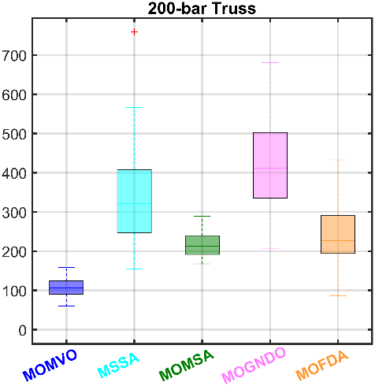 | 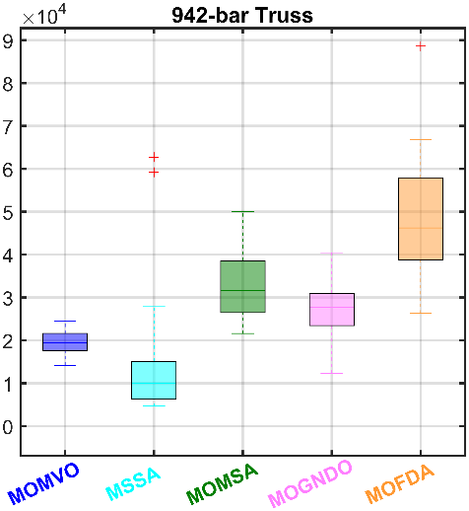 | 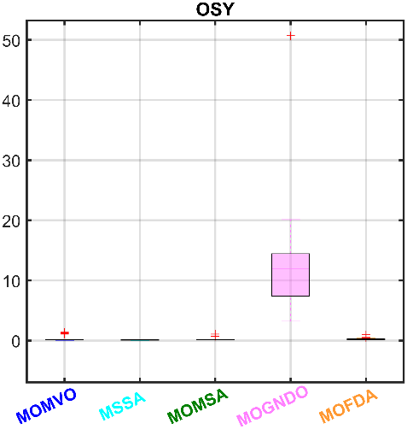 | 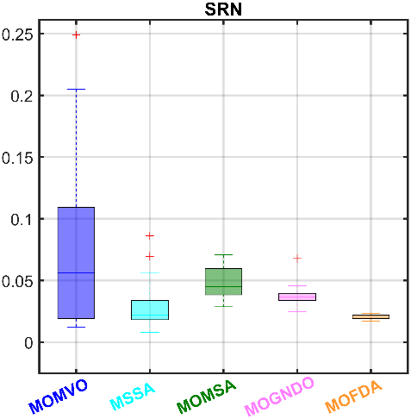 | 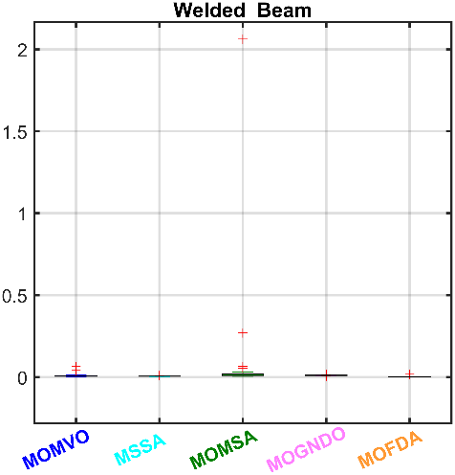
Fig. 13. (continued)

  - A real-world MOO of MOFDA for a steel frame structure
    - A real-world steel frame structure of a waiting station
One of the most significant contributions of this study is the application of the proposed MOFDA algorithm to optimize the design of a real-world steel frame structure. The case study focuses on the passenger waiting station at a ferry terminal located in Dong Bai, Cat Hai Island, Hai Phong, Vietnam (see Fig. 13). The original structure (see Fig. 14) features column of H400(150)×250×8×8, truss of H350(150)×250×8×8, and tie brace of $ϕ$76×3 (see Fig. 15). Through the redesign of this steel frame, the proposed MOFDA algorithm demonstrates its capability to tackle complex, real-world engineering challenges. The optimization aims to enhance structural performance and reduce material usage, underscoring the potential for significant cost savings and environmental benefits. This practical application validates MOFDA as a robust tool in structural engineering, setting a precedent for innovative and efficient design solutions.
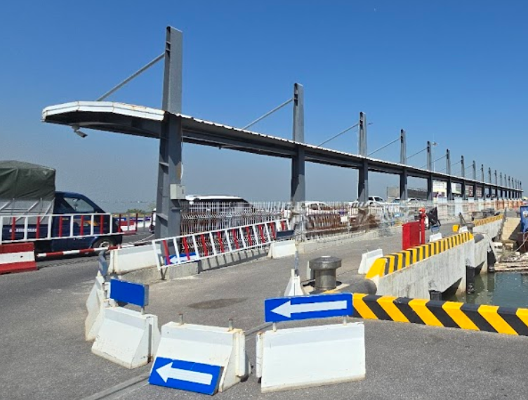
        - The waiting station for passengers at Dong Bai ferry terminal
    - Loads and Combinations
For this work, the design of the real-world steel structure complies with the ASCE7-10 standard [44], utilizing carefully defined load cases and combinations. The applied loads include the structure’s weight (Dead Load - DL), labour live load (labour load - LL), and wind loads acting in various directions (WXLA, WXLB, WXRA, WXRB), ensuring a comprehensive evaluation of the structure's performance. Detailed descriptions of the load types are outlined in Table 7. Furthermore, Table 8 presents 19 meticulously crafted load combinations based on ASCE7-10 guidelines, ensuring the design meets rigorous safety and reliability standards.
- Load definitions
Load case | Type | Design type | Definition
DL | Static | Dead | Structure’s weight
LL | Static | Live | Labor’s load
WXLA | Static | Wind | Wind load in X-direction from the left side for load case A of ASCE7-10
WXLB | Static | Wind | Wind load in X-direction from the left side for load case B of ASCE7-10
WXRA | Static | Wind | Wind load in X-direction from the right side for load case A of ASCE7-10
WXRB | Static | Wind | Wind load in X-direction from the right side for load case B of ASCE7-10
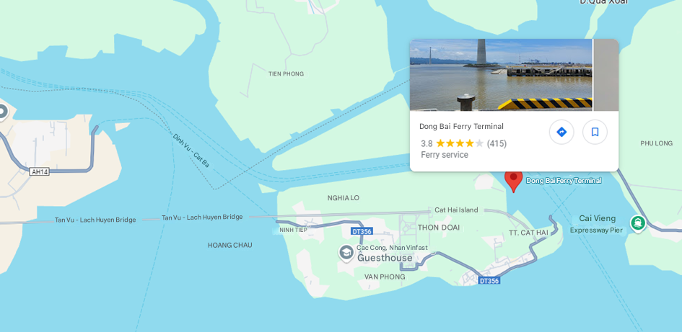
        - Location of Dong Bai ferry terminal in Cat Hai Island, Hai Phong, Vietnam (source: Google Map)
    - Defining the objective functions for the Steel structure of the waiting station
Establishing objective functions is pivotal in formulating and solving MOO problems. This step defines the key criteria and constraints that must be optimized, guiding the search for the best solution. In addition, the objective function is developed in alignment with the AISC 360-10 standard [45] (American Institute of Steel Construction 360-10), a widely recognized benchmark for steel design. By adhering to these established design guidelines, the study ensures the optimization process is efficient and compliant with industry standards.
For this study, the MOO problem for the steel frame structure incorporates two primary objectives (Eq. 13). The first objective, $f_{1}$​, focuses on minimizing the overall weight of the frame to enhance material efficiency and reduce costs. The second objective, $f_{2}$​, aims to minimize the displacement of the frame nodes, ensuring the structure's stability and performance under load. By addressing these objectives concurrently, the research seeks to achieve an optimal balance between efficiency and performance. The proposed MOFDA algorithm demonstrates its capability to address these real-world engineering challenges effectively.
- Load Combinations
Combination names | Type of combination case | Safety factor of loads in the combination case
 |  | DL | LL | WXLA | WXLB | WXRA | WXRB
COM01 | Linear-Add | 1.4 | -- | -- | -- | -- | --
COM02 | Linear-Add | 1.2 | 0.5 | -- | -- | -- | --
COM03 | Linear-Add | 0.9 | -- | 1.0 | -- | -- | --
COM04 | Linear-Add | 0.9 | -- | -- | 1.0 | -- | --
COM05 | Linear-Add | 0.9 | -- | -- | -- | 1.0 | --
COM06 | Linear-Add | 0.9 | -- | -- | -- | -- | 1.0
COM07 | Linear-Add | 1.2 | 1.6 | 0.5 | -- | -- | --
COM08 | Linear-Add | 1.2 | 1.6 | -- | 0.5 | -- | --
COM09 | Linear-Add | 1.2 | 1.6 | -- | -- | 0.5 | --
COM10 | Linear-Add | 1.2 | 1.6 | -- | -- |  | 0.5
COM11 | Linear-Add | 1.2 | 0.5 | 1.0 | -- | -- | --
COM12 | Linear-Add | 1.2 | 0.5 | -- | 1.0 | -- | --
COM13 | Linear-Add | 1.2 | 0.5 | -- | -- | 1.0 | --
COM14 | Linear-Add | 1.2 | 0.5 | -- | -- |  | 1.0
CVN01 | Linear-Add | 1.0 | 0.5 | 1.0 | -- | -- | --
CVN02 | Linear-Add | 1.0 | 0.5 |  | 1.0 |  | --
CVN03 | Linear-Add | 1.0 | 0.5 | -- | -- | 1.0 | --
CVN04 | Linear-Add | 1.0 | 0.5 | -- | -- | -- | 1.0
CVV01 | Linear-Add | 1.0 | 1.0 | -- | -- | -- | --

Minimize: $F\left(f_{1},f_{2}\right)=\left\{\begin{matrix}f_{1}=\sum_{i=1}^{n}{ρl_{i}A_{i}} \\ f_{2}=u_{i}\end{matrix}\right.$  Subjected to $\left\{\begin{matrix}{p_{i}=u}_{i}-u_{b} ≤0 \\ {k_{j}=R}_{i}-1≤0\end{matrix}\right.$ | (20)
Here, $A_{i}$ represents the cross-sectional area of the elements and $u_{i}$​ denotes the overall displacement of the nodes. The allowable displacement, $u_{b}$​, is set at 0.05 m, ensuring compliance with usage requirements. As the AISC 360-10 standard [45], $R_{i}$ represents the demand-to-capacity (D/C) ratio for each frame element, which is determined by evaluating the forces and moments across various design combinations. When $R_{i}$ exceeds the threshold of 1.0, it indicates a violation of the structural limit state. The interaction between axial compression and flexure for members with doubly symmetric I-shaped sections is defined as [43, 45]:
$\begin{matrix}R_{i}=\frac{P_{r}}{P_{c}}+\frac{8}{9}\left(\frac{M_{r33}}{M_{c33}}+\frac{M_{r22}}{M_{c22}}\right) & if \frac{P_{r}}{P_{c}}≥0.2\end{matrix}$ | (21)
$\begin{matrix}R_{i}=\frac{P_{r}}{{2P}_{c}}+\left(\frac{M_{r33}}{M_{c33}}+\frac{M_{r22}}{M_{c22}}\right) & if \frac{P_{r}}{P_{c}}<0.2\end{matrix}$ | (22)
Here, $P_{c}$​ is the available axial strength, while $M_{c}$ is the available flexural strengths about the strong (3) and weak (2) axes. They are calculated as:
$$P_{c}=\frac{P_{n}}{w_{c}};M_{c33}=\frac{M_{n33}}{w_{b}};M_{c22}=\frac{M_{n22}}{w_{b}}$$ | (23)
where $P_{n}$ is compressive capacity, $M_{n33}$ is major bending capacity, and $M_{n22}$ is minor bending capacity, where ​$w_{c}$ and $w_{b}$​ are safety factors set at 1.67 for compression and flexure, respectively. The required second-order flexural strength and axial strength are determined as:
$$\begin{matrix}M_{r}=B_{1}M_{nt}+B_{2}M_{lt} \\ P_{r}=P_{nt}+B_{2}P_{lt}\end{matrix}$$ | (24)
where $B_{1}$ and $B_{2}$ are given as:
$$\begin{matrix}B_{1}=\frac{C_{m}}{1-α\frac{P_{r}}{P_{e1}}}≥1 \\ B_{2}=\frac{1}{1-\frac{αP_{story}}{P_{e,story}}}≥1\end{matrix}$$ | (25)
For Allowable Stress Design (ASD), the factor $α$ is 1.6. The required second-order flexural strength, denoted as $M_{r}$​, is determined using ASD load combinations. The first-order moment without considering lateral translation of the frame is represented by $M_{nt}$​, whereas $M_{lt}$ ​ corresponds to the first-order moment caused solely by lateral translation.
Regarding axial forces, $P_{r}$​ refers to the first-order axial force using ASD load combinations, accounting for lateral translation, while $P_{nt}$​ represents the first-order axial force when lateral translation is not considered. Similarly, $P_{lt}$ is the first-order axial force derived from ASD load combinations, solely due to lateral translation effects.
The total vertical load sustained by a story, including gravity column loads, is denoted as $P_{story}$ ​ and is determined using ASD load combinations. The elastic critical buckling resistance of the story, derived from sidesway buckling analysis, is represented by $P_{e,story}$​. Furthermore, $P_{e1}$ signifies the elastic critical buckling resistance of a member within the plane of bending, assuming no sidesway, while $P_{e2}$ ​ represents the elastic critical buckling resistance of the story, considering sidesway effects. Lastly, the coefficient $C_{m}$ ​ is used under the assumption that the frame does not undergo lateral translation.
When constraints are violated, a penalty method adjusts the objective function as follows [43]:
$G(f_{1},f_{2},P_{i},K_{j}){=F\left(f_{1},f_{2}\right)+\left[\sum_{i=1}^{p}{r_{i}P_{i}}+\sum_{j=1}^{k}{c_{j}K_{j}}\right]}$ | (26)
where $G(f_{1},f_{2},P_{i},K_{j})$ is the adapted penalty objective function, $r_{i}$​ and $c_{j}$​ are penalty parameters (${10}^{10}$ is taken in this case), and $P_{i}$​, $K_{j}$​ are derived from the constraints:
$\begin{matrix}P_{i}={\max\left[0,p_{i}\right]}^{β} \\ K_{j}=\max{{\left[0,k_{j}\right]}^{γ}}\end{matrix}$ | (27)
Typically, $β$ and $γ$ are constants set to 1 or 2.
    - A hybrid updating-optimiser MOFDA of MATLAB, SAP2000, and SM ToolBox
In structural engineering, traditional solvers using programming languages such as Visual C++, MATLAB, Python, and others are widely used for solving simple problems, i.e., truss structures. However, these methods often face significant limitations when applied to real-world MOO problems involving complex structures, such as steel-framed passenger waiting stations with variable cross-sections. To address these challenges, this study introduces a novel approach that combines MATLAB and SAP2000, a robust structural analysis and design software developed by Computers and Structures, Inc. (CSI). CSI software, trusted by thousands of engineering firms across more than 160 countries, has been instrumental in designing iconic projects such as the Taipei 101 Tower in Taiwan, One World Trade Center in New York, the 2008 Olympics Birds Nest Stadium in Beijing, and the cable-stayed Centenario Bridge over the Panama Canal [46].
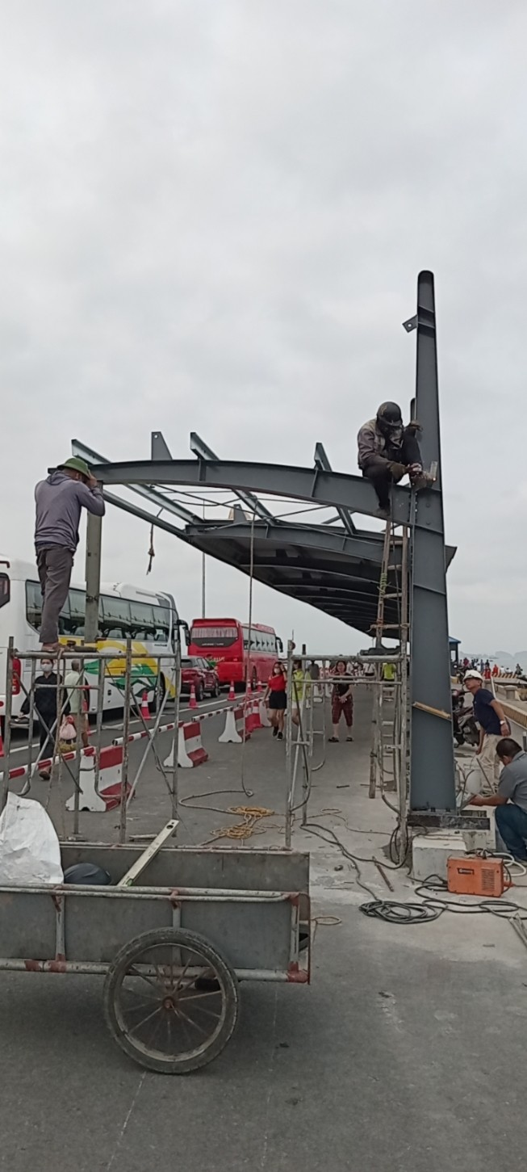
        - The current waiting station for Dong Bai ferry terminal passengers is on Cat Hai Island, Hai Phong, Vietnam.
Thus, a Finite-Element (FE) model was initially developed in SAP2000 to represent the steel structure of the passenger waiting station at Dong Bai ferry terminal, located on Cat Hai Island, Hai Phong, Vietnam (see Fig. 15 and Fig. 16). This FE model was integrated with MATLAB through the SM Toolbox to create a hybrid updating-optimizer model, enabling the calculation of the objective function as defined by Eq. (20). For this optimal design, the wind loads in the SAP2000 FE model were automatically determined following the ASCE7-10 standard [44], with input parameters including the following:
- Wind speed: $V_{3s,50}=61$ m/s (equivalent to 137 mph) based on the structure’s location in Hai Phong, Vietnam;
- Exposure type: D;
- Topographical factor: $K_{zt}=1$;
- Gust factor: 0.85;
- Directionality factor: $K_{d}=1$.
- 3D-FE model of Dong Bai ferry terminal in SAP2000. | 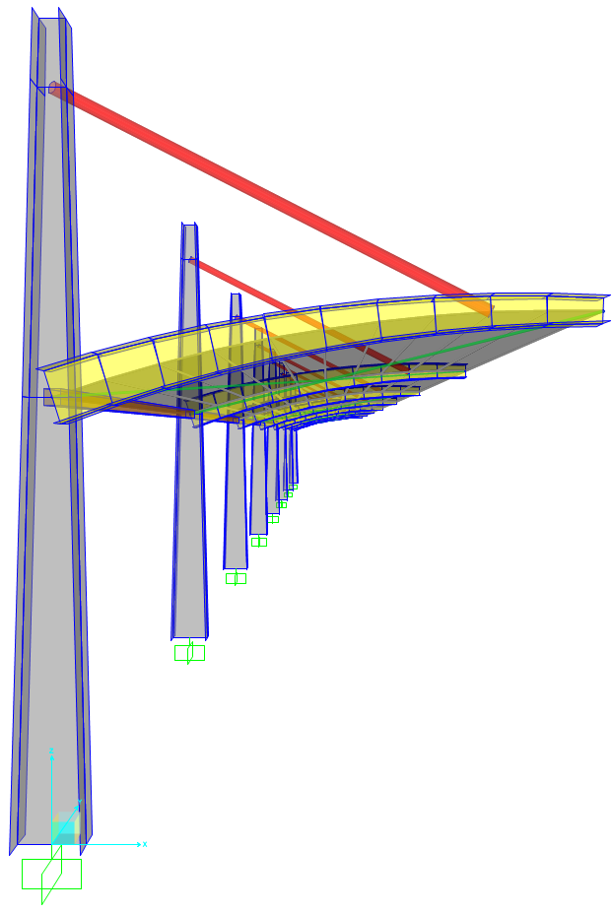
This setup ensures accurate simulation and compliance with international and national structural wind load design standards. Besides, the core mechanical concept behind solving a finite-element (FE) model under static loading in SAP2000 is based on the following linear system:
$$Ku=F$$ | (28)
Here, $K$ denotes the global stiffness matrix derived from the stiffness matrices of individual elements; $u$ represents the nodal displacement vector; and $F$ is the nodal force vector applied to the structure. Using the finite-element method (FEM), SAP2000 resolves Eq. (28) to compute the displacements at the nodes. From these results, the stress values $σ$ within the structural elements are determined using Hooke's law, which relates stress to strains $ϵ$ through the equation:
$$σ=Bϵ$$ | (29)
In Eq. (29), $B$ is the material property matrix that defines the relationship between stresses and strains. This process provides precise stress values in the structural elements, ensuring robust and reliable results for analysis and design.
Then, by utilizing the SAP2000 Open Application Programming Interface (SAP2000-OAPI) and integrating it with MATLAB, researchers can enhance the efficiency and practicality of solving complex MOO engineering problems. This integration is further supported by the SM Toolbox [46] introduced by Ahmadi-Nedushan and Javanmardi, which bridges the gap between SAP2000 and MATLAB applications. The SM Toolbox simplifies the use of CSI OAPI commands by converting them into explicit MATLAB functions, eliminating the need for MATLAB programmers to navigate the intricacies of Visual Basic-based commands. By combining MATLAB’s computational power, SAP2000’s advanced structural analysis capabilities, and the user-friendly functionality of the SM Toolbox, this approach provides a practical and streamlined solution for addressing complex MOO structural engineering challenges.
- Initial properties for the SAP2000 model
Properties | Values
Material | Steel
Density, $γ$ | $7.849$ T/m³
Modulus of Elasticity, $E$ | $2.0×{10}^{8}$ kN/m²
Poisson's Ratio, $U$ | 0.3
Coefficient of Thermal Expansion, $A$ | $1.170×{10}^{-5}$
Shear Modulus, $G$ | $76903069$
Minimum Yield Stress, $F_{y}$ | $344737.9$ kN/m²
Minimum Tensile Stress, $F_{u}$ | $448159.3$ kN/m²
Expected Yield Stress, $F_{ye}$ | $379211.7$ kN/m²
Expected Tension Stress, $F_{ue}$ | $492975.2$ kN/m²
Design Standard | AISC360-10—Allowable Stress Design (ASD)
Consequently, a hybrid updating-optimiser MOFDA of MATLAB, SAP2000, and SM ToolBox is generated as in Fig. 17 and the following steps:
Step1: The process begins with the initial design requirements, including the defined loads, boundary conditions, and the creation of the initial finite-element (FE) model in SAP2000, as illustrated in Fig. 16. The applicable design standards, along with appropriate options and material properties, are detailed in Table 9, ensuring a robust foundation for the design process.
Step 2: Open and launch the SAP2000 program through OAPI within MATLAB, utilizing the SM Toolbox for seamless integration. This step involves executing the required command codes, as outlined below, to establish the connection and initiate the process.
Step 3: The SAP2000 model is updated dynamically by modifying its parameters using MATLAB command lines. With the support of SM ToolBox, cross-sectional properties within the model are adjusted automatically, allowing the generation of a revised FE model that incorporates the necessary changes seamlessly.
- Flowchart of hybrid updating-optimiser MOFDA of MATLAB, SAP2000, and SM ToolBox |  | 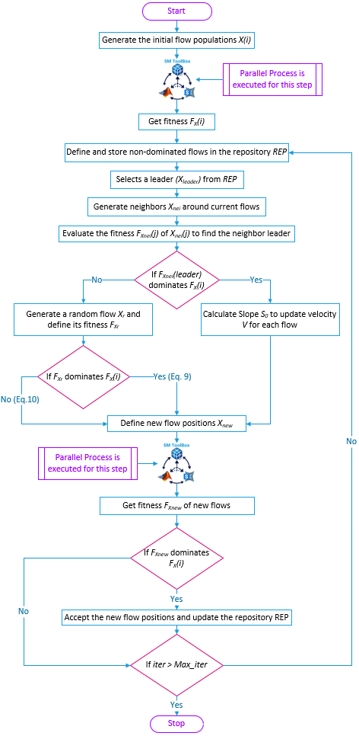
a) A - Cross-section | b) B – Cross-section |  | c) C, D - Cross-section | d) Tie Brace cross-section
        - The optimized variables control the objective functions of Eq. (20).
The codes to interact MATLAB with SAP2000 by SM ToolBox
spmd
% Open the Sap2000 model
SM.App('SAP');
SM.Ver('Version');
ProgramPath = 'path of SAP2000.exe';
APIDLLPath = 'path of SAP2000v1.dll';
[Sobj] = SM.Helper.CreateObject(ProgramPath,APIDLLPath);
[Smdl] = SM.SapModel();
SM.ApplicationStart;
SM.Hide
SM.File.OpenFile('Sap2000_model.sdb');
% Create the duplicated models for paralell computation
name_new = sprintf('Sap2000_model_%d.sdb',spmdIndex);
path_new = fullfile(pwd,'Sap2000_model');
mkdir(path_new,num2str(spmdIndex));
path_new = fullfile(pwd,'Sap2000_model',num2str(spmdIndex),name_new);
ret=SM.File.Save('FileName', path_new);
% Calculate the fitness from Sap2000 model
fitness = Sap2000_model(X);
end
    - Results and Discussions
The MOFDA algorithm optimizes the steel frame structure at the Dong Bai ferry terminal with carefully chosen parameters to ensure efficiency and precision. The initial algorithm parameters are defined as follows: the total number of searching flows is 100, the maximum number of iterations is 200, and other parameters are set by default values ​​as introduced in the algorithm. In addition, the optimization process focuses on seven key design variables, representing the dimensions of the frame cross-sections. The arrangement and significance of these variables in the frame design are illustrated in Fig. 18, providing an apparent reference for their role in the optimization. In addition, the optimal variables $X_{i}$ for the objective functions Eq. (20) is defined within the following carefully searched space: $X_{1},X_{2}, X_{4},X_{5}∈[50,500]$ (mm); $X_{6}∈[50,100]$; $X_{3},X_{7}∈\left[1,10\right]$ (mm).
Furthermore, this work considers continuous and discrete computation of variables. Continuous cases provide flexibility for design variables with smooth adjustments and a broad exploration of possible alternatives. Although it offers a well-balanced Pareto front, reality and production limitations might make it inapplicable. It is beneficial for the early design stages. Predefined sizes and dimensions by discrete variables are set up to improve real-world applicability. In this case, the discrete variables are predefined as: $X_{1},X_{2}, X_{4},X_{5}∈[50:10:500]$ (mm); $X_{6}∈[50:10:100]$; $X_{3},X_{7}∈\left[1:1:10\right]$ (mm). The results of continuous cases are shown in Fig. 19. a) and Table 10, while Table 11 and Fig. 19. b) present comprehensive optimal results of the discrete case. They affirm that all optimal results obtained by the MOFDA algorithm are superior to the existing design.
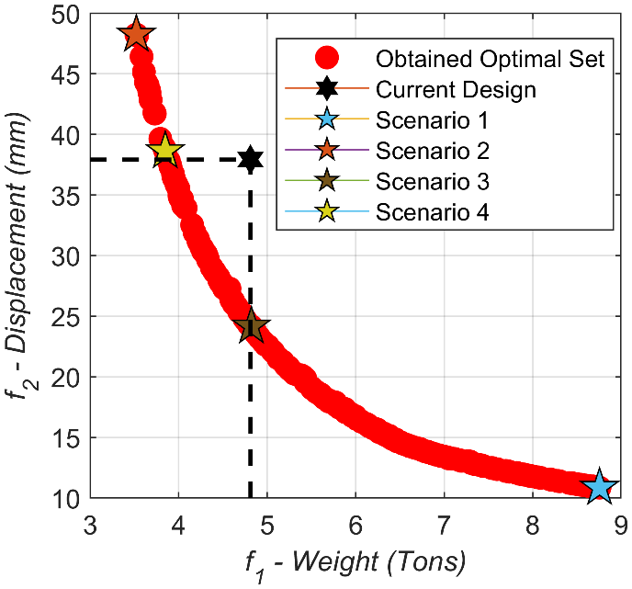 | 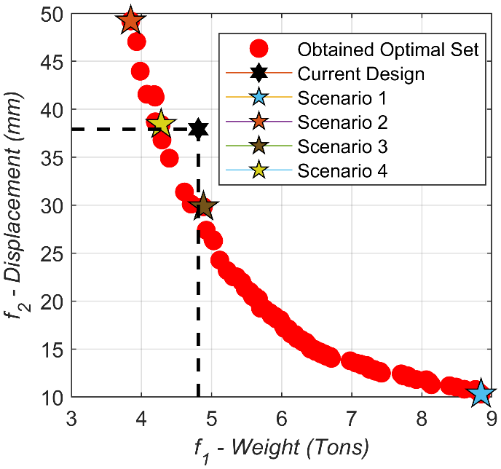
a) Continuous computation | b) Discrete computations
        - The MOO results for the frame at the Dong Bai terminal
Besides, the results of specific unique scenarios presented in Tables 10 and 11 provide valuable understanding in applying the MOFDA algorithm, especially in balancing displacement and structural weight. Every scenario shows the flexibility and effectiveness of the algorithm by insisting on a different trade-off between displacement and weight.
- A comparison of the current design to specific scenarios of continuous variables.
Designed variables | Current Design | Scenario 1 | Scenario 2 | Scenario 3 | Scenario 4
$X_{1}$ (mm) | 400.00 | 500.00 | 500.00 | 500.00 | 500.00
$X_{2}$ (mm) | 250 | 499.97 | 122.68 | 289.71 | 165.82
$X_{3}$ (mm) | 8 | 10.00 | 6.03 | 6.43 | 6.15
$X_{4}$ (mm) | 350 | 498.81 | 489.16 | 493.37 | 490.11
$X_{5}$ (mm) | 150 | 216.57 | 207.28 | 225.77 | 211.93
$X_{6}$ (mm) | 76 | 99.98 | 100.00 | 100.00 | 100.00
$X_{7}$ (mm) | 3 | 7.59 | 1.62 | 5.33 | 2.58
$f_{1}$ (Tons) | 4.8 | 8.75 | 3.52 | 4.82 | 3.85
$f_{2}$ (mm) | 37.9 | 10.85 | 48.23 | 24.17 | 38.62
For the continuous case, Scenario 1 shows a remarkable 71.4% reduction in displacement ($f_{2}$=10.85 mm), significantly improving structural stiffness. However, it is a notable trade-off of a cost for the weight reached $f_{1}$=8.75 tons, nearly doubling the weight of the current design. Although this situation is less economical regarding material use, it may be suitable for projects prioritising structural integrity and minimum displacement. Meanwhile, Scenario 2 emphasises a lightweight design with $f_{1}$ = 3.52 tons, reducing 26.7%. But this optimization indicates that the structure is now less rigid, causing a higher displacement of 27.3% ($f_{2}$=48.23mm). This situation would be perfect for projects with limited budgets where material savings are vital.
Scenario 3 strikes a balanced approach, maintaining a similar structural weight ($f_{1}$=4.82 tons) to the current design. Even so, it reduces displacement significantly ($f_{2}$=24.17 mm), bringing it down to two-thirds of the current design's displacement ($f_{2}$=37.9mm). This scenario is a good choice for projects where strength and material economy are crucial. At last, Scenario 4 offers a near-optimal solution with a 22.7% reduction in weight ($f_{1}$=3.85 tons) while maintaining displacement levels similar to the current design ($f_{2}$ = 38.62 mm). This case illustrates the MOFDA algorithm's ability to enhance material efficiency substantially while maintaining structural performance. It provides a pragmatic, comprehensive solution that surpasses traditional design.
- A comparison of the current design to specific scenarios of discrete variables.
Designed variables | Current Design | Scenario 1 | Scenario 2 | Scenario 3 | Scenario 4
$X_{1}$ (mm) | 400.00 | 500.00 | 500.00 | 480.00 | 500.00
$X_{2}$ (mm) | 250 | 500.00 | 140.00 | 300.00 | 180.00
$X_{3}$ (mm) | 8 | 10.00 | 8.00 | 7.00 | 8.00
$X_{4}$ (mm) | 350 | 500.00 | 390.00 | 450.00 | 500.00
$X_{5}$ (mm) | 150 | 250.00 | 50.00 | 100.00 | 50.00
$X_{6}$ (mm) | 76 | 100.00 | 50.00 | 80.00 | 50.00
$X_{7}$ (mm) | 3 | 10.00 | 10.00 | 3.00 | 9.00
$f_{1}$ (Tons) | 4.8 | 8.85 | 3.85 | 4.88 | 4.28
$f_{2}$ (mm) | 37.9 | 10.3 | 49.21 | 29.83 | 38.42
As seen in Table 11 and Fig. 19. b), the structural frame at the Dong Bai terminal was also optimized using discrete design variables, reflecting real-world manufacturing constraints and standard sizing practices. Scenario 1 again demonstrates the lowest displacement, achieving just 10.3 mm, which marks a substantial 73% reduction compared to the current design (37.9 mm). However, this improvement in stiffness comes at a significant cost in material usage, with the structural weight increasing to 8.85 tons. On the contrary, Scenario 2 prioritizes material efficiency. The design achieves a lighter weight of 3.85 tons, approximately 19.8% less than the current design. However, this leads to a significant increase in displacement, reaching 49.21 mm.
Scenario 3 offers a well-balanced compromise. The weight is maintained close to the original (4.88 tons), while the displacement is substantially reduced to 29.83 mm. Although it does not reach the performance of Scenario 1, it represents a practical solution that balances structural stiffness and material usage, making it highly suitable for real-world applications. Finally, Scenario 4 demonstrates a strong balance between efficiency and practicality. With a reduced weight of 4.28 tons (a 10.8% saving) and a displacement value of 38.42 mm, nearly identical to the current design, this scenario showcases a pragmatic solution. It improves material efficiency without compromising structural performance, making it attractive for design scenarios focused on cost-effectiveness and manufacturability.
While the $PF$ for the discrete case is less smooth due to the limited design resolution, the overall quality of the solutions remains strong. Scenarios 3 and 4 reveal that competitive and feasible designs can still be achieved under discrete constraints. It demonstrates the robustness of the MOFDA algorithm in practical engineering contexts.
Moreover, the consistent presence of high-quality trade-off solutions within the discrete design space reinforces the value of MOFDA for real-world decision-making. Engineers can use the generated solutions to tailor designs based on different project requirements, whether aiming for stiffness, material economy, or both. The results validate MOFDA’s support of informed structural optimization across various practical design conditions.
  - Conclusions and Future Works
    - Conclusions
This study has introduced the MOFDA algorithm, advancing the original FDA framework for multi-objective optimization by incorporating an external archive and a novel hybrid leader selection strategy. Extensive benchmarking and real-world engineering applications demonstrate that MOFDA produces accurate, diverse, well-distributed Pareto-optimal solutions, outperforming several state-of-the-art metaheuristic algorithms. The successful optimization of the Dong Bai ferry terminal’s steel frame validates MOFDA’s practical effectiveness, achieving substantial weight reduction and improved displacement control in full compliance with design standards. All results have been rigorously reproduced and analyzed in detail, underscoring the reliability and transparency of this work. Overall, MOFDA represents a significant step forward in the field of MOO, offering robust performance for both theoretical and practical challenges.
    - Perspectives for Improvement
While the proposed MOFDA has shown strong performance on benchmark tests and real-world engineering problems and has already demonstrated effectiveness in parallel computing environments, several avenues remain for further enhancement. Future research could explore integrating advanced machine learning methods, such as surrogate models or reinforcement learning, to accelerate convergence and improve solution quality, especially for high-dimensional or computationally intensive problems. Additionally, improving the algorithm’s robustness to uncertainty would make it more reliable in practical scenarios with variable conditions. Extending MOFDA to tackle many objective optimization problems and applying it to a wider range of engineering and industrial domains will help validate its versatility further. Finally, combining MOFDA with decision-making frameworks could make it even more valuable for complex engineering design and optimization processes.

Acknowledgements

References
1. Gunantara, N., A review of multi-objective optimization: Methods and its applications. Cogent Engineering, 2018. 5(1): p. 1502242.
2. Abouhawwash, M., M. Jameel, and K. Deb, A smooth proximity measure for optimality in multi-objective optimization using Benson’s method. Computers & Operations Research, 2020. 117: p. 104900.
3. Jameel, M. and M. Abouhawwash, Multi-objective Mantis Search Algorithm (MOMSA): A novel approach for engineering design problems and validation. Computer Methods in Applied Mechanics and Engineering, 2024. 422: p. 116840.
4. Khodadadi, N., et al., Multi-objective generalized normal distribution optimization: a novel algorithm for multi-objective problems. Cluster Computing, 2024.
5. Karami, H., et al., Flow Direction Algorithm (FDA): A Novel Optimization Approach for Solving Optimization Problems. Computers & Industrial Engineering, 2021. 156: p. 107224.
6. Rajwar, K., K. Deep, and S. Das, An exhaustive review of the metaheuristic algorithms for search and optimization: taxonomy, applications, and open challenges. Artificial Intelligence Review, 2023. 56(11): p. 13187-13257.
7. Mirjalili, S., et al., Optimization of problems with multiple objectives using the multi-verse optimization algorithm. Knowledge-Based Systems, 2017. 134: p. 50-71.
8. Nouhi, B., et al., Multi-Objective Material Generation Algorithm (MOMGA) for Optimization Purposes. IEEE Access, 2022. 10: p. 107095-107115.
9. Mirjalili, S., P. Jangir, and S. Saremi, Multi-objective ant lion optimizer: a multi-objective optimization algorithm for solving engineering problems. Applied Intelligence, 2017. 46(1): p. 79-95.
10. Zhang, J., et al., Mixture optimization for environmental, economical and mechanical objectives in silica fume concrete: A novel frame-work based on machine learning and a new meta-heuristic algorithm. Resources, Conservation and Recycling, 2021. 167: p. 105395.
11. Masoudi-Sobhanzadeh, Y., et al., A novel multi-objective metaheuristic algorithm for protein-peptide docking and benchmarking on the LEADS-PEP dataset. Computers in Biology and Medicine, 2021. 138: p. 104896.
12. Mirjalili, S., et al., Salp Swarm Algorithm: A bio-inspired optimizer for engineering design problems. Advances in Engineering Software, 2017. 114: p. 163-191.
13. Khodadadi, N., L. Abualigah, and S. Mirjalili, Multi-objective Stochastic Paint Optimizer (MOSPO). Neural Computing and Applications, 2022. 34(20): p. 18035-18058.
14. Khodadadi, N., F. Soleimanian Gharehchopogh, and S. Mirjalili, MOAVOA: a new multi-objective artificial vultures optimization algorithm. Neural Computing and Applications, 2022. 34(23): p. 20791-20829.
15. Premkumar, M., et al., A New Arithmetic Optimization Algorithm for Solving Real-World Multiobjective CEC-2021 Constrained Optimization Problems: Diversity Analysis and Validations. IEEE Access, 2021. 9: p. 84263-84295.
16. Wolpert, D.H. and W.G. Macready, No free lunch theorems for optimization. IEEE transactions on evolutionary computation, 1997. 1(1): p. 67-82.
17. Zitzler, E., K. Deb, and L. Thiele, Comparison of Multiobjective Evolutionary Algorithms: Empirical Results. Evolutionary Computation, 2000. 8(2): p. 173-195.
18. Deb, K., et al., Scalable Test Problems for Evolutionary Multiobjective Optimization, in Evolutionary Multiobjective Optimization: Theoretical Advances and Applications, A. Abraham, L. Jain, and R. Goldberg, Editors. 2005, Springer London: London. p. 105-145.
19. Panagant, N., et al., A Comparative Study of Recent Multi-objective Metaheuristics for Solving Constrained Truss Optimisation Problems. Archives of Computational Methods in Engineering, 2021. 28(5): p. 4031-4047.
20. Coello, C.A.C., G.T. Pulido, and M.S.J.I.T.o.e.c. Lechuga, Handling multiple objectives with particle swarm optimization. 2004. 8(3): p. 256-279.
21. Mirjalili, S., et al., Multi-objective grey wolf optimizer: A novel algorithm for multi-criterion optimization. Expert Systems with Applications, 2016. 47: p. 106-119.
22. Yüzgeç, U., M.J.B.J.o.E.R. Kusoglu, and Technology, Multi-objective harris hawks optimizer for multiobjective optimization problems. 2020. 1(1): p. 31-41.
23. Zhang, Q. and H. Li, MOEA/D: A Multiobjective Evolutionary Algorithm Based on Decomposition. IEEE Transactions on Evolutionary Computation, 2007. 11(6): p. 712-731.
24. Van Veldhuizen, D.A. and G.B. Lamont, Multiobjective evolutionary algorithm research: A history and analysis. 1998, Citeseer.
25. Knowles, J.D., L. Thiele, and E.J.T.r. Zitzler, A tutorial on the performance assessment of stochastic multiobjective optimizers. 2006. 214.
26. Tejani, G.G., et al., Structural optimization using multi-objective modified adaptive symbiotic organisms search. Expert Systems with Applications, 2019. 125: p. 425-441.
27. Coello Coello, C.A., Evolutionary multi-objective optimization: some current research trends and topics that remain to be explored. Frontiers of Computer Science in China, 2009. 3(1): p. 18-30.
28. Edgeworth, F., Mathematical Physics. P. Keagan London England. 1881.
29. Pareto, V., Cours d'économie politique. Vol. 1. 1964: Librairie Droz.
30. Riquelme, N., C.V. Lücken, and B. Baran. Performance metrics in multi-objective optimization. in 2015 Latin American Computing Conference (CLEI). 2015.
31. Audet, C., et al., Performance indicators in multiobjective optimization. European Journal of Operational Research, 2021. 292(2): p. 397-422.
32. Coello, C.A.C. and N.C. Cortés, Solving Multiobjective Optimization Problems Using an Artificial Immune System. Genetic Programming and Evolvable Machines, 2005. 6(2): p. 163-190.
33. O'Callaghan, J.F. and D.M. Mark, The extraction of drainage networks from digital elevation data. Computer Vision, Graphics, and Image Processing, 1984. 28(3): p. 323-344.
34. Jenson, S.K. and J.O. Domingue, Extracting topographic structure from digital elevation data for geographic information-system analysis. Photogrammetric Engineering and Remote Sensing, 1988. 54(11): p. 1593-1600.
35. Khodadadi, N., et al., Leader selection based Multi-Objective Flow Direction Algorithm (MOFDA): A novel approach for engineering design problems. Results in Engineering, 2025. 25: p. 103670.
36. Mohamed, A.W., et al. Evaluating the Performance of Adaptive GainingSharing Knowledge Based Algorithm on CEC 2020 Benchmark Problems. in 2020 IEEE Congress on Evolutionary Computation (CEC). 2020.
37. Zhang, Q., et al. Multiobjective optimization Test Instances for the CEC 2009 Special Session and Competition. 2009.
38. Srinivas, N. and K. Deb, Muiltiobjective Optimization Using Nondominated Sorting in Genetic Algorithms. Evolutionary Computation, 1994. 2(3): p. 221-248.
39. Ray, T. and K.M. Liew, A Swarm Metaphor for Multiobjective Design Optimization. Engineering Optimization, 2002. 34(2): p. 141-153.
40. Osyczka, A. and S. Kundu, A new method to solve generalized multicriteria optimization problems using the simple genetic algorithm. Structural optimization, 1995. 10(2): p. 94-99.
41. Derrac, J., et al., A practical tutorial on the use of nonparametric statistical tests as a methodology for comparing evolutionary and swarm intelligence algorithms. Swarm and Evolutionary Computation, 2011. 1(1): p. 3-18.
42. Coello, C.A.C.J.C.m.i.a.m. and engineering, Theoretical and numerical constraint-handling techniques used with evolutionary algorithms: a survey of the state of the art. 2002. 191(11-12): p. 1245-1287.
43. Minh, H.-L., et al., Design optimization of a large industrial steel structure using an enhanced K-means clustering optimizer and finite-element model updating. Archives of Civil and Mechanical Engineering, 2024. 25(1): p. 55.
44. ASCE7-10, Minimum design loads for buildings and other structures. 2010, American Society of Civil Engineers.
45. AISC. ANSI/AISC 360-10: Specification for structural steel buildings. 2010. AISC Chicago, IL, USA.
46. Ahmadi-Nedushan, B. and R. Javanmardi, SM Toolbox Version 6.9. 7 Instructions. 2021.

Note: In the result tables, indices (1) to (5) refer to the corresponding statistical indicators; and the bold values represent for the best results.

