Multi-objective Optimization Design of Marine Structures Based on An Enhanced Starfish Algorithm

ABSTRACT:
This study proposes two multi-objective optimization (MOO) algorithms for marine structural design: the Base MOSFOA (B-MOSFOA) and its enhanced variant (E-MOSFOA), extending the single-objective Starfish Optimization Algorithm (SFOA) to multi-objective domains. The proposed methods integrate Pareto-based archiving, grid-based diversity control, and leader-guided exploration to improve convergence and solution diversity. E-MOSFOA further enhances performance through adaptive phase control and mutation strategies. The algorithms are evaluated on standard benchmark suites (IMOP, UF, and RM-MEDA) using performance metrics including $IGD, ε, Δ$, and $MS$, and compared against state-of-the-art methods such as MOMSA, NS-MFO, and MOGNDO. To demonstrate practical applicability, the proposed framework is applied to the MOO of a real-world marine jetty system, including the berthing dolphin (BD), mooring dolphin (MD), and main jetty platform (MJP), under realistic loading and design constraints. Results show that both algorithms achieve superior convergence and solution distribution, with E-MOSFOA providing more stable and well-distributed Pareto fronts ($PF$). The optimized designs significantly reduce construction cost and structural displacement compared to the current design, confirming the effectiveness and robustness of the proposed approach for complex marine engineering applications.
KEYWORDS: Multi-objective optimization; Starfish Optimization Algorithm; Marine jetty structures; Finite element model; Pareto dominance; Adaptive mutation; Phase control.
  - Introduction
Designing marine infrastructures involves complex engineering challenges that require balancing multiple design objectives, including structural safety, cost efficiency, and compliance with technical standards under various loading conditions such as berthing impacts, mooring forces, and environmental actions. To address these challenges, MOO provides an effective framework for exploring design alternatives and identifying trade-off solutions.

MOO techniques, particularly population-based metaheuristics, are well suited for handling large, nonlinear, and high-dimensional problems. Unlike deterministic approaches, MOO generates a set of non-dominated solutions forming the Pareto front, where no objective can be improved without degrading another [1]. These solutions enable decision-makers to balance competing criteria such as cost, safety, and performance. Consequently, metaheuristic algorithms have gained increasing attention due to their ability to produce high-quality solutions with reasonable computational effort [2].
A wide range of MOO algorithms have been proposed in recent years, including MOGNDO [2], MOMSA [3], MSSA [4], and NS-MFO [5]. Despite their effectiveness, many methods still suffer from issues such as premature convergence and loss of diversity in complex search spaces. Moreover, the No Free Lunch theorem states that no single algorithm is universally optimal for all problems [6, 7], motivating the development of problem-specific optimization strategies.
Recently, the SFOA [8] has demonstrated promising performance in single-objective optimization due to its effective search mechanism. However, its direct application to MOO problems is limited by the lack of diversity preservation and Pareto-guided search mechanisms. To address this limitation, this study proposes two multi-objective extensions of SFOA, namely B-MOSFOA and E-MOSFOA, tailored for marine structural optimization. B-MOSFOA incorporates Pareto dominance, grid-based diversity control, and leader selection, while E-MOSFOA further enhances the framework through adaptive phase control, mutation strategies, and leader-guided refinement.
The performance of the proposed algorithms is evaluated using benchmark suites IMOP [9], UF [10], and RM-MEDA [11], covering diverse optimization scenarios. Solution quality is assessed using standard metrics, including $IGD$ [12], $ε$ [13], $Δ$ [17], and $MS$ [17], along with statistical indicators over multiple independent runs. Comparative results with MOMSA [3], NS-MFO [5], and MOGNDO [2] demonstrate that the proposed approaches achieve competitive or superior performance.
In addition, the proposed methods are applied to the optimal design of a real-world marine liquid bulk jetty system, including the berthing dolphin (BD), mooring dolphin (MD), and main jetty platform (MJP). A coupled SAP2000–MATLAB framework is used to simulate realistic loading conditions and structural constraints. The results confirm the effectiveness of B-MOSFOA and E-MOSFOA in producing cost-efficient and reliable structural designs for practical engineering applications.
The remainder of this paper is organized as follows: Section 2 presents the fundamentals of MOO; Section 3 introduces the proposed algorithms; Section 4 describes benchmark evaluations; Section 5 discusses the case study; and Section 6 concludes the paper.
  - Foundations Of MOO
MOO addresses problems involving multiple conflicting objectives, where improving one criterion may degrade others. Unlike single-objective optimization, which seeks a unique optimum, MOO aims to identify a set of trade-off solutions forming the Pareto set ($PS$) and its corresponding $PF$ [14, 15].
A general MOO problem is formulated as:
$$\underset{X}{minimize}{F\left(X\right)}=\left\{f_{1}\left(X\right),f_{2}\left(X\right),…,f_{m}\left(X\right)\right\}$$ | (1)
subject to inequality constraints $g_{i}(X)≤0$, equality constraints $h_{j}(X)=0$, and bounded decision variables $X∈[l_{b},u_{b}]$, where $f_{m}(X)$are the objective functions [16, 17].
A solution $x_{1}$ dominates $x_{2}$ if it is no worse in all objectives and strictly better in at least one. Non-dominated solutions constitute the $PS$, while their mapping in objective space forms the $PF$, representing optimal trade-offs for decision-making [17-20]. The primary challenge in MOO is to obtain a well-distributed approximation of the $PF$ rather than a single optimum. This becomes particularly difficult for nonlinear, discontinuous, or high-dimensional problems, where maintaining a balance between exploration (diversity) and exploitation (convergence) is critical.
Once a representative $PF$ is obtained, decision-makers select practical solutions based on preferences. Common approaches include weighted-sum methods, ε-constraint techniques, and interactive decision-making strategies [14, 21, 22]. Population-based metaheuristics, such as NSGA-II [23] and SPEA2 [24], are widely used for approximating PFs. However, they may suffer from premature convergence, loss of diversity, and parameter sensitivity in complex problems. To address these limitations, bio-inspired algorithms have been increasingly explored due to their adaptability and scalability.
Recently, the SFOA [8] has demonstrated promising performance in single-objective problems. Building on this, the present study proposes two multi-objective variants - B-MOSFOA and E-MOSFOA - designed to enhance convergence, maintain diversity, and improve robustness in high-dimensional search spaces through mechanisms such as leader-guided exploration, adaptive phase control, and archive-based selection.

  - Proposed MOSFOAs
This section presents the proposed MOSFOA algorithms, inspired by starfish behaviors such as movement, arm flexing, and regeneration. The framework addresses multi-objective optimization by integrating bio-inspired operators with a Pareto-based selection mechanism [14]. Two variants are developed:
- B-MOSFOA: introduces starfish-inspired operators and an archive-based leader selection strategy.
- E-MOSFOA: enhances convergence and diversity through adaptive control and mutation mechanisms.
    - B-MOSFOA
B-MOSFOA extends the original SFOA [8] into a multi-objective framework by incorporating key mechanisms from evolutionary multi-objective optimization (EMO):
- External archive: stores non-dominated solutions and preserves Pareto-optimal candidates throughout the search, similar to NSGA-II [23] and SPEA2 [24].
- Density-based leader selection: selects leaders from less crowded regions to balance exploration and exploitation, inspired by PAES [25] and MOPSO [26].
These mechanisms enable effective handling of multiple objectives within a bio-inspired search framework.
      - Exploration and Exploitation Dynamics
MOSFOA alternates between exploration and exploitation using a probabilistic control parameter $GP₀∈[0,1]$. At each iteration, a random variable $r\sim U(0,1)$ determines the search phase: exploration if $r<GP₀$, otherwise exploitation.
- Exploration phase
Two update modes are used depending on problem dimensionality $D$:
- Arm-twist ($D>5$): multiple dimensions are updated simultaneously using a sinusoidal motion toward the leader $X_{leader}$:
$$Y_{i}=X_{i}​+a_{1}​\left(X_{leader}-X_{i}​\right)⋅\left\{\begin{matrix}\cos\left(θ\right), r≤0.5 \\ \sin\left(θ\right), r>0.5\end{matrix}\right.​$$ | (2)
where $a1=(2r - 1)π$ and $θ=(π/2)(it / Max_it)$.
- Energy-step ($D ≤ 5$): one dimension is updated with a decaying energy factor:
$$Y_{i}=E{∙X}_{i}+A_{1}∙\left(X_{k_{1}}-X_{i}\right)+A_{2}∙\left(X_{k_{2}}-X_{i}\right)$$ | (3)
where $E=(Max_it - it)/Max_it·cos(θ)$, and $A1, A2 ∈ [-1,1]$.
- Exploitation phase
In exploitation, two behaviors are modeled:
- Preying: movement based on distances to other individuals:
$$Y_{i}=X_{i}+r_{1}d_{m1}+r_{2}d_{m2}$$ | (4)
$$d_{m}=X_{leader}-X_{m} \left(∀m=1..5\right)$$ | (5)
- Regeneration: applied to the last individual:
$$Y_{N}=e^{\left(-\frac{it×N}{Max_it} \right)}X_{N}$$ | (6)
These strategies promote local refinement while preserving diversity.
      - External Archive and Adaptive Grid:
An external archive maintains non-dominated solutions. When its size exceeds $Nr$, an adaptive grid partitions the objective space, and solutions in less crowded regions are preferred. This strategy follows principles widely used in EMO algorithms [23-25].
      - Leader Selection via Roulette Wheel
Leaders are selected via a density-based roulette wheel:
$$P_{i}=\frac{c}{N_{i}}$$ | (7)
where $Ni$ is the number of solutions in grid cell $i$. This favors less crowded regions and improves $PF$ coverage. This strategy favors less crowded regions and is consistent with grid-based selection mechanisms in MOPSO [26].
    - E-MOSFOA
E-MOSFOA is enhanced by introducing adaptive mechanisms to improve convergence and solution distribution while maintaining low computational cost.
      - Phase Control
The fixed $GP₀$ is replaced with a cosine-based schedule:
$$GP=\frac{GP_{0}}{2}\left(1+cos\left(π∙\frac{it}{Max_it} \right)\right)$$ | (8)
This scheduling strategy is commonly used in metaheuristics to balance exploration and exploitation [27].
      - Adaptive Mutation Strategy
For $D>5$, mutation is generated using Differential Evolution (DE) [27]:
$${mutant}_{i}=X_{r1}+F∙\left(X_{r2}-X_{r3}\right)+λ∙(X_{leader}-X_{r1})$$ | (9)
$$F=0.5\left(1-\frac{it}{Max_it}\right)$$ | (10)
The new position is obtained via crossover:
$$Y_{i}=crossover\left(X_{i},mutant_{i}\right)$$ | (11)
      - Archive Leader Refinement
- Pseudo-code of B-MOSFOA and E-MOSFOA
Input: objective functions $\{f_{1},…,f_{M}\}$; bounds $\left[l_{b},u_{b}\right]$; population size $N$; max iterations $Max_it$​; initial exploration probability $GP_{0}$​; archive size limit $N_{r}$.
Output: final archive $A$ of non-dominated solutions
Begin
Initialize population $X_{i}$ uniformly within bounds
Evaluate fitness of all individuals: $F\left(X\right)=f(X_{i})$
Initialize external archive $A$ with non-dominated solutions from $F\left(X\right)$
While $it≤Max_it$
Update $GP$ by Eq. (8) - (E-MOSFOA)
Select leader $X_{leader}$ from archive $A$ via density-based roulette by Eq. (7)
For $i=1:N$
Generate $r∈[0,1]$
if $r<GP_{0}$ (B-MOSFOA) || $r<GP$ (E-MOSFOA) - Exploration phase
if $D>5$
B-MOSFOA
Update $Y_{i}$ using the arm-twist strategy by Eq. (2)
E-MOSFOA
Generate $mutant$ by Eqs. (9) and (10)
Perform a crossover to get new $Y_{i}$ by Eq. (11)
else
Update $Y_{i}$ using energy-step strategy by Eq. (3)
end if
else Exploitation phase
if $i<N$
Update $Y_{i}$ using the preying mechanism by Eqs. (4)–(5)
else
Apply regeneration to $Y_{i}$ by Eq. (6)
end if
end if
Apply boundary handling to keep $Y_{i}$ within $[l_{b}, u_{b}]$
End For
E-MOSFOA
if $it > 0.8∙Max_it$
Select the best non-dominated solution $X^{*}$ from the archive by Eq. (12)
Reinitialize population using Gaussian perturbation by Eq. (13)
end if
Evaluate the new fitness of the updated population
Update external archive $A$ using Pareto dominance and adaptive grid
$it=it + 1$
End While
Return archive $A$
A refinement mechanism selects the best non-dominated solution:
$$X^{*}=argmin\left(\sum_{j=1}^{M}{f_{i,j} }\right)$$ | (12)
During the final stage, a subset of solutions is reinitialized using Gaussian perturbation:
$$Y_{i}=X^{*}+ϵ∙N(0,σ^{2})$$ | (13)
This strategy improves local search while preserving diversity, similar to perturbation-based refinement methods in EMO [28]. The Algorithm 1 illustrate the overall procedure of both the B-MOSFOA and E-MOSFOA, including initialization, leader selection, exploration-exploitation phases, archive update, and adaptive enhancements such as mutation, phase control, and leader refinement.
  - Experimental Sets
    - Benchmark Suites
To evaluate the performance of B-MOSFOA and E-MOSFOA, three widely used benchmark suites are employed: IMOP [9], UF [10], and RM-MEDA [11]. These test sets cover diverse optimization characteristics, including scalability, convergence behavior, and diversity maintenance across different problem structures. IMOP problems primarily assess scalability with increasing objectives, UF problems evaluate convergence and diversity under varying front shapes, while RM-MEDA problems simulate more irregular and practical optimization scenarios. A detailed summary is provided in Table 1.
- Benchmark suites.
Problems | No. of objectives $(M)$ | No. of variables $\left(D\right)$ | Range | Ref.
IMOP1-4 | 2 | 30 | $x_{i}∈\left[0,1\right]$ | [9]
IMOP5-8 | 3 | 10 | $x_{i}∈\left[0,1\right]$ | [9]
UF1,2 | 2 | 30 | $x_{i}∈\left[-1,1\right]$ | [10]
UF3 | 2 | 30 | $x_{i}∈\left[0,1\right]$ | [10]
UF4 | 2 | 30 | $x_{1}∈\left[0,1\right]$&$x_{i=2..D}∈\left[-2,2\right]$ | [10]
UF5-7 | 2 | 30 | $x_{1}∈\left[0,1\right]$&$x_{i=2..D}∈\left[-1,1\right]$ | [10]
UF8-9 | 3 | 30 | $x_{1,2}∈\left[0,1\right]$&$x_{i=3..D}∈\left[-2,2\right]$ | [10]
RM-MEDA-P1,2,3,5,6,7 | 2 | 10 | $\begin{matrix}x_{1}∈\left[0,1\right]\end{matrix}$ | [11]
RM-MEDA-P9 | 2 | 10 | $\begin{matrix}x_{1}∈\left[0,1\right]\end{matrix}$&$x_{i=2..D}∈\left[0,10\right]$ | [11]
RM-MEDA-P4,8 | 3 | 10 | $\begin{matrix}x_{1}∈\left[0,1\right]\end{matrix}$ | [11]
    - Performance Metrics
Solution quality is evaluated using four standard performance indicators: $IGD$ [12], $ε$ [13], $Δ$ [17], and $MS$ [17], which respectively measure convergence accuracy, approximation quality, distribution uniformity, and diversity coverage. For each algorithm and benchmark problem, results are reported using $Best$ (1) , $Worst$ (2), $Mean$ (3), and Standard Deviation ($SD$) (4) over 30 independent runs to ensure statistical reliability.
Solution quality is evaluated using four standard metrics: IGD [15], ε [16], Δ [17], and MS [17], measuring convergence and diversity. Results are reported using Best, Worst, Mean, and Standard Deviation over 30 independent runs.
A broad spectrum of performance indicators exists for MOO. They are usually grouped by purpose - cardinality (how many solutions), convergence/accuracy (closeness to the true $PF$), and diversity (coverage and uniformity)—and by usage mode: unary metrics evaluate a single approximation set, whereas binary metrics compare two sets [28]. To evaluate solution quality, this study adopts four widely recognized unary performance indicators, each measuring a specific aspect of $PF$ approximationa as in Table 2.
- Performance metrics.
Metric | Measures | Purpose | Preferred Value | Ref.
$ε$ | Minimum shift to dominate the reference front | Convergence | Low | [13]
$IGD$ | Average distance from the reference front to the approximation | Convergence and Diversity | Low | [12]
$Δ$ | Uniform spacing between consecutive solutions | Distribution | Low | [23]
$MS$ | Maximum extent covered in objective space | Diversity | High | [23]
To ensure fair comparison, all algorithms are evaluated under identical conditions. Each run uses a population size of 100, an external archive of 200 solutions, a grid size of 10, and 500 iterations. Each experiment is repeated 30 times. This comprehensive evaluation framework enables a balanced and statistically sound comparison between the proposed B-MOSFOA (IV) and E-MOSFOA (V) algorithms and state-of-the-art competitors including MOMSA (I), NS-MFO (II) and (III) MOGNDO.
    - Results of IMOPs

The performance of B-MOSFOA and E-MOSFOA on the IMOP suite is summarized in Table 3 and visualized through Fig. 1 and 2.
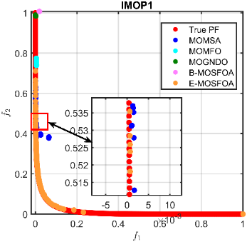 | 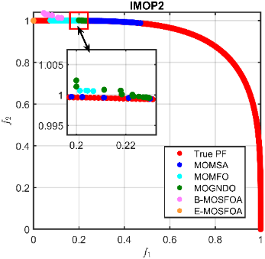 | 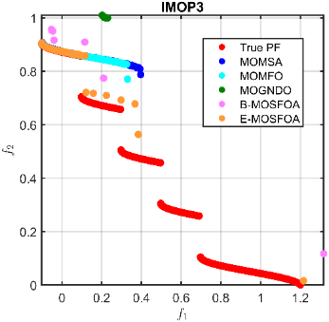
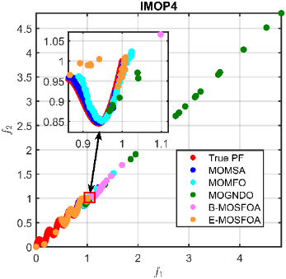 | 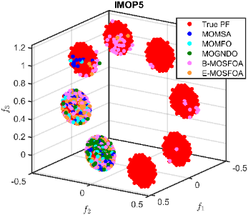 | 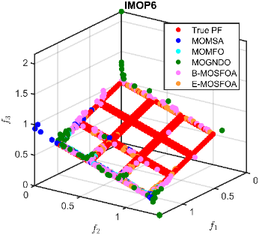
- Approximated Pareto fronts for IMOP problems. | 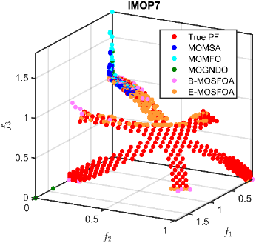 | 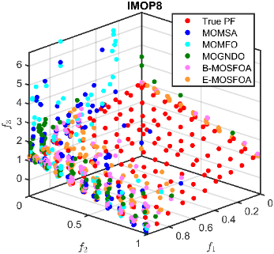
Overall, both proposed algorithms consistently outperform MOMSA, NS-MFO, and MOGNDO in terms of convergence. As shown in Table 3, E-MOSFOA achieves the best IGD values in 5 out of 8 problems (IMOP2, IMOP3, IMOP4, IMOP7, and IMOP8), demonstrating strong approximation of the true Pareto front. For instance, in IMOP2, E-MOSFOA attains an IGD of $5.83×{10}^{-3}$, significantly lower than MOMSA ($1.71×{10}^{-2}$), NS-MFO ($2.22×{10}^{-2}$), and MOGNDO ($2.28×{10}^{-2}$) (Table 3). B-MOSFOA remains highly competitive, achieving the best $IGD$ in IMOP1, IMOP5, and IMOP6 (Table 3). Notably, it reaches a perfect $IGD$ of $0.00$ in IMOP1, indicating exact convergence. Regarding dominance performance, E-MOSFOA also yields the best $ε$ values in several cases. For example, in IMOP4, it achieves $1.46×{10}^{-1}$, significantly outperforming all baselines (Table 3).

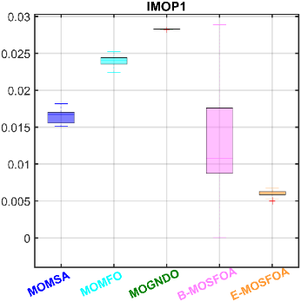 | 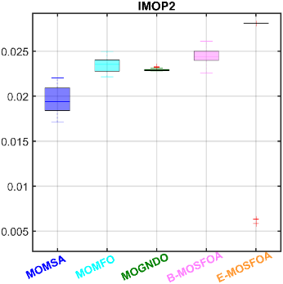 | 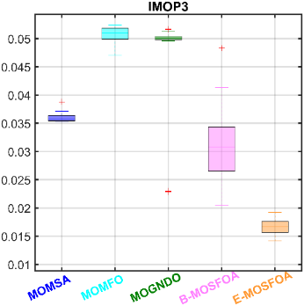
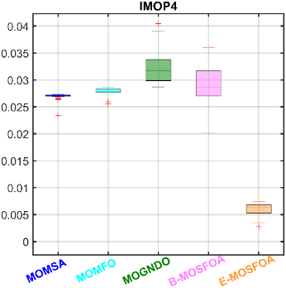 | 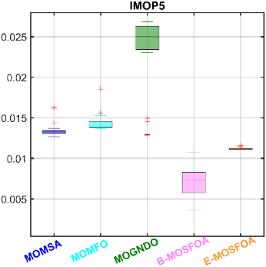 | 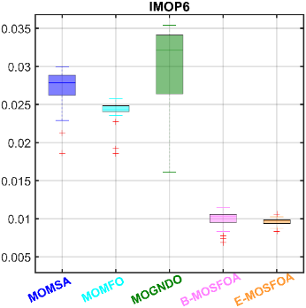
- $IGD$ comparison on IMOPs | 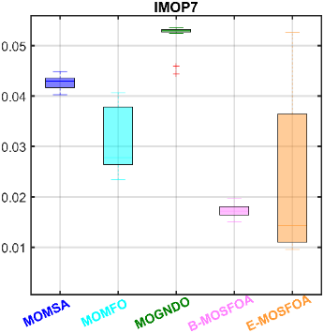 | 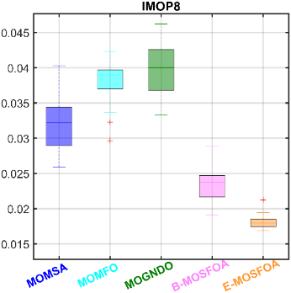
In terms of diversity, the two variants exhibit complementary behavior. E-MOSFOA generally maintains a better balance between convergence and uniformity (lower $Δ$), whereas B-MOSFOA achieves higher MS values in problems such as IMOP3 and IMOP7 (Table 3), indicating broader coverage. For instance, in IMOP6, E-MOSFOA achieves a lower $Δ$ ($5.70×{10}^{-1}$) than B-MOSFOA ($6.31×{10}^{-1}$). These trends are consistent with Fig. 1 and Fig. 2, where both methods produce solutions closer to the true Pareto front with improved distribution. Overall, E-MOSFOA demonstrates stronger convergence, while B-MOSFOA provides competitive performance with better coverage in several cases.
      - Results of UFs
The results on the UF suite are reported in Table 4 and illustrated in Figs. 3 and 4. Compared to IMOP, the UF problems present more diverse and challenging front shapes. As shown in Table 4, E-MOSFOA achieves the best $IGD$ values in multiple problems (UF2, UF4, UF6, UF7, and UF8), indicating robust convergence across complex landscapes.
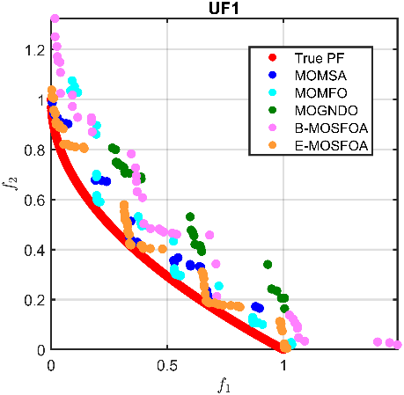 | 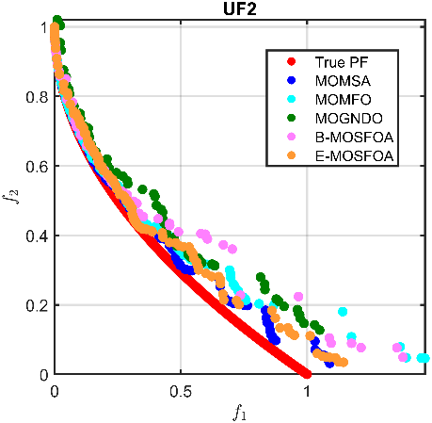 | 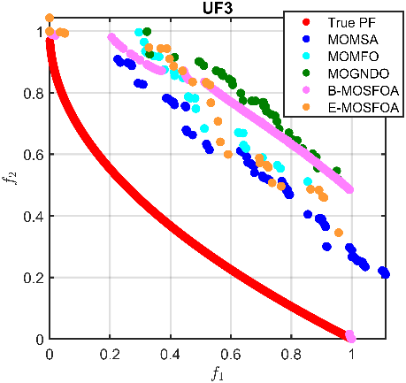
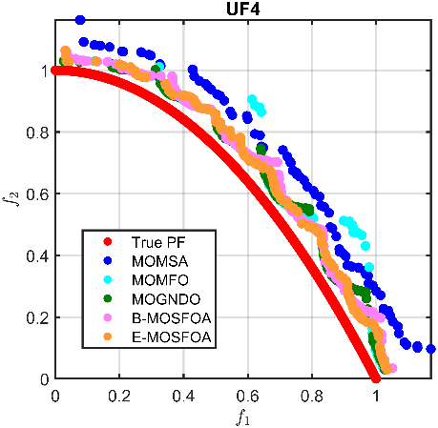 | 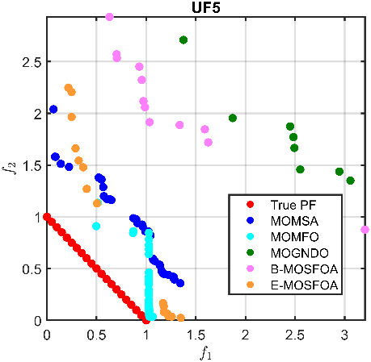 | 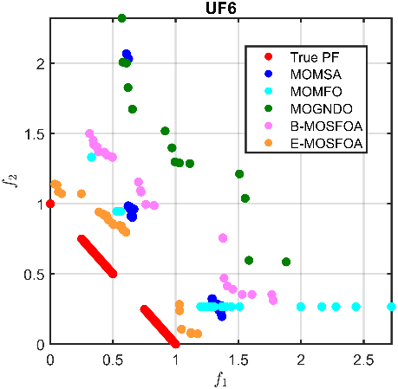
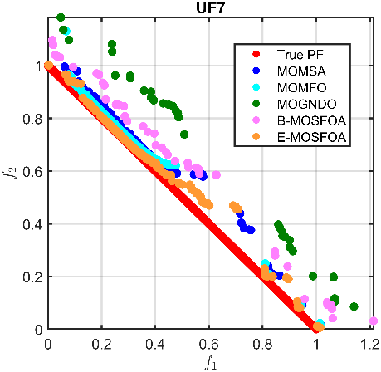 | 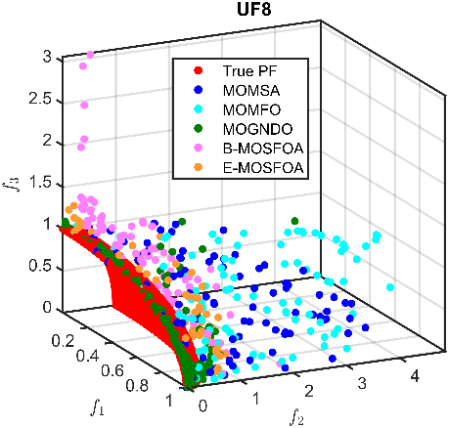 | 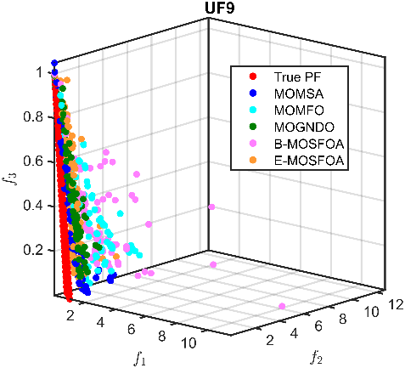
        - Approximated Pareto fronts for UF problems.
B-MOSFOA shows competitive performance but does not consistently achieve the best IGD values. However, it performs well in dominance metrics. For example, in UF4, B-MOSFOA attains the best ε value ($6.23×{10}^{-2}$), slightly outperforming E-MOSFOA ($7.75×{10}^{-2}$) (Table 4). The boxplot results in Fig. 4 further indicate that both methods exhibit stable performance, with lower medians and narrower interquartile ranges in several benchmarks (e.g., UF4–UF8), reflecting consistency across runs. It is worth noting that baseline methods still outperform the proposed algorithms in some cases (e.g., UF1 and UF3, Table 4), highlighting the increased difficulty of this test suite. Overall, E-MOSFOA shows the most consistent convergence performance on the UF benchmarks, while B-MOSFOA remains competitive, particularly in dominance-related metrics.
      - Results of the RM-MEDA suite:
The RM-MEDA results are summarized in Table 5 and visualized in Figs. 5 and 6.
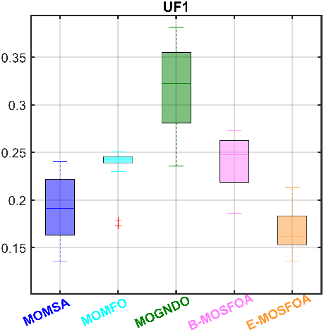 | 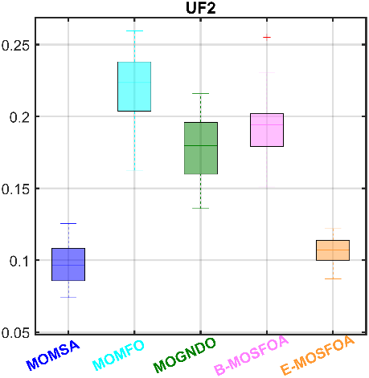 | 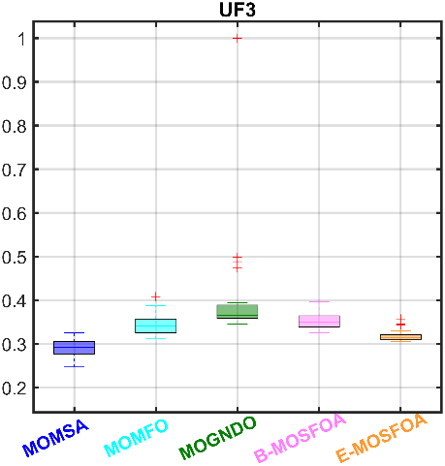
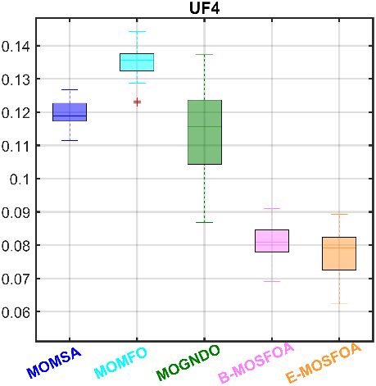 | 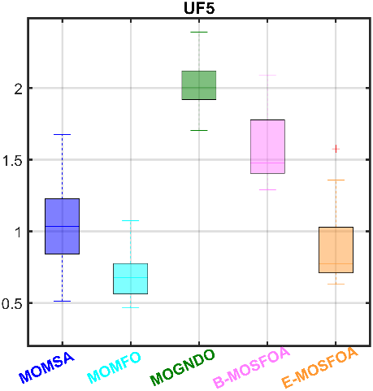 | 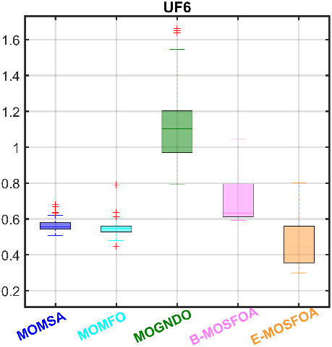
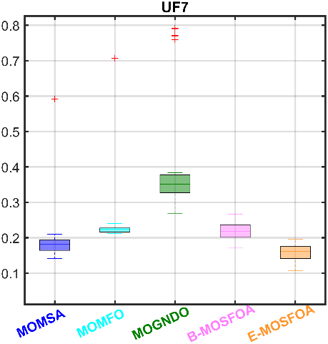 | 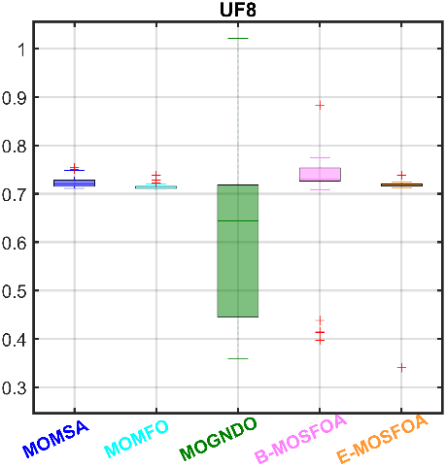 | 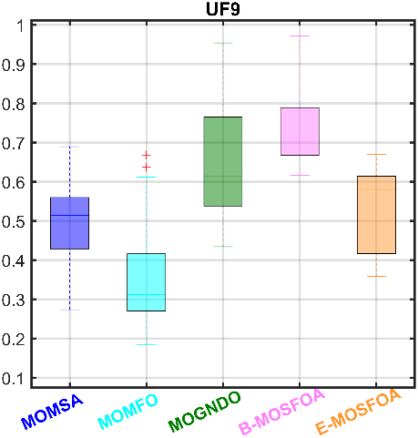
        - $ϵ$ comparison on UFs
On these more practical and irregular problems, both proposed methods remain competitive, although their strengths are more differentiated. As shown in Table 5, B-MOSFOA achieves the best IGD values in several cases. For example, in RM-MEDA2, it attains $8.50×{10}^{-5}$, outperforming all compared methods. E-MOSFOA demonstrates stronger performance in dominance metrics. In RM-MEDA5, it achieves the lowest $Mean ε$ ($1.41×{10}^{-2}$), clearly outperforming MOMSA, NS-MFO, and MOGNDO (Table 5).
For diversity metrics, neither method consistently dominates. E-MOSFOA often achieves lower $Δ$ values, indicating more uniform solution distribution, while B-MOSFOA shows competitive or higher $MS$ values in some problems, reflecting broader coverage (Table 5).

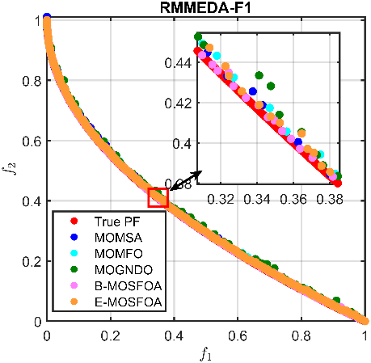 | 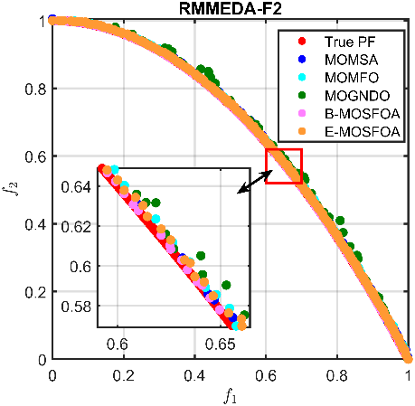 | 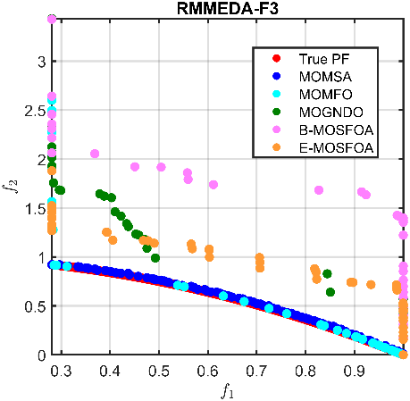
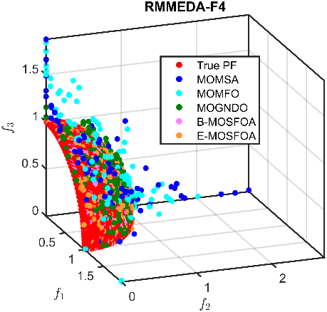 | 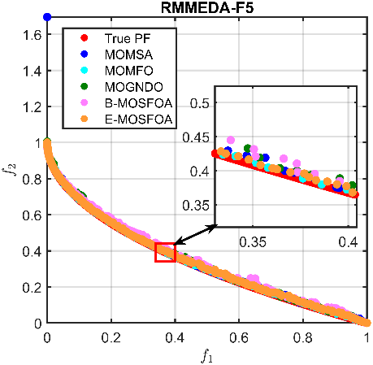 | 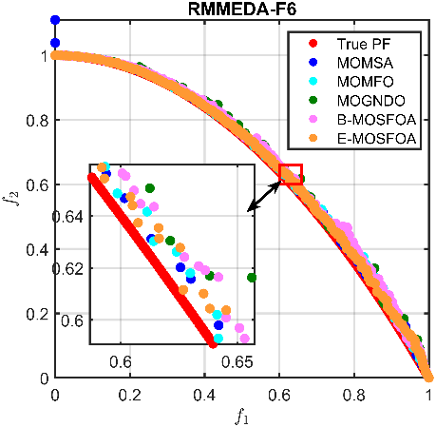
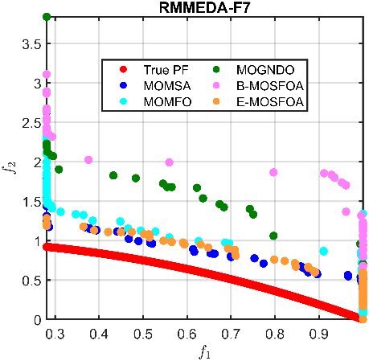 | 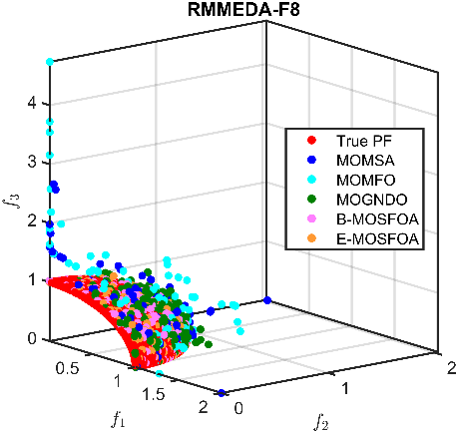 | 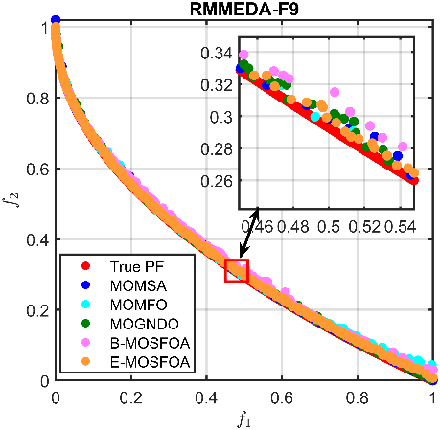
        - Approximated Pareto fronts for RM-MEDA problems.
The $PF$ visualizations in Fig. 5 confirm that both methods generate well-distributed solutions close to the true front, although performance varies depending on problem characteristics. Overall, the RM-MEDA results indicate that B-MOSFOA excels in convergence for certain problems, whereas E-MOSFOA provides better dominance accuracy and distribution uniformity. These results highlight complementary strengths between the two variants.

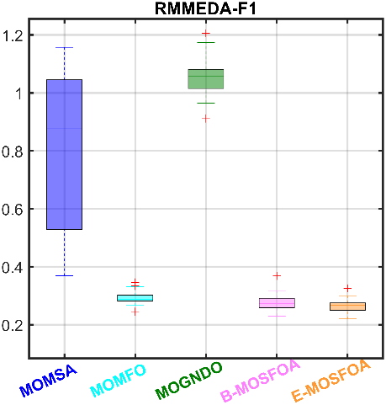 | 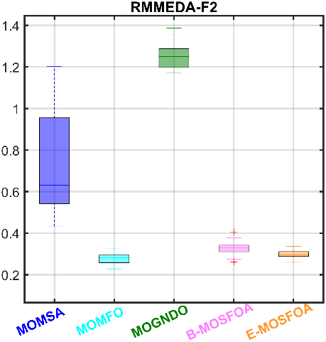 | 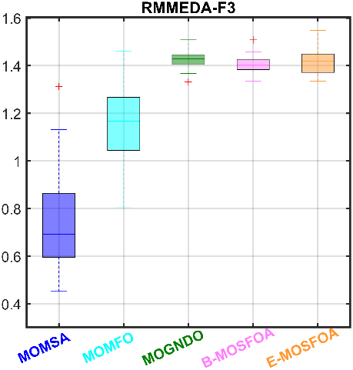
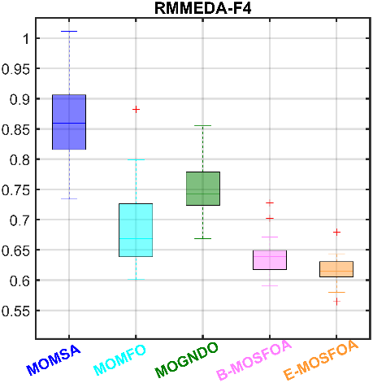 | 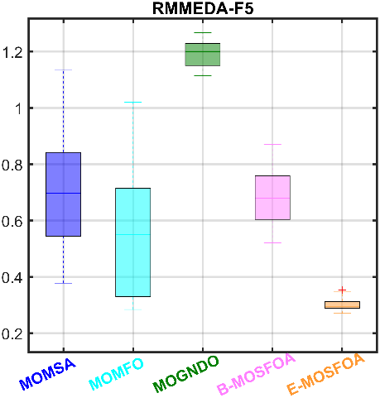 | 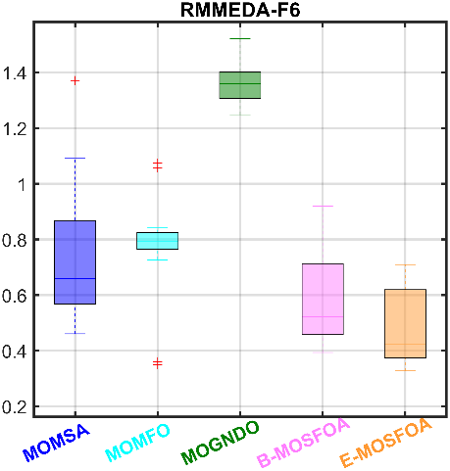
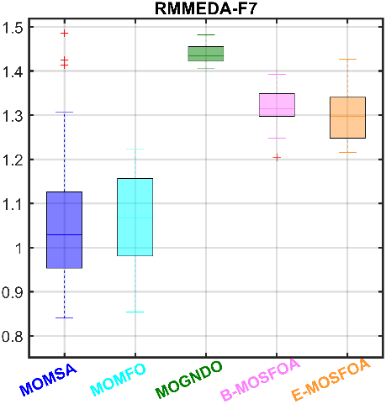 | 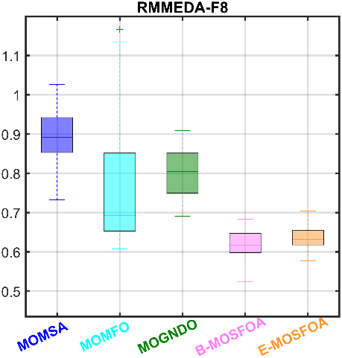 | 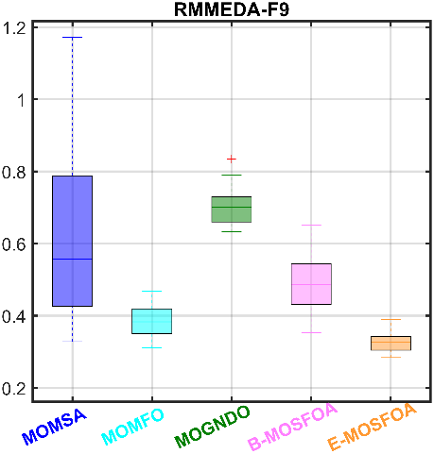
        - $Δ$ comparison on RM-MEDAs.

- Indicator results on IMOP benchmarks.
IMOP | SKs | $IGD$ |  |  |  |  | $ϵ$ |  |  |  |  | $Δ$ |  |  |  |  | $MS$
 |  | (I) | (II) | (III) | (IV) | (V) | (I) | (II) | (III) | (IV) | (V) | (I) | (II) | (III) | (IV) | (V) | (I) | (II) | (III) | (IV) | (V)
1 | (1) | 1.51E-2 | 2.24E-2 | 2.82E-2 | 0.00E+0 | 4.95E-3 | 3.04E-1 | 7.38E-1 | 9.84E-1 | 0.00E+0 | 1.07E-2 | 1.01E+0 | 9.44E-1 | 9.99E-1 | 0.00E+0 | 1.17E+0 | 1.54E-1 | 2.84E-3 | 2.71E-4 | 0.00E+0 | 7.94E-1
 | (2) | 1.82E-2 | 2.52E-2 | 2.83E-2 | 2.89E-2 | 6.71E-3 | 5.27E-1 | 8.62E-1 | 9.88E-1 | 1.02E+0 | 6.58E-2 | 1.32E+0 | 1.08E+0 | 1.00E+0 | 1.29E+0 | 1.26E+0 | 4.19E-1 | 1.06E-1 | 3.45E-3 | 1.03E+0 | 9.04E-1
 | (3) | 1.65E-2 | 2.40E-2 | 2.83E-2 | 1.38E-2 | 6.01E-3 | 4.24E-1 | 8.10E-1 | 9.87E-1 | 5.14E-1 | 2.99E-2 | 1.13E+0 | 1.00E+0 | 1.00E+0 | 1.01E+0 | 1.21E+0 | 3.02E-1 | 4.62E-2 | 1.06E-3 | 7.16E-1 | 8.47E-1
 | (4) | 8.74E-4 | 7.17E-4 | 2.56E-5 | 8.33E-3 | 4.23E-4 | 5.78E-2 | 3.15E-2 | 8.70E-4 | 2.95E-1 | 1.52E-2 | 6.76E-2 | 3.00E-2 | 2.82E-4 | 2.92E-1 | 2.60E-2 | 7.95E-2 | 3.39E-2 | 6.59E-4 | 4.37E-1 | 2.63E-2
2 | (1) | 1.71E-2 | 2.22E-2 | 2.28E-2 | 2.26E-2 | 5.83E-3 | 9.81E-1 | 1.00E+0 | 1.00E+0 | 1.01E+0 | 1.40E-2 | 9.19E-1 | 9.43E-1 | 9.88E-1 | 9.58E-1 | 1.00E+0 | 1.77E-1 | 3.76E-2 | 1.33E-2 | 0.00E+0 | 1.77E-7
 | (2) | 2.21E-2 | 2.50E-2 | 2.33E-2 | 2.61E-2 | 2.81E-2 | 1.00E+0 | 1.01E+0 | 1.01E+0 | 1.04E+0 | 1.00E+0 | 1.17E+0 | 1.05E+0 | 1.07E+0 | 1.01E+0 | 1.20E+0 | 3.52E-1 | 1.22E-1 | 1.13E-1 | 1.11E-1 | 8.77E-1
 | (3) | 1.96E-2 | 2.35E-2 | 2.29E-2 | 2.45E-2 | 2.66E-2 | 9.94E-1 | 1.00E+0 | 1.00E+0 | 1.03E+0 | 9.36E-1 | 1.03E+0 | 9.87E-1 | 9.98E-1 | 9.87E-1 | 1.01E+0 | 2.58E-1 | 8.37E-2 | 2.82E-2 | 5.21E-2 | 5.68E-2
 | (4) | 1.43E-3 | 8.08E-4 | 1.15E-4 | 7.71E-4 | 5.58E-3 | 5.14E-3 | 1.52E-3 | 2.35E-3 | 7.44E-3 | 2.44E-1 | 7.52E-2 | 2.56E-2 | 1.33E-2 | 1.18E-2 | 5.08E-2 | 4.65E-2 | 2.37E-2 | 1.81E-2 | 2.73E-2 | 2.16E-1
3 | (1) | 3.54E-2 | 4.71E-2 | 2.28E-2 | 2.05E-2 | 1.41E-2 | 7.43E-1 | 8.71E-1 | 9.51E-1 | 6.19E-1 | 4.79E-1 | 8.36E-1 | 9.33E-1 | 9.87E-1 | 9.16E-1 | 1.38E+0 | 2.06E-1 | 2.00E-2 | 1.77E-3 | 7.28E-2 | 9.87E-1
 | (2) | 3.88E-2 | 5.24E-2 | 5.17E-2 | 4.83E-2 | 1.92E-2 | 8.11E-1 | 8.97E-1 | 1.00E+0 | 9.20E-1 | 6.05E-1 | 9.42E-1 | 9.97E-1 | 1.01E+0 | 1.46E+0 | 1.64E+0 | 2.89E-1 | 9.37E-2 | 4.91E-2 | 1.01E+0 | 9.98E-1
 | (3) | 3.59E-2 | 5.07E-2 | 4.75E-2 | 3.08E-2 | 1.66E-2 | 7.82E-1 | 8.85E-1 | 9.66E-1 | 7.78E-1 | 5.46E-1 | 8.78E-1 | 9.76E-1 | 9.97E-1 | 1.21E+0 | 1.49E+0 | 2.70E-1 | 4.32E-2 | 1.82E-2 | 9.55E-1 | 9.92E-1
 | (4) | 7.20E-4 | 1.34E-3 | 8.36E-3 | 5.88E-3 | 1.31E-3 | 1.37E-2 | 6.62E-3 | 1.21E-2 | 8.69E-2 | 2.72E-2 | 2.65E-2 | 1.44E-2 | 4.14E-3 | 1.42E-1 | 7.61E-2 | 1.91E-2 | 1.79E-2 | 1.21E-2 | 1.67E-1 | 3.07E-3
4 | (1) | 2.34E-2 | 2.55E-2 | 2.87E-2 | 2.01E-2 | 2.72E-3 | 8.37E-1 | 9.44E-1 | 9.67E-1 | 7.53E-1 | 1.46E-1 | 8.93E-1 | 1.07E+0 | 8.34E-1 | 1.20E+0 | 8.83E-1 | 1.35E-1 | 1.21E+0 | 1.37E+0 | 1.47E+0 | 1.01E+0
 | (2) | 2.73E-2 | 2.86E-2 | 4.04E-2 | 3.60E-2 | 7.40E-3 | 9.31E-1 | 9.73E-1 | 1.32E+0 | 1.22E+0 | 3.52E-1 | 1.29E+0 | 1.42E+0 | 1.15E+0 | 1.39E+0 | 1.10E+0 | 1.71E+0 | 3.75E+0 | 3.18E+0 | 1.94E+0 | 1.09E+0
 | (3) | 2.69E-2 | 2.78E-2 | 3.24E-2 | 2.89E-2 | 5.95E-3 | 9.08E-1 | 9.58E-1 | 1.08E+0 | 1.04E+0 | 2.82E-1 | 1.02E+0 | 1.32E+0 | 9.96E-1 | 1.29E+0 | 9.60E-1 | 4.74E-1 | 2.68E+0 | 2.20E+0 | 1.69E+0 | 1.04E+0
 | (4) | 7.03E-4 | 6.64E-4 | 3.16E-3 | 3.55E-3 | 1.19E-3 | 1.47E-2 | 8.60E-3 | 9.26E-2 | 1.15E-1 | 4.78E-2 | 1.16E-1 | 7.27E-2 | 6.95E-2 | 4.77E-2 | 5.08E-2 | 4.29E-1 | 5.39E-1 | 5.32E-1 | 1.43E-1 | 1.83E-2
5 | (1) | 1.27E-2 | 1.37E-2 | 1.29E-2 | 3.59E-3 | 1.09E-2 | 4.42E-1 | 5.41E-1 | 5.28E-1 | 1.97E-1 | 3.94E-1 | 6.11E-1 | 7.59E-1 | 7.05E-1 | 7.36E-1 | 6.73E-1 | 4.33E-1 | 3.18E-1 | 7.75E-2 | 7.51E-1 | 6.85E-1
 | (2) | 1.63E-2 | 1.86E-2 | 2.68E-2 | 1.07E-2 | 1.17E-2 | 6.95E-1 | 8.01E-1 | 9.05E-1 | 4.38E-1 | 4.70E-1 | 9.21E-1 | 1.00E+0 | 1.09E+0 | 1.01E+0 | 7.95E-1 | 7.13E-1 | 7.55E-1 | 6.11E-1 | 8.89E-1 | 7.84E-1
 | (3) | 1.34E-2 | 1.43E-2 | 2.36E-2 | 7.15E-3 | 1.12E-2 | 5.07E-1 | 6.02E-1 | 8.50E-1 | 3.41E-1 | 4.19E-1 | 8.12E-1 | 8.97E-1 | 9.07E-1 | 8.22E-1 | 7.32E-1 | 5.96E-1 | 5.45E-1 | 1.79E-1 | 8.20E-1 | 7.26E-1
 | (4) | 8.30E-4 | 9.34E-4 | 4.08E-3 | 1.69E-3 | 1.56E-4 | 6.52E-2 | 5.74E-2 | 1.03E-1 | 6.22E-2 | 1.84E-2 | 7.49E-2 | 6.22E-2 | 9.50E-2 | 6.26E-2 | 3.20E-2 | 5.73E-2 | 7.33E-2 | 1.52E-1 | 3.57E-2 | 2.88E-2
6 | (1) | 1.86E-2 | 1.86E-2 | 1.61E-2 | 6.86E-3 | 8.35E-3 | 4.59E-1 | 3.58E-1 | 3.88E-1 | 1.75E-1 | 1.90E-1 | 7.80E-1 | 7.80E-1 | 8.04E-1 | 6.31E-1 | 5.70E-1 | 6.83E-1 | 1.09E+0 | 6.97E-1 | 1.02E+0 | 9.97E-1
 | (2) | 2.99E-2 | 2.58E-2 | 3.54E-2 | 1.15E-2 | 1.06E-2 | 8.21E-1 | 6.41E-1 | 9.84E-1 | 2.85E-1 | 2.38E-1 | 1.14E+0 | 1.02E+0 | 1.34E+0 | 7.65E-1 | 7.57E-1 | 1.77E+0 | 1.76E+0 | 2.32E+0 | 1.08E+0 | 1.08E+0
 | (3) | 2.72E-2 | 2.41E-2 | 2.94E-2 | 9.99E-3 | 9.62E-3 | 7.31E-1 | 4.77E-1 | 7.94E-1 | 2.34E-1 | 2.19E-1 | 9.62E-1 | 9.10E-1 | 1.07E+0 | 6.96E-1 | 6.71E-1 | 9.30E-1 | 1.41E+0 | 1.38E+0 | 1.05E+0 | 1.01E+0
 | (4) | 2.59E-3 | 1.56E-3 | 6.23E-3 | 1.15E-3 | 4.40E-4 | 9.78E-2 | 7.67E-2 | 2.08E-1 | 2.79E-2 | 1.27E-2 | 9.83E-2 | 5.66E-2 | 1.51E-1 | 3.61E-2 | 4.54E-2 | 3.07E-1 | 1.93E-1 | 4.79E-1 | 1.53E-2 | 1.61E-2
7 | (1) | 4.03E-2 | 2.34E-2 | 4.44E-2 | 1.50E-2 | 9.54E-3 | 9.18E-1 | 3.99E-1 | 9.98E-1 | 2.61E-1 | 2.22E-1 | 7.53E-1 | 9.21E-1 | 8.76E-1 | 8.95E-1 | 8.46E-1 | 2.46E-1 | 9.60E-1 | 1.15E-1 | 1.01E+0 | 8.21E-1
 | (2) | 4.48E-2 | 4.07E-2 | 5.36E-2 | 1.97E-2 | 5.26E-2 | 9.68E-1 | 9.95E-1 | 1.00E+0 | 3.36E-1 | 1.00E+0 | 1.05E+0 | 1.37E+0 | 1.30E+0 | 1.42E+0 | 1.57E+0 | 5.39E-1 | 1.68E+0 | 1.71E+0 | 1.08E+0 | 1.49E+0
 | (3) | 4.27E-2 | 3.03E-2 | 5.23E-2 | 1.72E-2 | 2.15E-2 | 9.48E-1 | 6.66E-1 | 1.00E+0 | 2.96E-1 | 4.47E-1 | 8.93E-1 | 1.15E+0 | 1.04E+0 | 1.26E+0 | 1.20E+0 | 3.56E-1 | 1.44E+0 | 3.92E-1 | 1.04E+0 | 1.05E+0
 | (4) | 1.16E-3 | 5.50E-3 | 2.35E-3 | 1.15E-3 | 1.43E-2 | 1.17E-2 | 2.36E-1 | 1.52E-3 | 1.83E-2 | 3.05E-1 | 6.57E-2 | 1.08E-1 | 9.43E-2 | 9.89E-2 | 2.01E-1 | 7.23E-2 | 1.69E-1 | 4.09E-1 | 1.91E-2 | 1.42E-1
8 | (1) | 2.59E-2 | 2.97E-2 | 3.33E-2 | 1.91E-2 | 1.69E-2 | 5.37E-1 | 5.58E-1 | 6.37E-1 | 4.29E-1 | 3.89E-1 | 7.54E-1 | 6.70E-1 | 6.26E-1 | 6.74E-1 | 5.82E-1 | 1.09E+0 | 8.73E-1 | 1.00E+0 | 9.31E-1 | 9.69E-1
 | (2) | 4.03E-2 | 4.23E-2 | 4.62E-2 | 2.89E-2 | 2.13E-2 | 7.63E-1 | 7.51E-1 | 8.53E-1 | 1.14E+0 | 6.28E-1 | 9.76E-1 | 8.90E-1 | 8.38E-1 | 8.44E-1 | 7.12E-1 | 1.38E+0 | 1.04E+0 | 1.26E+0 | 1.02E+0 | 1.02E+0
 | (3) | 3.21E-2 | 3.82E-2 | 3.96E-2 | 2.36E-2 | 1.81E-2 | 6.73E-1 | 7.00E-1 | 7.71E-1 | 6.90E-1 | 4.62E-1 | 8.59E-1 | 7.70E-1 | 7.25E-1 | 7.63E-1 | 6.52E-1 | 1.28E+0 | 9.36E-1 | 1.11E+0 | 9.78E-1 | 9.86E-1
 | (4) | 3.72E-3 | 2.78E-3 | 3.62E-3 | 2.47E-3 | 8.99E-4 | 6.30E-2 | 3.69E-2 | 4.98E-2 | 2.04E-1 | 5.89E-2 | 5.58E-2 | 5.21E-2 | 4.73E-2 | 4.91E-2 | 2.67E-2 | 8.16E-2 | 4.14E-2 | 6.75E-2 | 2.79E-2 | 1.05E-2

- Indicator results on UF benchmarks.
UF | SKs | $IGD$ |  |  |  |  | $ϵ$ |  |  |  |  | Δ |  |  |  |  | $MS$
 |  | (I) | (II) | (III) | (IV) | (V) | (I) | (II) | (III) | (IV) | (V) | (I) | (II) | (III) | (IV) | (V) | (I) | (II) | (III) | (IV) | (V)
1 | (1) | 2.53E-3 | 2.80E-3 | 6.43E-3 | 4.57E-3 | 2.57E-3 | 1.35E-1 | 1.73E-1 | 2.36E-1 | 1.86E-1 | 1.36E-1 | 1.09E+0 | 1.47E+0 | 7.47E-1 | 6.49E-1 | 7.99E-1 | 6.96E-1 | 8.21E-1 | 6.38E-1 | 1.09E+0 | 7.09E-1
 | (2) | 4.82E-3 | 4.48E-3 | 8.81E-3 | 6.08E-3 | 3.97E-3 | 2.40E-1 | 2.50E-1 | 3.82E-1 | 2.73E-1 | 2.14E-1 | 1.44E+0 | 1.86E+0 | 1.23E+0 | 1.07E+0 | 1.26E+0 | 1.66E+0 | 1.53E+0 | 1.18E+0 | 2.34E+0 | 1.41E+0
 | (3) | 3.60E-3 | 4.22E-3 | 7.17E-3 | 5.15E-3 | 3.11E-3 | 1.92E-1 | 2.38E-1 | 3.18E-1 | 2.40E-1 | 1.67E-1 | 1.25E+0 | 1.68E+0 | 1.03E+0 | 8.53E-1 | 9.68E-1 | 1.16E+0 | 1.04E+0 | 9.24E-1 | 1.36E+0 | 1.10E+0
 | (4) | 4.30E-4 | 2.98E-4 | 5.33E-4 | 3.88E-4 | 2.98E-4 | 3.25E-2 | 1.76E-2 | 4.16E-2 | 2.65E-2 | 2.06E-2 | 9.35E-2 | 1.02E-1 | 1.14E-1 | 1.06E-1 | 1.04E-1 | 1.91E-1 | 1.39E-1 | 2.04E-1 | 2.87E-1 | 1.51E-1
2 | (1) | 1.33E-3 | 2.75E-3 | 3.02E-3 | 3.30E-3 | 1.64E-3 | 7.39E-2 | 1.63E-1 | 1.36E-1 | 1.51E-1 | 8.70E-2 | 4.72E-1 | 6.58E-1 | 6.45E-1 | 1.27E+0 | 9.81E-1 | 9.37E-1 | 1.01E+0 | 9.69E-1 | 9.48E-1 | 9.83E-1
 | (2) | 2.10E-3 | 4.24E-3 | 3.69E-3 | 5.00E-3 | 2.32E-3 | 1.25E-1 | 2.60E-1 | 2.16E-1 | 2.55E-1 | 1.22E-1 | 7.40E-1 | 8.59E-1 | 9.53E-1 | 1.58E+0 | 1.20E+0 | 1.15E+0 | 1.28E+0 | 1.71E+0 | 1.57E+0 | 1.40E+0
 | (3) | 1.61E-3 | 3.54E-3 | 3.33E-3 | 3.82E-3 | 2.05E-3 | 9.79E-2 | 2.20E-1 | 1.80E-1 | 1.95E-1 | 1.07E-1 | 6.21E-1 | 7.43E-1 | 8.33E-1 | 1.38E+0 | 1.08E+0 | 1.06E+0 | 1.13E+0 | 1.43E+0 | 1.24E+0 | 1.13E+0
 | (4) | 1.90E-4 | 3.80E-4 | 1.76E-4 | 3.65E-4 | 1.77E-4 | 1.51E-2 | 2.37E-2 | 2.25E-2 | 2.06E-2 | 9.96E-3 | 6.31E-2 | 5.12E-2 | 7.43E-2 | 7.33E-2 | 5.95E-2 | 5.28E-2 | 7.40E-2 | 1.97E-1 | 1.56E-1 | 9.35E-2
3 | (1) | 8.28E-3 | 9.41E-3 | 1.13E-2 | 1.07E-2 | 9.84E-3 | 2.47E-1 | 3.11E-1 | 3.46E-1 | 3.26E-1 | 3.06E-1 | 8.57E-1 | 1.16E+0 | 1.00E+0 | 8.73E-1 | 1.30E+0 | 9.65E-1 | 1.00E+0 | 0.00E+0 | 1.00E+0 | 8.37E-1
 | (2) | 1.21E-2 | 1.08E-2 | 2.24E-2 | 1.25E-2 | 1.14E-2 | 3.25E-1 | 4.08E-1 | 1.00E+0 | 3.96E-1 | 3.57E-1 | 1.30E+0 | 1.60E+0 | 1.76E+0 | 1.26E+0 | 1.61E+0 | 1.95E+0 | 1.05E+0 | 1.44E+0 | 1.00E+0 | 1.00E+0
 | (3) | 9.93E-3 | 1.04E-2 | 1.29E-2 | 1.15E-2 | 1.04E-2 | 2.91E-1 | 3.45E-1 | 4.41E-1 | 3.54E-1 | 3.18E-1 | 1.04E+0 | 1.41E+0 | 1.59E+0 | 1.08E+0 | 1.46E+0 | 1.33E+0 | 1.00E+0 | 9.33E-1 | 1.00E+0 | 9.95E-1
 | (4) | 9.43E-4 | 3.65E-4 | 3.24E-3 | 4.47E-4 | 3.25E-4 | 1.85E-2 | 2.37E-2 | 1.93E-1 | 1.97E-2 | 1.22E-2 | 1.07E-1 | 1.27E-1 | 2.08E-1 | 9.42E-2 | 9.24E-2 | 2.60E-1 | 1.07E-2 | 3.35E-1 | 0.00E+0 | 2.97E-2
4 | (1) | 3.71E-3 | 2.84E-3 | 1.76E-3 | 1.80E-3 | 1.71E-3 | 1.11E-1 | 1.23E-1 | 8.68E-2 | 6.91E-2 | 6.23E-2 | 5.89E-1 | 8.84E-1 | 6.69E-1 | 6.08E-1 | 5.81E-1 | 1.04E+0 | 1.00E+0 | 1.00E+0 | 1.00E+0 | 1.00E+0
 | (2) | 4.15E-3 | 3.06E-3 | 3.77E-3 | 2.39E-3 | 2.51E-3 | 1.27E-1 | 1.44E-1 | 1.37E-1 | 9.10E-2 | 8.93E-2 | 7.98E-1 | 1.14E+0 | 1.13E+0 | 8.86E-1 | 1.04E+0 | 1.11E+0 | 1.05E+0 | 1.07E+0 | 1.06E+0 | 1.07E+0
 | (3) | 3.91E-3 | 3.00E-3 | 2.83E-3 | 2.09E-3 | 2.00E-3 | 1.19E-1 | 1.35E-1 | 1.14E-1 | 8.05E-2 | 7.77E-2 | 6.65E-1 | 1.03E+0 | 8.74E-1 | 7.40E-1 | 7.68E-1 | 1.07E+0 | 1.01E+0 | 1.02E+0 | 1.03E+0 | 1.02E+0
 | (4) | 1.07E-4 | 5.47E-5 | 5.88E-4 | 1.88E-4 | 1.91E-4 | 3.75E-3 | 4.84E-3 | 1.40E-2 | 5.85E-3 | 7.17E-3 | 4.71E-2 | 6.71E-2 | 1.31E-1 | 7.00E-2 | 1.10E-1 | 1.68E-2 | 1.07E-2 | 1.97E-2 | 1.45E-2 | 1.78E-2
5 | (1) | 1.14E-1 | 7.29E-2 | 4.46E-1 | 3.14E-1 | 1.04E-1 | 5.13E-1 | 4.65E-1 | 1.70E+0 | 1.29E+0 | 6.30E-1 | 1.05E+0 | 1.04E+0 | 7.75E-1 | 7.32E-1 | 9.40E-1 | 5.96E-1 | 8.16E-1 | 7.32E-1 | 1.78E+0 | 1.34E-1
 | (2) | 4.11E-1 | 2.44E-1 | 5.69E-1 | 5.32E-1 | 3.20E-1 | 1.68E+0 | 1.07E+0 | 2.39E+0 | 2.09E+0 | 1.58E+0 | 1.46E+0 | 1.50E+0 | 9.61E-1 | 9.86E-1 | 1.34E+0 | 3.87E+0 | 3.65E+0 | 2.24E+0 | 3.99E+0 | 2.44E+0
 | (3) | 2.20E-1 | 1.25E-1 | 5.08E-1 | 3.98E-1 | 1.55E-1 | 1.03E+0 | 7.01E-1 | 2.03E+0 | 1.56E+0 | 8.88E-1 | 1.23E+0 | 1.24E+0 | 8.75E-1 | 8.39E-1 | 1.06E+0 | 1.84E+0 | 1.68E+0 | 1.55E+0 | 2.46E+0 | 1.56E+0
 | (4) | 6.64E-2 | 3.56E-2 | 3.51E-2 | 6.20E-2 | 4.44E-2 | 2.54E-1 | 1.69E-1 | 1.74E-1 | 2.29E-1 | 2.47E-1 | 8.97E-2 | 1.14E-1 | 5.32E-2 | 5.43E-2 | 8.02E-2 | 7.81E-1 | 6.49E-1 | 4.52E-1 | 4.54E-1 | 6.27E-1
6 | (1) | 1.94E-2 | 1.65E-2 | 3.98E-2 | 2.60E-2 | 1.03E-2 | 5.08E-1 | 4.48E-1 | 7.91E-1 | 5.91E-1 | 2.97E-1 | 1.11E+0 | 1.10E+0 | 7.67E-1 | 7.78E-1 | 8.45E-1 | 1.04E+0 | 4.06E-1 | 2.12E-1 | 1.27E+0 | 4.02E-1
 | (2) | 2.99E-2 | 2.16E-2 | 5.67E-2 | 4.49E-2 | 2.24E-2 | 6.80E-1 | 7.91E-1 | 1.66E+0 | 1.05E+0 | 8.00E-1 | 1.56E+0 | 1.55E+0 | 1.05E+0 | 1.04E+0 | 1.20E+0 | 2.83E+0 | 3.28E+0 | 2.39E+0 | 4.47E+0 | 2.71E+0
 | (3) | 2.22E-2 | 1.99E-2 | 4.94E-2 | 3.25E-2 | 1.69E-2 | 5.70E-1 | 5.53E-1 | 1.15E+0 | 7.01E-1 | 4.74E-1 | 1.34E+0 | 1.41E+0 | 8.93E-1 | 9.15E-1 | 1.05E+0 | 1.60E+0 | 1.31E+0 | 8.97E-1 | 1.96E+0 | 1.10E+0
 | (4) | 2.25E-3 | 1.16E-3 | 4.47E-3 | 5.60E-3 | 3.15E-3 | 4.25E-2 | 6.18E-2 | 2.55E-1 | 1.24E-1 | 1.34E-1 | 9.15E-2 | 9.81E-2 | 6.60E-2 | 5.91E-2 | 8.72E-2 | 5.60E-1 | 6.06E-1 | 5.25E-1 | 7.20E-1 | 4.00E-1
7 | (1) | 2.03E-3 | 3.03E-3 | 5.85E-3 | 3.34E-3 | 1.59E-3 | 1.41E-1 | 2.12E-1 | 2.69E-1 | 1.71E-1 | 1.06E-1 | 7.57E-1 | 1.03E+0 | 7.30E-1 | 6.77E-1 | 7.28E-1 | 4.70E-1 | 7.81E-1 | 3.32E-1 | 1.05E+0 | 1.00E+0
 | (2) | 9.48E-3 | 1.47E-2 | 1.48E-2 | 5.03E-3 | 4.13E-3 | 5.92E-1 | 7.07E-1 | 7.92E-1 | 2.66E-1 | 1.95E-1 | 1.22E+0 | 1.32E+0 | 9.93E-1 | 9.20E-1 | 1.23E+0 | 1.62E+0 | 1.30E+0 | 1.34E+0 | 1.61E+0 | 1.31E+0
 | (3) | 2.89E-3 | 3.72E-3 | 8.60E-3 | 4.04E-3 | 2.54E-3 | 1.92E-1 | 2.39E-1 | 4.11E-1 | 2.20E-1 | 1.59E-1 | 9.66E-1 | 1.15E+0 | 8.68E-1 | 7.90E-1 | 1.00E+0 | 1.08E+0 | 1.03E+0 | 1.00E+0 | 1.21E+0 | 1.05E+0
 | (4) | 1.28E-3 | 2.09E-3 | 2.76E-3 | 4.68E-4 | 5.85E-4 | 7.79E-2 | 8.87E-2 | 1.69E-1 | 2.20E-2 | 2.07E-2 | 1.25E-1 | 6.07E-2 | 6.58E-2 | 6.06E-2 | 1.45E-1 | 1.94E-1 | 1.03E-1 | 2.73E-1 | 1.31E-1 | 6.89E-2
8 | (1) | 1.15E-2 | 1.13E-2 | 8.58E-3 | 9.69E-3 | 7.87E-3 | 7.11E-1 | 7.07E-1 | 3.60E-1 | 3.97E-1 | 3.40E-1 | 6.10E-1 | 5.91E-1 | 5.73E-1 | 1.05E+0 | 6.61E-1 | 2.07E+0 | 1.32E+0 | 9.09E-1 | 8.20E-1 | 8.31E-1
 | (2) | 1.24E-2 | 1.34E-2 | 1.81E-2 | 1.92E-2 | 1.98E-2 | 7.54E-1 | 7.39E-1 | 1.02E+0 | 8.84E-1 | 7.39E-1 | 9.91E-1 | 7.69E-1 | 1.21E+0 | 1.63E+0 | 1.33E+0 | 3.45E+0 | 3.70E+0 | 3.14E+0 | 4.66E+0 | 1.51E+0
 | (3) | 1.19E-2 | 1.19E-2 | 1.16E-2 | 1.39E-2 | 1.62E-2 | 7.24E-1 | 7.15E-1 | 6.06E-1 | 7.02E-1 | 7.06E-1 | 7.31E-1 | 6.81E-1 | 9.06E-1 | 1.38E+0 | 8.12E-1 | 2.76E+0 | 2.27E+0 | 1.52E+0 | 2.09E+0 | 9.12E-1
 | (4) | 2.04E-4 | 3.99E-4 | 2.19E-3 | 2.63E-3 | 2.83E-3 | 1.10E-2 | 6.17E-3 | 1.77E-1 | 1.18E-1 | 6.93E-2 | 7.57E-2 | 4.72E-2 | 1.95E-1 | 1.47E-1 | 1.41E-1 | 3.27E-1 | 5.70E-1 | 5.36E-1 | 8.47E-1 | 1.39E-1
9 | (1) | 8.62E-3 | 5.19E-3 | 1.45E-2 | 2.08E-2 | 1.35E-2 | 2.74E-1 | 1.84E-1 | 4.34E-1 | 6.16E-1 | 3.58E-1 | 8.83E-1 | 8.40E-1 | 5.56E-1 | 8.47E-1 | 6.86E-1 | 1.93E+0 | 8.14E-1 | 1.42E+0 | 2.45E+0 | 1.49E+0
 | (2) | 2.35E-2 | 2.40E-2 | 3.09E-2 | 3.63E-2 | 2.43E-2 | 6.90E-1 | 6.68E-1 | 9.54E-1 | 9.72E-1 | 6.70E-1 | 1.11E+0 | 1.24E+0 | 1.14E+0 | 1.48E+0 | 1.22E+0 | 5.88E+0 | 2.67E+0 | 4.74E+0 | 1.10E+1 | 4.29E+0
 | (3) | 1.67E-2 | 1.04E-2 | 2.30E-2 | 2.58E-2 | 1.80E-2 | 4.98E-1 | 3.53E-1 | 6.39E-1 | 7.34E-1 | 5.31E-1 | 1.00E+0 | 9.91E-1 | 8.56E-1 | 1.17E+0 | 9.35E-1 | 3.70E+0 | 1.60E+0 | 2.18E+0 | 6.92E+0 | 2.71E+0
 | (4) | 3.69E-3 | 4.75E-3 | 4.50E-3 | 3.84E-3 | 2.47E-3 | 9.83E-2 | 1.33E-1 | 1.34E-1 | 9.84E-2 | 9.86E-2 | 6.59E-2 | 8.84E-2 | 1.74E-1 | 1.79E-1 | 1.50E-1 | 9.70E-1 | 4.53E-1 | 7.22E-1 | 2.09E+0 | 8.63E-1

- Indicator results on RM-MEDA benchmarks.
RM-MEDA | SKs | $IGD$ |  |  |  |  | $ϵ$ |  |  |  |  | $Δ$ |  |  |  |  | $MS$
 |  | (I) | (II) | (III) | (IV) | (V) | (I) | (II) | (III) | (IV) | (V) | (I) | (II) | (III) | (IV) | (V) | (I) | (II) | (III) | (IV) | (V)
1 | (1) | 2.14E-4 | 1.86E-4 | 3.29E-4 | 8.91E-5 | 1.13E-4 | 1.34E-2 | 1.11E-2 | 2.26E-2 | 6.09E-3 | 6.89E-3 | 3.69E-1 | 2.45E-1 | 9.11E-1 | 2.30E-1 | 2.20E-1 | 9.95E-1 | 1.00E+0 | 1.00E+0 | 1.00E+0 | 1.00E+0
 | (2) | 2.73E-4 | 2.11E-4 | 4.51E-4 | 2.77E-4 | 1.32E-4 | 2.09E-2 | 1.49E-2 | 4.55E-2 | 1.62E-2 | 1.35E-2 | 1.16E+0 | 3.47E-1 | 1.21E+0 | 3.68E-1 | 3.26E-1 | 2.72E+0 | 1.00E+0 | 1.00E+0 | 1.00E+0 | 1.00E+0
 | (3) | 2.41E-4 | 1.96E-4 | 3.86E-4 | 1.72E-4 | 1.22E-4 | 1.64E-2 | 1.28E-2 | 2.90E-2 | 1.14E-2 | 9.10E-3 | 7.87E-1 | 2.93E-1 | 1.06E+0 | 2.77E-1 | 2.63E-1 | 1.58E+0 | 1.00E+0 | 1.00E+0 | 1.00E+0 | 1.00E+0
 | (4) | 1.71E-5 | 5.38E-6 | 3.30E-5 | 4.34E-5 | 4.78E-6 | 2.02E-3 | 9.46E-4 | 4.99E-3 | 2.51E-3 | 1.73E-3 | 2.69E-1 | 2.29E-2 | 6.60E-2 | 2.84E-2 | 2.27E-2 | 5.64E-1 | 0.00E+0 | 0.00E+0 | 0.00E+0 | 0.00E+0
2 | (1) | 2.17E-4 | 1.87E-4 | 5.81E-4 | 8.50E-5 | 1.18E-4 | 1.44E-2 | 1.02E-2 | 2.50E-2 | 5.36E-3 | 6.38E-3 | 4.34E-1 | 2.26E-1 | 1.17E+0 | 2.61E-1 | 2.60E-1 | 9.87E-1 | 1.00E+0 | 1.00E+0 | 1.00E+0 | 1.00E+0
 | (2) | 3.33E-4 | 2.14E-4 | 1.51E-3 | 1.30E-4 | 2.18E-4 | 2.76E-2 | 1.78E-2 | 5.48E-2 | 1.21E-2 | 1.14E-2 | 1.20E+0 | 3.25E-1 | 1.39E+0 | 4.06E-1 | 3.37E-1 | 3.12E+0 | 1.00E+0 | 1.00E+0 | 1.00E+0 | 1.00E+0
 | (3) | 2.51E-4 | 1.98E-4 | 8.33E-4 | 1.01E-4 | 1.39E-4 | 1.94E-2 | 1.23E-2 | 3.46E-2 | 7.25E-3 | 7.92E-3 | 7.39E-1 | 2.78E-1 | 1.25E+0 | 3.28E-1 | 2.98E-1 | 1.46E+0 | 1.00E+0 | 1.00E+0 | 1.00E+0 | 1.00E+0
 | (4) | 2.13E-5 | 7.95E-6 | 1.86E-4 | 1.30E-5 | 1.98E-5 | 3.69E-3 | 1.46E-3 | 6.35E-3 | 1.61E-3 | 1.30E-3 | 2.45E-1 | 2.79E-2 | 5.32E-2 | 3.05E-2 | 1.91E-2 | 6.22E-1 | 0.00E+0 | 0.00E+0 | 0.00E+0 | 0.00E+0
3 | (1) | 3.13E-4 | 1.65E-3 | 6.58E-3 | 1.32E-2 | 7.28E-3 | 1.44E-2 | 9.12E-2 | 2.69E-1 | 6.33E-1 | 2.50E-1 | 4.52E-1 | 8.04E-1 | 1.33E+0 | 1.33E+0 | 1.33E+0 | 9.99E-1 | 1.09E+0 | 1.68E+0 | 2.08E+0 | 1.27E+0
 | (2) | 2.86E-3 | 1.05E-2 | 1.46E-2 | 1.35E-2 | 1.00E-2 | 9.23E-2 | 3.63E-1 | 5.61E-1 | 7.19E-1 | 3.51E-1 | 1.31E+0 | 1.46E+0 | 1.51E+0 | 1.51E+0 | 1.55E+0 | 4.42E+0 | 6.09E+0 | 6.79E+0 | 4.93E+0 | 4.67E+0
 | (3) | 7.05E-4 | 5.61E-3 | 9.61E-3 | 1.32E-2 | 8.44E-3 | 2.96E-2 | 2.30E-1 | 4.13E-1 | 6.94E-1 | 2.89E-1 | 7.36E-1 | 1.16E+0 | 1.43E+0 | 1.40E+0 | 1.42E+0 | 1.42E+0 | 2.08E+0 | 3.53E+0 | 2.88E+0 | 1.77E+0
 | (4) | 5.10E-4 | 2.43E-3 | 2.19E-3 | 7.79E-5 | 7.53E-4 | 1.51E-2 | 8.24E-2 | 8.27E-2 | 2.38E-2 | 2.85E-2 | 1.99E-1 | 1.57E-1 | 3.76E-2 | 3.57E-2 | 5.13E-2 | 7.04E-1 | 1.15E+0 | 1.48E+0 | 7.11E-1 | 7.92E-1
4 | (1) | 4.22E-3 | 2.65E-3 | 2.53E-3 | 1.58E-3 | 1.68E-3 | 1.93E-1 | 1.13E-1 | 9.94E-2 | 6.42E-2 | 7.75E-2 | 7.34E-1 | 6.01E-1 | 6.69E-1 | 5.91E-1 | 5.64E-1 | 1.67E+0 | 1.01E+0 | 1.00E+0 | 1.00E+0 | 1.00E+0
 | (2) | 6.16E-3 | 4.00E-3 | 4.05E-3 | 1.77E-3 | 2.02E-3 | 3.04E-1 | 1.75E-1 | 3.43E-1 | 1.20E-1 | 1.45E-1 | 1.01E+0 | 8.82E-1 | 8.55E-1 | 7.28E-1 | 6.79E-1 | 4.46E+0 | 3.73E+0 | 3.71E+0 | 1.77E+0 | 1.01E+0
 | (3) | 5.16E-3 | 3.05E-3 | 2.94E-3 | 1.67E-3 | 1.84E-3 | 2.41E-1 | 1.36E-1 | 1.47E-1 | 9.16E-2 | 1.02E-1 | 8.61E-1 | 6.88E-1 | 7.48E-1 | 6.39E-1 | 6.16E-1 | 2.64E+0 | 1.51E+0 | 1.39E+0 | 1.06E+0 | 1.00E+0
 | (4) | 4.87E-4 | 3.08E-4 | 2.89E-4 | 5.88E-5 | 7.35E-5 | 2.48E-2 | 1.48E-2 | 5.01E-2 | 1.68E-2 | 1.77E-2 | 7.14E-2 | 6.39E-2 | 4.43E-2 | 2.88E-2 | 2.23E-2 | 6.35E-1 | 6.67E-1 | 7.18E-1 | 1.46E-1 | 3.24E-3
5 | (1) | 2.57E-4 | 2.05E-4 | 4.01E-4 | 5.10E-4 | 2.03E-4 | 1.57E-2 | 1.20E-2 | 2.50E-2 | 3.04E-2 | 1.17E-2 | 3.78E-1 | 2.84E-1 | 1.11E+0 | 5.21E-1 | 2.70E-1 | 9.23E-1 | 3.98E-1 | 1.00E+0 | 1.00E+0 | 1.00E+0
 | (2) | 7.55E-4 | 1.44E-2 | 5.29E-4 | 9.94E-4 | 2.79E-4 | 6.56E-2 | 5.01E-1 | 4.23E-2 | 5.86E-2 | 1.83E-2 | 1.14E+0 | 1.02E+0 | 1.27E+0 | 8.71E-1 | 3.54E-1 | 2.40E+0 | 1.00E+0 | 1.00E+0 | 1.00E+0 | 1.00E+0
 | (3) | 3.92E-4 | 3.88E-3 | 4.62E-4 | 7.69E-4 | 2.36E-4 | 3.08E-2 | 1.61E-1 | 3.05E-2 | 4.45E-2 | 1.41E-2 | 6.99E-1 | 5.42E-1 | 1.20E+0 | 6.74E-1 | 3.01E-1 | 1.27E+0 | 8.54E-1 | 1.00E+0 | 1.00E+0 | 1.00E+0
 | (4) | 1.58E-4 | 5.41E-3 | 2.94E-5 | 1.18E-4 | 1.92E-5 | 1.55E-2 | 1.91E-1 | 3.28E-3 | 6.92E-3 | 1.46E-3 | 2.04E-1 | 2.08E-1 | 4.44E-2 | 1.01E-1 | 2.16E-2 | 3.73E-1 | 2.47E-1 | 8.12E-4 | 0.00E+0 | 0.00E+0
6 | (1) | 3.07E-4 | 3.12E-4 | 5.17E-4 | 4.01E-4 | 2.12E-4 | 2.28E-2 | 2.51E-2 | 3.04E-2 | 2.88E-2 | 1.64E-2 | 4.61E-1 | 3.50E-1 | 1.25E+0 | 3.93E-1 | 3.27E-1 | 8.33E-1 | 2.63E-1 | 1.00E+0 | 3.99E-1 | 4.62E-1
 | (2) | 2.57E-3 | 1.50E-2 | 8.68E-4 | 1.14E-2 | 9.34E-3 | 3.19E-1 | 8.83E-1 | 6.44E-2 | 7.88E-1 | 6.93E-1 | 1.37E+0 | 1.07E+0 | 1.52E+0 | 9.19E-1 | 7.10E-1 | 2.83E+0 | 1.00E+0 | 1.00E+0 | 1.00E+0 | 1.00E+0
 | (3) | 9.85E-4 | 1.08E-2 | 6.74E-4 | 2.26E-3 | 2.86E-3 | 1.53E-1 | 7.20E-1 | 4.31E-2 | 1.59E-1 | 2.41E-1 | 7.28E-1 | 7.81E-1 | 1.36E+0 | 5.78E-1 | 4.89E-1 | 1.20E+0 | 4.44E-1 | 1.00E+0 | 9.06E-1 | 8.29E-1
 | (4) | 5.85E-4 | 3.78E-3 | 9.36E-5 | 3.70E-3 | 3.36E-3 | 7.21E-2 | 2.25E-1 | 8.95E-3 | 2.68E-1 | 2.77E-1 | 2.19E-1 | 1.39E-1 | 6.85E-2 | 1.50E-1 | 1.33E-1 | 4.61E-1 | 2.10E-1 | 0.00E+0 | 2.15E-1 | 2.18E-1
7 | (1) | 5.31E-3 | 7.97E-3 | 1.11E-2 | 1.32E-2 | 6.10E-3 | 1.83E-1 | 2.95E-1 | 3.91E-1 | 6.42E-1 | 2.15E-1 | 8.40E-1 | 8.54E-1 | 1.41E+0 | 1.20E+0 | 1.22E+0 | 1.56E+0 | 1.42E+0 | 2.29E+0 | 2.23E+0 | 1.21E+0
 | (2) | 6.69E-3 | 1.09E-2 | 1.84E-2 | 1.33E-2 | 8.55E-3 | 2.32E-1 | 4.16E-1 | 7.19E-1 | 7.16E-1 | 2.87E-1 | 1.49E+0 | 1.22E+0 | 1.48E+0 | 1.39E+0 | 1.43E+0 | 4.55E+0 | 4.64E+0 | 7.42E+0 | 3.80E+0 | 2.30E+0
 | (3) | 5.99E-3 | 9.41E-3 | 1.39E-2 | 1.32E-2 | 7.37E-3 | 2.07E-1 | 3.50E-1 | 6.14E-1 | 6.91E-1 | 2.55E-1 | 1.07E+0 | 1.07E+0 | 1.44E+0 | 1.31E+0 | 1.30E+0 | 2.32E+0 | 2.07E+0 | 5.02E+0 | 2.85E+0 | 1.50E+0
 | (4) | 3.76E-4 | 8.14E-4 | 1.50E-3 | 2.90E-5 | 5.32E-4 | 1.36E-2 | 3.39E-2 | 9.32E-2 | 2.34E-2 | 1.81E-2 | 1.63E-1 | 1.01E-1 | 2.25E-2 | 3.97E-2 | 5.78E-2 | 9.48E-1 | 6.06E-1 | 1.67E+0 | 4.25E-1 | 1.92E-1
8 | (1) | 4.22E-3 | 2.90E-3 | 2.80E-3 | 1.85E-3 | 1.85E-3 | 1.89E-1 | 1.28E-1 | 1.11E-1 | 8.39E-2 | 8.84E-2 | 7.32E-1 | 6.07E-1 | 6.91E-1 | 5.23E-1 | 5.77E-1 | 1.72E+0 | 1.00E+0 | 1.00E+0 | 1.00E+0 | 1.00E+0
 | (2) | 5.70E-3 | 6.52E-3 | 3.69E-3 | 3.16E-3 | 2.87E-3 | 3.04E-1 | 2.45E-1 | 2.86E-1 | 1.72E-1 | 1.37E-1 | 1.03E+0 | 1.17E+0 | 9.08E-1 | 6.83E-1 | 7.04E-1 | 4.27E+0 | 4.32E+0 | 2.59E+0 | 1.63E+0 | 1.16E+0
 | (3) | 4.93E-3 | 3.97E-3 | 3.21E-3 | 2.26E-3 | 2.08E-3 | 2.49E-1 | 1.67E-1 | 1.70E-1 | 1.23E-1 | 1.12E-1 | 8.96E-1 | 7.57E-1 | 8.05E-1 | 6.19E-1 | 6.37E-1 | 2.84E+0 | 1.84E+0 | 1.29E+0 | 1.09E+0 | 1.01E+0
 | (4) | 4.22E-4 | 8.12E-4 | 2.25E-4 | 2.99E-4 | 2.13E-4 | 3.00E-2 | 3.25E-2 | 4.36E-2 | 2.04E-2 | 1.34E-2 | 7.01E-2 | 1.54E-1 | 5.73E-2 | 3.62E-2 | 2.97E-2 | 6.70E-1 | 1.11E+0 | 4.40E-1 | 1.48E-1 | 3.24E-2
9 | (1) | 2.15E-4 | 4.06E-4 | 1.95E-4 | 4.31E-4 | 1.67E-4 | 1.29E-2 | 3.87E-2 | 1.22E-2 | 3.05E-2 | 1.28E-2 | 3.28E-1 | 3.11E-1 | 6.32E-1 | 3.53E-1 | 2.84E-1 | 9.99E-1 | 8.21E-1 | 9.71E-1 | 9.02E-1 | 9.74E-1
 | (2) | 3.08E-4 | 2.33E-3 | 3.10E-4 | 1.93E-3 | 3.39E-4 | 2.24E-2 | 1.37E-1 | 3.01E-2 | 1.36E-1 | 2.45E-2 | 1.17E+0 | 4.67E-1 | 8.35E-1 | 6.51E-1 | 3.89E-1 | 2.87E+0 | 9.92E-1 | 1.00E+0 | 9.85E-1 | 9.96E-1
 | (3) | 2.44E-4 | 7.98E-4 | 2.39E-4 | 9.24E-4 | 2.23E-4 | 1.63E-2 | 6.81E-2 | 1.85E-2 | 6.52E-2 | 1.78E-2 | 6.17E-1 | 3.85E-1 | 7.00E-1 | 4.91E-1 | 3.26E-1 | 1.24E+0 | 9.43E-1 | 9.90E-1 | 9.64E-1 | 9.92E-1
 | (4) | 2.08E-5 | 4.29E-4 | 2.88E-5 | 3.31E-4 | 3.31E-5 | 2.25E-3 | 2.32E-2 | 3.97E-3 | 2.61E-2 | 3.18E-3 | 2.40E-1 | 4.11E-2 | 4.87E-2 | 7.86E-2 | 2.58E-2 | 4.27E-1 | 3.96E-2 | 7.55E-3 | 1.69E-2 | 5.01E-3

  - Case Study: Moo For a Liquid Bulk Jetty
    - Hai Linh's Liquid Bulk Jetty
The jetty consists of three key subsystems, as illustrated in Fig. 7, including the BD, MD, and MJP, all of which are modeled parametrically and analyzed using SAP2000.
      - Berthing Dolphin
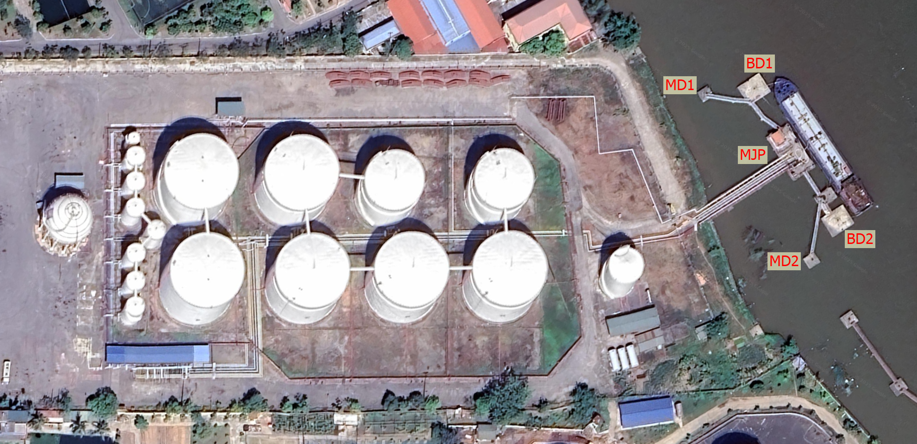
a) Terminal Layout (Source: Google Map)
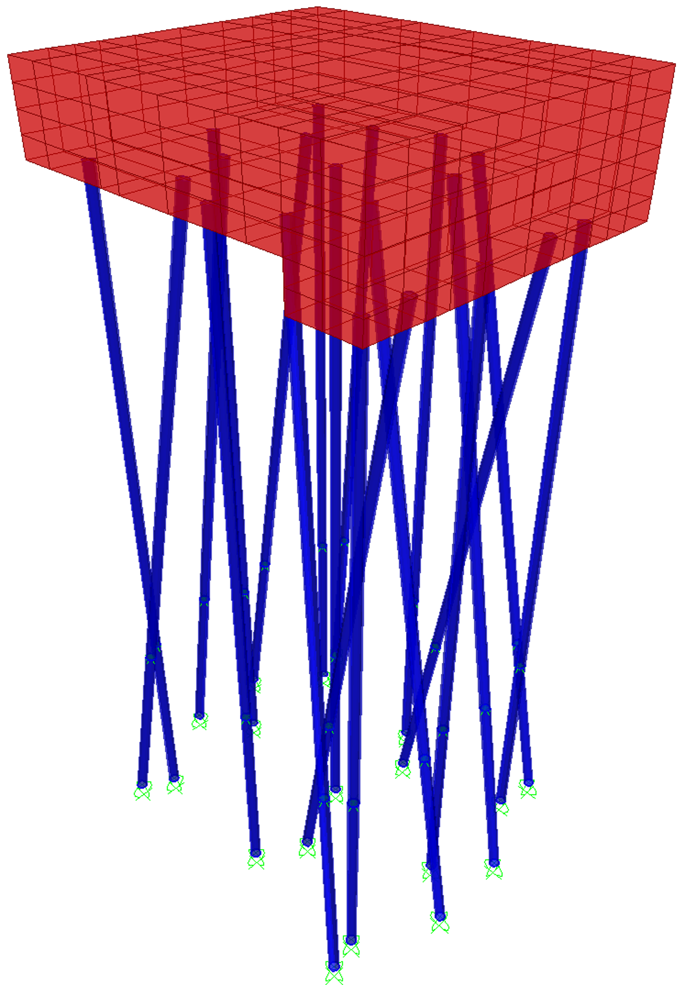 | 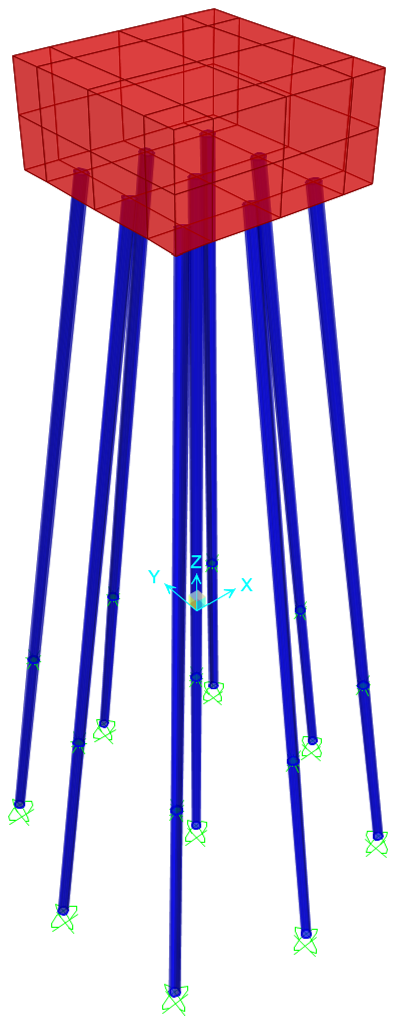 | 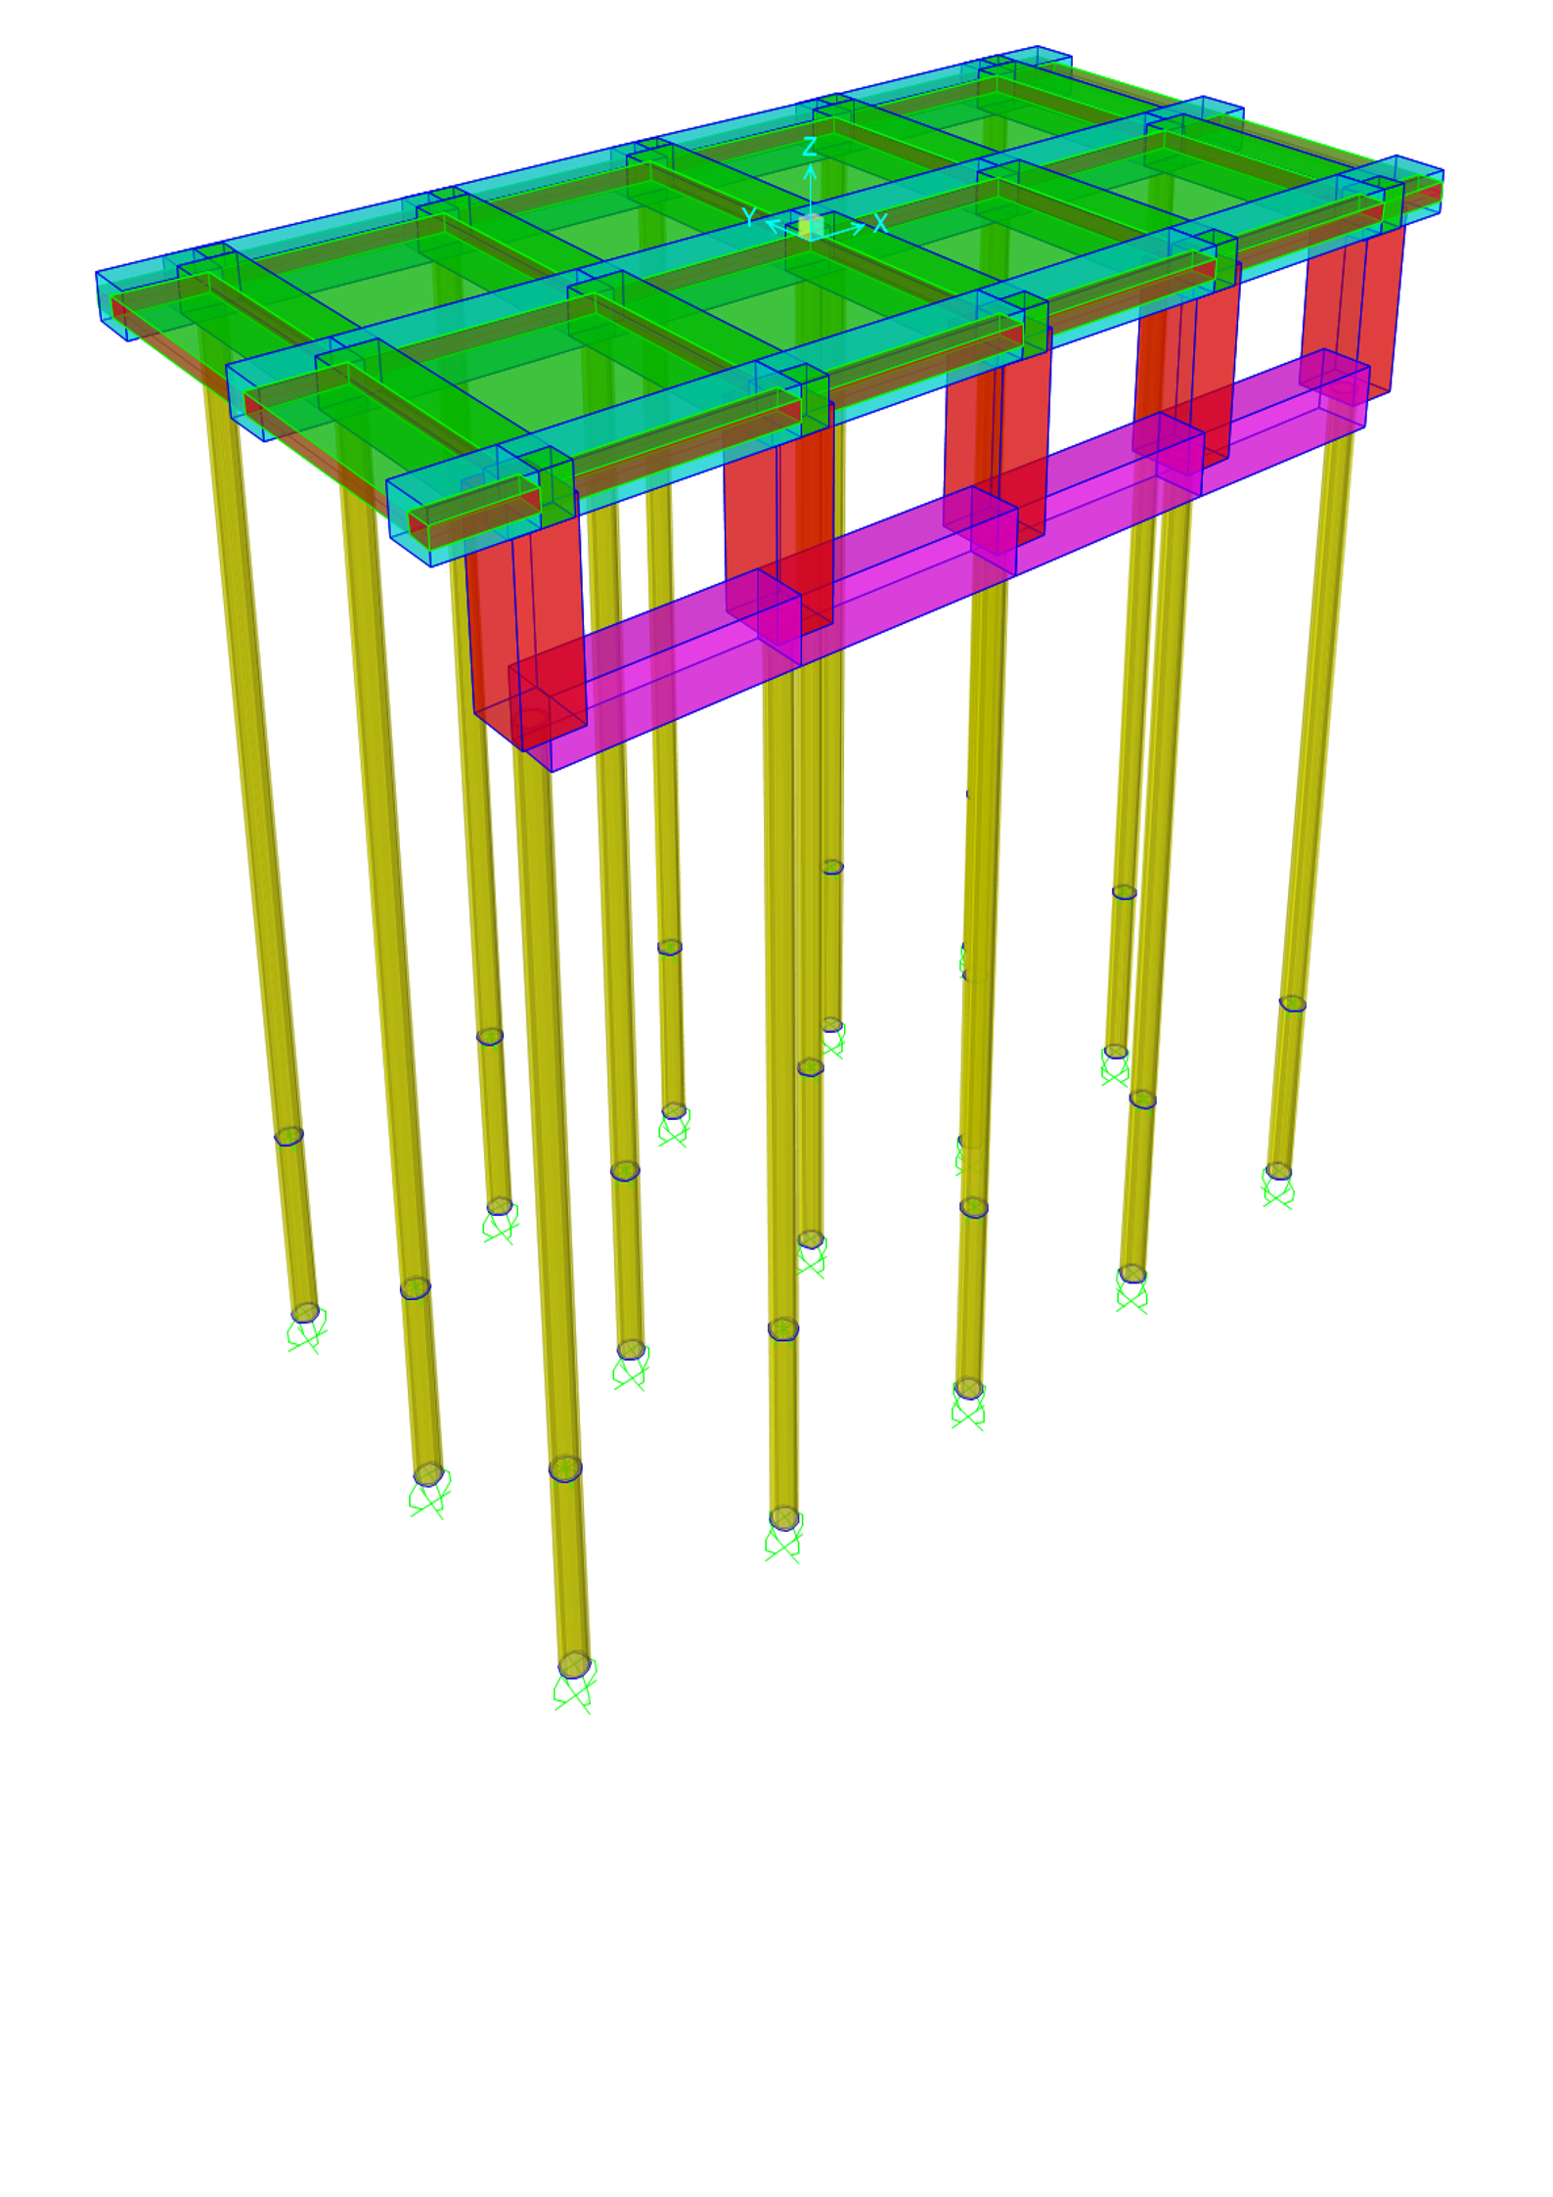
b) FEM model of BD | c) FEM model of MD | d) FEM model of MJP
        - Layout of Hai Linh liquid bulk terminal and corresponding FEM models of BD, MD, and MJP in SAP2000.
BDs are robust pile-supported marine structures designed to absorb and dissipate kinetic energy and horizontal forces generated during ship berthing. In addition, they support mooring operations, contributing to the overall safety and functionality of the jetty system. The current BD configuration consists of 19 prestressed concrete piles (D600B), each with a length of 39 m. The pile arrangement is designed to provide multidirectional resistance to berthing loads, including 9 vertical piles for axial load transfer, 6 in-plane inclined piles with a slope of 6:1, and 4 spatially inclined piles (6:1 slope) rotated at 30° or 60° to enhance resistance in diagonal directions. The structural configuration is illustrated in Fig. 8(a).
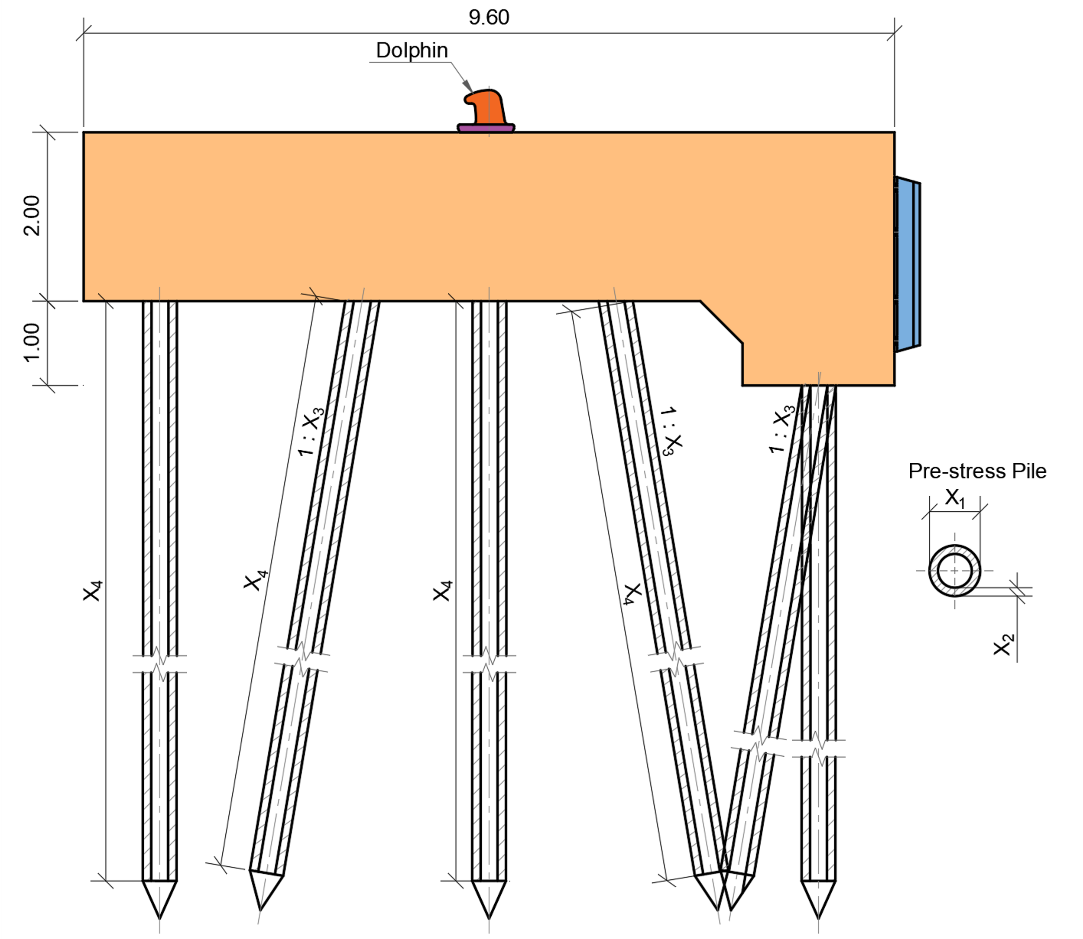 | 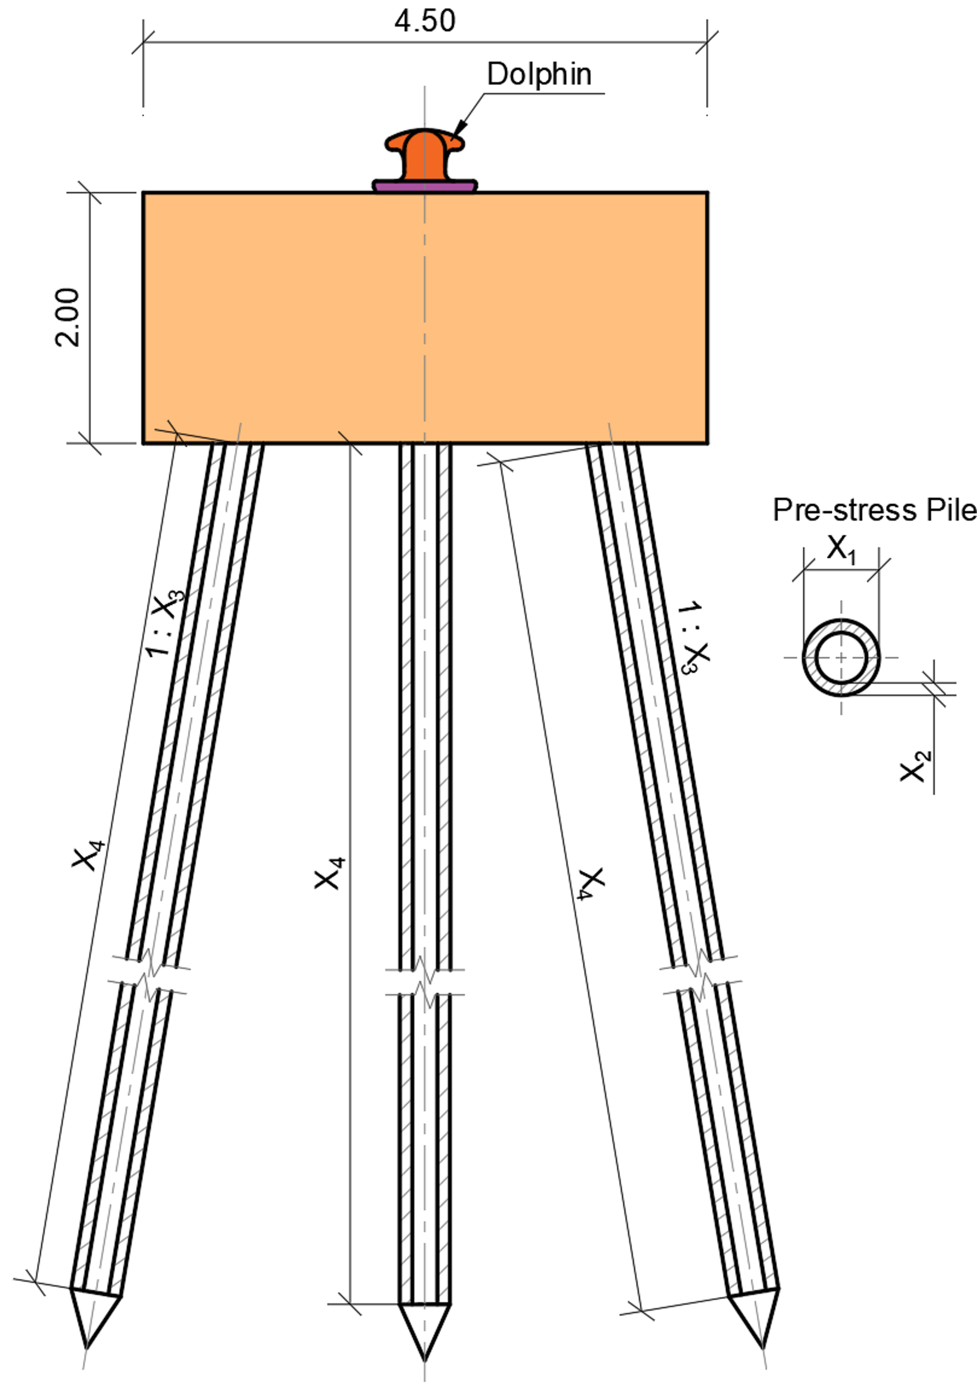
a) BD | b) MD
- Cross-sectional configurations of BD, MD, and MJP subsystems. | 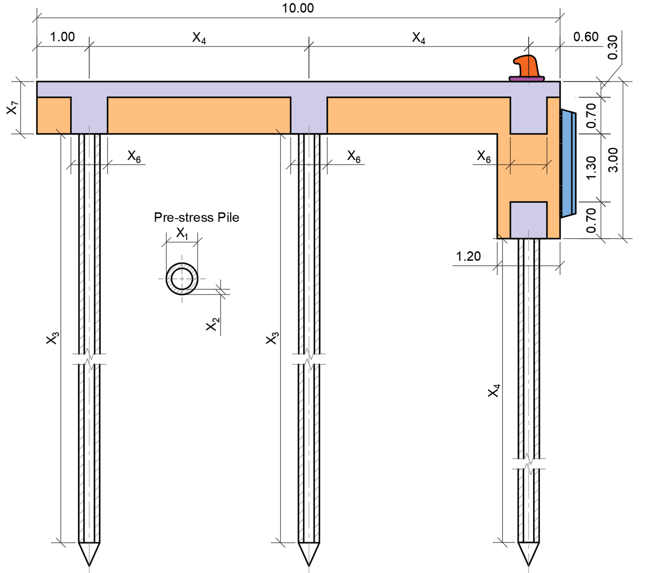
 | c) MJP
A cast-in-place reinforced concrete cap (grade C40/50), with dimensions of 8.4 × 9.6 × (2.0–3.0) m, is constructed on top of the pile group. An extended region beneath the fender mounting zone is incorporated to improve flexural and shear capacity under berthing impact, while also increasing the effective area for anchoring high-capacity fenders. A finite element (FE) model of the BD structure is developed in SAP2000, as part of the unified modeling framework shown in Fig. 7(b). The model includes the full geometry of the pile foundation and cap. Dynamic loads, including berthing loads (BL) and mooring loads (ML), are applied according to standard load combinations based on PIANC (2002) [29] and OCDI (2002) [30]. The envelope combination (EV-COMB) is used to capture the most critical structural responses (see Table 6). The model outputs, including maximum displacements, internal forces, and bending moments in the pile foundation, are extracted and utilized in the MATLAB-based optimization process.
- Load cases and combinations for jetty subsystems
Structures | Load cases | Combinations (Linear Add)
 |  | COMB1 | COMB2 | COMB3
BD | DL | X | X | X
 | BL | --- | X | ---
 | ML | --- | --- | X
 | Envelop-Combination (EV-COMB) | X | X | X
MD | DL | X | X | ---
 | ML | --- | X | ---
 | Envelop-Combination (EV-COMB) | X | X | ---
MJP | DL | X | X | ---
 | LL | --- | X | ---
 | Envelop-Combination (EV-COMB) | X | X | ---
      - Mooring Dolphin
MDs are independent pile-supported structures designed to anchor mooring lines and resist lateral and tensile forces induced by ship motions under the effects of wind, waves, and tides. The current MD configuration consists of nine prestressed concrete piles (D600B), each with a length of 40 m. The pile system includes one vertical pile, four in-plane inclined piles with a slope of 6:1, and four spatially inclined piles (6:1 slope with an inclination angle of 45°) to enhance resistance against multidirectional mooring forces. The structural configuration of the MD system is illustrated in Fig. 8(b). A reinforced concrete pile cap (grade C40/50) with dimensions of 4.5 × 4.5 × 2.0 m is constructed on top of the pile group, providing sufficient stiffness and load transfer capacity for mooring operations.
- Design variables for BD, MD, and MJP structures.
Structures | Variable | Description | Type | Range & References
BD, MD | $X_{1}$ | $D_{p}$ - Pile outside diameter (mm) | Discrete | Ref. [31]
 | $X_{2}$ | $t_{p}$ - Pile wall thickness (mm) | Discrete | Ref. [31]
 | $X_{3}$ | $θ$ - Inclination angle relative to the $z$-axis | Discrete | [6,7,8]
 | $X_{4}$ | $L_{p}$ - Pile length (m) | Discrete | [1:0.1:40]
MJP | $X_{1}$ | $D_{p}$ - Pile outside diameter (mm) | Discrete | Ref. [31]
 | $X_{2}$ | $t_{p}$ - Pile wall thickness (mm) | Discrete | Ref. [31]
 | $X_{3}$ | $L_{p}$ - Pile length (m) | Discrete | [1-40]
 | $X_{4}$ | $L_{long}$ - Longitudinal beam span (m) | Discrete | [3-6]
 | $X_{5}$ | $L_{trans}$ - Transverse beam span (m) | Discrete | [3-6]
 | $X_{6}$ | $B$ - Beam width (m) | Discrete | [0.5-2]
 | $X_{7}$ | $h$ - Beam height (m) | Discrete | [0.5-2]
The MD structure is modeled within the unified finite element framework shown in Fig. 7(c), where the full geometry of the pile cap and pile system is represented. The model is subjected to relevant load cases, including dead load (DL) and mooring load (ML), based on standard load combinations summarized in Table 6. These loading scenarios follow established guidelines from PIANC (2002) [29] and OCDI (2002) [30], ensuring realistic representation of marine operational conditions. The numerical outputs from the SAP2000 model, including maximum displacements, axial forces, and bending moments, are extracted and integrated into the MATLAB-based optimization process. In addition, for the BD and MD structures, four discrete design variables are defined, as summarized in Table 7. These variables are used to explore optimal design configurations under the specified loading conditions.
      - Main Jetty Platform
The MJP is a reinforced concrete deck structure that connects the berthing and mooring dolphins, serving as the main operational platform for transporting petroleum products and supporting equipment such as loading arms, pipelines, firefighting systems, and access walkways. The current MJP configuration is supported by 15 vertical prestressed concrete piles (D500B), each with a length of 39 m, arranged in a 3×5 rectangular grid. The structural layout of the MJP system is illustrated in Fig. 8(c). The transverse and longitudinal beam spans are 4.2 m and 4.5 m, respectively. The superstructure consists of five transverse beams (70×100 cm), three longitudinal beams (70 × 100 cm), and a 30 cm thick cast-in-place reinforced concrete deck (grade C40/50).
The MJP is modeled within the unified finite element framework shown in Fig. 7(d), incorporating the full geometry of the pile foundation and deck system. Unlike the BD and MD structures, the MJP is not subjected to direct ship impact loads. Instead, it is designed for operational loading conditions, including dead load (DL) from structural components and live load (LL) from equipment and personnel. The load combinations used in the analysis are summarized in Table 6, including the envelope combination (EV-COMB), which governs the critical structural responses.
The numerical results obtained from the SAP2000 model, including displacements, internal forces, and bending moments, are extracted and used in the MATLAB-based optimization process. In addition, seven discrete design variables are defined for the MJP structure, as summarized in Table 7, including pile diameter, wall thickness, pile length, beam spans, and beam cross-sectional dimensions. These variables enable systematic exploration of optimal design configurations under the specified loading conditions. The structural design of reinforced concrete members in the MJP follows the CSA A23.3-14 standard and is automatically performed within SAP2000. The flexural capacity is verified by satisfying:
$$M_{u}≤ϕM_{n}$$ | (14)
where $M_{u}$ is the factored bending moment, $M_{n}$ is the nominal moment resistance, and $ϕ=0.9$ is the resistance factor. The minimum flexural reinforcement requirement is given by:
$A_{s}≥0.002bd$ | (15)
where $b$ is the beam width and $d$ is the effective depth. Shear capacity is checked using:
$$V_{u}≤ϕV_{n}$$ | (16)
where $V_{u}$is the factored shear force, $V_{n}$ is the nominal shear strength, and $ϕ=0.75$. For columns subjected to combined axial load and bending, the interaction condition is evaluated as:
$$\frac{N_{u}}{ϕP_{n}}+\frac{M_{u2}}{ϕM_{n2}}+\frac{M_{u3}}{ϕM_{n3}}≤1.0$$ | (17)
where $N_{u}$ is the axial force, $M_{u2}$ and $M_{u3}$ are bending moments about principal axes, and $ϕ=0.65$ is the resistance factor for axial capacity. The reinforcement ratio is controlled within $0.01 ≤ ρ ≤ 0.08$ to ensure structural stability and ductility.
    - Objective Functions
This case study evaluates the performance of the proposed B-MOSFOA and E-MOSFOA algorithms through the structural optimization of the Hai Linh Liquid Bulk Jetty in Thuy Nguyen, Hai Phong, Vietnam (see 0). The terminal serves large vessels transporting petroleum products. Its primary objective is to enhance structural performance (stability and serviceability) while minimizing construction cost, using a multi-objective optimization (MOO) approach. The multi-objective nature involves:
$$\underset{X}{minimize}{F\left(X\right)}=\left\{f_{1}\left(X\right),f_{2}\left(X\right)\right\}$$ | (18)
where: $f_{1}\left(X\right)$ is the construction cost (via material volume and the prices). For the BD and MD structure, the dimensions of the cap is fixed so $f_{1}(X)$ is computed as:
$$f_{1}\left(X\right)=\sum_{i=1}^{N_{p}}{L_{p}×P_{p}}$$ | (19)
in which, $N_{p}$ is the total number of piles; $L_{p}$ is the length of the pile; and $P_{p}$is the price of a pile per meter long. Meanwhile, for the MJP structure, the thickness of the slab is fixed, so $f_{1}\left(X\right)$ is defined by:
$$f_{1}\left(X\right)=\sum_{i=1}^{N_{p}}{L_{p}×P_{p}}+\sum{V_{beam}}×P_{cr}+\sum{M_{s}}×P_{st}$$ | (20)
where, $V_{beam}$ is the total volume of concrete for beams; $M_{s}$ is the total weight of steel for beams designed by Sap2000; and $P_{cr}$ and $P_{st}$ are the prices of concrete and steel. Then, $f_{2}\left(X\right)$ is the maximum displacement of the structure (derived from the SAP2000 FEM model). To ensure engineering realism, the optimization model adheres strictly to the same design standards applied in the current engineering design dossier of the Hai Linh terminal. These include: (1) The pile's outer diameter and wall thickness, respectively, constrained according to TCVN 7888:2014 standards; (2) TCVN 10304:2014 governs pile foundation design, particularly axial bearing and tensile capacities under geotechnical constraints; (3) PIANC-2002 guidelines [29] and OCDI (2002) [30] the Japanese standard Technical Standards for Port and Harbour Facilities in Japan. These standards provide reliable methods for estimating the dynamic forces generated during ship berthing, ensuring that the structural design can safely accommodate such loads.
    - Loads and soil properties
To ensure consistent structural simulation and compliance with engineering standards, a unified set of load cases is adopted for all three jetty subsystems (BD, MD, and MJP). These include dead load (DL), mooring load (ML), berthing load (BL), and live load (LL). The definitions and corresponding load values are summarized in Table 8. Dead load (DL) represents the self-weight of structural components and is automatically calculated within SAP2000. Mooring load (ML) consists of lateral and vertical forces induced by mooring operations. Berthing load (BL) corresponds to impact forces during ship docking and is primarily applied to the berthing dolphin (BD). Live load (LL) accounts for operational loads from equipment and personnel acting on the main jetty platform (MJP). The magnitudes and directions of these loads are determined in accordance with internationally recognized standards, including PIANC (2002) [29] and OCDI (2002) [30], ensuring realistic representation of marine operational conditions. These standardized load definitions provide a consistent basis for evaluating structural responses and enable reliable comparison across different design configurations.
- Load cases and corresponding load values.
Load case | Type | Design type | Values |  |  | References
 |  |  | X (kN) | Y (kN) | Z (kN)
DL | Static | Dead | --- | --- | --- | Computed internally by SAP2000
BL | Static | Live | 222.42 | 444.83 | 0 | [29, 30]
ML | Static | Live | 99.05 | 118.07 | 71.2 | [29, 30]
LL | Static | Live | 0 | 0 | 9.81 | [29, 30]
The soil conditions at the project site reveal a predominantly cohesive soil profile, interspersed with sandy deposits at greater depths. As detailed in Table 9, the soil stratigraphy comprises multiple layers, primarily consisting of soft to stiff clay with varying degrees of consistency. The uppermost layer is characterized by very soft clay with a high consistency index ($I_{B}$ = 0.76), while deeper layers exhibit more consolidated behavior. Notably, the deepest layer transitions to a medium-grained sand deposit with a relatively low consistency index ($I_{B}$ = 0.20). Soil properties
Layer No. | Soil Type | State | Thickness (m) | Consistency Index ($I_{B}$)
1. | Clay | Soft to very soft | 4.8 | 0.76
2. | Clay | Stiff to hard | 5.3 | 0.31
3. | Clay | Soft | 9.6 | 0.63
4. | Clay | Stiff to hard | 1.7 | 0.35
5. | Clay | Soft | 4.9 | 0.67
6. | Sand | Medium-grainned | 2.3 | 0.20
These variations in soil type and mechanical properties play a critical role in determining pile foundation behavior, particularly in terms of axial bearing capacity, lateral resistance, and settlement performance. Therefore, the soil parameters presented in Table 9 are incorporated into the structural and geotechnical analyses to ensure realistic modeling of soil–structure interaction effects.
    - Constraint Handling via Penalty Method:
To ensure that all candidate designs satisfy both structural and geotechnical requirements, a penalty-based constraint handling approach is adopted. This method integrates constraint violations directly into the optimization process, guiding the search toward feasible and practically implementable solutions. For all three subsystems (BD, MD, and MJP), a unified set of strength-based constraints is defined to guarantee the safe performance of the pile foundation system. These constraints evaluate whether the axial bearing capacity and bending resistance of the piles are exceeded, based on SAP2000 simulation results and geotechnical design standards (TCVN 10304:2014 [32]):
$$g_{1}\left(X\right)=R_{c-FEA}-N_{c,d}≤0$$ | (21)
$$g_{2}\left(X\right)=M_{2,3-FEA}-M_{c,r}≤0$$ | (22)
where $R_{c}$ and $M_{u}$ denote the axial force and bending moment obtained from the structural analysis, respectively; $M_{cr}$ is the nominal cracking moment capacity of the selected pile section according to TCVN 7888:2014 [35]; and $N_{cd}$ is the design axial bearing capacity of the pile, calculated as:
$$N_{c,d}=\frac{γ_{0}}{γ_{n}γ_{k}}R_{c,u} =γ_{c}\left(γ_{cq}q_{b}A_{b}+u ∑γ_{cf}f_{i}l_{i}\right)$$ | (23)
where $γ₀$ is the working condition factor, $γ_{n}$ is the structural importance factor, $γ_{k}$ is the reliability coefficient of soils, and $R_{c,u}$ is the ultimate axial bearing resistance. The terms $q_{b}$ and $f_{i}$ represent the unit end-bearing and shaft friction resistances, respectively; $A_{b}$ is the pile base area, u is the pile perimeter, and $l_{i}$ is the embedded length within the $i_{th}$ soil layer. In addition, geotechnical constraints are imposed to ensure that the pile tip is embedded in a competent soil layer. For cohesive soils, the consistency index must satisfy:
$$g_{3}\left(X\right)=I_{B}≤0.35$$ | (24)
Furthermore, the thickness of the competent bearing layer at the pile tip must satisfy:
$$g_{4}\left(X\right)=h_{tip}≥2$$ | (25)
These constraints ensure adequate load-bearing capacity while limiting excessive settlement and enhancing lateral stability. For the MJP structure, an additional geometric constraint is introduced to maintain structural compatibility between beams and piles:
$$g_{5}\left(X\right)=B_{beam}≥D_{p}+0.2$$ | (26)
where $B_{beam}$ is the beam width and $D_{p}$ is the pile diameter.
To handle constraint violations, a penalty function is incorporated into the objective functions. The original multi-objective formulation is modified as:
$$\underset{X}{minimize}{\hat{F}\left(X\right)}=\left\{f_{1}\left(X\right)+P\left(X\right),f_{2}\left(X\right)+P\left(X\right)\right\}$$ | (27)
where the penalty term $P(X)$ is defined as:
$$P\left(X\right)=\sum_{i=1}^{m}{α_{i}×\max\left(0,g_{i}\left(X\right)\right)}$$ | (28)
in which $g_{i}(X)$ represents the $i_{th}$ constraint function, $α_{i}$ is the corresponding penalty coefficient, and $m$ is the total number of constraints.
    - Results and Discussions
      - BD structure
For the BD structure, both B-MOSFOA and E-MOSFOA are implemented under identical settings, including a population size of 100, 300 iterations, and a 100-slot archive for storing non-dominated solutions. The convergence behavior is evaluated using the $HV$ metric [33], which measures both convergence toward the $PF$ and solution diversity.
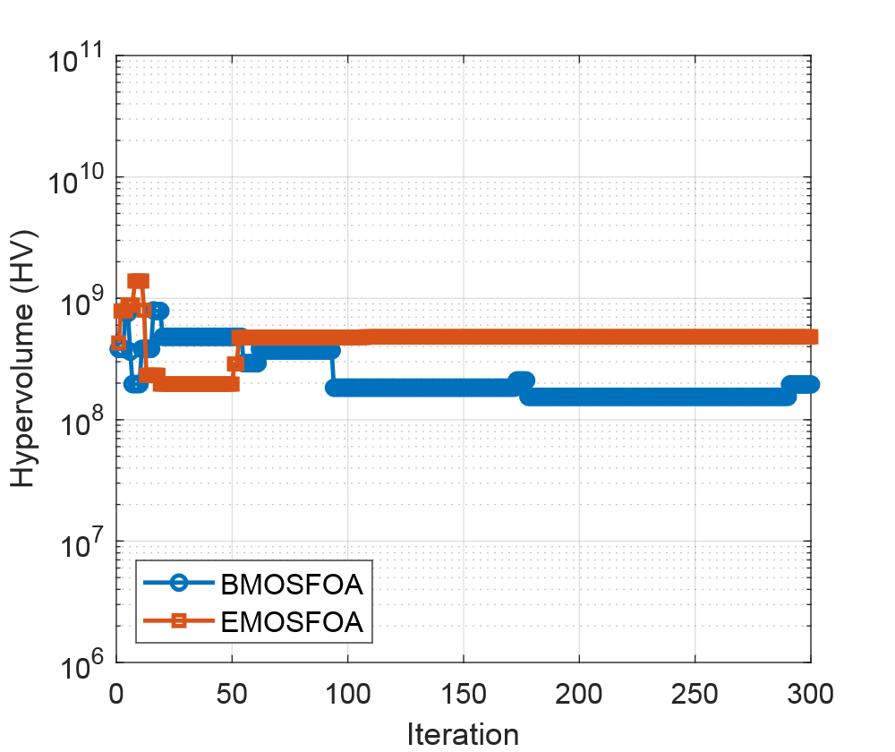 | 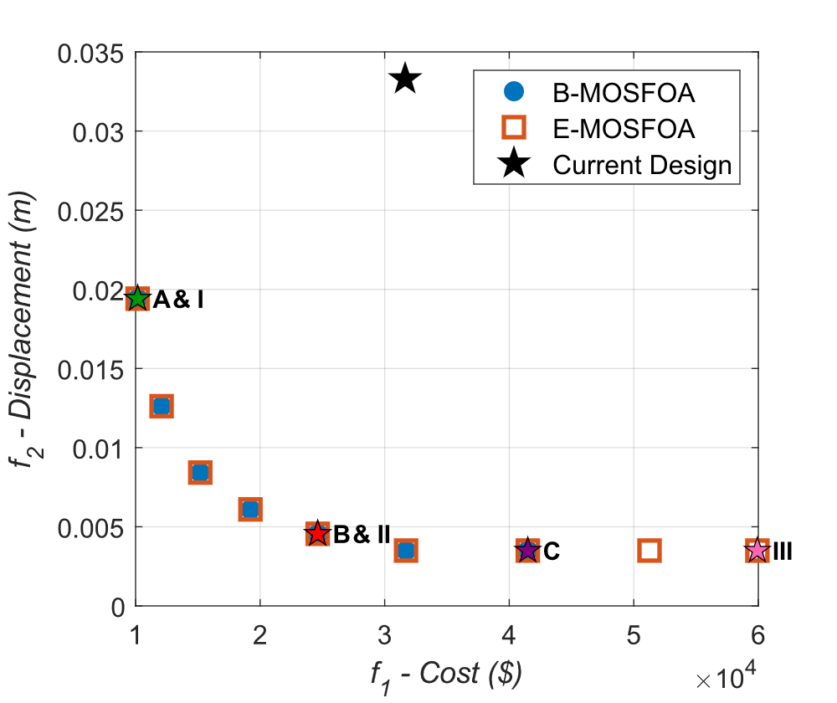
a) $HV$ convergence; | b) $PF$s obtained by B-MOSFOA and E-MOSFOA compared with the current design.
        - Optimization results for BD structure.
Fig. 9(a) shows that both algorithms achieve stable convergence within 300 iterations. Noticeable oscillations in $HV$ values are observed during the early iterations (iteration < 50), indicating active exploration of the design space. After approximately 100 iterations, the $HV$ values stabilize, suggesting convergence toward the Pareto-optimal front. E-MOSFOA consistently achieves slightly higher $HV$ values than B-MOSFOA, indicating improved balance between convergence and diversity. The $PF$s obtained by both algorithms are illustrated in Fig. 9(b), where each point represents a trade-off between construction cost ($f_{1}$) and maximum displacement ($f_{2}$). Compared with the current design (black star), all optimized solutions demonstrate significant improvements, achieving both lower cost and reduced displacement.
- Comparison of BD designs using B-MOSFOA, E-MOSFOA, and the BD current design
 | B-MOSFOA |  |  | E-MOSFOA |  |  | Curent  Design
 | A | B | C | I | II | III
Pile Type | 700A | 1200A | 1200B | 700A | 1100A | 1200C | 600C
Price ($/m) | 32.16 | 100.95 | 132.05 | 32.16 | 80.30 | 190.72 | 42.99
$X_{1}$ (m) | 0.70 | 1.20 | 1.2 | 0.70 | 1.10 | 1.20 | 0.60
$X_{2}$(m) | 0.10 | 0.15 | 0.15 | 0.10 | 0.14 | 0.15 | 0.10
$X_{3}$ | 6 | 6 | 6 | 6 | 6 | 6 | 6
$X_{4}$ (m) | 16.90 | 16.80 | 16.8 | 16.9 | 16.40 | 16.8 | 39.00
$f_{1}$ ($) | 10164.82 | 31718.61 | 41491.17 | 10164.82 | 24621.44 | 59924.15 | 31640.22
$f_{2}$ (m) | 0.0194 | 0.0035 | 0.0035 | 0.0194 | 0.0046 | 0.0035 | 0.0333
As summarized in Table 9, the optimized designs (A-C for B-MOSFOA and I-III for E-MOSFOA) exhibit distinct trade-offs. Solutions A and I achieve the lowest construction cost while maintaining acceptable displacement levels. Solutions B and II provide a balanced compromise between cost and stiffness. In contrast, solutions C and III minimize displacement but at a higher construction cost. Notably, the optimized solutions adopt shorter inclined piles (approximately 16.8-16.9 m) compared to the 39 m piles in the current design, resulting in significant cost savings. Overall, E-MOSFOA demonstrates more consistent convergence and better distribution of solutions along the $PF$.
      - MD structure
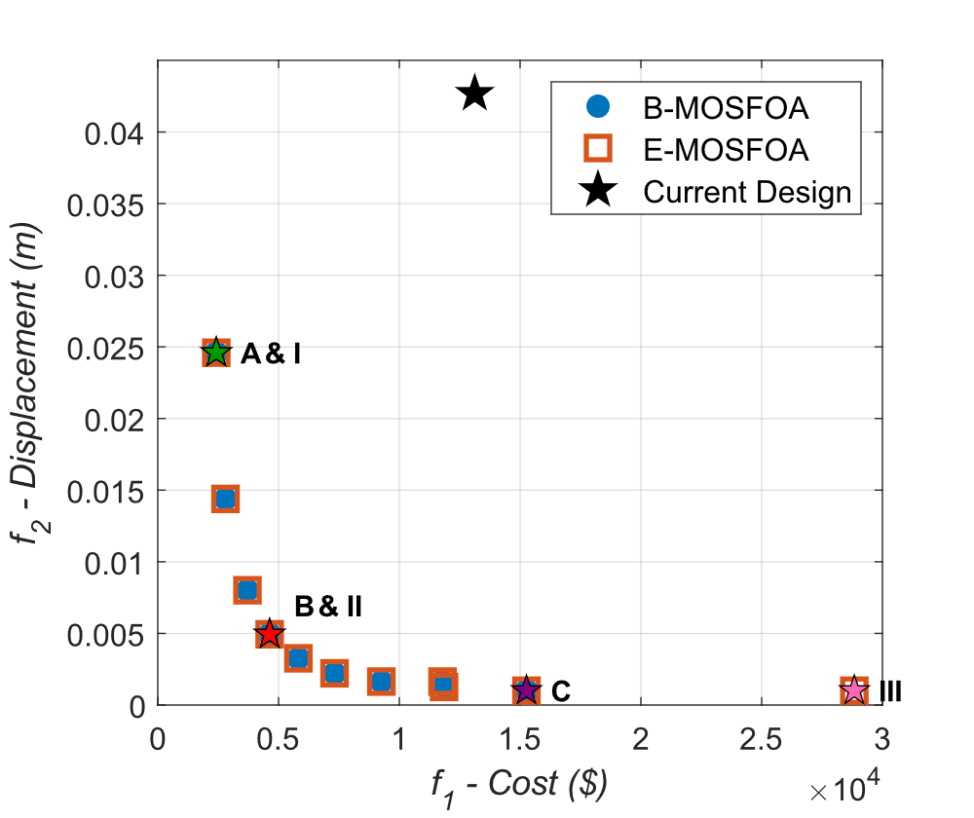 | 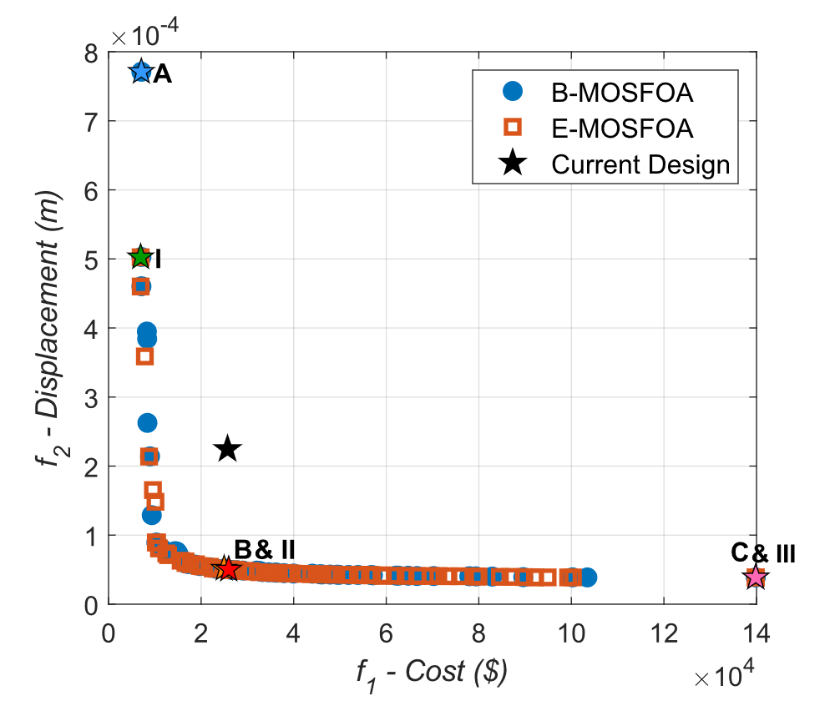
a) | b)
        - $PF$s for (a) MD and (b) MJP structures obtained by B-MOSFOA and E-MOSFOA, compared with current designs.
For the MD structure, the same optimization settings are applied to ensure a fair comparison. The obtained $PF$s are shown in Fig. 10(a), and the corresponding design variables and objective values are summarized in Table 10. Both algorithms significantly outperform the current MD design in terms of cost reduction and displacement improvement. Similar to the BD case, the optimized solutions exhibit clear trade-offs between the two objectives. Solutions A and I achieve moderate cost and displacement, while solutions B and II reduce displacement more effectively at higher costs. Solutions C and III provide the minimum displacement but require substantially higher investment.
- Comparison of BD designs using B-MOSFOA, E-MOSFOA, and the MD current design
 | B-MOSFOA |  |  | E-MOSFOA |  |  | Curent  Design
 | A | B | C | I | II | III
Pile Type | 450A | 700A | 1200A | 450A | 600A | 1200C | 600B
Price ($/m) | 16.82 | 32.16 | 100.95 | 16.82 | 25.78 | 190.72 | 37.38
$X_{1}$ (m) | 0.45 | 0.70 | 1.20 | 0.45 | 0.60 | 1.20 | 0.60
$X_{2}$(m) | 0.07 | 0.10 | 0.15 | 0.07 | 0.09 | 0.15 | 0.09
$X_{3}$ | 7 | 6 | 6 | 7 | 6 | 6 | 6
$X_{4}$ (m) | 16 | 16 | 16.8 | 16 | 16 | 16.8 | 39.00
$f_{1}$ ($) | 2422.23 | 4630.61 | 15263.70 | 2422.23 | 3712.43 | 28836.83 | 13121.12
$f_{2}$ (m) | 0.025 | 0.005 | 0.001 | 0.025 | 0.008 | 0.001 | 0.043
Compared to the current design, which exhibits both high cost and large displacement, all optimized solutions lie closer to the Pareto front, confirming the effectiveness of the proposed optimization framework. Additionally, E-MOSFOA again shows slightly better distribution of solutions, indicating improved search capability.
      - MJP structure
The optimization results for the MJP structure are presented in Fig. 10(b) and Table 11. Similar trends are observed as in the BD and MD cases. Both algorithms successfully generate well-distributed Pareto fronts, offering a wide range of design alternatives.
- Comparison of BD designs using B-MOSFOA, E-MOSFOA, and the MJP current design
 | B-MOSFOA |  |  | E-MOSFOA |  |  | Curent  Design
 | A | B | C | I | II | III
Pile Type | 300A | 500A | 1200B | 300A | 400A | 1200C | 500B
Price ($/m) | 8.12 | 19.47 | 163.16 | 8.12 | 13.17 | 190.72 | 27.26
$X_{1}$ (m) | 0.300 | 0.500 | 1.200 | 0.300 | 0.400 | 1.200 | 0.500
$X_{2}$(m) | 0.060 | 0.080 | 0.150 | 0.060 | 0.065 | 0.150 | 0.080
$X_{3}$ | 38.70 | 16.60 | 16.80 | 37.40 | 19.10 | 16.80 | 38.00
$X_{4}$ (m) | 5.30 | 3.00 | 3.00 | 5.30 | 3.00 | 3.00 | 4.20
$X_{5}$ (m) | 5.60 | 3.00 | 3.00 | 3.70 | 3.00 | 3.00 | 4.50
$X_{6}$ (m) | 0.50 | 1.00 | 1.40 | 0.50 | 0.80 | 1.40 | 0.70
$X_{7}$ (m) | 0.50 | 0.90 | 2.00 | 0.50 | 1.00 | 2.00 | 1.00
$f_{1}$ ($) | 5350.32 | 24723.06 | 126865.66 | 6935.46 | 21891.29 | 139831.48 | 25708.94
$f_{2}$ (m) | 1.0E-03 | 5.0E-05 | 3.9E-05 | 5.0E-04 | 5.4E-05 | 3.9E-05 | 2.2E-04
The current design is clearly dominated by the optimized solutions, as it exhibits higher cost and displacement compared to most Pareto-optimal solutions. Among the optimized results, solution A provides the lowest construction cost ($5,350.32) with an acceptable displacement (1.0×10⁻³ m), while solution C minimizes displacement (3.9×10⁻⁵ m) at a significantly higher cost. The E-MOSFOA solutions follow similar trends but generally achieve slightly lower displacements for comparable cost levels. In particular, solution III achieves the minimum displacement with competitive cost performance, indicating a superior balance between the two objectives.
Across all three structures (BD, MD, and MJP), both B-MOSFOA and E-MOSFOA demonstrate strong capability in solving the multi-objective optimization problem. The results consistently show that the optimized solutions significantly outperform the current designs in terms of both construction cost and structural performance. While both algorithms perform effectively, E-MOSFOA exhibits more stable convergence behavior and generates better-distributed Pareto fronts, suggesting enhanced exploration-exploitation balance. These findings confirm the robustness and practical applicability of the proposed optimization approaches for real-world marine structural design problems.

  - Conclusions And Future Works
This study proposes two multi-objective optimization algorithms, B-MOSFOA and E-MOSFOA, as extensions of the single-objective SFOA framework. The methods integrate advanced search mechanisms, including phase-controlled exploration, adaptive mutation, and leader-guided refinement, improving both convergence and solution diversity. Their effectiveness is validated on benchmark suites (IMOP, UF, and RM-MEDA) using standard metrics ($IGD$, $ε$, $Δ$, and $MS$). Results show that both algorithms are competitive with - and often outperform - state-of-the-art methods such as MOMSA, NS-MFO, and MOGNDO.
Importantly, their practical applicability is demonstrated through real-world optimization of a liquid bulk jetty system (BD, MD, and MJP). The optimized designs achieve lower construction costs and reduced structural displacements while satisfying engineering constraints. In particular, E-MOSFOA produces better-distributed Pareto fronts and more stable convergence, indicating a stronger balance between exploration and exploitation. Overall, the proposed MOSFOA framework shows strong robustness and effectiveness for solving complex constrained multi-objective problems in marine structural engineering.
Future work will focus on improving scalability and adaptability, including integrating machine learning to guide search, developing surrogate-assisted optimization to reduce computational cost, and incorporating real-time decision-support mechanisms. Extending the framework to handle uncertainty and dynamic loading conditions is also a promising direction.
Data Availability Statement
References
1. Abouhawwash, M., M. Jameel, and K. Deb, A smooth proximity measure for optimality in multi-objective optimization using Benson’s method. Computers & Operations Research, 2020. 117: p. 104900.
2. Khodadadi, N., et al., Multi-objective generalized normal distribution optimization: a novel algorithm for multi-objective problems. Cluster Computing, 2024.
3. Jameel, M. and M. Abouhawwash, Multi-objective Mantis Search Algorithm (MOMSA): A novel approach for engineering design problems and validation. Computer Methods in Applied Mechanics and Engineering, 2024. 422: p. 116840.
4. Mirjalili, S., et al., Salp Swarm Algorithm: A bio-inspired optimizer for engineering design problems. Advances in Engineering Software, 2017. 114: p. 163-191.
5. Savsani, V. and M.A. Tawhid, Non-dominated sorting moth flame optimization (NS-MFO) for multi-objective problems. Engineering Applications of Artificial Intelligence, 2017. 63: p. 20-32.
6. Rajwar, K., K. Deep, and S. Das, An exhaustive review of the metaheuristic algorithms for search and optimization: taxonomy, applications, and open challenges. Artificial Intelligence Review, 2023. 56(11): p. 13187-13257.
7. Wolpert, D.H. and W.G. Macready, No free lunch theorems for optimization. IEEE transactions on evolutionary computation, 1997. 1(1): p. 67-82.
8. Zhong, C., et al., Starfish optimization algorithm (SFOA): a bio-inspired metaheuristic algorithm for global optimization compared with 100 optimizers. Neural Computing and Applications, 2024.
9. Tian, Y., et al., Diversity Assessment of Multi-Objective Evolutionary Algorithms: Performance Metric and Benchmark Problems [Research Frontier]. IEEE Computational Intelligence Magazine, 2019. 14(3): p. 61-74.
10. Zhang, Q., et al. Multiobjective optimization Test Instances for the CEC 2009 Special Session and Competition. 2009.
11. Zhang, Q., A. Zhou, and Y. Jin, RM-MEDA: A Regularity Model-Based Multiobjective Estimation of Distribution Algorithm. IEEE Transactions on Evolutionary Computation, 2008. 12(1): p. 41-63.
12. Knowles, J.D., L. Thiele, and E.J.T.r. Zitzler, A tutorial on the performance assessment of stochastic multiobjective optimizers. 2006. 214.
13. Zitzler, E., K. Deb, and L. Thiele, Comparison of Multiobjective Evolutionary Algorithms: Empirical Results. Evolutionary Computation, 2000. 8(2): p. 173-195.
14. Deb, K., Multi-Objective Optimization using Evolutionary Algorithms. 2001: Wiley.
15. Marler, R.T. and J.S. Arora, Survey of multi-objective optimization methods for engineering. Structural and Multidisciplinary Optimization, 2004. 26(6): p. 369-395.
16. Benson, H.P., Multicriteria Optimization, Matthias Ehrgott, Springer (2005), 323 pages, ISBN: 3-540-21398-8. 2007, Elsevier.
17. Miettinen, K., Nonlinear multiobjective optimization. Vol. 12. 1999: Springer Science & Business Media.
18. Edgeworth, F., Mathematical Physics. P. Keagan London England. 1881.
19. Pareto, V., Cours d'économie politique. Vol. 1. 1964: Librairie Droz.
20. Zitzler, E. and L. Thiele, Multiobjective evolutionary algorithms: a comparative case study and the strength Pareto approach. IEEE Transactions on Evolutionary Computation, 1999. 3(4): p. 257-271.
21. Mavrotas, G., Effective implementation of the ε-constraint method in Multi-Objective Mathematical Programming problems. Applied Mathematics and Computation, 2009. 213(2): p. 455-465.
22. Miettinen, K., F. Ruiz, and A.P. Wierzbicki, Introduction to Multiobjective Optimization: Interactive Approaches, in Multiobjective Optimization: Interactive and Evolutionary Approaches, J. Branke, et al., Editors. 2008, Springer Berlin Heidelberg: Berlin, Heidelberg. p. 27-57.
23. Deb, K., et al., A fast and elitist multiobjective genetic algorithm: NSGA-II. IEEE Transactions on Evolutionary Computation, 2002. 6(2): p. 182-197.
24. Zitzler, E., M. Laumanns, and L.J.T.r. Thiele, SPEA2: Improving the strength Pareto evolutionary algorithm. 2001. 103.
25. Knowles, J.D. and D.W. Corne, Approximating the Nondominated Front Using the Pareto Archived Evolution Strategy. Evolutionary Computation, 2000. 8(2): p. 149-172.
26. Coello, C.A.C., G.T. Pulido, and M.S.J.I.T.o.e.c. Lechuga, Handling multiple objectives with particle swarm optimization. 2004. 8(3): p. 256-279.
27. Storn, R. and K. Price, Differential Evolution – A Simple and Efficient Heuristic for global Optimization over Continuous Spaces. Journal of Global Optimization, 1997. 11(4): p. 341-359.
28. Riquelme, N., C.V. Lücken, and B. Baran. Performance metrics in multi-objective optimization. in 2015 Latin American Computing Conference (CLEI). 2015.
29. International Navigation Association (PIANC), Guidelines for the Design of Fender Systems. 2002, PIANC – International Navigation Association: Brussels, Belgium, .
30. The Overseas Coastal Area Development Institute of Japan - OCDI, Technical Standards for Port and Harbour Facilities in Japan. 2002, Tokyo, Japan: The Overseas Coastal Area Development Institute of Japan (OCDI).
31. Ministry of Science and Technology, TCVN 7888:2014 - Pre-Stressed Concrete Piles – Vietnamese National Design Standard. Vol. TCVN 7888:2014. 2014, Hanoi, Vietnam: Ministry of Science and Technology.
32. Ministry of Science and Technology of Vietnam, TCVN 10304:2014 - Pile Foundation – Vietnamese National Design Standard. Vol. TCVN 10304:2014. 2014, Hanoi, Vietnam: Ministry of Science and Technology of Vietnam.
33. Audet, C., et al., Performance indicators in multiobjective optimization. European Journal of Operational Research, 2021. 292(2): p. 397-422.

Note: In the result tables, indices (1) to (4) refer to the corresponding statistical indicators, while labels (I) to (V) identify the algorithms.
Bold values represent the best result across algorithms for each metric

