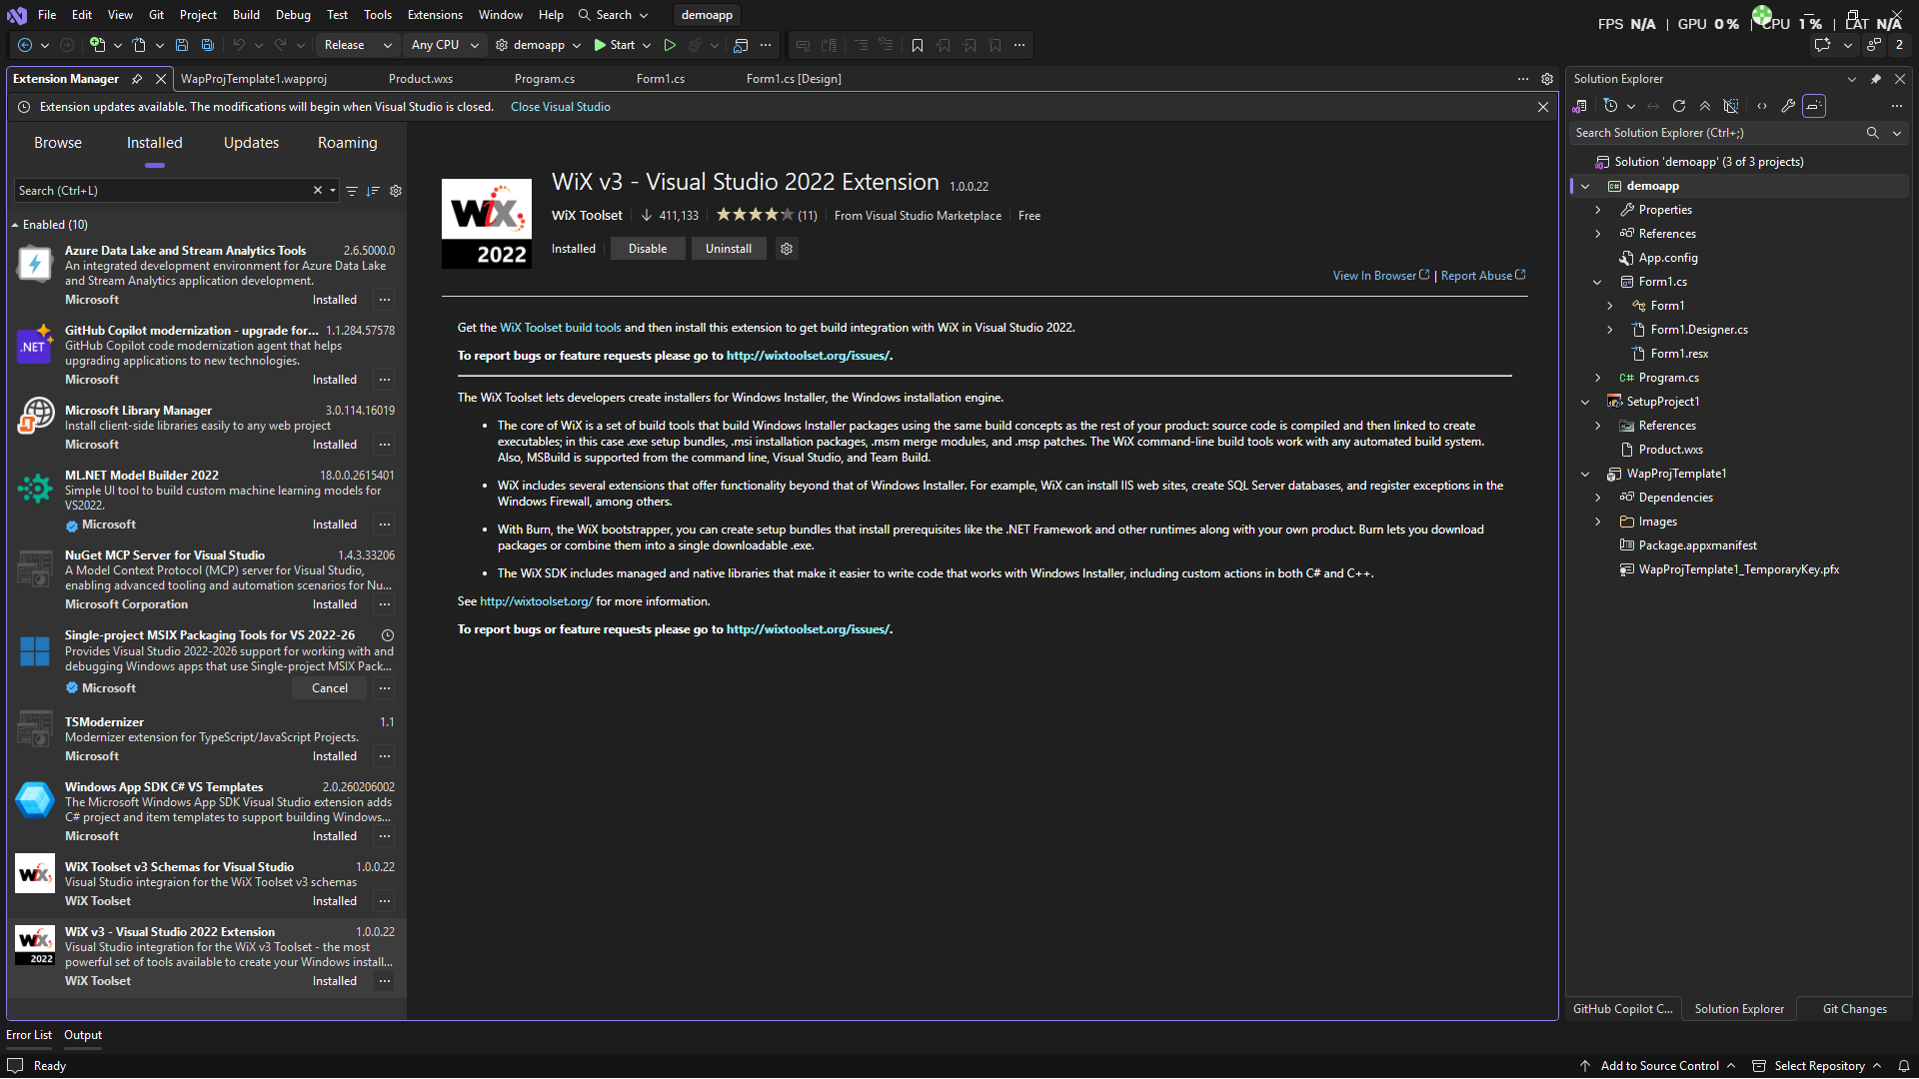
Visual Studio with WiX extension installed

WiX v3.11 installed through https://github.com/wixtoolset/wix3/releases/tag/wix3112rtm?utm_source=chatgpt.com

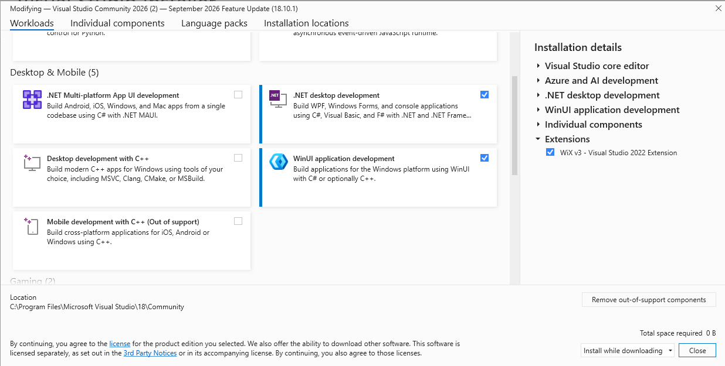
winUI installed in place of UWP Development since the package does not exist in Visual Studio 2026. The current package helps develop MSIX bundle instead of APPX (which basically the same)
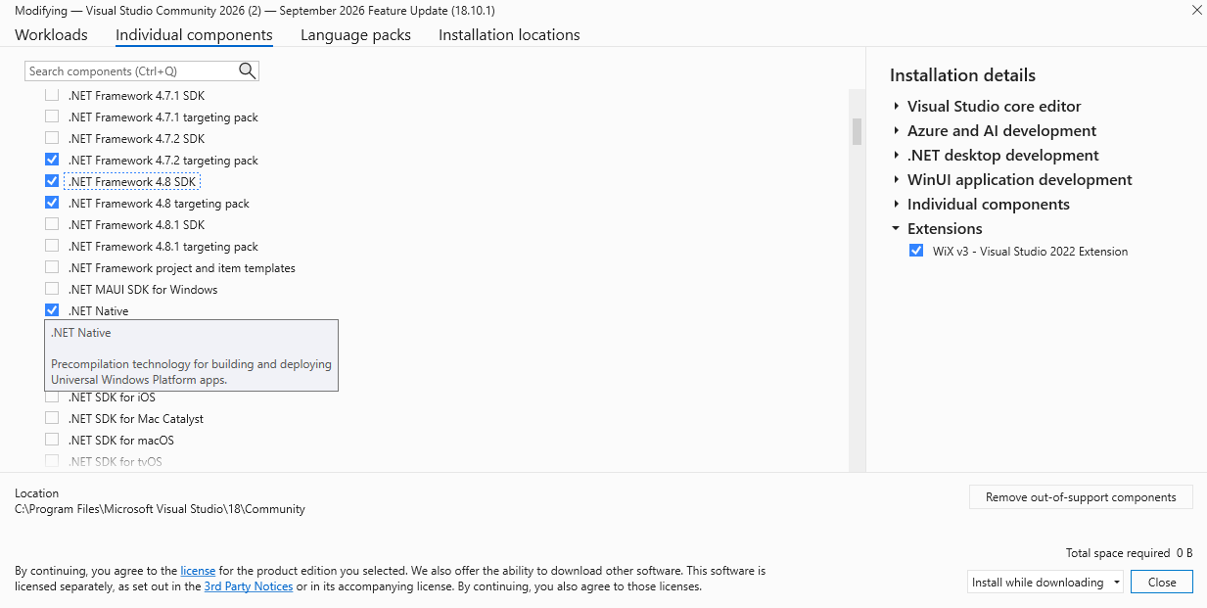
NetSDK installed

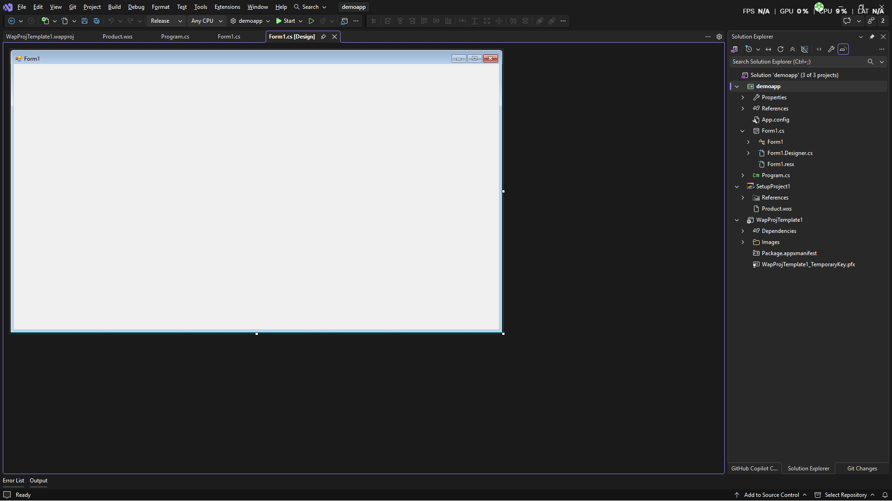
Template form application (WiX walkthrough)

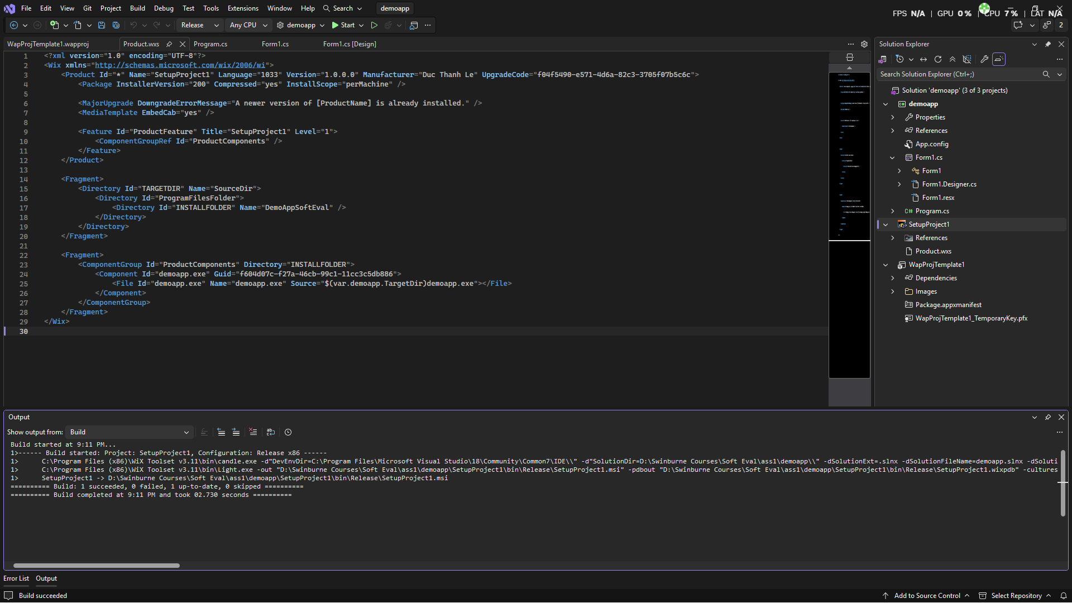
WiX setup successfully & app built

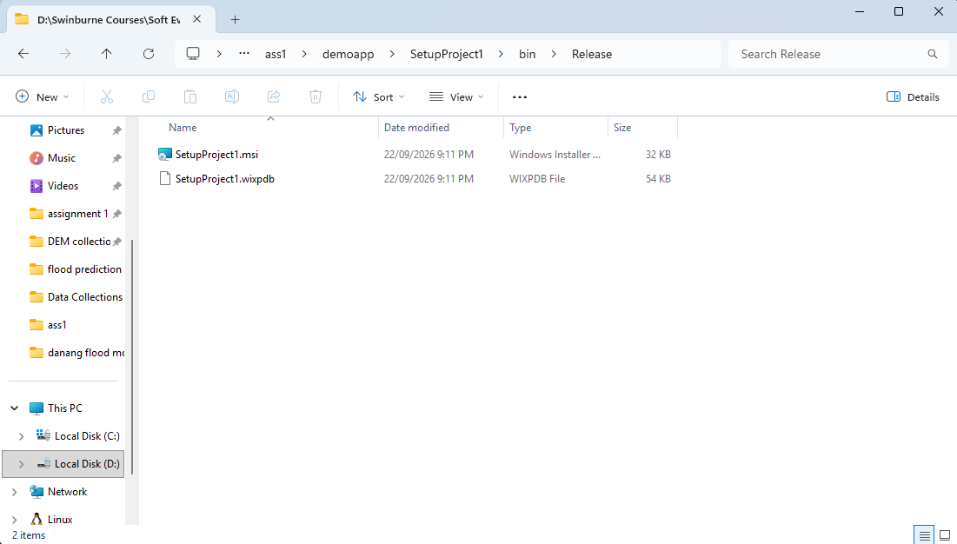
Msi file created

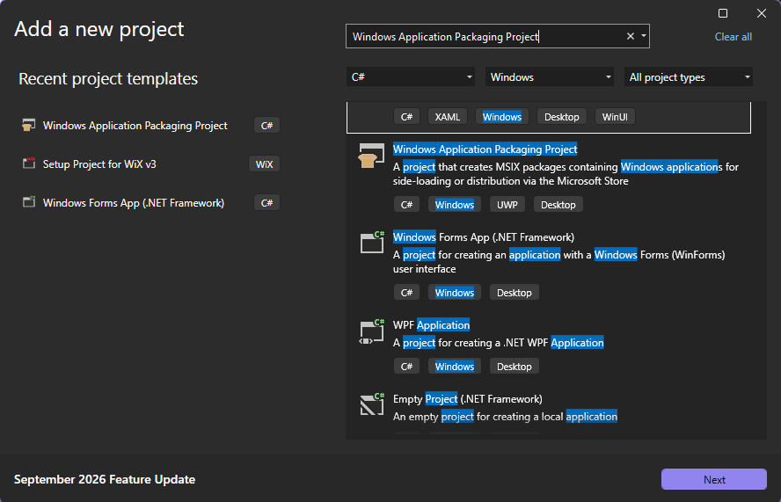
Windows Application Packaging Project (but export MSIX instead of APPX bundle)
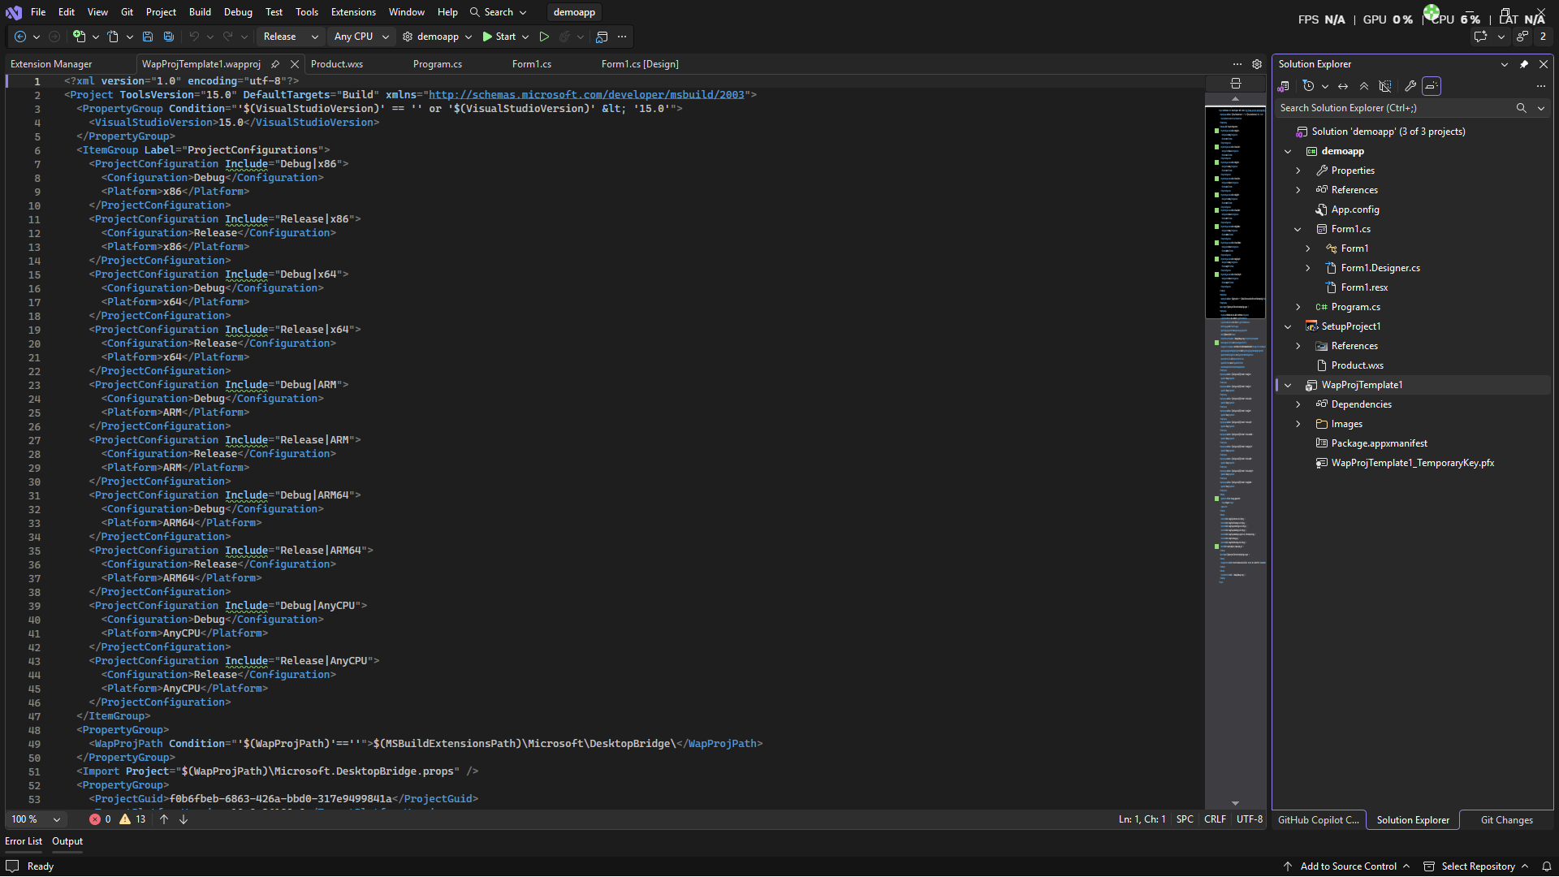
Result of successful setup

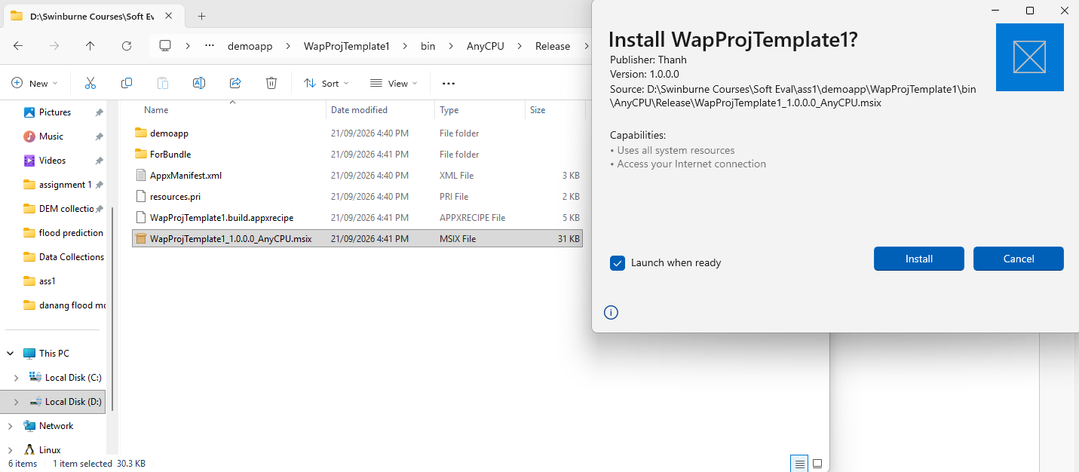
MSIX file created and can be installed through double click

Phase 2: deploy own app
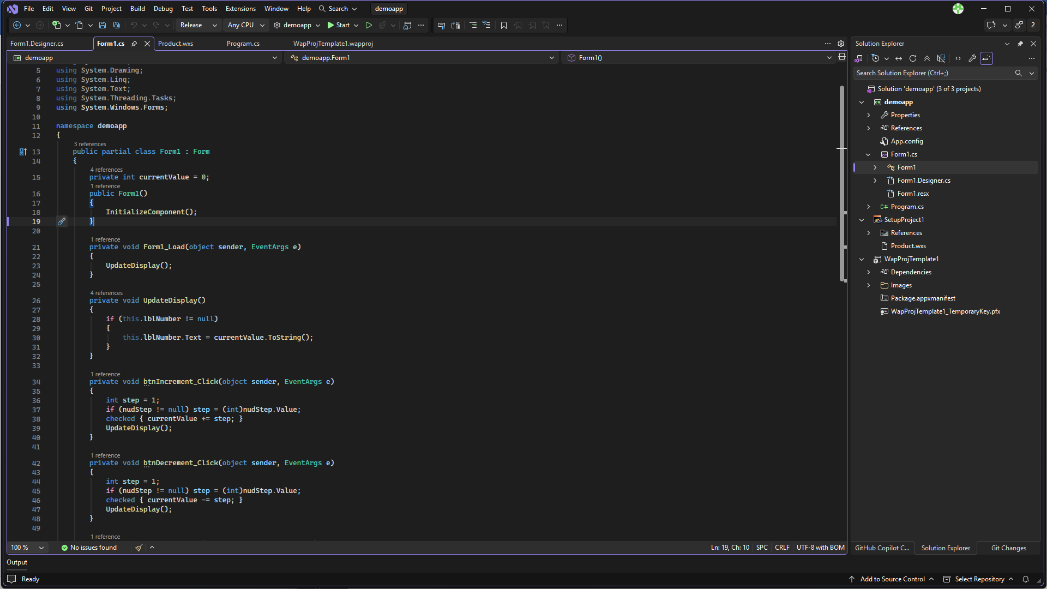
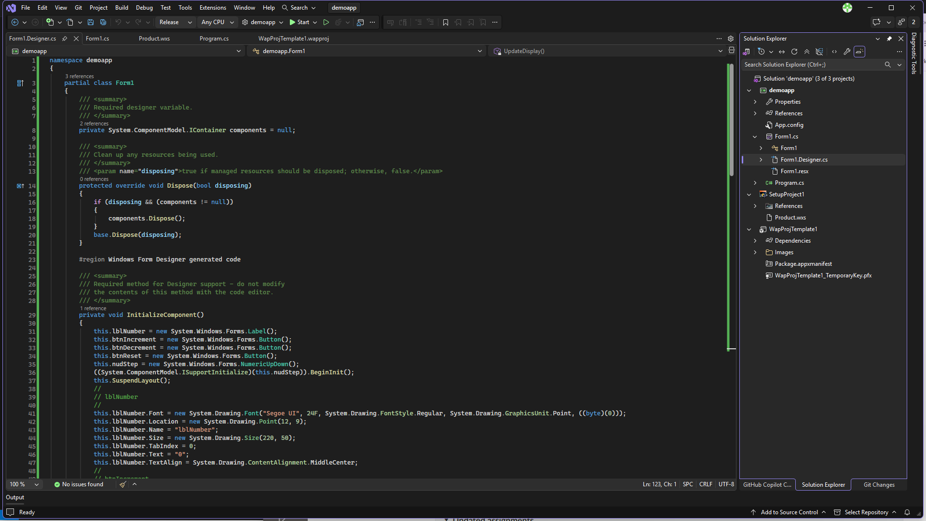
App codebase sample
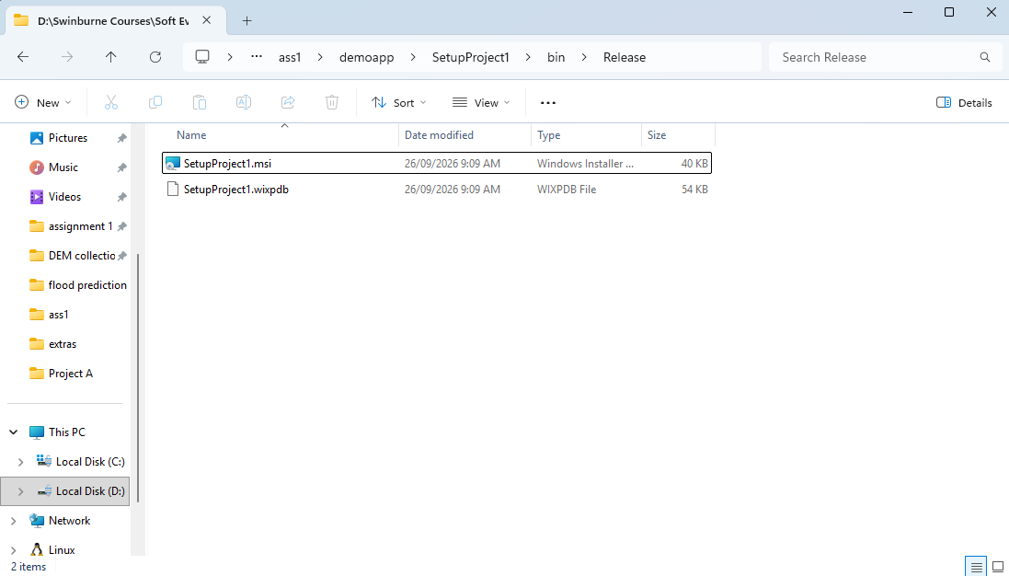
MSI file (implemented on the blank project in phase 1)
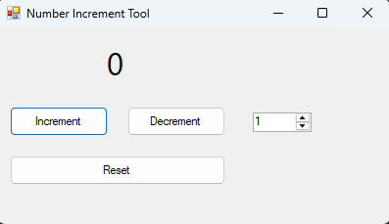
An increment/decrement application with step setting on the right
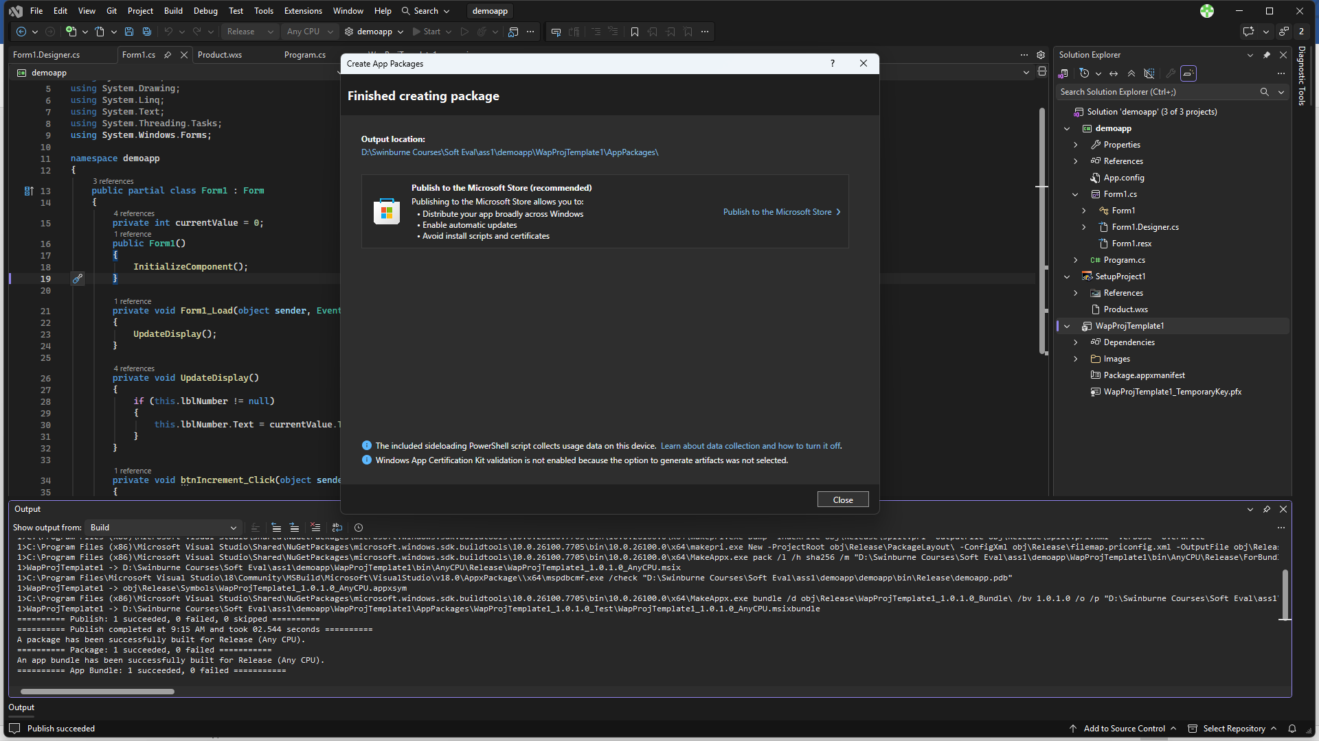
Created MSIX package
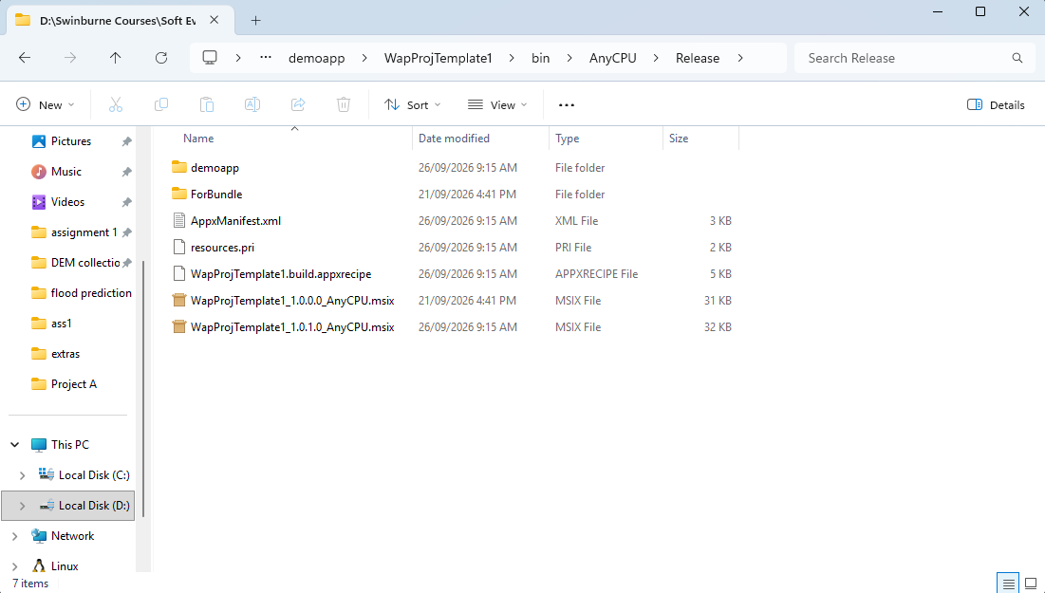
Newer MSIX package created indicating implementation on the old codebase (which is a blank canvas)

Phase 3: custom DLL
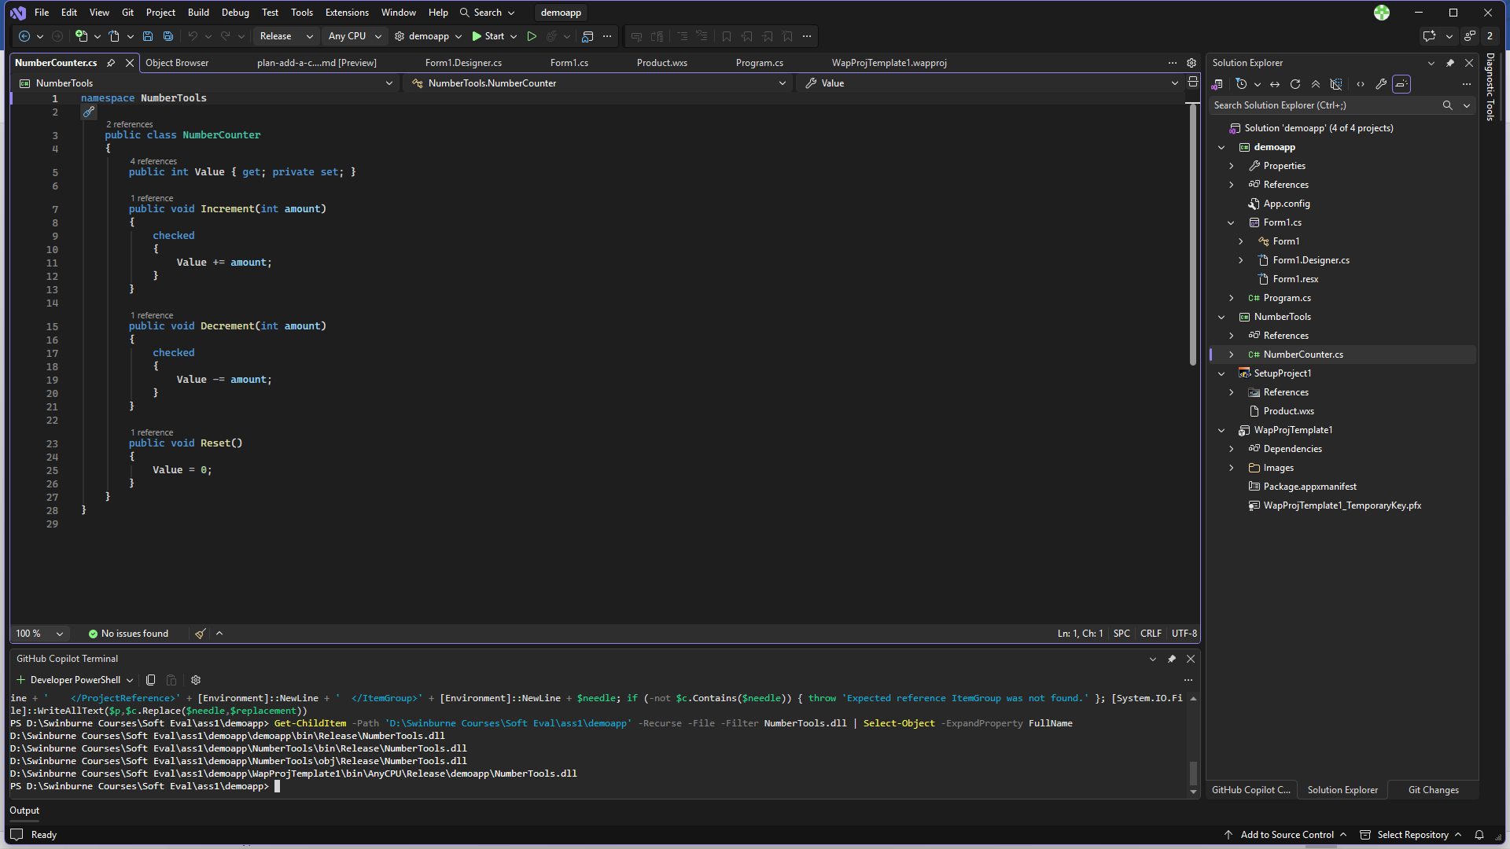
Custom DLL
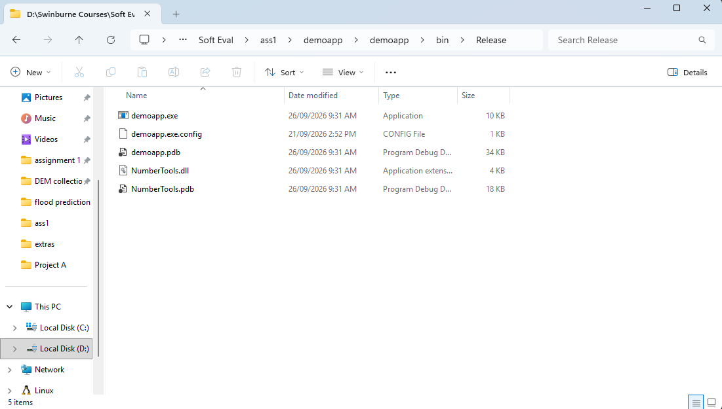
Actual DLL file
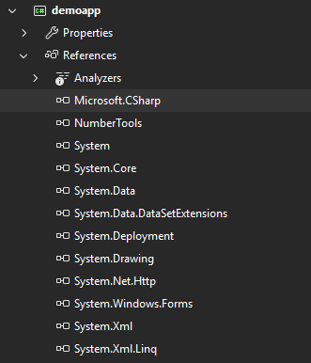
Reference in the project
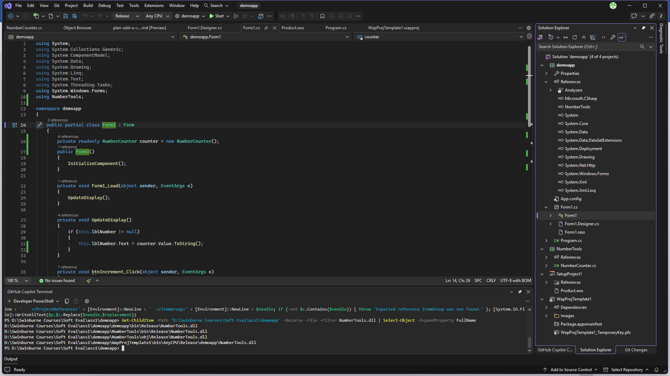
New code after implemented DLL

