

**HealthCare System**

**Software Design Document**

**Hà Nội, ngày  tháng  năm 2023**

**1. Overall Description**

* 1. **Assumptions**

This system is designed based on the following assumptions:

* Window 10
* ReactJS, .NET Core
* SQL Server
* Google Chrome
  1. **Design Constraints**

This system should comply with the following items:

* It has 2 websites at the client-side to serve two types of actors: normal users and admin. They can use a web browser and application to send requests and connect to the front-end application.
* End-user’s Environment: Windows.
* Database using SQL Server.
* Support languages: Vietnamese, English.
* The web application must be responsive and snappy.
* The user must have a stable connection to the internet.
  1. **Technology Suggestion**
* Database: SQL Server
* Web Application: .NET 6
* Server: Local server

**2. System Architecture Design**

**2.1 Overall Architecture**

**2.1.1 Diagram**

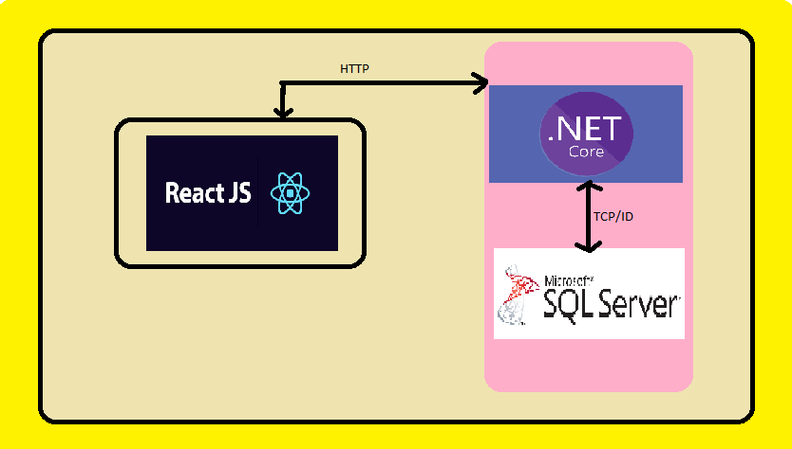

**2.2.2 Component Explanation**

**2.1.1 Microsoft SQL Server**

SQL Server is a relational database management system (RDBMS) developed by Microsoft. It is primarily designed and developed to compete with MySQL and Oracle databases. SQL Server supports ANSI SQL, which is the standard SQL (Structured Query Language) language. However, SQL Server comes with its own implementation of the SQL language, T-SQL (Transact-SQL). T-SQL is a Microsoft proprietary Language known as Transact-SQL. It provides further capabilities of declaring variables, exception handling, stored procedure, etc. SQL Server Management Studio (SSMS) is the main interface tool for SQL Server, and it supports both 32-bit and 64-bit environments.

**2.1.2 : .NET Core**

.NET Core is a new version of .NET Framework, which is a free, open-source, general-purpose development platform maintained by Microsoft. It is a cross-platform framework that runs on Windows, macOS, and Linux operating systems.

.NET Core Framework can be used to build different types of applications such as mobile, desktop, web, cloud, IoT, machine learning, microservices, game, etc.

**2.1.3 : ReactJS**

The React.js framework is an open-source JavaScript framework and library developed by Facebook. It’s used for building interactive user interfaces and web applications quickly and efficiently with significantly less code than you would with vanilla JavaScript.

React’s primary role in an application is to handle the view layer of that application just like the V in a model-view-controller (MVC) pattern by providing the best and most efficient rendering execution.

**2.2 System Architecture**

**2.2.1 SAFO Front-end Architecture**

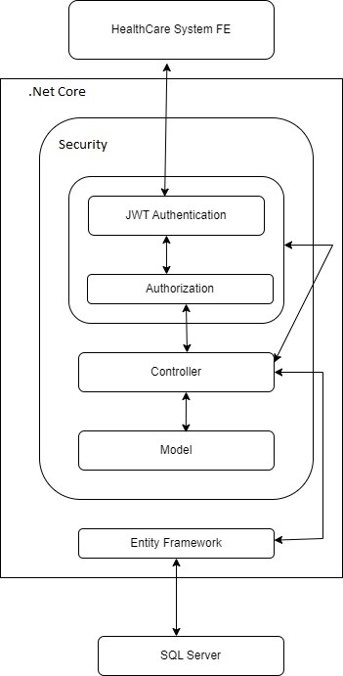

**2.2.2 SAFO Back-end Architecture**

