HTML

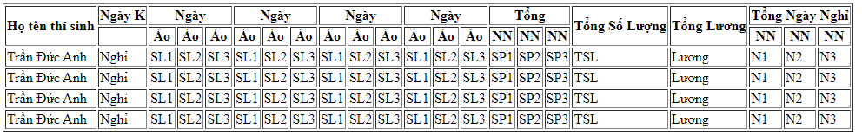

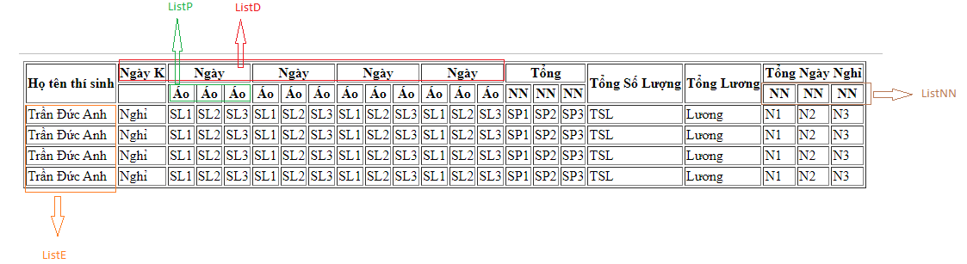

ListP

sql = select \* from Product

ListNN

sql = select \* from DayOffType

ListE

sql = select e.eid, e.ename, ISNULL(ts.tsid, -1) as tsid, p.pname, p.pprice, ts.eid, ts.pid, ts.amount, ts.dates from Employee e left join

(select \* from TimeSheet where dates >= ? and dates <= ?) ts on e.eid = ts.eid

left join Product p on ts.pid = p.pid