- docker –version
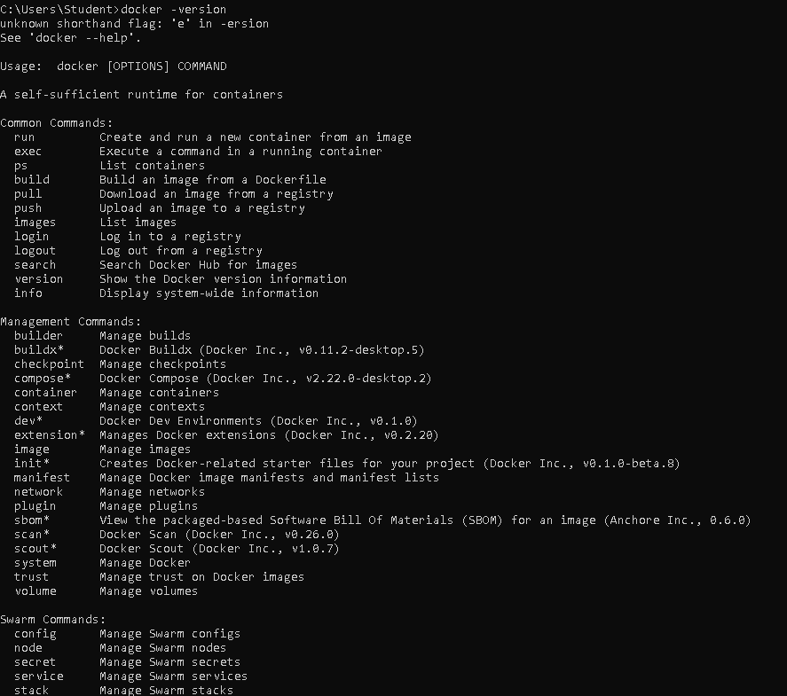
- docker run hello-world
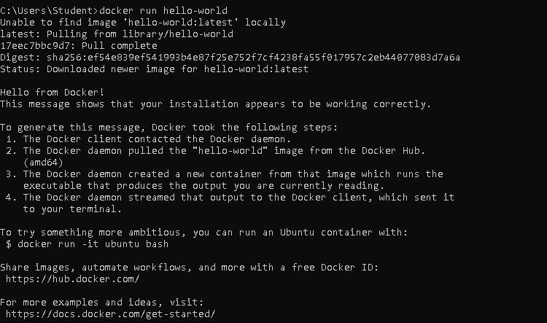
- docker pull nginx
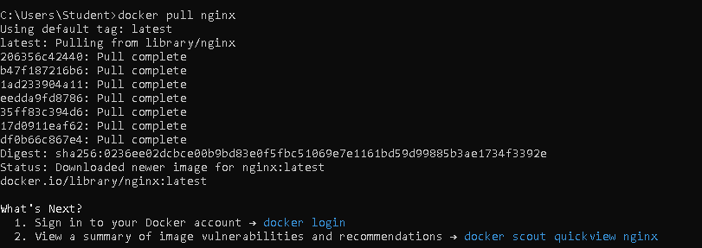
- docker images
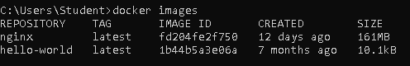
- docker run -d nginx
- docker ps
- docker ps –a

- docker logs <container_id>
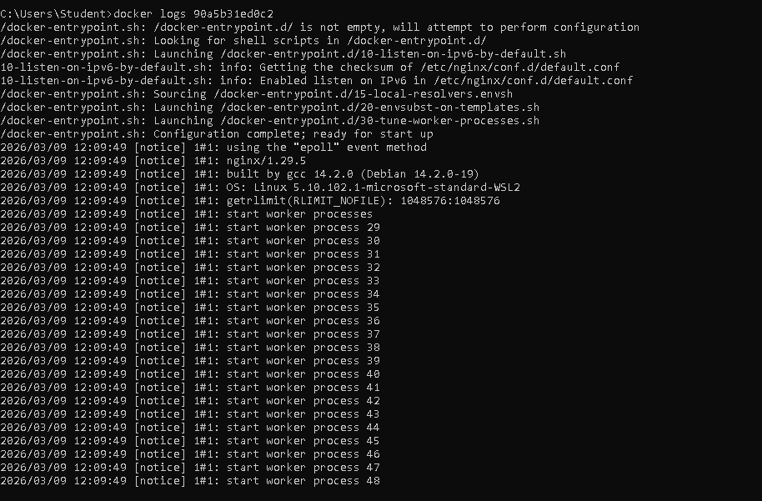
- docker exec -it <container_id> /bin/sh
- docker stop <container_id>
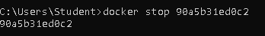
- docker restart <container_id>
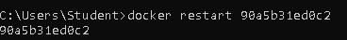
- docker rm <container_id>
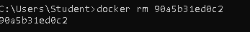
- docker container prune
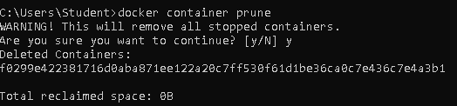
- docker rmi <image_id>
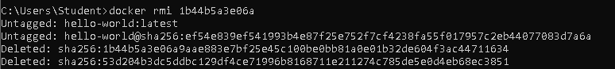
- docker image prune –a
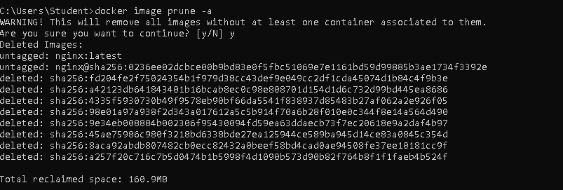
- docker run -d -p 8080:80 nginx
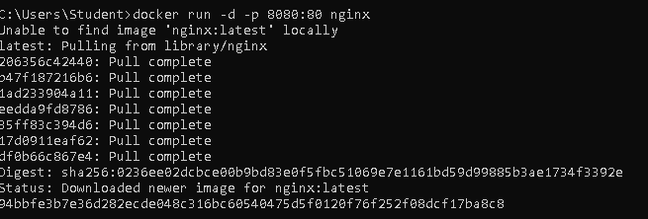
- docker inspect <container_id>
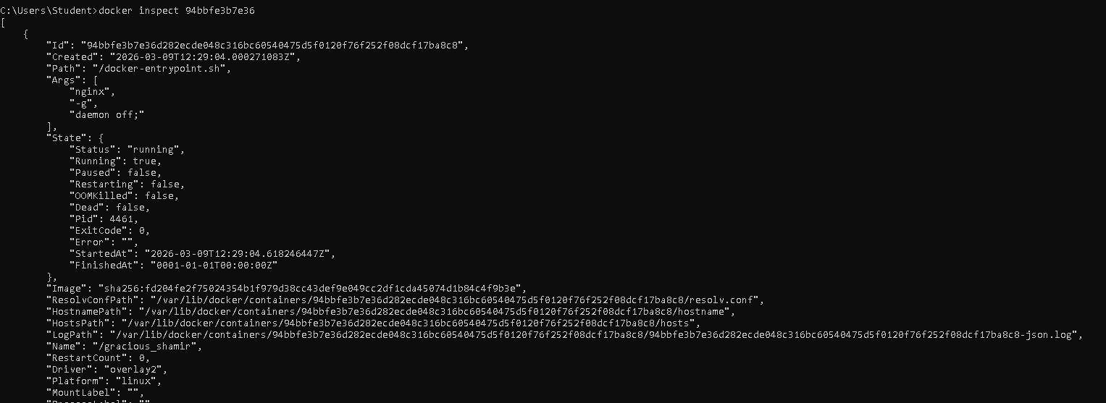
- docker run -d -v mydata:/data nginx
- docker volume ls
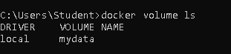
- docker volume prune
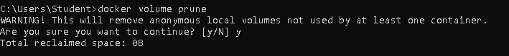
- docker run -d --name my_nginx nginx
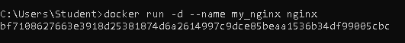
- docker stats
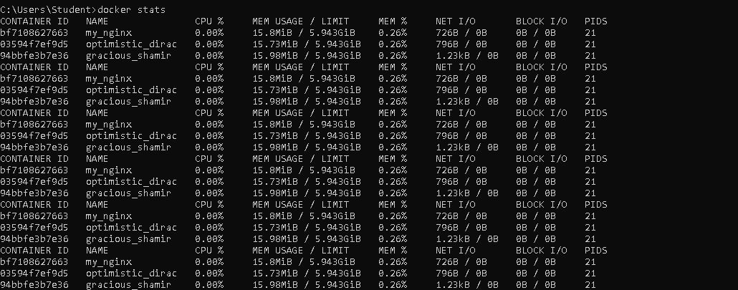
- docker network ls
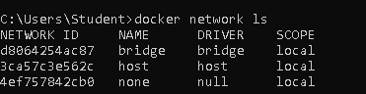
- docker network create my_network
- docker run -d --network my_network --name my_container nginx
- docker network connect my_network my_nginx
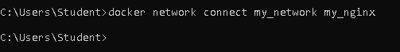
- docker run -d -e MY_ENV=hello_world nginx
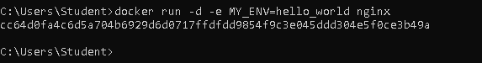
- docker logs -f my_nginx
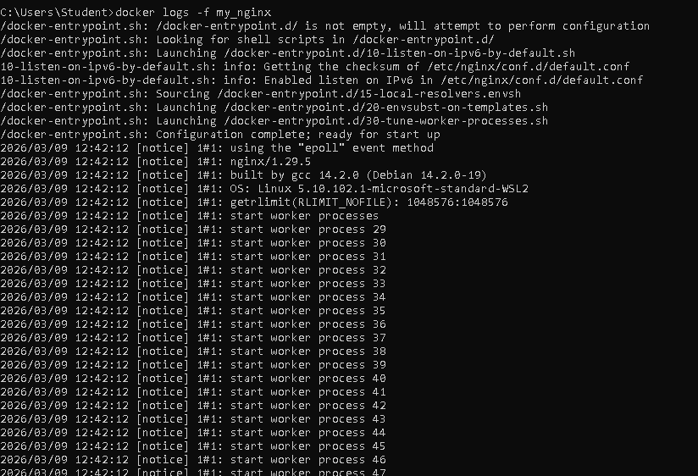
- FROM nginx
COPY index.html /usr/share/nginx/html/index.html
- docker build -t my_nginx_image .
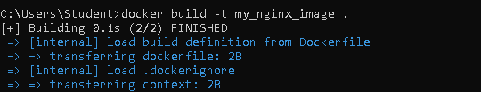

- docker run -d -p 8080:80 my_nginx_image

