IC TRAINING CENTER VIET NAM
FUNDAMENTAL IC DESIGN AND VERIFICATION COURSE


FINAL PROJECT
TIMER IP DESIGN SPECIFICATION

Student: Nguyễn Tân Thành
Class: IC30
Instructor: Nguyễn Thanh Trí

Contents
LIST OF TABLES 3
LIST OF FIGURES 3
1.Overview 4
1.1. Introduction 4
1.2. Main features 4
1.3. Block diagram 5
1.4. Interface signals 6
2.Register Specification 6
2.1. Register Summary 6
2.2. Timer Control Register (TCR) 7
2.3. Timer Data Register 0 (TDR0) 8
2.4. Timer Data Register 1 (TDR1) 8
2.5. Timer Compare Register 0 (TCMP0) 9
2.6. Timer Compare Register 1 (TCMP1) 9
2.7. Timer Interrupt Enable Register (TIER) 10
3. Functional Description 12
3.1. APB slave 12
3.2. Diagram Explanation 13
4. History 16

LIST OF TABLES
Table 1 : Interface signals of timer IP 6
Table 2 : Register Summary 6
Table 3 . Timer Control Register (TCR) 7
Table 4 : Timer Data Register 0 (TDR0) 8
Table 5 : Timer Data Register 1 (TDR1) 9
Table 6 : Timer Compare Register 0 (TCMP0) 9
Table 7 : Timer Compare Register 1 (TCMP1) 10
Table 8 : Timer Interrupt Enable Register (TIER) 10
Table 9 : Timer Interrupt Status Register (TISR) 11

LIST OF FIGURES
Figure 1 : Block diagram of Timer IP 5
Figure 2 : Block diagram of counter 5
Figure 3 : Waveform of operation 12
Figure 4 : Sub block internal_cnt 13
Figure 5 : Sub block cnt_control 14
Figure 6 : Block diagram of TCR 14
Figure 7 : Block diagram of TDR0 15
Figure 8 : Block diagram of TDR1 15
Figure 9 : Block diagram of TCMP0 15
Figure 10 : Block diagram of TCMP1 16
Figure 11 : Block diagrams of TIER and TISR 16

1.Overview

1.1. Introduction
The timer is a fundamental and indispensable peripheral module integrated into modern microcontroller units (MCUs) and system-on-chips (SoCs). Its primary function is to provide a reliable and precise mechanism for generating specific timing intervals, thereby orchestrating the timing of various internal operations and external events. By operating from the system clock or an independent oscillator, it delivers a critical timing reference that allows the central processing unit (CPU) to execute tasks asynchronously or at predetermined rates, significantly enhancing system efficiency and control.
The utility of timer modules extends across a vast array of critical applications within embedded systems and digital circuits. They are primarily employed for the generation of precise digital waveforms, including pulses and Pulse Width Modulation (PWM) signals, which are essential for controlling motors, LEDs, and power converters. Furthermore, timers are crucial for creating programmed delays, scheduling periodic events, and generating interrupt requests to signal the CPU that a specific time-based condition has been met. This versatility makes them a cornerstone for implementing real-time operating system (RTOS) schedulers, communication protocol timeouts, and sensor data sampling routines.

1.2. Main features
This timer module is architected around a 64-bit count-up counter and features a 12-bit address space for register access. It is configured as an APB slave, with its register set programmable via the APB bus. The IP supports a standard compliance level, which includes 32-bit APB transfers with no wait states and no error handling, and an advanced level that adds support for single-cycle wait states, error handling, byte access, and debug-mode halt functionality. The module operates from a 200 MHz system clock and utilizes an active-low asynchronous reset. The counter can be clocked directly from the system clock or from a divided version, with a division factor of up to 256. Additionally, the timer provides a configurable interrupt output that can be enabled or disabled as required.

1.3. Block diagram
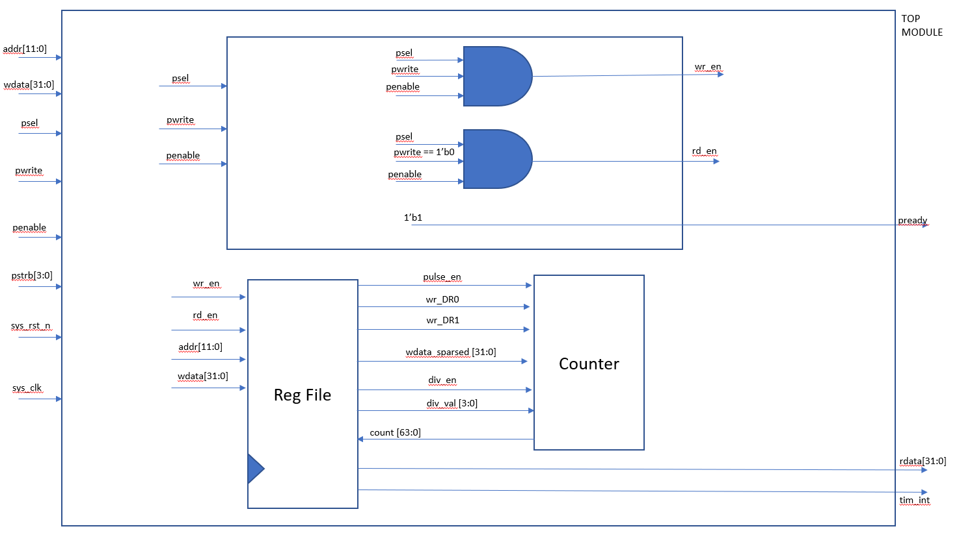
Figure 1: Block diagram of Timer IP
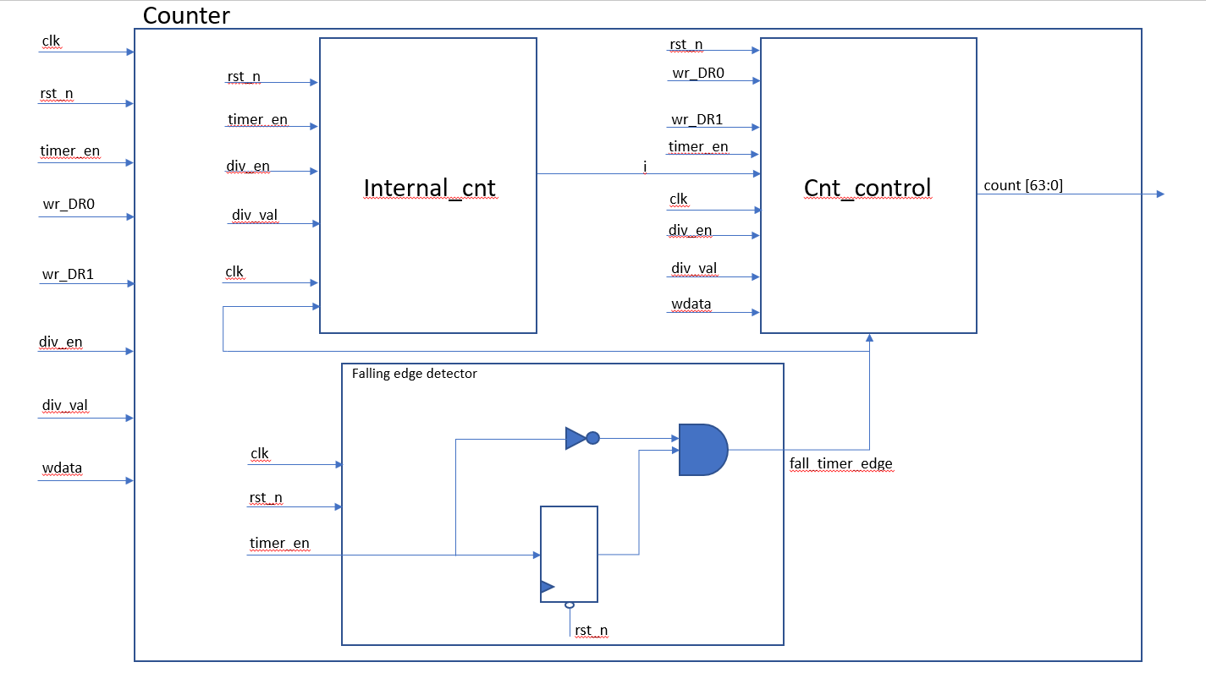
Figure 2: Block diagram of counter

1.4. Interface signals
Table 1: Interface signals of timer IP
Signal name | Width | Direction | Description
sys_clk | 1 | input | System's clock, sampling at the edge of clk
sys_rst_n | 1 | input | Low active reset, release for normal operation
tim_psel | 1 | input | Select which slaves need to be in charge during the transaction
tim_pwrite | 1 | input | Signal indicating whether write or not
tim_penable | 1 | input | Signal indicating the start of Access phase
tim_paddr | 12 | input | Select which addr in slave required for execution
tim_pwdata | 32 | input | Data that will be written to slave from master
tim_prdata | 32 | output | Data that master received from slave
tim_pstrb | 4 | input | Signal enables sparse data transfer
tim_pready | 1 | output | Signal indicating that slave is ready for the transfer
tim_pslverr | 1 | output | Signal indicating an error condition during APB transfer
tim_int | 1 | output | Update the status of interrupt reg, check the trigger condition
dbg_mode | 1 | input | dbg_mode does not change after timer_en is High

2.Register Specification

2.1. Register Summary
Table 2: Register Summary
Offset | Abbreviation | Register name
0x00 | TCR | Timer Control Register
0x04 | TDR0 | Timer Dara Register 0
0x08 | TDR1 | Timer Dara Register 1
0x0C | TCMP0 | Timer Compare Register 0
0x10 | TCMP1 | Timer Compare Register 1
0x14 | TIER | Timer Interrupt Enable Register
0x18 | TISR | Timer Interrupt Status Register
0x1C | THCSR | Timer Halt Control Status Register
Others | Reserved

2.2. Timer Control Register (TCR)
Offset address: 0x0
Reset value: 0x0000_0100
31 | 30 | 29 | 28 | 27 | 26 | 25 | 24 | 23 | 22 | 21 | 20 | 19 | 18 | 17 | 16
Reserved

15 | 14 | 13 | 12 | 11 | 10 | 9 | 8 | 7 | 6 | 5 | 4 | 3 | 2 | 1 | 0
Reserved |  |  |  | DIV_VAL[3:0] |  |  |  | Reserved |  |  |  |  |  | DIV_  EN | TIM_  EN
 |  |  |  | rw |  |  |  |  |  |  |  |  |  | rw | rw

Table 3. Timer Control Register (TCR)
Bit | Name | Type | Default value | Description
31:12 | Reserved | - | 20’b0 | Reserved
11:8 | DIV_VAL[3:0] | RW | 4’b0001 | Counter control mode setting:  • 4’b0000: Counting speed is not divided  • 4’b0001: Counting speed is divided by 2 (default)  • 4’b0010: Counting speed is divided by 4  • 4’b0011: Counting speed is divided by 8  • 4’b0100: Counting speed is divided by 16  • 4’b0101: Counting speed is divided by 32  • 4’b0110: Counting speed is divided by 64  • 4’b0111: Counting speed is divided by 128  • 4’b1000: Counting speed is divided by 256  • Others: reserved  When setting the prohibit value, div_val is not changed. Note: user must not change div_en while timer_en is High
7:2 | Reserved | RO | 6’b0 | Reserved
1 | DIV_EN | RW | 1’b0 | Counter control mode enable.  • 0: Disabled. Counter counts with normal speed based on system clock  • 1: Enabled.  The couting speed of counter is controlled based on div_valNote: user must not change div_en while timer_en is High
0 | TIM_EN | RW | 1’b0 | Timer enable  • 0: Disabled. Counter does not count.  • 1: Enabled. Counter starts counting

2.3. Timer Data Register 0 (TDR0)
Offset address: 0x4
Reset value: 0x0000_0000
31 | 30 | 29 | 28 | 27 | 26 | 25 | 24 | 23 | 22 | 21 | 20 | 19 | 18 | 17 | 16
TDR0
rw

15 | 14 | 13 | 12 | 11 | 10 | 9 | 8 | 7 | 6 | 5 | 4 | 3 | 2 | 1 | 0
TDR0
rw

Table 4: Timer Data Register 0 (TDR0)
Bit | Name | Type | Default value | Description
31:0 | TDR0 | RW | 32’h0000_0000 | Lower 32-bit of 64-bit counter

2.4. Timer Data Register 1 (TDR1)
Offset address: 0x8
Reset value: 0x0000_0000
31 | 30 | 29 | 28 | 27 | 26 | 25 | 24 | 23 | 22 | 21 | 20 | 19 | 18 | 17 | 16
TDR1
rw

15 | 14 | 13 | 12 | 11 | 10 | 9 | 8 | 7 | 6 | 5 | 4 | 3 | 2 | 1 | 0
TDR1
rw

Table 5: Timer Data Register 1 (TDR1)
Bit | Name | Type | Default value | Description
31:0 | TDR1 | RW | 32’h0000_0000 | Upper 32-bit of 64-bit counter

2.5. Timer Compare Register 0 (TCMP0)
Offset address: 0xC
Reset value: 0xFFFF_FFFF
31 | 30 | 29 | 28 | 27 | 26 | 25 | 24 | 23 | 22 | 21 | 20 | 19 | 18 | 17 | 16
TCMP0
rw

15 | 14 | 13 | 12 | 11 | 10 | 9 | 8 | 7 | 6 | 5 | 4 | 3 | 2 | 1 | 0
TDR0
rw

Table 6: Timer Compare Register 0 (TCMP0)
Bit | Name | Type | Default value | Description
31:0 | TCMP0 | RW | 32’hffff_ffff | Lower 32-bit of 64-bit compare value

2.6. Timer Compare Register 1 (TCMP1)
Offset address: 0x10
Reset value: 0xFFFF_FFFF
31 | 30 | 29 | 28 | 27 | 26 | 25 | 24 | 23 | 22 | 21 | 20 | 19 | 18 | 17 | 16
TCMP1
rw

15 | 14 | 13 | 12 | 11 | 10 | 9 | 8 | 7 | 6 | 5 | 4 | 3 | 2 | 1 | 0
TDR1
rw

Table 7: Timer Compare Register 1 (TCMP1)
Bit | Name | Type | Default value | Description
31:0 | TCMP1 | RW | 32’hffff_ffff | Upper 32-bit of 64-bit compare value

2.7. Timer Interrupt Enable Register (TIER)
Offset address: 0x14
Reset value: 0x0000_0000
31 | 30 | 29 | 28 | 27 | 26 | 25 | 24 | 23 | 22 | 21 | 20 | 19 | 18 | 17 | 16
Reserved
-

15 | 14 | 13 | 12 | 11 | 10 | 9 | 8 | 7 | 6 | 5 | 4 | 3 | 2 | 1 |  | 0
Reserved |  |  |  |  |  |  |  |  |  |  |  |  |  |  | int_en
- |  |  |  |  |  |  |  |  |  |  |  |  |  |  | rw

Table 8: Timer Interrupt Enable Register (TIER)
Bit | Name | Type | Default value | Description
31:1 | Reserved | RO | 31’h0 | Reserved
0 | int_en | RW | 1’b0 | Timer interrupt enable  0: Timer interrupt is disabled.  1: Timer interrupt is enabled.  When this bit is 0, no timer interrupt is output.  When this bit is 1, timer interrupt can be output when reaching trigger condition.  Clearing this bit to 0 while interrupt is asserting will mask the interrupt to 0 but does not affect the interrupt pending bit TISR.int_st bit.

2.8. Timer Interrupt Status Register (TISR)
Offset address: 0x18
Reset value: 0x0000_0000
31 | 30 | 29 | 28 | 27 | 26 | 25 | 24 | 23 | 22 | 21 | 20 | 19 | 18 | 17 | 16
Reserved
-

15 | 14 | 13 | 12 | 11 | 10 | 9 | 8 | 7 | 6 | 5 | 4 | 3 | 2 | 1 |  | 0
Reserved |  |  |  |  |  |  |  |  |  |  |  |  |  |  | int_st
- |  |  |  |  |  |  |  |  |  |  |  |  |  |  | rw1c

Table 9: Timer Interrupt Status Register (TISR)
Bit | Name | Type | Default value | Description
31:1 | Reserved | RO | 31’h0 | Reserved
0 | int_st | RW1C | 1’b0 | Timer interrupt trigger condition status bit (interrupt pending bit)  0: the interrupt trigger condition does not occur.  1: the interrupt trigger condition occurred.  Write 1 when this bit is 1 to clear it  Write 0 when this bit is 1 has no effect  Write to this bit when it is 0 has no effect.  Note: When interrupt trigger condition occurred (counter reached compare value), counter continues to count normally.

3. Functional Description

3.1. APB slave
The timer IP has an APB slave to receive settings from user. This APB slave has below features:
- 12-bit width address
- 32-bit width read/write data
- Not support wait state and error response

<Waveform Figure>
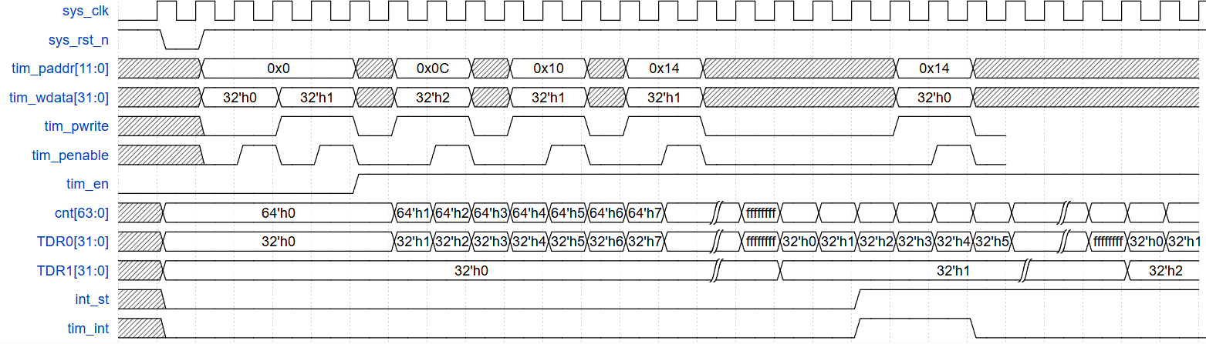
Figure 3: Waveform of operation
At the 4th clock, the transfer to write 32’h1 to TCR is set up and enables the bit timer_en to toggle up in the next 2 cycles (6th edge). Then, the counter starts to operate in the normal mode and TDR0, TDR1 stores the values of 64 bits of counter.
At the 7th clock, 32’h2 is written into the TCMP0 register and the same transfer of 32’h1 is executed in TCMP1 register (at the 10th clock).
At the clock, int_en rises to the high level which is illustrated by writing 32’h1 into TIER, when TDR0 reaches TCMP0 and TDR1 is as same as TCMP1 at 19th clock, int_st will be toggled up and result in HIGH output tim_int.

3.2. Diagram Explanation
The “Counter” block contains 2 more sub-blocks, “internal_cnt” and “cnt_control”. Both of them are configured for correct operation during the control mode of counter. Regarding the “internal_cnt” block, it enables a variable “i” to count up and allows the counter to update its value until “i” reaches a specific value. Finally, the “cnt_control” will update the data based on the given “i” from the left block. The detailed diagrams of these sub-blocks are given below:
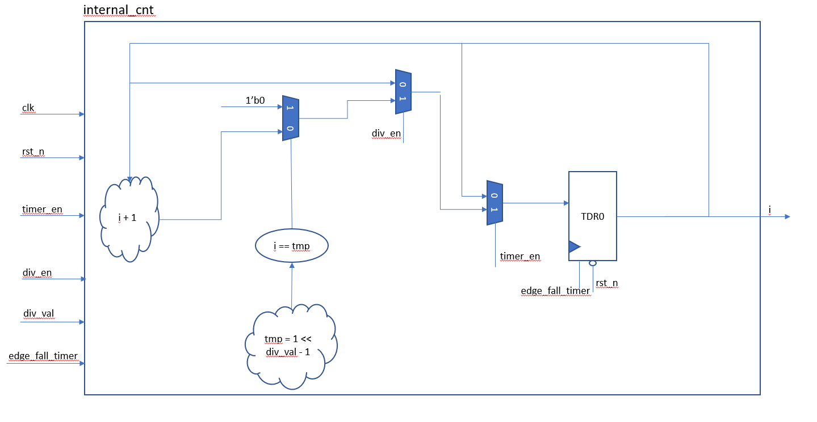
Figure 4: Sub block internal_cnt
The above sub-block can operate to count in parallel with the sub-block “Cnt_control” below so that it can release an internal output “i” to control the “count [63:0]”. The role of this block is at the temporary value: , when i reaches this value, the counter can be allowed to updata the new value.
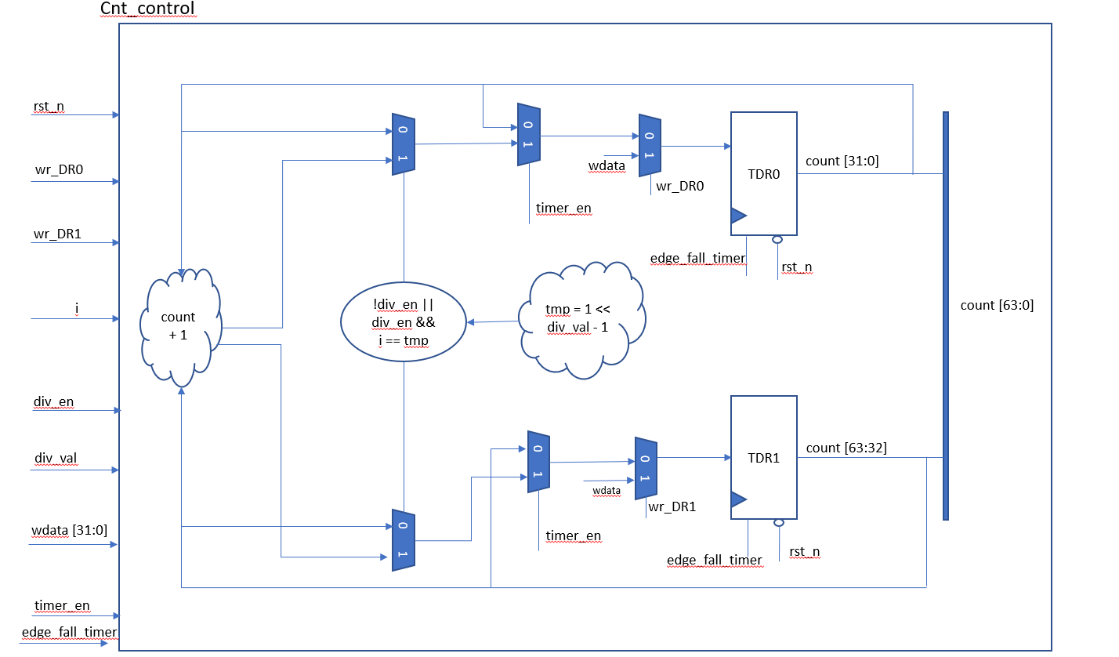
Figure 5: Sub block cnt_control
Sub-block “cnt_control” can execute the counting performance of “count [63:0]” in accordance with “internal_cnt” block’s allowance. With regards to 2 inputs “wr_DR0” and “wr_DR1”, both of them are used to update the counter immediately with the value written into TDR0 and TDR1.

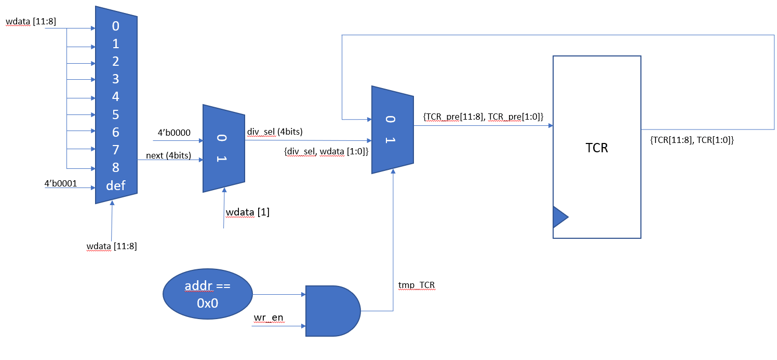
Figure 6: Block diagram of TCR
In the TCR block, the two multiplexers at the left-hand side can select the valid value for div_val [3:0] based on wdata[11:8] and div_en (passed to TCR[1] via wdata[1]). Then, there are two ranges in the bit width of TCR (TCR[11:8] and TCR[1:0]) that can be updated based on the wr_en signal input.
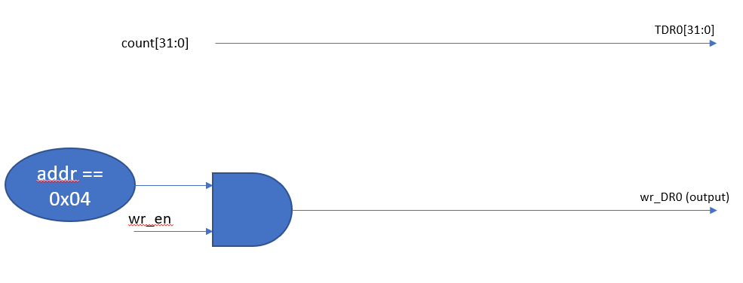
Figure 7: Block diagram of TDR0

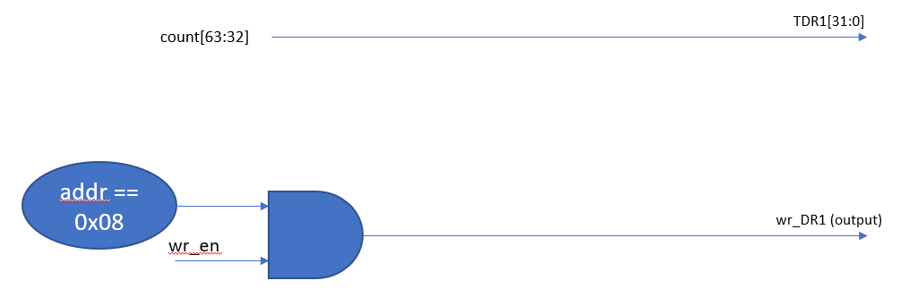
Figure 8: Block diagram of TDR1
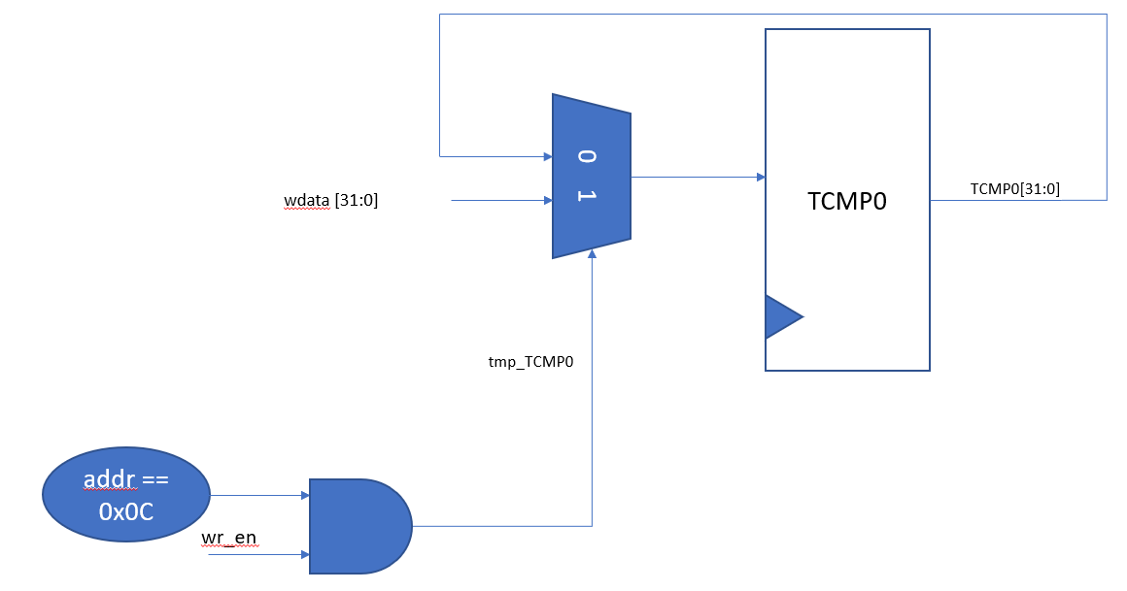
Figure 9: Block diagram of TCMP0

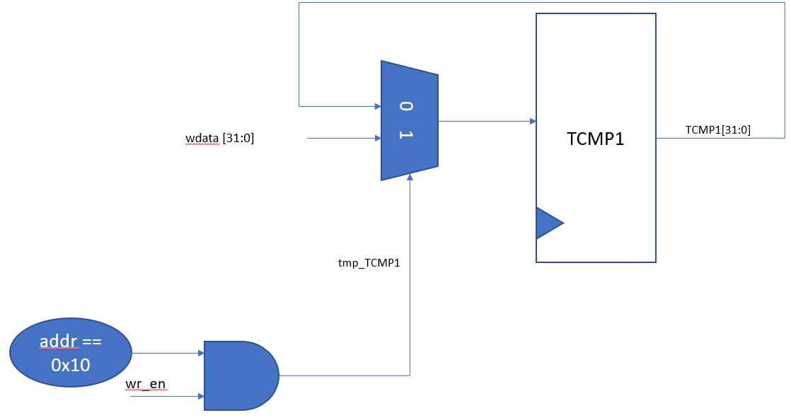
Figure 10: Block diagram of TCMP1
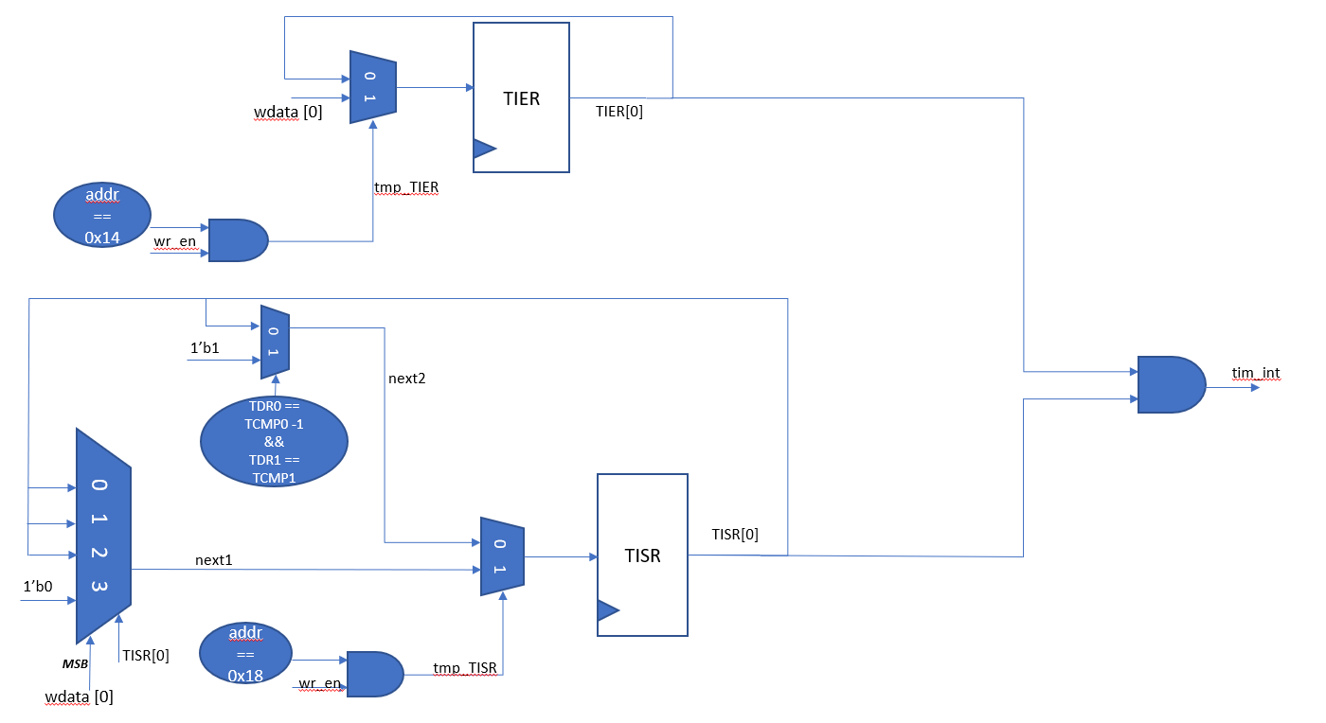
Figure 11: Block diagrams of TIER and TISR
Regarding the TISR block, its function is to rise the int_st up when there is a matching detection between count [63:0] and {TCMP1, TCMP0}. Additionally, it also has a function to write 1 to clear the its high output, which can be detailed described at the left-hand side of the figure.

4. History
Date | Version | Description | Author
 | 1.0 | Newly created | Nguyễn Tân Thành

