Air Quality Report

# City:

sandakan

# Current AQI:

39 (Good)

Air quality is considered satisfactory, and air pollution poses little or no risk.

# Cautionary Statement:

None

# Dominent Pollutant:

# Charts:

## IAQI Bar Chart

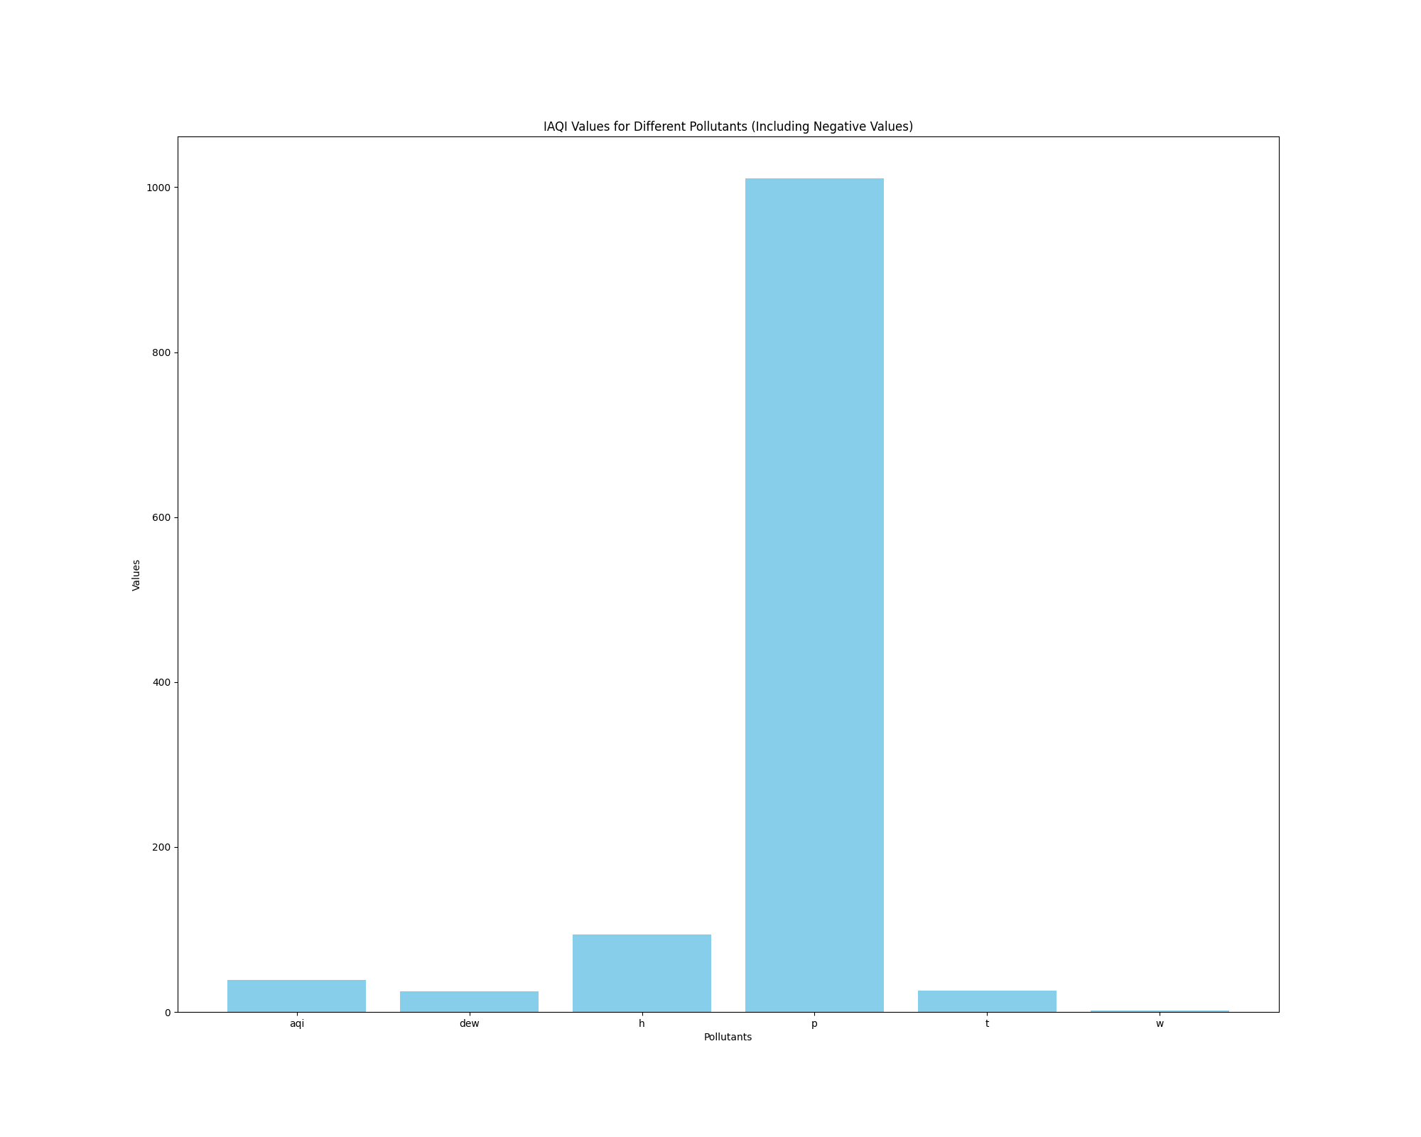

## PM2.5 Forecast

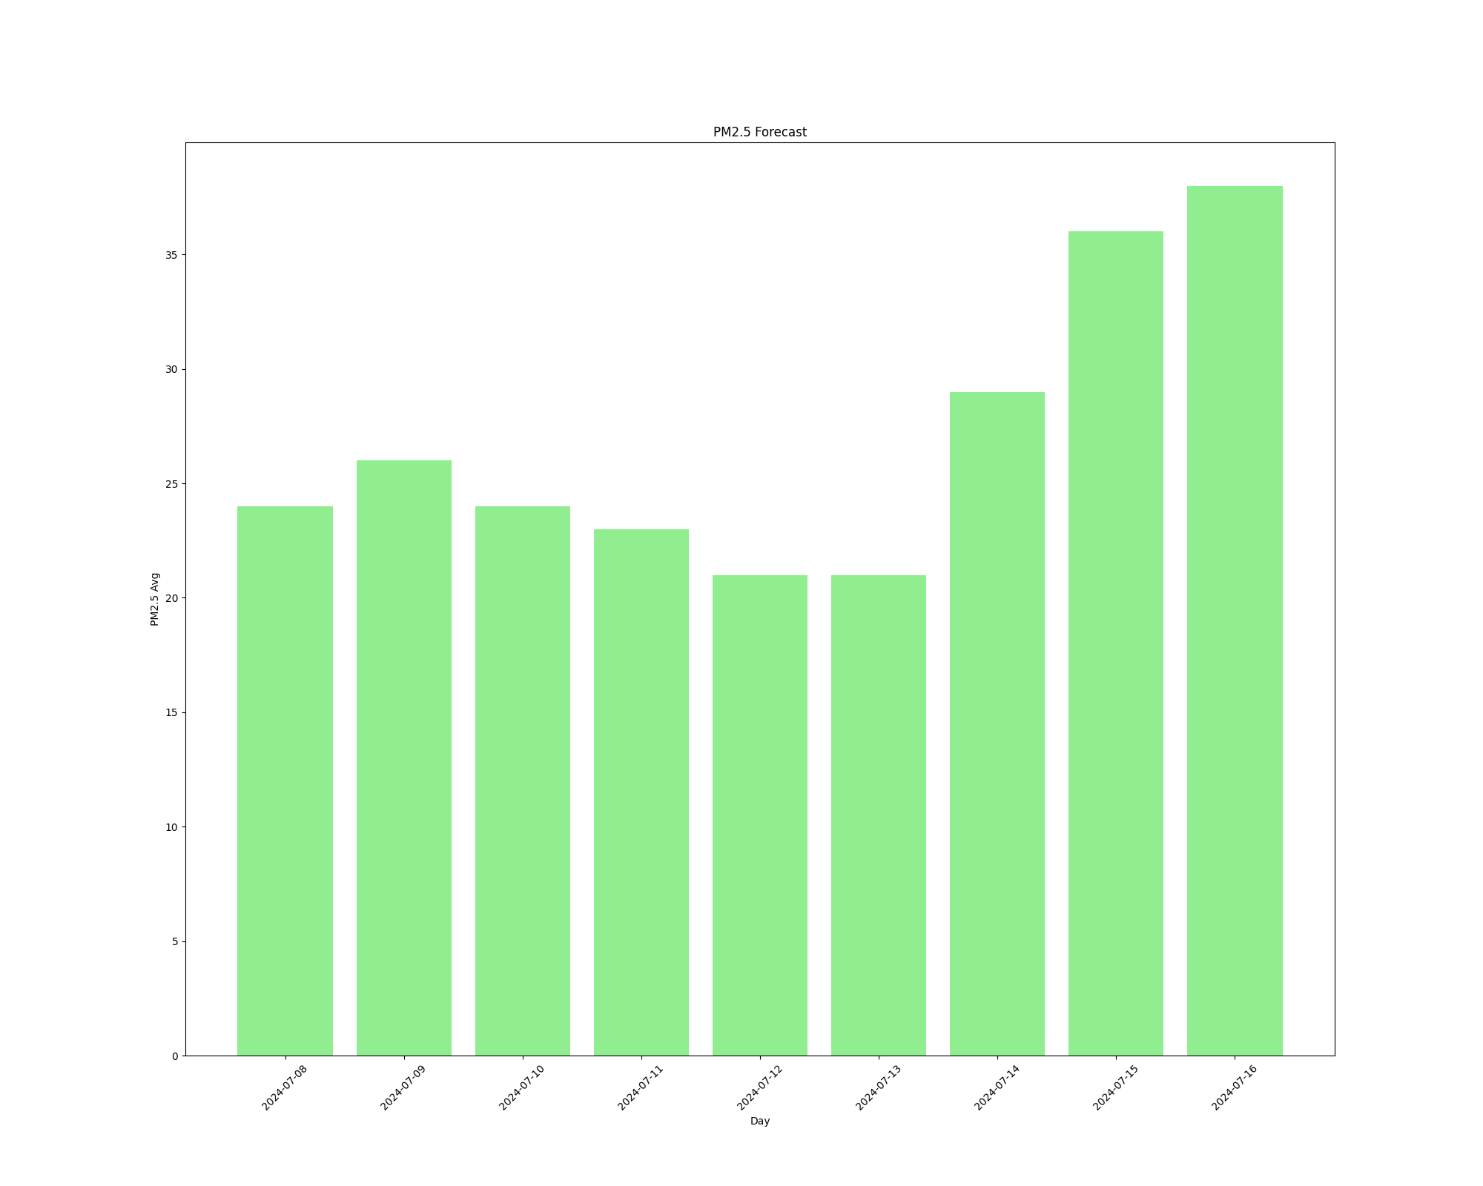

## PM2.5 Forecast (Grouped Bar Chart)

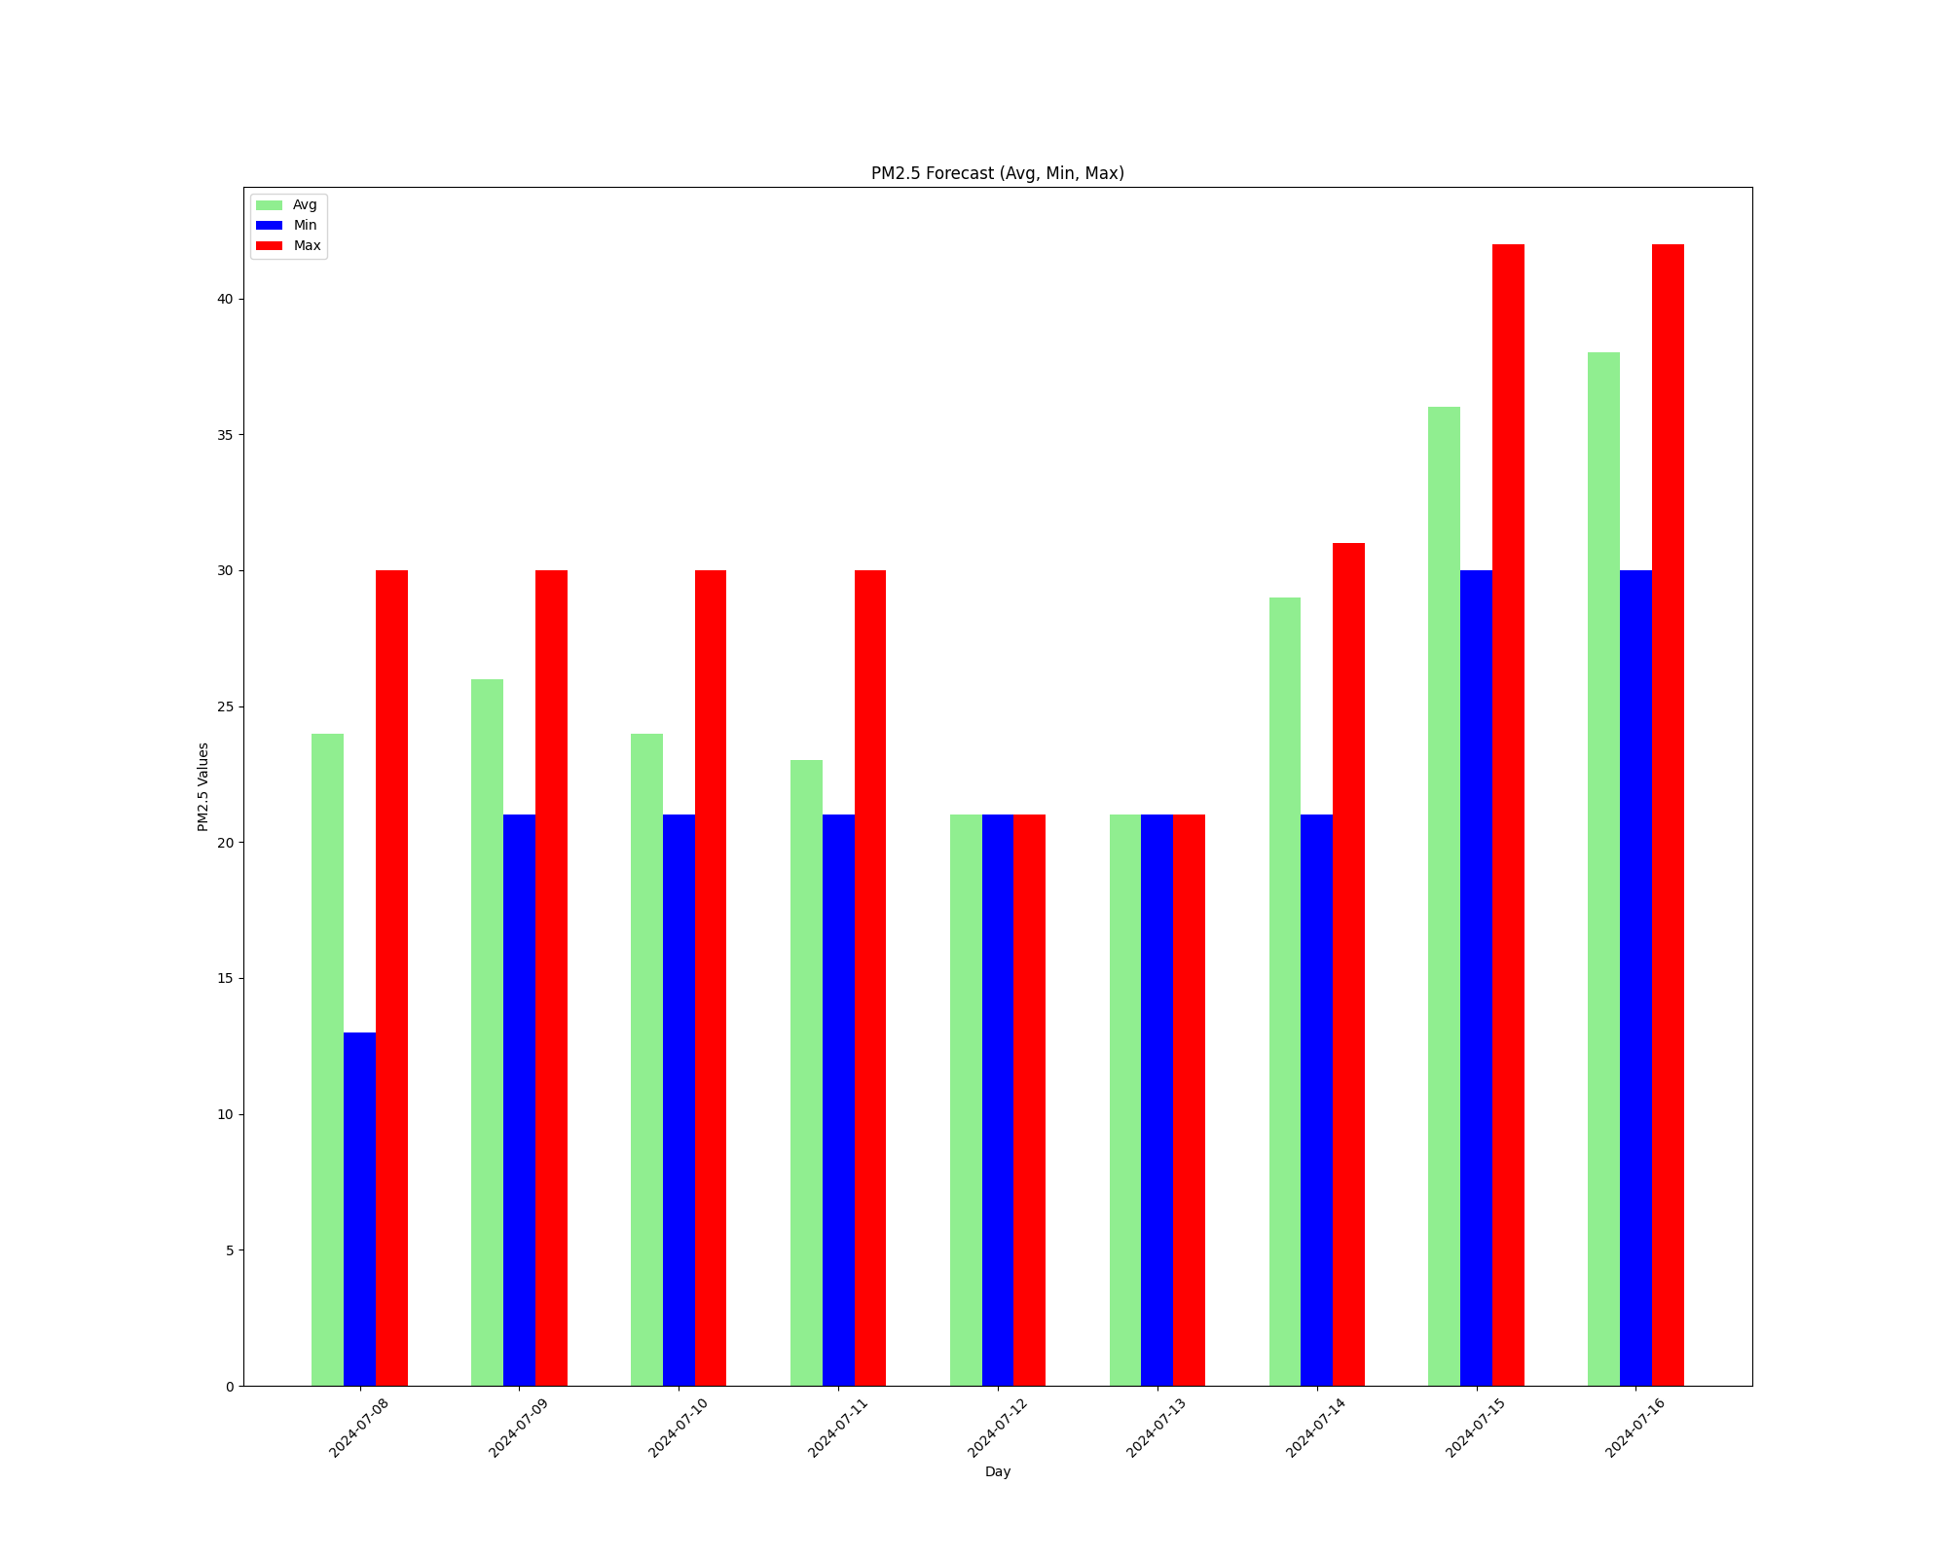

## PM10 Forecast

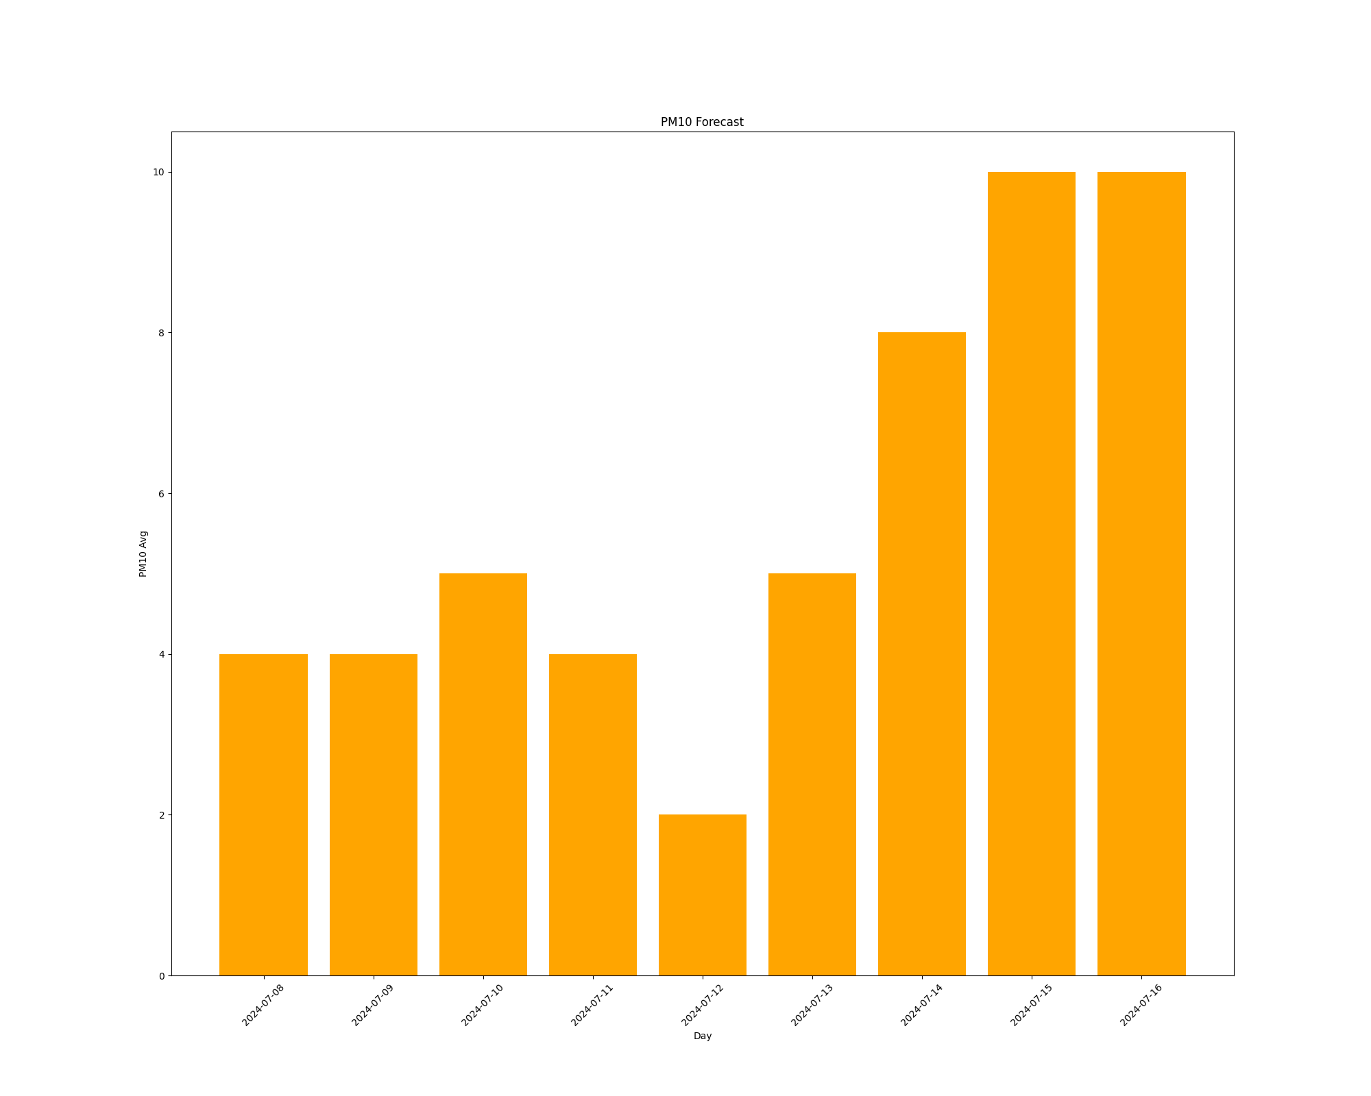

## PM10 Forecast (Grouped Bar Chart)

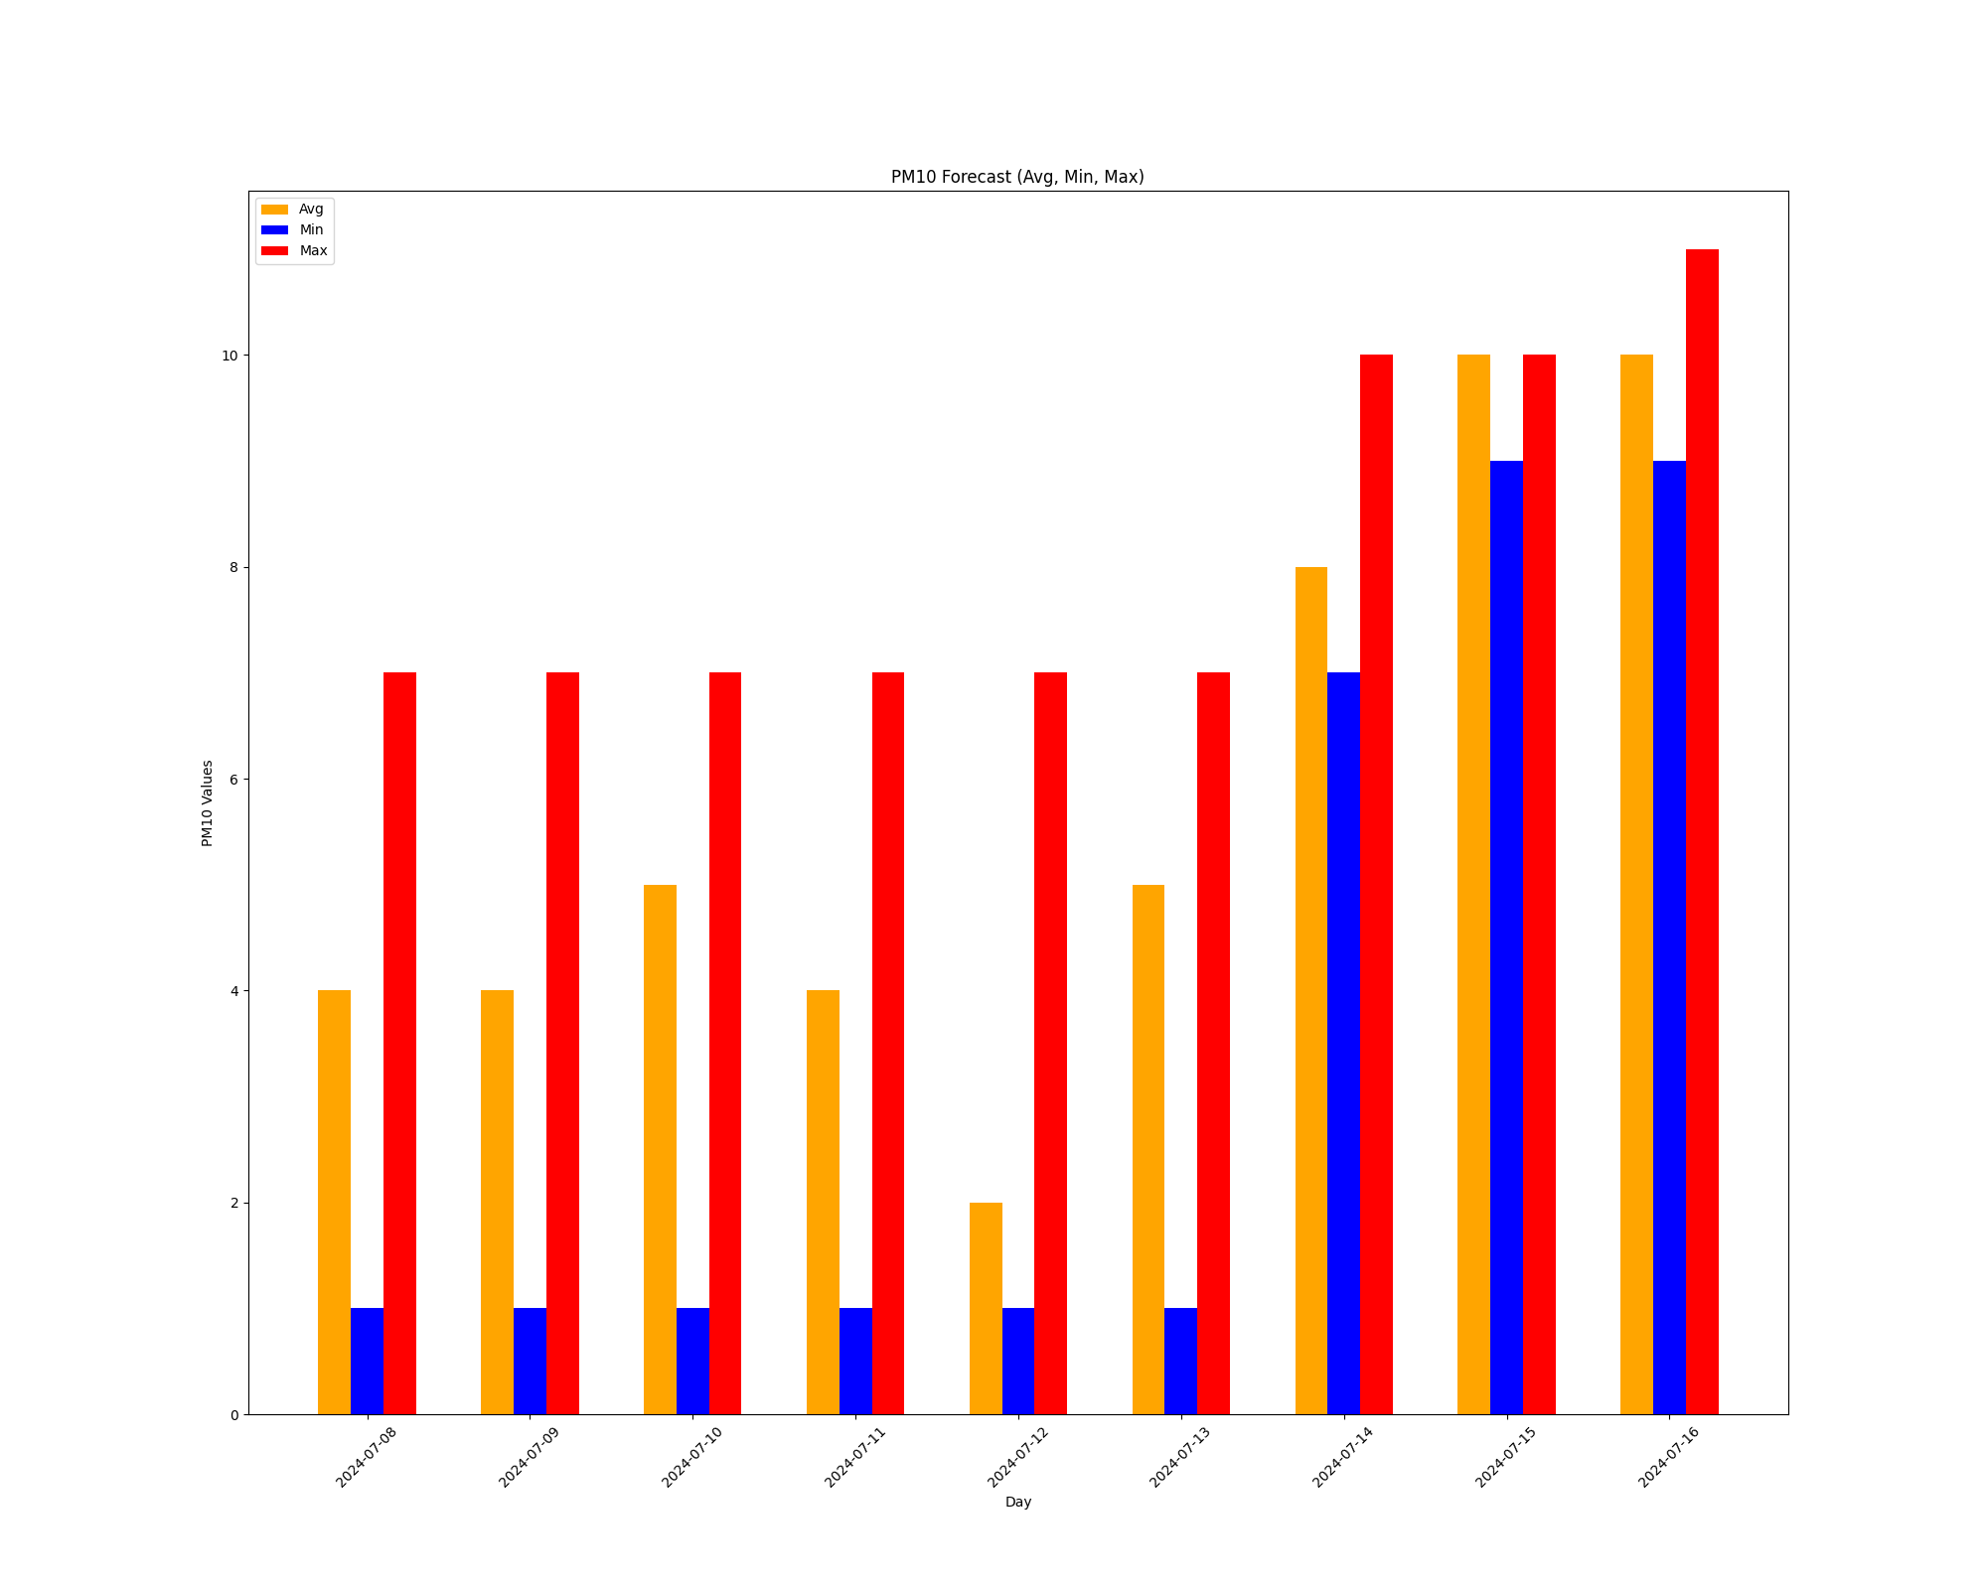

## O3 Forecast

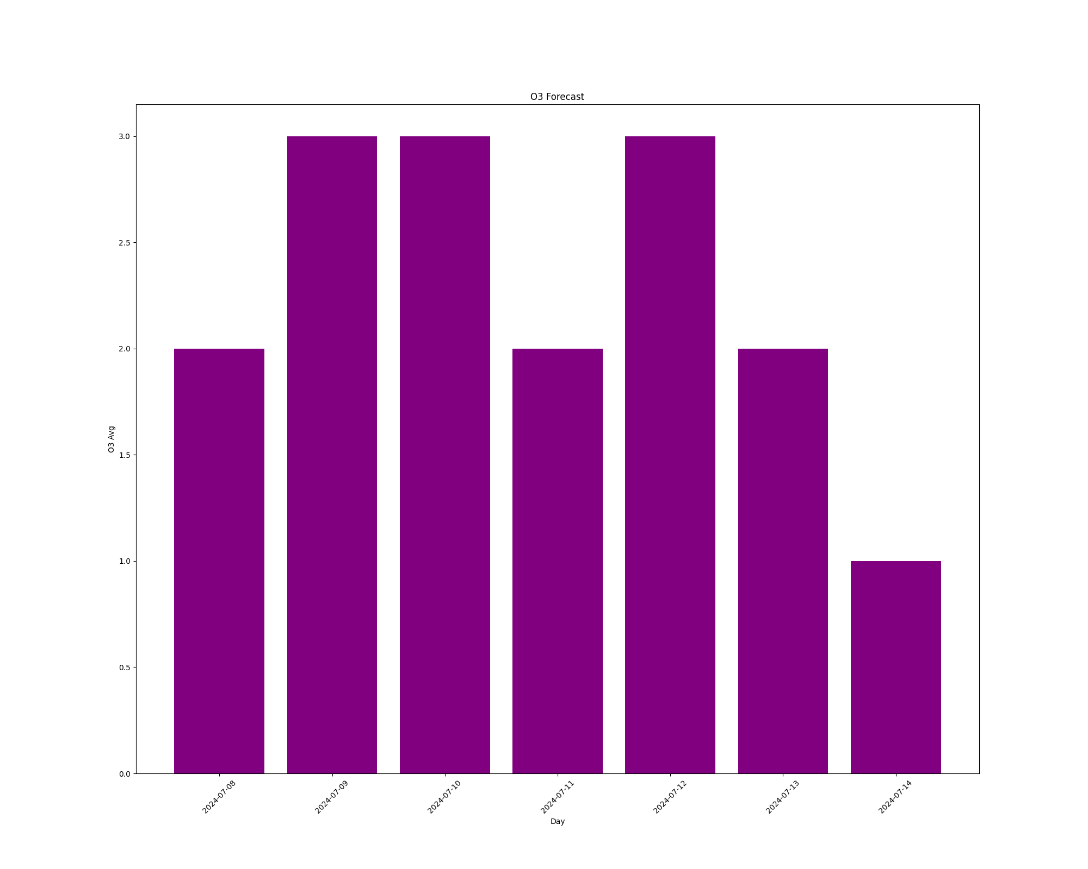

## O3 Forecast (Grouped Bar Chart)

