LAB 6:

WINFORM KẾT NỐI CƠ SỞ DỮ LIỆU NÂNG CAO

Tạo 2 bảng của CSDL QuanLyBanSach:

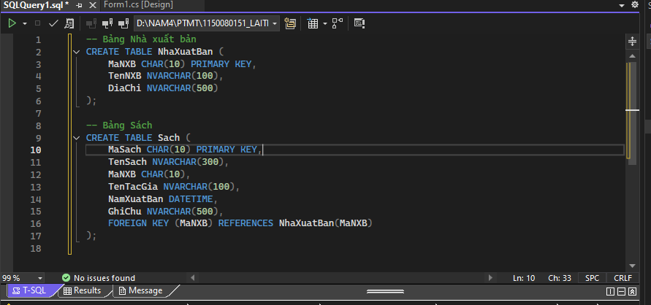

Tạo liên kết khóa ngoại để kết nối giữa 2 bảng:

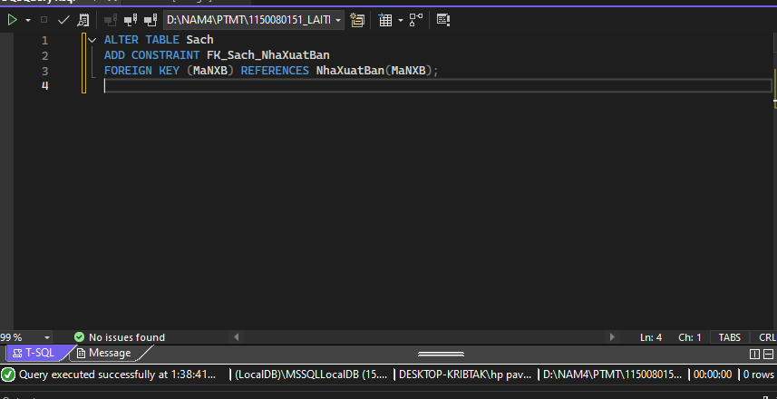

Tạo dữ liệu mẫu cho các bảng:

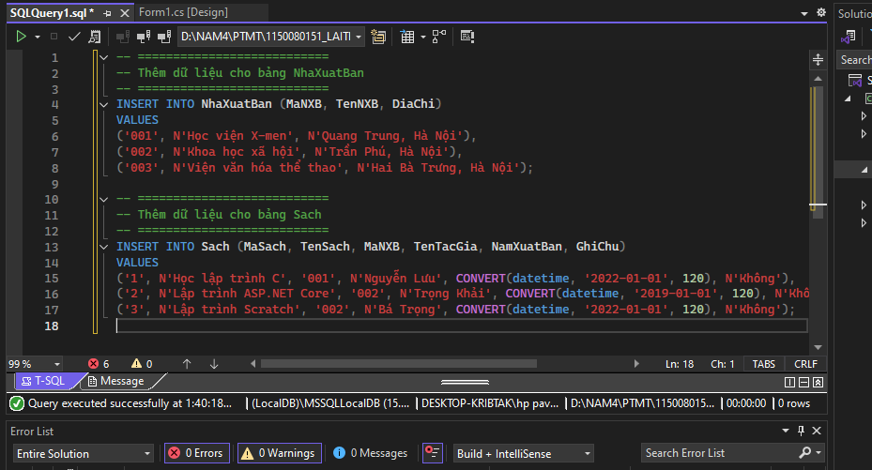

**Thực hành 1: Hiển thị danh sách nhà xuất bản sách.**

**Mở Server Explorer  
 → Chuột phải vào file Database1.mdf  
 → Chọn Open hoặc New Query.**

**Thêm thủ tục mới  
 → Mở thư mục Stored Procedures  
 → Chuột phải → Add New Stored Procedure.**

**Viết câu lệnh T-SQL  
 (ví dụ:)  
  
 CREATE PROC HienThiNXB**

**AS**

**BEGIN**

**SELECT * FROM NhaXuatBan**

**END**

**Lưu thủ tục  
 → Nhấn Ctrl + S.  
 → Hộp thoại Preview Database Updates hiện ra.**

**Xác nhận cập nhật  
 → Chọn Include transactional scripts.  
 → Bấm Update Database ✅.**

**Kiểm tra kết quả  
 → Mở lại thư mục Stored Procedures trong Server Explorer.  
 → Thấy thủ tục vừa tạo xuất hiện (ví dụ: dbo.HienThiNXB).**

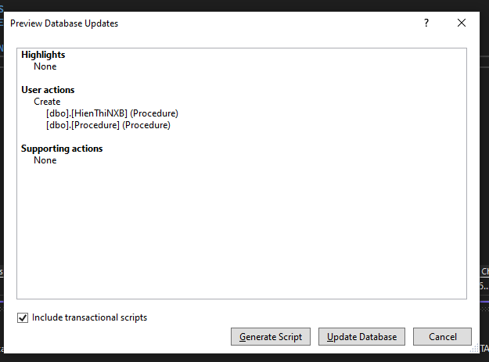

**Mở cơ sở dữ liệu  
 Trong Server Explorer, mở Database1.mdf.**

**Thêm thủ tục mới  
 → Mở thư mục Stored Procedures  
 → Chuột phải chọn Add New Stored Procedure.**

**Nhập câu lệnh T-SQL  
 Ví dụ:  
  
 CREATE PROC HienThiChiTietNXB**

**@MaNXB CHAR(10)**

**AS**

**BEGIN**

**SELECT * FROM NhaXuatBan WHERE MaNXB = @MaNXB**

**END**

**Lưu và cập nhật  
 → Nhấn Ctrl + S  
 → Cửa sổ Preview Database Updates hiện ra  
 → Tick chọn Include transactional scripts  
 → Bấm Update Database ✅.**

**Kiểm tra kết quả  
 → Mở lại thư mục Stored Procedures  
 → Thấy tên thủ tục mới (ví dụ: dbo.HienThiChiTietNXB) đã được thêm thành công.**

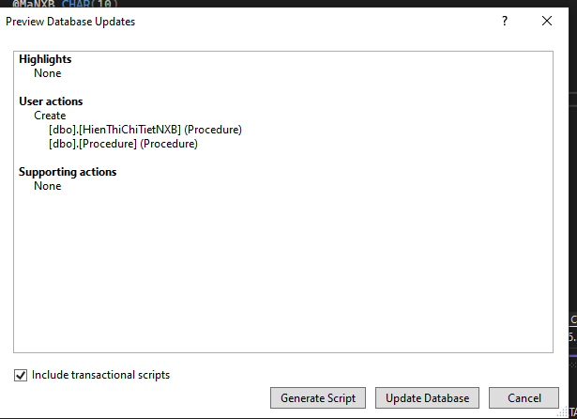

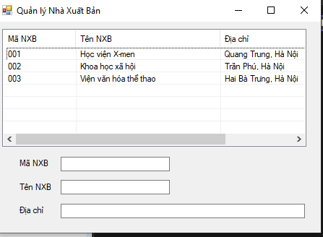

[**Form1.cs**](http://form1.cs)

**using System;**

**using System.Data;**

**using System.Data.SqlClient;**

**using System.Windows.Forms;**

**namespace QuanLyNXB**

**{**

**public partial class Form1 : Form**

**{**

**// 🔹 Chuỗi kết nối (đường dẫn của anh)**

**string strCon =**

**@"Data Source=(LocalDB)\MSSQLLocalDB;**

**AttachDbFilename=D:\NAM4\PTMT\1150080151_LAITHANHNHAN_LAB6\1150080151_LAITHANHNHAN_LAB6\Database1.mdf;**

**Integrated Security=True";**

**SqlConnection sqlCon = null;**

**public Form1()**

**{**

**InitializeComponent();**

**}**

**// ===== MỞ KẾT NỐI =====**

**private void MoKetNoi()**

**{**

**if (sqlCon == null)**

**sqlCon = new SqlConnection(strCon);**

**if (sqlCon.State == ConnectionState.Closed)**

**sqlCon.Open();**

**}**

**// ===== ĐÓNG KẾT NỐI =====**

**private void DongKetNoi()**

**{**

**if (sqlCon != null && sqlCon.State == ConnectionState.Open)**

**sqlCon.Close();**

**}**

**// ===== HIỂN THỊ DANH SÁCH NHÀ XUẤT BẢN =====**

**private void HienThiDanhSachNXB()**

**{**

**MoKetNoi();**

**SqlCommand sqlCmd = new SqlCommand();**

**sqlCmd.CommandType = CommandType.StoredProcedure;**

**sqlCmd.CommandText = "HienThiNXB";**

**sqlCmd.Connection = sqlCon;**

**SqlDataReader reader = sqlCmd.ExecuteReader();**

**lsvDanhSach.Items.Clear();**

**while (reader.Read())**

**{**

**string maXB = reader.GetString(0);**

**string tenXB = reader.GetString(1);**

**string diaChi = reader.GetString(2);**

**ListViewItem lvi = new ListViewItem(maXB);**

**lvi.SubItems.Add(tenXB);**

**lvi.SubItems.Add(diaChi);**

**lsvDanhSach.Items.Add(lvi);**

**}**

**reader.Close();**

**}**

**// ===== FORM LOAD =====**

**private void Form1_Load(object sender, EventArgs e)**

**{**

**HienThiDanhSachNXB();**

**}**

**// ===== SỰ KIỆN CHỌN 1 DÒNG TRONG LISTVIEW =====**

**private void lsvDanhSach_SelectedIndexChanged(object sender, EventArgs e)**

**{**

**if (lsvDanhSach.SelectedItems.Count == 0) return;**

**ListViewItem lvi = lsvDanhSach.SelectedItems[0];**

**string maXB = lvi.SubItems[0].Text;**

**HienThiThongTinNXBTheoMa(maXB);**

**}**

**// ===== HIỂN THỊ CHI TIẾT NXB THEO MÃ =====**

**private void HienThiThongTinNXBTheoMa(string maXB)**

**{**

**MoKetNoi();**

**SqlCommand sqlCmd = new SqlCommand();**

**sqlCmd.CommandType = CommandType.StoredProcedure;**

**sqlCmd.CommandText = "HienThiChiTietNXB";**

**sqlCmd.Connection = sqlCon;**

**SqlParameter parMaXB = new SqlParameter("@MaNXB", SqlDbType.Char);**

**parMaXB.Value = maXB;**

**sqlCmd.Parameters.Add(parMaXB);**

**SqlDataReader reader = sqlCmd.ExecuteReader();**

**txtMaXB.Text = txtTenXB.Text = txtDiaChi.Text = "";**

**if (reader.Read())**

**{**

**txtMaXB.Text = reader.GetString(0);**

**txtTenXB.Text = reader.GetString(1);**

**txtDiaChi.Text = reader.GetString(2);**

**}**

**reader.Close();**

**}**

**}**

**}**

[**Form1.design.cs**](http://form1.design.cs)

**namespace QuanLyNXB**

**{**

**partial class Form1**

**{**

**private System.ComponentModel.IContainer components = null;**

**protected override void Dispose(bool disposing)**

**{**

**if (disposing && (components != null))**

**{**

**components.Dispose();**

**}**

**base.Dispose(disposing);**

**}**

**#region Windows Form Designer generated code**

**private void InitializeComponent()**

**{**

**this.lsvDanhSach = new System.Windows.Forms.ListView();**

**this.colMa = ((System.Windows.Forms.ColumnHeader)(new System.Windows.Forms.ColumnHeader()));**

**this.colTen = ((System.Windows.Forms.ColumnHeader)(new System.Windows.Forms.ColumnHeader()));**

**this.colDiaChi = ((System.Windows.Forms.ColumnHeader)(new System.Windows.Forms.ColumnHeader()));**

**this.txtMaXB = new System.Windows.Forms.TextBox();**

**this.txtTenXB = new System.Windows.Forms.TextBox();**

**this.txtDiaChi = new System.Windows.Forms.TextBox();**

**this.lblMa = new System.Windows.Forms.Label();**

**this.lblTen = new System.Windows.Forms.Label();**

**this.lblDiaChi = new System.Windows.Forms.Label();**

**this.SuspendLayout();**

**//**

**// lsvDanhSach**

**//**

**this.lsvDanhSach.Columns.AddRange(new System.Windows.Forms.ColumnHeader[] {**

**this.colMa,**

**this.colTen,**

**this.colDiaChi});**

**this.lsvDanhSach.FullRowSelect = true;**

**this.lsvDanhSach.GridLines = true;**

**this.lsvDanhSach.HideSelection = false;**

**this.lsvDanhSach.Location = new System.Drawing.Point(12, 12);**

**this.lsvDanhSach.MultiSelect = false;**

**this.lsvDanhSach.Name = "lsvDanhSach";**

**this.lsvDanhSach.Size = new System.Drawing.Size(560, 200);**

**this.lsvDanhSach.TabIndex = 0;**

**this.lsvDanhSach.UseCompatibleStateImageBehavior = false;**

**this.lsvDanhSach.View = System.Windows.Forms.View.Details;**

**this.lsvDanhSach.SelectedIndexChanged += new System.EventHandler(this.lsvDanhSach_SelectedIndexChanged);**

**//**

**// colMa**

**//**

**this.colMa.Text = "Mã NXB";**

**this.colMa.Width = 100;**

**//**

**// colTen**

**//**

**this.colTen.Text = "Tên NXB";**

**this.colTen.Width = 200;**

**//**

**// colDiaChi**

**//**

**this.colDiaChi.Text = "Địa chỉ";**

**this.colDiaChi.Width = 250;**

**//**

**// txtMaXB**

**//**

**this.txtMaXB.Location = new System.Drawing.Point(120, 230);**

**this.txtMaXB.Name = "txtMaXB";**

**this.txtMaXB.Size = new System.Drawing.Size(200, 22);**

**this.txtMaXB.TabIndex = 1;**

**//**

**// txtTenXB**

**//**

**this.txtTenXB.Location = new System.Drawing.Point(120, 270);**

**this.txtTenXB.Name = "txtTenXB";**

**this.txtTenXB.Size = new System.Drawing.Size(200, 22);**

**this.txtTenXB.TabIndex = 2;**

**//**

**// txtDiaChi**

**//**

**this.txtDiaChi.Location = new System.Drawing.Point(120, 310);**

**this.txtDiaChi.Name = "txtDiaChi";**

**this.txtDiaChi.Size = new System.Drawing.Size(450, 22);**

**this.txtDiaChi.TabIndex = 3;**

**//**

**// lblMa**

**//**

**this.lblMa.AutoSize = true;**

**this.lblMa.Location = new System.Drawing.Point(40, 233);**

**this.lblMa.Name = "lblMa";**

**this.lblMa.Size = new System.Drawing.Size(56, 16);**

**this.lblMa.TabIndex = 4;**

**this.lblMa.Text = "Mã NXB";**

**//**

**// lblTen**

**//**

**this.lblTen.AutoSize = true;**

**this.lblTen.Location = new System.Drawing.Point(40, 273);**

**this.lblTen.Name = "lblTen";**

**this.lblTen.Size = new System.Drawing.Size(60, 16);**

**this.lblTen.TabIndex = 5;**

**this.lblTen.Text = "Tên NXB";**

**//**

**// lblDiaChi**

**//**

**this.lblDiaChi.AutoSize = true;**

**this.lblDiaChi.Location = new System.Drawing.Point(40, 313);**

**this.lblDiaChi.Name = "lblDiaChi";**

**this.lblDiaChi.Size = new System.Drawing.Size(50, 16);**

**this.lblDiaChi.TabIndex = 6;**

**this.lblDiaChi.Text = "Địa chỉ";**

**//**

**// Form1**

**//**

**this.AutoScaleDimensions = new System.Drawing.SizeF(8F, 16F);**

**this.AutoScaleMode = System.Windows.Forms.AutoScaleMode.Font;**

**this.ClientSize = new System.Drawing.Size(600, 360);**

**this.Controls.Add(this.lblDiaChi);**

**this.Controls.Add(this.lblTen);**

**this.Controls.Add(this.lblMa);**

**this.Controls.Add(this.txtDiaChi);**

**this.Controls.Add(this.txtTenXB);**

**this.Controls.Add(this.txtMaXB);**

**this.Controls.Add(this.lsvDanhSach);**

**this.Name = "Form1";**

**this.Text = "Quản lý Nhà Xuất Bản";**

**this.Load += new System.EventHandler(this.Form1_Load);**

**this.ResumeLayout(false);**

**this.PerformLayout();**

**}**

**#endregion**

**private System.Windows.Forms.ListView lsvDanhSach;**

**private System.Windows.Forms.ColumnHeader colMa;**

**private System.Windows.Forms.ColumnHeader colTen;**

**private System.Windows.Forms.ColumnHeader colDiaChi;**

**private System.Windows.Forms.TextBox txtMaXB;**

**private System.Windows.Forms.TextBox txtTenXB;**

**private System.Windows.Forms.TextBox txtDiaChi;**

**private System.Windows.Forms.Label lblMa;**

**private System.Windows.Forms.Label lblTen;**

**private System.Windows.Forms.Label lblDiaChi;**

**}**

**}**

**Thực hành 2: Thêm dữ liệu cho bảng Nhà xuất bản**

**Mở Database trong Visual Studio**

* **Vào Server Explorer → Database1.mdf**
* **Mở thư mục Stored Procedures**

**Thêm thủ tục mới**

* **Chuột phải → Add New Stored Procedure**

**Nhập nội dung thủ tục  
  
 CREATE PROC ThemDuLieu**

**@MaNXB CHAR(10),**

**@TenNXB NVARCHAR(100),**

**@DiaChi NVARCHAR(500)**

**AS**

**BEGIN**

**INSERT INTO NhaXuatBan(MaNXB, TenNXB, DiaChi)**

**VALUES (@MaNXB, @TenNXB, @DiaChi)**

**END**

**Lưu và cập nhật CSDL**

* **Nhấn Ctrl + S**
* **Hộp thoại Preview Database Updates xuất hiện**
* **Tích chọn Include transactional scripts**
* **Nhấn Update Database ✅**

**Kiểm tra kết quả**

* **Mở lại Stored Procedures**
* **Xuất hiện thủ tục mới: dbo.ThemDuLieu**

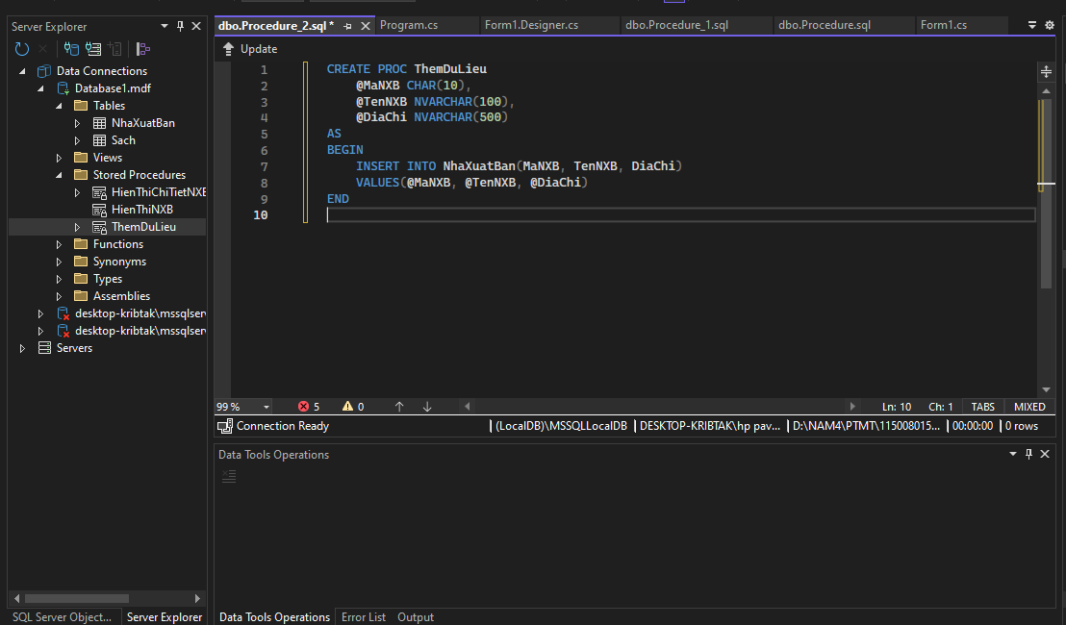

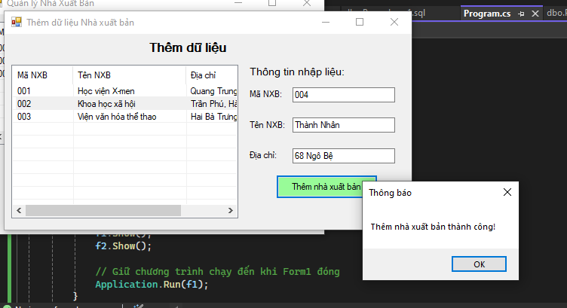

[**Form2.cs**](http://form2.cs)

**using System;**

**using System.Data;**

**using System.Data.SqlClient;**

**using System.Windows.Forms;**

**namespace QuanLyNXB**

**{**

**public partial class Form2 : Form**

**{**

**// 🔹 Chuỗi kết nối đúng đường dẫn của anh**

**string strCon =**

**@"Data Source=(LocalDB)\MSSQLLocalDB;**

**AttachDbFilename=D:\NAM4\PTMT\1150080151_LAITHANHNHAN_LAB6\1150080151_LAITHANHNHAN_LAB6\Database1.mdf;**

**Integrated Security=True";**

**SqlConnection sqlCon = null;**

**public Form2()**

**{**

**InitializeComponent();**

**}**

**// ===== MỞ KẾT NỐI =====**

**private void MoKetNoi()**

**{**

**if (sqlCon == null)**

**sqlCon = new SqlConnection(strCon);**

**if (sqlCon.State == ConnectionState.Closed)**

**sqlCon.Open();**

**}**

**// ===== ĐÓNG KẾT NỐI =====**

**private void DongKetNoi()**

**{**

**if (sqlCon != null && sqlCon.State == ConnectionState.Open)**

**sqlCon.Close();**

**}**

**// ===== HIỂN THỊ DANH SÁCH NXB =====**

**private void HienThiDanhSachNXB()**

**{**

**MoKetNoi();**

**SqlCommand sqlCmd = new SqlCommand();**

**sqlCmd.CommandType = CommandType.StoredProcedure;**

**sqlCmd.CommandText = "HienThiNXB"; // Thủ tục lấy danh sách NXB**

**sqlCmd.Connection = sqlCon;**

**SqlDataReader reader = sqlCmd.ExecuteReader();**

**lsvDanhSach.Items.Clear();**

**while (reader.Read())**

**{**

**string ma = reader.GetString(0);**

**string ten = reader.GetString(1);**

**string diachi = reader.GetString(2);**

**ListViewItem lvi = new ListViewItem(ma);**

**lvi.SubItems.Add(ten);**

**lvi.SubItems.Add(diachi);**

**lsvDanhSach.Items.Add(lvi);**

**}**

**reader.Close();**

**}**

**// ===== FORM LOAD =====**

**private void Form2_Load(object sender, EventArgs e)**

**{**

**HienThiDanhSachNXB();**

**txtMaXB.Focus();**

**}**

**// ===== THÊM DỮ LIỆU =====**

**private void btnThem_Click(object sender, EventArgs e)**

**{**

**MoKetNoi();**

**SqlCommand sqlCmd = new SqlCommand();**

**sqlCmd.CommandType = CommandType.StoredProcedure;**

**sqlCmd.CommandText = "ThemDuLieu"; // Thủ tục đã tạo trong SQL**

**sqlCmd.Connection = sqlCon;**

**// Thêm tham số**

**sqlCmd.Parameters.Add("@MaNXB", SqlDbType.Char).Value = txtMaXB.Text.Trim();**

**sqlCmd.Parameters.Add("@TenNXB", SqlDbType.NVarChar, 100).Value = txtTenXB.Text.Trim();**

**sqlCmd.Parameters.Add("@DiaChi", SqlDbType.NVarChar, 500).Value = txtDiaChi.Text.Trim();**

**int kq = sqlCmd.ExecuteNonQuery();**

**if (kq > 0)**

**{**

**MessageBox.Show("Thêm nhà xuất bản thành công!", "Thông báo");**

**HienThiDanhSachNXB();**

**txtMaXB.Text = txtTenXB.Text = txtDiaChi.Text = "";**

**}**

**DongKetNoi();**

**}**

**}**

**}**

[**Form2.design.cs**](http://form2.design.cs)

**namespace QuanLyNXB**

**{**

**partial class Form2**

**{**

**private System.ComponentModel.IContainer components = null;**

**protected override void Dispose(bool disposing)**

**{**

**if (disposing && (components != null))**

**{**

**components.Dispose();**

**}**

**base.Dispose(disposing);**

**}**

**#region Windows Form Designer generated code**

**private void InitializeComponent()**

**{**

**this.lsvDanhSach = new System.Windows.Forms.ListView();**

**this.colMa = ((System.Windows.Forms.ColumnHeader)(new System.Windows.Forms.ColumnHeader()));**

**this.colTen = ((System.Windows.Forms.ColumnHeader)(new System.Windows.Forms.ColumnHeader()));**

**this.colDiaChi = ((System.Windows.Forms.ColumnHeader)(new System.Windows.Forms.ColumnHeader()));**

**this.lblTitle = new System.Windows.Forms.Label();**

**this.lblNhap = new System.Windows.Forms.Label();**

**this.lblMa = new System.Windows.Forms.Label();**

**this.lblTen = new System.Windows.Forms.Label();**

**this.lblDiaChi = new System.Windows.Forms.Label();**

**this.txtMaXB = new System.Windows.Forms.TextBox();**

**this.txtTenXB = new System.Windows.Forms.TextBox();**

**this.txtDiaChi = new System.Windows.Forms.TextBox();**

**this.btnThem = new System.Windows.Forms.Button();**

**this.SuspendLayout();**

**//**

**// lsvDanhSach**

**//**

**this.lsvDanhSach.Columns.AddRange(new System.Windows.Forms.ColumnHeader[] {**

**this.colMa,**

**this.colTen,**

**this.colDiaChi});**

**this.lsvDanhSach.FullRowSelect = true;**

**this.lsvDanhSach.GridLines = true;**

**this.lsvDanhSach.HideSelection = false;**

**this.lsvDanhSach.Location = new System.Drawing.Point(12, 50);**

**this.lsvDanhSach.Name = "lsvDanhSach";**

**this.lsvDanhSach.Size = new System.Drawing.Size(400, 250);**

**this.lsvDanhSach.TabIndex = 0;**

**this.lsvDanhSach.UseCompatibleStateImageBehavior = false;**

**this.lsvDanhSach.View = System.Windows.Forms.View.Details;**

**//**

**// colMa**

**//**

**this.colMa.Text = "Mã NXB";**

**this.colMa.Width = 80;**

**//**

**// colTen**

**//**

**this.colTen.Text = "Tên NXB";**

**this.colTen.Width = 150;**

**//**

**// colDiaChi**

**//**

**this.colDiaChi.Text = "Địa chỉ";**

**this.colDiaChi.Width = 150;**

**//**

**// lblTitle**

**//**

**this.lblTitle.AutoSize = true;**

**this.lblTitle.Font = new System.Drawing.Font("Microsoft Sans Serif", 12F, System.Drawing.FontStyle.Bold);**

**this.lblTitle.Location = new System.Drawing.Point(250, 10);**

**this.lblTitle.Name = "lblTitle";**

**this.lblTitle.Size = new System.Drawing.Size(121, 25);**

**this.lblTitle.TabIndex = 1;**

**this.lblTitle.Text = "Thêm dữ liệu";**

**//**

**// lblNhap**

**//**

**this.lblNhap.AutoSize = true;**

**this.lblNhap.Font = new System.Drawing.Font("Microsoft Sans Serif", 10F);**

**this.lblNhap.Location = new System.Drawing.Point(430, 50);**

**this.lblNhap.Name = "lblNhap";**

**this.lblNhap.Size = new System.Drawing.Size(130, 20);**

**this.lblNhap.TabIndex = 2;**

**this.lblNhap.Text = "Thông tin nhập liệu:";**

**//**

**// lblMa**

**//**

**this.lblMa.AutoSize = true;**

**this.lblMa.Location = new System.Drawing.Point(430, 90);**

**this.lblMa.Name = "lblMa";**

**this.lblMa.Size = new System.Drawing.Size(53, 16);**

**this.lblMa.TabIndex = 3;**

**this.lblMa.Text = "Mã NXB:";**

**//**

**// lblTen**

**//**

**this.lblTen.AutoSize = true;**

**this.lblTen.Location = new System.Drawing.Point(430, 140);**

**this.lblTen.Name = "lblTen";**

**this.lblTen.Size = new System.Drawing.Size(57, 16);**

**this.lblTen.TabIndex = 4;**

**this.lblTen.Text = "Tên NXB:";**

**//**

**// lblDiaChi**

**//**

**this.lblDiaChi.AutoSize = true;**

**this.lblDiaChi.Location = new System.Drawing.Point(430, 190);**

**this.lblDiaChi.Name = "lblDiaChi";**

**this.lblDiaChi.Size = new System.Drawing.Size(50, 16);**

**this.lblDiaChi.TabIndex = 5;**

**this.lblDiaChi.Text = "Địa chỉ:";**

**//**

**// txtMaXB**

**//**

**this.txtMaXB.Location = new System.Drawing.Point(510, 87);**

**this.txtMaXB.Name = "txtMaXB";**

**this.txtMaXB.Size = new System.Drawing.Size(180, 22);**

**this.txtMaXB.TabIndex = 6;**

**//**

**// txtTenXB**

**//**

**this.txtTenXB.Location = new System.Drawing.Point(510, 137);**

**this.txtTenXB.Name = "txtTenXB";**

**this.txtTenXB.Size = new System.Drawing.Size(180, 22);**

**this.txtTenXB.TabIndex = 7;**

**//**

**// txtDiaChi**

**//**

**this.txtDiaChi.Location = new System.Drawing.Point(510, 187);**

**this.txtDiaChi.Name = "txtDiaChi";**

**this.txtDiaChi.Size = new System.Drawing.Size(180, 22);**

**this.txtDiaChi.TabIndex = 8;**

**//**

**// btnThem**

**//**

**this.btnThem.BackColor = System.Drawing.Color.PaleGreen;**

**this.btnThem.Location = new System.Drawing.Point(480, 230);**

**this.btnThem.Name = "btnThem";**

**this.btnThem.Size = new System.Drawing.Size(180, 40);**

**this.btnThem.TabIndex = 9;**

**this.btnThem.Text = "Thêm nhà xuất bản";**

**this.btnThem.UseVisualStyleBackColor = false;**

**this.btnThem.Click += new System.EventHandler(this.btnThem_Click);**

**//**

**// Form2**

**//**

**this.AutoScaleDimensions = new System.Drawing.SizeF(8F, 16F);**

**this.AutoScaleMode = System.Windows.Forms.AutoScaleMode.Font;**

**this.ClientSize = new System.Drawing.Size(720, 320);**

**this.Controls.Add(this.btnThem);**

**this.Controls.Add(this.txtDiaChi);**

**this.Controls.Add(this.txtTenXB);**

**this.Controls.Add(this.txtMaXB);**

**this.Controls.Add(this.lblDiaChi);**

**this.Controls.Add(this.lblTen);**

**this.Controls.Add(this.lblMa);**

**this.Controls.Add(this.lblNhap);**

**this.Controls.Add(this.lblTitle);**

**this.Controls.Add(this.lsvDanhSach);**

**this.Name = "Form2";**

**this.Text = "Thêm dữ liệu Nhà xuất bản";**

**this.Load += new System.EventHandler(this.Form2_Load);**

**this.ResumeLayout(false);**

**this.PerformLayout();**

**}**

**#endregion**

**private System.Windows.Forms.ListView lsvDanhSach;**

**private System.Windows.Forms.ColumnHeader colMa;**

**private System.Windows.Forms.ColumnHeader colTen;**

**private System.Windows.Forms.ColumnHeader colDiaChi;**

**private System.Windows.Forms.Label lblTitle;**

**private System.Windows.Forms.Label lblNhap;**

**private System.Windows.Forms.Label lblMa;**

**private System.Windows.Forms.Label lblTen;**

**private System.Windows.Forms.Label lblDiaChi;**

**private System.Windows.Forms.TextBox txtMaXB;**

**private System.Windows.Forms.TextBox txtTenXB;**

**private System.Windows.Forms.TextBox txtDiaChi;**

**private System.Windows.Forms.Button btnThem;**

**}**

**}**

**Thực hành 3: Sửa dữ liệu cho bảng Nhà Xuất bản.**

**Mở Database trong Visual Studio**

* **Vào Server Explorer → Database1.mdf → Stored Procedures**
* **Chuột phải → Add New Stored Procedure**

**Nhập câu lệnh SQL  
  
 CREATE PROC CapNhatThongTin**

**@MaNXB CHAR(10),**

**@TenNXB NVARCHAR(100),**

**@DiaChi NVARCHAR(500)**

**AS**

**BEGIN**

**UPDATE NhaXuatBan**

**SET TenNXB = @TenNXB,**

**DiaChi = @DiaChi**

**WHERE MaNXB = @MaNXB**

**END**

**Lưu và cập nhật cơ sở dữ liệu**

* **Nhấn Ctrl + S**
* **Hộp thoại Preview Database Updates hiện ra**
* **Tích chọn Include transactional scripts**
* **Nhấn Update Database ✅**

**Kiểm tra**

* **Trong Stored Procedures xuất hiện dbo.CapNhatThongTin**

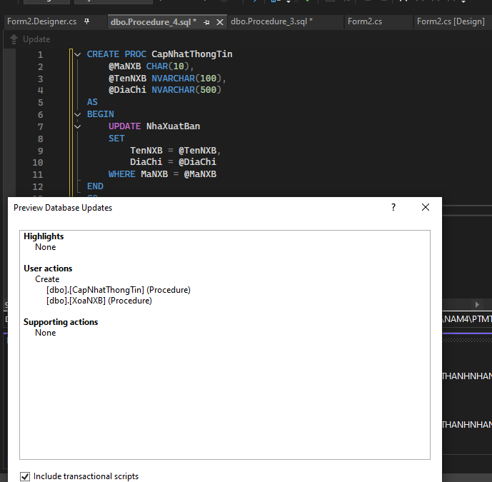

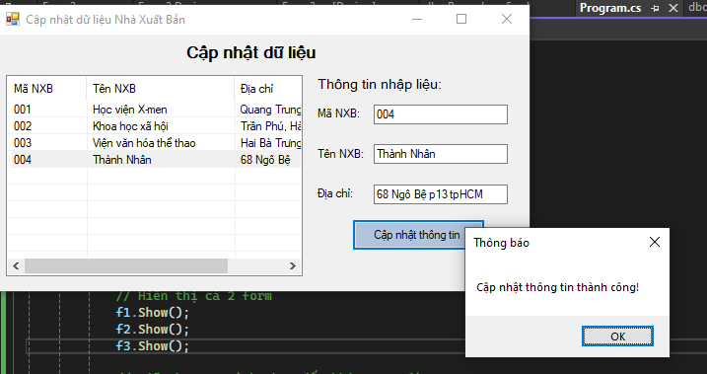

[**Form3.cs**](http://form3.cs)

**using System;**

**using System.Data;**

**using System.Data.SqlClient;**

**using System.Windows.Forms;**

**namespace QuanLyNXB**

**{**

**public partial class Form3 : Form**

**{**

**// 🔹 Chuỗi kết nối đúng đường dẫn của anh**

**string strCon =**

**@"Data Source=(LocalDB)\MSSQLLocalDB;**

**AttachDbFilename=D:\NAM4\PTMT\1150080151_LAITHANHNHAN_LAB6\1150080151_LAITHANHNHAN_LAB6\Database1.mdf;**

**Integrated Security=True";**

**SqlConnection sqlCon = null;**

**public Form3()**

**{**

**InitializeComponent();**

**}**

**// ===== MỞ KẾT NỐI =====**

**private void MoKetNoi()**

**{**

**if (sqlCon == null)**

**sqlCon = new SqlConnection(strCon);**

**if (sqlCon.State == ConnectionState.Closed)**

**sqlCon.Open();**

**}**

**// ===== ĐÓNG KẾT NỐI =====**

**private void DongKetNoi()**

**{**

**if (sqlCon != null && sqlCon.State == ConnectionState.Open)**

**sqlCon.Close();**

**}**

**// ===== HIỂN THỊ DANH SÁCH NXB =====**

**private void HienThiDanhSachNXB()**

**{**

**MoKetNoi();**

**SqlCommand cmd = new SqlCommand("HienThiNXB", sqlCon);**

**cmd.CommandType = CommandType.StoredProcedure;**

**SqlDataReader reader = cmd.ExecuteReader();**

**lsvDanhSach.Items.Clear();**

**while (reader.Read())**

**{**

**string ma = reader.GetString(0);**

**string ten = reader.GetString(1);**

**string diachi = reader.GetString(2);**

**ListViewItem lvi = new ListViewItem(ma);**

**lvi.SubItems.Add(ten);**

**lvi.SubItems.Add(diachi);**

**lsvDanhSach.Items.Add(lvi);**

**}**

**reader.Close();**

**DongKetNoi();**

**}**

**// ===== LOAD FORM =====**

**private void Form3_Load(object sender, EventArgs e)**

**{**

**HienThiDanhSachNXB();**

**}**

**// ===== KHI CHỌN DÒNG TRONG LISTVIEW =====**

**private void lsvDanhSach_SelectedIndexChanged(object sender, EventArgs e)**

**{**

**if (lsvDanhSach.SelectedItems.Count == 0)**

**return;**

**ListViewItem lvi = lsvDanhSach.SelectedItems[0];**

**txtMaXB.Text = lvi.SubItems[0].Text;**

**txtTenXB.Text = lvi.SubItems[1].Text;**

**txtDiaChi.Text = lvi.SubItems[2].Text;**

**}**

**// ===== NÚT CẬP NHẬT =====**

**private void btnCapNhat_Click(object sender, EventArgs e)**

**{**

**if (txtMaXB.Text.Trim() == "")**

**{**

**MessageBox.Show("Vui lòng chọn Nhà xuất bản cần cập nhật!", "Thông báo");**

**return;**

**}**

**MoKetNoi();**

**SqlCommand cmd = new SqlCommand("CapNhatThongTin", sqlCon);**

**cmd.CommandType = CommandType.StoredProcedure;**

**cmd.Parameters.Add("@MaNXB", SqlDbType.Char).Value = txtMaXB.Text.Trim();**

**cmd.Parameters.Add("@TenNXB", SqlDbType.NVarChar, 100).Value = txtTenXB.Text.Trim();**

**cmd.Parameters.Add("@DiaChi", SqlDbType.NVarChar, 500).Value = txtDiaChi.Text.Trim();**

**int kq = cmd.ExecuteNonQuery();**

**if (kq > 0)**

**{**

**MessageBox.Show("Cập nhật thông tin thành công!", "Thông báo");**

**HienThiDanhSachNXB();**

**}**

**else**

**{**

**MessageBox.Show("Không tìm thấy mã NXB cần cập nhật!", "Thông báo");**

**}**

**DongKetNoi();**

**}**

**}**

**}**

[**Form3.design.cs**](http://form3.design.cs)

**namespace QuanLyNXB**

**{**

**partial class Form3**

**{**

**private System.ComponentModel.IContainer components = null;**

**protected override void Dispose(bool disposing)**

**{**

**if (disposing && (components != null))**

**{**

**components.Dispose();**

**}**

**base.Dispose(disposing);**

**}**

**#region Windows Form Designer generated code**

**private void InitializeComponent()**

**{**

**this.lsvDanhSach = new System.Windows.Forms.ListView();**

**this.colMa = ((System.Windows.Forms.ColumnHeader)(new System.Windows.Forms.ColumnHeader()));**

**this.colTen = ((System.Windows.Forms.ColumnHeader)(new System.Windows.Forms.ColumnHeader()));**

**this.colDiaChi = ((System.Windows.Forms.ColumnHeader)(new System.Windows.Forms.ColumnHeader()));**

**this.lblTitle = new System.Windows.Forms.Label();**

**this.lblNhap = new System.Windows.Forms.Label();**

**this.lblMa = new System.Windows.Forms.Label();**

**this.lblTen = new System.Windows.Forms.Label();**

**this.lblDiaChi = new System.Windows.Forms.Label();**

**this.txtMaXB = new System.Windows.Forms.TextBox();**

**this.txtTenXB = new System.Windows.Forms.TextBox();**

**this.txtDiaChi = new System.Windows.Forms.TextBox();**

**this.btnCapNhat = new System.Windows.Forms.Button();**

**this.SuspendLayout();**

**//**

**// lsvDanhSach**

**//**

**this.lsvDanhSach.Columns.AddRange(new System.Windows.Forms.ColumnHeader[] {**

**this.colMa,**

**this.colTen,**

**this.colDiaChi});**

**this.lsvDanhSach.FullRowSelect = true;**

**this.lsvDanhSach.GridLines = true;**

**this.lsvDanhSach.HideSelection = false;**

**this.lsvDanhSach.Location = new System.Drawing.Point(12, 50);**

**this.lsvDanhSach.Name = "lsvDanhSach";**

**this.lsvDanhSach.Size = new System.Drawing.Size(400, 250);**

**this.lsvDanhSach.TabIndex = 0;**

**this.lsvDanhSach.UseCompatibleStateImageBehavior = false;**

**this.lsvDanhSach.View = System.Windows.Forms.View.Details;**

**this.lsvDanhSach.SelectedIndexChanged += new System.EventHandler(this.lsvDanhSach_SelectedIndexChanged);**

**//**

**// colMa**

**//**

**this.colMa.Text = "Mã NXB";**

**this.colMa.Width = 80;**

**//**

**// colTen**

**//**

**this.colTen.Text = "Tên NXB";**

**this.colTen.Width = 150;**

**//**

**// colDiaChi**

**//**

**this.colDiaChi.Text = "Địa chỉ";**

**this.colDiaChi.Width = 150;**

**//**

**// lblTitle**

**//**

**this.lblTitle.AutoSize = true;**

**this.lblTitle.Font = new System.Drawing.Font("Microsoft Sans Serif", 12F, System.Drawing.FontStyle.Bold);**

**this.lblTitle.Location = new System.Drawing.Point(250, 10);**

**this.lblTitle.Name = "lblTitle";**

**this.lblTitle.Size = new System.Drawing.Size(174, 25);**

**this.lblTitle.TabIndex = 1;**

**this.lblTitle.Text = "Cập nhật dữ liệu";**

**//**

**// lblNhap**

**//**

**this.lblNhap.AutoSize = true;**

**this.lblNhap.Font = new System.Drawing.Font("Microsoft Sans Serif", 10F);**

**this.lblNhap.Location = new System.Drawing.Point(430, 50);**

**this.lblNhap.Name = "lblNhap";**

**this.lblNhap.Size = new System.Drawing.Size(130, 20);**

**this.lblNhap.TabIndex = 2;**

**this.lblNhap.Text = "Thông tin nhập liệu:";**

**//**

**// lblMa**

**//**

**this.lblMa.AutoSize = true;**

**this.lblMa.Location = new System.Drawing.Point(430, 90);**

**this.lblMa.Name = "lblMa";**

**this.lblMa.Size = new System.Drawing.Size(53, 16);**

**this.lblMa.TabIndex = 3;**

**this.lblMa.Text = "Mã NXB:";**

**//**

**// lblTen**

**//**

**this.lblTen.AutoSize = true;**

**this.lblTen.Location = new System.Drawing.Point(430, 140);**

**this.lblTen.Name = "lblTen";**

**this.lblTen.Size = new System.Drawing.Size(57, 16);**

**this.lblTen.TabIndex = 4;**

**this.lblTen.Text = "Tên NXB:";**

**//**

**// lblDiaChi**

**//**

**this.lblDiaChi.AutoSize = true;**

**this.lblDiaChi.Location = new System.Drawing.Point(430, 190);**

**this.lblDiaChi.Name = "lblDiaChi";**

**this.lblDiaChi.Size = new System.Drawing.Size(50, 16);**

**this.lblDiaChi.TabIndex = 5;**

**this.lblDiaChi.Text = "Địa chỉ:";**

**//**

**// txtMaXB**

**//**

**this.txtMaXB.Location = new System.Drawing.Point(510, 87);**

**this.txtMaXB.Name = "txtMaXB";**

**this.txtMaXB.Size = new System.Drawing.Size(180, 22);**

**this.txtMaXB.TabIndex = 6;**

**//**

**// txtTenXB**

**//**

**this.txtTenXB.Location = new System.Drawing.Point(510, 137);**

**this.txtTenXB.Name = "txtTenXB";**

**this.txtTenXB.Size = new System.Drawing.Size(180, 22);**

**this.txtTenXB.TabIndex = 7;**

**//**

**// txtDiaChi**

**//**

**this.txtDiaChi.Location = new System.Drawing.Point(510, 187);**

**this.txtDiaChi.Name = "txtDiaChi";**

**this.txtDiaChi.Size = new System.Drawing.Size(180, 22);**

**this.txtDiaChi.TabIndex = 8;**

**//**

**// btnCapNhat**

**//**

**this.btnCapNhat.BackColor = System.Drawing.Color.LightSteelBlue;**

**this.btnCapNhat.Location = new System.Drawing.Point(480, 230);**

**this.btnCapNhat.Name = "btnCapNhat";**

**this.btnCapNhat.Size = new System.Drawing.Size(180, 40);**

**this.btnCapNhat.TabIndex = 9;**

**this.btnCapNhat.Text = "Cập nhật thông tin";**

**this.btnCapNhat.UseVisualStyleBackColor = false;**

**this.btnCapNhat.Click += new System.EventHandler(this.btnCapNhat_Click);**

**//**

**// Form3**

**//**

**this.AutoScaleDimensions = new System.Drawing.SizeF(8F, 16F);**

**this.AutoScaleMode = System.Windows.Forms.AutoScaleMode.Font;**

**this.ClientSize = new System.Drawing.Size(720, 320);**

**this.Controls.Add(this.btnCapNhat);**

**this.Controls.Add(this.txtDiaChi);**

**this.Controls.Add(this.txtTenXB);**

**this.Controls.Add(this.txtMaXB);**

**this.Controls.Add(this.lblDiaChi);**

**this.Controls.Add(this.lblTen);**

**this.Controls.Add(this.lblMa);**

**this.Controls.Add(this.lblNhap);**

**this.Controls.Add(this.lblTitle);**

**this.Controls.Add(this.lsvDanhSach);**

**this.Name = "Form3";**

**this.Text = "Cập nhật dữ liệu Nhà Xuất Bản";**

**this.Load += new System.EventHandler(this.Form3_Load);**

**this.ResumeLayout(false);**

**this.PerformLayout();**

**}**

**#endregion**

**private System.Windows.Forms.ListView lsvDanhSach;**

**private System.Windows.Forms.ColumnHeader colMa;**

**private System.Windows.Forms.ColumnHeader colTen;**

**private System.Windows.Forms.ColumnHeader colDiaChi;**

**private System.Windows.Forms.Label lblTitle;**

**private System.Windows.Forms.Label lblNhap;**

**private System.Windows.Forms.Label lblMa;**

**private System.Windows.Forms.Label lblTen;**

**private System.Windows.Forms.Label lblDiaChi;**

**private System.Windows.Forms.TextBox txtMaXB;**

**private System.Windows.Forms.TextBox txtTenXB;**

**private System.Windows.Forms.TextBox txtDiaChi;**

**private System.Windows.Forms.Button btnCapNhat;**

**}**

**}**

**Thực hành 4: Xóa dữ liệu cho bảng Nhà xuất bản.**

**ở Database trong Visual Studio**

* **Vào Server Explorer → Database1.mdf → Stored Procedures**
* **Chuột phải → Add New Stored Procedure**

**Nhập câu lệnh SQL  
  
 CREATE PROC XoaNXB**

**@MaNXB CHAR(10)**

**AS**

**BEGIN**

**DELETE FROM NhaXuatBan**

**WHERE MaNXB = @MaNXB**

**END**

**Lưu và cập nhật cơ sở dữ liệu**

* **Nhấn Ctrl + S**
* **Hộp thoại Preview Database Updates xuất hiện**
* **Chọn Include transactional scripts**
* **Bấm Update Database ✅**

**Kiểm tra**

* **Thấy thủ tục dbo.XoaNXB hiển thị trong thư mục Stored Procedures**

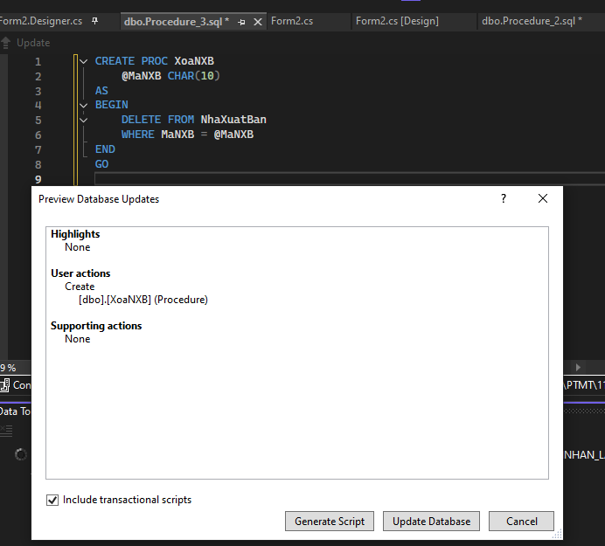

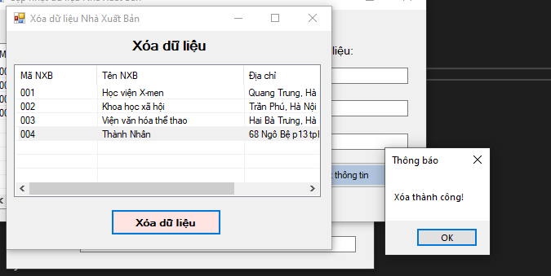

[**Form4.cs**](http://form4.cs)

**using System;**

**using System.Data;**

**using System.Data.SqlClient;**

**using System.Windows.Forms;**

**namespace QuanLyNXB**

**{**

**public partial class Form4 : Form**

**{**

**// 🔹 Chuỗi kết nối**

**string strCon =**

**@"Data Source=(LocalDB)\MSSQLLocalDB;**

**AttachDbFilename=D:\NAM4\PTMT\1150080151_LAITHANHNHAN_LAB6\1150080151_LAITHANHNHAN_LAB6\Database1.mdf;**

**Integrated Security=True";**

**SqlConnection sqlCon = null;**

**public Form4()**

**{**

**InitializeComponent();**

**}**

**// ===== MỞ KẾT NỐI =====**

**private void MoKetNoi()**

**{**

**if (sqlCon == null)**

**sqlCon = new SqlConnection(strCon);**

**if (sqlCon.State == ConnectionState.Closed)**

**sqlCon.Open();**

**}**

**// ===== ĐÓNG KẾT NỐI =====**

**private void DongKetNoi()**

**{**

**if (sqlCon != null && sqlCon.State == ConnectionState.Open)**

**sqlCon.Close();**

**}**

**// ===== HIỂN THỊ DANH SÁCH NXB =====**

**private void HienThiDanhSachNXB()**

**{**

**MoKetNoi();**

**SqlCommand cmd = new SqlCommand("HienThiNXB", sqlCon);**

**cmd.CommandType = CommandType.StoredProcedure;**

**SqlDataReader reader = cmd.ExecuteReader();**

**lsvDanhSach.Items.Clear();**

**while (reader.Read())**

**{**

**string ma = reader.GetString(0);**

**string ten = reader.GetString(1);**

**string diachi = reader.GetString(2);**

**ListViewItem lvi = new ListViewItem(ma);**

**lvi.SubItems.Add(ten);**

**lvi.SubItems.Add(diachi);**

**lsvDanhSach.Items.Add(lvi);**

**}**

**reader.Close();**

**DongKetNoi();**

**}**

**// ===== LOAD FORM =====**

**private void Form4_Load(object sender, EventArgs e)**

**{**

**HienThiDanhSachNXB();**

**}**

**// ===== NÚT XÓA =====**

**private void btnXoa_Click(object sender, EventArgs e)**

**{**

**if (lsvDanhSach.SelectedItems.Count == 0)**

**{**

**MessageBox.Show("Vui lòng chọn một nhà xuất bản để xóa!", "Thông báo");**

**return;**

**}**

**string ma = lsvDanhSach.SelectedItems[0].SubItems[0].Text;**

**DialogResult dr = MessageBox.Show(**

**$"Bạn có chắc muốn xóa nhà xuất bản {ma} không?",**

**"Xác nhận xóa",**

**MessageBoxButtons.YesNo,**

**MessageBoxIcon.Warning);**

**if (dr == DialogResult.No) return;**

**MoKetNoi();**

**SqlCommand cmd = new SqlCommand("XoaNXB", sqlCon);**

**cmd.CommandType = CommandType.StoredProcedure;**

**cmd.Parameters.Add("@MaNXB", SqlDbType.Char).Value = ma;**

**int kq = cmd.ExecuteNonQuery();**

**if (kq > 0)**

**{**

**MessageBox.Show("Xóa thành công!", "Thông báo");**

**HienThiDanhSachNXB();**

**}**

**else**

**{**

**MessageBox.Show("Không tìm thấy mã NXB cần xóa!", "Thông báo");**

**}**

**DongKetNoi();**

**}**

**}**

**}**

[**Form4.design.cs**](http://form4.design.cs)

**namespace QuanLyNXB**

**{**

**partial class Form4**

**{**

**private System.ComponentModel.IContainer components = null;**

**protected override void Dispose(bool disposing)**

**{**

**if (disposing && (components != null))**

**{**

**components.Dispose();**

**}**

**base.Dispose(disposing);**

**}**

**#region Windows Form Designer generated code**

**private void InitializeComponent()**

**{**

**this.lsvDanhSach = new System.Windows.Forms.ListView();**

**this.colMa = ((System.Windows.Forms.ColumnHeader)(new System.Windows.Forms.ColumnHeader()));**

**this.colTen = ((System.Windows.Forms.ColumnHeader)(new System.Windows.Forms.ColumnHeader()));**

**this.colDiaChi = ((System.Windows.Forms.ColumnHeader)(new System.Windows.Forms.ColumnHeader()));**

**this.lblTitle = new System.Windows.Forms.Label();**

**this.btnXoa = new System.Windows.Forms.Button();**

**this.SuspendLayout();**

**//**

**// lsvDanhSach**

**//**

**this.lsvDanhSach.Columns.AddRange(new System.Windows.Forms.ColumnHeader[] {**

**this.colMa,**

**this.colTen,**

**this.colDiaChi});**

**this.lsvDanhSach.FullRowSelect = true;**

**this.lsvDanhSach.GridLines = true;**

**this.lsvDanhSach.HideSelection = false;**

**this.lsvDanhSach.Location = new System.Drawing.Point(12, 50);**

**this.lsvDanhSach.Name = "lsvDanhSach";**

**this.lsvDanhSach.Size = new System.Drawing.Size(500, 200);**

**this.lsvDanhSach.TabIndex = 0;**

**this.lsvDanhSach.UseCompatibleStateImageBehavior = false;**

**this.lsvDanhSach.View = System.Windows.Forms.View.Details;**

**//**

**// colMa**

**//**

**this.colMa.Text = "Mã NXB";**

**this.colMa.Width = 100;**

**//**

**// colTen**

**//**

**this.colTen.Text = "Tên NXB";**

**this.colTen.Width = 180;**

**//**

**// colDiaChi**

**//**

**this.colDiaChi.Text = "Địa chỉ";**

**this.colDiaChi.Width = 220;**

**//**

**// lblTitle**

**//**

**this.lblTitle.AutoSize = true;**

**this.lblTitle.Font = new System.Drawing.Font("Microsoft Sans Serif", 12F, System.Drawing.FontStyle.Bold);**

**this.lblTitle.Location = new System.Drawing.Point(200, 10);**

**this.lblTitle.Name = "lblTitle";**

**this.lblTitle.Size = new System.Drawing.Size(108, 25);**

**this.lblTitle.TabIndex = 1;**

**this.lblTitle.Text = "Xóa dữ liệu";**

**//**

**// btnXoa**

**//**

**this.btnXoa.BackColor = System.Drawing.Color.MistyRose;**

**this.btnXoa.Font = new System.Drawing.Font("Microsoft Sans Serif", 9F, System.Drawing.FontStyle.Bold);**

**this.btnXoa.Location = new System.Drawing.Point(170, 270);**

**this.btnXoa.Name = "btnXoa";**

**this.btnXoa.Size = new System.Drawing.Size(180, 40);**

**this.btnXoa.TabIndex = 2;**

**this.btnXoa.Text = "Xóa dữ liệu";**

**this.btnXoa.UseVisualStyleBackColor = false;**

**this.btnXoa.Click += new System.EventHandler(this.btnXoa_Click);**

**//**

**// Form4**

**//**

**this.AutoScaleDimensions = new System.Drawing.SizeF(8F, 16F);**

**this.AutoScaleMode = System.Windows.Forms.AutoScaleMode.Font;**

**this.ClientSize = new System.Drawing.Size(530, 330);**

**this.Controls.Add(this.btnXoa);**

**this.Controls.Add(this.lblTitle);**

**this.Controls.Add(this.lsvDanhSach);**

**this.Name = "Form4";**

**this.Text = "Xóa dữ liệu Nhà Xuất Bản";**

**this.Load += new System.EventHandler(this.Form4_Load);**

**this.ResumeLayout(false);**

**this.PerformLayout();**

**}**

**#endregion**

**private System.Windows.Forms.ListView lsvDanhSach;**

**private System.Windows.Forms.ColumnHeader colMa;**

**private System.Windows.Forms.ColumnHeader colTen;**

**private System.Windows.Forms.ColumnHeader colDiaChi;**

**private System.Windows.Forms.Label lblTitle;**

**private System.Windows.Forms.Button btnXoa;**

**}**

**}**