**SWP - G1 - SE1640**

**Group Member**

**Bùi Trần Trọng Thắng - HE163741**

**Đỗ Trọng Nghĩa - HE163512**

**Đinh Toàn Thắng - HE163539**

**Vũ Sỹ Luân - CE160860**

**Nguyễn Thành Phát - HE140856**

1. **Overview**
2. **Screen Flow**

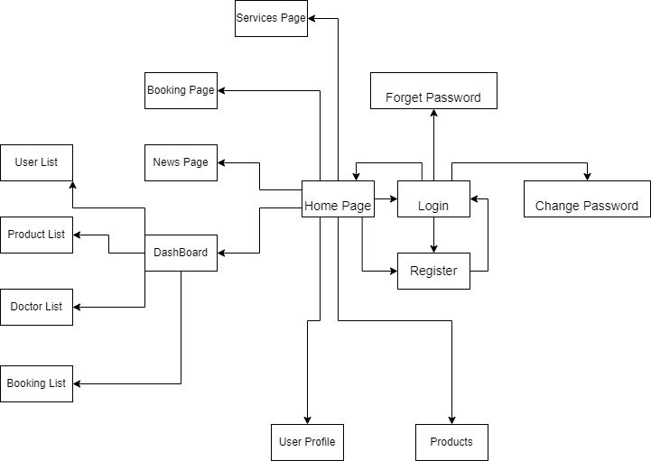

**Update:**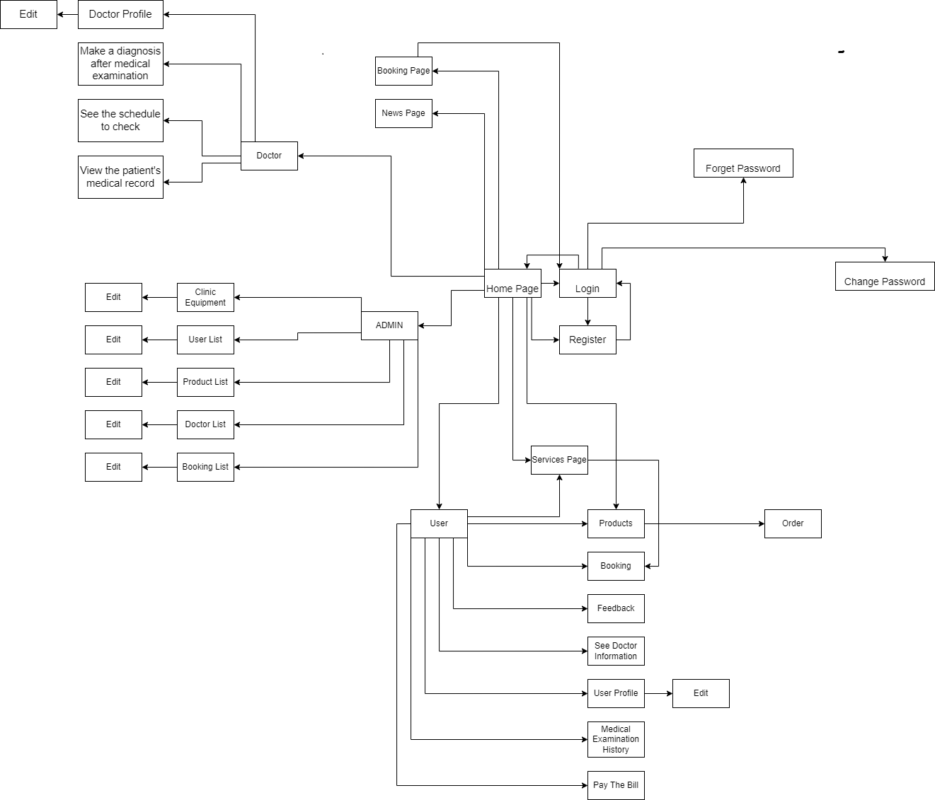

1. **Database Schema**

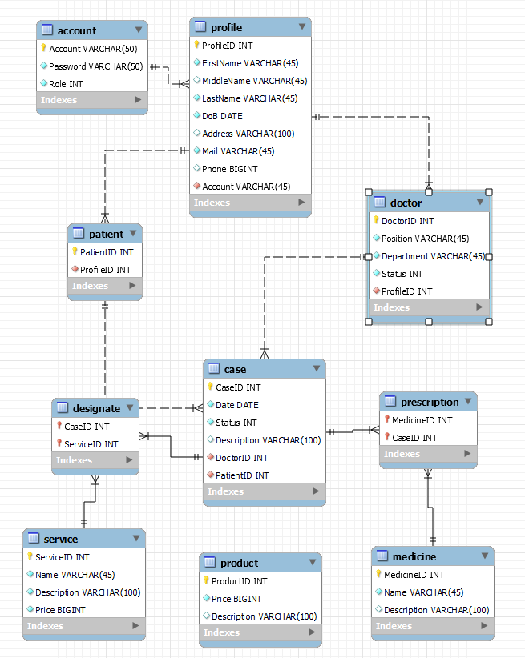

1. **Implementing Prioties**

| **Priority** | **Screens(Prioritize from left to right)** |
| --- | --- |
| #1 | HomePage, Login, DashBoard, Register |
| #2 | Forget Password, Change Password, News Page, Booking Page, Services Page |
| #3 | User Profile, UserList, Products List, Doctor List, Booking List, Products |

1. **Folder Structure**

