

|  |
| --- |
| | **BUSINESS BLUEPRINT** | | --- |  | **Document information** | | | --- | --- | | Project Name | Material Master Data Management | | Module | MM | | Created by | Nguyễn Thị Ý Nhi - SS160124  Vương Thanh Hà - SS160126  Tạ Thị Bích Diễm - SS171321 | | Version | 1.1 | | Date | 25/12/2024 | |
|  |

| **Change history** | | | | | |
| --- | --- | --- | --- | --- | --- |
| Changed date | Items have been changed | Changed content/Reason | Updated by | Type  (A/C/D) | Version |
| 23/9/2024 |  | Create Document | NhiNTY  DiemTTB  HaVT | A | 1.0 |
| 25/12/2024 |  | Update Document | NhiNTY  DiemTTB  HaVT | A | 1.1 |
| ***A*** *– Create* ***C*** *– Change* ***D*** *– Delete* | | | | | |

| **Advisor Signature** | | | | |
| --- | --- | --- | --- | --- |
|  | **Full name & Role** | **Signature** | **Date** | **Note** |
| **Created by** | Nguyễn Thị Ý Nhi - SS160124  Vương Thanh Hà - SS160126  Tạ Thị Bích Diễm - SS171321 |  |  |  |
| **Reviewed by** | Bùi Thị Ny Ny |  | 8/1/2025 |  |
| **Approved by** |  |  |  |  |

| **FU Signature** | | | | |
| --- | --- | --- | --- | --- |
|  | **Full name & Role** | **Signature** | **Date** | **Note** |
| **Reviewed by** | Bùi Thị Ny Ny |  | 8/1/2025 |  |
| **Approved by** |  |  |  |  |

| **Table of Contents** |
| --- |

**1 OVERVIEW 6**

1.1 Glossary 6

1.2 Flowchart shapes usage 7

**2 ORGANISATIONAL STRUCTURE 8**

2.1 Organization Structure Diagram 8

2.2 Introduction 8

2.3 Company code 9

2.4 Plants 9

2.5 Storage locations 10

2.6 Purchasing organization 10

2.7 Purchasing Group 11

**3 BUSINESS PROCESS 11**

Template Upload Material Master Data 11

3.1 Material Master 11

3.1.1 Brief about Material Master 11

3.1.2 Industry Sector 11

3.1.3 Material Type 12

3.1.4 Valuation Method 12

3.1.5 Split Valuation 13

3.1.6 Services (ZDIE) 13

3.1.7 Material Number Range 13

3.1.8 Material Group 16

3.1.9 Material Master View 16

3.2 Process Flow 20

3.2.1. Flowchart 20

3.2.2. Process Description 22

Process Description of Display Flow 28

**4 REPORTS 29**

# OVERVIEW

## 

## 1.1 **Glossary**

Managing materials data in the SAP system is a critical function for organizations in maintaining the accuracy and efficiency of business processes within an enterprise. Operations such as production, sales, inventory management, accounting, and procurement are all enhanced through the use of precise material data.The task of managing, editing, and updating material data can become complicated as the number of assets in the system increases, requiring an effective and easy-to-use solution.

This report outlines the process of designing and developing transaction code (T-code) in SAP specifically for managing material master data. This goal is to allow users to create, edit, and extend material. Besides, it allows users to download Excel files and upload Excel files material master data simply and effectively. This transaction code will provide an intuitive interface, helping users easily interact with material while ensuring that the data entry process is performed accurately and without errors.

| **Term** | **Definition** | **Note** |
| --- | --- | --- |
| FSOFT | FPT Software Ho Chi Minh Co., Ltd. |  |
| FU | FPT University |  |
| MM | Material Management |  |
| BP | Business Blueprint |  |
| BD | Database |  |
| T-code | Transaction code, a shortcut in SAP to access specific tasks or processes |  |
| BAPI | Business Application Programming Interface: A standardised programming interface that allows external applications to interact with SAP. |  |
| ABAP | Advanced Business Application Programming: The primary programming language used to develop SAP applications. | Used for custom enhancements and T-code development. |
| ALV | ABAP List Viewer, a tool used to display data in SAP | Tool for displaying data in table format |
| SAP GUI | SAP Graphical User Interface: The client software that allows users to interact with the SAP system. | Standard interface for executing T-codes. |
| MARA, MARD, MARC, MVKE, MLAN,... | Standard SAP table for material master data | Contains detailed information about fields |

## 1.2 **Flowchart shapes usage**

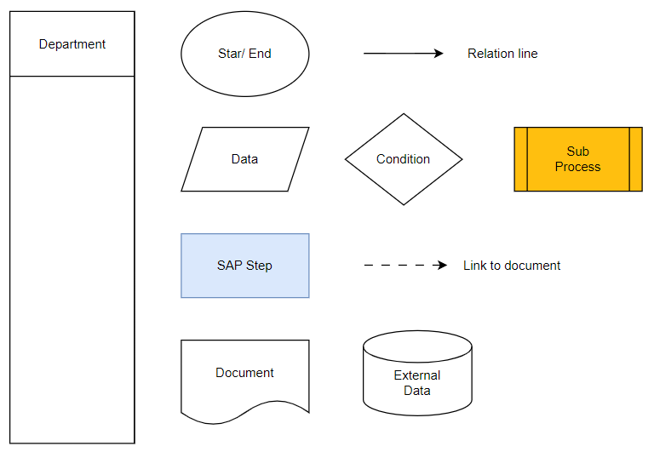

# ORGANISATIONAL STRUCTURE

Organisational structure is the key to a successful SAP implementation. From a Materials Management (MM) perspective, purchasing organisation, plants, storage locations, and purchasing groups are important elements of an organisational structure.

## 2.1 Organization Structure Diagram

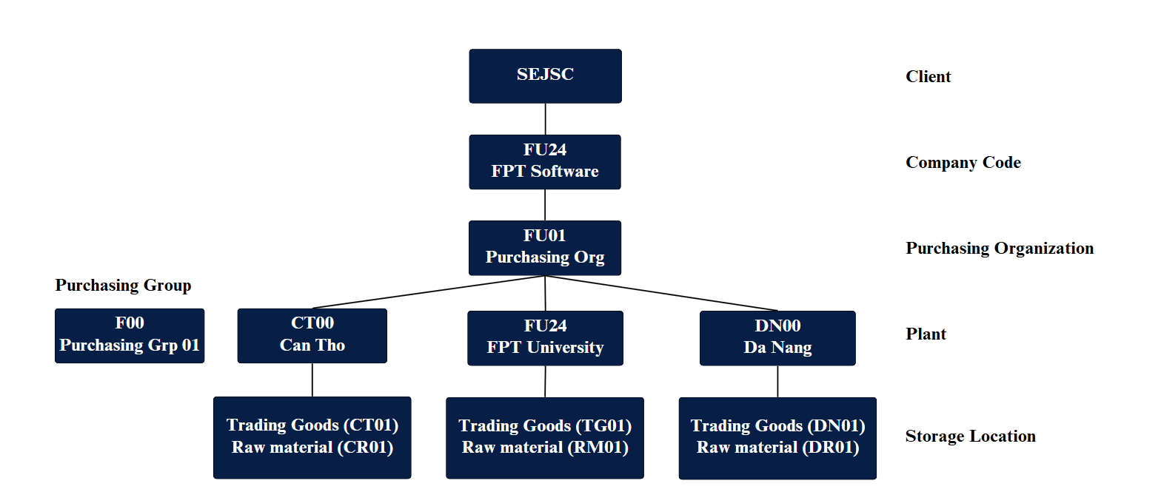

## 2.2 Introduction

Sunrise Electronics Joint Stock Company **(SEJSC)** is a company specialising in providing customers with electronic devices such as phones, tablets, laptops, and services in Hanoi, Da Nang, and Can Tho. SEJSC ensures providing quality and reputable products that bring trust to customers. With the mission of bringing customers the best quality technology products and services. The plant is managed by a purchasing organization responsible for purchasing material centrally in 3 areas: Hanoi, Da Nang, and Can Tho, with respectively 3 storage locations: Cau Giay, Lien Chieu, and Ninh Kieu.

## 2.3 Company code

SEJSC is defined in company code (FU24) in the system, which is responsible for key financial reports and critical business operations, ensuring smooth integration and accurate financial tracking across various departments.

| **Company Cope** | **Company Name** |
| --- | --- |
| FU24 | FPT Software |

## 2.4 Plants

Currently, SEJSC has three plants that will be defined in the system. Each plant is a location where either material contains goods or services are provided.

| **Plant Code** | **Plant Name** | **Address** |
| --- | --- | --- |
| CT00 | Can Tho | Can Tho |
| FU24 | FPT University | Ha Noi |
| DN00 | Da Nang | Da Nang |

The assignments of plants to company codes are as follows:

| **Company Code** | **Plant Code** | **Plant Names** |
| --- | --- | --- |
| FU24 | CT00 | Can Tho |
| FU24 | FPT University |
| DN00 | Da Nang |

## 2.5 Storage locations

There are 3 storage locations defined in the plants. Each storage location is the place where stocks are physically kept within a plant. Inventory management on a quantity basis is carried out at the storage location level in the plant. Physical inventory is also carried out at this level.

| **Plant Code** | **Plant Description** | **Storage Location** | **Storage Location Description** |
| --- | --- | --- | --- |
| CT00 | Can Tho | CT01 | Trading Goods |
| CR01 | Raw material |
| FU24 | FPT University | TG01 | Trading Goods |
| RM01 | Raw material |
| DN00 | Da Nang | DN01 | Trading Goods |
| DR01 | Raw material |

## 2.6 Purchasing organization

Currently in SEJSC, there is one purchasing organization. The purchasing department is responsible for all purchasing transactions and for negotiating conditions of purchase with vendors for plants. One purchasing organization in SEJSC is used for all purchasing processes.

| **Purchasing Organization** | **Purchasing Organization Detail** | **Plant Names** |
| --- | --- | --- |
| FU01 | Purchasing Org 01 | CT00 (Can Tho) |
| FU24 (FPT University) |
| DN00 (Da Nang) |

## 2.7 Purchasing Group

SEJSEC will have one purchasing group with reference to different purchasers who are responsible for purchasing activities. It is defined (F00) in the SAP system.

| **Purchasing Group** | **Purchasing Group Description** |
| --- | --- |
| F00 | Purchasing Grp 01 |

# BUSINESS PROCESS

## 3.1 Material Master

### 3.1.1 Brief about Material Master

This process covers the Material Master record, which is one of the most important things that have information for various transactions and activities in relation to materials and is termed the Material Master. The Material Master should contain data relevant for various functions. The information in Material Master Record should include Purchasing, Sales, Accounting, Classification, Storage data for the material. It should also consider the various organizational levels for which the data is maintained. It has mainly two controlling fields, namely Industry Sector and Material Type.

### 3.1.2 Industry Sector

SEJSC will define an industry sector for the specific industry in which a company operates relating to electronic products. It is assigned an industry sector to materials that cannot change the industry sector subsequently.

| **Industry Sector** | **Industry Sector Description** |
| --- | --- |
| E | Electronics Industry |

### 3.1.3 Material Type

SEJSC will define materials with similar basic attributes that are grouped together and used in the system, including trading goods and services related to materials. This helps manage different materials in a uniform manner, in accordance with the company's requirements, to ensure efficient operating processes management from purchasing, storage, sales,...

Material Types for Sunrise Electronics Joint Stock Company.

| **Material Type** | **Description** |
| --- | --- |
| HAWA | Trading goods |
| ZRAW | Raw materials for ZMM01 |
| ZDIE | Services for MMGR3 |

### 

### 

### 

### 3.1.4 Valuation Method

Material valuation is carried out according to the price controls set in the SAP system and determines the value of a stock of materhave. We have the following valuation methods: moving average price (price control V) or standard price (price control S). With Trading Goods, we use the moving average price method (V).

The moving average price is the weighted average price of a material and will change regularly if the PO prices of a material are changed regularly. This price is calculated based on total stock and total value using the following equation:

*Moving average price = total stock value / total stock quantity*

The current moving average price will always be updated into the material master record.

The accounting view requires us to assign the valuation method when creating the material master record. The system automatically posts entries in the stock G/L account during material movement, including goods receipt, goods issuance, and invoice posting. The value amount is determined using the valuation method specified in the material master.

With Raw material, we use the standard price method (S). In the standard price procedure, the valuation price is defined and fixed in the material master record. If a PO price is different (either more or less) from the standard price, the difference amounts are posted into a price difference account.

### 3.1.5 Split Valuation

The valuation type identifies split-valued stocks of material.The valuation category indicates the criteria for defining partial stock. The valuation class enables assignment to accounts on a basis specific to the material type (Trading Goods) using the moving average price of valuation method.

### 3.1.6 Services (ZDIE)

For service materials, in cases where the Accounting view is not used and only a manual price is applied, the service values will be manually entered into the system when creating purchase orders or related documents. This allows for easy adjustments when there are changes in prices according to service requirements.

### 3.1.7 Material Number Range

Number Ranges for the material types, including (Trading Goods and Services) will be maintained in the external number range. The length of the number range would be 18-40 characters.

1. With the Material Number for **Trading Goods** we design 8 characters (########)

* Prefix (#): Classification of product lines including Phone “**P**”, Laptop “**L**”, Tablet “**T**”
* Next (##): Product brand
* Final (#####): Product sequence number

Ex: PIP00001: Iphone 14 Pro Max 128GB

| **Product Brand** | **Description** |
| --- | --- |
| IP | Iphone |
| SA | Samsung |
| HU | Huawei |
| HO | Honor |
| XI | Xiaomi |
| VI | Vivo |
| OP | Oppo |
| NO | Nokia |
| RE | Realme |
| TE | Tecno |
| DE | Dell |
| HP | HP |
| LE | Lenovo |
| LG | LG |
| MS | MSI |
| MI | Microsoft |
| AS | ASUS |
| AC | Acer |
| VA | VAIO |
| MA | Macbook |
| ID | Ipad |

1. With the Material Number for **Raw Materials** we design 8 characters (########)

* Prefix (##): Default is “**RA**” to indicate Raw materials
* Final (######): Product sequence number

Ex: RA000001: Heat Sink

1. With the Material Number for **Services** we design 8 characters (########).

* Prefix (##): Default is “**SE**” to indicate Service.
* Next (#): Classification of product lines, including Phone “**P**”, Laptop “**L**”, Tablet “**T**”.
* Next (##): Classification of Service Types, including **01, 02, 03, 04.**
* Final (###): The service sequence number is entered into the system.

Ex: SEP01001: Hardware Repair Phone

| **Service Type** | **Description** | **Usage** |
| --- | --- | --- |
| 01 | Hardware Repair | Repair speakers and microphones |
| Screen repair |
| Repair charging port |
| Motherboard repair |
| 02 | Software Repair | Fix operating system errors |
| Fix application errors |
| Remove viruses |
| 03 | Component Replacement | Replace the battery |
| Replace the speaker |
| Replace the camera |
| Replace the screen |
| Replace the keyboard |
| 04 | Maintenance | Clean hardware |
| Clean equipment |

### **3.1.**8 **Material Group**

The SEJSC uses product lines to categorize materials according to common characteristics. It facilitates efficient material management in accounting, purchasing, inventory, and other processes. Phones, tablets, services, and laptops are among the product lines that define it. The following details are included:

| **Material Group** | **Material Group Description** |
| --- | --- |
| PHONE | Trading goods |
| LAPTOP | Trading goods |
| TABLET | Trading goods |
| ZREPAIR | Service |
| ZREC | Elec. Components |

### 3.1.9 Material Master View

A Material Master Record is made up of several views in SAP. Each view contains several fields that are specific to different business processes. These views are maintained at various organizational unit levels to manage and access data relevant to their function. Each view corresponds to a specific area of material management, and the fields within the views store detailed information for those specific areas.

| **Material Type** | **Basic data** | **Classification** | **Purchasing** | **Sale: General/Plant** | **Sales** | **Plant/storage** | **Accounting** |
| --- | --- | --- | --- | --- | --- | --- | --- |
| HAWA | x | x | x |  | x | x | x |
| ZRAW | x |  | x | x | x | x | x |
| ZDIE | x |  | x |  | x |  |  |

• **Basic Data View**

* **Material Number:** Uniquely identifies a material.
* **Industry Sector:** The assignment of a material to a certain industry.
* **Material Type:** The definition of a group of materials with similar attributes.
* **Material Description** (Short Text): Text containing 40 characters that describes the material in more detail.
* **Base unit of measure**: Unit of measure in which stocks of the material are managed. The system converts all the quantities you enter in other units of measure (alternative units of measure) to the base unit of measure (the base unit of measure should always be at the measurable least count of that unit).
* **Material Group**: Key that is used to group together several materials or services with the same attributes and to assign them to a particular material group.
* **Gross Weight**: Gross weight expressed in the unit of weight specified by the unit of weight field.
* **Weight Unit**: Unit referring to the gross weight or net weight of the material.
* **Net weight**: Net weight expressed in the unit of weight specified by you in the unit of weight field.

**• Classification view**

Materials can be classified in order to be found by their class. Based on the requirement business, we manage materials according to batch characteristics.

* **Class Type:** The type of classification is batch (023).
* **Class**: Classify materials with the same characteristics. A material can be assigned to one or more classes.

• **Purchasing view**

* **Purchasing Group**: Buyer or group of buyers who are in charge of specific purchasing tasks.The default value for every item entered in the purchase documentation will be this one.
* **Batch management**: Each batch of a product can be uniquely identified by a batch number. This number allows for tracking and tracing of products throughout the storage
* **Order unit**: Default unit used for ordering this material.
* **Planned Delivery Time:** Number of calendar days needed to obtain the material or service if it is procured externally.
* **GR processing time:** number of workdays required after receiving the material for inspection and placement into storage.
* **Post to Insp. Stock:** Indicate whether a quality examination of the material is being conducted.
* **Purchasing value key:** Key indicating the valid reminder days and tolerance limitations, together with the delivery guidelines and order acknowledgment requirements for the purchased item.
* **Planned Delivery Time:** The number of days needed (after the date of order) for a material to arrive.
* **Source list indicator:** Provides a list of suppliers for a specific plant and material.

• **Sales Organization view**

* **Sales organisation:** An organisational unit responsible for the sale of certain products or services. The responsibility of a sales organisation may include legal liability for products and customer claims.
* **Distribution Channel:** Wholesale, retail, or direct sales,...
* **Division:** A method of dividing products and services into different categories.
* **Sales unit:** Enter a value in this field only if you want to use a unit of measure differing from the measure. If the field does not contain an entry, the system will assume that the unit of measure is the base unit of measure.
* **Tax classification:** For sales, we have defined a tax indicator as the tax is applied for sales inside the country.
* **Cash Discount:** The percentage discount on the purchase price that you are guaranteed under the terms of payment if you pay the invoiced amount within a certain period.
* **Minimum Order Quantity:** This is a minimal order quantity accepted for this material.
* **Delivery unit:** The delivery unit consists of a number and a unit of measure. In the case of a delivery unit of 30 pieces, 30, 60, 90, and so on pieces can be delivered, but not, however, 100 pieces.
* **Unit of Measure of Delivery Unit:** Unit in which materials can be delivered.
* **Delivery Plant:** The plant from which the goods are to be delivered to the customer, within a specific sales organization and distribution channel.
* **Minimum delivery quantity:** The minimum quantity we must deliver to the customer. The minimum delivery quantity is automatically checked during delivery processing.

**• Sale: General/Plant**

* **Availability check:** very essential attribute, used to define the stock availability check method.

**• Plant/Storage view**

* **Unit of issue:** This is the unit in which material is issued from storage location within the plant.
* **Maximum storage period:** Maximum period of time for which a material can be stored
* **Minimum remaining shelf life:** Minimum remaining time for the material to be allowed to be stored (in case the remaining time is shorter than minimum, the system will deny goods receipts).
* **Period Indicator for SLED:** Used as a unit of time for minimum remaining shelf life. If this field contains D, then the minimum remaining shelf life is maintained in d days. Indicator M is for month, etc.
* **Temperature conditions:** The required temperature range for storing specific materials. This ensures that products remain viable and safe for use throughout their shelf life.
* Period indication SLED
* **Time units:** The measurement of time used in various processes within SAP MM, such as defining lead times, delivery times, and minimum shelf life.
* **Storage conditions**: Storage conditions required by material.
* **Container requirements**: Conditions in the container in which the material is shipped

**• Accounting view**

* **Valuation Class**: For valuated stocks of this material, the default value for the valuation class. It permits the posting of stock values to various G/L accounts for materials of the same material category. It enables the posting of material kinds' stock values to the G/L account.
* **Valuation Area:** The organizational level at which materials are valued, such as at the plant.
* **Valuation category:** Indicates whether the material's stock is to be valuated as one unit or in parts.
* **Valuation Type:** A key that identifies split-valued stocks of a material and indicates the characteristic of a partial stock.
* **Price determine:** Determining the valuation price of materials in SAP. It influences how costs are recorded in financial accounting and how inventory is valued.
* **Price Control**: Indicates the price control used to evaluate the stock of a material. We have the following option: Moving Average Price (V).
* **Price Unit**: Unit of measure for unit price of material.
* **Standard Price**: The valuation of material stocks at standard prices means that all goods movements are valued at the same price over an extended period.
* **Moving Price/Per Unit Price**: By dividing the total of all storage location stocks in the relevant plant by the material value in the stock account, the system automatically determines the moving average price. Every time there is a movement that affects valuation, the price changes.
* **Future Price:** Price of a material that is expected to be valid in the future, typically for a future period or for future transactions.
* **Valid Form of Future Price:** Date is valid in future price.

**• Additional Fields**

* **Attribute 1…Attribute n:** Custom field to store additional information that the standard SAP system does not provide

## 3.2 Process Flow

### 3.2.1. Flowchart

The process flow outlined in this document represents the steps required to create, modify, and extend material master data in SAP by using a custom transaction code (T-code). This flow integrates both manual and automated data handling by offering the capability to upload and download data via Excel templates. It ensures that material data can be effectively created, checked for duplicates, and extended across plants, reducing potential errors in manual entry. The process also supports reviewing and editing entries through a user-friendly interface and allows for corrections to be made to invalid or duplicated entries, maintaining data accuracy and integrity. The key elements include initiating the transaction by entering the T-code, Utilising Excel templates for ease of data entry, checking and validating data to prevent duplicates, and expanding or changing existing material data as necessary. This process aims to streamline the management of material master data by ensuring proper data handling, validation, and integration within the SAP system.

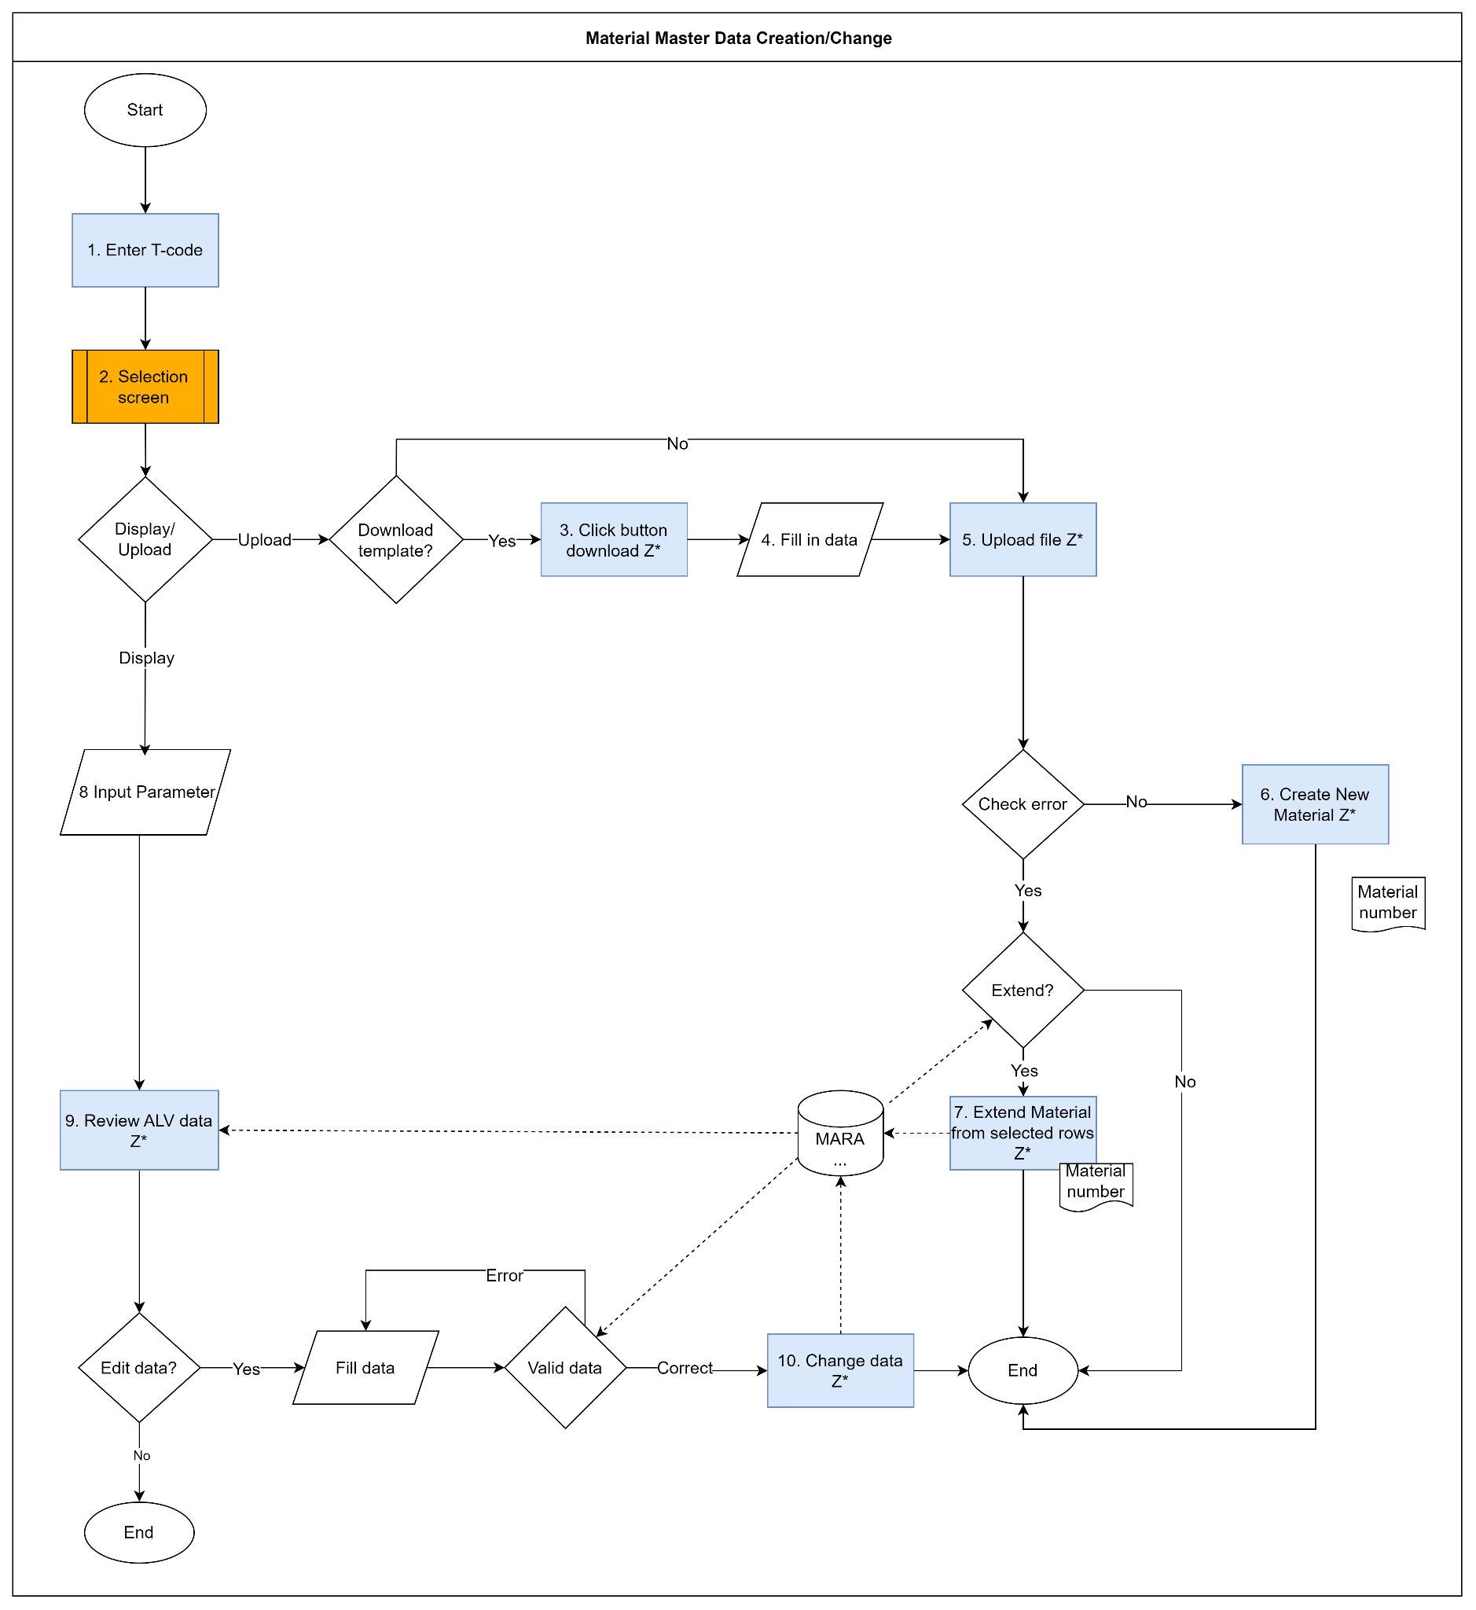

### 3.2.2. Process Description

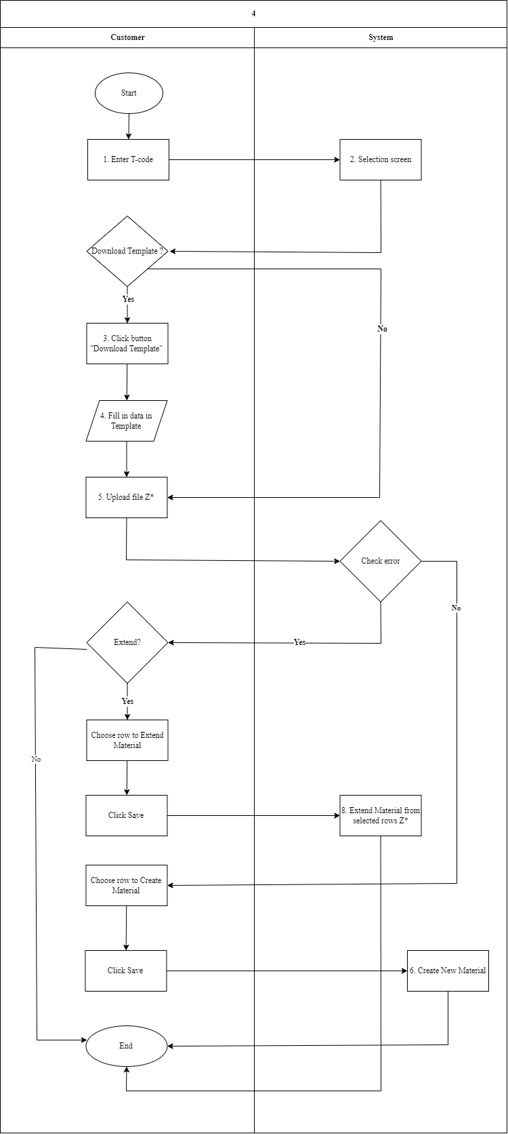

## 

| **Step #** | **Step Name** | **Detailed Description of Upload Flow** | **Role** |
| --- | --- | --- | --- |
| 1. | Enter T-code | * The process begins when the user initiates the custom transaction code (Z*). The user enters the SAP Tcode (Z*) for this specific function to access the Material Master Data processing screen. | User |
| 2. | Selection Screen | * A selection screen appears, there are two options in the screen that allows user to choose options, including “Display” button and “Upload” button | User |
| 3. | Click Button Download Z* | * If the user selects the “Upload**”** button, the system offers a button to download Excel templates for data input. * This template includes: Excel template for creating/extending material and Excel template for multiple description language with typically an Excel file(.xlsx or .xls), which contains predefined fields to ensure data is entered in the correct format. This helps in standardising data entry, reducing errors, and improving efficiency for bulk data input. | User |
| 4. | Fill in Data | * The user fills data into the Excel template with the required Material Master data. This includes mandatory fields and optional fields to create or extend materials in the system, such as material number, material type, plant, storage location, base unit of measure, material group, purchasing group,... | User |
| 5. | Upload File Z* | * After filling in the data completely, the users upload the file back into the system using the custom transaction code (Z*): Excel template for creating/extending material and Excel template for multiple description language * The system validates the data in the uploaded file and it will check: * Correctness of the format (whether all mandatory fields are filled in and whether values meet the expected criteria). * Data validity (whether the material number or relating to other fields is correct). * If there is an error, the process notifies and directs the user to the error-correction steps. | Data Maintainer/IT Specialist |
| 6. | Create New Material | * After no error in the system, the valid data from the uploaded file are processed. * The system completed the upload process. If the material number does not already exist in the database, the material is created successfully in the database. | Data Maintainer |
| 7. | Extend Material | * After uploading data successfully, the system will get database from MARA table to display user's message * If the system notifies the material number already existed in the database, user will extend the material with plant and storage location as required for trading goods and raw material * In extending material (trading goods), we will extend plants and storage location as required with valuation type * In extending material ( raw material ), we will extend plants and storage location as required | Data Maintainer/ |

# 

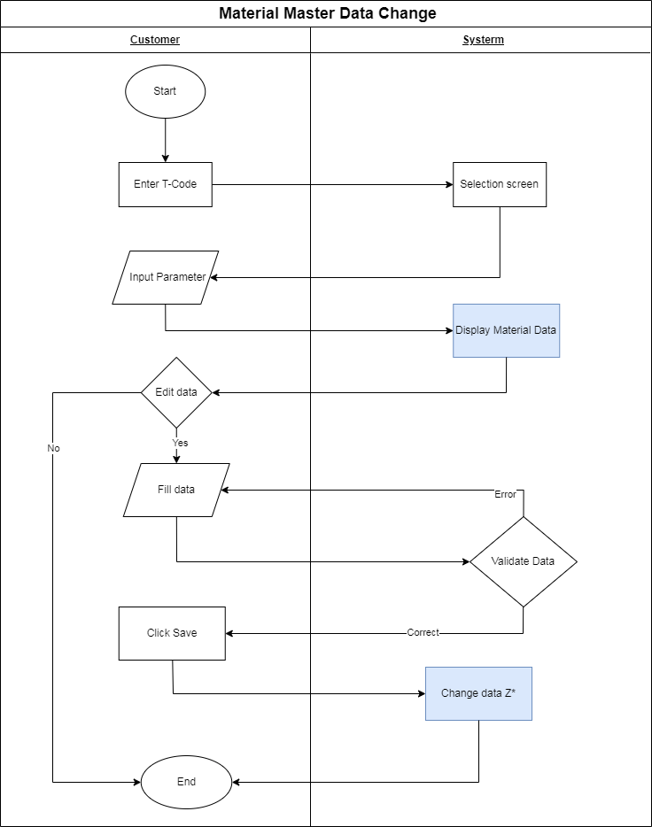

## 

## 

## Process Description of Display Flow

| **Step #** | **Step Name** | **Detailed Description of Display Flow** | **Role** |
| --- | --- | --- | --- |
| 1. | Eter T-code | * The process begins when the user initiates the custom transaction code (Z*). The user enters the SAP Tcode (Z*) for this specific function to access the Material Master Data processing screen. | User |
| 2. | Selection Screen | * A selection screen appears, There are two options on the screen that allow the user to choose options, including “Display” button and “Upload” button | User |
| 3. | Input Parameter | * If the user opts for the “Display” button (instead of uploading data), they need to manually input parameters on the selection screen to fetch specific material data. * On the input parameters screen, user will fill in material number (mandatory field) and plant, material type, industry sector, and storage location (optional fields) depending on what the user wants to these | User |
| 4. | Review ALV Data Z* | * Whether the user manually inputs data in a parameter, the system presents the Material Master Data in the ALV (ABAP List Viewer) format. * The user can review information data of material | Data Maintainer |
| 5. | Fill in data | * If data in the ALV is incorrect or the user wants to modify field information, the user can fill in or edit the necessary field ( that is allowed to change) directly, such as material description, gross weight,... These key fields, likeMaterial Number, Sales Organization, Material Type,... are non-editable. * The system will automatically check fields based on tables in SAP such as MARA, MARC,... | User |
| 6. | Change Data Z**\*** | * After the user fills in valid fields, the system will proceed to update the SAP database with new information by saving data * Updated data is recorded in the corresponding tables in the system, and the system saves the updated material data under the respectivematerial number. | Data Maintainer |

# 

# REPORTS

Based on local requirement, following are reports that can use in the future

| **No.** | **Description** | **T-Code** |
| --- | --- | --- |
| 1. | **Create Material**: In the SAP system, it is used to generate new materials by entering data for various perspectives, including Basic Data, Sales Data, Purchasing Data, Accounting Data, etc. | **MM01** |
| 2. | **Change Material:** Gives users the ability to change data about materials that are already in the system. Information can be altered from many perspectives. | **MM02** |
| 3. | **Display Material**: Show comprehensive material information without the ability to change it. Information can be viewed by users from several perspectives. | **MM03** |
| 4. | **Change Documents for Material:** Permit to monitor and view the history of changes for a particular material. We can observe which details, such as prices and technical information, have changed. | **MM04** |
| 5. | **Stock Overview:** Displays an inventory overview for materials, allowing you to see the quantity in stock at different warehouses and the status of the material | **MMBE** |
| 6. | **Flag Material for Deletion**: Used to flag a material for deletion in the system. If a material is no longer in use, you can mark it to prevent it from appearing in active material lists. | **MM06** |
| 7. | **Create Characteristic**: Used to add characteristics to SAP that represent the features of materials or products in the classification system, such as color, storage capacity, etc. | **CT04** |
| 8. | **Create Class**: Used to create a new classification class that defines properties and classification criteria for materials or products in the system | **CL01** |
| 9. | **Change Class**: Used to change or update the information of an existing class | **CL02** |
| 10. | **Display Class:** Allows users to view the details of a classification that has been assigned to a class in the SAP system. | **CL03** |
| 11. | **Delete Class:** Users can delete the characteristics of a classification in the classification system. | **CL04** |
| 12. | **Class Types:** Users can manage and modify object dependencies that determine how characteristics are interrelated for configurable products. | **CL2B** |
| 13. | Manage materials and configure parameters related to materials and install information fields in material master (basic information about materials) to manage product information. | **SPRO** |
| 14. | **Change Characteristic:** Used to edit information of a property that already exists in the system, allowing you to update attributes, values ​​or information related to the property without creating a new one | **CT02** |
| 15. | **Display Characteristic -** Displays detailed information about a property without editing providing an overview of the properties of the defined property | **CT03** |
| 16. | **Change Characteristic Assignment: Use** to edit the assignment of properties to a class classification type (class) allows the user to change properties associated with a classification class, such as adding, deleting, or updating | **CL20N** |
| 17. | **Stock Overview: Displays** an inventory overview for materials, allowing you to see the quantity in stock at different warehouses and the status of the material | **MMBE** |
| 18. | **Mass Change of Material Data:** Allows you to edit information for multiple materials at once. It's useful when you need to make similar changes to a group of materials. | **MM17** |
| 19. | **Extend Material View(s):** Extend material master views across multiple materials efficiently | **MM50** |
| 20. | **The Data Browser is used** to display, analyse, and filter data from SAP tables. Users can access almost any table in the SAP database, provided they have the necessary authorizations. | **SE16** |
| 21. | **General Table Display:** Users can view, filter, and analyse data from SAP database tables efficiently. It supports various data management features and is widely used for reporting and troubleshooting. | **SE16N** |
| 22. | **Data Dictionary:** (ABAP Dictionary) Users can create new database tables or modify existing ones, including adding or removing fields and defining the data type and attributes of fields | **SE11** |
| 23. | **Define Material Type:** Used to define whether a particular material type is to be validated on quantity basis a value basis or on both | **OMS2** |
| 24. | **Function Modules:** Program, report, or other function module that can call this reusable code to accomplish a certain task | **SE37** |
| 25. | **ABAP Editor:** Used for creating, editing, and running ABAP programs. | **SE38** |
| 26. | **Price change:** Used to change the value of a material that has been entered into inventory or to change the value of materials in procurement orders or contracts. | **MR21** |
| 27. | **Debit/credit material:** Used to adjust invoice values ​​entered in the system. Especially in cases where there is a difference between the invoice value and the value of materials or services received from the supplier. | **MR22** |
| 28 | **Materials list**: This transaction allows users to view a list of materials based on different parameters such as material type, material group, plant, or price | **MM60** |