

**ORCHID FLOWER TRADING AND AUCTION PLATFORM**

**Software Design Document**

– Ho Chi Minh, February 2024 –

**Table of Contents**

I. Record of Changes 3

II. Software Design Document 4

1. System Design 4

**2. Activity Diagram** 7

# I. Record of Changes

|  |  |  |  |
| --- | --- | --- | --- |
| Date | A* M, D | In charge | Change Description |
| 10/1/2024 | A | PhongTT, BaoND, NamTN | Activity Diagram |
| 31/1/2024 | A | PhongTT | State Diagram |
| 26/2/2024 | A | PhongTT | Sequence Diagram |
| 10/3/2024 | M | PhongTT CatLD, NguyenTPP | Sequence Diagram |
| 15/3/2024 | M | PhongTT | State Diagram |
| 20/3/2024 | M | BaoND | Class Diagram |
|  |  |  |  |
|  |  |  |  |
|  |  |  |  |
|  |  |  |  |
|  |  |  |  |
|  |  |  |  |
|  |  |  |  |

*A - Added M - Modified D - Deleted

# II. Software Design Document

## 1. System Design

**1.1 Class Diagram**

**1.2 State machine diagram**

**1.2.1 Order**

**1.2.2 Task**

**1.2.3 Product**

**2. Activity Diagram**

**2.1 Buy Product**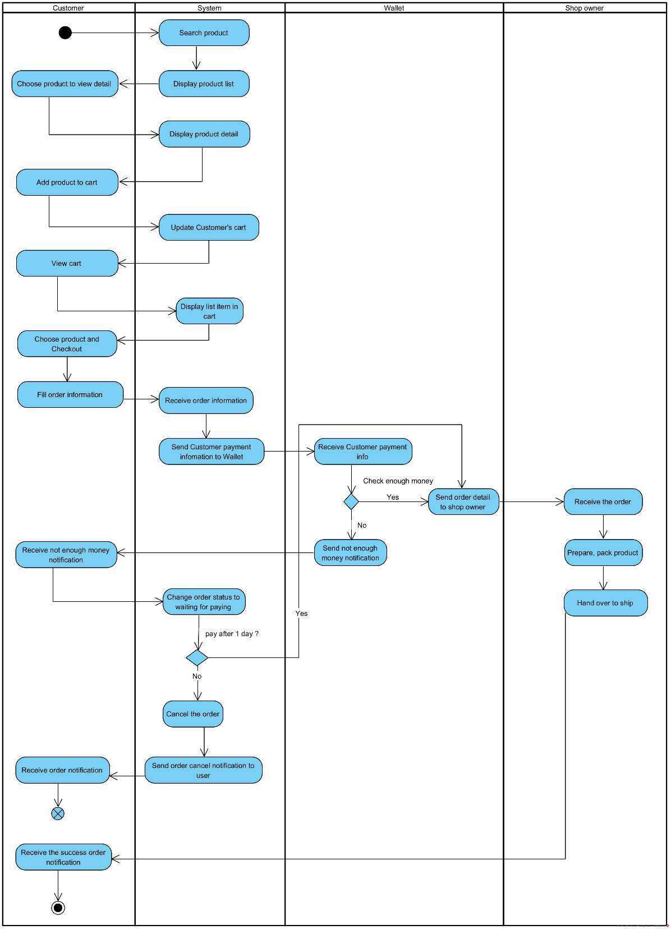

**2.2 Register to Auction product**

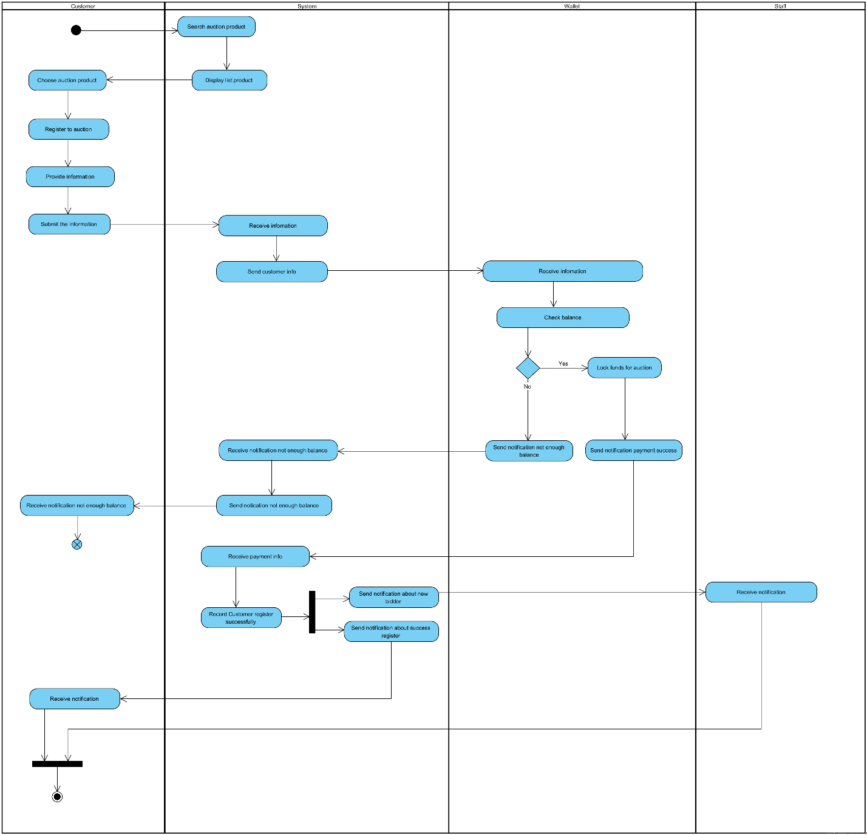

**2.3 Request Auction**

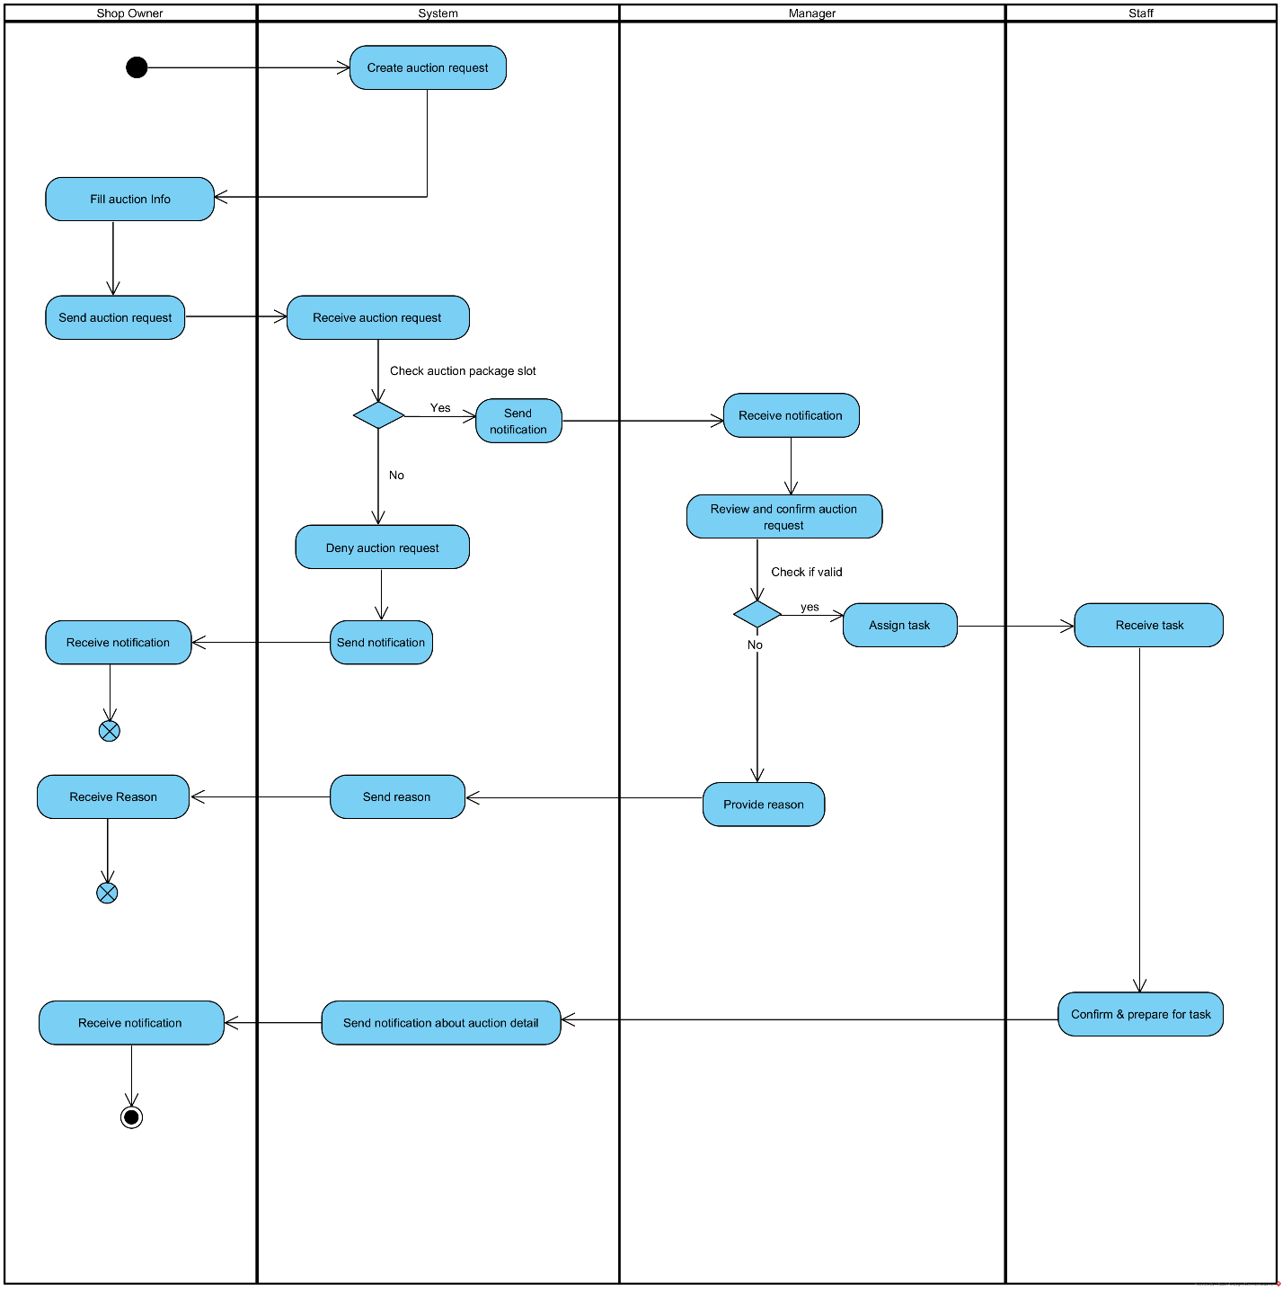

**2.4 Auction Product**

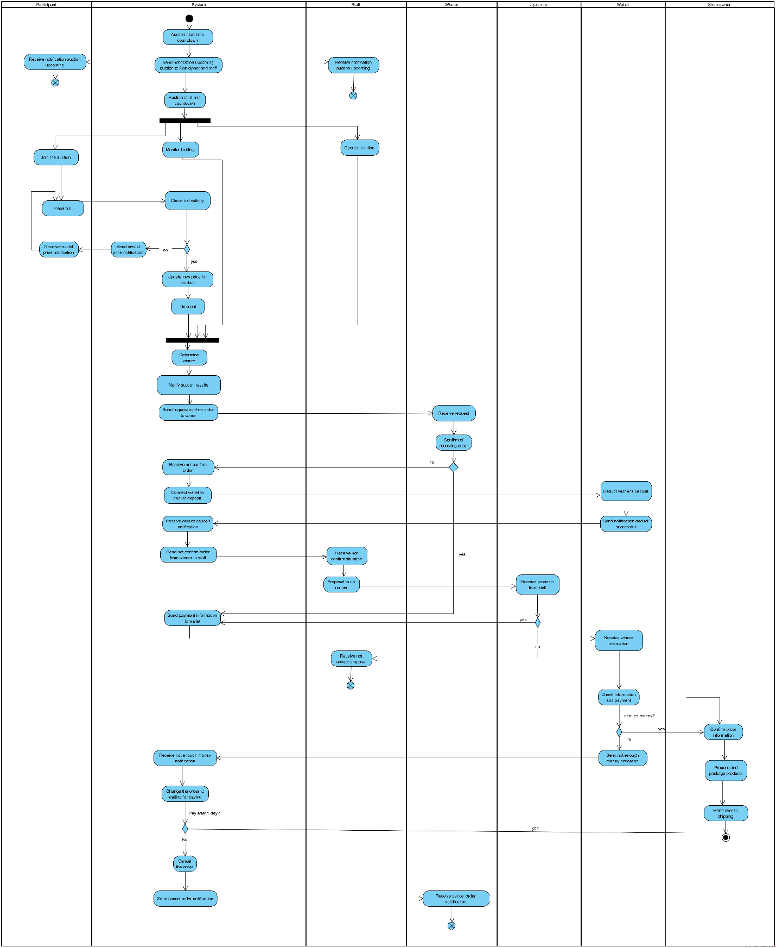

**2.5 Shipping Process**

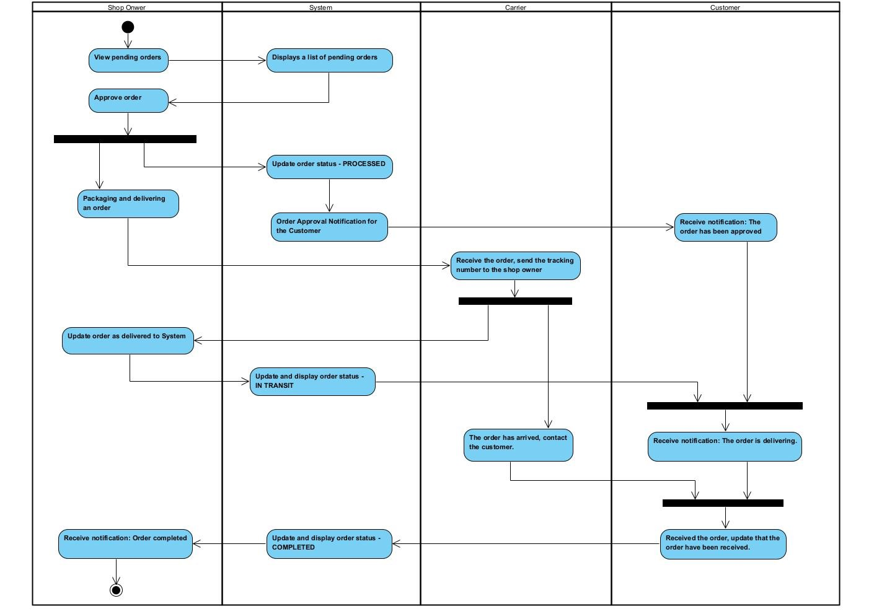

**2.6 Refund Process**

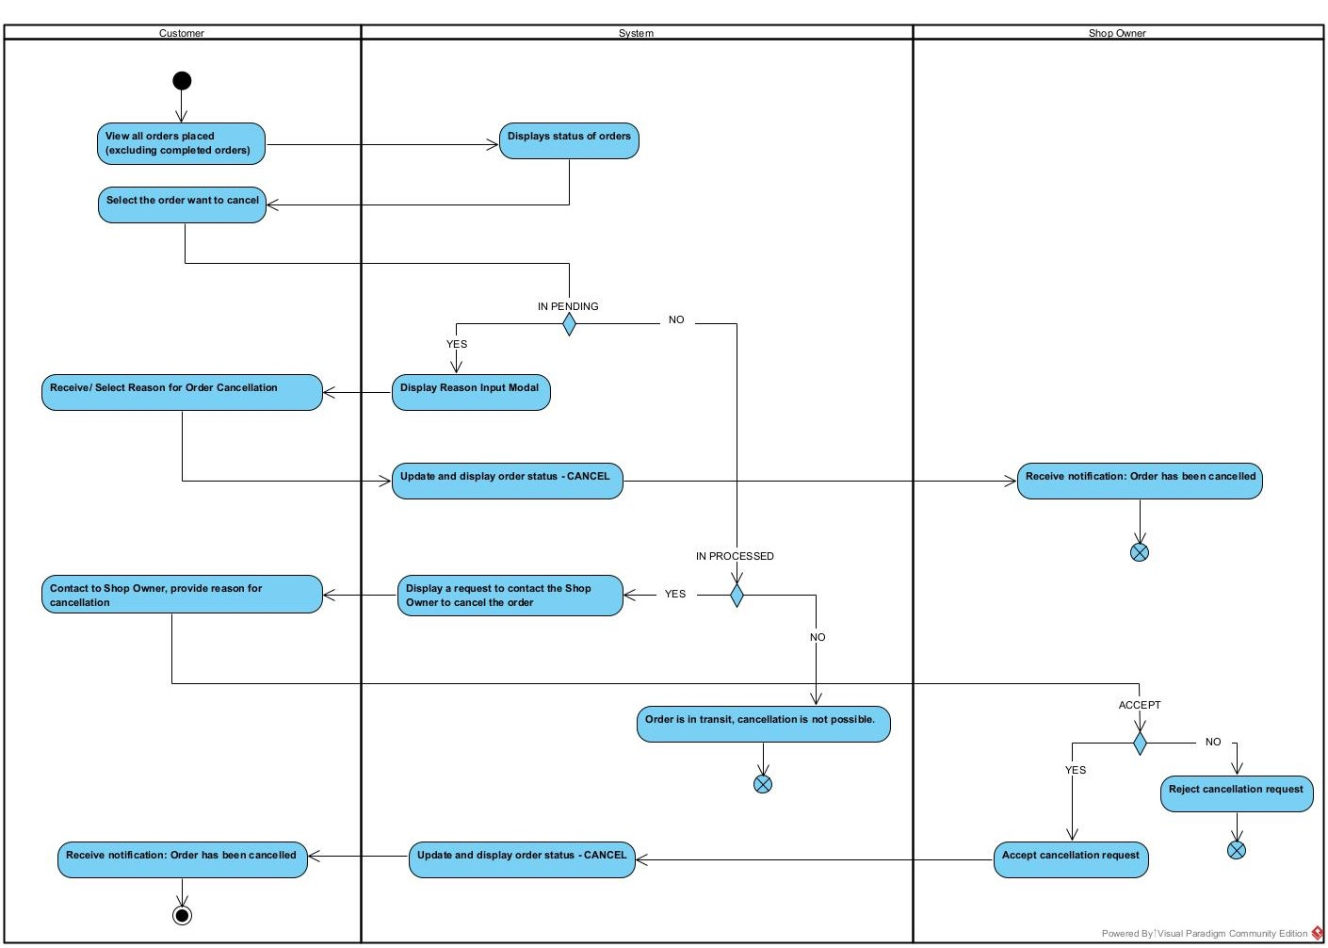

**3.Sequence Diagram**

**3.1 Login**

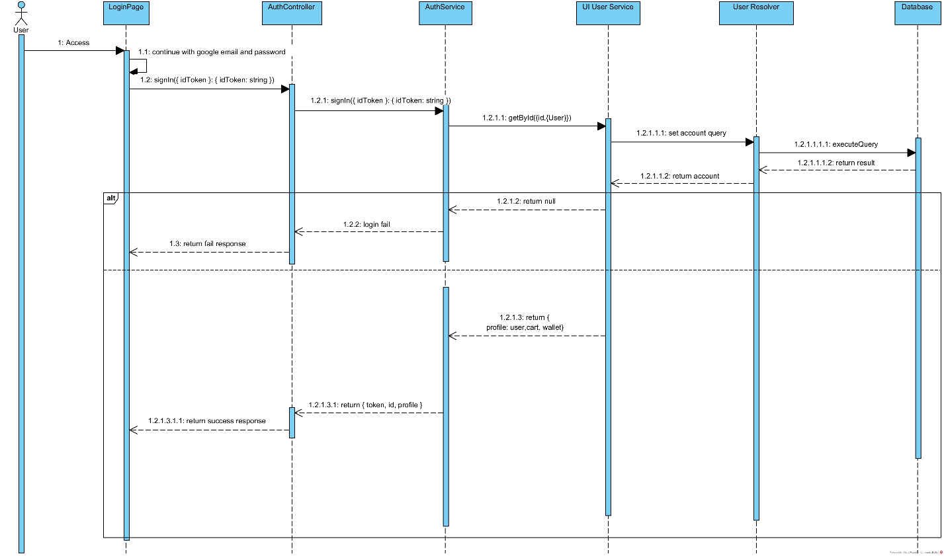

**3.2 Create Product**

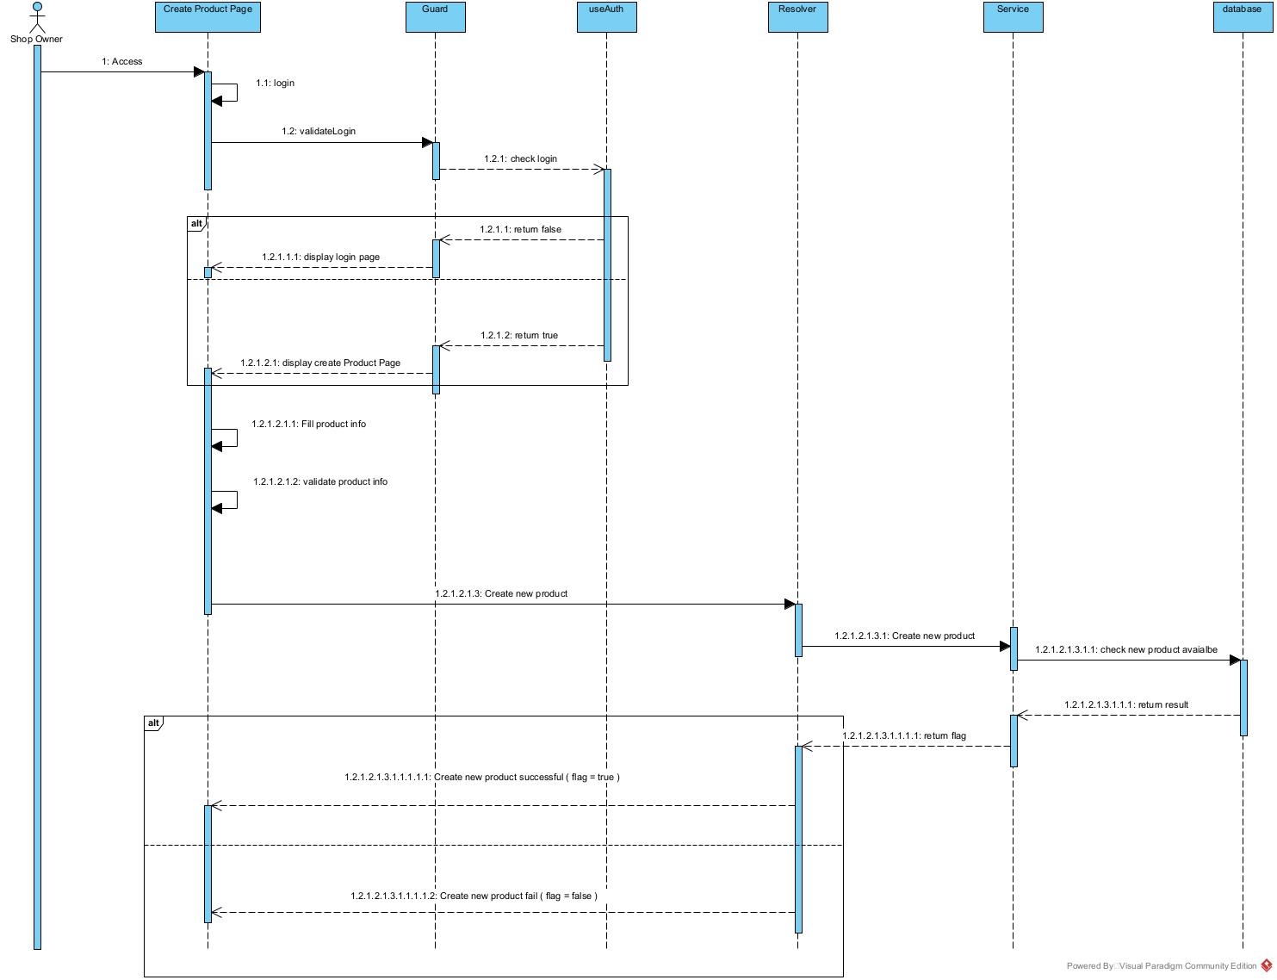

**3.3 Register to Participate in Auction**

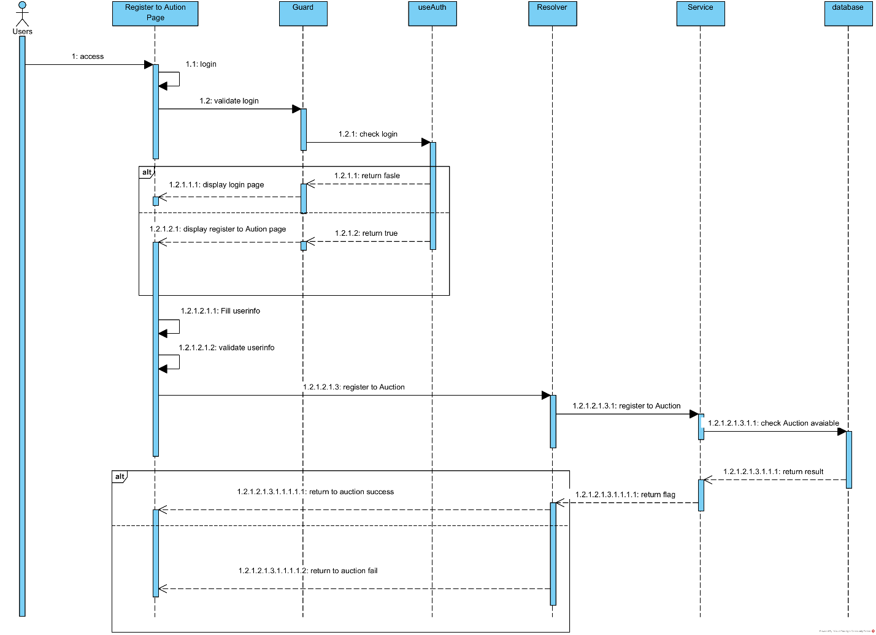

**3.4 Bidding**

**3.5 Buy Product**

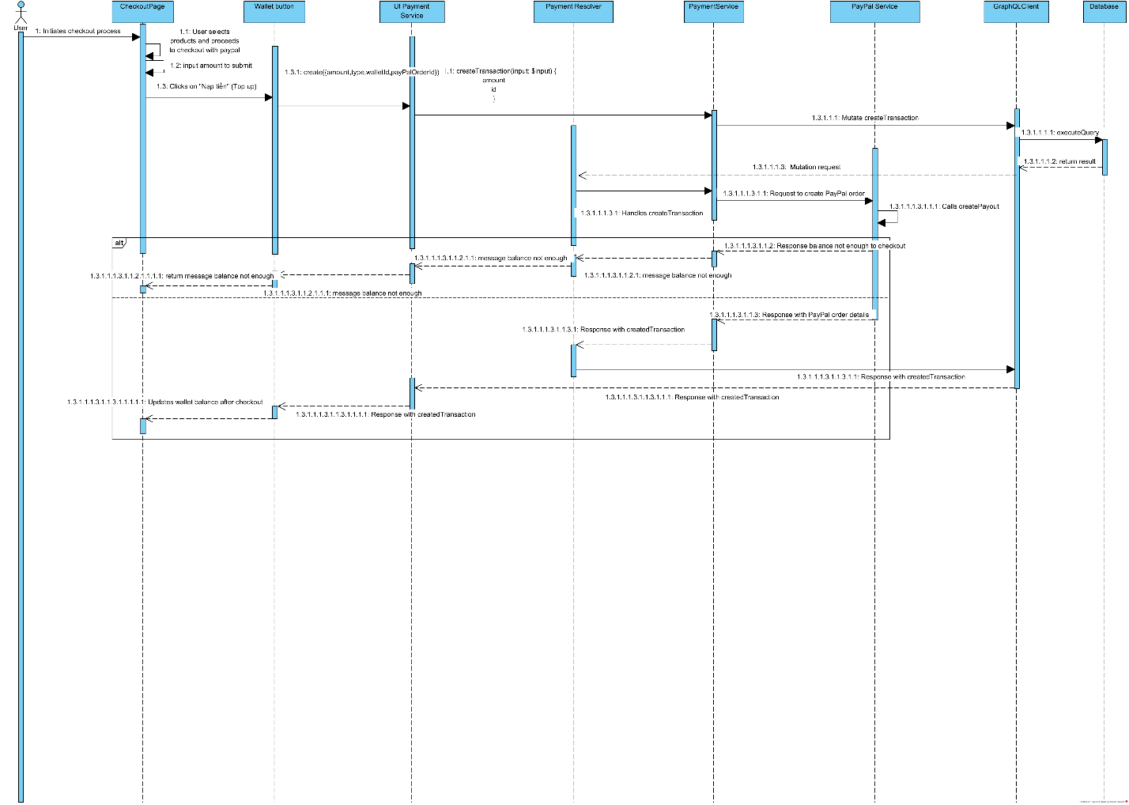

**3.6 Register as Shop Ownner**

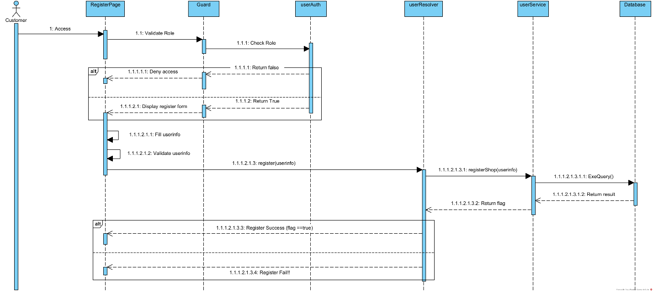

**3.7 Register Product to Auction**