

**ONLINE OLD STUFF EXCHANGE WEBSITE FOR STUDENTS AT FPTU**

**Software Requirement Specification**

– HoChiMinh, May 2023 –

**Table of Contents**

I. Overview 3

1. Vison 3

**1.1. Background** 3

**1.2. Business opportunities** 3

**1.3. Defenition** 3

2. Scope 3

3. System Functions 5

**3.1. Screen Flow 5**

**3.2. Screen Details 5**

**3.3. User Authorization 6**

**3.4. Non-Screen Functions 7**

4. Overall Description 7

4.1. Product overview 7

4.1.1. Guest requirements 7

4.1.2. User requirements 7

4.1.3. Moderator requirements 8

4.1.4. Admin requirements 8

4.2 Business Rule 8

II. Functional Requirements 9

1. User Case Diagram 9

2. User Case Detail 10

**2.1. Login** 10

**2.2 Create New Stuff** 10

**2.3 View Exchange Page** 13

**2.4 View Exchange Details** 14

**2.5 View Market Details** 15

**2.6 View Auction Detail** 15

**2.7 Manage Stuff** 16

**2.8 Exchange Stuff** 19

**2.9 Market Stuff** 21

**2.10 Stuff Detail’s Built-in Chat** 22

**2.11 Private Chat** 23

# I. Overview

## 1. Vison

**1.1. Background**

Students at FPT University are presently using some platform such as Facebook, Zalo, or ask friends, relationships to exchange or sell their old stuff. But this process wastes amounts of time finding the right people to exhange with, or stuff to buy. Also, Internet is incognito, so it can not avoid some situations as scam or fake news.

**1.2. Business opportunities**

Based on our survey, many students have requested a website/system that would allow them to post their old stuff online and view others. The website/system would save student time and increase the chances of their getting items they prefer. It protects users from scams or fake posts by a team of moderators working 24/7. We use another currency - Point that allows users that don’t have much money to still exchange some stuff they need.

**1.3. Defenition**

|  |  |
| --- | --- |
| Acronym | Definition |
| Guest | A person using the application without signing in. |
| User | A person who signed in as Normal User, the purpose is to exchange/buy/sell/bid stuff or donate their stuff. |
| Moderator | A person who signed in as Moderator, the purpose is to manage requests from user (donate, delete on-going bid...) and inspect contents on application. |
| Admin | A person who signed in as Admin, the purpose is to manage account, transaction on application. |

## 2. Scope

FXChange – an old stuff exchange website was created to support old stuff exchange for student at FPT University's Campuses via the internet.

FXChange is a website perfect for students who want to find, exchange, or donate old stuff. The system is expected to connecting sellers or exchangers of old stuff, from clothing to furniture to collectibles and more using our own currency-points or money in the future.

## 3. System Functions

#### 3.1. Screen Flow

#### 3.2. Screen Details

|  |  |  |  |
| --- | --- | --- | --- |
| **#** | **Feature** | **Screen** | **Description** |
| 1 | Login | Login | Login by email to access web feature. |
| 2 | New stuff | Create Stuff | Users can fast create stuff for each type. |
| 3 | View Account | DashBoard\Account | Admin can view list account. |
| 4 | Edit Account | DashBoard\Account | Admin can change account status(active/inactive). |
| 5 | View Request | DashBoard\Request | Admin, Moderator can view all request. |
| 6 | Edit Request | DashBoard\Request | Admin, Moderator can approve/disapprove request. |
| 7 | View History | User Profile | Users can view their transaction history. |
| 8 | Edit Profile | User Profile | User can update their information. |
| 9 | Search Stuff | Home Page | Search Stuff. |
| 10 | New Exchange | Exchange | Users can create new exchange stuff. |
| 11 | View Exchange Detail | Exchange | Users can view exchange stuff detail. |
| 12 | Edit Exchange | Manage Stuff | Users can update or delete exchange stuff. |
| 13 | New Sale | Market | Users can create new sale stuff |
| 14 | View Sale Stuff Detail | Market | Users can view sale stuff detail. |
| 15 | Edit Sale Stuff | Manage Stuff | Users can update or delete their sale stuff. |
| 16 | New Auction | Auction | Users can create new auction. |
| 17 | View Auction | Auction | Users can view auction detail. |
| 18 | Edit Auction | Mange Stuff | Users can update or delete(request) auction. |
| 19 | View Own Stuff | Manage Stuff | Users can view their own stuff. |
| 20 | Edit Stuff | Mangage Stuff | Users can update or delete their own stuff. |
| 21 | Check Attendance | Earn Points | Users can earn points for first login of the day |
| 22 | New Users | Earn points | Users can earn points for first time login in web |
| 23 | Invite Friend | Earn points | Users can earn points for enter friends code |

#### 3.3. User Authorization

|  |  |  |  |  |
| --- | --- | --- | --- | --- |
| **Screen** | **Guest** | **Customer** | **Moderator** | **Admin** |
| <<Screen Login>> | x | x | x | x |
| Login Email FPT | x | x | x | x |
|  |  |  |  |  |
| <<Screen Home Page>> | x | x | x | x |
| Search Stuff | x | x | x |  |
| Filter Stuff | x | x | x |  |
| Create New Stuff |  | x | x |  |
|  |  |  |  |  |
| <<Screen Profile>> |  | x | x |  |
| Update Profile |  | x | x |  |
| View History |  | x | x |  |
|  |  |  |  |  |
| <<Screen Exchange>> | x | x | x |  |
| Create new exchange |  | x | x |  |
| View Exchange Detail | x | x | x |  |
| Edit Exchange |  | x | x |  |
|  |  |  |  |  |
| <<Screen Market>> | x | x | x |  |
| Create new Sale Stuff |  | x | x |  |
| View Sale Stuff Detail | x | x | x |  |
| Edit Sale Stuff |  | x | x |  |
|  |  |  |  |  |
| <<Screen Auction>> | x | x | x |  |
| Create New Auction |  | x | x |  |
| View Auction detail | x | x | x |  |
|  |  |  |  |  |
| <<Screen Manage Stuff>> |  | x | x |  |
| View Own Stuff |  | x | x |  |
| Edit Stuff |  | x | x |  |
|  |  |  |  |  |
| <<Screen Earn Point>> |  | x | x |  |
| Check Attendance |  | x | x |  |
| New User |  | x | x |  |
| Invite Friends |  | x | x |  |
|  |  |  |  |  |
| <<Screen DashBoard>> |  |  | x | x |
| View Account List |  |  |  | x |
| Edit Account |  |  |  | x |
| View Request List |  |  | x | x |
| Edit Request |  |  | x | x |

#### 3.4. Non-Screen Functions

|  |  |  |  |
| --- | --- | --- | --- |
| **#** | **Feature** | **System Function** | **Description** |
| 1 | New Stuff | createStuff | Insert new stuff information into database. |
| 2 | Delete Stuff (Donate) | deleteStuff | Send delete request to review. Delete in database if approved. |
| 3 | Edit profile | updateProfile | Update information of user in database |

## 

## 4. Overall Description

## 4.1. Product overview

**4.1.1. Guest requirements**

Guests are people who have not been authenticated to the system. They only have access to following functions:

* Sign in.
* Search and View stuff: Exchange, Market, Auction

**4.1.2. User requirements**

Users are people who have signed into the website with “User” role. They can use all Guest functions, plus the following functions:

* View/Edit Profile
* View Inventory
* Add/Modify Stuff
* Exchange, Buy, Sell, Donate, Bid Stuff
* Earn Points

**4.1.3. Moderator requirements**

Moderators are people who have signed into the website with “Mod” role. They can use all User functions, plus the following functions:

* Stuff moderation
* View/ Edit Request from User: Donate, delete in-progess stuff...

**4.1.4. Admin requirements**

Admin is a person who have signed into the website with “Admin” role. They can access the following functions:

* View/ Edit Account: User, Moderator
* View/ Edit Request from User: Donate, delete in-progess stuff...

**4.2 Business Rule**

|  |  |
| --- | --- |
| **ID** | **Rule Definition** |
| BR-01 | The internet connection is available |
| BR-02 | User must own an FPT University gmail account |
| BR-03 | All fields must be validated |
| BR-04 | Have required fields |
| BR-05 | User point must enough to make a transaction |
| BR-06 | Actor’s point must be at least 3 steps larger than current price |
| BR-07 | Request must send to complete action |
| BR-08 | Limit the amount of image user upload (Under 5 image) |
| BR-09 | The notification sent to the user must be a push notification, it can show on the device's screen. |
| BR-10 | Built-in chat system must be realtime |

# II. Functional Requirements

## 1. User Case Diagram

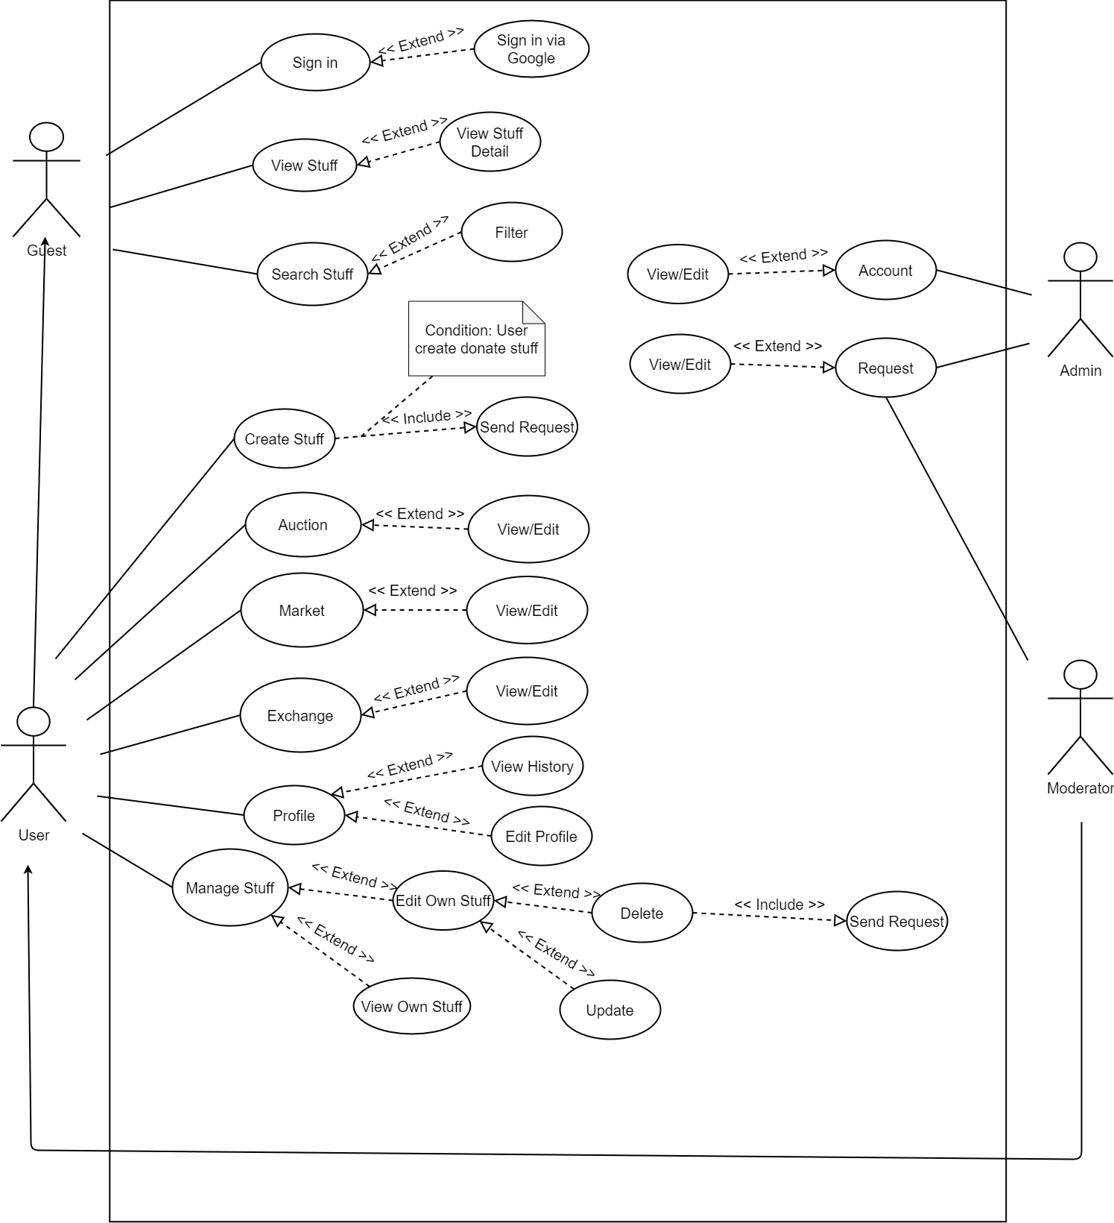

## 2. User Case Detail

**2.1. Login**

|  |  |  |  |
| --- | --- | --- | --- |
| Primary Actor | Guest | Secondary Actor: | N/A |
| Trigger: | The actor wants to sign in to the FxChange web | | |
| Description | This feature allow actor to login the system | | |
| Pre-condition | Actor has FPTU email address | | |
| Post-condition | Success: Redirect to home Page  Fail: The system shows error message corresponding to error code | | |
| Normal Flow | |  |  |  | | --- | --- | --- | | Step | Actor Action | System Response | | 1 | In login page, Actor clicks on “Tiếp tục Với Google” | System shows a list of google.  accounts of users | | 2 | Actor clicks the account they want to use to sign in | System redirects to the home page | | | |
| Abnormal Flow | N/A | | |
| Bussiness Rules: | BR-01, BR-02 | | |
| Assumtions: |  | | |

**2.2 Create New Stuff**

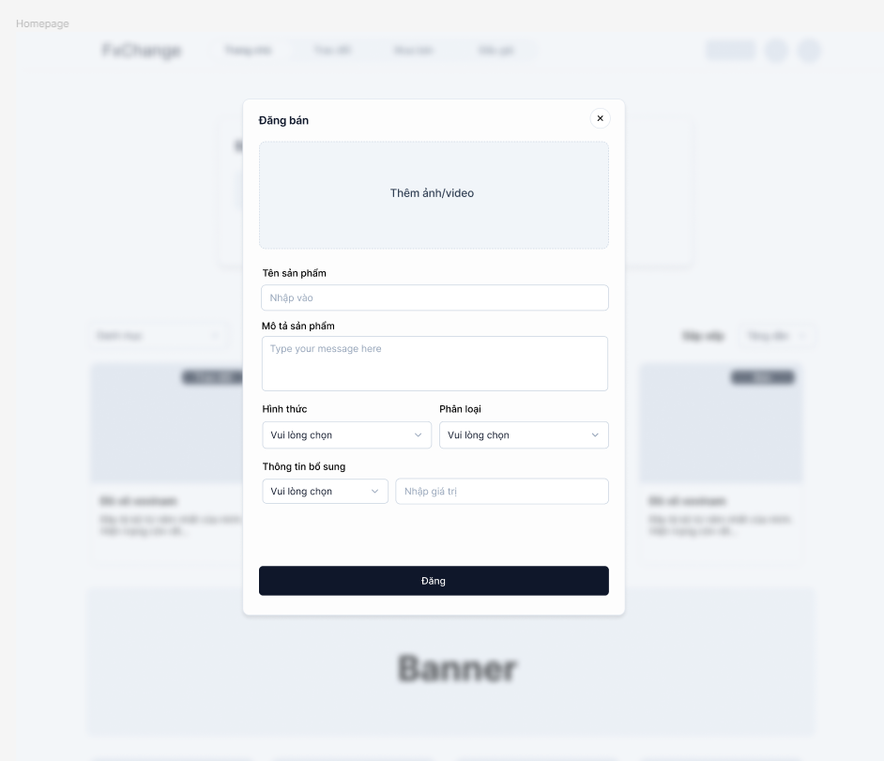

|  |  |  |  |
| --- | --- | --- | --- |
| Primary Actor | User | Secondary Actor: | N/A |
| Trigger: | The actor wants to create new stuff. | | |
| Description | This feature allow actor to create new stuff tp exchange, donate, sell... | | |
| Pre-condition | N/A | | |
| Post-condition | Success: The system show message and user can view their stuff.  Fail: The system shows error message corresponding to error code | | |
| Normal Flow | |  |  |  | | --- | --- | --- | | Step | Actor Action | System Response | | 1 | In home page actor click “Đăng Bán” | System shows a form to enter information. | | 2 | Actor inputs information in textbox | System check and validate the inputs | | 3 | Actor clicks “Đăng” | System redirect to home page and actor can view the stuff | | | |
| Abnormal Flow | N/A | | |
| Bussiness Rule: | BR-06, BR-02 | | |
| Assumptions: |  | | |

**2.3 View Exchange Page**

|  |  |  |  |
| --- | --- | --- | --- |
| Primary Actor | User | Secondary Actor: | N/A |
| Trigger: | The actor wants to see the exchange page and exchange stuff. | | |
| Description | This feature allows actors to view exchange stuff list | | |
| Pre-condition | N/A | | |
| Post-condition | Success: Redirect to Exchange page  Fail: The system shows error message corresponding to error code | | |
| Normal Flow | |  |  |  | | --- | --- | --- | | Step | Actor Action | System Response | | 1 | In home page, Actor clicks on “Trao Đổi” tab | System redirects to exchange page. | | | |
| Abnormal Flow | N/A | | |
| Bussiness Rules: | BR-02 | | |
| Assumtions: |  | | |

**2.4 View Exchange Details**

|  |  |  |  |
| --- | --- | --- | --- |
| Primary Actor | User | Secondary Actor: | N/A |
| Trigger: | The actor wants to view exchange stuff detail | | |
| Description | This feature allow actor to view exchange stuff detail. | | |
| Pre-condition | N/A | | |
| Post-condition | Success: Show exchange stuff detail  Fail: The system shows error message corresponding to error code | | |
| Normal Flow | |  |  |  | | --- | --- | --- | | Step | Actor Action | System Response | | 1 | In Exchange page, Actor clicks on stuff post | System shows stuff detail:  - Image  - Name  - Description | | 2 | Actor clicks “Bình Luận” | System shows all comment in stuff post | | 3 | Actor clicks “Gợi ý đổi” | System show suggest stuff to exchange | | | |
| Abnormal Flow | N/A | | |
| Bussiness Rules: | BR-02 | | |
| Assumtions: |  | | |

**2.5 View Market Details**

|  |  |  |  |
| --- | --- | --- | --- |
| Primary Actor | User | Secondary Actor: | N/A |
| Trigger: | The actor wants to view sale stuff detail | | |
| Description | This feature allow actor to view sale stuff detail. | | |
| Pre-condition | N/A | | |
| Post-condition | Success: Show sale stuff detail  Fail: The system shows error message corresponding to error code | | |
| Normal Flow | |  |  |  | | --- | --- | --- | | Step | Actor Action | System Response | | 1 | In Market page, Actor clicks on stuff post | System shows stuff detail:  - Image  - Name  - Description | | 2 | Actor clicks “Bình Luận” | System shows all comment in stuff post | | 3 | Actor clicks “Đề xuất cho bạn” | System show suggest stuff to exchange | | | |
| Abnormal Flow | N/A | | |
| Bussiness Rules: |  | | |
| Assumtions: | - Actor’s internet connection is available | | |

**2.6 View Auction Detail**

|  |  |  |  |
| --- | --- | --- | --- |
| Primary Actor | User | Secondary Actor: | N/A |
| Trigger: | The actor wants to view auction detail | | |
| Description | This feature allow actor to view auction detail. | | |
| Pre-condition | N/A | | |
| Post-condition | Success: Show auction detail  Fail: The system shows error message corresponding to error code | | |
| Normal Flow | |  |  |  | | --- | --- | --- | | Step | Actor Action | System Response | | 1 | In Auction page, Actor clicks on auction post | System shows stuff detail:  - Image  - Name  - Description  - Time left  - Current price | | 2 | Actor clicks “Tăng thêm” | System shows new price | | | |
| Abnormal Flow | N/A | | |
| Bussiness Rules: | - Actor’s point must be at least 3 steps larger than current price | | |
| Assumtions: | - Actor’s internet connection is available | | |

**2.7 Manage Stuff**

|  |  |  |  |
| --- | --- | --- | --- |
| Primary Actor | User | Secondary Actor: | N/A |
| Trigger: | The actor wants to view own stuff, its status, edit it. | | |
| Description | This feature allow actor to view own stuff detail and edit it. | | |
| Pre-condition | N/A | | |
| Post-condition | Success: Show actor’s stuff, actor can edit stuff  Fail: The system shows error message corresponding to error code | | |
| Normal Flow | 1. View Stuff  |  |  |  | | --- | --- | --- | | Step | Actor Action | System Response | | 1 | In Manage Stuff page, Actor clicks on Auction/Market/Exchange | System shows stuff detail base on class:  - Image  - Name  - Description  - Time left  - Current price |  1. Update Stuff  |  |  |  | | --- | --- | --- | | Step | Actor Action | System Response | | 1 | In Manage Stuff page, Actor clicks on Auction/Market/Exchange | System shows stuff detail base on class:  - Image  - Name  - Status  - Description | | 2 | Actor change information in textbox | System validates inputs | | 3 | Actor clicks “Update” | System saves new inputs to database |  1. Delete Stuff  |  |  |  | | --- | --- | --- | | Step | Actor Action | System Response | | 1 | In Manage Stuff page, Actor clicks on Auction/Market/Exchange | System shows stuff detail base on class:  - Image  - Name  - Status  - Description | | 3 | Actor clicks “Delete” | System shows message “Are you sure to delete this stuff?” | | 4 | Actor clicks yes | System inactive the stuff and stop display it | | | |
| Abnormal Flow | |  |  |  | | --- | --- | --- | | No | Cause | System Respone | | 1 | Actor deletes stuff being auction | System show message “Stuff is being auctioned. You still want to delete it”. If yes, send request to Admin/Moderator | | 2 | Actor deletes donate stuff that are waiting for review | System show message “Stuff is being reviewed. You still want to delete it”. If yes, send request to Admin/Moderator | | | |
| Bussiness Rules: |  | | |
| Assumtions: | - Actor’s internet connection is available | | |

**2.8 Exchange Stuff**

|  |  |  |  |
| --- | --- | --- | --- |
| Primary Actor | User | Secondary Actor: | N/A |
| Trigger: | The actor wants to exchange stuff on the application | | |
| Description | This feature allow actor to exchange stuff with other people | | |
| Pre-condition | Stuff is valid on the application | | |
| Post-condition | Success: Show notification, actor can see transaction  Fail: The system shows error message corresponding to error code | | |
| Normal Flow | 1.Actor is not the owner   |  |  |  | | --- | --- | --- | | Step | Actor Action | System Response | | 1 | In Exchange Stuff page, Actor clicks on Exchange stuff to see it detail | System shows stuff detail base on class:  - Image  - Name  - Status  - Description | | 2 | Actors click “Trao đổi ngay” | System displays the Actor’s stuff | | 3 | Actors choose the stuff to trade with | System show notification that exchange request has been sent to the owner |   2. Actor is the owner   |  |  |  | | --- | --- | --- | | Step | Actor Action | System Response | | 1 | Actor can view the suggested stuff | System shows stuff detail base on class:  - Image  - Name  - Status  - Description | | 2 | Actors click “Đồng ý trao đổi” | System redirect actor to chatbox | | | |
| Abnormal Flow | 1.if owner and user agree to exchange   |  |  |  | | --- | --- | --- | | Step | Actor Action | System Response | | 1 | Owner and User click “Xác nhận trao đổi” | System creates a transaction | | 2 | Both users decide a schedule and set schedule | System store schedule and send notification to both user | | 3 | Users give feedback and rate for the stuff owner | System store feedback and rate to display to owner |   2.if owner does not agree to exchange   |  |  |  | | --- | --- | --- | | Step | Actor Action | System Response | | 1 | Ower clicks notification to view suggested stuff | System shows stuff detail base on class:  - Image  - Name  - Status  - Description | | 2 | Owner clicks “Từ chối trao đổi” | System closes the modal and redirect to home page |   2.if user does not agree to exchange   |  |  |  | | --- | --- | --- | | Step | Actor Action | System Response | | 1 | User and owner use chatbox to discuss | Show chat to both user | | 2 | Users click “Từ chối trao đổi” | System closes the chat, send notification, redirect to home page | | | |
| Bussiness Rules: |  | | |
| Assumtions: |  | | |

**2.9 Market Stuff**

|  |  |  |  |
| --- | --- | --- | --- |
| Primary Actor | User | Secondary Actor: | N/A |
| Trigger: | The actor wants to buy/sell stuff on the application | | |
| Description | This feature allow actor to buy/sell stuff with other people | | |
| Pre-condition | Stuff is valid on the application | | |
| Post-condition | Success: Show notification, actor can see transaction  Fail: The system shows error message corresponding to error code | | |
| Normal Flow | 1.Actor is the buyer   |  |  |  | | --- | --- | --- | | Step | Actor Action | System Response | | 1 | In Market Stuff page, Actor clicks on Market stuff to see it detail | System shows stuff detail base on class:  - Image  - Name  - Status  - Description | | 2 | Actors click “Mua ngay” | System displays the form to input the information | | 3 | Actors choose two type of ship method: direct purchase, Ship by Seller | System shows fields to input address or send notification to seller |   2. Actor is the seller   |  |  |  | | --- | --- | --- | | Step | Actor Action | System Response | | 1 | Actors can view buyer request | System shows buyer’s information and ship method | | 2 | Actors view the address and ship the stuff to buyer | System changes the status to “Giao dịch đang được thực hiện” | | | |
| Abnormal Flow | 1.Buyer choose direct purchase   |  |  |  | | --- | --- | --- | | Step | Actor Action | System Response | | 1 | Actor can view buyer request | System shows buyer’s information and ship method | | 2 | Buyer and seller chat to schedule to meet | System provides private chat | | | |
| Bussiness Rules: | BR-02, BR-03 | | |
| Assumtions: |  | | |

**2.10 Stuff Detail’s Built-in Chat**

|  |  |  |  |
| --- | --- | --- | --- |
| Primary Actor | User | Secondary Actor: | N/A |
| Trigger: | The actor wants to discuss about the stuff | | |
| Description | This feature allow actor to chat with the stuff owner | | |
| Pre-condition | Stuff is valid on the application | | |
| Post-condition | Success: Actor can send message and receive it  Fail: The system shows error message corresponding to error code | | |
| Normal Flow | 1. The conversation is new.  |  |  |  | | --- | --- | --- | | Step | Actor Action | System Response | | 1 | Actors click chat button in view stuff detail | System creates new conversation and pin stuff in conversation | | 2 | Both actor and owner chat to discuss | System renders message of conversation |  1. The conversation is existed.  |  |  |  | | --- | --- | --- | | Step | Actor Action | System Response | | 1 | Actors click chat button in view stuff detail | System renders chat history, update stuff status in conversation | | 2 | Both actor and owner chat to discuss | System renders message of conversation | | | |
| Abnormal Flow |  | | |
| Bussiness Rules: | BR-02, BR-03 | | |
| Assumtions: |  | | |

**2.11 Private Chat**

|  |  |  |  |
| --- | --- | --- | --- |
| Primary Actor | User | Secondary Actor: | N/A |
| Trigger: | The actor wants to view chat history | | |
| Description | This feature allow actor to view and join to old conversation | | |
| Pre-condition | Stuff is valid on the application | | |
| Post-condition | Success: Actor can send message and receive it  Fail: The system shows error message corresponding to error code | | |
| Normal Flow | |  |  |  | | --- | --- | --- | | Step | Actor Action | System Response | | 1 | Actors click chat button in the page header | System open chat drawer and render lists conversation | | 2 | Actors select conversation to join chat | System renders list message and scroll to newest message | | 3 | Actors enter message and click send | Store message to session, transfer message to socket, send to receiver. | | | |
| Abnormal Flow |  | | |
| Bussiness Rules: | BR-02, BR-03 | | |
| Assumtions: |  | | |