

**FxChange**

**Old Stuff Exchange for FPTU Student**

– Ho Chi Minh, May 2023 –

**Table of Contents**

I. Overview 3

**1. Code Packages 3**

**2. Database Design 4**

**a. Database Schema 4**

**b. Table Description 4**

II. Designs 6

**1. Class diagram 6**

**2. Sequence diagram 6**

**3. Activity Diagram 10**

**4. State diagram 11**

# I. Overview

## 1. Code Packages

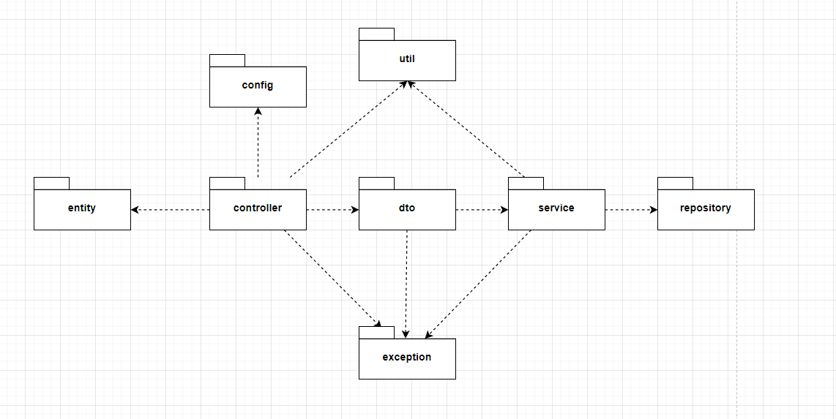

***Package descriptions***

|  |  |  |
| --- | --- | --- |
| **No** | **Package** | **Description** |
| 01 | config | - This package contains classes related to configuration of the Spring framework and other third-party libraries.  - ClassName + “Config” (eg: AppConfig.java) |
| 02 | controller | contains classes that handle and route incoming HTTP requests  - ClassName + “Controller” (eg: DashboardController.java) |
| 03 | entities | - contains entity classes which represent the data model of the application.  - ClassName + “Entity” (eg: UserEntity.java) |
| 04 | service | - contains service classes which implement the business logic of the application.  - ClassName + “Service” (eg: UserService.java) |
| 05 | dto | - contains data transfer objects which are used to transfer data between layers, contain the data that is necessary for the operation being performed.  - ClassName + “DTO” (ex: UserDTO.java) |
| 06 | exception | - contains exception classes which are thrown when errors occur during request processing.  - ClassName + “Exception” (eg: CreateNewProductException.java) |
| 07 | repository | - contains repository interfaces which handle data access and storage directly to database.  - ClassName + “Repository” (eg: UserRepository.java) |

## 2. Database Design

### a. Database Schema

### b. Table Description

|  |  |  |
| --- | --- | --- |
| **No** | **Table** | **Description** |
| 01 | users | - contains user’s information (name, address, phone,…)  - primary key: _id |
| 02 | stuffs | - contains stuff’s information:  - primary key: _id  - foreign key: category_id, type_id, author_id |
| 03 | categories | - stuff’s category  - primary key: _id |
| 04 | types | - stuff’s type (exchange, market)  - primary key: _id |
| 05 | tags | - stuff’s tag (size, color…)  - primary key: _id |
| 06 | transactions | - contains stuff’s transaction, result when exchange, trade, auction.  - primary key: _id  - foreign key: customer_id, stuff_id |
| 07 | roles | - system’s role, aims to authorization  - primary key: _id |
| 08 | permissions | - list permission corresponding for each role  - primary key: _id  - foreign key: resource_url_id |
| 9 | notifications | - contains all the notification of specific action corresponding for each user on system.  - primary key: _id  - foreign keys: user_id, target_id, notification_type_id |
| 10 | Notification_type | - store type of notification include date, name, slug...  - Primary key: -id |
| 11 | comments | - contains all comments on system.  - primary key: _id  - foreign keys: user_id, stuff_id |
| 12 | point_history | - store history changing points of user  - primary key: _id  - foreign keys: user_id |
| 13 | Suggested stuff | - store stuff that others user suggests to stuff owner  - Primary key: _id  - foreign key: target_id, stuff_id |
| 14 | feedback | - store user’s feedback to stuff owner and services  - primary key: _id  - foreign key: stuff_id, user_id |
| 15 | conservations | - store list of user’s conservation on the website and its date  - primary key: _id  - foreign key: stuff_id, message_id |
| 16 | messages | - store user’s message on the website  - primary key: _id  - foreign key: conservation_id, user_id |
| 17 | keys | - store user key for authorization, date when it generates.  - primary key: _id  - foreign key: user_id |
| 18 | auctions | - store auction stuff with price, step, time, create and expire date  - primary key: _id  - foreign key: stuff_id |
| 19 | Bidding_history | - store bidding stuff history with ower id, date, price  - primary key: _id  - foreign key: auction_id, user_id |

# II. Designs

1. **Class diagram**

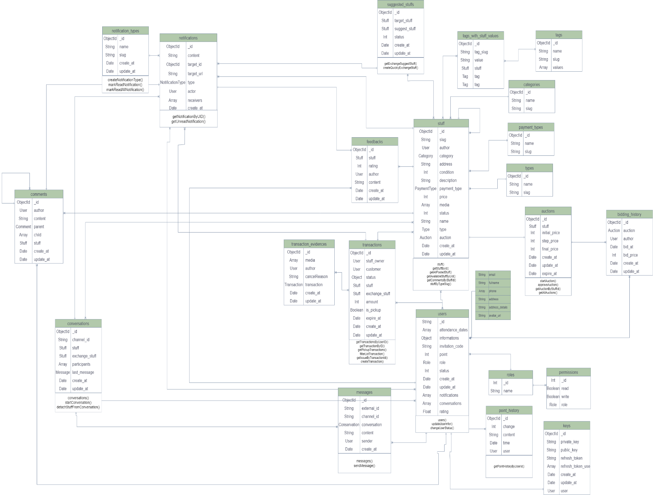

## Sequence diagram

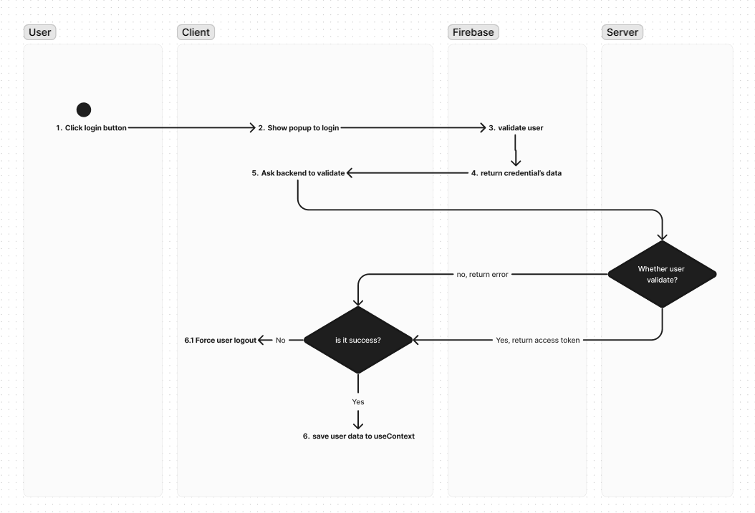

1. 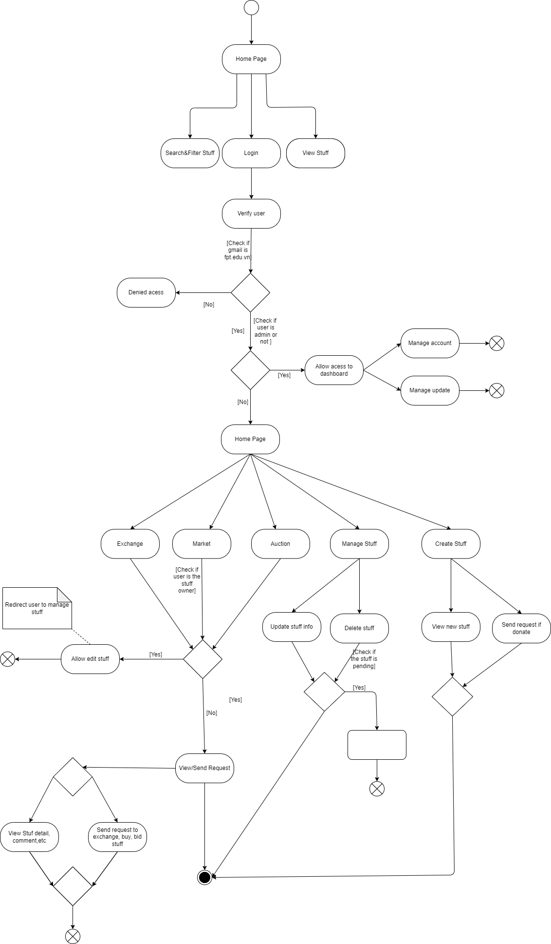**Activity Diagram**
2. 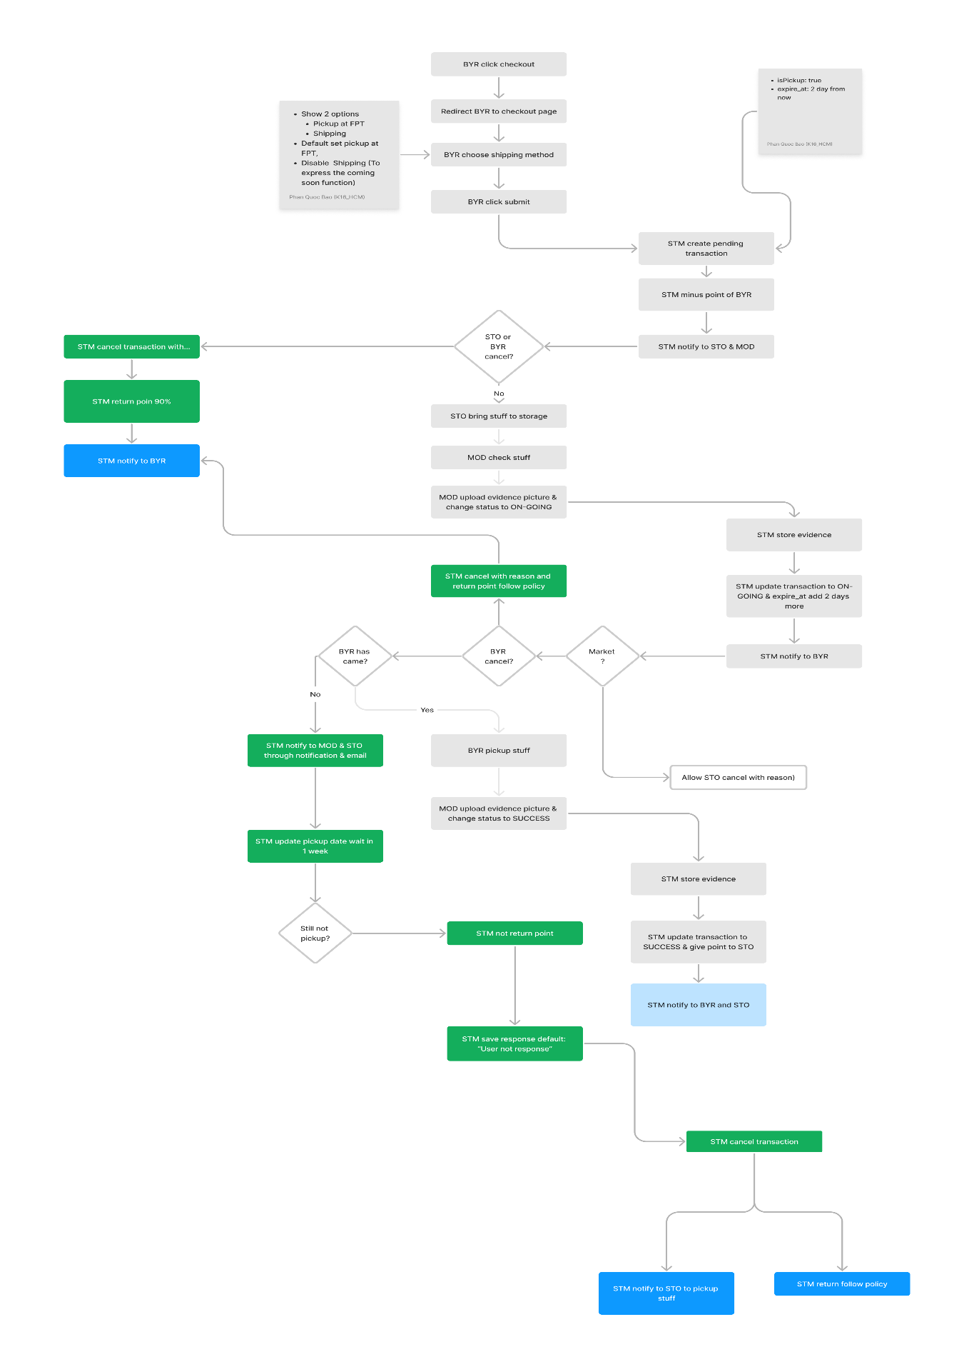**State diagram**

