**BÁO CÁO ĐỒ ÁN CÁ NHÂN**

Đề tài: Game Brain Battle

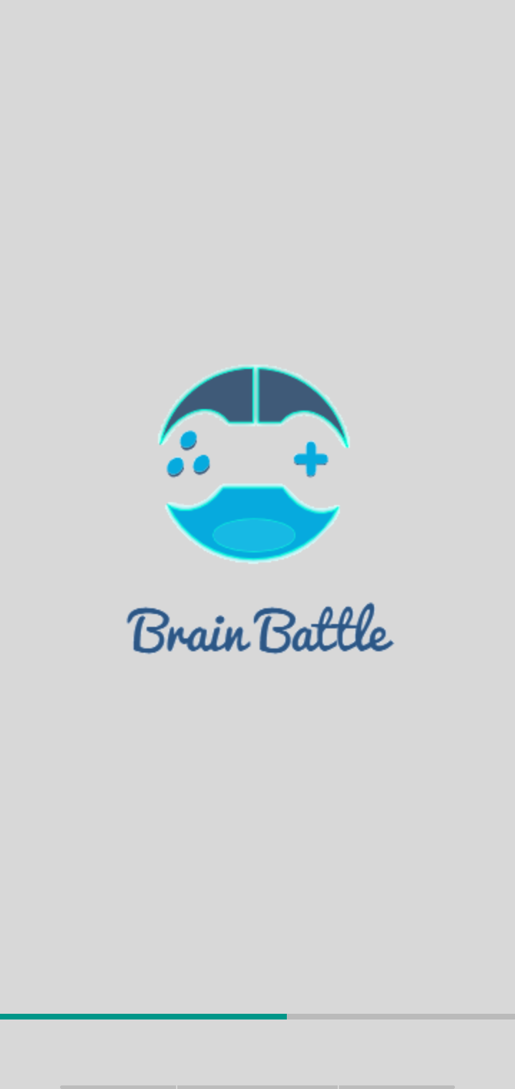

Họ và tên: Nguyễn Văn An

Mssv: 17211Tt3235

Gvhd: Thầy Trương Bá Thái

Chương 1: Mở đầu

1. Muc đích

Ý tưởng tạo ra game Brain Battle với mục đích giúp cho người chơi giải tỏa đươc tinh thần và kích thích trí não phát triển linh hoạt.

1. Công cụ

Sử dụng phần mềm Android Studio và Genymotion.

1. Chức năng và hướng dẫn chơi game

Ghép các mảnh nhỏ của ảnh gốc bị cắt ra sao cho khi người chơi ghép lại các mảnh nhỏ đó giống với bức ảnh gốc, tính điểm với mỗi lần thắng +100đ, thời gian với 60s khi kết thúc thời gian mà người chơi chưa hoàn thành thì bị -100đ.

Chương 2: Phân công công việc

* Nguyễn Văn An: Thiết kế giao diện và viết chức năng cho màn hình game round 4(game ghép tranh siêu anh hùng).

Chương 3: Hình ảnh trong game và code chức năng

1: Màn hình hướng dẫn chơi game và code giao diện

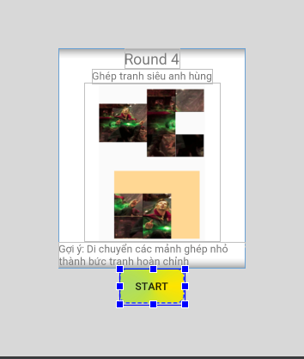

Code giao diện.

<?xml version="1.0" encoding="utf-8"?>  
<LinearLayout xmlns:android="http://schemas.android.com/apk/res/android"  
 xmlns:app="http://schemas.android.com/apk/res-auto"  
 xmlns:tools="http://schemas.android.com/tools"  
 android:layout_width="match_parent"  
 android:layout_height="match_parent"  
 android:orientation="vertical"  
 android:background="#D8D8D8"  
 tools:context=".Round4">  
  
 <LinearLayout  
 android:layout_width="match_parent"  
 android:layout_height="wrap_content"  
 android:gravity="center"  
 android:layout_marginHorizontal="80dp"  
 android:layout_marginTop="200dp"  
 android:background="#fff"  
 android:orientation="vertical">  
  
 <TextView  
 android:layout_width="wrap_content"  
 android:layout_height="wrap_content"  
 android:textSize="20dp"  
 android:text="Round 4" />  
  
 <TextView  
 android:layout_width="wrap_content"  
 android:layout_height="wrap_content"  
 android:text="Ghép tranh siêu anh hùng" />  
  
 <ImageView  
 android:layout_width="183dp"  
 android:layout_height="213dp"  
 android:src="@drawable/doc" />  
  
 <TextView  
 android:layout_width="wrap_content"  
 android:layout_height="wrap_content"  
 android:text="Gợi ý: Di chuyển các mảnh ghép nhỏ thành bức tranh hoàn chỉnh" />  
  
 </LinearLayout>  
 <Button  
 android:id="@+id/btnstart"  
 android:layout_width="wrap_content"  
 android:layout_height="wrap_content"  
 android:layout_gravity="center"  
 android:background="@drawable/btnthaydoi"  
 android:text="Start" />

Code main.

package com.example.myapplication;  
  
import android.content.Intent;  
import android.support.v7.app.AppCompatActivity;  
import android.os.Bundle;  
import android.view.View;  
import android.widget.Button;  
  
public class Round4 extends AppCompatActivity {  
 Button btnStart;  
 @Override  
 protected void onCreate(Bundle savedInstanceState) {  
 super.onCreate(savedInstanceState);  
 setContentView(R.layout.*activity_round4*);  
 setControl();  
 setEvent();  
 }  
 private void setControl() {  
 btnStart = (Button)findViewById(R.id.*btnstart*);  
 }  
 private void setEvent(){  
 btnStart.setOnClickListener(new View.OnClickListener() {  
 @Override  
 public void onClick(View v) {  
 Intent intent = new Intent(Round4.this, Main5Activity.class);  
 intent.setFlags(Intent.*FLAG_ACTIVITY_REORDER_TO_FRONT*);  
 startActivity(intent);  
 }  
 });  
 }  
}

2. Màn hình game chính

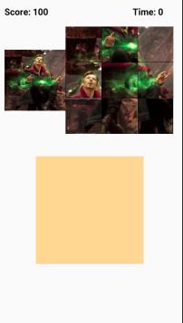

Code giao diện màn hình game.

<?xml version="1.0" encoding="utf-8"?>  
<LinearLayout xmlns:android="http://schemas.android.com/apk/res/android"  
 xmlns:app="http://schemas.android.com/apk/res-auto"  
 xmlns:tools="http://schemas.android.com/tools"  
 android:id="@+id/activity_main"  
 android:layout_width="match_parent"  
 android:layout_height="match_parent"  
 android:paddingBottom="@dimen/activity_vertical_margin"  
 android:paddingLeft="@dimen/activity_horizontal_margin"  
 android:paddingRight="@dimen/activity_horizontal_margin"  
 android:paddingTop="@dimen/activity_vertical_margin"  
 android:orientation="vertical"  
 tools:context="com.example.myapplication.Main5Activity">  
  
 <LinearLayout  
 android:layout_width="match_parent"  
 android:layout_height="wrap_content"  
 android:orientation="horizontal">  
  
 <TextView  
 android:layout_width="wrap_content"  
 android:layout_height="wrap_content"  
 android:text="Score: "  
 style="@style/txtdiem"  
 android:textSize="20sp" />  
  
 <TextView  
 android:id="@+id/txtDiem"  
 android:layout_width="62dp"  
 android:layout_height="wrap_content"  
 style="@style/txtdiem"  
 android:text="100"  
 android:textSize="20sp" />  
  
 <TextView  
 android:id="@+id/txtThoiGian1"  
 android:layout_width="wrap_content"  
 android:layout_height="wrap_content"  
 android:layout_marginLeft="160dp"  
 android:text="Time: "  
 style="@style/txtdiem"  
 android:textSize="20sp" />  
 <TextView  
 android:id="@+id/txtThoiGian"  
 android:layout_width="62dp"  
 android:layout_height="wrap_content"  
 style="@style/txtdiem"  
 android:text="0"  
 android:textSize="20sp" />  
  
  
  
 </LinearLayout>  
  
 <LinearLayout  
 android:layout_width="match_parent"  
 android:layout_height="239dp"  
 android:layout_marginTop="20dp">  
  
 <ImageView  
 android:id="@+id/imageView2"  
 android:layout_width="136dp"  
 android:layout_height="match_parent"  
 app:srcCompat="@drawable/doctor" />  
  
 <LinearLayout  
 android:layout_width="240dp"  
 android:layout_height="239dp"  
 android:orientation="vertical">  
  
 <LinearLayout  
 android:id="@+id/layou3"  
 android:layout_width="match_parent"  
 android:layout_height="80dp"  
 android:orientation="horizontal">  
  
 <ImageView  
 android:id="@+id/img1"  
 android:layout_width="80dp"  
 android:layout_height="80dp"  
 android:src="@drawable/doc1" />  
  
 <ImageView  
 android:id="@+id/img4"  
 android:layout_width="80dp"  
 android:layout_height="80dp"  
 android:src="@drawable/doc5" />  
  
 <ImageView  
 android:id="@+id/img5"  
 android:layout_width="80dp"  
 android:layout_height="80dp"  
 android:src="@drawable/doc3" />  
  
 </LinearLayout>  
  
 <LinearLayout  
 android:id="@+id/layou4"  
 android:layout_width="match_parent"  
 android:layout_height="80dp"  
 android:orientation="horizontal">  
  
 <ImageView  
 android:id="@+id/img2"  
 android:layout_width="80dp"  
 android:layout_height="80dp"  
 android:src="@drawable/doc2" />  
  
 <ImageView  
 android:id="@+id/img3"  
 android:layout_width="80dp"  
 android:layout_height="80dp"  
 android:src="@drawable/doc6" />  
  
 <ImageView  
 android:id="@+id/img6"  
 android:layout_width="80dp"  
 android:layout_height="80dp"  
 android:src="@drawable/doc4" />  
 </LinearLayout>  
  
 <LinearLayout  
 android:id="@+id/layou6"  
 android:layout_width="match_parent"  
 android:layout_height="80dp"  
 android:orientation="horizontal">  
  
 <ImageView  
 android:id="@+id/img11"  
 android:layout_width="80dp"  
 android:layout_height="80dp"  
 android:src="@drawable/doc9" />  
  
 <ImageView  
 android:id="@+id/img44"  
 android:layout_width="80dp"  
 android:layout_height="80dp"  
 android:src="@drawable/doc7" />  
  
 <ImageView  
 android:id="@+id/img55"  
 android:layout_width="80dp"  
 android:layout_height="80dp"  
 android:src="@drawable/doc8" />  
  
 </LinearLayout>  
 </LinearLayout>  
  
 </LinearLayout>  
  
 <LinearLayout  
 android:layout_width="match_parent"  
 android:layout_height="424dp"  
 android:gravity="center|top"  
 android:orientation="vertical">  
  
 <LinearLayout  
 android:layout_marginTop="50dp"  
 android:layout_width="240dp"  
 android:layout_height="240dp"  
 android:background="#ffd793"  
 android:orientation="vertical">  
  
 <LinearLayout  
 android:id="@+id/layout1"  
 android:layout_width="match_parent"  
 android:layout_height="80dp"  
 android:orientation="horizontal">  
  
 </LinearLayout>  
  
 <LinearLayout  
 android:id="@+id/layout2"  
 android:layout_width="match_parent"  
 android:layout_height="80dp"  
 android:orientation="horizontal">  
  
 </LinearLayout>  
  
 <LinearLayout  
 android:id="@+id/layout5"  
 android:layout_width="match_parent"  
 android:layout_height="80dp"  
 android:orientation="horizontal">  
  
 </LinearLayout>  
 </LinearLayout>  
  
 </LinearLayout>  
</LinearLayout>

Code main.

public class Main5Activity extends AppCompatActivity {  
 private ImageView img1, img2, img3, img4, img5, img6, img44, img55, img11;  
 private LinearLayout layout1, layout2, layout6;  
 private LinearLayout layout4, layout3, layout5;  
 private int soAnh1 = 0, soAnh2 = 0, soAnh3 = 0;  
  
 Integer[] arrayImage = {};  
  
 CountDownTimer demthoigian;  
 TextView txtDiem, txtThoiGian;  
 int tongdiemcu, tongdiemmoi, diemcong, id_amthanh;  
 SharedPreferences luutru;  
  
 private Dialog dialog;  
 private Button btnLogout;  
  
 SharedPreferences luuTru;

Hàm setControl

private void setConTrol() {  
 img1 = (ImageView) findViewById(R.id.*img1*);  
 img2 = (ImageView) findViewById(R.id.*img2*);  
 img3 = (ImageView) findViewById(R.id.*img3*);  
 img4 = (ImageView) findViewById(R.id.*img4*);  
 img5 = (ImageView) findViewById(R.id.*img5*);  
 img6 = (ImageView) findViewById(R.id.*img6*);  
 img44 = (ImageView) findViewById(R.id.*img44*);  
 img55 = (ImageView) findViewById(R.id.*img55*);  
 img11 = (ImageView) findViewById(R.id.*img11*);  
  
  
 layout1 = (LinearLayout) findViewById(R.id.*layout1*);  
 layout2 = (LinearLayout) findViewById(R.id.*layout2*);  
 layout5 = (LinearLayout) findViewById(R.id.*layout5*);  
  
  
  
 layout3 = (LinearLayout) findViewById(R.id.*layou3*);  
 layout4 = (LinearLayout) findViewById(R.id.*layou4*);  
 layout6 = (LinearLayout) findViewById(R.id.*layou6*);  
  
  
 txtDiem = (TextView) findViewById(R.id.*txtDiem*);  
 txtThoiGian = (TextView) findViewById(R.id.*txtThoiGian*);  
  
}

Hàm setEvent

private void setEvent() {  
 layout1.setOnDragListener(dang1);  
 layout2.setOnDragListener(dang1);  
 layout3.setOnDragListener(dang1);  
 layout4.setOnDragListener(dang1);  
 layout5.setOnDragListener(dang1);  
 layout6.setOnDragListener(dang1);  
  
 luuTru = getSharedPreferences("luutruthongtin", Context.*MODE_PRIVATE*);  
 tongdiemcu = luuTru.getInt("TongDiem", 0);  
 txtDiem.setText(String.*valueOf*(tongdiemcu));  
  
  
 img1.setOnLongClickListener(new View.OnLongClickListener() {  
 @Override  
 public boolean onLongClick(View view) {  
  
 View.DragShadowBuilder dang2 = new View.DragShadowBuilder(view);  
 view.startDrag(null, dang2, view, 0);  
 return true;  
 }  
 });  
 img2.setOnLongClickListener(new View.OnLongClickListener() {  
 @Override  
 public boolean onLongClick(View view) {  
  
 View.DragShadowBuilder dang2 = new View.DragShadowBuilder(view);  
 view.startDrag(null, dang2, view, 0);  
 return true;  
 }  
 });  
 img3.setOnLongClickListener(new View.OnLongClickListener() {  
 @Override  
 public boolean onLongClick(View view) {  
  
 View.DragShadowBuilder dang2 = new View.DragShadowBuilder(view);  
 view.startDrag(null, dang2, view, 0);  
 return true;  
 }  
 });  
 img4.setOnLongClickListener(new View.OnLongClickListener() {  
 @Override  
 public boolean onLongClick(View view) {  
  
 View.DragShadowBuilder dang2 = new View.DragShadowBuilder(view);  
 view.startDrag(null, dang2, view, 0);  
 return true;  
 }  
 });  
 img5.setOnLongClickListener(new View.OnLongClickListener() {  
 @Override  
 public boolean onLongClick(View view) {  
  
 View.DragShadowBuilder dang2 = new View.DragShadowBuilder(view);  
 view.startDrag(null, dang2, view, 0);  
 return true;  
 }  
 });  
 img6.setOnLongClickListener(new View.OnLongClickListener() {  
 @Override  
 public boolean onLongClick(View view) {  
  
 View.DragShadowBuilder dang2 = new View.DragShadowBuilder(view);  
 view.startDrag(null, dang2, view, 0);  
 return true;  
 }  
 });  
 img44.setOnLongClickListener(new View.OnLongClickListener() {  
 @Override  
 public boolean onLongClick(View view) {  
  
 View.DragShadowBuilder dang2 = new View.DragShadowBuilder(view);  
 view.startDrag(null, dang2, view, 0);  
 return true;  
 }  
 });  
 img55.setOnLongClickListener(new View.OnLongClickListener() {  
 @Override  
 public boolean onLongClick(View view) {  
  
 View.DragShadowBuilder dang2 = new View.DragShadowBuilder(view);  
 view.startDrag(null, dang2, view, 0);  
 return true;  
 }  
 });  
 img11.setOnLongClickListener(new View.OnLongClickListener() {  
 @Override  
 public boolean onLongClick(View view) {  
  
 View.DragShadowBuilder dang2 = new View.DragShadowBuilder(view);  
 view.startDrag(null, dang2, view, 0);  
 return true;  
 }  
 });

Hàm tạo

@Override  
protected void onCreate(Bundle savedInstanceState) {  
 super.onCreate(savedInstanceState);  
 setContentView(R.layout.*activity_main5*);  
 setConTrol();  
 setEvent();  
  
}

Hàm kiểm tra id cho vị trí Layout

private void checkID2(int id) {  
 switch (id) {  
 case R.id.*layout1*:  
 if (soAnh1 > 0) {  
 soAnh1--;  
 }  
 break;  
 case R.id.*layout2*:  
 if (soAnh2 > 0) {  
 soAnh2--;  
 }  
 break;  
 case R.id.*layout5*:  
 if (soAnh3 > 0) {  
 soAnh3--;  
 }  
 break;  
 }  
}

Hàm Boolean kiểm tra Win trả về giá trị True hoặc False.

private boolean checkWin() {  
 int check = 0;  
 if (soAnh1 == 3) {  
 if (R.id.*img1* == layout1.getChildAt(0).getId()  
 && R.id.*img2* == layout1.getChildAt(1).getId()  
 && R.id.*img5* == layout1.getChildAt(2).getId())  
 {  
 check++;  
  
 } else {  
  
 }  
 }  
 if (soAnh2 == 3) {  
 if (R.id.*img3* == layout2.getChildAt(0).getId()  
 && R.id.*img4* == layout2.getChildAt(1).getId()  
 && R.id.*img6* == layout2.getChildAt(2).getId() )  
 {  
 check++;  
 } else {  
  
 }  
 }  
 if (soAnh3 == 3) {  
 if (R.id.*img11* == layout5.getChildAt(0).getId()  
 && R.id.*img55* == layout5.getChildAt(1).getId()  
 && R.id.*img44* == layout5.getChildAt(2).getId() )  
 {  
 check++;  
 } else {  
  
 }  
 }  
 if (check == 3) {  
 return true;  
 } else {  
 return false;  
 }  
}

Hàm lưu lại dữ liệu của người chơi.

private void LuuDuLieuNguoiDung(int diemcong) {  
 Editor edit = luuTru.edit();  
 tongdiemcu = luuTru.getInt("TongDiem", 1000);  
 tongdiemmoi = tongdiemcu + 100;  
 edit.putInt("TongDiem", tongdiemmoi);  
 edit.commit();  
}

Hàm thông báo khi người chơi thắng.

public void youWin() {  
 AlertDialog.Builder alertDialogBuilder = new AlertDialog.Builder(this);  
 alertDialogBuilder.setTitle("You win");  
 alertDialogBuilder.setIcon(R.drawable.*iconcuoi*);  
  
 alertDialogBuilder.setPositiveButton("Tiếp tục", new DialogInterface.OnClickListener() {  
 @Override  
 public void onClick(DialogInterface arg0, int arg1) {  
 final Intent intent = new Intent(Main5Activity.this, Main3Activity.class);  
 intent.setFlags(Intent.*FLAG_ACTIVITY_REORDER_TO_FRONT*);  
 startActivity(intent);  
 }  
 });  
  
 alertDialogBuilder.setNegativeButton("Choi lai", new DialogInterface.OnClickListener() {  
 @Override  
 public void onClick(DialogInterface dialog, int which) {  
 final Intent intent = new Intent(Main5Activity.this, Round4.class);  
 intent.setFlags(Intent.*FLAG_ACTIVITY_REORDER_TO_FRONT*);  
 startActivity(intent);  
 }  
 });  
  
 AlertDialog alertDialog = alertDialogBuilder.create();  
 alertDialog.show();  
}

Hàm thông báo khi người chơi thua

private void gameOver(){  
 AlertDialog.Builder alertDialogBuilder = new AlertDialog.Builder(this);  
 alertDialogBuilder.setTitle("You lose");  
 alertDialogBuilder.setIcon(R.drawable.*iconcuoi*);  
  
 alertDialogBuilder.setPositiveButton("Chơi lại", new DialogInterface.OnClickListener() {  
 @Override  
 public void onClick(DialogInterface arg0, int arg1) {  
 Intent intent = new Intent(Main5Activity.this, Round4.class);  
 intent.setFlags(Intent.*FLAG_ACTIVITY_REORDER_TO_FRONT*);  
 startActivity(intent);  
 arg0.dismiss();  
  
 }  
 });  
  
 alertDialogBuilder.setNegativeButton("Thoát", new DialogInterface.OnClickListener() {  
 @Override  
 public void onClick(DialogInterface dialog, int which) {  
 finish();  
 dialog.dismiss();  
 }  
 });  
  
 AlertDialog alertDialog = alertDialogBuilder.create();  
 alertDialog.show();  
}

Màn hình thông báo khi người dùng chơi thua.

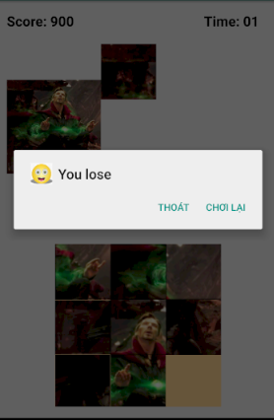

Màn hình thông báo khi người dùng chơi thắng.

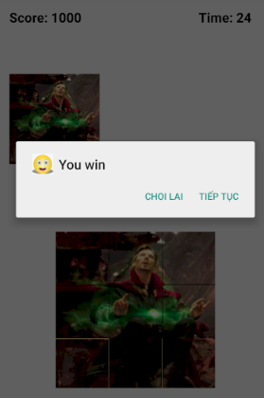

Hàm đếm thời gian.

demthoigian = new CountDownTimer(60000, 1000) {  
 @Override  
 public void onTick(long millisUntilFinished) {  
 long milis = millisUntilFinished;  
 //long gio = TimeUnit.MILLISECONDS.toHours(milis);  
 //long phut = TimeUnit.MILLISECONDS.toMinutes(milis) - TimeUnit.HOURS.toMinutes(TimeUnit.MILLISECONDS.toHours(milis));  
 long giay = TimeUnit.*MILLISECONDS*.toSeconds(milis) - TimeUnit.*MINUTES*.toSeconds(TimeUnit.*MILLISECONDS*.toMinutes(milis));  
  
 // String giophutgiay = String.format("%02d:%02d:%02d", gio, phut, giay);  
 String sgiay = String.*format*("%02d", giay);  
 txtThoiGian.setText(sgiay);  
 }  
  
 @Override  
 public void onFinish() {  
 Toast.*makeText*(getApplicationContext(), "Game Over", Toast.*LENGTH_LONG*).show();  
 Editor edit = luuTru.edit();  
 tongdiemcu = luuTru.getInt("TongDiem", 1000);  
 tongdiemmoi = tongdiemcu - 100;  
 edit.putInt("TongDiem", tongdiemmoi);  
 edit.commit();  
  
 txtDiem.setText(String.*valueOf*(tongdiemmoi));  
 demthoigian.cancel();  
 gameOver();  
  
 }  
 };  
 demthoigian.start();  
}

Hàm kéo thả đối tượng nào đó.

View.OnDragListener dang1 = new View.OnDragListener() {  
 @Override  
 public boolean onDrag(View view, DragEvent dragEvent) {  
 switch (dragEvent.getAction()) {  
 case DragEvent.*ACTION_DROP*:  
 View con = (View) dragEvent.getLocalState();  
 ViewGroup chaRuot = (ViewGroup) con.getParent();  
 LinearLayout chaNuoi = (LinearLayout) view;  
 if (check1(chaNuoi.getId())) {  
 chaRuot.removeView(con);  
 chaNuoi.addView(con);  
 con.setVisibility(View.*VISIBLE*);  
 checkID2(chaRuot.getId());  
 if (checkWin()) {  
 Toast.*makeText*(getApplicationContext(), "you win", Toast.*LENGTH_SHORT*).show();  
 demthoigian.cancel();  
 LuuDuLieuNguoiDung(diemcong);  
 txtDiem.setText(String.*valueOf*(tongdiemmoi));  
 youWin();  
  
 }  
 } else {  
  
 }  
 break;  
 }  
 return true;  
 }  
 };

Chương 4: Tổng kết

Game chạy tốt trên thiết android, giao diện đơn giản dễ chơi.