

**Final Year Project**

**Build Website Study Japanese Language**

Course**: COMP1682**

Submitted by**: Le Thanh Tai**

Student ID: **GCD17110**

**September 2020**

*Author : Supervisor :*

*Le Thanh Tai Mr.Tran Trong Minh*

Table of Contents

Chapter 1 : Project Proposal 3

I. Overview: 3

II. Project Aim: 4

III. Objectives: 4

1. Research : 4

2. Build website learn japanese. 5

3. Testing and Demo Website: 6

4. Deployment: 6

5. Evaluate: 6

IV. Legal, Social, Ethical and Professional 6

V. Planning 7

To build my project plan, I have set milestones and timelines to work on 7

Chapter 2 : Literature Review 10

1. General analysis why should we learn Japanese? 10

2. Analysis of Course Online trend situation : 16

2.1. Why do many people create websites to sell online courses? 16

3. What is website, web application: 19

3.1. The origin of the Website: 19

3.2. Website : 19

3.1.1. Web Application: 20

3.3. Website Architechtures: 20

3.2.1. So how does it work? 22

3.4. Interaction With Humans: 24

4. Web Application Technology : 25

Client-Side Programming 25

4.1. HTML, CSS , Bootstrap 4 25

4.2. Jquery Framework 25

4.3. Codeigniter PHP 26

4.4. JSON 26

4.4. Xampp 27

4.5. MySQL 27

References 29

# Chapter 1 : Project Proposal

## **Overview:**

E-learning is an online learning method, using an Internet connection to serve learning, document reference, and interaction between students and lecturers without having to meet face to face to discuss face to face. Moreover, the E-learning system is also understood as a different traditional learning environment with the support of data storage and transmission technology. Here, learners can interact with each other on the online training system.

COVID-19 has had a great impact on different educational models in recent years, not only causing schools to change the way of teaching, but also changing enrolment methods. Parents and students are more likely to turn to online information updates.

In the enrolment work for the COVID-19 season this year, students have many opportunities to approach and understand more about universities, as well as to ask questions and have people immediately answer all questions.

## **Japanese Language Study Online**

## **Dekiru Education**

In fact, online education or online learning was still a trend before the outbreak of the epidemic, the problem is that offline courses won't work. So the solution is that we have courses that do not have barriers of geographical distance, space, and time, which have helped to solve many needs of many learners in different conditions. Even universities are moving more and more of the model online.

## **Project Aim:**

In this final year project, my main goal is to build a website to help all students learn Japanese in the best way, everyone will learn online through video lessons. Without class, everyone learns through video lectures of lecturers at the website. It will be build on two main areas: mobile and website.

## **Objectives:**

### **Research :**

* 1. Indentify the components included in the project:
* I will research my current technologies and ideas to help people learn the Japanese language that I am pursuing. Currently, building a Japanese learning website is completely difficult. The goal of this activity is to learn about how a website works in general and a learning website in particular, and learn about technologies that help to develop Website development, necessary criteria of a learning website.
  1. Write the review:
* After I complete my research, I will write a report of what I find out, and this little report is expected to be 2-4 pages.

### **Build website learn japanese.**

* 1. Build a website:
* First want to make a website. I will think about what the website will be like. And draw a map for what a website consists of. Then from there I will do other things.
  1. Prepare content for website:
* After I mocked my idea for the website I finished. I will focus on the content. After preparing content. I will make videos of courses, pictures, documents for each section of the website.
  1. Choose the main technology to develop the website:
* Developing my website. I will use the main php language. In PHP I use a framework called Codeigniter written in MVC model. And the database I will use is MySQL. Besides, I can also use JSON or AJAX to facilitate data retrieval. On the Front-end side, I will use HTML, CSS, Bootstrap 4, JS mainly to create interfaces for the website. In Javascript I will use Angular JS framework to create SPA page to load data on a page to make the website run smoothly.
  1. Build the website interface:
* Conducting construction of the website's interface and external interactions (front-end) of the website.
  1. Build the website function (server):
* Conducting construction functionality of the website.
  1. Choose Database for Website:
* MySQL is the most popular open source database management system in the world and is especially popular in application development. This is a high-speed, stable and easy-to-use database management system, capable of changing usage patterns in accordance with portable work conditions. MySQL works on many operating systems, providing a large system of very powerful utility functions.



Figure 1: Database MySQL

### **Testing and Demo Website:**

* After completing my website, I will run a test to check if the website really works well or not, there are unexpected errors or not. If there is an error I will fix the error to put the website on hosting.

### **Deployment:**

* In order to get my website on the internet, I would probably buy a domain name or use free platforms like 000webhost.

### **Evaluate:**

* 1. Results achieved after completion
  2. Discovering but limited in the project implementation
  3. Development direction after completing the project.

## **Legal, Social, Ethical and Professional**

**Copyright:** the use of 'courses' must permit the fair use of materials for private research. Making multiple copies of resources without the express permission of the copyright owner or the copyright claim acknowledges this is a legitimate, unacceptable use.

**License:** A license is a legal statement of how a person may use copyrighted material of e-learning websites. Usually, educational institutions will need a website license.

**This ethical** issues can be resolved if the e-learning site software developer pay attention to the design of the e-learning site software.

**Lega**l issues on e-learning sites: There are many different legal issues surrounding the use of e-learning sites in learning that we all need to keep in mind. The toughest legal issues are found in the areas of copyright, data protection, and licensing.

## **Planning**

### To build my project plan, I have set milestones and timelines to work on

|  |  |  |
| --- | --- | --- |
| **ID** | **Content** | **Time** |
| **1** | Learn about back-end and front-end to design the website Learning Study. | 1 Month |
| **2** | Write a review report on website learning | 2 Week |
| **3** | Build in user and admin login features | 1 Week |
| **4** | shopping cart and shipping system building | 3 Month |
| **5** | Deploy the application on Hosting | 1 Week |
| **6** | Project writing and evaluation | 2 Week |

Figure 2: Project Milestones

### 

After creating the milestones in the Table, I will then use the Gantt Chart to divide specific jobs with different timelines to build the project more scientifically.

After creating the milestones in the Table, I will then use the Gantt Chart to divide specific jobs with different timelines to build the project more scientifically.

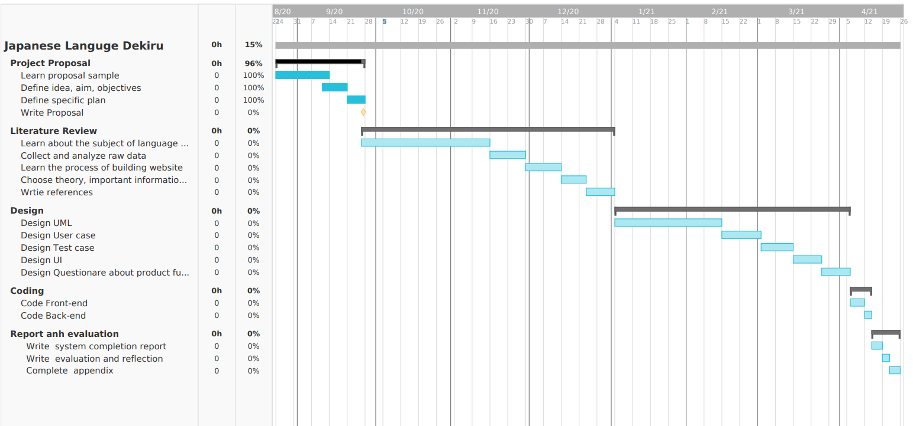

# 

# Chapter 2 : Literature Review

## **General analysis why should we learn Japanese?**

In order to give a full definition of the Japanese language, we first need to learn about the history of the Japanese language’s origins.

Japanese, Japanese or Japanese (日本語 に ほ ん ご (Japanese) is an East Asian language spoken by more than 125 million people in Japan and Japanese immigrant communities around the world. sticky language (different from Vietnamese, which belongs to a highly analytical single language) and stands out with a strict and coherent system of etiquette, especially a complex system of honorifics expressing text. hierarchical quality of Japanese society, with variations of verbs and a combination of words to indicate the relationship between the speaker, the listener and the speaker in the conversation. Japan is quite small, with a pronounced word-based intonation system.The oldest known mainly based on its state in the eighth century. (Wikipedia, n.d.)

## **The 10 Most Spoken Languages In The World.**

Japanese is the world's most popular language in 2020.

Japan is home to a myriad of technological innovations, so this could be the best language to learn in 2020 if you plan to bring the world into your new tech empire. It is not the easiest language to learn if you start with the English language as your foundation, because its writing system is very different from the Latin alphabet..

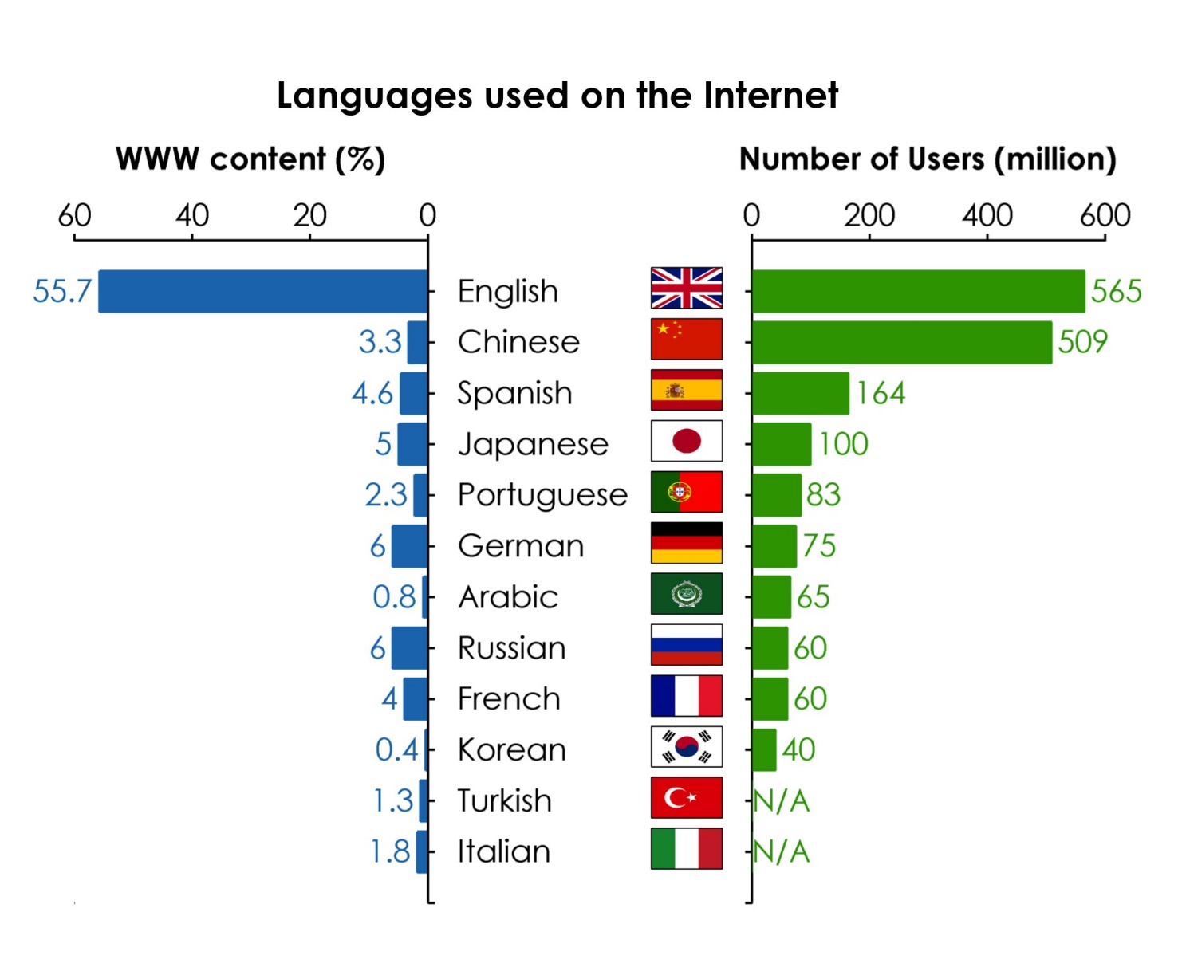

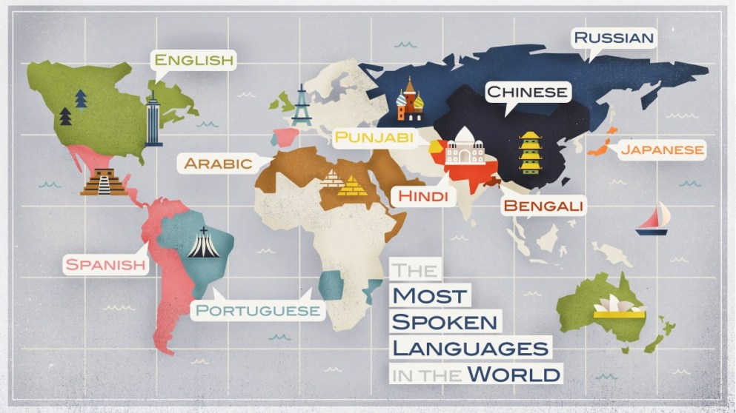

Figure 3: Top 10 Most Spoken Languages In The World.

## **Easy or difficult to learn Japanese?**

According to **Ranker.com** - a global reputable website that aggregates news and ranks many different areas of life, Japanese is ranked 5th in the top 10 difficult languages ​​in the world.

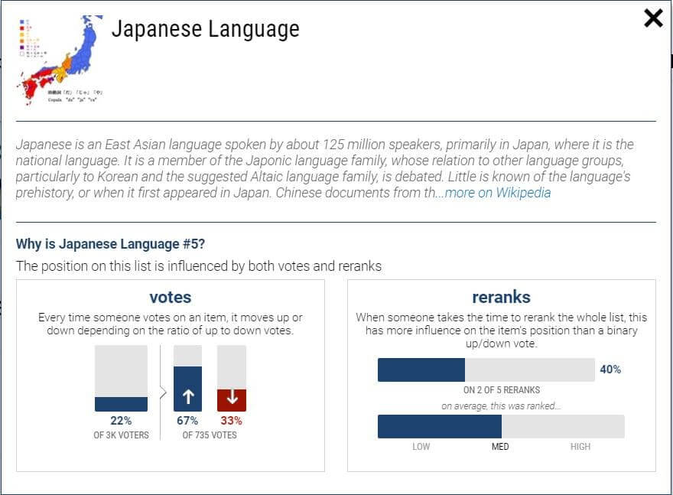

Figure 4: Easy or difficult to learn Japanese?

Japanese is the top language in terms of its difficulty. So, why we want to make a website to learn Japanese is because we will help you learn Japanese in the best way. Moreover, whether learning a foreign language is easy or difficult depends on the method of learning, so you should choose the right learning method for yourself.

* **So why should we learn Japanese?**

As of 2019, Japan is one of the largest direct investment countries in Vietnam with thousands of investment projects, joint ventures and cooperation.

The increasing number of businesses investing in Vietnam has led to an increasing demand for recruiting Japanese-speaking personnel.

In particular, Japan is a country with a huge labor shortage, so the demand for foreign workers is high, and it is an attractive job market for Vietnamese who know Japanese.

What language do you study?
96%
2% 1% 0%
10%
15%
1%
8%
1%
0%
10%
20%
30%
40%
50%
60%
70%
80%
90%
100%
English Fench Russia...

Figure 5: What language do you study?

According to Q & Me's statistics, by 2020 in Asia. English is of course the most popular language in the world. Up to 96% of people in Asia are learning English. In addition, the Boss is followed by Japanese with 15% and Chinese with 10% and Korean with 8%.

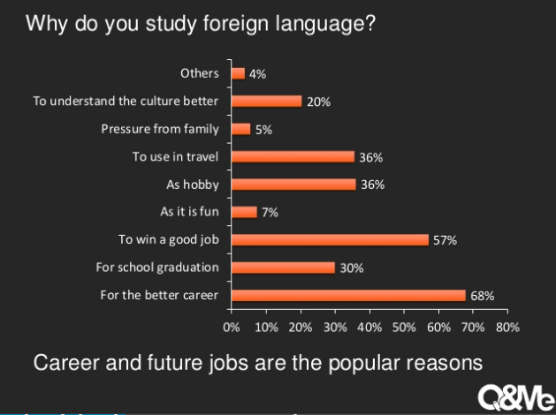

Figure 6: Why do you study foreign language?

There are many reasons, we learn more English language and another language?

Knowing more languages ​​is a strong point for everyone in the workplace. According to figure 6, 68% is the highest number of people who think that learning a foreign language will make their job better. And more clearly: Japan is the most developed country in the world. Learning Japanese will help you have a better job in the future.

## **2.** **Analysis of Course Online trend situation :**

**2.1. Why do many people create websites to sell online courses?**

**2.1.1 Everyone’s need for online learning:**

The epidemic situation is becoming more and more complicated, so many people choose online courses to protect themselves and their loved ones. With the development of websites selling online courses, it has partly attracted the attention of many centers and parents. With a variety of fast and convenient convenience, eye-catching designs and outstanding features, these websites are now attractive and extremely impressive.



**2.1.2 Online course selling services are born, websites become effective sales tools:**

With the continuous development and development of commercial techniques and the support of great scientific and technical achievements, it has contributed to promoting the advent of online sales services. In particular, it is impossible to ignore the service of making website selling online courses, this is a new form of development recently and receives a lot of favor from customers. For those who have been concerned about disease transmission as quickly as recently, this can be the most effective and effective solution in this time.



**2.1.3 Benefits of online learning:**

* Helping learners save time effectively: online learning means that you can participate in lectures, in the course anytime, anywhere. Therefore, without wasting time traveling, you can also take advantage of the free time effectively. Therefore, online learning becomes an ideal choice to help learning meet, with a reasonable time, avoiding unnecessary waste.
* Helping learners save maximum costs: no money for travel, being able to listen to the lecture many times if needed, reasonable cost, ... help learning online can bring the possibility of saving. save money per person to the maximum. It is that that helps learning to have the ideal benefits and efficiency as desired.



* Open up the most comfortable and pleasant study space: you can choose the space that you like, you feel most comfortable to start the lesson. Be it at home, at a coffee shop, ... or where it's most convenient. At this point, a comfortable space for easy and effective study is what we can achieve.



* Support to help store learning materials effectively: if storing documents through broken books causes a lot of troubles, now the problem will be solved by online learning plan. Can store documents, lectures right on computers, even mobile phones, ... both proactively and easily at the same time helping the search achieve higher results. That is why each person's own learning is best supported.



## **3.** **What is website, web application:**

### **3.1. The origin of the Website:**

**3.1.1. What is web technology?**

Công nghệ web là một thuật ngữ chung đề cập đến nhiều ngôn ngữ và gói đa phương tiện được sử dụng kết hợp với nhau, để tạo ra các trang web. Web có nguồn gốc và lịch sử phát triển khá lâu đời kể từ năm 1989 Internet bắt đầu được sử dụng rộng rãi trên thế giới. Khái niệm World Wide Web gắn liền với HTML( Hyper Text Markup Language) được Berners-Lee Phát triển.

### **3.2. Website :**

In the old days, when the Internet was rudimentary, websites were written in single html. Every single web page is written in html called Web Page. Gathering many single websites, into one large website, sharing the same domain name, is called Website.

Web sites only include text, images and videos, linked together through links. The purpose of the website is to store and display information. Users can only read, view and click the links to navigate between pages.

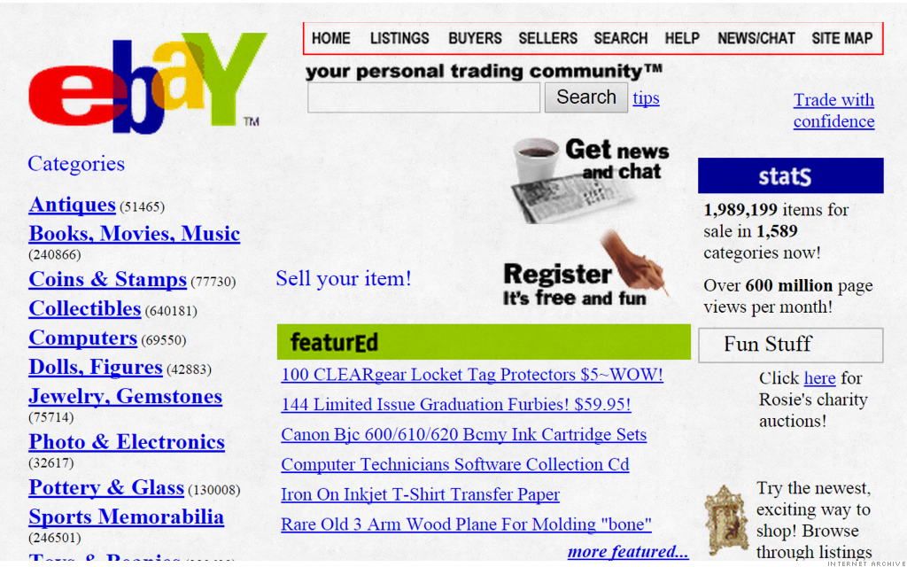

Figure 7: This is Example for Website Old

### **3.1.1. Web Application:**

Later, with the advent of server languages: Python, Perl, PHP, ... websites became more "dynamic", able to interact with users. From here, users can use the web to "perform a certain job with the computer", thus a web app was born.

In simple terms, web apps are web apps. Through the web app, users can perform a number of jobs: compute, share images, shopping ... The web app's interactivity is much higher than the website's.

### **3.3. Website Architechtures:**

Based on the web development process, a web developer, also known as a programmer, creates web applications that can be easily accessed by everyone on the Internet. These websites and apps have specific features and functions that a developer is responsible for building through his programming skills..

Web developer consists of 2 main parts, to become a true web guru you can choose one of the two certain specializations below:

* Front-end Developer: FE is responsible for the construction and design of the layout, features, and appearance of a website. This role is also known as client-side developer, with user interaction covering everything you see while navigating across the Internet, from fonts and colors to drop-down menus and bars. to slide

Front-end developers mainly use three main languages: HTML, CSS, Javascript. In the past few years, the role of frontend developers has increased, so knowledge of how to use frameworks such as React is required.

* Back-end Developer: Be responsible for building the system that allows it to run smoothly of a website. They are responsible for building the best system that allows data to be easily transferred from the web server to the web browser - allowing the frontend part of the website to be viable.

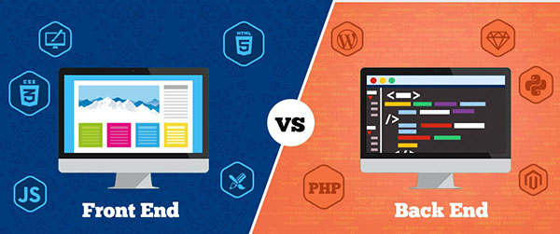

### **3.2.1. So how does it work?**

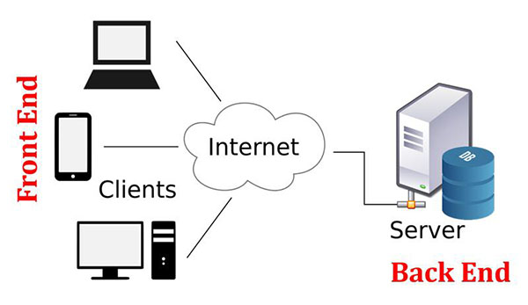

Here is the operation diagram of the website, the clients here are devices such as laptops, PCs, smartphones. The Front-end is what these devices see. And the back-end is on the server side, this is the part that the user cannot see. Back-end uses commands to get data from the database to access the front-end to help the user see..

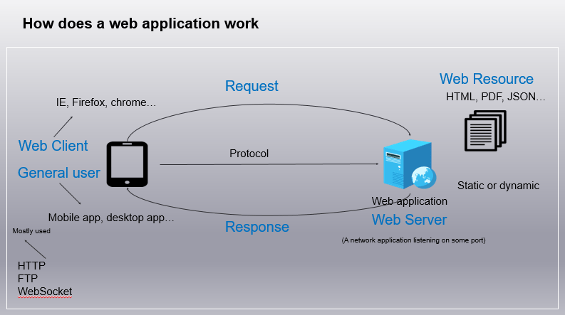

In addition, due to the requirement of frequently manipulating data, **Back-end Developers** also need to have knowledge of SQL and database management systems such as MySQL, Oracle, and SQL Server ... These are popular database management systems these days.



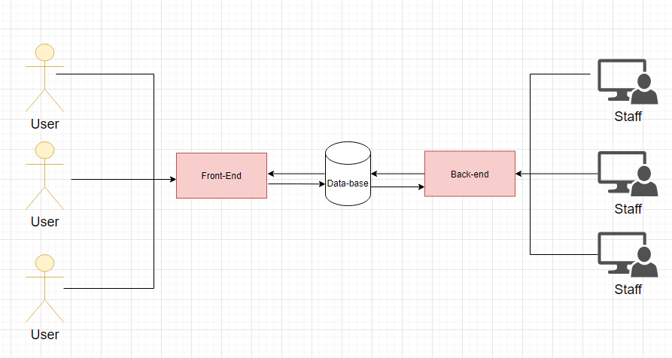

The main purpose of a front-end website is to look good to attract as many visitors as possible. The practical function is always quite simple - show customers what they can buy and encourage them to buy it. The language for writing front-end is HTML, plus CSS for styling, Javascript / Ajax for fancy interactions and lots of sexy graphics along with some Search Engine Optimization (SEO).

In order for the front-end of a website to work, the back-end must be well-built. The back-end consists of a server, an application, and a database. Code written by the back-end developer is the part that will help the front-end communicate and interact with the user.

### **3.4. Interaction With Humans:**

## **4. Web Application Technology :**

Some of the libraries for this project development and the primary language used to create this system are:

### **Client-Side Programming**

Client-side (front end) web development involves everything users see on their screens:

### **4.1. HTML, CSS , Bootstrap 4**

Hypertext Markup Language (HTML) and Cascading Style Sheets (CSS). HTML tells a browser how to display content of web page. And CSS styles that content. Bootstrap is a helpful framework for managing HTML and CSS.

Bootstrap 4 is the most popular HTML, CSS, and JavaScript frameworks for responsive web design, preferably on mobile platforms. It was created to build website interfaces that are compatible with all devices with different screen sizes.

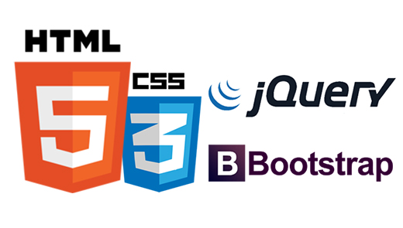

### **4.2. Jquery Framework**

jQuery is a popular JavaScript library in the programming community. It was created by John Resig in 2006 with the aim of making it easier for programmers to apply JavaScript to the website. It is not a separate programming language and works in conjunction with JavaScript.

**Server-Side Programming**

As for server-side programming languages, these are used to generate the logic of the web pages. Frameworks for programming languages ​​provide a lot of tools for simpler and faster coding. (B., n.d.)

### **4.3. Codeigniter PHP**

Codeigniter (CI) is a PHP framework built on MVC model, includes libraries pre-written in PHP, and libraries in Codeigniter help us to connect and perform database related tasks. , file upload, image processing, pagination, cookies, sessions, and some basic security methods ... this helps us to build a website faster, while organizing better code with the MVC model.

### **4.4. JSON**

JSON stands for Javascript Object Notation, this is a form of data that follows a certain rule that most of today's programming languages ​​can read, you can use it to save it to a file, A record in the database is very easy. JSON has a simpler format, is easier to use and more queries than XML, so its applicability is very popular nowadays.

In what situations should JSON be used?

Simple data storage. This is when you want to store the data as metadata on the server side. JSON string will be saved to the database and then decoded when needed. PHP example, providing JSON related functions for coding and decoding are json_encode and json_decode.

### **4.4. Xampp**

Xampp software is one of the software used by many programmers to set up a website in PHP language. XAMPP is used to set up a web server with pre-installed tools such as PHP, Apache, MySQL ... Xampp owns a user-friendly interface design, allowing programmers to open / close or reboot features. server at all times. In addition, Xampp is built under open source code.

**Xampp** is considered as one of the essential software in building website for PHP programmers. Xampp installs essential elements, supporting each other including:

* Apache
* PHP (set the platform for * .php script files to work)
* MySQL (Database)
* Perl



### **4.5. MySQL**

MySQL is an open source database management system (Relational Database Management System, abbreviated as RDBMS) operating in a client-server model.

MySQL is one of the RDBMS softwares. RDBMS and MySQL are often attributed to the sheer popularity of MySQL. The largest web applications like Facebook, Twitter, YouTube, Google, and Yahoo! all use MySQL for data storage purposes.

# References

Anon., n.d. *Vì sao nhiều người lập website bán khóa học online.* [Online]   
Available at: https://tech5s.com.vn/danh-ra-30-phut-tim-hieu-cach-lap-website-ban-khoa-hoc-online-don-gian

Anon., n.d. *Website.* [Online]   
Available at: https://en.wikipedia.org/wiki/Website

Anon., n.d. *What is the Advantages Of Online Education? – Benefits Of Online Classes.* [Online]   
Available at: https://www.takshilalearning.com/advantage-of-online-education-benefits-of-online-classes/

B., G., n.d. *Technology Stack for Web Application Development.* [Online]   
Available at: https://rubygarage.org/blog/technology-stack-for-web-development

Lane, J., n.d. *The 10 Most Spoken Languages In The World.* [Online]   
Available at: https://www.babbel.com/en/magazine/the-10-most-spoken-languages-in-the-world

Wikipedia, F., n.d. *Japanese language.* [Online]   
Available at: https://en.wikipedia.org/wiki/Japanese_language