**Project’s Report OOP**

**BANKING ACCOUNT SYSTEM**

Member: Nguyen Le Thanh Tam ITITIU18110 100%

Table Of Contents

**Overview:** 3

**Class Diagram:** 4

**Language:** 5

**Process:** 5

Database: 5

Front-end and back-end: 8

Package Tool Group: 9

Package Manipulate: 10

Package LoginandPage: 10

Package Class: 10

Package Customer_Do: 10

**Achievement:** 10

**Further Development:** 10

# **Overview:**

Our Project is Banking Account System. The reason why I choose this project is that nowaday, database management is become more and more popular. It not only reduces the manula work but also increases the efficiency for staff. Banking Account System is a system that helps the admin easy to manage the database of customer. They can edit or delete customers’ informaiton the same as card and some services that they want. Admin can recharge, withdraw and transfer the money for customers if the customer asks them to do for them. Besides, customer can easily use to see their information. Customer can also recharge the money if they want and also they can withdraw and tranfer the money to the other account.

# **Class Diagram:**

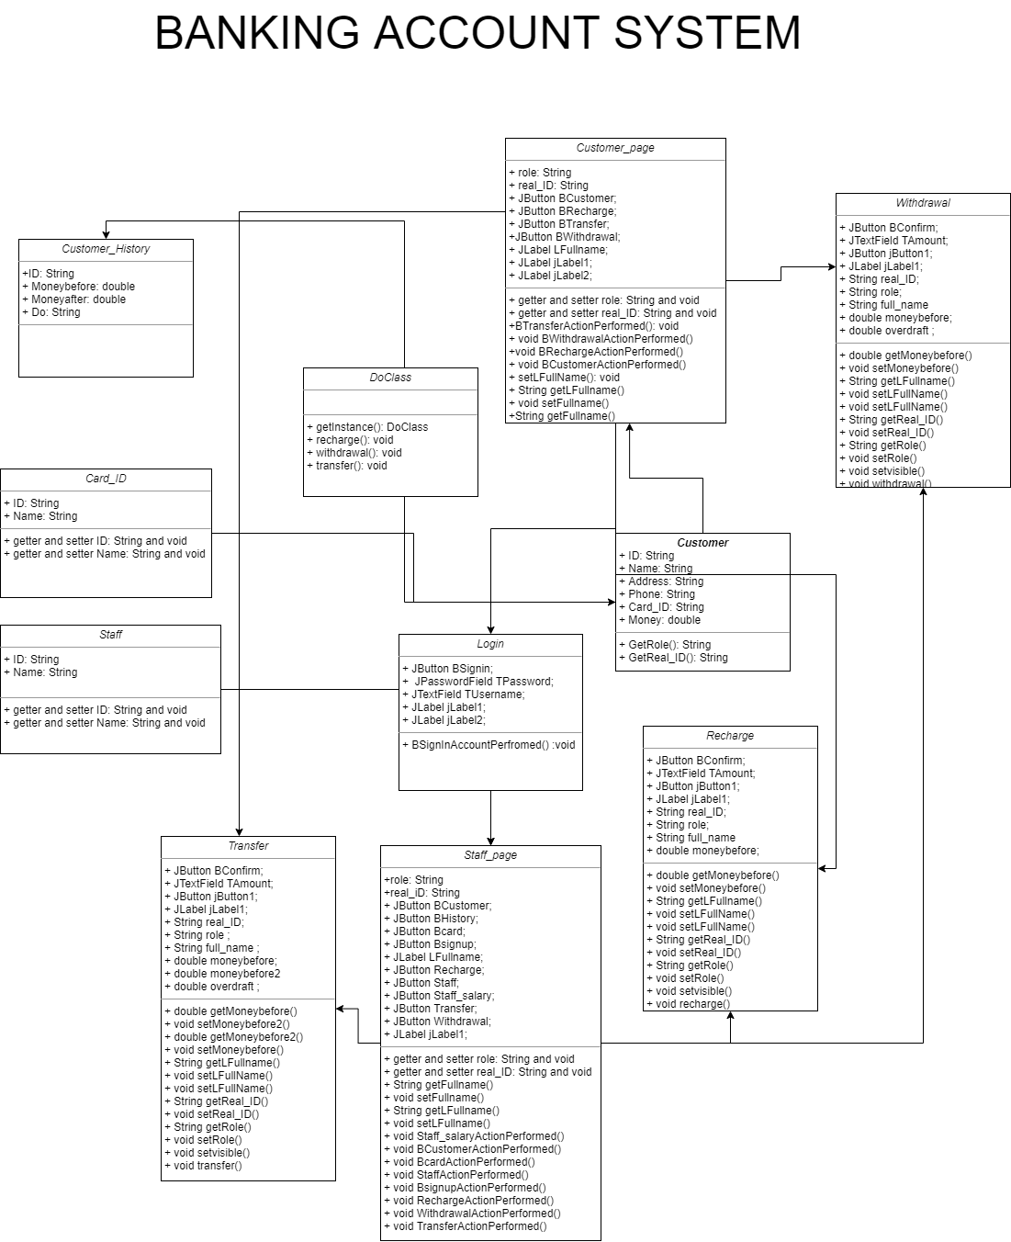

# **Language:**

To store data, I use SQL server to store the database with Authentication type: SQL Server Authentication it require to login with username is sa and the password is sa too for easy to use.

I use Java to design my UI and call function because I can do both in the java programming. I also use some specific library to connection the server and use them, it called mssql-jdbc-8.2.2.jre8.jar

# **Process:**

## Database:

At first, we create database and table in the SQL query here this is the script to create table

USE master

IF EXISTS (SELECT name FROM sys.databases WHERE name = 'BankingAccountSystem')

DROP DATABASE BankingAccountSystem;

GO

CREATE DATABASE BankingAccountSystem;

GO

USE BankingAccountSystem

GO

DROP TABLE IF EXISTS dbo.Account

CREATE TABLE Account (

Name VARCHAR (255),

Username VARCHAR (255),

Password VARCHAR (255),

Role VARCHAR (255),

ID VARCHAR (255),

CHECK (Password <> Username),

UNIQUE (Username, Password)

)

GO

DROP TABLE IF EXISTS dbo.Staff

CREATE TABLE Staff (

Staff_ID VARCHAR (255) PRIMARY KEY,

Staff_name VARCHAR (255) NOT NULL

)

GO

DROP TABLE IF EXISTS dbo.Card

CREATE TABLE Card (

Card_ID VARCHAR (255) PRIMARY KEY,

Card_name VARCHAR (255) NOT NULL

)

GO

DROP TABLE IF EXISTS dbo.Customer

CREATE TABLE Customer (

Customer_ID VARCHAR (255) PRIMARY KEY,

Customer_name VARCHAR (255) NOT NULL,

Customer_gender VARCHAR (6) NOT NULL,

Customer_phone VARCHAR(20) NOT NULL,

Customer_address VARCHAR(255) NOT NULL,

Card_ID VARCHAR (255) REFERENCES Card (Card_ID)

ON DELETE CASCADE ON UPDATE SET NULL,

Customer_money MONEY NOT NULL

)

GO

DROP TABLE IF EXISTS dbo.Staff_salary

CREATE TABLE Staff_salary (

Staff_ID VARCHAR (255) REFERENCES Staff (Staff_ID)

ON DELETE CASCADE ON UPDATE NO ACTION,

Staff_name VARCHAR (255),

Salary MONEY

)

GO

DROP TABLE IF EXISTS dbo.Customer_history

CREATE TABLE Customer_history (

Customer_ID VARCHAR (255) REFERENCES Customer (Customer_ID)

ON DELETE CASCADE ON UPDATE NO ACTION,

Money_beforedo MONEY,

Money_afterdo MONEY,

Do VARCHAR (255)

)

GO

Some thing that you need to know is REFERENCES is to link to other table that exist. Therefore, we have to create to the table that we want to link first if it does not exist it will announce error. ON DELETE CASCADE ON UPDATE … is used to catch up with the table he have deleted some data that related to linked table. It will delete all the information that have that information that linked to them.

Besides, we use excel to import the data for fast and not have to wirte query for them

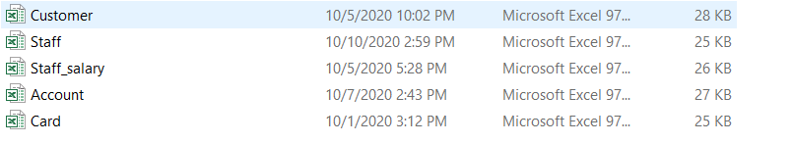

GO is used to interrupt the query, after completing one part, then another one in sequence

## Front-end and back-end:

For the system front-end and back-end, I use java to run the system. I create class to call the database. There are also some class to call functions: recharge, withdrawal, transfer. To present these function I use Jframe for the UI.

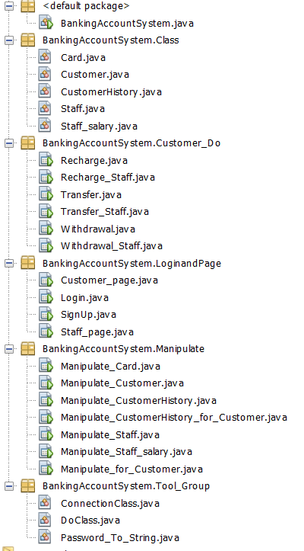

### Package Tool Group:

ConnectionClass.java use for create connection to sql and I do not have to write many time

DoClass.java is used to store function of Recharge, Withdrawal and Transfer

Password_To_String.java is used to transform to password type into String type

### Package Manipulate:

Is a manage information file admin and some file can be access by customer with some permission in it to prevent the customer to change the information of them: Manipulate_Customerhistory_for_Customer.java, Manipulate_for_Customer.java

### Package LoginandPage:

Is a package to store the login UI and signup and customer and staff’s main page

### Package Class:

Is used to take the information of SQL server and use them in the java language

### Package Customer_Do:

Is a package that user can do some function like recharge, withdrawal and transfer their money.

And staff can do for them to if the customer ask them with

Finally, the BankingAccountSystem.java is the main to run the whole system

# **Achievement:**

I now can

Create login system

Present the database

Give the authour for the approximate users.

Create function for recharge, withdrawal and transfer.

Reduce the coding function with I/O Principline (SOLID)

# **Further Development:**

I want to create some services for user and announcement board and help the admin to post the latest new. Besides, I will divide into 3 role to manage: admin, staff and customer. Finally, I want to manage the database online like mongodb to reduce the memory for my computer. Besides, user can do it online at anywhere anytime.