MSSV: N20DCCN142 – LỚP: D20CQCNPM02-N

HỌ VÀ TÊN: NGUYỄN HUỲNH TRÚC THANH

**HOMEWORK 1**

1.Contrast limit histogram equalization

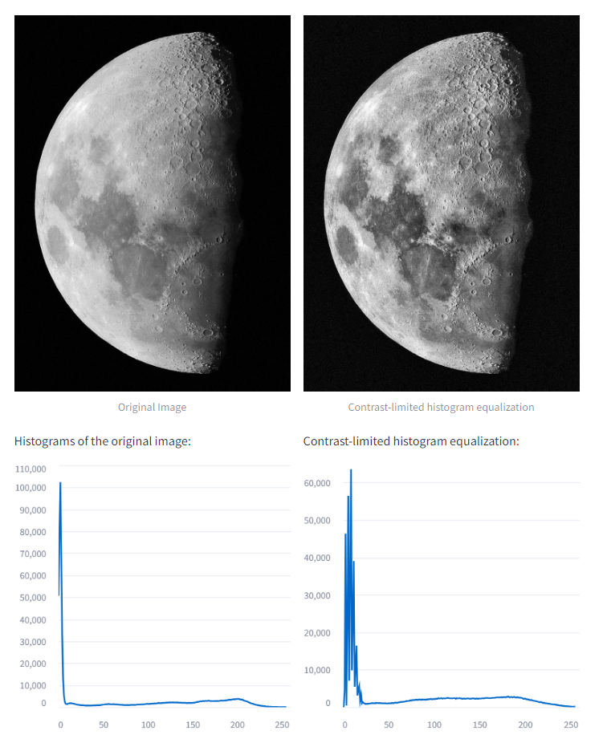

2. Adaptive Histogram Equalization

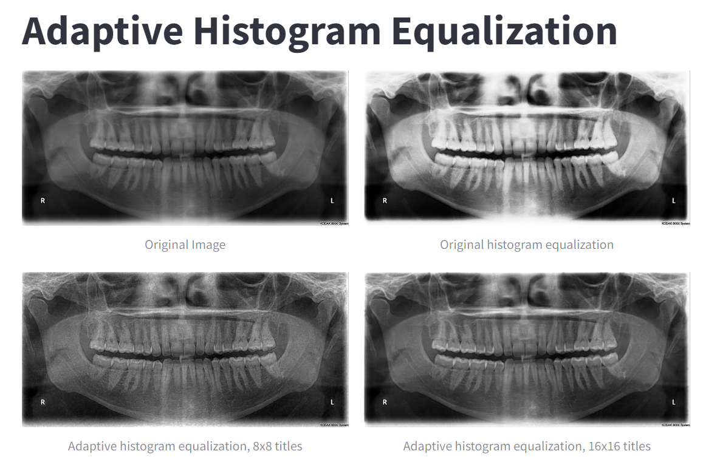

**HOMEWORK 2**

**1.**

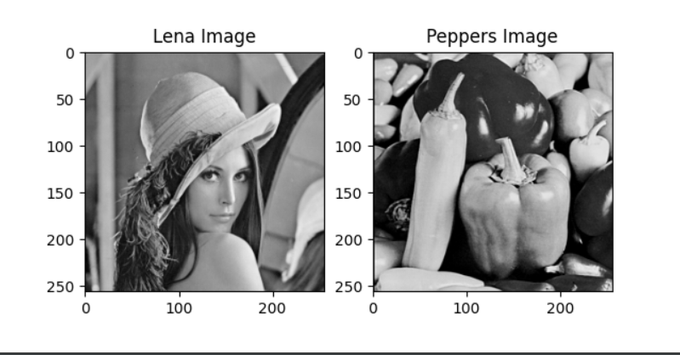

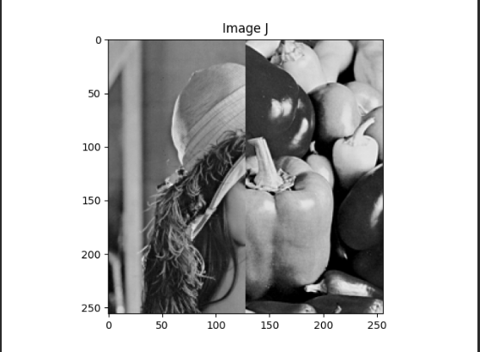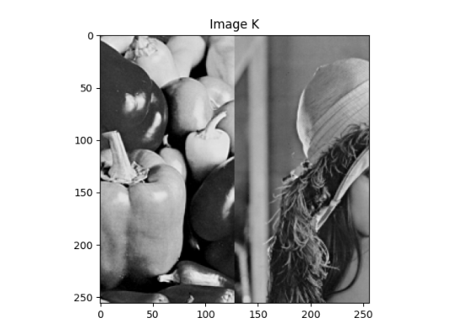

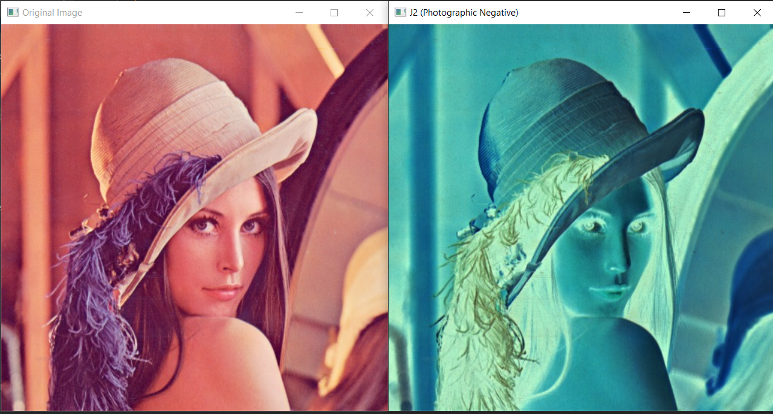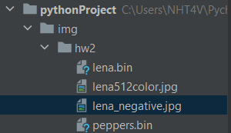**2.**

**3.**



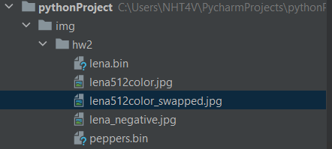

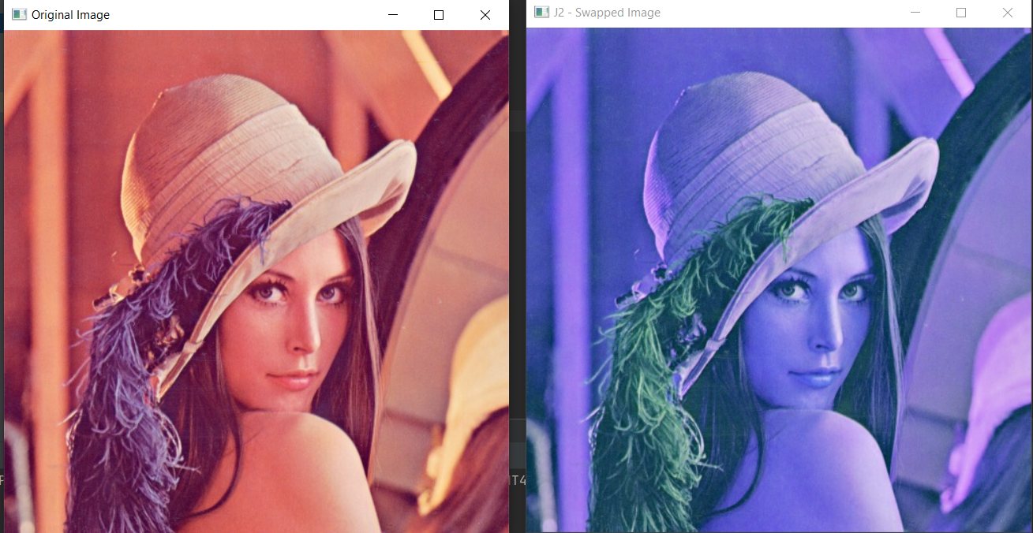

Link github: <https://github.com/NHT2-gh/Image_Processing.git>