See discussions, stats, and author profiles for this publication at: [https://www.researchgate.net/publication/358633189](https://www.researchgate.net/publication/358633189_A_Machine_Learning_Application_for_Football_Players%27_Selection?enrichId=rgreq-5bece0bd4a7529ca5897c2670ca3c070-XXX&enrichSource=Y292ZXJQYWdlOzM1ODYzMzE4OTtBUzoxMTIzOTU5MjE5MjA0MTAxQDE2NDQ5ODQxNjg5NTc%3D&el=1_x_2&_esc=publicationCoverPdf)

[A Machine Learning Application for Football Players' Selection](https://www.researchgate.net/publication/358633189_A_Machine_Learning_Application_for_Football_Players%27_Selection?enrichId=rgreq-5bece0bd4a7529ca5897c2670ca3c070-XXX&enrichSource=Y292ZXJQYWdlOzM1ODYzMzE4OTtBUzoxMTIzOTU5MjE5MjA0MTAxQDE2NDQ5ODQxNjg5NTc%3D&el=1_x_3&_esc=publicationCoverPdf)

**Article** · February 2022

CITATIONS READS

10 694

**2 authors:**

[Uzochukwu Onwuachu](https://www.researchgate.net/profile/Uzochukwu-Onwuachu?enrichId=rgreq-5bece0bd4a7529ca5897c2670ca3c070-XXX&enrichSource=Y292ZXJQYWdlOzM1ODYzMzE4OTtBUzoxMTIzOTU5MjE5MjA0MTAxQDE2NDQ5ODQxNjg5NTc%3D&el=1_x_5&_esc=publicationCoverPdf) [Promise Enyindah](https://www.researchgate.net/profile/Promise-Enyindah?enrichId=rgreq-5bece0bd4a7529ca5897c2670ca3c070-XXX&enrichSource=Y292ZXJQYWdlOzM1ODYzMzE4OTtBUzoxMTIzOTU5MjE5MjA0MTAxQDE2NDQ5ODQxNjg5NTc%3D&el=1_x_5&_esc=publicationCoverPdf)

[Imo State University](https://www.researchgate.net/institution/Imo-State-University?enrichId=rgreq-5bece0bd4a7529ca5897c2670ca3c070-XXX&enrichSource=Y292ZXJQYWdlOzM1ODYzMzE4OTtBUzoxMTIzOTU5MjE5MjA0MTAxQDE2NDQ5ODQxNjg5NTc%3D&el=1_x_6&_esc=publicationCoverPdf) [University of Port Harcourt](https://www.researchgate.net/institution/University_of_Port_Harcourt?enrichId=rgreq-5bece0bd4a7529ca5897c2670ca3c070-XXX&enrichSource=Y292ZXJQYWdlOzM1ODYzMzE4OTtBUzoxMTIzOTU5MjE5MjA0MTAxQDE2NDQ5ODQxNjg5NTc%3D&el=1_x_6&_esc=publicationCoverPdf)

**13** PUBLICATIONS **30** CITATIONS **15** PUBLICATIONS **29** CITATIONS



[SEE PROFILE](https://www.researchgate.net/profile/Uzochukwu-Onwuachu?enrichId=rgreq-5bece0bd4a7529ca5897c2670ca3c070-XXX&enrichSource=Y292ZXJQYWdlOzM1ODYzMzE4OTtBUzoxMTIzOTU5MjE5MjA0MTAxQDE2NDQ5ODQxNjg5NTc%3D&el=1_x_7&_esc=publicationCoverPdf) [SEE PROFILE](https://www.researchgate.net/profile/Promise-Enyindah?enrichId=rgreq-5bece0bd4a7529ca5897c2670ca3c070-XXX&enrichSource=Y292ZXJQYWdlOzM1ODYzMzE4OTtBUzoxMTIzOTU5MjE5MjA0MTAxQDE2NDQ5ODQxNjg5NTc%3D&el=1_x_7&_esc=publicationCoverPdf)

**Some of the authors of this publication are also working on these related projects:**

A Hybrid technique for Job Shop Scheduling in an Interconnected System [View project](https://www.researchgate.net/project/A-Hybrid-technique-for-Job-Shop-Scheduling-in-an-Interconnected-System?enrichId=rgreq-5bece0bd4a7529ca5897c2670ca3c070-XXX&enrichSource=Y292ZXJQYWdlOzM1ODYzMzE4OTtBUzoxMTIzOTU5MjE5MjA0MTAxQDE2NDQ5ODQxNjg5NTc%3D&el=1_x_9&_esc=publicationCoverPdf)



A Machine Learning Application for Football Players’ Selection [View project](https://www.researchgate.net/project/A-Machine-Learning-Application-for-Football-Players-Selection?enrichId=rgreq-5bece0bd4a7529ca5897c2670ca3c070-XXX&enrichSource=Y292ZXJQYWdlOzM1ODYzMzE4OTtBUzoxMTIzOTU5MjE5MjA0MTAxQDE2NDQ5ODQxNjg5NTc%3D&el=1_x_9&_esc=publicationCoverPdf)

All content following this page was uploaded by [Uzochukwu Onwuachu](https://www.researchgate.net/profile/Uzochukwu-Onwuachu?enrichId=rgreq-5bece0bd4a7529ca5897c2670ca3c070-XXX&enrichSource=Y292ZXJQYWdlOzM1ODYzMzE4OTtBUzoxMTIzOTU5MjE5MjA0MTAxQDE2NDQ5ODQxNjg5NTc%3D&el=1_x_10&_esc=publicationCoverPdf) on 16 February 2022.

The user has requested enhancement of the downloaded file.

**A Machine Learning Application for Football**

**Players’ Selection**

Onwuachu Uzochukwu C

Department of Computer Sciences, Imo state University, Owerri, Nigeria.

P. Enyindah

Department of Computer Sciences, University of Port Harcourt, Choba, Nigeria.

***Abstract*: The process of football team player selection is ultimately where the success of a team is determined. This is because the successful collection of individual talented players forms an effective team. In general, the selection of players in a football team is a decision made by the club on the basis of the best available information. This paper proposes a model that groups the attributes needed for player selection into four major categories which include the player’s technique, the player’s speed, the player’s physical status and the player’s resistance using neural network technique to determine these major attributes for each player. The system was developed and implemented using Matlab 2008. The result has shown that Neural Network is a good tool for selecting players in a football team.**

**Keywords: *Football Team, Decision Support System, Player Selection, Neural Network.***

# I. INTRODUCTION

The success of any football match lies in player selection which a difficult decision is making task for football managers. Football managers may need to use a decision support system to aid their decision making process. These attributes may include the player’s individual skills and performance statistics, combination of players, physical fitness, psychological factors, and injuries among others [1]. Some coaches may also use importance weights to determine the impact of each attribute. Importance weights are useful to the football managers since they indicate how the impact of a particular attribute relates to the probability of a successful outcome.

Football is a team sport that is popular in almost every country in the world. The player selection process for professional football teams is crucial in the quest for winning. So much so that a wrong selection can cost football team the championship and even millions of dollars if the player turns out not living up to the team’s expectations [22]. Traditionally, professional football teams use a variety of sports psychology assessments for evaluating players. There is no doubt that these assessments are of great benefit and are extremely useful when trying to form a winning football team. However, this is just one part of the big puzzle when trying to assess a player’s suitability for a team. The ability to select suitable players is indispensable when it comes to building an effective team [11].

This paper makes use of Neural Network technique to build a decision support system for player selection in a football team. The system uses neural network to evaluate some attribute that makes up the four major categories to be considered by the football managers in selecting a player for a football team. A selected player will be judged based on these four categories which include the player’s technique, the player’s speed, the player’s physical status and the player’s resistance.

II. LITERATURE REVIEW

Katzenbach and Smith (1993) defined a team as a small number of people with complementary skills who are committed to a common purpose, performance goals, and approach for which they hold themselves mutually accountable [11]. A variety of approaches for the selection of team members have been proposed in the literature. Most of these studies have focused on the use of teams in business and industry. The business and industry’s adoption of a teamwork methodology in the pursuit of cost effectiveness and greater innovation has spawned significant research [9][7][10].

Braha (2002) has proposed a team-building approach based on task partitioning by specifying task dependencies and partitioning the tasks among a number of teams [13]. Chen and Lin (2004) proposed a team member model for the formation of a multi-functional team in concurrent engineering. They used the analytic hierarchy process and Myers–Briggs type indicators to model team member characteristics [14].

Gronau et al (2006) developed an algorithm to propose a team composition for a specific task by analyzing the knowledge and skills of the employees in the project management field [15]. Durmusoglu and Kulak (2008) proposed a team building process using axiomatic design principles. They proposed to establish teams by identifying the needed skills and preparing a skill development procedure to ensure maximum utilization of team members’ talents[20].

Feng, et al (2010) proposed a member selection method in cross functional teams where both the individual performance of the candidates and the collaborative performance between candidates were considered. Fuzzy set theory has also been used in the team member selection and team formation research [19].

Liang and Wang (1992) proposed integrating fuzzy logic into weighted complete bipartite graphs and developing a polynomial time algorithm for solving personnel placement[18].

DeKorvin, et al(2002) developed a model for the selection of personnel in multiple phase projects, which took into account the match between the skills possessed by each individual, the skills needed for each phase, and flexible budget considerations. They used the fuzzy construct of compatibility to measure the fit of a person’s skill set to the goal set for each project phase in fuzzy environment [16]

Boon and Sierksma (2003) formulated a linear optimization model to headhunt or scout a new team in soccer and volleyball by combining the qualities of the candidates and players with the functional requirements.[4]. Merigo´ and Gil-Lafuente (2011) analyzed the use of the ordered weighted averaging (OWA) operator in the selection of human resources in sport management. They used the Hamming distance, the adequacy coefficient and the index of maximum and minimum level to parameterize these decision-making techniques and select of a football player for a team.[12]

Ahmed et al (2011) considered the overall batting and bowling strength of a cricket team and proposed a constrained multi-objective optimization model for selection of the players on the team [2].

Askin and Sodhi (1994) have presented a novel method for organizing teams in concurrent engineering. They developedfive different criteria for team formation and discussed team training, leadership, and computer support issues [2].

Zakarian and Kusiak (1999) proposed an analytical model for the selection of multi-functional teams. They used the analytic hierarchyprocess and the quality function deployment method to prioritize ‘‘team membership’’ based on customer requirements andproduct specifications under fuzzy environment[21].

# II. MATERIALS AND METHOD

Neural network technique was used to develop a model for player selection, in this model different attributes needed for player selection is analyzed into four major categories using a neural network model and this major categories which include the player’s technique, the player’s speed, the player’s physical status and the player’s resistance. The data used in this paper was collected from www.pesstatsdatabase.com/PSD/playerClassic.php?id=157 98&club=0. These major categories will be used to make the final decision on which player to be selected for a football team.Figure1, figure 2, figure 3. and fig 4 shows the neural network model architecture for calculating the player’s technique, the player’s speed, the player’s physical status and the player’s resistance respectively.

Attack Awareness

Defence

Form

Tenacity

Team

work

Acceleration

Figure

1.

Neural Network M

odel

Architecture for

Player’s Resistance

Status

Response

Explosive

power

Dribble Speed

Top Speed

Neural

network

Neural

network

**Player’s**

**Resistance**

**Player’s**

**Speed**

Figure 2. Neural Network Model Architecture for Player’s Speed Status

Body Balance

Neural

network

Player’s

Physical

Stamina

Jumping

Kicking Power

Injury Tolerance

Figure 3. Neural Network Model Architecture for Player’s Physical status

Attack

Defence

Header Accuracy

Dribble Accuracy

Short Pass Accuracy

Short Pass Speed

Long Pass Accuracy

Long Pass Speed

Shot Accuracy Place Kicking

Swerve

Ball Control

Goal Keeping Skills

Weak Foot Accuracy

Weak Foot Frequency

Neural

network

Player’s

Technique

Figure 4. Neural Network Model Architecture for Player’s Technique

The feed forward algorithm was used to calculate the optimal weights of the individual attributes that make up these categories. The mathematical models for the feed forward algorithm are as follows:

***Inputj***  ***x j*** *yiwij* .................................1 yiis the generated output and wi j represents weights

1

*f* (*x*)  *x j* .........................................2

1*e*

*f (x)* is a sigmoid that is used as the activation function ***Error*** *Tk* *Ok*...............................................3

Tk is the observed (True) output while Ok is the calculated

(actual) output

The error in the output layer is calculated by using the formula in equation 3.4

# *k* *ok****(1-ok )(Tk*** *ok*)..................................4

Where Ok is the calculated (actual) output expressed in equation 3.5

1

*Ok*  1 *xk* ..............................................5 *e*

Tk is the observed (True) output

The back propagation error in the hidden layer is calculated by using the formula in equation 3.6

*j* *oj****(1-oj )******k*** \**wjk*..................................6

***k***

Where wjk is the weight of the connection from unit j to unit k in the next layer and δk is the error of unit k.

The weight adjustment formula in equation (3.7) is used to adjust the weights to produce new weights which are fed back into the input layer.

***Wnew*** ***Wold*** ***η* δ* input***........................7

Where η is a constant called the learning rate. The learning rate takes value between 0 and 1.

*A. THE CONDITION FOR PLAYER SELECTION*

The Average Status = (Physical status + Technique status + Speed status + Resistance status) / 4

X < 50

Average stat (X) = X = 50

X > 50

From the first condition, if the player’s average status is below 50 then the player rating is below average and with this information the coach will reject the player. If the player’s average status is equal to 50 then the player rating is average and with this information the coach can choose the player but he must not be in the starting eleven, which means he/she can be in the bench. If the player’s average status is above 50 thenthe player rating is above average and with this information the coach can choose the player in the starting eleven.

## IV. EXPERIMENTS AND RESULTS

The simulation was done using Matlab 2008. Figure 5 shows the Neural Network fitting tool for data selection. This Interface helps in collection of input data and the target data from the work space.

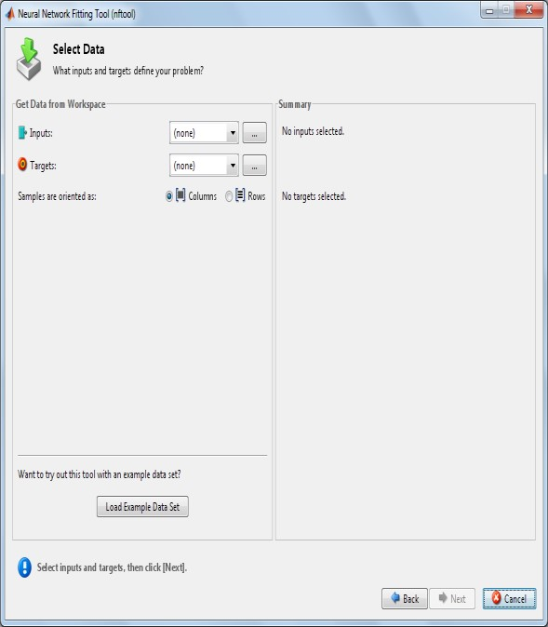

Figure 5. Neural Network Fitting Tool for Data Selection

Figure 6 shows the Neural Network fitting tool for selection of network size. This interface gives the user the opportunity to select the number of neuron in the network’s hidden layer. The user can return to this panel and change the number of the neuron if the network does not perform well after training.

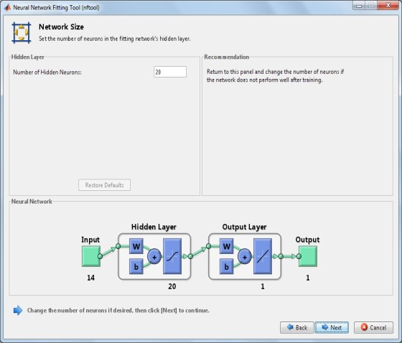

Figure 6. Neural Network Fitting Tool for Network Size Selection

Figure 7.shows the Neural Network training. The Neural Network model was trained using Levenberg-Marquardt back propagation. The network is trained to fit the inputs and the target. This means that neural network map between a data of numeric inputs and a set of numeric targets. Training automatically stops when generalization stops improving as indicated by the increase in the mean square error of the validation samples.

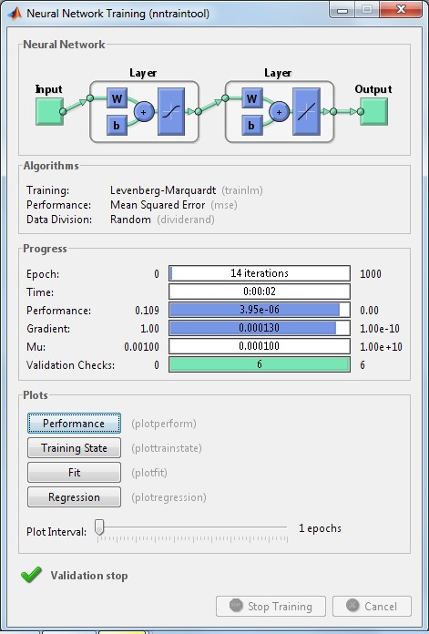

Figure 7. Neural Network Training Tool

The neural network fitting tool will help in training network and evaluation its performance using mean square error and regression analysis. Training multiple times will generate different results due to different initial condition and sampling. Figure 8.shows the result of the trained Network.

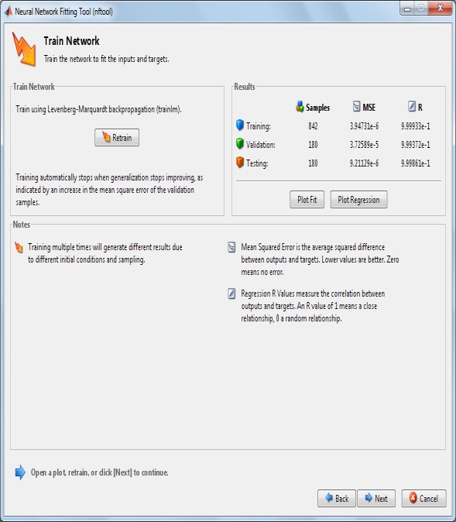

Fig 8. Neural Network Fitting Tool for Displaying the Result of the Trained Network.

Table 1. shows the comprehensive summary of the results from the developed system. The result shows the different player capabilities, and the team managers select their players’ base on the generated result. The table also displays the average result based on the four major categories for easy clarification and selection.

Table 1: The Comprehensive Summary of the Results from the developed system

|  |  |  |  |  |  |  |  |
| --- | --- | --- | --- | --- | --- | --- | --- |
| Players Name | Technique status | Speed status | Physical status | Resistance status | Average status | Player rating | Decision |
| Lionel Messi | 85.1 | 92.1 | 62.9 | 28.2 | 67.075 | Above Average | Select |
| Christiano Ronaldo | 82.3 | 92.4 | 78.3 | 33.4 | 71.6 | Above Average | Select |
| Arjen Robben | 82.2 | 93.1 | 64.6 | 32.8 | 68.175 | Above Average | Select |
| Andres Iniesta | 88.4 | 76.3 | 62.8 | 59.3 | 71.7 | Above Average | Select |
| Luis Suarez | 79.6 | 83.7 | 79.4 | 43.3 | 71.5 | Above Average | Select |
| Franck Ribery | 86.2 | 88.8 | 62.3 | 30.5 | 66.95 | Above Average | Select |
| Eden Hazard | 85.1 | 88.1 | 63.5 | 32.6 | 67.325 | Above Average | Select |

Table 2: The Comprehensive Summary of the online Results on 16th Dec 2014

|  |  |  |  |  |
| --- | --- | --- | --- | --- |
| Players Name | Technique status | Speed status | Physical status | Resistance status |
| Lionel Messi | 86 | 93 | 62 | 27 |
| Christiano Ronaldo | 81 | 93 | 79 | 32 |
| Arjen Robben | 83 | 93 | 64 | 32 |
| Andres Iniesta | 89 | 75 | 63 | 59 |
| Luis Suarez | 79 | 83 | 79 | 42 |
| Franck Ribery | 85 | 89 | 62 | 29 |
| Eden Hazard | 84 | 89 | 64 | 32 |

0

20

40

60

80

100

Technique

status

Speed

status

Physical

status

Resistance

status

Franck Ribery online

value

Franck Ribery system

value

Figure 10: A Line Graph That Shows the Relationship Between Online and System Result of Frank Ribery

0

20

40

60

80

100

Technique

status

Speed

status

Physical

status

Resistance

status

Christiano Ronaldo

online value

Christiano Ronaldo

system value

Figure 11: A Line Graph That Shows the Relationship Between Online and System Result of Christiano Ronaldo

0

20

40

60

80

100

Technique

status

Speed

status

Physical

status

Resistance

status

Andres Iniesta online

value

Andres Iniesta system

value

Figure 12: A Line Graph That Shows the Relationship Between Online and System Result of Andres Iniesta

0

20

40

60

80

100

Technique

status

Speed

status

Physical

status

Resistance

status

Arjen Robben online

value

Arjen Robben system

value

Figure 13: A Line Graph That Shows the Relationship between Online and System Result of Arjen Robben

0

20

40

60

80

100

Technique

status

Speed

status

Physical

status

Resistance

status

Lionel Messi online

value

Lionel Messi system

value

Figure 14: A Line Graph That Shows the Relationship Between Online and System Result of Lionel Messi

0

20

40

60

80

100

Technique

status

Speed

status

Physical

status

Resistance

status

Luis Suarez online

value

Luis Suarez system

value

Figure 15: A Line Graph That Shows the Relationship Between Online and System Result of Luis Suarez

0

20

40

60

80

100

Technique

status

Speed

status

Physical

status

Resistance

status

Eden Hazard online

value

Eden Hazard system

value

Figure 16: A Line Graph That Shows the Relationship Between Online and System Result of Eden Hazard

V. RESULT DISCUSSION

Table 1.shows the comprehensive summary of the results from the developed system. The result shows the different player capabilities. Based on this generated result, players are being selected by the team manager. The table also displays the average result based on the four major categories for easy clarification and selection. Table 2.displays the comprehensive summary of the online results on 16th Dec 2014. The reason for this result is to compare the accuracy of the developed system with the existing system. Figures 10, 11, 12, 13, 14, 15 and 16 show a line graph displaying the relationship between online and system result ofFrank Ribery,Christiano Ronaldo, Andres Iniesta, ArjenRobben, Lionel Messi, Luis Suarez and Eden Hazard respectively. From the graphs, it can be seen that neural network can be used to predict player performance in a team with minimum error. These results have shown that Neural Network is a good tool in building a decision support system for a football team manager.

## VI. CONCLUSION

Neural Network has been proven in the paper to be a good tool for building a decision support system for a football team manager. There are some attributes that a football player may have which cannot be neglected when it comes to choosing a rightful player for a football team. This system has employed the idea of neural network in considering this large amount of attributes needed in secting the rightful player for a football team. The result generated from the system has shown that neural network technique can help the football managers in player selection for a football team.

## REFERENCES

1. Arnason, A., Sigurdsson, S. B., Gudmundsson, A., Holme, I., Engebretsen, L., & Bahr, R. (2004).Physical fitness, injuries, and team performance in soccer.Medicine &Science in Sports & Exercise, 36, 278–285.
2. Ahmed, F., Deb, K., & Jindal, A. (2011).Evolutionary multiobjective optimization and decision making approaches to cricket team selection.In Proceedings of the Second International Conference on Swarm, Evolutionary, and

Memetic Computing. Berlin, Heidelberg: SpringerVerlaghttp://dx.doi.org/10.1007/978-3-642- 27242-4_9.

1. Askin, R. G., &Sodhi, M. (1994).Organization of teams in concurrent engineering.In R. D. Dorf& A. Kusiak (Eds.), Handbook of design, manufacturing, and automation (pp. 85–105). New York: John Wiley & Sons
2. Boon, B. H., &Sierksma, G. (2003). Team formation: Matching quality supply and quality demand. European Journal of Operational Research, 148, 277–292.
3. Katzenbach, J. R., & Smith, D. K. (1993).The wisdom of teams. Boston: Harvard Business School Press.
4. Kinlaw, D. C. (1991).Developing superior work teams. San

Diego: Lexington Books

1. Chen, Y. L., Cheng, L. C., & Chuang, C. N. (2008).A group recommendation system with consideration of interactions among group members.Expert Systems with Applications, 34, 2082–2090.
2. English, A., Griffith, R. L., &Steelman, L. A. (2004). Team performance: The effect of team conscientiousness and task type. Small Group Research, 35(6), 643–665
3. Kirkman, B. L., Rosen, B., Tesluk, P. E., & Gibson, C. B. (2004). The impact of team empowerment on team performance: The moderating role of face-to-face interaction. Academy of Management Journal, 47(2), 175–192.
4. Mannix, E., & Neale, M. (2005). What differences make a difference? The promise and reality of diverse teams in organizations. American Psychological Society, 6(2), 31–55
5. Boon, B. H., &Sierksma, G. (2003). Team formation: Matching quality supply and quality demand. European Journal of Operational Research, 148, 277–292.
6. Merigo´ , J. M., & Gil-Lafuente, A. M. (2011). Decisionmaking in sport management based on the OWA operator. Expert Systems with Applications, 38, 10408–10413.
7. Braha, D. (2002). Partitioning tasks to product development teams. Paper presented at the International Design Engineering Technical Conferences of American Society of Mechanical Engineers (DETC’02 ASME).
8. Chen, S. J., & Lin, L. (2004).Modeling team member characteristics for the formation of a multifunctional team in concurrent engineering.IEEE Transactions on Engineering Management, 51(2), 111–124.
9. Gronau, N., Fro¨ming, J., Schmid, S., &Ru¨ ssbu¨ ldt, U. (2006). Approach for requirement oriented team building in industrial processes. Computers in Industry, 58(2), 179–187.
10. DeKorvin, A., Shipley, M., &Kleyle, R. (2002). Utilizing fuzzy compatibility of skill sets for team selection in multiphase projects. Journal of Engineering and Management, 19, 307–319
11. TechnoDereli, T., Baykasoglu, A., & Das, S. (2007). Fuzzy quality-team formation for value added auditing: A case study. Journal of Engineering and Technology Management, 24, 366–394.
12. Yaakob, S. B., &Kawata, S. (1999). Workers’ placement in an industrial environment. Fuzzy Sets and Systems, 106, 289–297.
13. Liang, G. S., & Wang, M. J. J. (1992).Personnel placement in a fuzzy environment. Computers and Operations Research, 19, 107–121.

[View publication stats](https://www.researchgate.net/publication/358633189)

1. Feng, B., Jiang, Z. Z., Fan, Z. P., & Fu, N. (2010).A method for member selection of cross-functional teams using the individual and collaborative performances.European Journal of Operational Research, 203, 652–661.
2. Durmusoglu, M., & Kulak, O. (2008). A methodology for the design of office cells using axiomatic design principles. Omega, 36, 633–652
3. Zakarian, A., &Kusiak, A. (1999).Forming teams: An analytical approach. IIE Transactions, 31, 85–97.
4. Madjid Tavana, Farshad Azizi, Farzad Azizi, Majid Behzadian. (2012), A fuzzy inference system with application to player selection and team formation in multiplayer sports, Sport Management Review, jour n al homepag e: www .elsevier .c om /lo cate/s m r