Students: 19127551 – Huỳnh Thu Thảo, 19127647 – Nguyễn Phú Quí, 19127144 – Nguyễn Thành Hiệu, 19127649 – Tô Thanh Tuấn (Nhóm trưởng)

Lecturer: Hồ Thị Hoàng Vy

PROJECT#01  - ADVANCED DATABASE

TERM 1 – 2021-2022

**ADVANCED DATABASE**

**INFORMATION SYSTEM DEPARTMENT – INFORMATION TECHNOLOGY FACULITY**

**VNU UNIVERSITY OF SCIENCE, NATIONAL UNIVERSITY**

**DETAILED GROUP’S INFORATION TABLE**

|  |  |  |  |
| --- | --- | --- | --- |
| **Group ID** | **ADB1_13** | | |
| **Group name** | **1G3B** | | |
| **Numbers** | **4** | | |
| **Student ID** | **Full name** | **Email** | **Phone number** |
| 19127649 | Tô Thanh Tuấn | tttuan19@clc.fitus.edu.vn | 0383273384 |
| 19127647 | Nguyễn Phú Quí | npqui19@clc.fitus.edu.vn | 0971930839 |
| 19127551 | Huỳnh Thu Thảo | htthao19@clc.fitus.edu.vn | 0981019561 |
| 19127144 | Nguyễn Thành Hiệu | nthieu19@clc.fitus.edu.vn | 0356726457 |

|  |  |  |  |
| --- | --- | --- | --- |
| **Work assignment and work evaluation** | | | |
| **Task** | **Responsibility** | **Performance evaluation** | **Group evaluation** |
| Design GUI(4), Trigger(3-a) | Tô Thanh Tuấn | 100% | 10/10 |
| Generate data(1), script query(3-bdf, 5-a) | Nguyễn Phú Quí | 100% | 10/10 |
| Design GUI(4), trigger(3-b) | Nguyễn Thành Hiệu | 100% | 10/10 |
| Generate data(1), script query(3-ace, 5-b) | Huỳnh Thu Thảo | 100% | 10/10 |
| Synthesize report | Huỳnh Thu Thảo | 100% | 10/10 |

**HOMEWORK’S TAGRET**

|  |  |
| --- | --- |
| **TYPE** | ** THEORY 🗹 PRACTICE 🗹PROJECT  EXERCISE** |
| **START DATE** | **31/10/2021** |
| **END DATE** | **14/11/2021** |

# **Homework’s tagret**

<https://drive.google.com/drive/folders/1Sb4e6dH3fOC_tgQaXpZ4bVVZSVOxyMKd>

# **Result**

**Table of Contents**

**A.** **Homework’s tagret** 2

**B.** **Result** 2

I. Query result explanation 2

II. Excution plan 2

## 

## I. Query result explanation

### Query 3a)

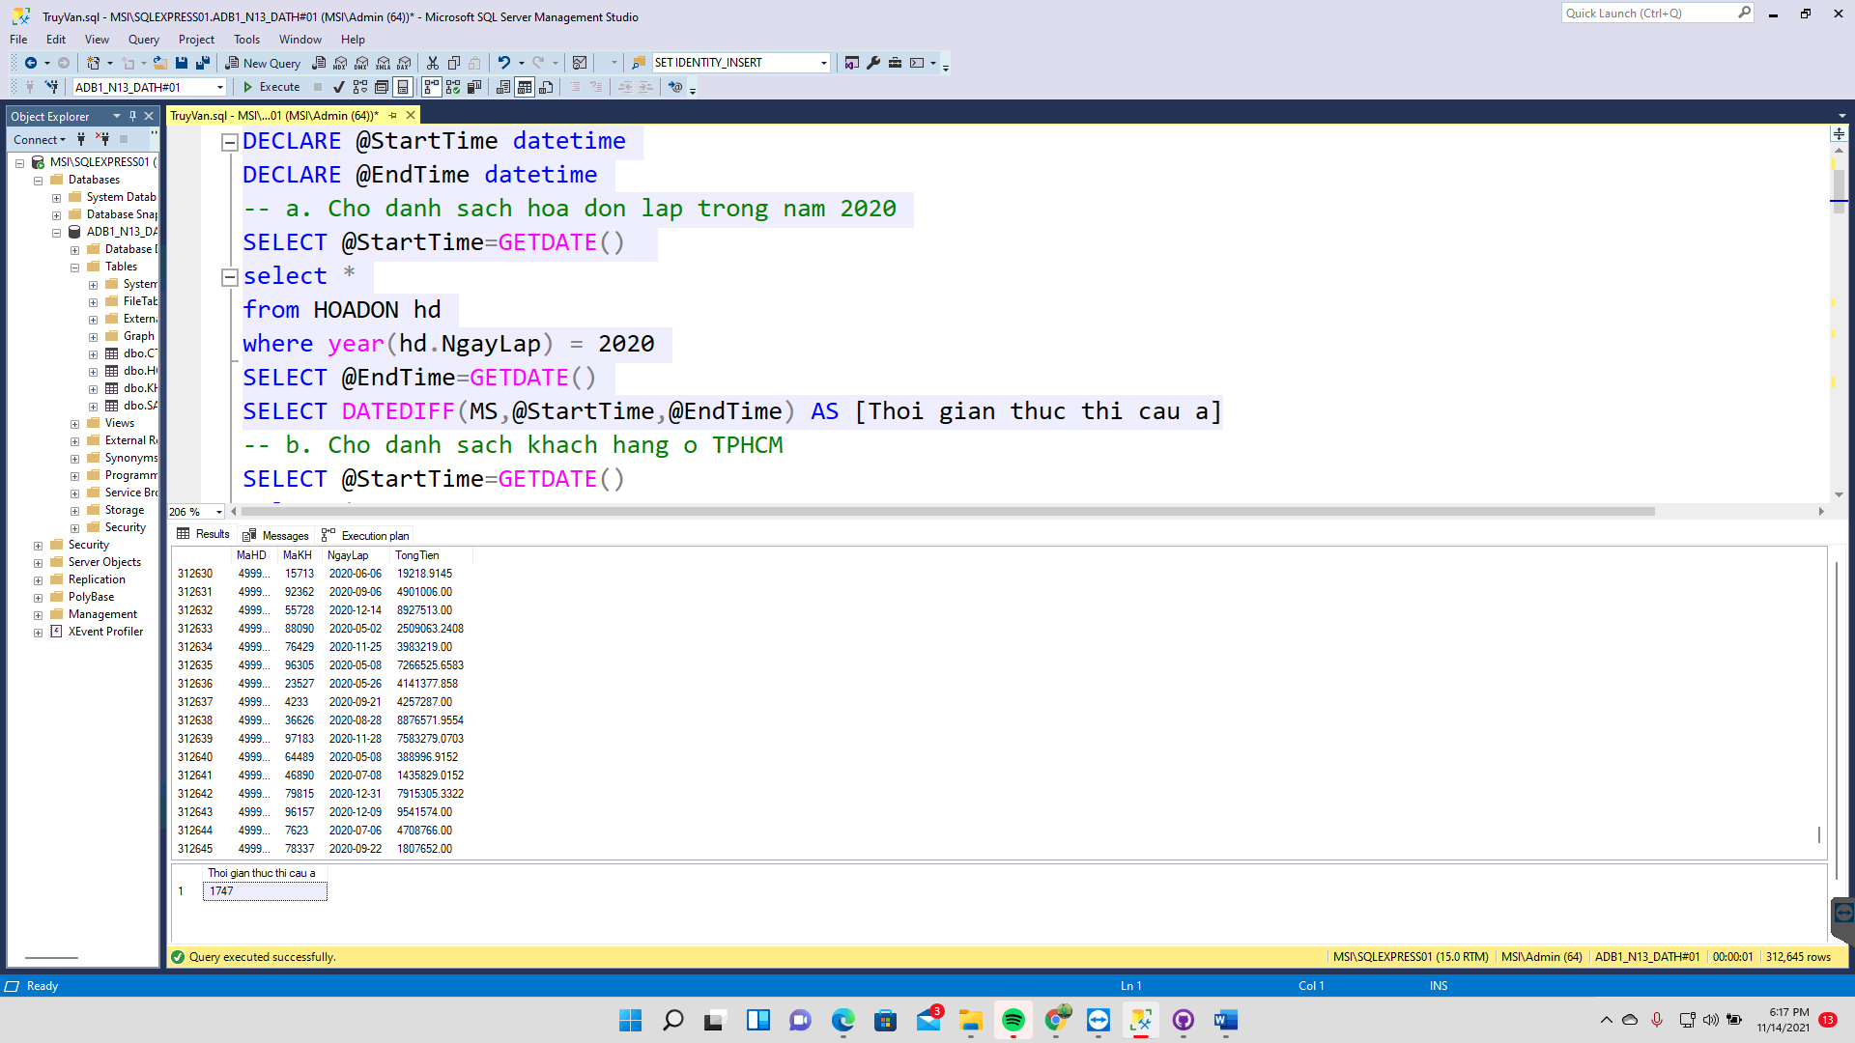

### Query 3b)

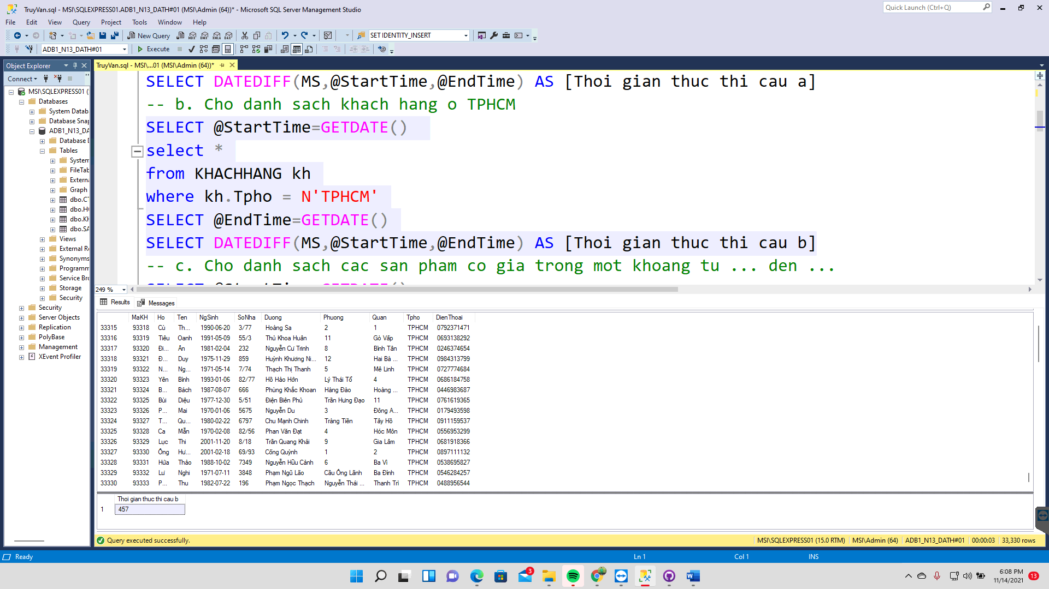

### Query 3c)

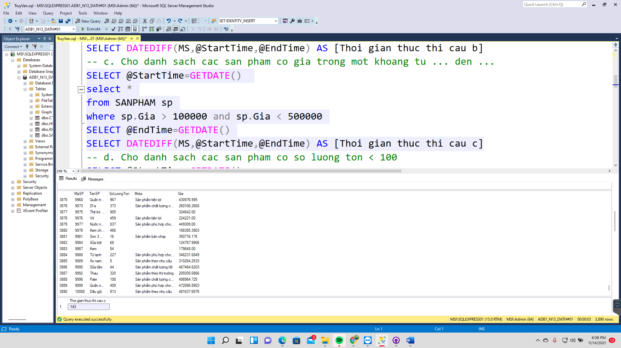

### Query 3d)

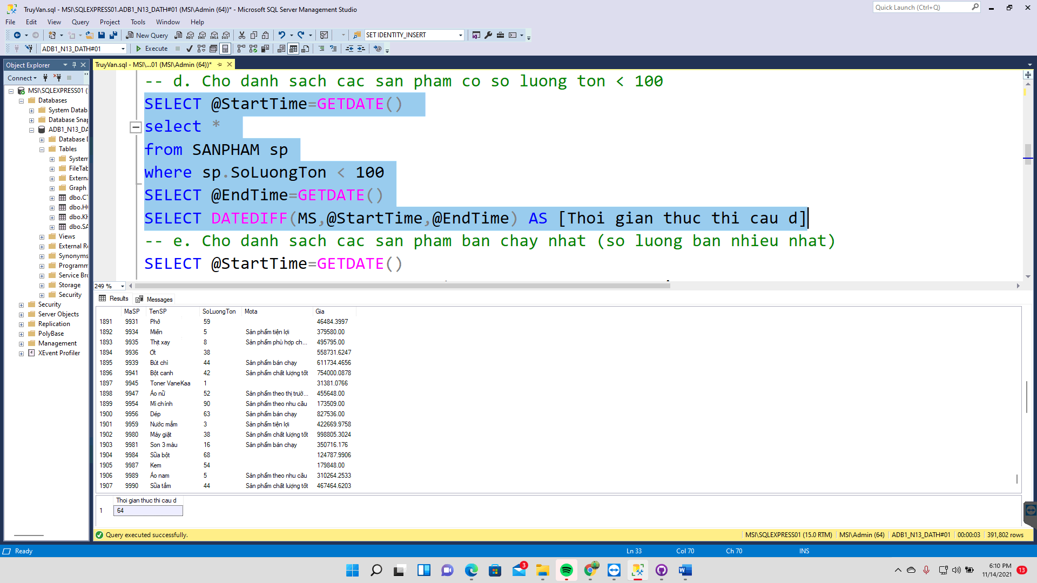

### Query 3e)

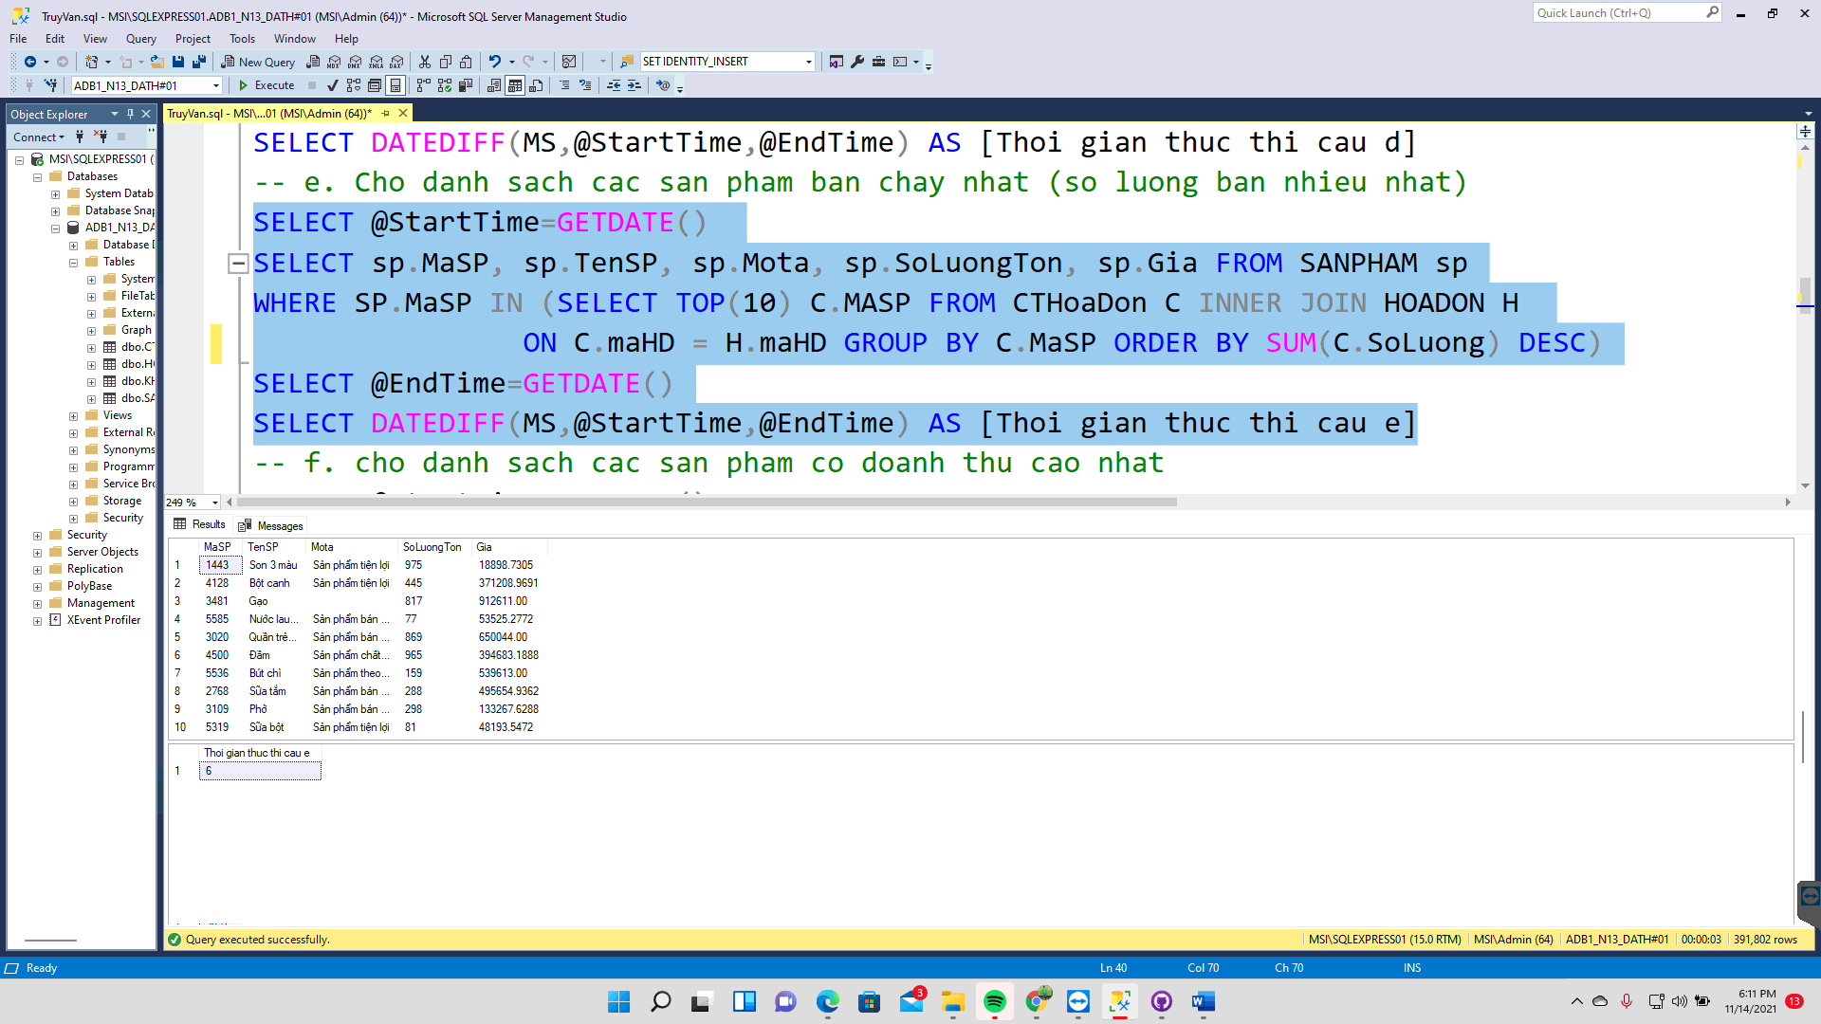

### Query 3f)

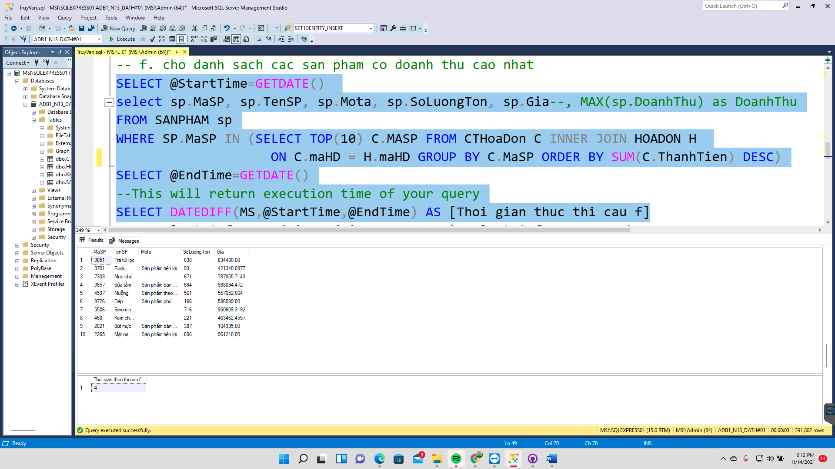

### Query 5a)

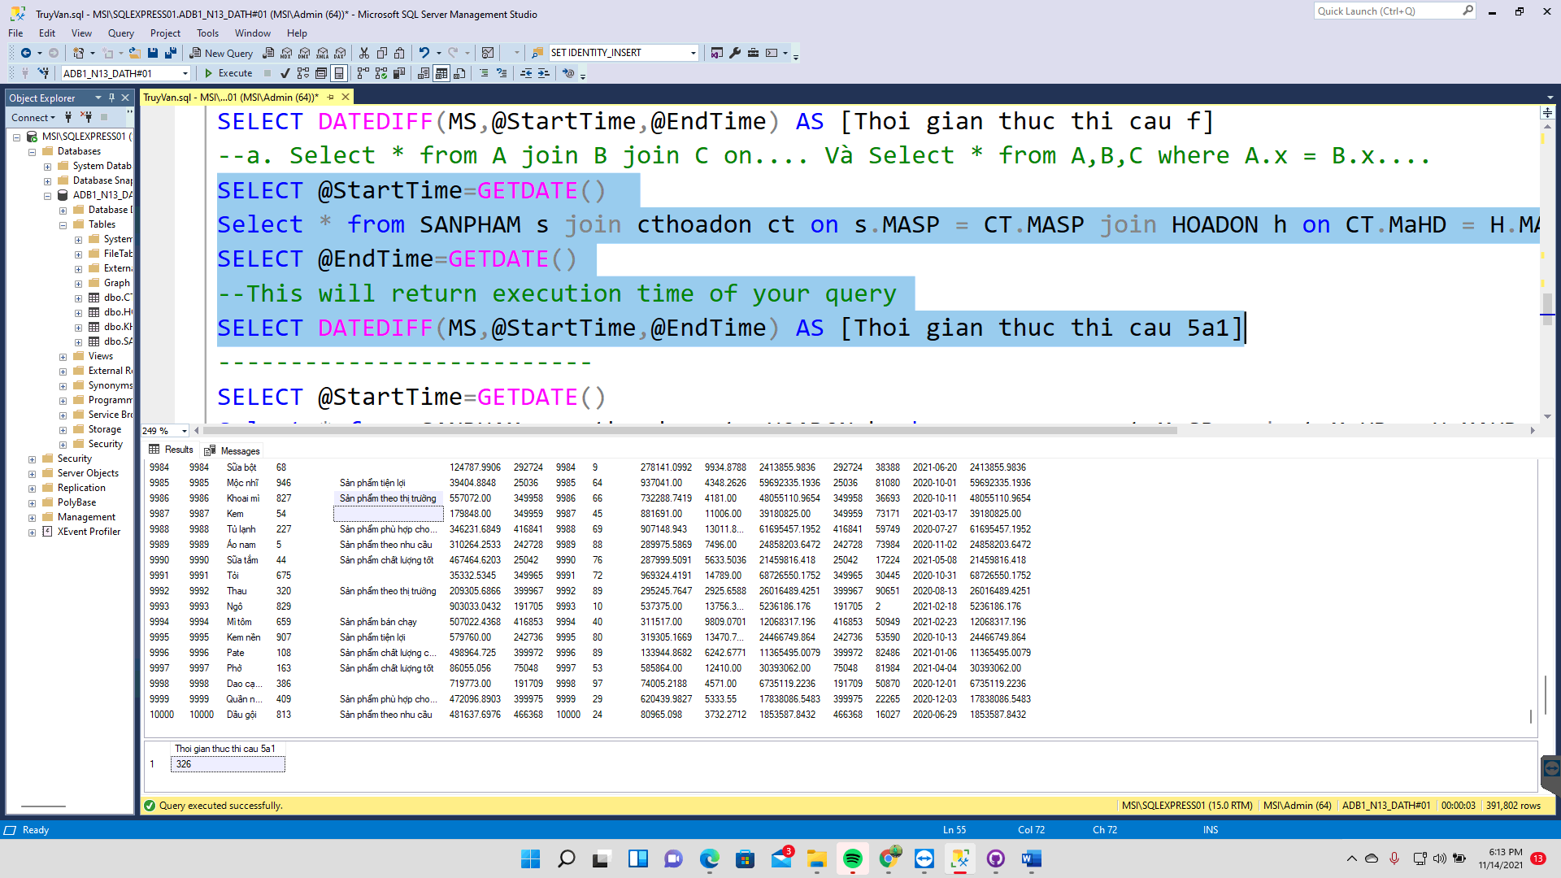

### Query 5a)

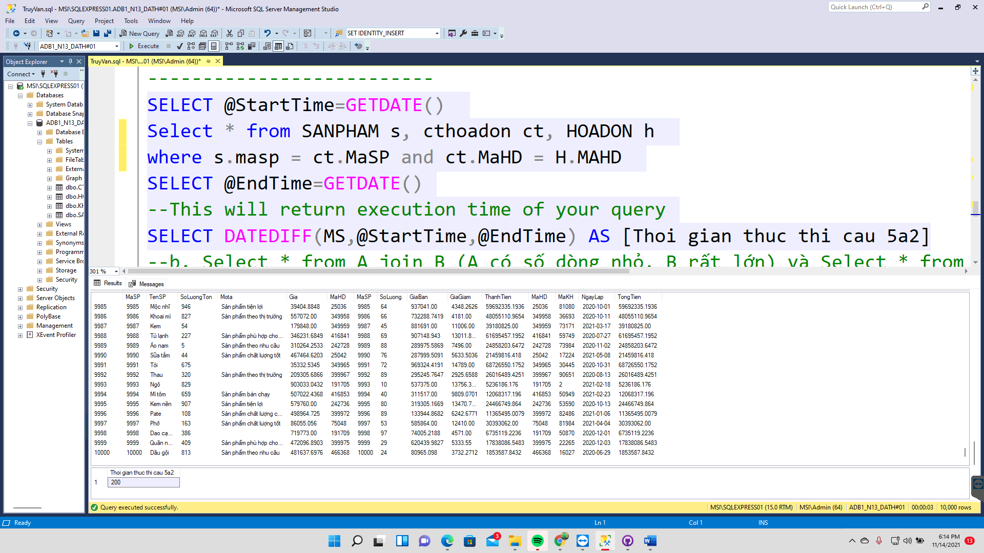

### Query 5b)

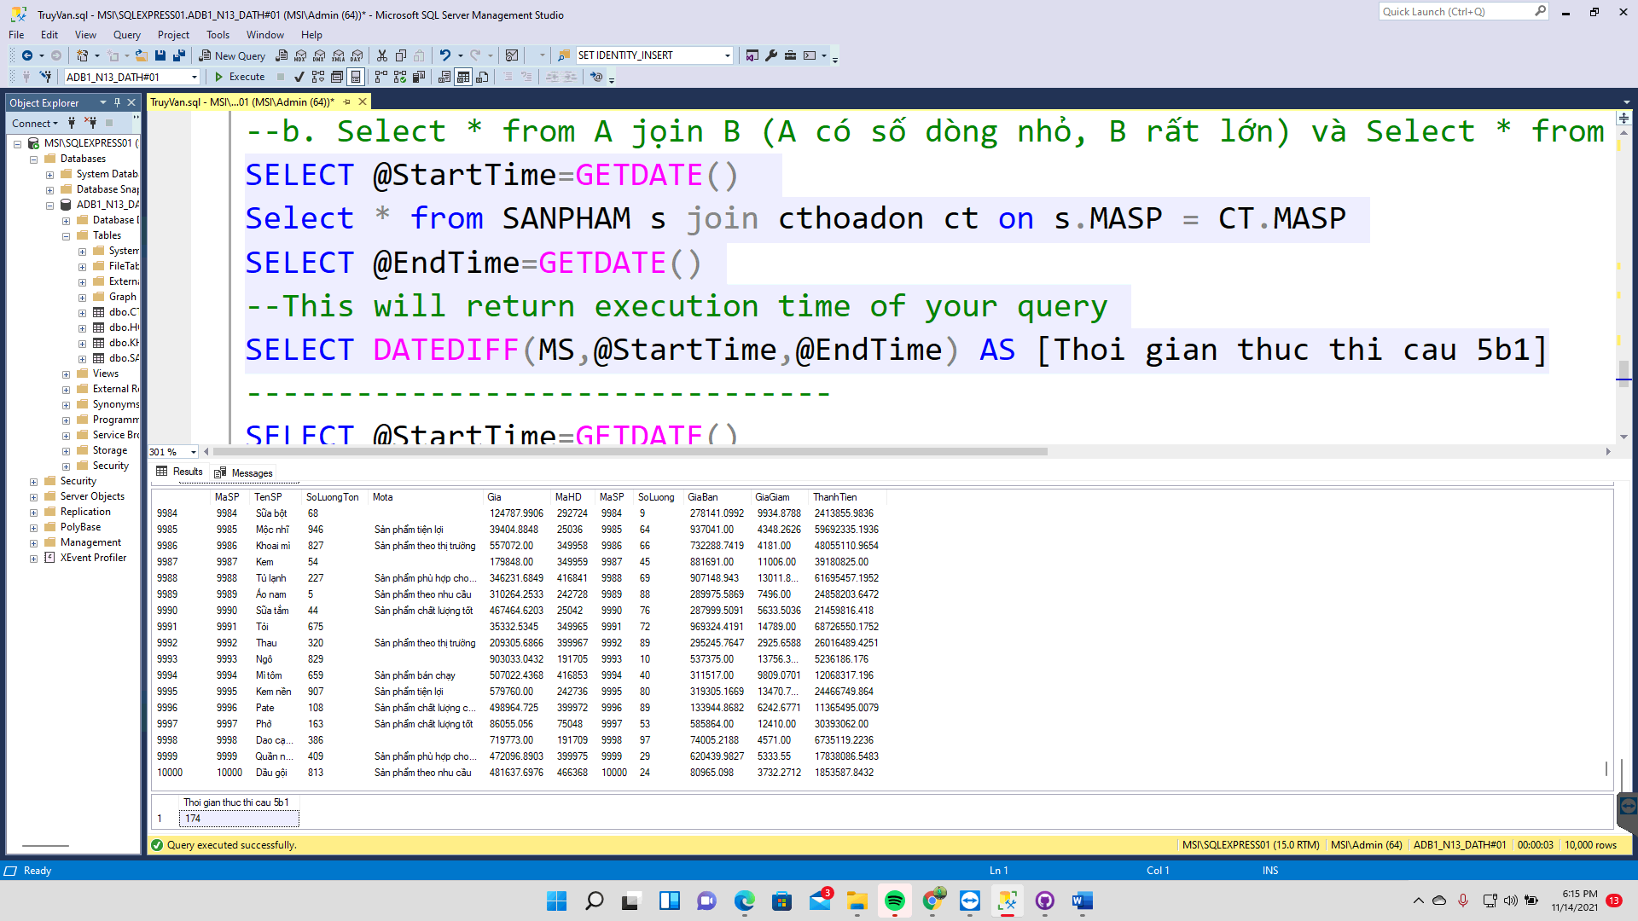

### Query 5b)

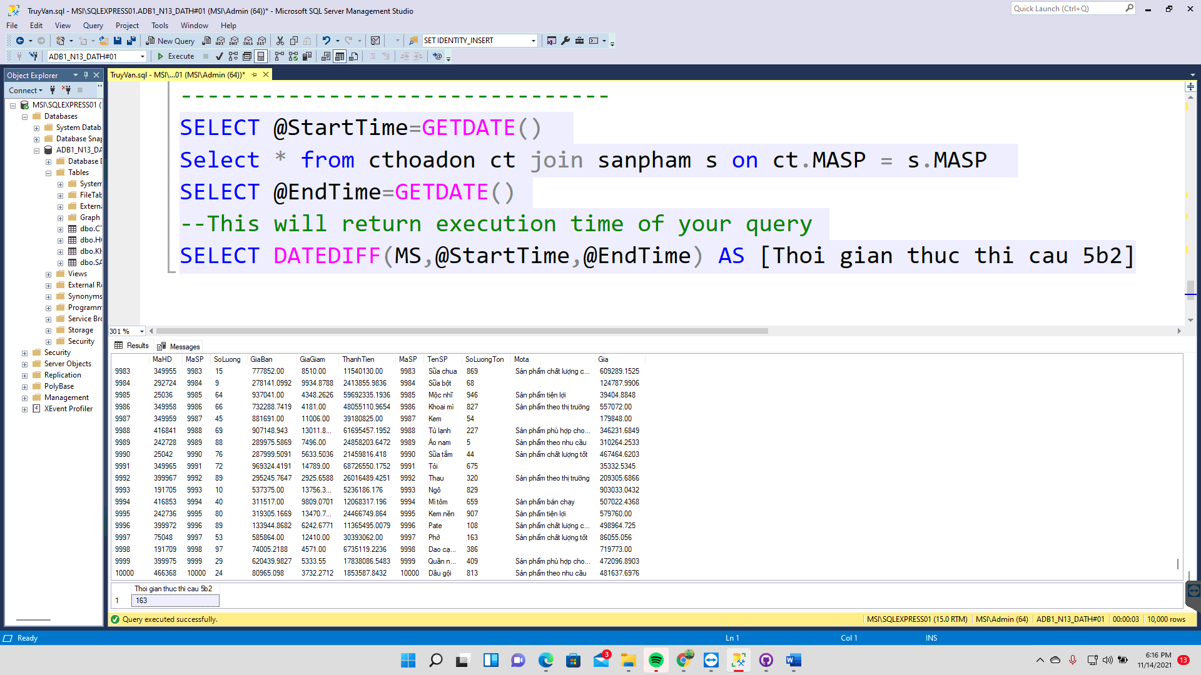

## II. Execution plan

### Query 3a)

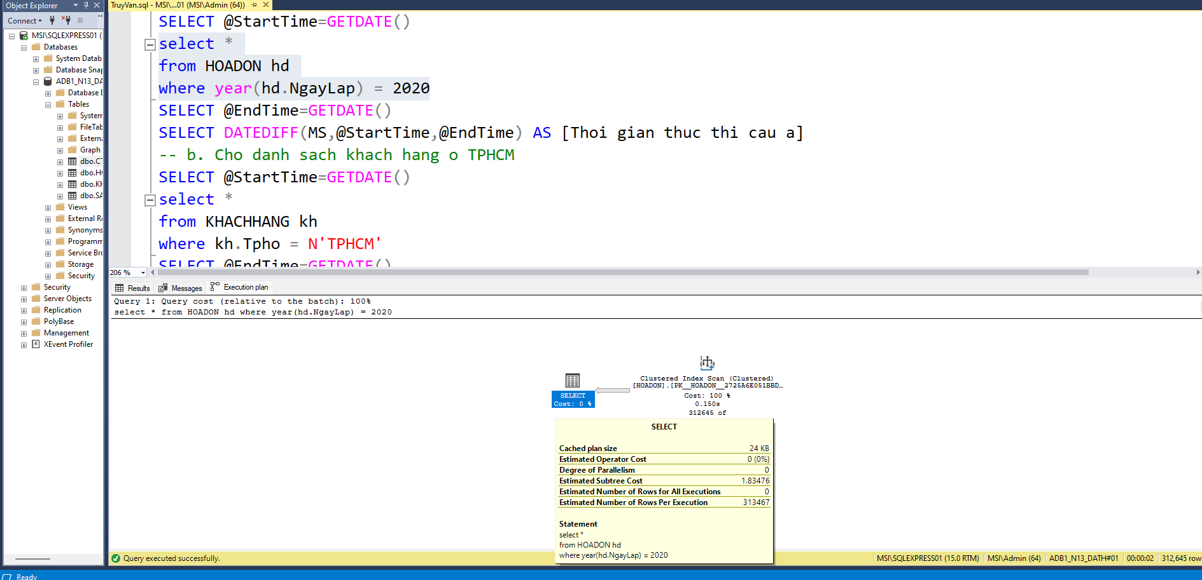

### Query 3b)

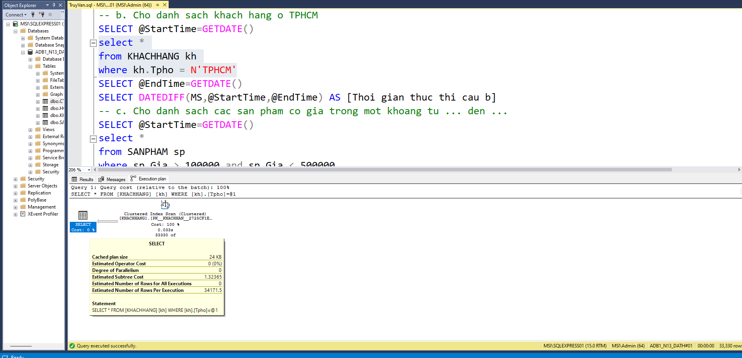

### Query 3c)

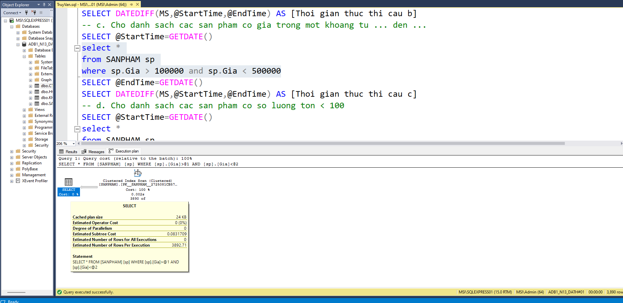

### Query 3d)

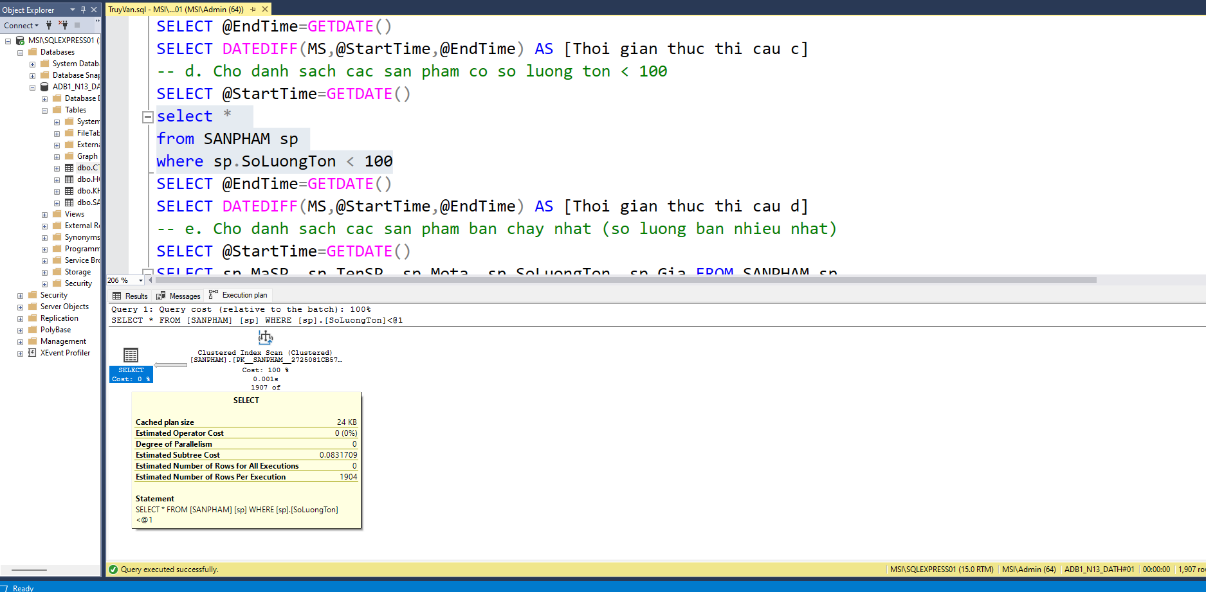

### Query 3e)

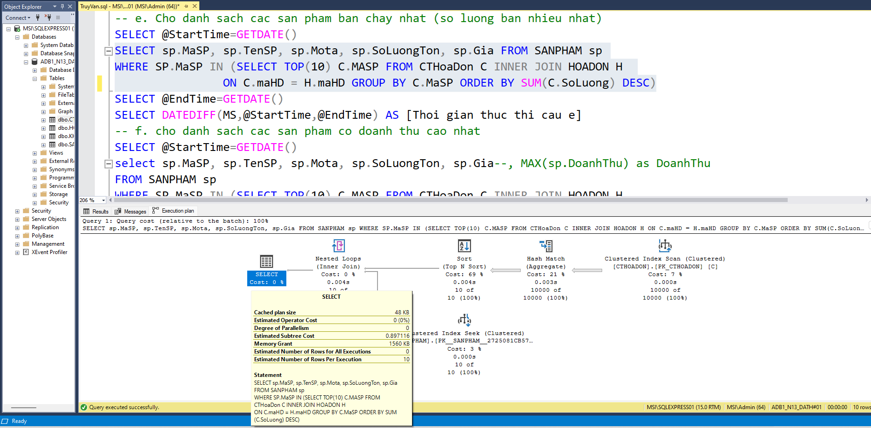

### Query 3f)

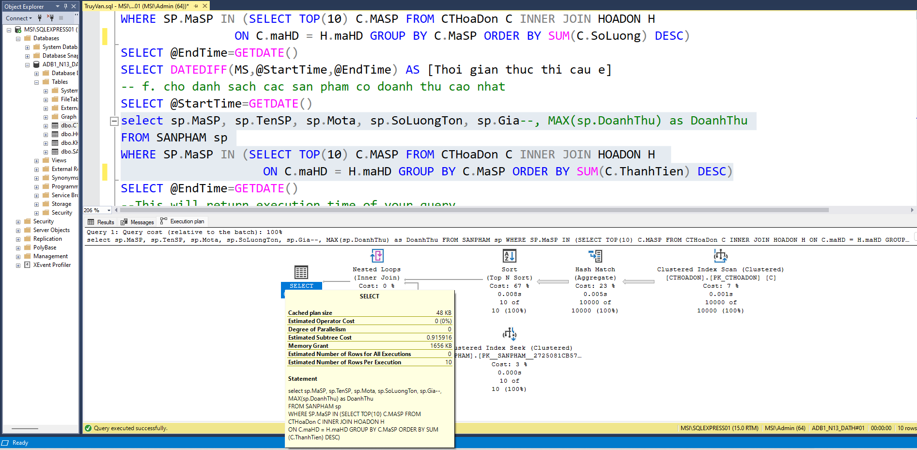

### Query 5a)

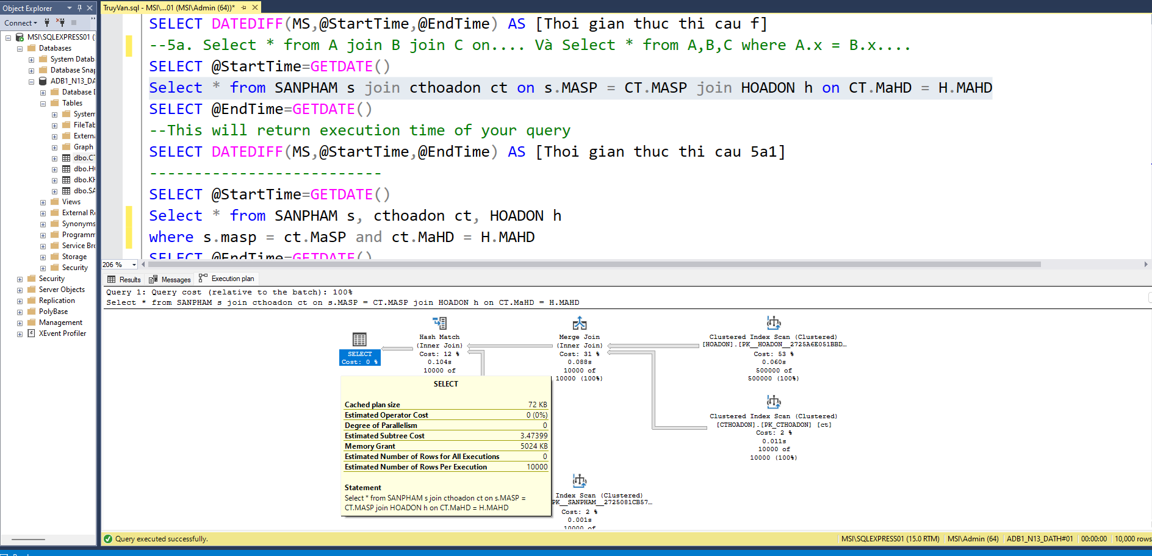

### Query 5a)

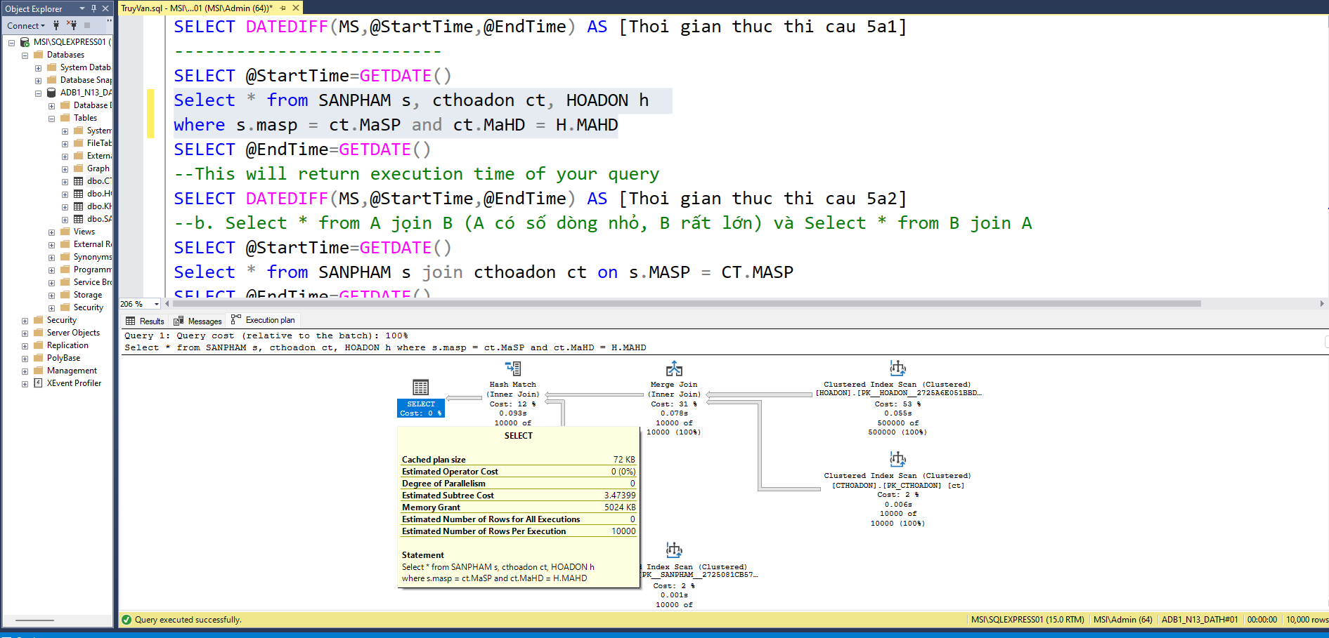

### Query 5b)

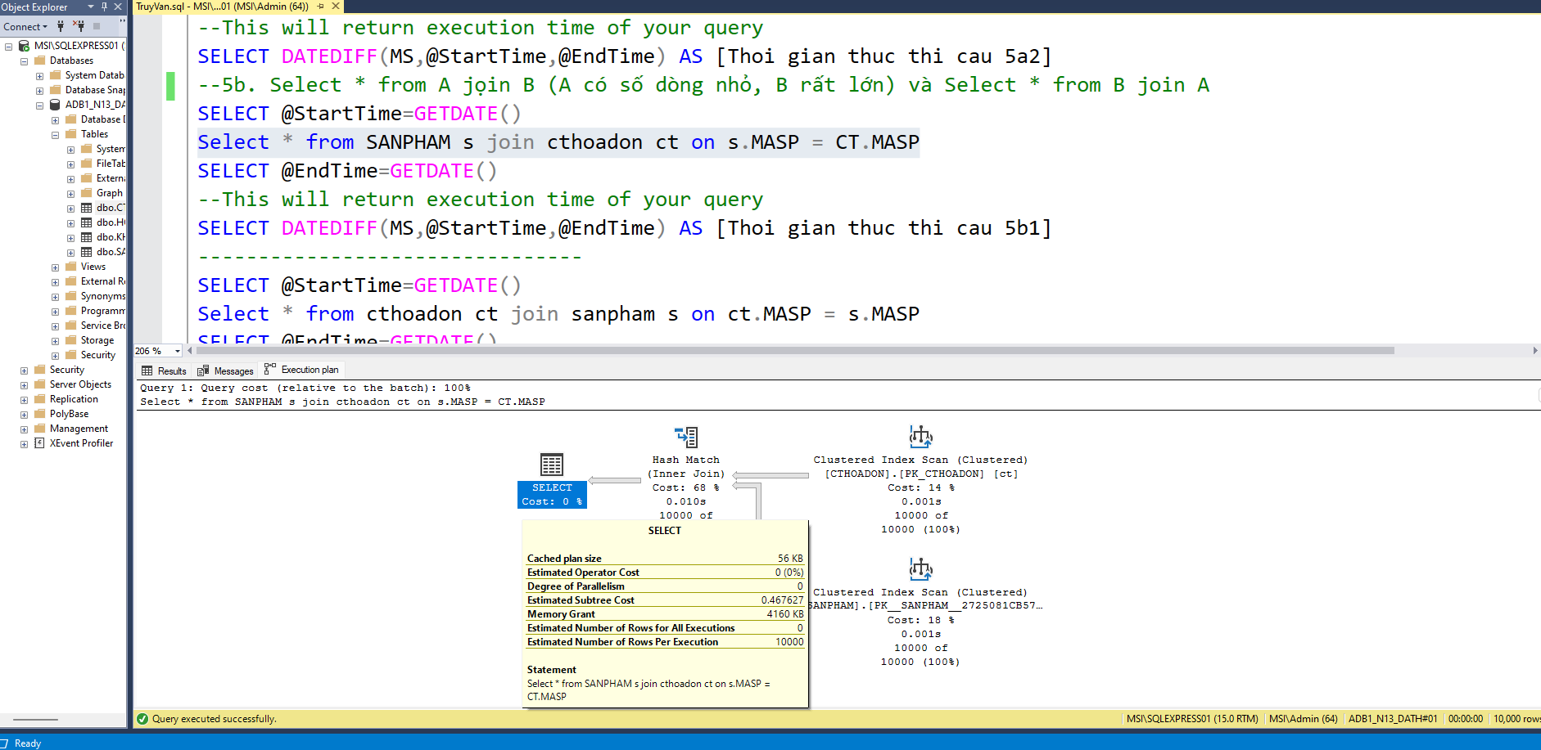

### Query 5b)

