1. Mô tả thuật toán tính điểm trung bình

Begin

Input a, b, c

A = (a + b + c)/3

Display A

End

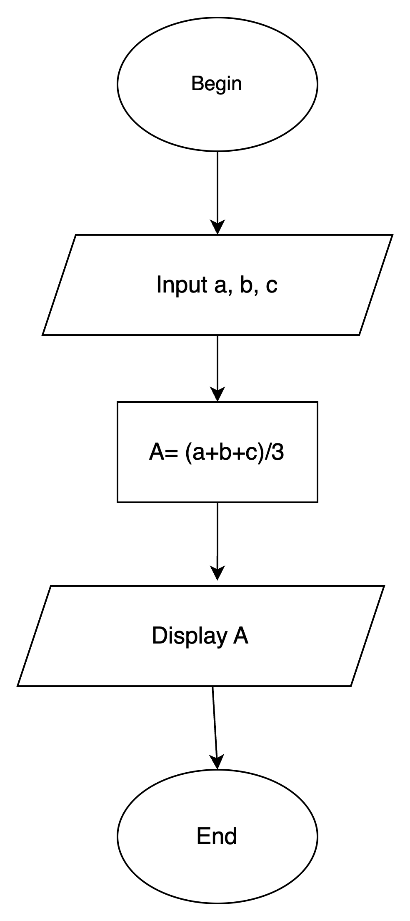

1. Mô tả thuật toán chuyển đổi tiền tệ

Begin

Input D

V = 23000 \* D

Display V

End

%3CmxGraphModel%3E%3Croot%3E%3CmxCell%20id%3D%220%22%2F%3E%3CmxCell%20id%3D%221%22%20parent%3D%220%22%2F%3E%3CmxCell%20id%3D%222%22%20value%3D%22Begin%22%20style%3D%22ellipse%3BwhiteSpace%3Dwrap%3Bhtml%3D1%3B%22%20vertex%3D%221%22%20parent%3D%221%22%3E%3CmxGeometry%20x%3D%22300%22%20y%3D%2280%22%20width%3D%22120%22%20height%3D%2280%22%20as%3D%22geometry%22%2F%3E%3C%2FmxCell%3E%3CmxCell%20id%3D%223%22%20value%3D%22Input%20D%22%20style%3D%22shape%3Dparallelogram%3Bperimeter%3DparallelogramPerimeter%3BwhiteSpace%3Dwrap%3Bhtml%3D1%3BfixedSize%3D1%3BfontSize%3D14%3B%22%20vertex%3D%221%22%20parent%3D%221%22%3E%3CmxGeometry%20x%3D%22255%22%20y%3D%22210%22%20width%3D%22210%22%20height%3D%2260%22%20as%3D%22geometry%22%2F%3E%3C%2FmxCell%3E%3CmxCell%20id%3D%224%22%20value%3D%22%22%20style%3D%22endArrow%3Dclassic%3Bhtml%3D1%3Brounded%3D0%3BfontSize%3D14%3BexitX%3D0.5%3BexitY%3D1%3BexitDx%3D0%3BexitDy%3D0%3BentryX%3D0.5%3BentryY%3D0%3BentryDx%3D0%3BentryDy%3D0%3B%22%20edge%3D%221%22%20source%3D%222%22%20target%3D%223%22%20parent%3D%221%22%3E%3CmxGeometry%20width%3D%2250%22%20height%3D%2250%22%20relative%3D%221%22%20as%3D%22geometry%22%3E%3CmxPoint%20x%3D%22390%22%20y%3D%22370%22%20as%3D%22sourcePoint%22%2F%3E%3CmxPoint%20x%3D%22440%22%20y%3D%22320%22%20as%3D%22targetPoint%22%2F%3E%3C%2FmxGeometry%3E%3C%2FmxCell%3E%3CmxCell%20id%3D%225%22%20style%3D%22edgeStyle%3DorthogonalEdgeStyle%3Brounded%3D0%3BorthogonalLoop%3D1%3BjettySize%3Dauto%3Bhtml%3D1%3BentryX%3D0.5%3BentryY%3D0%3BentryDx%3D0%3BentryDy%3D0%3BfontSize%3D14%3B%22%20edge%3D%221%22%20source%3D%226%22%20target%3D%228%22%20parent%3D%221%22%3E%3CmxGeometry%20relative%3D%221%22%20as%3D%22geometry%22%2F%3E%3C%2FmxCell%3E%3CmxCell%20id%3D%226%22%20value%3D%22V%20%3D%2023000%20\*%20D%22%20style%3D%22rounded%3D0%3BwhiteSpace%3Dwrap%3Bhtml%3D1%3BfontSize%3D14%3B%22%20vertex%3D%221%22%20parent%3D%221%22%3E%3CmxGeometry%20x%3D%22300%22%20y%3D%22310%22%20width%3D%22120%22%20height%3D%2260%22%20as%3D%22geometry%22%2F%3E%3C%2FmxCell%3E%3CmxCell%20id%3D%227%22%20value%3D%22%22%20style%3D%22endArrow%3Dclassic%3Bhtml%3D1%3Brounded%3D0%3BfontSize%3D14%3BexitX%3D0.5%3BexitY%3D1%3BexitDx%3D0%3BexitDy%3D0%3BentryX%3D0.5%3BentryY%3D0%3BentryDx%3D0%3BentryDy%3D0%3B%22%20edge%3D%221%22%20source%3D%223%22%20target%3D%226%22%20parent%3D%221%22%3E%3CmxGeometry%20width%3D%2250%22%20height%3D%2250%22%20relative%3D%221%22%20as%3D%22geometry%22%3E%3CmxPoint%20x%3D%22390%22%20y%3D%22370%22%20as%3D%22sourcePoint%22%2F%3E%3CmxPoint%20x%3D%22440%22%20y%3D%22320%22%20as%3D%22targetPoint%22%2F%3E%3C%2FmxGeometry%3E%3C%2FmxCell%3E%3CmxCell%20id%3D%228%22%20value%3D%22Display%20D%22%20style%3D%22shape%3Dparallelogram%3Bperimeter%3DparallelogramPerimeter%3BwhiteSpace%3Dwrap%3Bhtml%3D1%3BfixedSize%3D1%3BfontSize%3D14%3B%22%20vertex%3D%221%22%20parent%3D%221%22%3E%3CmxGeometry%20x%3D%22245%22%20y%3D%22420%22%20width%3D%22230%22%20height%3D%2260%22%20as%3D%22geometry%22%2F%3E%3C%2FmxCell%3E%3CmxCell%20id%3D%229%22%20value%3D%22End%22%20style%3D%22ellipse%3BwhiteSpace%3Dwrap%3Bhtml%3D1%3BfontSize%3D14%3B%22%20vertex%3D%221%22%20parent%3D%221%22%3E%3CmxGeometry%20x%3D%22300%22%20y%3D%22530%22%20width%3D%22120%22%20height%3D%2280%22%20as%3D%22geometry%22%2F%3E%3C%2FmxCell%3E%3CmxCell%20id%3D%2210%22%20value%3D%22%22%20style%3D%22endArrow%3Dclassic%3Bhtml%3D1%3Brounded%3D0%3BfontSize%3D14%3BexitX%3D0.5%3BexitY%3D1%3BexitDx%3D0%3BexitDy%3D0%3BentryX%3D0.5%3BentryY%3D0%3BentryDx%3D0%3BentryDy%3D0%3B%22%20edge%3D%221%22%20source%3D%228%22%20target%3D%229%22%20parent%3D%221%22%3E%3CmxGeometry%20width%3D%2250%22%20height%3D%2250%22%20relative%3D%221%22%20as%3D%22geometry%22%3E%3CmxPoint%20x%3D%22390%22%20y%3D%22370%22%20as%3D%22sourcePoint%22%2F%3E%3CmxPoint%20x%3D%22440%22%20y%3D%22320%22%20as%3D%22targetPoint%22%2F%3E%3CArray%20as%3D%22points%22%2F%3E%3C%2FmxGeometry%3E%3C%2FmxCell%3E%3C%2Froot%3E%3C%2FmxGraphModel%3E

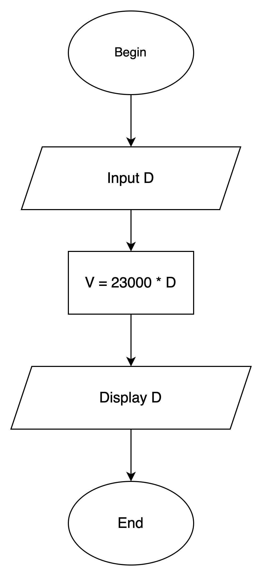

1. Mô tả thuật toán tìm giá trị lớn nhất trong 3 số

Begin

Input A, B, C

Max = A

IF ( B > Max)

Display B

ELSE ( C > Max )

Display C

ELSE

Display A

End

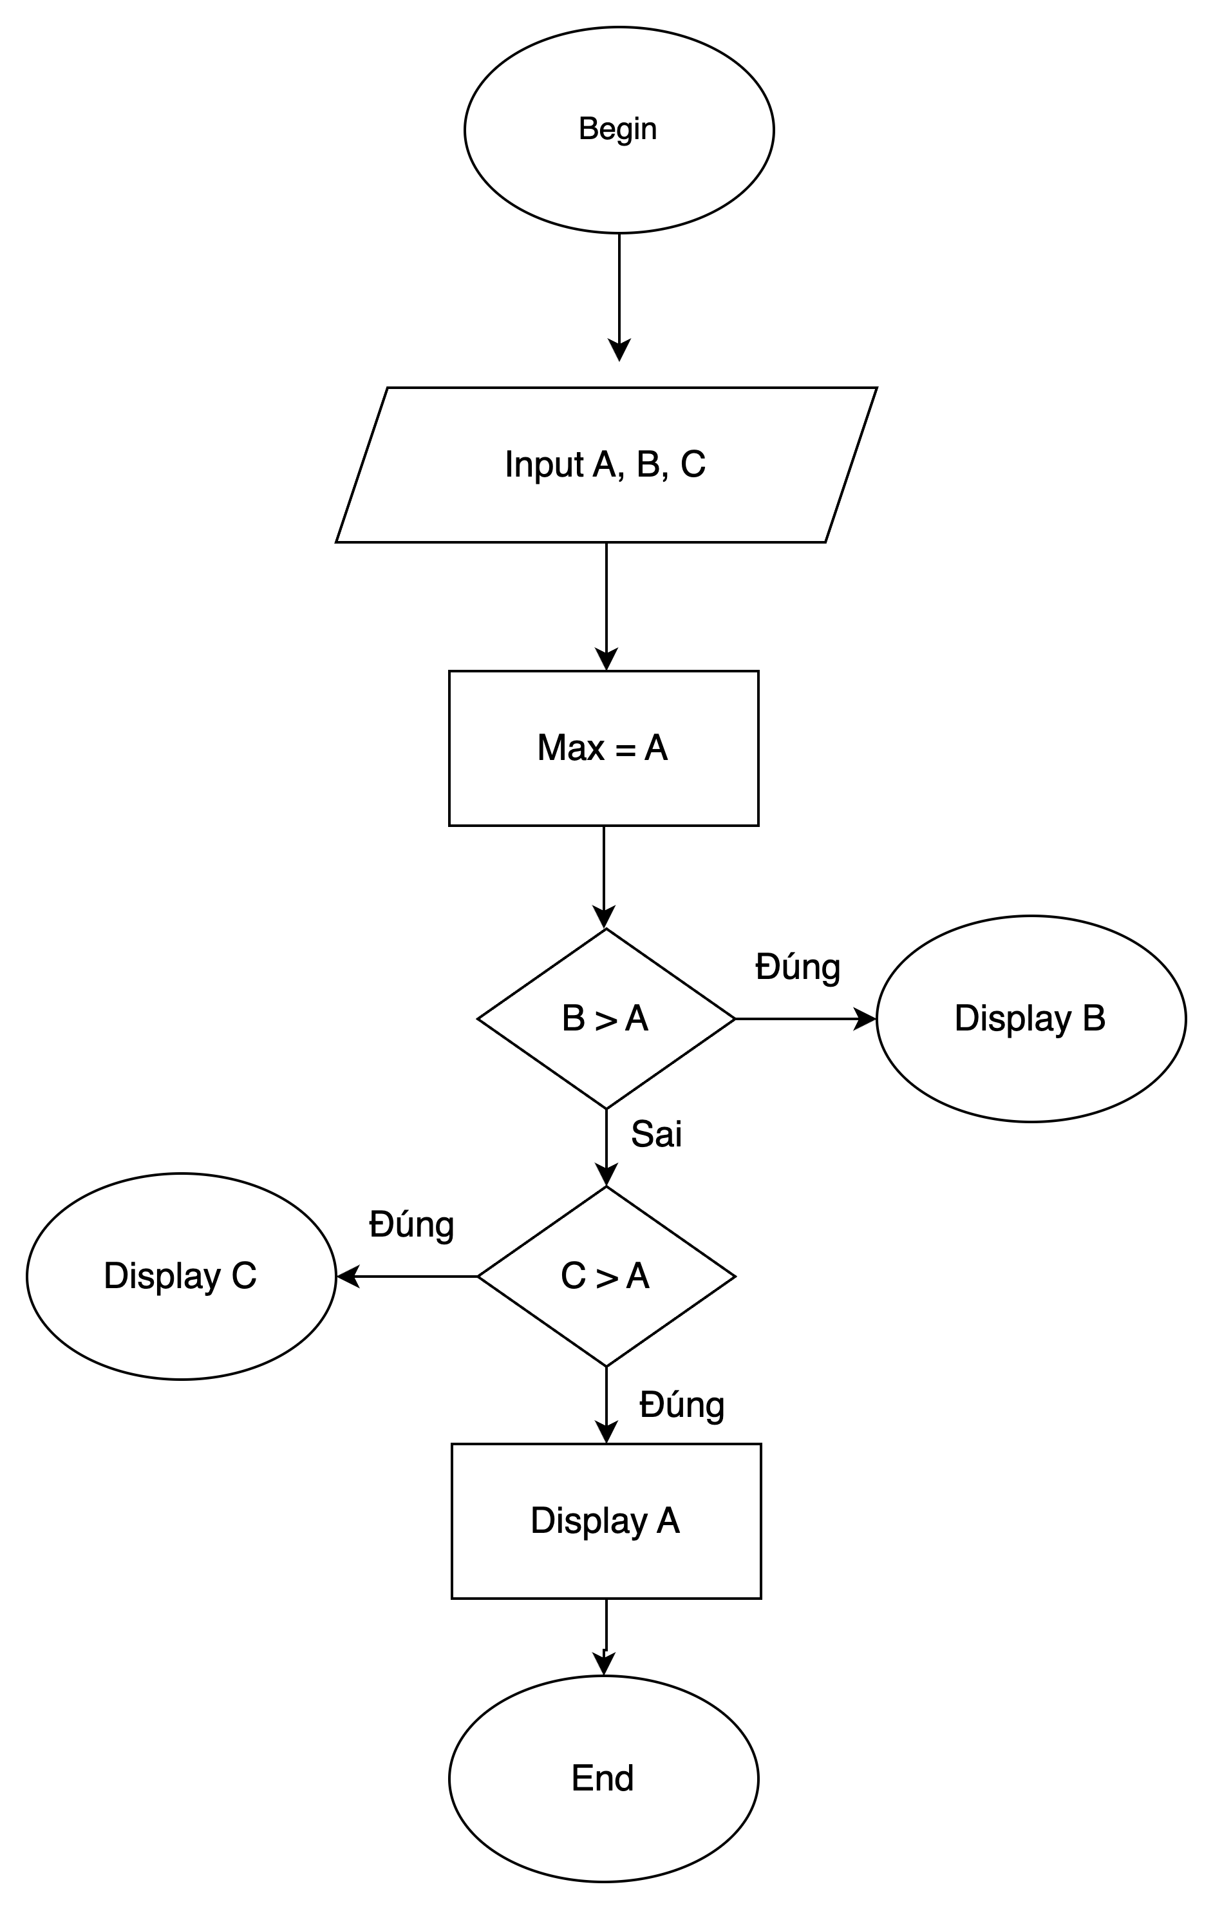

1. Mô tả thuật toán tìm giá trị lớn nhất trong một dãy số

Begin

Input N và a1, a2,...,aN

Max = a1

FOR ( i = 2; i < N; i++)

IF ( ai > Max )

Display ai

End

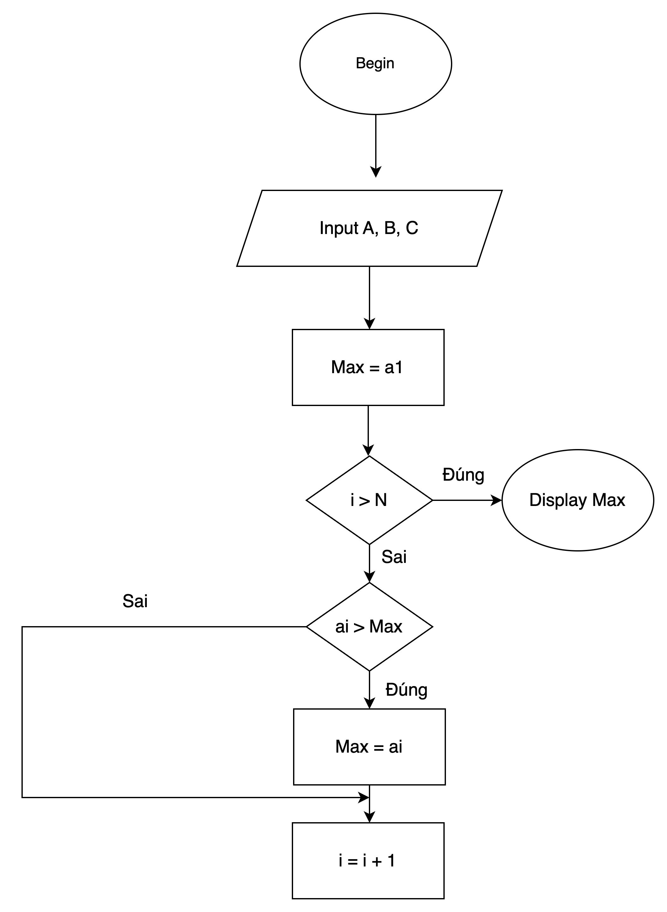

5 .Mô tả thuật toán có cấu trúc điều kiện

Begin

Input 0 < N < 100

IF ( N => 75 )

Display A

ELSE ( 60 <= N < 75 )

Display B

ELSE ( 45 <= N < 60 )

Display C

ELSE ( 35 <= N < 45 )

Display D

ELSE ( N < 35)

Display E

End

