

HANOI UNIVERSITY OF SCIENCE AND TECHNOLOGY
SCHOL OF INFORMATION TECHNOLOGY AND COMMUNICATION
----------



AI PROJECT REPORT

Project name: Predicting Housing Prices

Supervisor Assoc. Prof. Phạm Văn Hải

Group 14

Student names:

Tống Thành Vinh | 20194884
Phan Nguyên Anh | 20194727
Phạm Vũ Huy | 20194779
Phạm Đức Minh | 20194803

Hà Nôi, 11/2021

Hà Nội, tháng 10 năm 2012

AI Project name:

Predicting Housing Prices
¹ Class ICT Global, Hanoi University of Science and Technology, No1. Dai Co Viet st., Hanoi, Vietnam
²
Abstract. Summary about 200 words.

House prices increase every year, so there is a need for a system to predict house prices in the future. House price prediction can help the developer determine the selling price of a house and can help the customer to arrange the right time to purchase a house. A model trained on this data that is seen as a good fit could then be used to make certain predictions about a home — in particular, its monetary value. This model would prove to be invaluable for someone like a real estate agent who could make use of such information on a daily basis.
Keywords: loss function graph, Mini-batch gradient descent.
Table of content

1. Introduction / Overview of System / Background
2. related works
2.1 House Price Affecting Factors
2.2 Hedonic Pricing

3. The proposed model / Algorithm / Steps of the Algorithm / System
4. Experiments and results / Evaluation
4.1 Datasets
4.2 Testing methods
4.3 Experimental results
5. Conclusion

- Introduction / Overview of System/ Background

Prediction house prices are expected to help people who plan to buy a house so they can know the price range in the future, then they can plan their finance well. In addition, house price predictions are also beneficial for property investors to know the trend of housing prices in a certain location.
In this first section of this project, since the main goal of this project is to construct a working model which has the capability of predicting the value of houses, we will need to separate the dataset into features and the target variable. The features, 'RM', 'LSTAT', and 'PTRATIO', give us quantitative information about each data point. The target variable, 'MEDV', will be the variable we seek to predict. Next, we will observe the features to see how the features will affect the housing price.
In the second section of this project, we will develop a model. Firstly, we need to define a performance metric so that the AI knows how well it performs, regression analysis will be used for this part as it often describes how "good" that model is at making predictions. For the next implementation, it is required to take the Boston housing dataset and split the data into training and testing subsets. Typically, the data is also shuffled into a random order when creating the training and testing subsets to remove any bias in the ordering of the dataset.
In the third section of this project, we'll take a look at several models' learning and testing performances on various subsets of training data. Additionally, we'll investigate one particular algorithm with an increasing 'max_depth' parameter on the full training set to observe how model complexity affects performance. Graphing the model's performance based on varying criteria can be beneficial in the analysis process, such as visualizing behavior that may not have been apparent from the results alone.
In the final section of the project, we will construct a model and make a prediction on the client's feature set using an optimized model from fit_model. We will be using the grid search technique to optimize the learning algorithm, cross validation to support the grid search and finally gathering everything together and train a model using the mini-batch gradient descent algorithm

- Related Works
- House Price Affecting Factors
There are several factors that affect house prices. In his research Rahadi, et al. [1] divide these factors into three main groups, there are physical condition, concept and location. Physical conditions are properties possessed by a house that can be observed by human senses, including the size of the house, the number of bedrooms, the availability of kitchen and garage, the availability of the garden, the area of land and buildings, and the age of the house [2], while the concept is an idea offered by developers who can attract potential buyers, for example, the concept of a minimalist home, healthy and green environment, and elite environment. Location is an important factor in shaping the price of a house. This is because the location determines the prevailing land price [3]. In addition, the location also determines the ease of access to public facilities, such as schools, campus, hospitals and health centers, as well as family recreation facilities such as malls, culinary tours, or even offer a beautiful scenery [4], [5]. In general, the factors affecting the house prices will be presented in Table 1

TABLE I. HOUSE PRICE AFFECTING FACTORS
Literature | Physical condition |  |  |  |  |  |  | Concept | Location
[2] (Limsombunchai, 2004)
[5] (Jim and Chen, 2009)
[4] (kisilevich, Keim and Rokach, 2013)
[3] (Zhu and Wei, 2013)
[1] (Rahadi, et all, 2015)
[6] (Bryant, 2016)

- Hedonic Pricing
Hedonic pricing is a price prediction model based on the hedonic price theory, which assumes that the value of a property is the sum of all its attributes value [7]. In the implementation, hedonic pricing can be implemented using regression model. Equation 1 will show the regression model in determining a price. Where, y is the predicted price, and x1, x2, xi are the attributes of a house. While a, b, ... n indicate the correlation coefficients of each variables in the determination of house prices. nodes.
- The proposed model / Algorithm / Steps of the Algorithm / System
- The proposed model called House Price Prediction mainly uses Batch Gradient Descent on Regression to predict price of house based on given data sets.
- We have the following functions:

Get_permutation | This function will get a random degree permutation of feature N.
Polynomial_degree | Because with three given features can produce prediction results that are not very close to reality, we will use polynomial degree to increase the degree of the features by a predetermined value in order to get more accurate predictions.
Split_data | The processed data will be divided into training and testing sets using this function. Splitting data is required to create a firm foundation for training, comparing, and testing our models.
Feature_normalized | Because data might be too large for AI to learn easily, so this function exists to normalize such data.
Load_data_and_split | The function will read the data from the csv file and then process it by using Polynomial_degree, Feature_normalized and Split_data funtions for subsequent training.
Training_GD | This function will train the AI using mini-batch gradient descent algorithm.
Process_data | This function is the main function of our project. It is used to emphasize the values of the datasets as well as to call the function Training_GD in order to predict the houses’ prices and then display the result's score test.

Step 1. Collect data sets from UCI website
The dataset for this project originates from the UCI Machine Learning Repository. The Boston housing data was collected in 1978 and each of the 506 entries represent aggregated data about 14 features for homes from various suburbs in Boston, Massachusetts. For the purposes of this project, the following preprocessing steps have been made to the dataset:
- 16 data points have an 'MEDV' value of 50.0. These data points likely contain missing or censored values and have been removed.
- 1 data point has an 'RM' value of 8.78. This data point can be considered an outlier and has been removed.
- The features 'RM', 'LSTAT', 'PTRATIO', and 'MEDV' are essential. The remaining non-relevant features have been excluded.
- The feature 'MEDV' has been multiplicatively scaled to account for 35 years of market inflation.

Step 2: Exploring the datasets
- Minimum price is the lowest house’s price in the given datasets
- Maximum price is the highest house’s price in the given datasets
- Mean price is the average price of houses in the given datasets
- Median price is the middle point for real estate prices. It is not the same as the average price. The median price is the price in the very middle of a data set, with exactly half of the houses priced for less and half priced for more.
- Standard deviation of price is the statistical measure of market volatility, measuring how widely prices are dispersed from the average price. If prices trade in a narrow trading range, the standard deviation will return a low value that indicates low volatility.

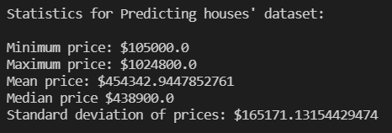

Step 3: Feature Observation
We are using three features from the Boston housing dataset: 'RM', 'LSTAT', and 'PTRATIO'. For each data point (neighborhood):
- 'RM' is the average number of rooms among homes in the neighborhood.
- 'LSTAT' is the percentage of homeowners in the neighborhood considered "lower class" (working poor).
- 'PTRATIO' is the ratio of students to teachers in primary and secondary schools in the neighborhood.

Step 4: Polynomial Features Transform (Polynomial_degree function)
Linear regression is linear in the model parameters and adding polynomial terms to the model can be an effective way of allowing the model to identify nonlinear patterns. This approach provides a simple way to provide a non-linear fit to data.

Step 5: Normalize the Polynomial Features (Feature_normalized function)
After step 4, the features become too large! So we would want to reducing the amount of the data while retaining its essential qualities

Step 6: Implementation: Shuffle and Split Data (Load_data_and_split function)
For the next implementation it is required to take the Boston housing dataset and split the data into training and testing subsets. Typically, the data is also shuffled into a random order when creating the training and testing subsets to remove any bias in the ordering of the dataset.

For a learning algorithm, splitting a dataset into some ratio of training and testing subsets is important for evaluating our model after it has been learned. We want to know if it has learned properly from a training split of the data. There can be 3 different situations:
1) The model didn´t learn well on the data thus can't predict even the outcomes of the training set, this is called underfitting and it is caused because a high bias.
2) The model learns too well the training data, up to the point that it memorized it and is not able to generalize on new data, this is called overfitting, it is caused because high variance.
3) The model just had the right balance between bias and variance; it learned well and was able to predict the outcomes correctly on new data.

Step 7. Calculate weights from the datasets (Training_GD function)

ALGORITHM: Mini-Batch Gradient Descent
Goals: We want to discover the weights so that the forecast price data produced (from given data and weights) is as near to the true price data as feasible.
- Idea: At each step, Mini-batch GD computes gradients based on a small random set of data and the data points are called mini-batches. The main advantage of Mini-batch GD over Stochastic GD is that we can make the most of hardware performance when performing math operations on matrices, such as GPUs.
- Input: Features produced from datasets (matrix X_train).
- Output: Matrix final_weight
1 | For i in range(number_iterations):
2 | Random ← random of permutation of (int(X_train.shape[0]/batch_size))
3 | New_weight ← none
4 | Foreach j in random:
5 | X_{j} ← X_train[j * batch_size to (j + 1) * batch_size]
6 | Y_{j} ← Y_train[j * batch_size to (j + 1) * batch_size]
7 | Temporary_predic ← dot product of (Xj and weight)
8 | New_weight ← weight – learning_rate * Xj.dot(Zj - Yj)
9 | If new_weight – weight < eplison:
10 | Final_weight ← weight Then Break;
11 | Else:
12 | New_weight ← weight – learning_rate

Step 8. Calculate predict price from given data and final weight (Training_GD function)

After getting the final_weight, we can extract the predict_price by calculating matrix production of processed_data and final_weight.
- Experiments and results / Evaluation
  - Dataset
The experiments of the proposed model has been tested in data sets, getting from the link [7]: https://archive.ics.uci.edu/ml/machine-learning-databases/housing
  - Testing method:
- The mean absolute error (MAE) calculates the average of absolute error for each predicted result. MAE is useful when measuring errors in certain units. MAE values can be calculated using:
$$MAE = \frac{\sum_{i=1}^{n}{|y_{i}-x_{i}|}}{n}$$

- The mean squared error (MSE) tells you how close a regression line is to a set of points. It does this by taking the distances from the points to the regression line (these distances are the “errors”) and squaring them. The squaring is necessary to remove any negative signs. It also gives more weight to larger differences. It’s called the mean squared error as you’re finding the average of a set of errors. The lower the MSE, the better the forecast.
$$MSE = \frac{\sum_{i=1}^{n}{(y_{i}-x_{i})^{2}}}{n}$$

- A Loss Function measures how well a given machine learning model fits the specific data set. It boils down all the different under- and overestimations of the model to a single number, known as the prediction error. The bigger the difference between the prediction and the ground truth, the higher the value of the loss function. In our project, we use the MSE Loss function type.

  - Experimental results
- Because of the properties of Mini-Batch Gradient Descent, the software will forecast the price of a property differently each time it is run based on various training and testing sets. However, the anticipated price will very certainly be as close to the actual price as posible.

- The AI will store the predicted price in a file called “log.txt”. In this file, there will be 3 main columns: Given Data, Predicted Price, Real Price

- TEST RESULT after some program executed:

- MAE and MSE table:

Execute the program # | Training Sets |  | Testing Sets
Execute the program # | Accuracy
Execute the program # | MAE Score | MSE Score | MAE Score | MSE Score
1 | 51636.996 | 4546750067.408 | 55906.879 | 5568714226.275
2 | 54845.593 | 4994352505.634 | 55792.066 | 5087867093.858
3 | 55532.204 | 5378901634.049 | 47168.951 | 3845657202.529
4 | 53281.204 | 4874864454.950 | 57065.828 | 6154367454.409
5 | 55537.205 | 5093993926.779 | 56468.790 | 4995068746.961

- Loss function graph for the 5th time the program executed:
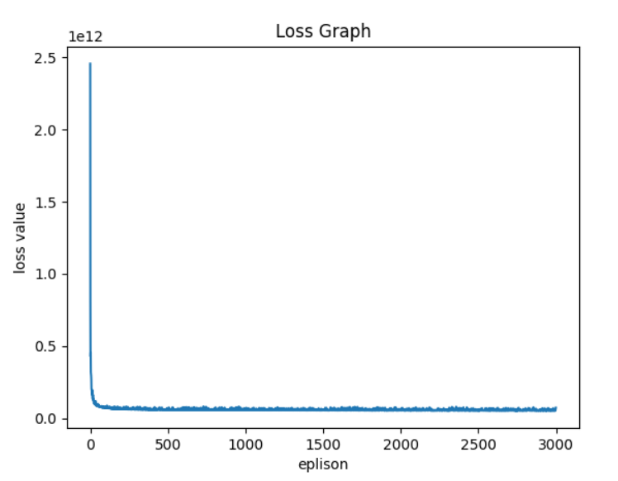
- Conclusion
In this paper, several tests have been performed using Mini-Batch Gradient Descent for polynomial regression. Due to the properties of this algorithm, the program forecasts the price of the property very close to the actual price. As can be seen above from the experimental results, each time the program executes a different score is obtained. The mean absolute error (MAE) score ranges from 47000 to 56000 for each execution due to the different sets of data being used. The score between training sets and testing sets are close approximate after training 3000 times due to the loss value asymptotes to 0 meaning the program stopped learning after around 50-100 trials.

References
- R. A. Rahadi, S. K. Wiryono, D. P. Koesrindartotoor, and I. B. Syamwil, ―Factors influencing the price of housing in Indonesia,‖ Int. J. Hous. Mark. Anal., vol. 8, no. 2, pp. 169–188, 2015.
- V. Limsombunchai, ―House price prediction: Hedonic price model vs. artificial neural network,‖ Am. J. …, 2004.
- D. X. Zhu and K. L. Wei, ―The Land Prices and Housing Prices —— Empirical Research Based on Panel Data of 11 Provinces and Municipalities in Eastern China,‖ Int. Conf. Manag. Sci. Eng., no. 2009, pp. 2118–2123, 2013
- S. Kisilevich, D. Keim, and L. Rokach, ―A GIS-based decision support system for hotel room rate estimation and temporal price prediction: The hotel brokers’ context,‖ Decis. Support Syst., vol. 54, no. 2, pp. 1119– 1133, 2013.
- C. Y. Jim and W. Y. Chen, ―Value of scenic views: Hedonic assessment of private housing in Hong Kong,‖ Landsc. Urban Plan., vol. 91, no. 4, pp. 226–234, 2009.
- L. Bryant, ―Housing affordability in Australia: an empirical study of the impact of infrastructure charges,‖ J. Hous. Built Environ., 2016.
- S. Rosen, ―Hedonic Prices and Implicit Markets: Product Differentiation in Pure Competition,‖ J. Polit. Econ., vol. 82, no. 1, pp. 34–55, 1974.

