
PEOPLE'S COMMITTEES
HO CHI MINH CITY
SAIGON UNIVERSITY



FINAL REPORT OF SOFTWARE TESTING
SNEAKER SHOP SOFTWARE TEST

Group:
Le Duc Nam - 3121411135
Tieu Quang Phu - 3121411165
Nguyen Van Ngan - 3121411142
Pham Thanh Vuong - 3121411229

GVHD: Dr. Do Nhu Tai

Ho Chi Minh City, December 2024

PREFACE
In today's information technology era, software plays an important role in managing and operating business activities. In particular, with the strong development of e-commerce, software applications not only help increase the efficiency of product management but also improve the customer experience. Our MWC slipper store has decided to implement an online sales management system to better serve the needs of our customers.
This report is carried out within the framework of the Software Testing course, in order to analyze and evaluate the testing process for the sales management system of MWC sneaker store. The content of the report will present the software requirements, design test scenarios, perform test cases, and analyze the test results.
Through this report, we hope to not only ensure the quality of the software but also improve customer satisfaction when experiencing in-store service. We also look forward to receiving valuable feedback from teachers and friends to improve the learning and research process.
We would like to express our sincere gratitude for the support and guidance of our lecturers and friends throughout the implementation of this report.

ACKNOWLEDGMENTS
We would like to express our sincere thanks to the Faculty of Information Technology, Saigon University for creating favorable conditions for us to implement the subject project "Software Testing". This is a valuable opportunity to help us consolidate our knowledge and develop the necessary skills, as a premise for further steps in our studies and work in the future.
We would also like to thank the teachers and teachers in the Faculty for always enthusiastically teaching and supporting, equipping us with a comprehensive and thorough knowledge base. Thanks to the dedication of teachers, we are more motivated and confident when facing challenges in the subject as well as in practical projects.
In particular, we would like to express our deep gratitude to Mr. Do Nhu Tai, who has imparted valuable knowledge to us and enthusiastically supported us throughout the learning process. Thanks to his guidance, we have more knowledge and skills necessary to complete this essay.
We would like to thank you very much.
TABLE OF CONTENTS
CHAPTER 1: TOPIC OVERVIEW 9
1. Introduction 9
2. Professional context 10
3. Conceptual model 11
CHAPTER 2: SOFTWARE SPECIFICATION 12
1. Overview 12
1.1. Use case diagram 12
1.2. ERD(Entity relationship diagram) 13
2. Specification of functions 14
2.1. Product Categories 14
2.2. Shopping Cart 16
2.3. Payment 19
2.4. User Management 23
2.5. Warehouse management 25
3. Functional Requirements 29
3.1. Registration and login 29
3.1.1. Registration and login for customers 29
3.1.2. Login for Administrators 31
3.2. Product list 32
2.2.1. Featured products 32
2.2.2. Products by item 33
2.2.3. Product Search 34
2.2.4. Product Details 34
3.3. Shopping Cart 35
3.4. Payment 37
3.5. User Management 39
3.5.1. User List 39
3.5.2. List of administrators 39
3.6. Inventory management 41
2.6.1. Product list 41
2.6.2. Product List 41
2.6.3. Add products 43
3.7. Invoice Management 43
3.7.1. Order Management 43
3.7.2. Invoice management 45
CHAPTER 3: TESTING PLAN 46
1. Testing Objectives 46
2. Test Scope 46
3. Features to check 47
3.1. Function 47
3.1.1. Product Management 47
3.1.2. Shopping Cart 47
3.1.3. Abate 47
3.1.4. User Management 47
3.1.5. Inventory 47
3.2. Non-functional 48
3.2.1. Session Support 48
3.2.2. Display Support 48
3.3. Design constraints 48
3.3.1. Maximum Character Length 48
3.3.2. Test Environment 48
3.3.3. Characters 48
3.4. Interface 49
3.4.1. User Interface 49
3.4.2. Admin Interface 49
4. Features not tested 49
4.1. User Accounts 49
4.2. User Account Lock 49
4.3. Delete a user account 49
4.4. Log in, register 49
5. Testing Strategy 50
6. Resources and roles 50
7. Testing Milestones 50
8. Test Results 51
CHAPTER 4: TEST DESIGN 51
1. Manual Testing 51
1.1. Business Requirement Document (BRD) 51
1.2. Technical Requirement Document (TRD) 52
2. White Box Testing 55
2.1. Test Design Workflow 55
2.1.1. Shopping Cart 56
2.1.2. Product list 59
2.1.3 Payment 61
2.1.4. User Management 63
2.1.5. Inventory management 65
2.1.5.1. Add a product category 65
2.1.5.2 Add products 67
2.2. Test Design 68
2.2.1. Shopping Cart 68
2.2.2. Product list 68
2.2.3. Payment 69
2.2.4. User Management 69
2.2.5. Inventory management 69
3. Black Box Testing 70
3.1. Test Case Review Checklist 70
3.2. Test case 71
3.2.1. Shopping Cart 72
3.2.2. Product list 72
3.2.3. Payment 72
3.2.4. User Management 72
3.2.5. Inventory management 73
3.3. Sequence of the shopping cart function 73
3.4. Unit Testing of the shopping cart management function 75
CHAPTER 5: TEST RESULTS 76
1. Test Report Test Case 76
1.1. Overview of results 76
1.2. Results by Module 76
1.3. Comments and suggestions 77
1.3.1. Overview Comments 77
1.3.2. Suggestions for improvement 77
2. Test Report Unit Testing 78
2.1. Overview of results 78
2.2. Results by Module 78
2.3. Comments 79
3. Defect List 79
CHAPTER 6: CONCLUSION 81
1. Advantage 81
2. Shortcoming 81
3. Development direction 81

PHOTO CATEGORIES
Figure 1: Product and Purchasing Management System Concept Model 11
Figure 2: General Model Usecase Diagram 12
Figure 3: Mô hình Entity relationship diagram 13
Figure 4: Sequence chart for product catalog function 16
Figure 5: Sequence chart for cart function 19
Figure 6: Sequence chart for payment function 22
Figure 7: Sequence chart for user management function 25
Figure 8: Home Interface 29
Figure 9: Registration and login interface for customers 30
Figure 10: Interface for entering account registration information 30
Figure 11: Login interface for admin 31
Figure 12: Admin management interface 32
Figure 13: Featured Product Interface 33
Figure 14: Horizontal Strap Slippers Product Catalog Interface 33
Figure 15: Product search interface 34
Figure 16: Detailed Product Interface 35
Figure 17: Cart interface when there are no products 36
Figure 18: Cart interface when products have been added 36
Figure 19: Pickup information interface 37
Figure 20: Payment Interface 38
Figure 21: Detailed interface and order history 38
Figure 22: Customer list interface 39
Figure 23: Admin list interface 40
Figure 24: Interface for adding administrators 40
Figure 25: Product Catalog Interface 41
Figure 26: Product List Interface 42
Figure 27: Product update interface 42
Figure 28: Add product interface 43
Figure 29: Order Management Interface 44
Figure 30: Order Details Interface 45
Figure 31: Invoice Management Interface 45
Figure 32: Activity diagram of the shopping cart function 56
Figure 33: Workflow of the shopping cart function 58
Figure 34: Activity diagram of the product catalog function 59
Figure 35: Workflow of the product catalog function 60
Figure 36: Activity diagram of the payment function 61
Figure 37: Workflow of the payment function 62
Figure 38: Activity diagram of the user management function 63
Figure 39: Workflow of the user management function 64
Figure 40: Activity diagram of the function of adding a product category 65
Figure 41: Workflow of the function of adding product categories 66
Figure 42: Activity diagram of the function of adding products 67
Figure 43: Workflow of the function of adding products 68
Figure 44: Test design of shopping cart function 68
Figure 45: Test design of product catalog function 68
Figure 46: Test design of payment function 69
Figure 47: Test design of the user management function 69
Figure 48: Test design of inventory management function 69
Figure 49: Test case review checklist 71
Figure 50: Test case 71
Figure 51: Test case of the function Shopping Cart 72
Figure 52: Test case of product catalog function 72
Figure 53: Test case of payment function 72
Figure 54: Test case of the user management function 72
Figure 55: Test case of inventory management function 73
Figure 56: The sequence model of the shopping cart function 74
Figure 57: Unit Testing of Cart Management Function 75
Figure 58: Test report của test case 76
Figure 59: Test report of unit test 78
Figure 60: Defect list in the system 79

TABLE CATEGORIES

Table 1: List of functions in the system 12
Table 2: List of entities in the system 13
Table 3: Focus use case description of the product catalog function 14
Table 4: Table describing the focus use case of the cart function 17
Table 5: Focus use case description table for the payment function 20
Table 6: Focus use case description table for user management functions 23
Table 7: Focus use case description table for inventory management function 26
Table 8: System Function Requirements Description 51
Table 9: Detailed functional requirements table of the system 53

CHAPTER 1: TOPIC OVERVIEW

1. Introduction
The MWC website is built on a modern architecture, ensuring flexibility, scalability, and high performance. Using leading technologies such as CSS, HTML, JS, PHP, and other popular libraries, MWC leverages the benefits of advanced development tools in the HTML ecosystem.
By using new components and open-source libraries, the MWC website not only improves the user experience but also increases the security and reliability of the application.
The modern programming architecture makes it easy for MWC to upgrade, add new features and ensure stable operation, meeting the needs of customers in the digital era.
In this report, my team focused on testing the main functions of the website with features such as product management, shopping cart, checkout, and user management, along with non-functional requirements such as interface and performance.
The steps include:
- Requirements Analysis
- Test Planning
- Test Design
- Perform the test
- Report Results
- Conclude
This report helps us better understand how the website works and the testing process, thereby detecting and fixing errors in time, ensuring the system operates stably and efficiently. In addition, testing forms the foundation for future software maintenance and development, helping to optimize performance, improve security, and enhance the user experience.

2. Professional context
The MWC website offers the following key functions:
- Account Registration and Login: Users can create a new account and log in to the system to use personalization and order management features.
- Product Categories: Buyers can browse product listings with filtering and sorting by product type. They can view the product details by clicking on it on the listing page. On the details page, they can see the product name, description, and the number of products in stock.
- Test the function of filtering products by category.
- Test the product search function.
- Test your product's paging functionality.
- Shopping cart and order management: Buyers can purchase any product in the product list via the "Buy" button on any product. Alternatively, they can purchase the product from the product detail page. After purchasing, they will see these products in the cart and a summary table with basic information such as the total cart cost, total order amount. Whenever they purchase more products or remove products from the cart, the summary table and cart are updated. They can then enter the address and proceed with the order by clicking on the "Checkout" button on the cart page. Administrators can view all user orders and can edit the status of orders. Administrators in the system can manage products and have the ability to assign them to existing warehouses.
- Test the function of adding, removing, and updating the number of products in the cart.
- Test the function of viewing the product list in the shopping cart.
- Check the total price in the cart.
- Test the function of viewing product information in the shopping cart.
- Payment: After the buyer clicks the "Place Order" button, the system will validate the product information, create an invoice, and the user can choose the payment method. After the user chooses the payment method, they need to press the "Order" button to confirm the order.
- Test your payments when you're signed in and you're not signed in.
- Test payment when the information entered is incomplete and when it has been entered sufficiently.
- User management: The system allows searching, adding, editing, and removing users/administrators.
- Test the function of adding, unlocking, and locking administrator accounts.
- Test the function of unlocking and locking customer accounts.
- Inventory management: The system allows administrators to add, delete, and update information and product quantities.
- Test the function of adding, deleting, modifying, and cataloging products.
- Test the function of adding, removing, and modifying products.

3. Conceptual model

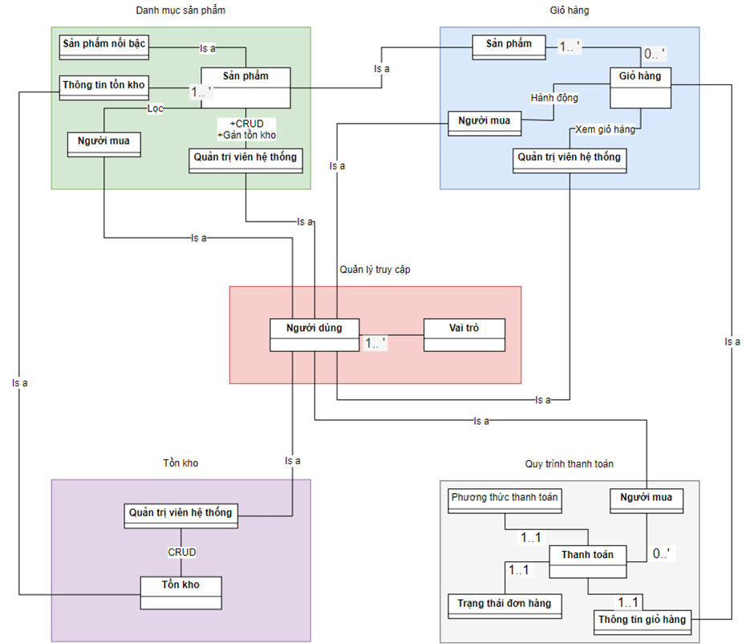
Figure 1: Product and Purchasing Management System Concept Model

CHAPTER 2: SOFTWARE SPECIFICATION

1. Overview

1.1. Use case diagram
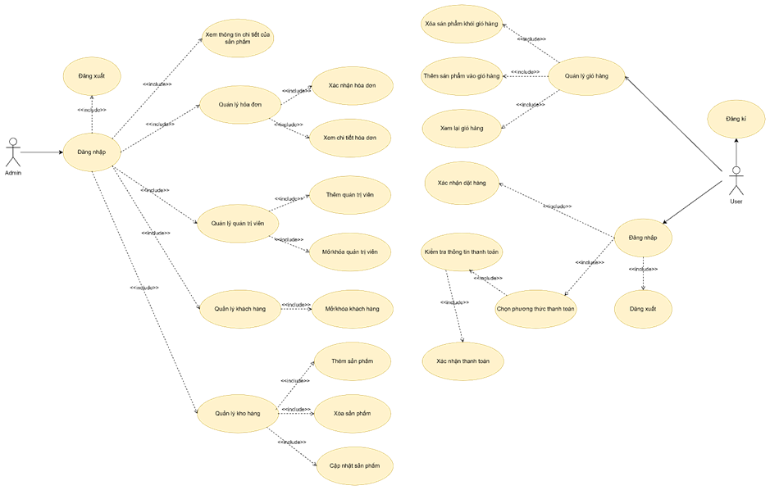
Figure 1:Heheh
Figure 2: General Model Usecase Diagram
Table 1: List of functions in the system
# | Name | Describe
1 | Login/Logout and Registration | Allows users to log out, log in, and register
2 | Customer Management | Allow customer unlock/lock
3 | Warehouse Management | Allows you to add products, delete products, edit product details, update product quantities.
4 | Admin Management | Allow adding and unlocking/unlocking admins
5 | Invoice Management | Allows viewing details and order confirmation
6 | Cart Management | Allows to view details and add, delete, edit carts

1.2. ERD(Entity relationship diagram)
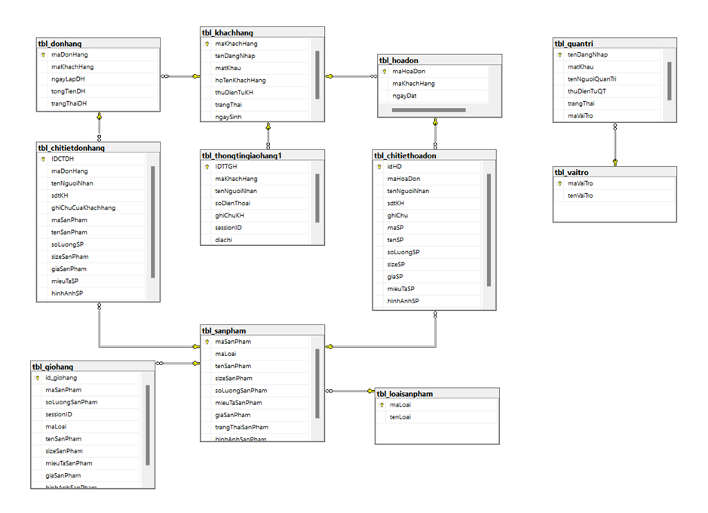
Figure 3: Mô hình Entity relationship diagram

Table 2: List of entities in the system
# | Entity | Describe
1 | tbl_khachhang | A list of all customers in the system.
2 | tbl_quantri | Information about admins in the organization.
3 | tbl_sanpham | Information about the products available in the system.
4 | tbl_giohang | Manage the items in your customer's cart.
5 | tbl_thongtingiaohang1 | Store customer contact information and shipping addresses.
6 | tbl_donhang | A list of all the orders that have been placed by the customer.
7 | tbl_loaisanpham | List of product types in the system.
8 | tbl_hoadon | Information about the invoices that are generated for the orders.
9 | tbl_vaitro | A list of all roles or positions in the organization.
10 | tbl_chitiethoadon | Store invoice details related to orders.
11 | tbl_chitietdonhang | Store the details of the products in each order.

2. Specification of functions
Functional specifications help to describe in detail the specific operations of the system through Focus Use Cases. This helps the reader understand the tasks that the user can perform, as well as how the system responds to each user's actions.

2.1. Product Categories
Focus Use Case "Product Catalog" describes a function that allows users to view product listings, search for insights, and filter products by different criteria. Below is a diagram of the Focus Use Case and details of the steps to interact between the user and the system:

Table 3: Focus use case description of the product catalog function
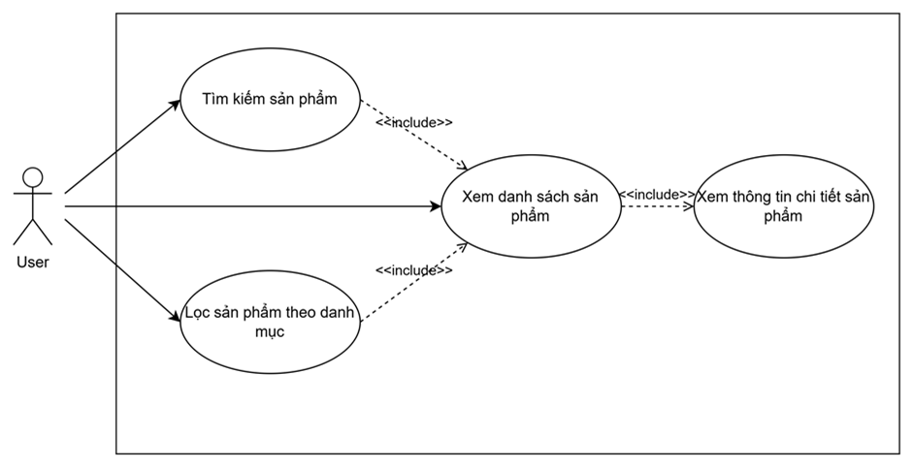
Use Case Number: | UC1
Use Case Name: | Product Categories
Actor(s): | User
Maturity: | Focused
Summary: | This function allows users to view detailed information about the products included in the website's product catalog, search for products by criteria, and filter products by categories.
Basic Course of Events: | Actor Action | System Response
 | 1. The user accesses the system
 |  | 2. The system displays the welcome page with key features for users to choose.
 | 3. User option to enter the product to view the product details. A1,A2
 |  | 4. The system displays the product detail page, including Product Name, Product Price, Detailed Description and Product Images.
Alternative Paths: | A1. Users search for products
 | Actor Action | System Response
 | 1. Users enter the product name and press "search"
 |  | 2. The system displays the list of suitable products. E1
 | A2. Users Filter products by category
 | Actor Action | System Response
 | 1. The user selects the product category.
 |  | 2. The system displays a list of products in the selected category.
Exception Paths: | E1. If the user presses "Search" with the criteria that there is no matching product, the system will display an error.  Go back to step 3.
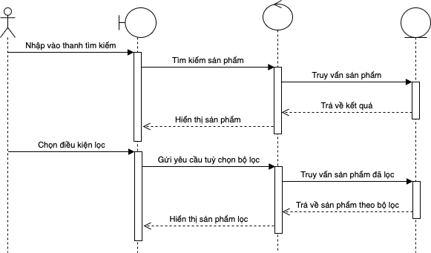
Figure 4: Sequence chart for product catalog function

2.2. Shopping Cart
The Focus Use Case "Cart" describes a function that allows users to manage the products in the cart, including adding, updating, deleting products, and viewing the total quantity and value of the selected products. Below is a diagram of the Focus Use Case and details of the steps to interact between the user and the system:

Table 4: Table describing the focus use case of the cart function
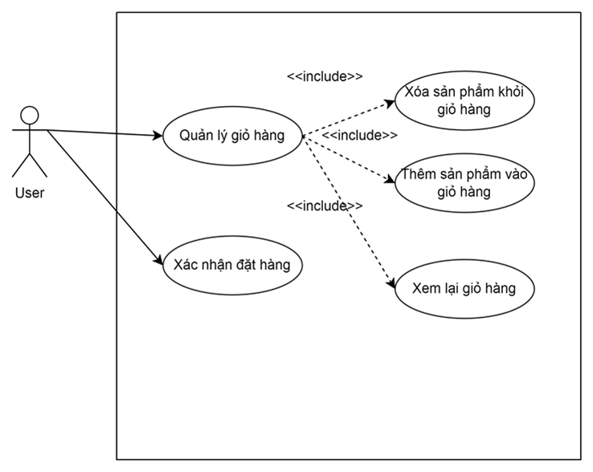
Use Case Number: | UC2
Use Case Name: | Shopping Cart
Actor(s): | User
Maturity: | Focused
Summary: | The Shopping Cart function allows users to add products from the product catalog to their personal shopping cart, manage quantities, view total funds, and proceed to checkout.
Basic Course of Events: | Actor Action | System Response
 | 1. The user selects the product, the number of products, and adds the product to the cart from the product detail page. A1
 |  | 2. Product quantity inspection system. E1
 |  | 3. The system will add the product to the user's cart.
 | 4. User option to go to "Shopping Cart". A2, A3
 |  | 5. The system displays a list of products in the shopping cart, including the following information: Product name, Product image, Stock status, Product price, Product quantity.
Alternative Paths: | Actor Action | System Response
 | 1. A1.The user selects to the shopping cart. A2, A3
 |  | 2. The system displays the products added to the cart.
 | A2. Users update the number of products in the cart
 | Actor Action | System Response
 | 1. The user changes the amount he wants.
 |  | 2. The system displays the shopping cart after updating. E2
 | A3. Delete the product in the cart.
 | Actor Action | System Response
 | 1. The user selects the "Delete" button of the product in the cart
 |  | 2. The system will update the number of products left in the cart.
Exception Paths: | E1: If the user adds a product to the cart and the quantity is more than the inventory, the system will message an error  Go back to step 1.  E2: If the user updates the quantity more than the inventory quantity, the system will message an error.  Return to step 1 of A2.

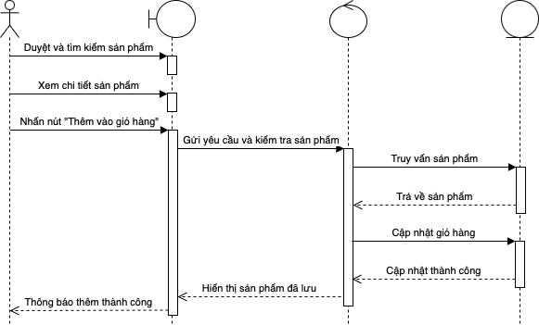
Figure 5: Sequence chart for cart function

2.3. Payment
The Focus Use Case "Checkout" describes a function that allows users to complete the shopping process through payment for the selected products in the cart. This function allows the user to double-check the shopping cart, select a payment method, enter the necessary information such as the shipping address and credit card information, and then confirm and complete the payment. Once the payment is successful, the system will notify you of the result and provide details about the order.
Table 5: Focus use case description table for the payment function
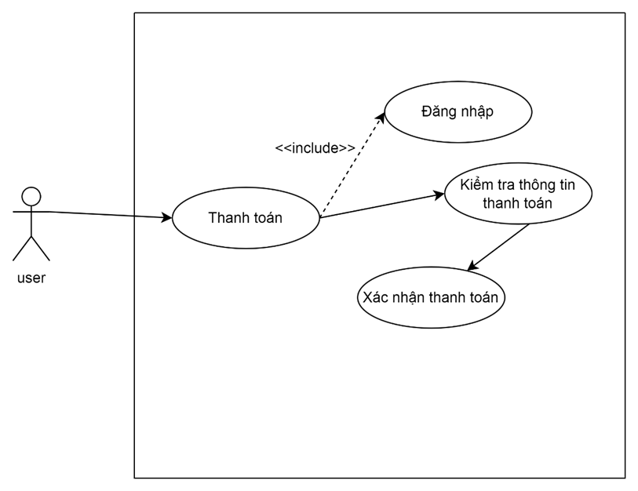
Use Case Number: | UC3
Use Case Name: | Abate
Actor(s): | User
Maturity: | Focused
Summary: | The Checkout function allows users to pay for products that have been added to their personal cart.
Basic Course of Events: | Actor Action | System Response
 | 1. The user taps the "Checkout" button in the shopping cart interface.
 |  | 2. The system displays Payment Information for users to enter information. E1,E2
 | 3. After the user enters the order information, the user will proceed with the order process.
 |  | 4. The system will display product information and order information. E3
 | 5. After the user re-checks the order and selects the payment method, the user will proceed to place the order.
 |  | 6. The system will announce the order is successful and the user's cart will be emptied. E4
Exception Paths: | E1: If the user has not logged in to the system, the system will take the user to the login page to log in to the system.  E2: If there are no products in the user's cart, the system will notify the user of the error.  E3: If the user does not enter complete order information, the system will message an error.  E4: If the user does not select a payment method, the system will message an error message

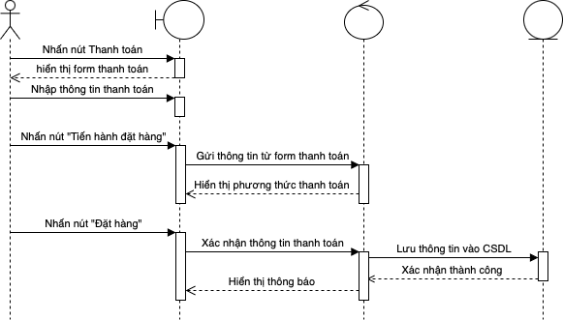
Figure 6: Sequence chart for payment function

2.4. User Management
The Forcus Use Case "User Management" describes a function that allows system administrators to perform user-related operations, including adding new ones, editing, locking/unlocking accounts, and managing access. This function helps to ensure that user accounts are properly controlled, secure, and have the right access to the system's functions.
Table 6: Focus use case description table for user management functions
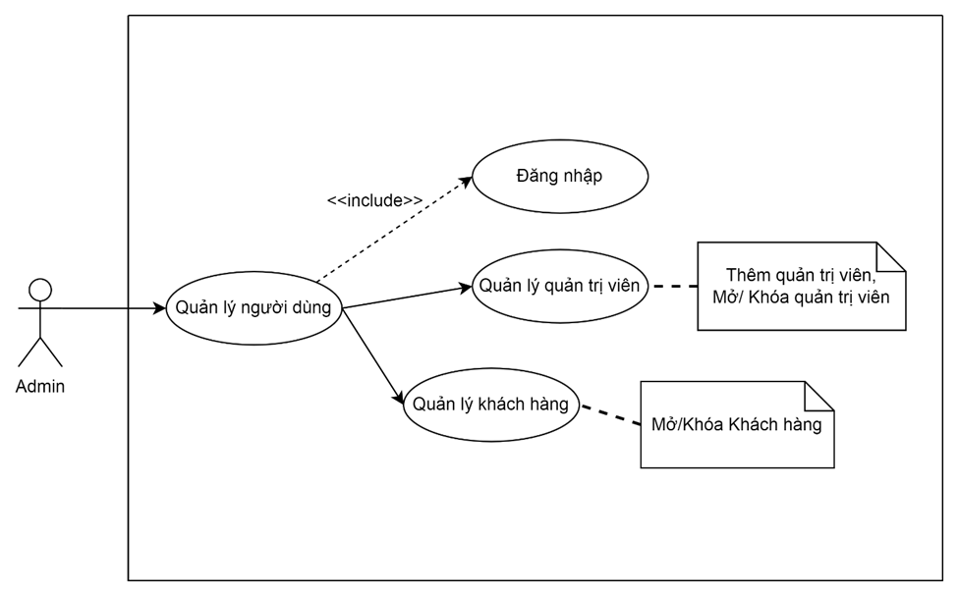
Use Case Number | UC4
Use Case Name: | User Management
Actor(s): | Admin
Maturity:
Summary: | This function allows administrators to track and manage user/administrator information, including viewing user/administrator lists, locking user/administrator accounts if needed, and adding new administrators.
Basic Course of Events: | Actor Action | System Response
 | 1. The administrator logs in to the admin page.
 |  | 2. The system displays the interface of the admin page.
 | 3. The administrator selects "Manage Administrators". A1
 |  | 4. The system displays the admin management page interface.
 | 5. The administrator selects "Add administrator". A2
 |  | 6. The system displays the interface to add administrators.
 | 7. The administrator enters the information and clicks "Add administrator".
 |  | 8. The system updates and adds new administrators to the system. E1
Alternative Paths: | A1 Admin chooses to manage customers
 | Actor Action | System Response
 | 1. The administrator selects "Client List".
 |  | 2. The system displays a list of customer accounts.
 | 3. Admin selects Open/Lock Client Account
 |  | 4. The system updates the status of the customer account and saves it to the system.
 | A2 Admin select "Open/Lock" for Admin
 | Actor Action | System Response
 | 1. The administrator selects "Open/Lock" the administrator's account
 |  | 2. The system updates the status of the administrator's account and saves it to the system.
Exception Paths: | E1. If the information is entered incorrectly, the system will report an error
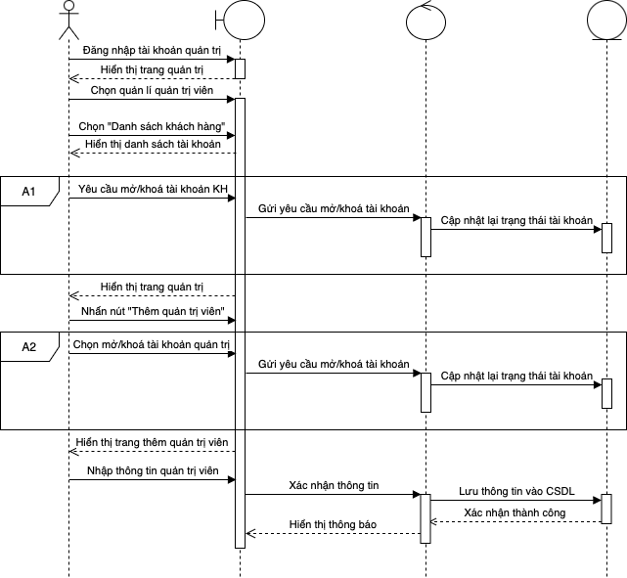
Figure 7: Sequence chart for user management function

2.5. Warehouse management
Focus Use Case "Warehouse Management" describes a function that allows administrators to perform operations to manage products in stock, including adding new ones, updating quantities, removing products from inventory, and checking inventory. This function helps to maintain the accuracy and completeness of inventory information, ensuring that products are always available for the sales process, while avoiding shortages or excess of goods.
Table 7: Focus use case description table for inventory management function
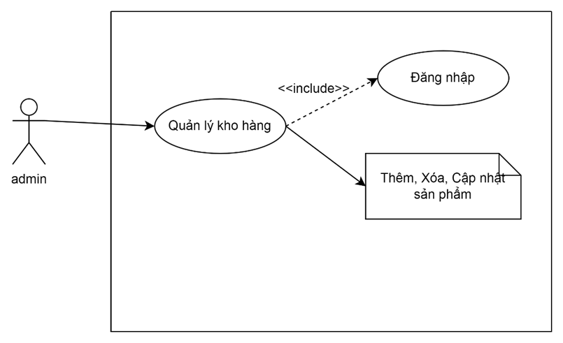
Use Case Number: | UC5
Use Case Name: | Warehouse Management
Actor(s): | Admin
Maturity:
Summary: | This function allows administrators to manage activities related to product catalogs, product listings, and adding products. The goal of this function is to help manage products effectively, ensure goods are closely tracked, and information is updated in a timely manner.
Basic Course of Events: | Actor Action | System Response
 | 1. The administrator logs in to the admin page.
 |  | 2. The system displays the interface of the admin page.
 | 3. Admin select "Product Category". A1
 |  | 4. The system displays the product catalog page interface.
 | 5. The administrator fills in the name and selects "Add" to add the product category. A2, A3
 |  | 6. The system updates the product catalog and returns to the interface of the product catalog.
Alternative Paths: | A1. Admin select "Products"
 | Actor Action | System Response
 | 1. Admin select "Products".
 |  | 2. The system displays the "Product List" and "Add Products" sections.
 | 3. Admin select "Product List".
 |  | 4. The system displays the product list page.
 | 5. Admin select "Add Product". A4, A5
 |  | 6. The system displays the interface for administrators to add products.
 | 7. The administrator enters the information of the product and selects "Add Product".
 |  | 8. The system updates the product and announces the successful addition of the product. E1
 | A2. Admin select "Edit" to edit the product category
 | Actor Action | System Response
 | 1. Admin select "Edit" to edit the name of the product category
 |  | 2. The system displays the page for the administrator to correct the product name.
 | 3. The administrator corrects the product name and clicks "Update".
 |  | 4. The system updates the name of the corrected product catalog and returns to the product catalog page
 | A3. Admin select "Delete" to delete the product catalogue
 | 1. The administrator selects "Delete" to delete the product catalog.
 |  | 2. The system confirms whether the administrator wants to delete or not.
 | 3. The user clicks "OK". A6
 |  | 4. Product catalog deletion system.
 | A4. Admin select "Edit" to edit the product's information
 | 1. The administrator selects "Edit" to edit the product information.
 |  | 2. The system displays the information of the product.
 | 3. The administrator corrects the information he wants to edit and clicks "Product Update".
 |  | 4. The system updates product information.
 | A5. Admin select "Delete" to delete the product
 | 1. The administrator selects "Delete" to delete the product.
 |  | 2. The system reconfirms whether you want to delete this product or not.
 | 3. The administrator selects "Ok". A6
 |  | 4. The system removes the product from the product list.
 | A6. The administrator selects "Cancel"
 | 1. The administrator selects "Cancel"
 |  | 2. The system returns to the current interface.
Exception Paths: | E1. If it is left blank or filled in in the wrong format, the system will message an error.

3. Functional Requirements

3.1. Registration and login

3.1.1. Registration and login for customers
When users visit the website, the system will display the option to "Log in" or register for new customers.
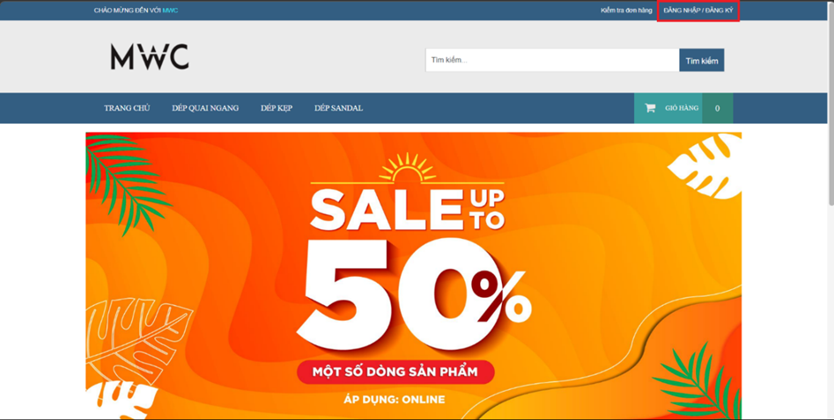
Figure 8: Home Interface
Or when the customer checks out the cart without logging in to the account, the system will ask the customer to log in or register to confirm the purchase.
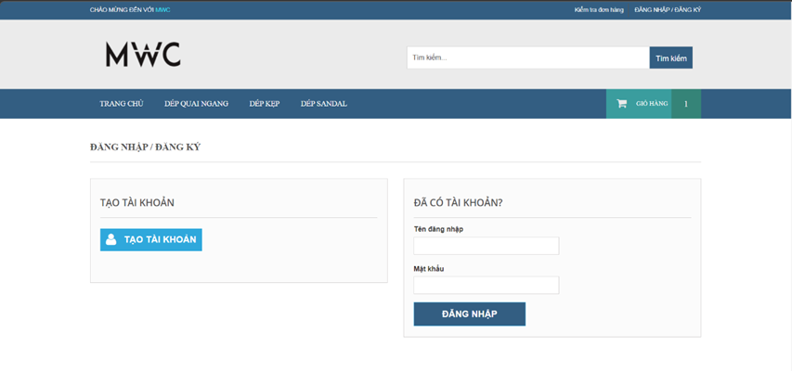
Figure 9: Registration and login interface for customers
If the user does not have an account yet, they can click on the "Create Account" button to begin the registration process. The system will ask you to enter the required information as follows:
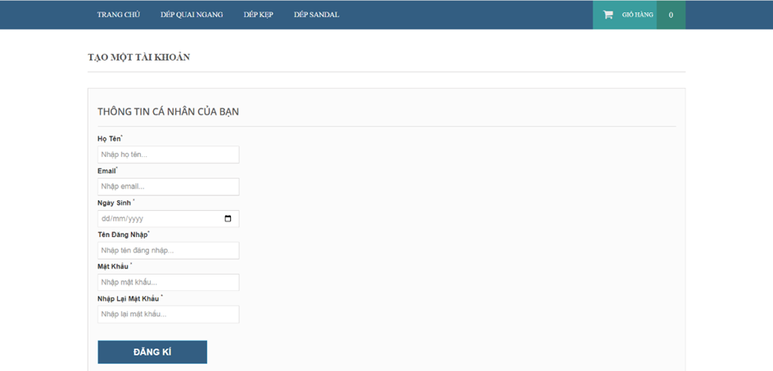
Figure 10: Interface for entering account registration information
- Full Name: Minimum 6 characters, maximum 20 characters. If you do not enter, the system will display the message "Please enter your full name".
- Email: Minimum 6 characters, maximum 50 characters. If you do not enter the correct format, the system will say "Please enter the correct email format". If you don't enter an email, the message "Please enter an email" will appear.
- Date of Birth: The user must select a valid date of birth. If not selected, the system will say "Please select date of birth".
- Username: Minimum 6 characters, maximum 20 characters. If you don't, the system will say "Please enter your account name". If the username already exists, the system will message "The username already exists, please re-enter".
- Password: Minimum 6 characters, maximum 15 characters. If you don't enter it, the system will say "Please enter the password".
- Re-enter the password: The user must confirm that the password matches the previously entered password. If you don't enter it, the system will say "Please re-enter the password". If the password does not match, the system will say "Confirm password does not match password".
After filling in all the information, users click "Register" to complete the account creation process.
For users who already have an account, they will enter their account information and password in the "Already have an account" section. If the login information is incorrect, the system will display the message "Wrong login information". After successfully logging in, users will be redirected to the product homepage.

3.1.2. Login for Administrators
When the administrator accesses the website, the system will display the login interface for the administrator only. The administrator will enter the Username and Password in the login form.
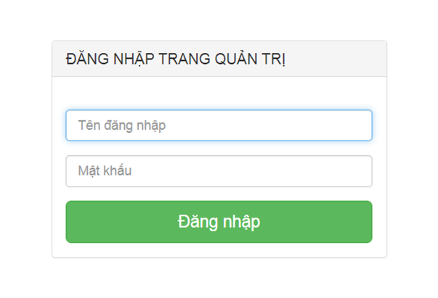
Figure 11: Login interface for admin
The administrator will enter his or her login information. If the information is incorrect, the system will display an error message: "Wrong login information". If the login is successful, the administrator will be redirected to the Admin Dashboard. If you enter the wrong information, the website will announce "Wrong login information!"
After a successful login, administrators will have access to the Admin Console, where they can manage all activities on the system, including:
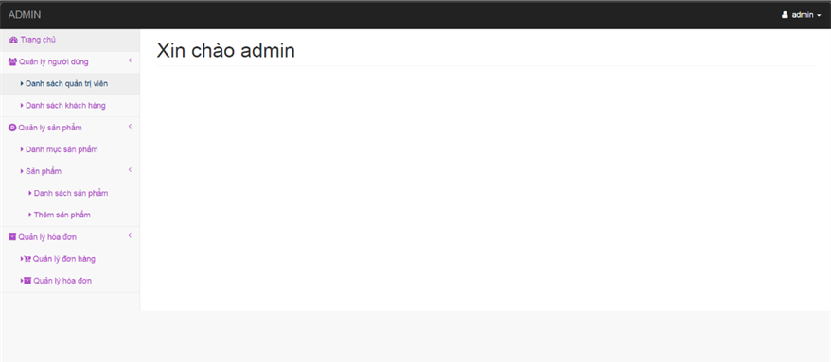
Figure 12: Admin management interface
- Product management (add, edit, delete products).
- Portfolio management.
- Manage orders and customers.
- Manage users and permissions.

3.2. Product list
The homepage will display the "Featured Products" section and the "Product Categories", making it easy for users to access and discover products by category.

2.2.1. Featured products
The homepage will have a "Featured Products" section to introduce the most outstanding products, making it easy for users to access popular products.
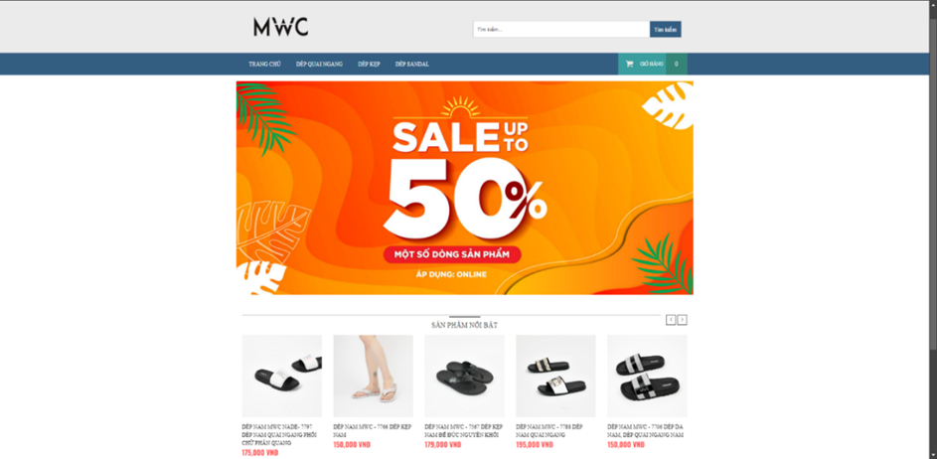
Figure 13: Featured Product Interface
Users can tap on each product in the list to see details about the product name, product price, product description and availability.

2.2.2. Products by item
In addition to "Featured Products", the homepage will also display products by category.
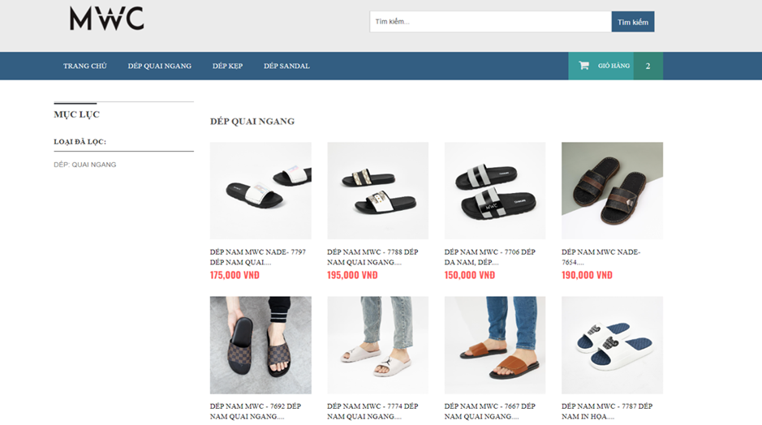
Figure 14: Horizontal Strap Slippers Product Catalog Interface
The homepage will include "Product Categories", allowing users to explore products by specific categories. Users can choose from available product categories such as: 'Horizontal Strap Slippers', 'Flip Flops' and 'SANDAL Slippers'

2.2.3. Product Search
On the homepage, there will be a "Search" bar to search for the products that users want to find.

Figure 15: Product search interface
Users can search for products by entering keywords in the search bar. The system will return a matching result or display a "No data found" message if the corresponding product is not available.

2.2.4. Product Details
Users can view the details of each product on the website, making it easy for them to choose and purchase products that suit their individual needs. Product details will include factors such as: product name, price, detailed description, and condition (in stock or out of stock). This information is clearly displayed to help users better understand the product before making a purchase decision.
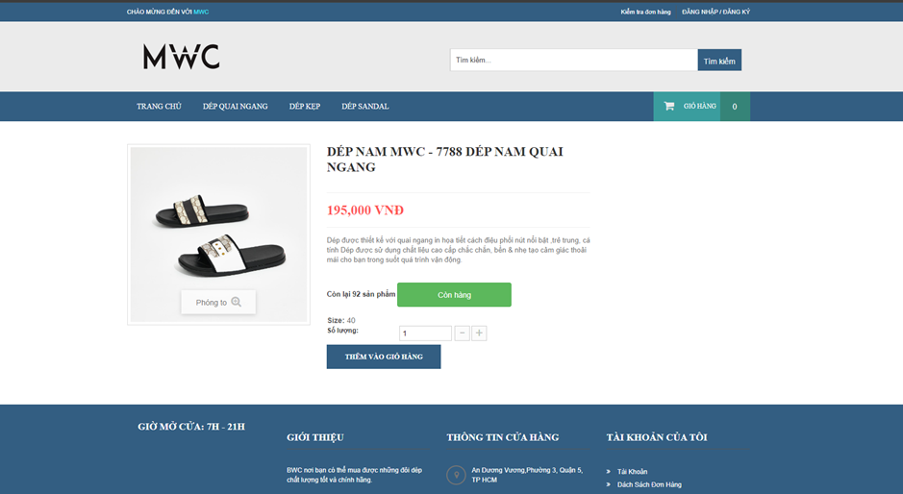
Figure 16: Detailed Product Interface
Users can also add products to the cart and select the desired quantity. This feature allows users to store the selected products in their cart, in order to make a purchase after completing the selection process.
When the user clicks the "Add to cart" button, the system will automatically add the product along with the selected quantity to the personal cart. The product will be saved in the cart until the user decides to make a purchase or remove it from the cart.

3.3. Shopping Cart
When the user clicks on the "Shopping Cart" section from the Home Page, the system will display the "Shopping Cart" screen, which lists all the products that have been added. The list of products in the shopping cart will display information such as the product name, condition, quantity, unit price, and total price of the product.
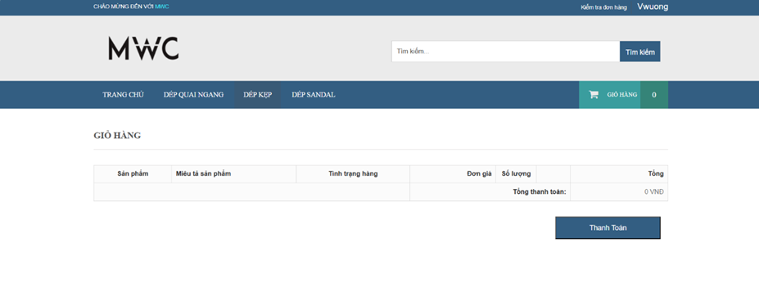
Figure 17: Cart interface when there are no products
If the cart is empty, the user will not be able to proceed with the checkout. In this case, when the user clicks checkout, the system may display a "No products in cart yet" message reminding the user to add the product to the cart before proceeding.
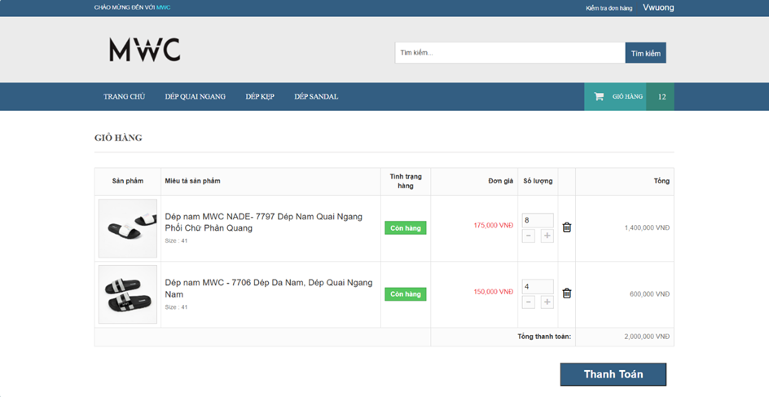
Figure 18: Cart interface when products have been added
Users can update the number of products in their cart if they want to buy more than one product.
If a user wants to remove a product from their cart, they can click on the 'Remove' button to remove it from their cart.
Users can view the total value of the cart in the bottom part of the screen, including the total value of all the products in the cart.
If the user wants to proceed with the payment, they can click on the 'Payment' button. The system will redirect the user to the 'Checkout' screen to continue the purchase process.

3.4. Payment
By clicking on the 'Checkout' section from the shopping cart, the 'Checkout' screen will be displayed where the user can complete their order.
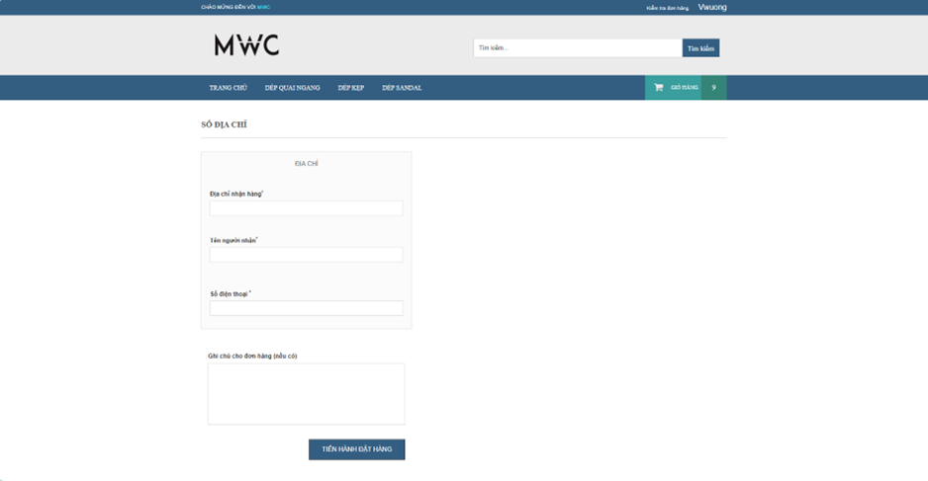
Figure 19: Pickup information interface
Before placing an order, the user must fill in the delivery information such as 'Shipping Address', 'Recipient Name', 'Phone Number' and 'Notes' for the user's order.
After the user fills in the delivery information, the user can press the 'Proceed to Order' button. Users will be redirected to the 'Payment' screen.
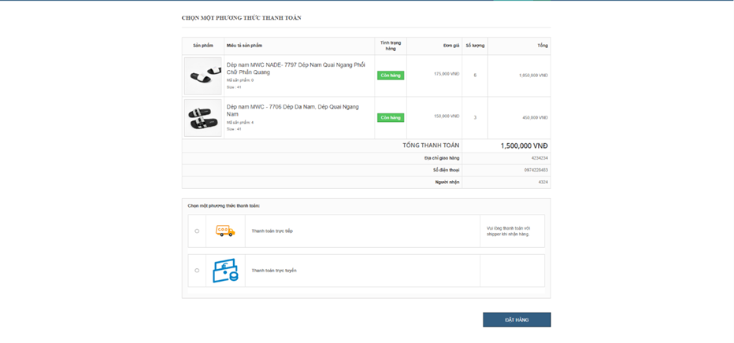
Figure 20: Payment Interface
Users can double-check that the product added to the cart, the total price that needs to be paid, and their pickup information is correct.
Users can choose a payment method to be able to pay more conveniently.
After double-checking the complete information, the user can press the order button, the system will send back the order confirmation message after the order is successfully placed.
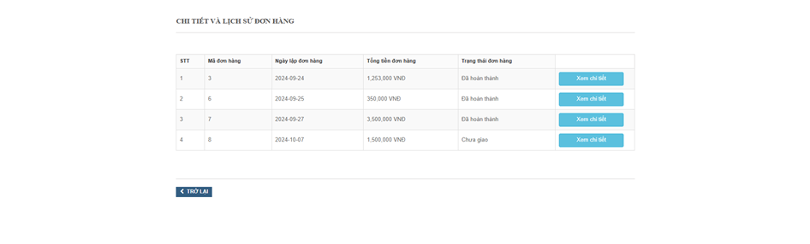
Figure 21: Detailed interface and order history
After placing an order, the user can review the details and order history that the user has placed earlier.

3.5. User Management
Once the administrator has logged in to the system, the Administrator who clicks on 'Manage Users' will display the 'administrator list' and 'customer list' for the administrator to select.

3.5.1. User List
By clicking on the 'User List' item from 'User Management', the 'User List' management screen will be displayed.
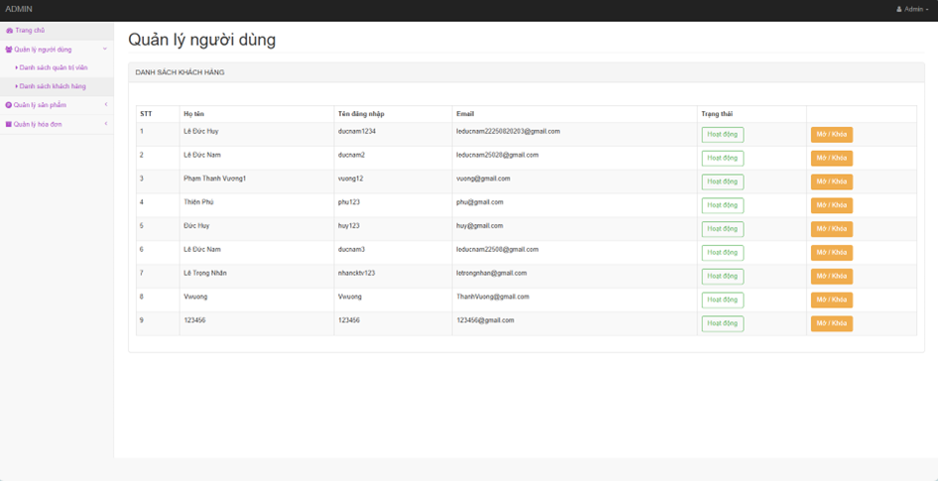
Figure 22: Customer list interface
Administrators can view a list of users in the system so that they can easily manage and track.
Administrators can lock/unlock users.

3.5.2. List of administrators
By clicking on the 'Admin List' item from 'User Management', the 'Admin List' management screen will be displayed.
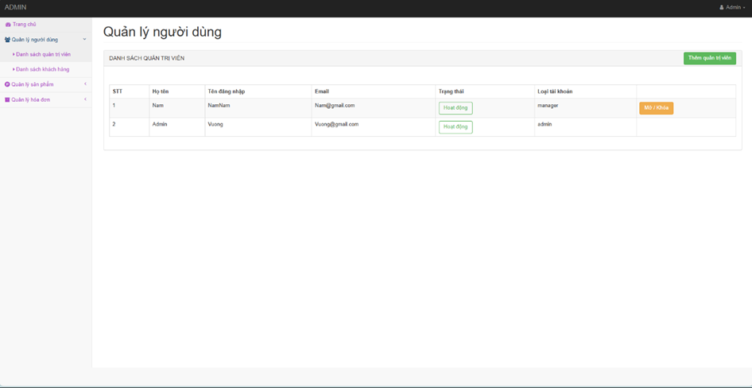
Figure 23: Admin list interface
Administrators can view the list of administrators in the system so that they can easily manage and track.
Administrators can lock/unlock users.
Administrators can add new users to the system to expand the team.
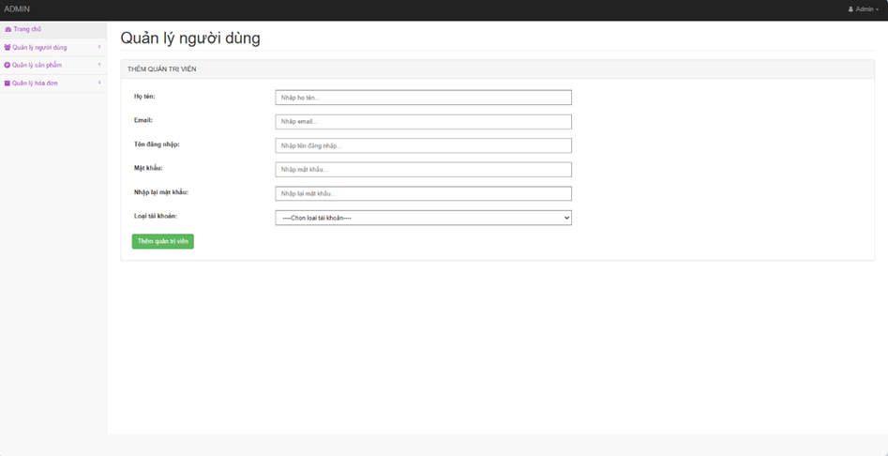
Figure 24: Interface for adding administrators
The administrator fills in information such as 'Full name', 'Email', 'Username', 'password', 'Account type'. After filling in the information, the administrator can click 'Add Administrator'.

3.6. Inventory management
Where admins can manage the product categories included in the store.

2.6.1. Product list
By tapping "Product Catalog" in the "Product Management" section, the interface of the "Product Catalog" page will be displayed.
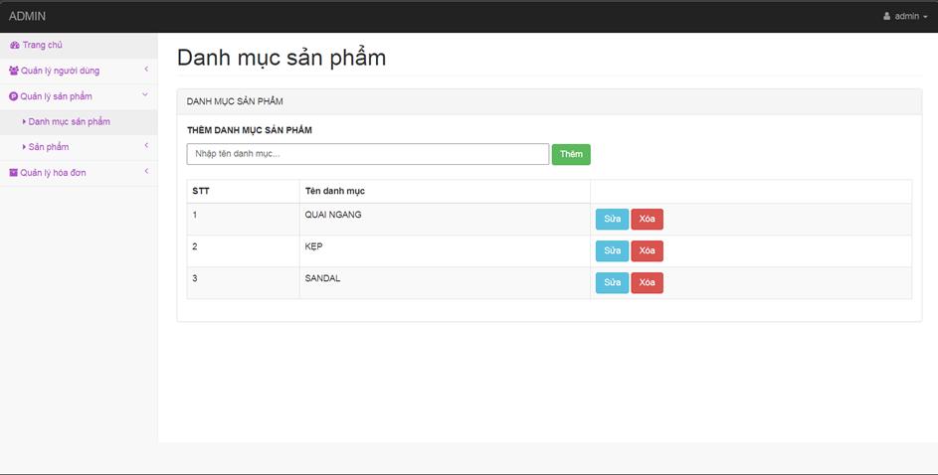
Figure 25: Product Catalog Interface
Admins can select "Add" to add a new product type to the product catalog. If you leave it blank and select "Add", the system will notify "Not left blank", on the contrary, after entering the product type name and then selecting "Add", the system will notify "Add category successfully".
In addition, admins can also select "Edit" to edit the product category name, or select "Delete" to remove that product type from the product catalog.

2.6.2. Product List
The product list is where admins can manage existing products. It displays in detail the product information, status, and administrators can take actions such as adding, deleting, editing.
By tapping "Product List" the product list interface will be displayed.
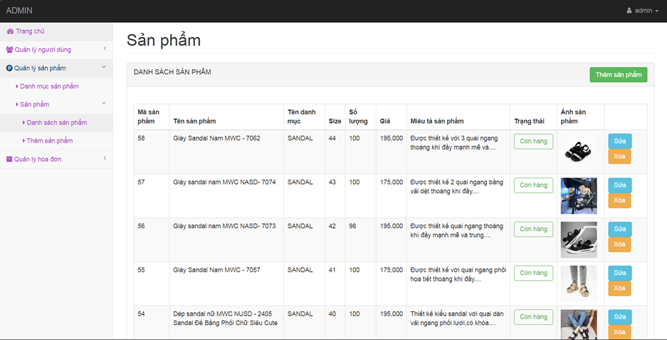
Figure 26: Product List Interface
By clicking "Edit", the system will display the information interface of the product, and the administrator can edit the information of each product.
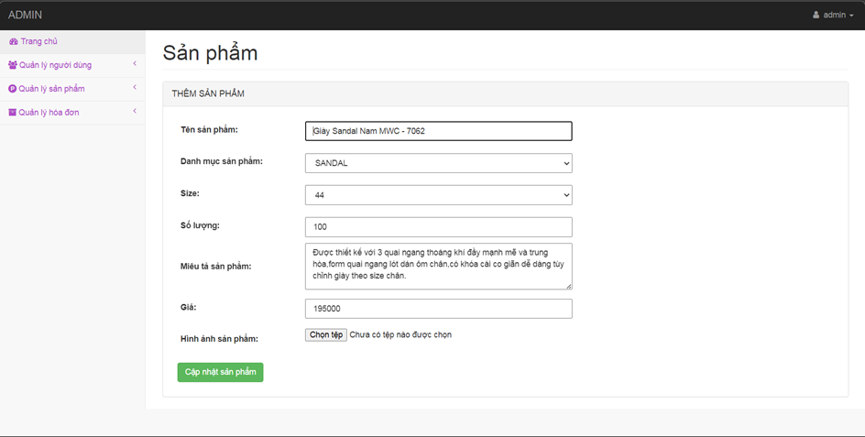
Figure 27: Product update interface
After correcting the information, click "Product Update".
In addition, administrators can also select "Delete". After selecting "Delete" a product, the system will ask for confirmation "Are you sure you want to delete this product". If you select "OK", then the product will be removed from the product list. If you select "Cancel", you will return to the product list interface.

2.6.3. Add products
By selecting "Add Product", the add product interface will appear.
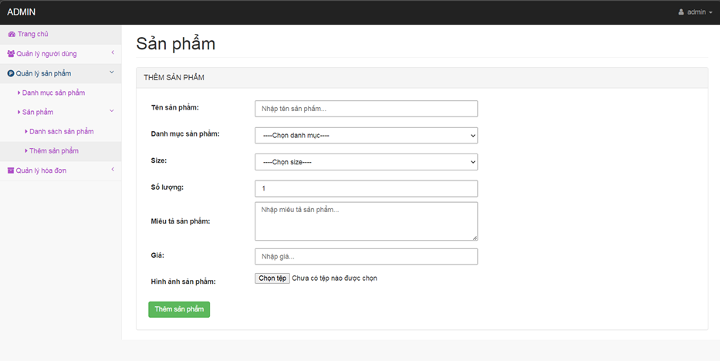
Figure 28: Add product interface
The administrator enters each product's information one by one, then selects "Add Product".

3.7. Invoice Management
Admins can review invoices, purchase history, or order confirmations.

3.7.1. Order Management
By tapping "Manage Orders" in the "Manage Invoices" section, administrators can review the list of undelivered or completed orders.
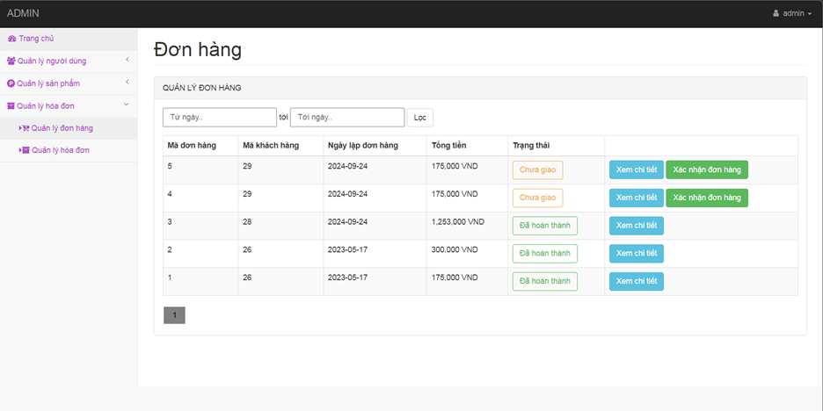
Figure 29: Order Management Interface
Administrators can filter the list of orders by date for easy management.
Admins can view information about each order such as 'order ID', 'customer ID', 'order date', 'total amount' and 'status' of that order.
Administrators can quickly search for orders by filtering orders by order creation date.
Admins can change the status of an order (for example, switch from "Undelivered" to "Completed").
Admins can tap 'view details', the system will display the specific details of the order.
Admins can view order details such as: 'Recipient Name', 'Phone Number', 'Shipping Address'.
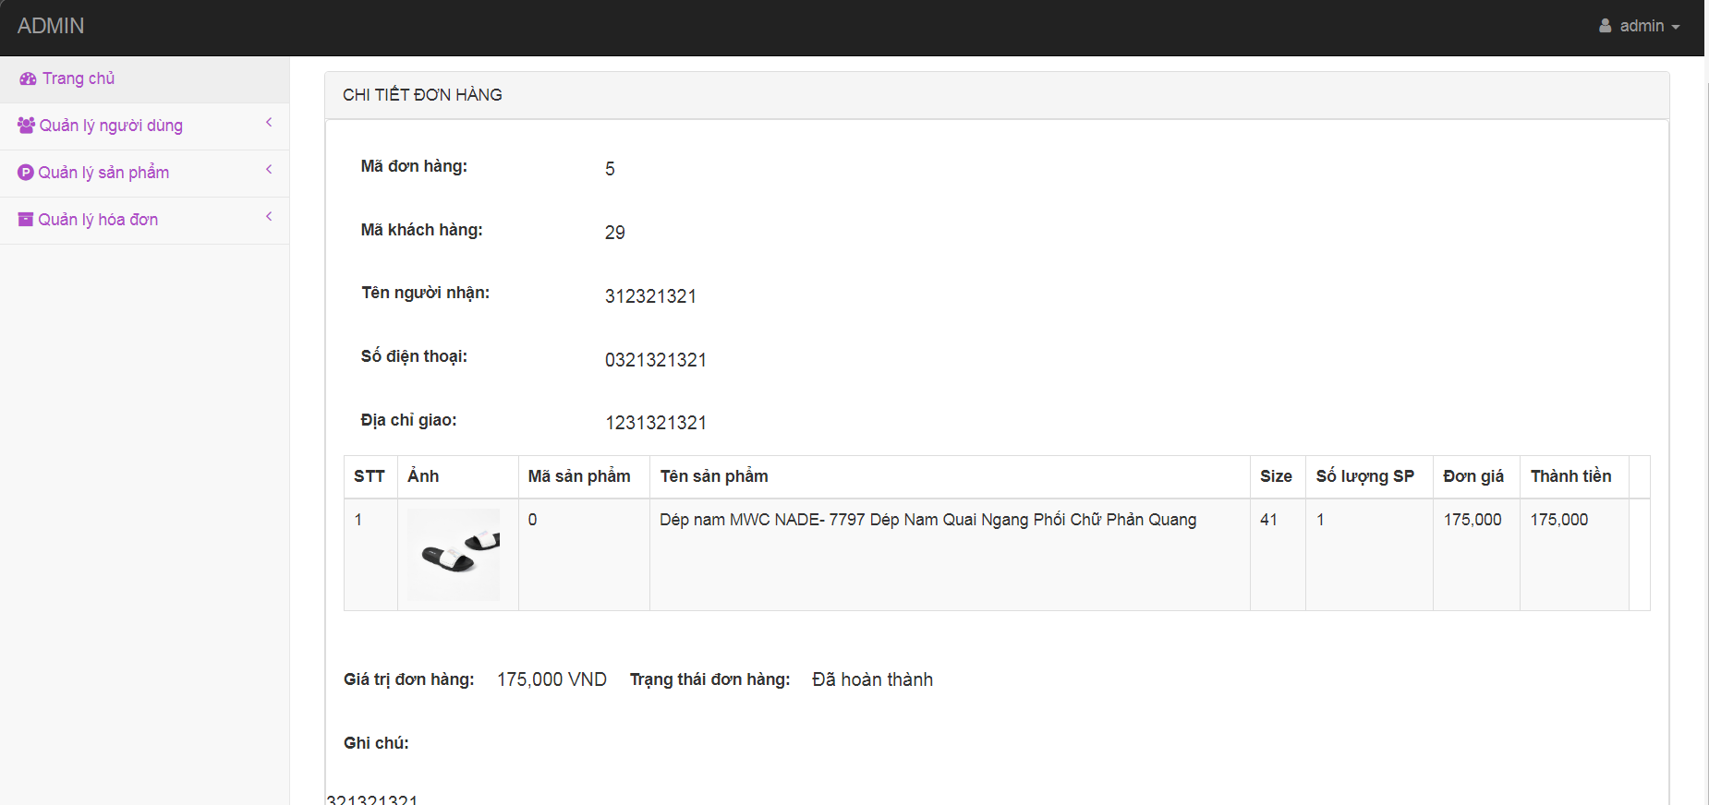
Figure 30: Order Details Interface
After completion, the administrator can select "Confirm Order" to mark this order as completed.

3.7.2. Invoice management
By selecting "Manage Invoices" in the "Manage Invoices" section of the web will display a list of orders and their values, administrators can click on "View Details" to view the order details.
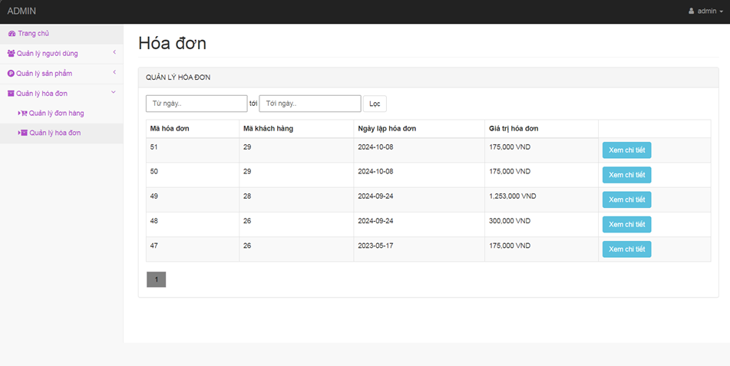
Figure 31: Invoice Management Interface

CHAPTER 3: TESTING PLAN
The software testing plan for the MWC website sets clear testing goals to ensure stability, performance, and a smooth user experience. The software needs to meet functional and non-functional requirements according to predetermined standards. This test document defines the methods, scope, and testing strategies for all components of the system, from the user interface to data management and security.

Testing Objectives
The test plan is established to achieve the following key objectives:
- Ensure Functional Correctness: Verify that all major functions of the system work in accordance with the requirements of the specification document.
- Error Detection and Repair: Detect all errors and issues that arise during operation, from user interface errors to database-related or security-related issues.
- Ensure compatibility and performance: Test the system's performance on multiple platforms, different browsers, and under heavy load pressure.
- Improve user experience: Evaluate the user interface and usability to ensure ease of understanding, usability, and support for the online shopping process.

Test Scope
The test scope of MWC software includes all the main features and processes of the system:
- Product Management:
- Featured product display on the homepage and product categories allow users to search, filter, and browse products.
- Supports viewing product details with information such as name, price, description, and condition.
- Shopping Cart and Checkout:
- Users can add products to the cart, update quantities, and delete products.
- The checkout process includes requiring a login or registration for users who do not have an account.
- The system supports multiple payment methods and manages order statuses.
- User Management:
- Users can register, log in, and manage personal accounts.
- The system manages client accounts and admin accounts, with appropriate decentralization.
- Administrators:
- Administrative features include managing products, categories, orders, and users.
- The admin interface will be tested to ensure that functions such as adding new, editing, and deleting data are working correctly.

Features to check

Function

Product Management
Add new products: Verify that the system provides the ability to add new products to the product list. The manager must provide product details (e.g., name, price, description).
Edit products: Verify that the system allows managers to edit existing product information.
Remove the product: Verify that the system requires confirmation from the manager when removing the product from the list.

Shopping Cart
Add products to cart: Verify that users can add products to carts.
Cart view: Verify that users can see a list of products in the cart, including information about quantities and total prices.
Update cart: Verify that users can change the number of products in the cart.

Abate
Make a payment: Verify that the system provides the ability to pay for the selected order. Users need to provide payment information (e.g., credit card, shipping address).
Order confirmation: Verify that the system requires user confirmation before completing the payment.

User Management
User account management: Verify that the system allows managers to view, edit, and delete user accounts.
User decentralization: Verify that the system allows decentralization for users (e.g., managers, buyers).

Inventory
Inventory Tracking: Verify that the system offers the ability to track the number of products in stock.
Inventory updates: Verify that the system allows managers to update the number of products available in stock after an order is fulfilled or a new item is imported.

Non-functional

Session Support
Verify that the system provides the ability to open multiple product browsing sessions at the same time: The number of open sessions should be limited only by the maximum number of network connections and memory available on the device.

Display Support
Verify that the system automatically adjusts to the device's capabilities: For high-resolution devices, the system needs to support the corresponding display format.
For mobile devices, for example, the resolution will automatically adjust to fit the screen size, ensuring a smooth and easy-to-see experience for users.

Design constraints

Maximum Character Length
Maximum length limit: Set a maximum length limit for a field (for example, user passwords can only be up to 15 characters). This helps to avoid entering too many unnecessary characters and minimizes security risks.
Minimum length limit: Set a minimum length limit to ensure that the input data is valid (for example, the password must be at least 6 characters long).

Test Environment
Verify that the system runs on modern browser versions such as Google Chrome, Firefox, Cốc Cốc , and Microsoft Edge.
Make sure that the system also works properly on popular mobile browser versions and mobile device emulators.

Characters
Verify that the app supports accurate interaction with different languages, especially Vietnamese and special characters, ensuring proper visibility and no errors when users type or interact in different languages on the MWC website.

Interface

User Interface
Verify that the system provides users with a user-friendly, modern, and compatible interface with different devices. The interface must comply with modern web design standards and the MWC branding.
Make sure all text input areas on the website (e.g. registration form, login) accept input from the keyboard and fully support Vietnamese characters.

Admin Interface
The admin interface must be simple, easy to use, allowing to manage functions such as order tracking, product management, and updating website information effectively. Make sure the admin interface is also compatible with different devices so that administrators can manage the website from a computer or mobile device at their convenience.

Features not tested

User Accounts
Verify that the system provides the ability to set up a user account for the MWC website, allowing users to register an account to manage personal information and place orders.
Verify that the system offers the ability to set up multiple user accounts, ensuring that each user can create and manage their own account.

User Account Lock
Verify that the system provides the ability to lock user accounts: Make sure that administrators can lock user accounts when needed, (for example, in the event that a user violates system policies or behaves suspiciously).

Delete a user account
Verify that the system provides the ability to delete user accounts: Make sure that administrators have permission to delete user accounts in special situations. When an account is deleted, all information related to the account must be deleted or hidden in accordance with security and privacy regulations.

Log in, register
Register an account: Verify that the system provides the ability to create a new account for the user. Users need to provide the required information (e.g., name, email, password) to complete the registration process.
Login: Verify that the system allows the user to log in to the registered account by providing a username and password.

Testing Strategy
The testing strategy is specifically designed for the MWC Slipper Shop system to clear the interface-based testing, with the goal of ensuring that all functions work as required and provide the best user experience:
- Functional Testing:
- Register and log in users (customers and administrators).
- Manage product categories: add, edit, delete categories.
- Cart operations: add products, delete, update quantities.
- Payment process: confirm the information, select the payment method, and save the order history.
- Administrative functions: manage users, orders, inventory.
- Non-Functional Testing:
- Evaluate compatibility across browsers (Chrome, Firefox, Microsoft Edge).
- Check the interface on different screen sizes (computer, tablet, phone).
- Evaluate page load speed, especially when you have a high user base.

Resources and roles
The MWC Slipper Shop system testing process uses the following resources and roles:
- Tester:
- Perform tests of key functions such as product management, shopping cart, checkout, and user management.
- Record detected bugs, coordinate with the development team to fix them.
- Resources:
- Test data: product listings, hypothetical orders.
- Testing tools: Excel for test case management, browser debugging tools.

Testing Milestones
Testing milestones for MWC Slipper Shop:
- Test Planning:
- Complete test documents, prepare test data.
- Test case design:
- Describe in detail testing scenarios such as adding products to carts, processing payments, etc.
- Perform the test:
- Test each of the main modules (shopping cart, product catalog, checkout, inventory management, user management).
- Report the results:
- Compile fault lists, assess system status, and recommend improvements.

Test Results
The test results of the MWC Slipper Shop system include:
- Functional Test Report: All key functions are tested with the following results:
- Error List:
- Record errors such as incorrectly displaying product status in the shopping cart, faulty interface on small screens.
- These errors have been classified according to severity and corrected in a timely manner.
- Overall Rating:
- The system fully meets the functional requirements.

CHAPTER 4: TEST DESIGN

Manual Testing
Manual testing plays an important role in the test design process, helping to identify and ensure that the functions of the system work properly from the user's perspective, including inputs and outputs.

Business Requirement Document (BRD)
BRD (Business Requirement Document) is designed to describe in detail the functional and non-functional requirements of the system. BRD plays an important role in defining core functions, defining the scope of work, as well as serving as a basis for the team to develop and test the implementation of the project effectively.
To clarify the functional requirements in the system, the BRD table below will describe in detail each function, the roles of the users, and specific descriptions:
Table 8: System Function Requirements Description
BR# | Function Name | Role | Describe
BR1 | Register, Login | Users, Administrators | User: Register a new account and log in to the system to use the functions.  Administrator: Log in to the system as an administrator, have access to and manage the entire system.
BR2 | Product Categories | User | Users: View product categories, search and view product details such as price, description, images, add products to cart.
BR3 | Shopping Cart | User | Users: Add products to the cart, update the number of products in the cart, remove products that you don't want to buy in the cart, and view the total payment amount.
BR4 | Abate | Users, Administrators | User: Make an order payment through the available payment methods.  Admin: Track transactions, manage orders, and view the details of each transaction.
BR5 | User Management | Admin | Admin: Admin  - Manage user accounts, check user activity status.  - View user lists, lock/unlock accounts, and manage user or system administrator access.  - Manage admin accounts, delegate permissions and check admin activity status.  - View the list of administrators, add new, lock/unlock accounts, and manage the access rights of users or system administrators.
BR6 | Warehouse Management | Admin | Administrators:  - Manage inventory, update the number of products in stock.  - Track the status of goods and import new goods into the warehouse.

Technical Requirement Document (TRD)
After the business requirements have been defined through the BRD document, the next step is to describe in detail the technical requirements of the system in the TRD. This document focuses on the technical criteria that need to be ensured during software development and testing, helping the system to operate properly and stably.
The table below details the technical requirements for the functions. Each technical requirement is numbered sequentially (TR#) and specifically described as follows:
Table 9: Detailed functional requirements table of the system
Function Name | TR# |  | Details
LOGIN AND REGISTRATION MANAGEMENT | Log | T1 | Usernames and passwords are not left blank
 |  | T2 | Usernames and passwords must be correct
 |  | T3 | If the login information is correct, the system allows access to the account
 |  | T4 | Data entry cells must be active and accept input
 |  | T5 | Function buttons must work properly
 | Application | T6 | Provide a detailed error message if there is incorrect or invalid information.
 |  | T7 | Registration fields are not left blank (username, password, email, etc.).
 |  | T8 | The username must be unique and not yet in the system.
 |  | T9 | Passwords must be of minimum length and contain special characters, uppercase letters, and numbers.
 |  | T10 | The email must be valid and not previously registered.
 |  | T11 | If the registration information is valid, the system creates a new account for the user.
 |  | T11 | Function buttons such as "Register" must work correctly.
 |  | T12 | Provide a detailed error message if there is incorrect or invalid information.
PRODUCT MANAGEMENT | Detailed Product Description | T13 | All required product information must be filled in and valid
 |  | T14 | The product code must be unique, not identical to existing product codes
 |  | T15 | Information fields must not be left blank
 |  | T16 | The product price must be positive, greater than 0
 |  | T17 | The product name must be 3 characters or more
 |  | T18 | Data entry cells must work
 |  | T19 | Function buttons must work properly
 | Delete a product | T20 | Products must be selected before deletion
 |  | T21 | If the product already has a related order, then it can't be deleted
 |  | T22 | If the information is valid, the product will be removed from the system
 |  | T23 | Function buttons must work properly
SHOPPING CART MANAGEMENT | Add products | T24 | Products and quantities must be selected before adding to cart
 |  | T25 | The number of products must be a positive integer, at least 1
 |  | T26 | Data entry cells must work
 |  | T27 | Function buttons must work properly
 | View Cart | T28 | If the cart is empty, the message "Cart is empty" is displayed
 |  | T29 | Calculate the total value of the cart based on all products and quantities
 |  | T30 | Data entry cells must work
 |  | T31 | Function buttons must work properly
PAYMENT MANAGEMENT | Abate | T32 | If the cart is empty, checkout cannot be made
 |  | T33 | The system must require the user to sign in before making a payment if they are not already logged in
 |  | T34 | Must validate complete and valid delivery information
 |  | T35 | Calculate the total amount including shipping if applicable
 |  | T36 | Function buttons must work properly
USER MANAGEMENT | Check the information | T37 | All required fields must be filled in and valid
 |  | T38 | Emails must be properly formatted, not identical to existing emails
 |  | T38 | Passwords must be at least 6 characters long
 |  | T40 | Function buttons must work properly
ORDER MANAGEMENT | Check Order | T41 | If you don't enter search information, then the entire order list is displayed
 |  | T42 | If there is a valid search information, then the corresponding order is displayed
 |  | T43 | If there are no results, the message "No matching order found" is displayed.
 |  | T44 | Data entry cells must work
 |  | T45 | Function buttons must work properly

White Box Testing
After completing the manual testing method. However, this method usually focuses only on testing the inputs and outputs without delving into the structure of the source code. To overcome this limitation and increase test coverage, the group switched to the white-box testing method to ensure the accuracy and logic of each function in the system and detect potential errors. Includes Test Design Workflow and Test Design.

2.1. Test Design Workflow
Test Design Workflow is the process of building a testing strategy to ensure all components of the system are fully tested. This process includes analyzing the requirements, selecting the appropriate testing method, identifying the parts to be tested, and making a detailed plan for each testing phase. The goal is to maximize the scope of testing, thereby detecting potential errors in the system early.

2.1.1. Shopping Cart
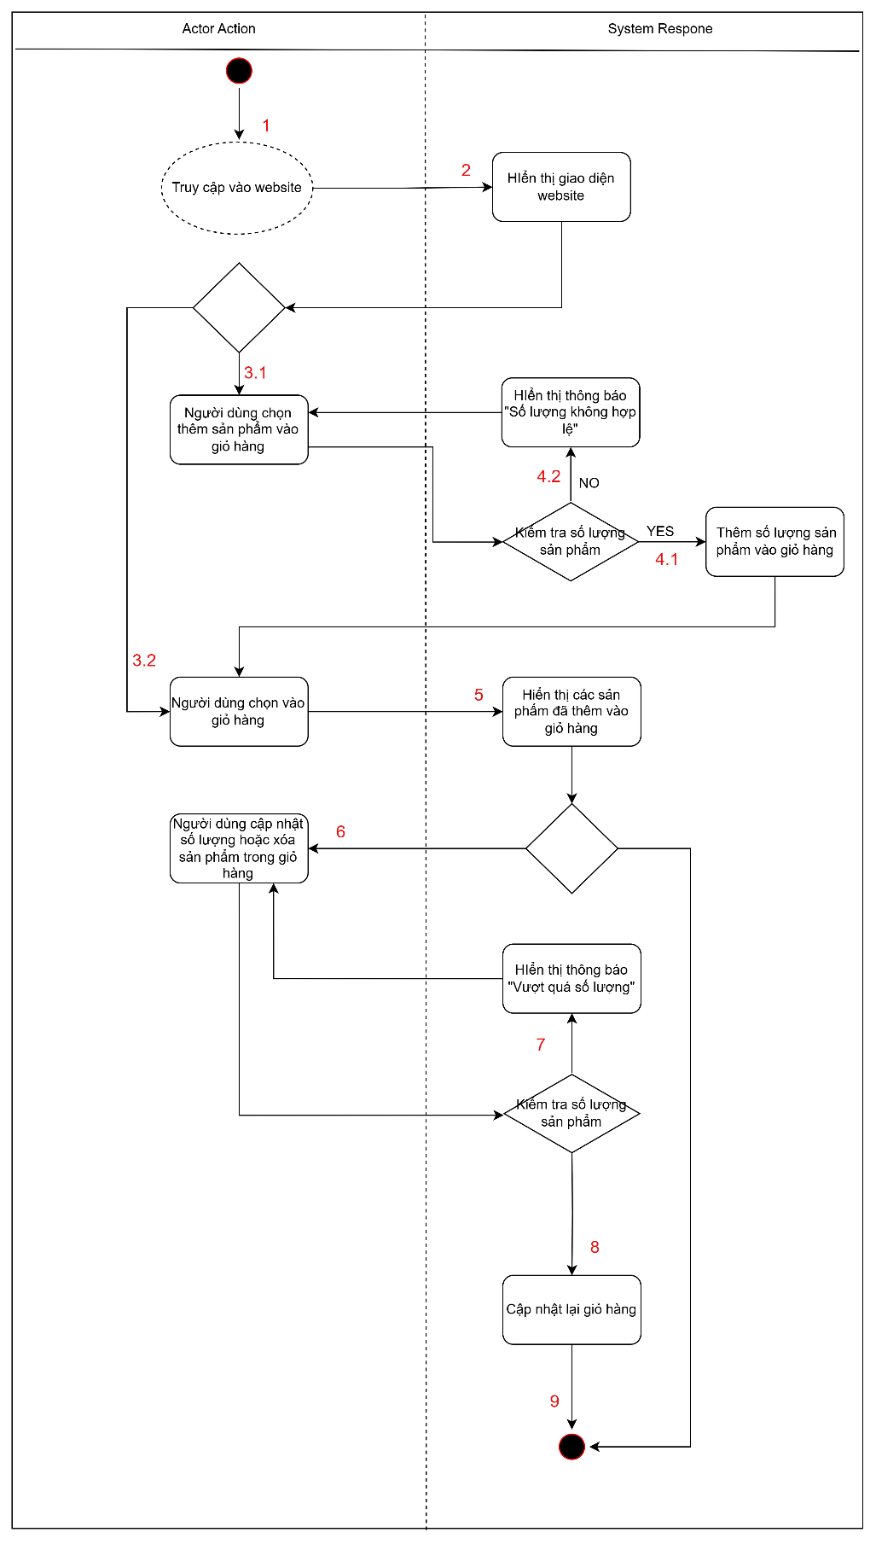
Figure 32: Activity diagram of the shopping cart function
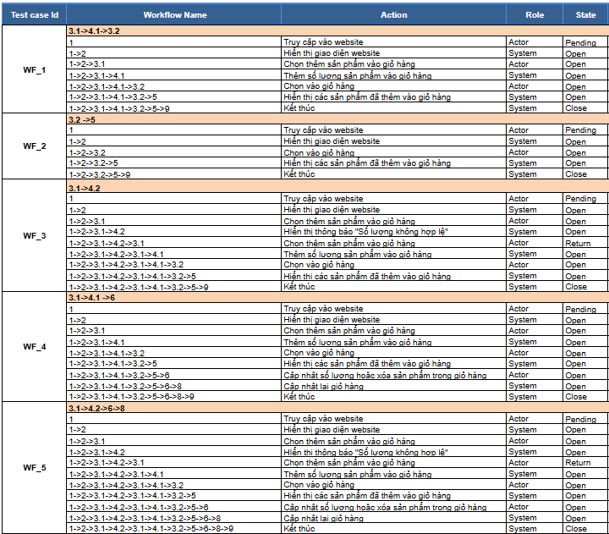
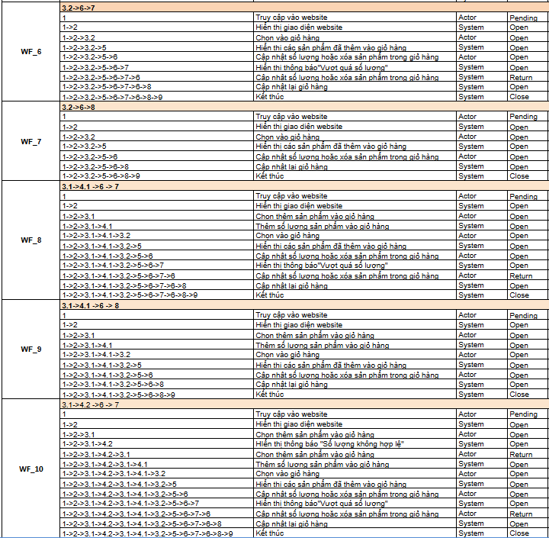
Figure 33: Workflow of the shopping cart function

2.1.2. Product list
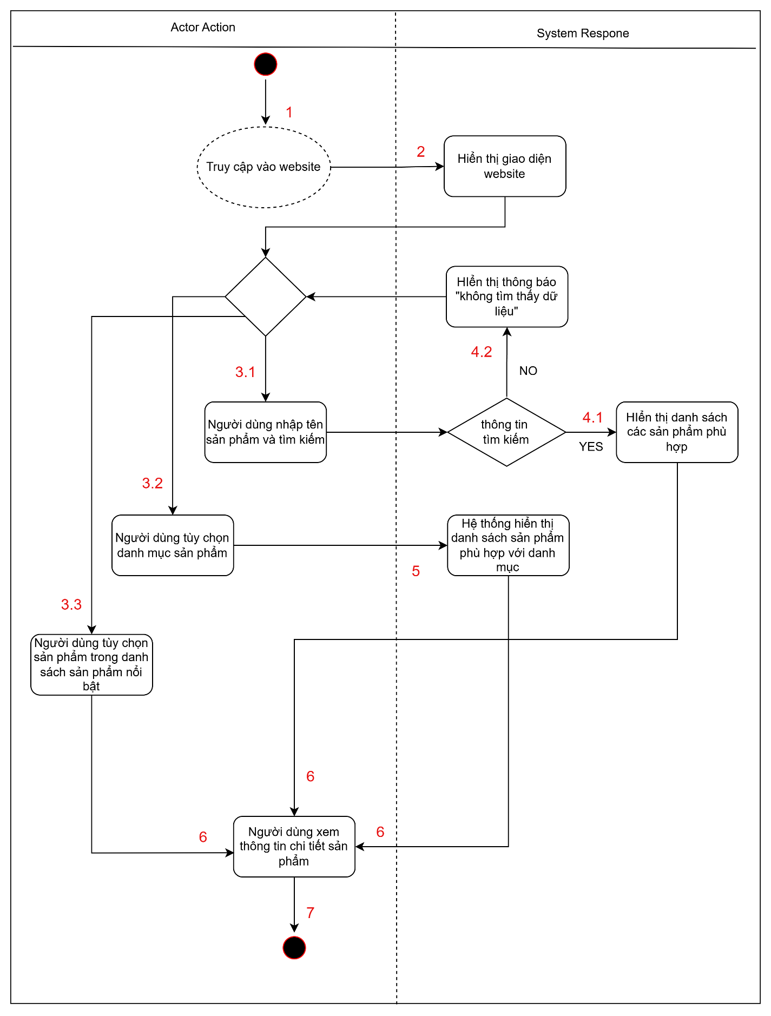
Figure 34: Activity diagram of the product catalog function
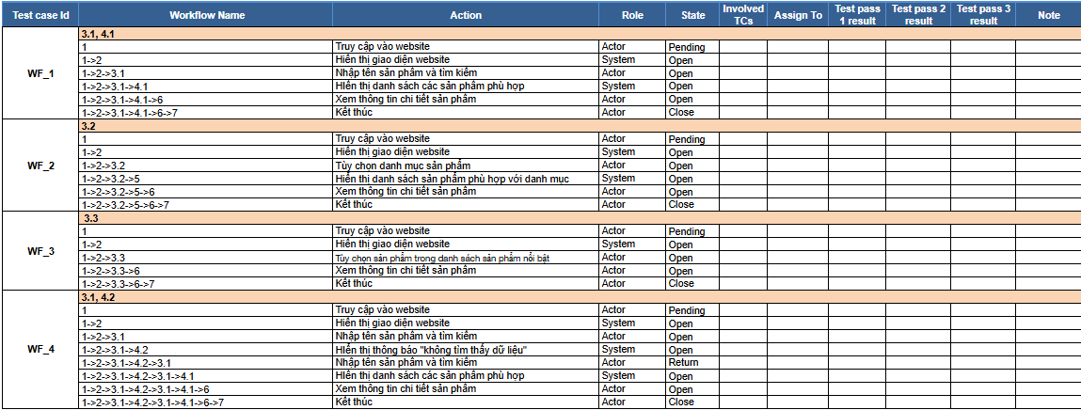
Figure 35: Workflow of the product catalog function

2.1.3 Payment
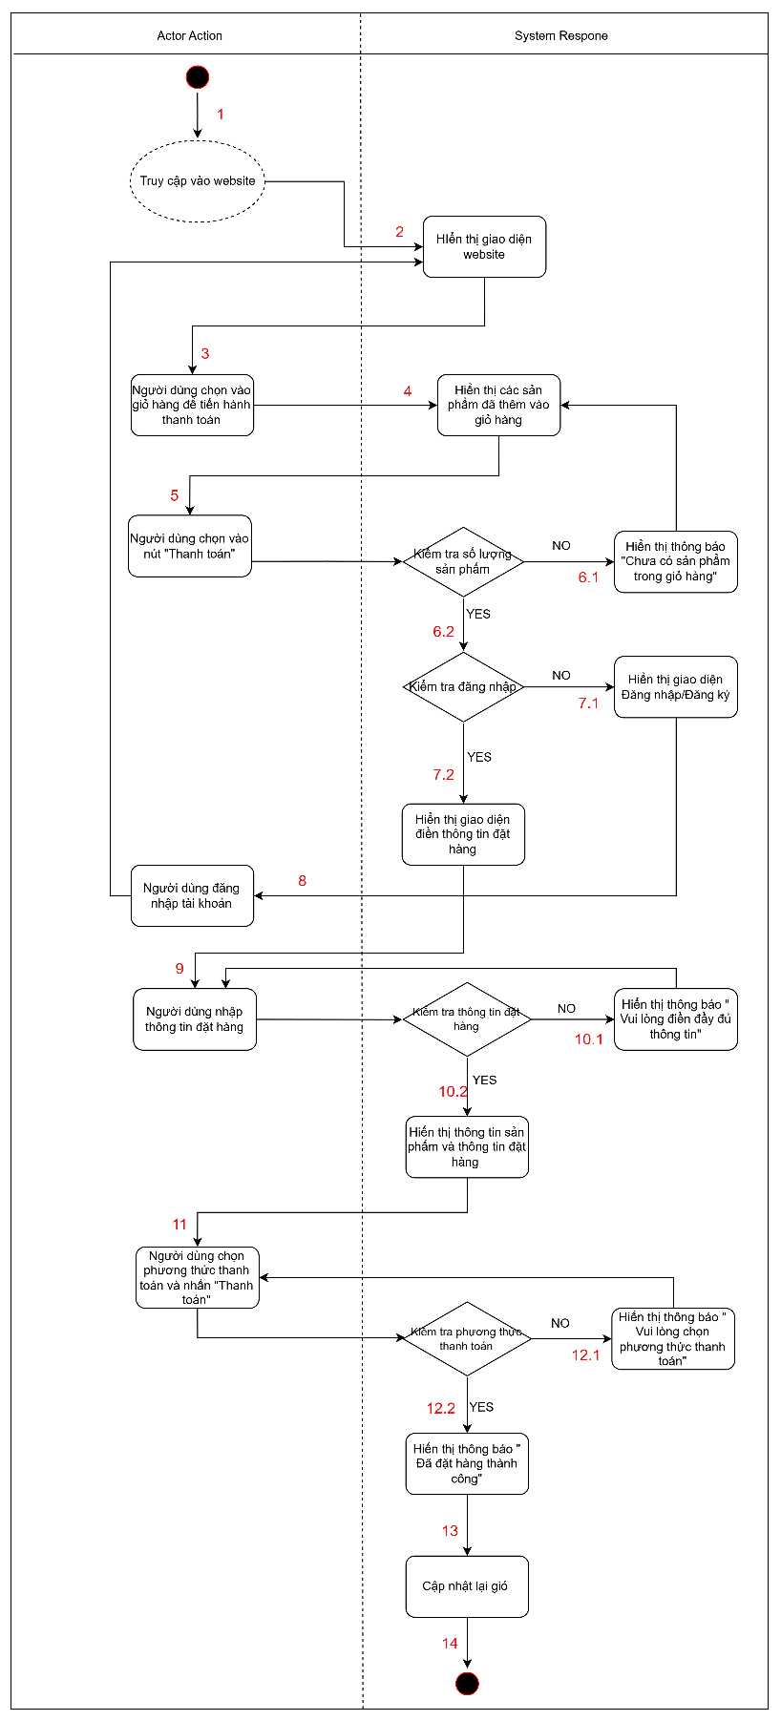
Figure 36: Activity diagram of the payment function

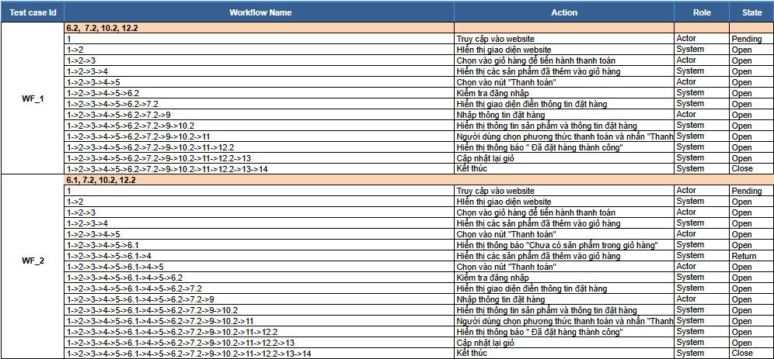
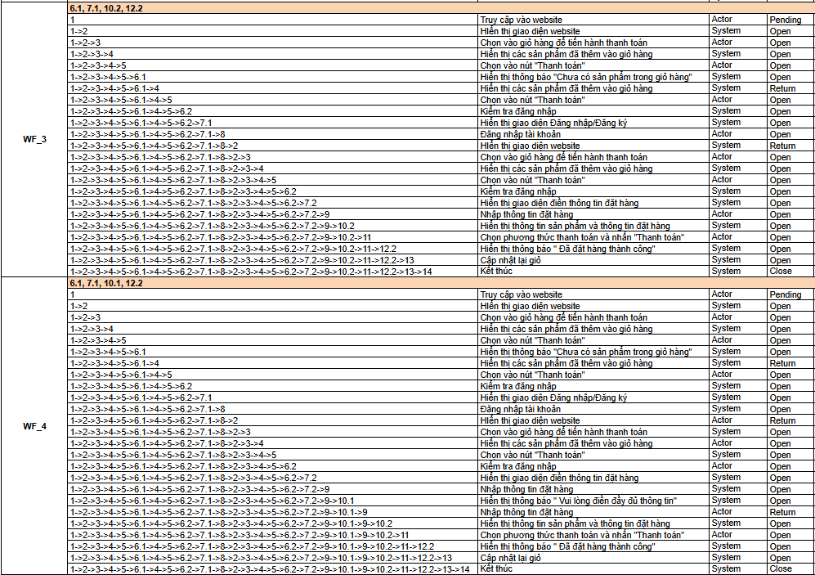
Figure 37: Workflow of the payment function

2.1.4. User Management
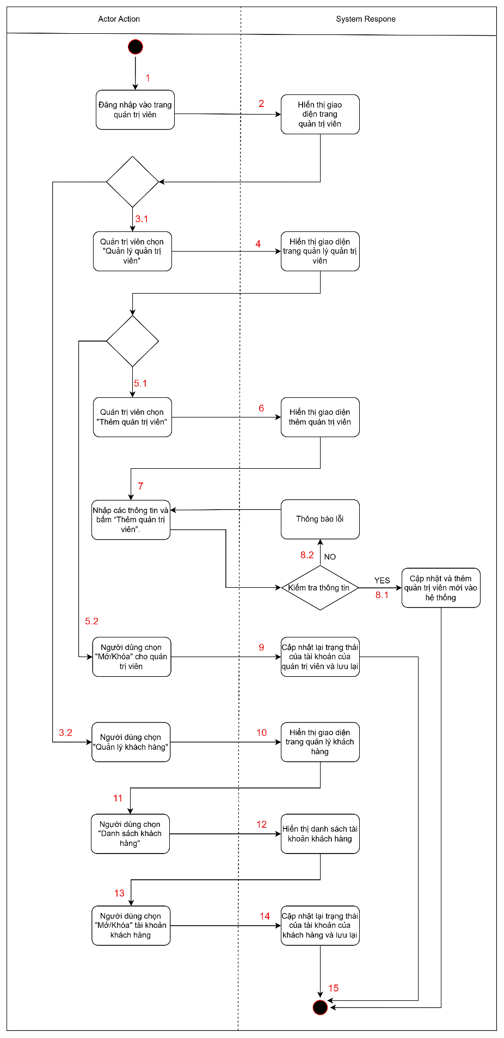
Figure 38: Activity diagram of the user management function

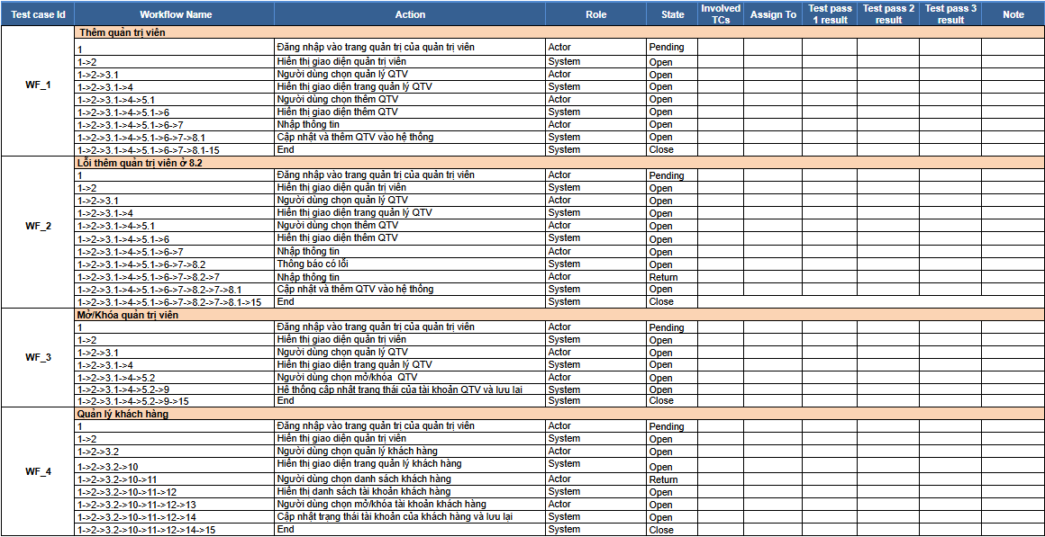
Figure 39: Workflow of the user management function

2.1.5. Inventory management

2.1.5.1. Add a product category
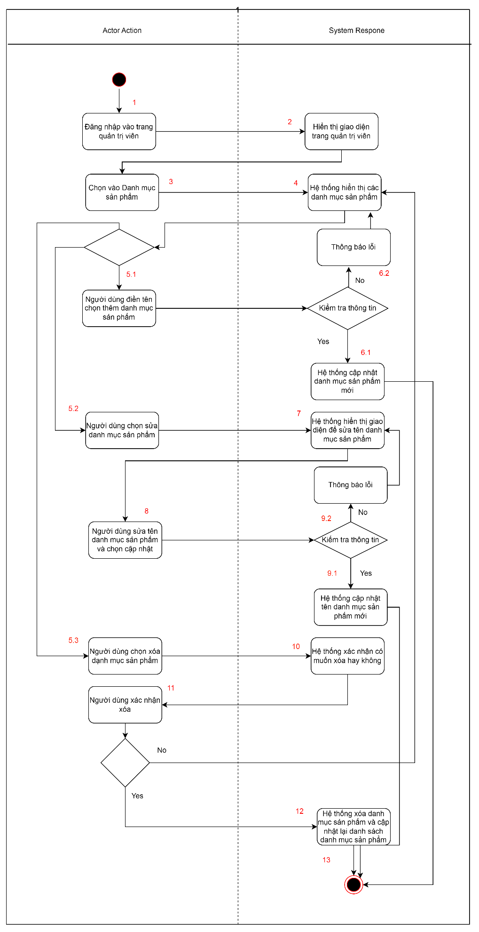
Figure 40: Activity diagram of the function of adding a product category

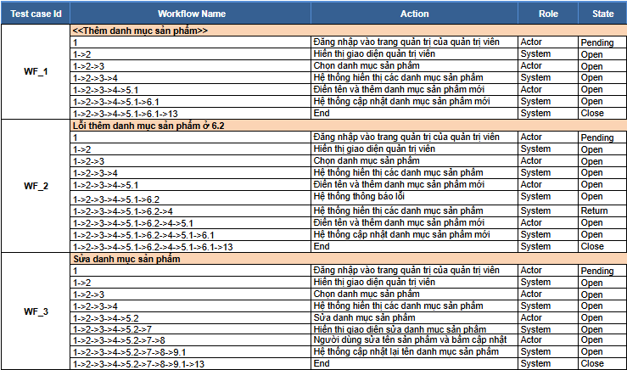
Figure 41: Workflow of the function of adding product categories

2.1.5.2 Add products
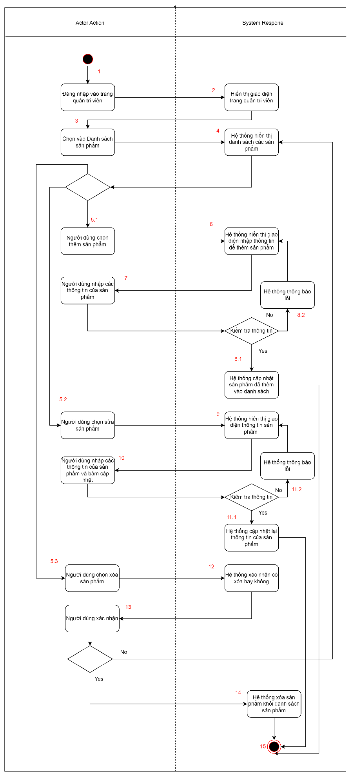
Figure 42: Activity diagram of the function of adding products
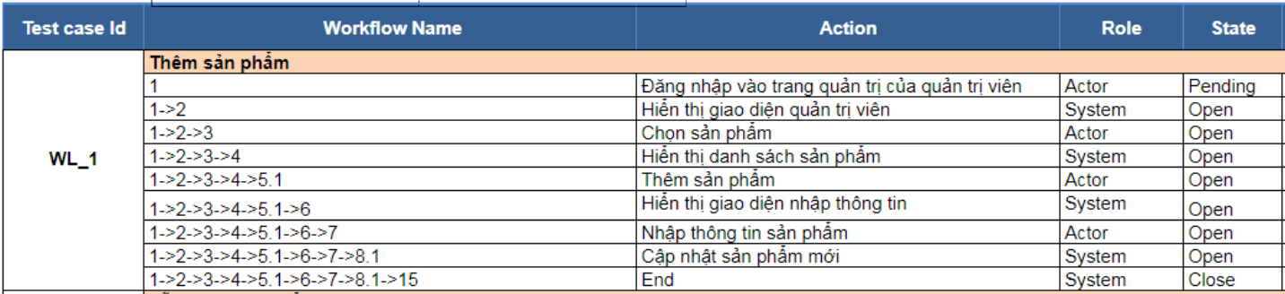
Figure 43: Workflow of the function of adding products

2.2. Test Design
Test Design is the process of designing specific test cases based on the source code and functional requirements of the system. These test cases will test the correctness of each part of the system, including testing the conditions, logic, and algorithms in the source code to ensure the software is working as required. The design of test cases helps to detect potential errors that other test methods may miss. The test design is done more clearly through the tables below.

2.2.1. Shopping Cart
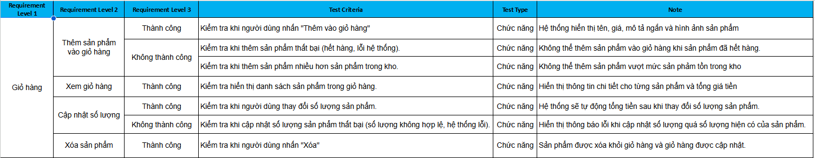
Figure 44: Test design of shopping cart function

2.2.2. Product list
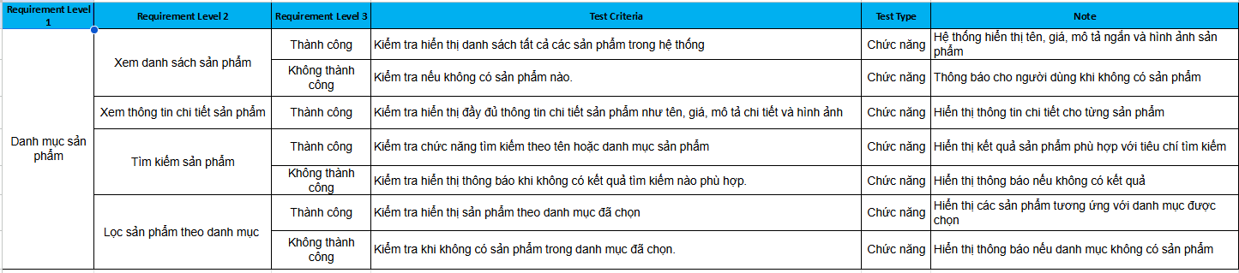
Figure 45: Test design of product catalog function

2.2.3. Payment
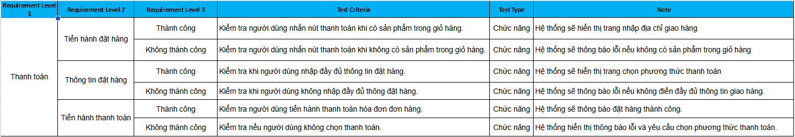
Figure 46: Test design of payment function

2.2.4. User Management
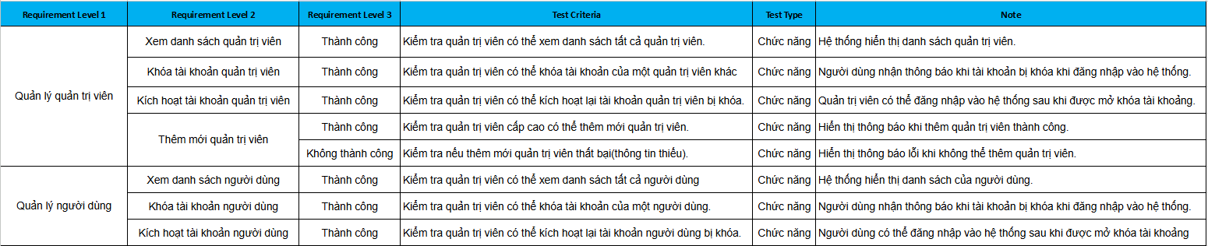
Figure 47: Test design of the user management function

2.2.5. Inventory management
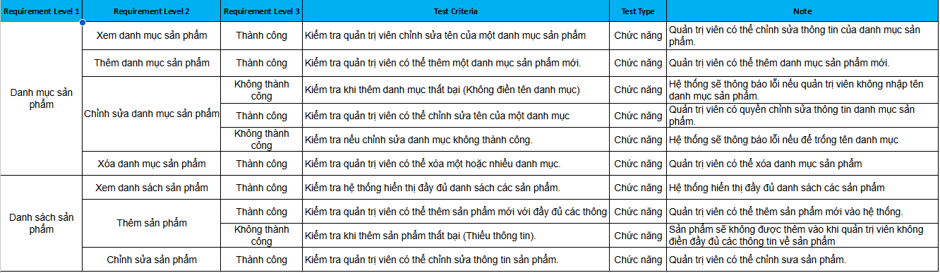
Figure 48: Test design of inventory management function

Black Box Testing
After completing the white box test, the group continued to conduct the black box test. This testing method focuses on testing the functionality of the system based on pre-defined requirements and specifications, without regard to the intrinsic structure of the source code. Black box testing helps to evaluate the performance of the system from the end-user perspective, verifying whether the system meets the functional, performance, and feature requirements as defined.

3.1. Test Case Review Checklist
The Test Case Review Checklist is an important tool to help ensure that test cases are designed adequately and accurately. This checklist includes elements such as: clearly verifying the goal of the test case, ensuring the test case has sufficient information such as inputs, outputs, and execution steps, checking the validity of input and output scenarios, and ensuring that the test cases are tested for special margins and situations. The use of checklists helps the test team detect and fix errors early, thereby improving the efficiency of the testing process.
Below is a detailed checklist, including items related to documentation control and test case evaluation, to ensure that all requirements and conditions are met before the testing process continues:

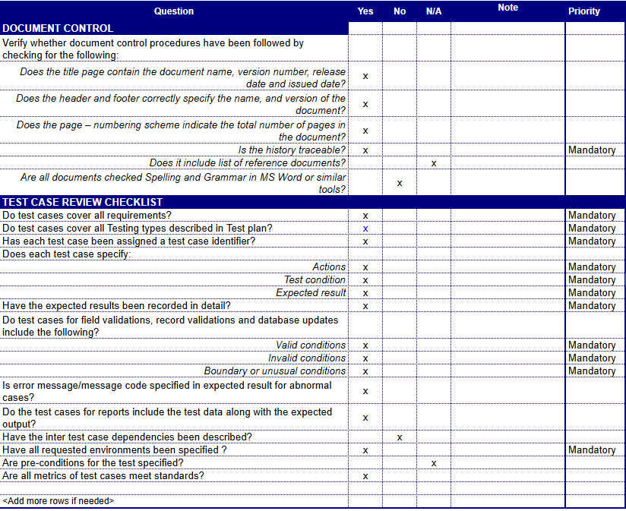
Figure 49: Test case review checklist

3.2. Test case
Below is a list of Test Cases designed to test critical functions in the system. This table details each test case, including the function name, description, and prerequisites. Each test case will help determine if the system is working as expected, especially the functions related to product catalog management, shopping cart, checkout, and user management. The full implementation of these test cases will help ensure the accuracy and stability of the system during operation.
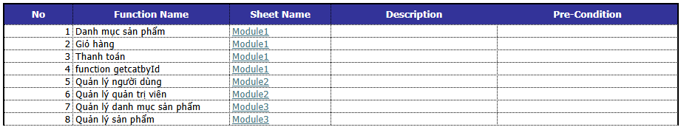
Figure 50: Test case

3.2.1. Shopping Cart
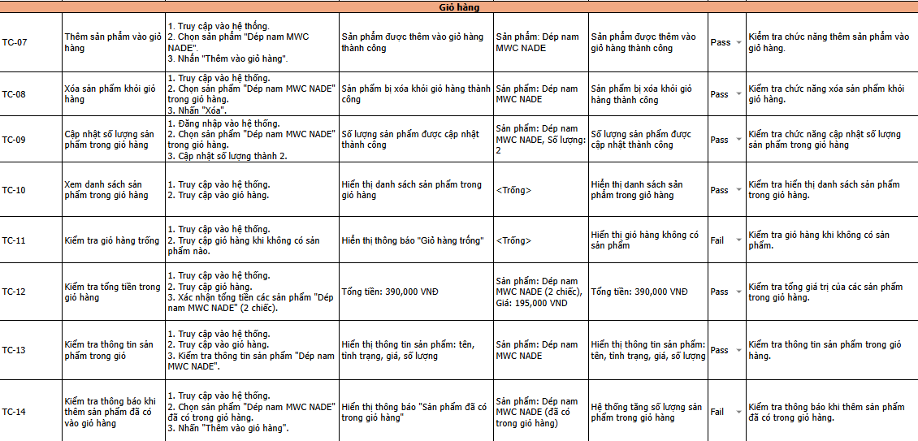
Figure 51: Test case of the function Shopping Cart

3.2.2. Product list
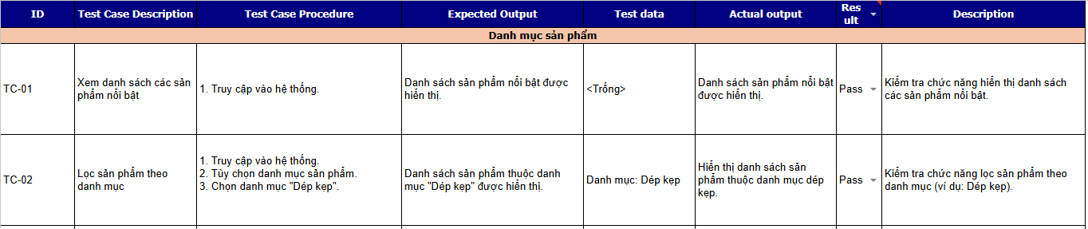
Figure 52: Test case of product catalog function

3.2.3. Payment
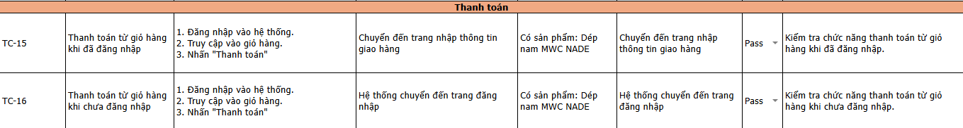
Figure 53: Test case of payment function

3.2.4. User Management
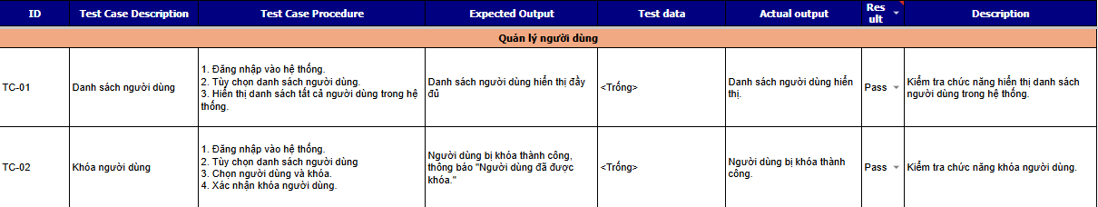
Figure 54: Test case of the user management function

3.2.5. Inventory management
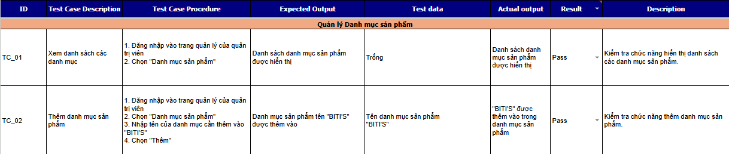
Figure 55: Test case of inventory management function

3.3. Sequence of the shopping cart function
The figure below illustrates a sequence diagram depicting the operation flow of the shopping cart function in an e-commerce website system. The schema represents the steps of interaction between the user and the system from viewing product details, adding products to the cart, to managing the cart through operations such as decreasing the quantity, increasing the quantity, and deleting the product. This process is divided into processing stages in single-product.php files, add_cart.php, cart.php, and database queries in web2.sql.
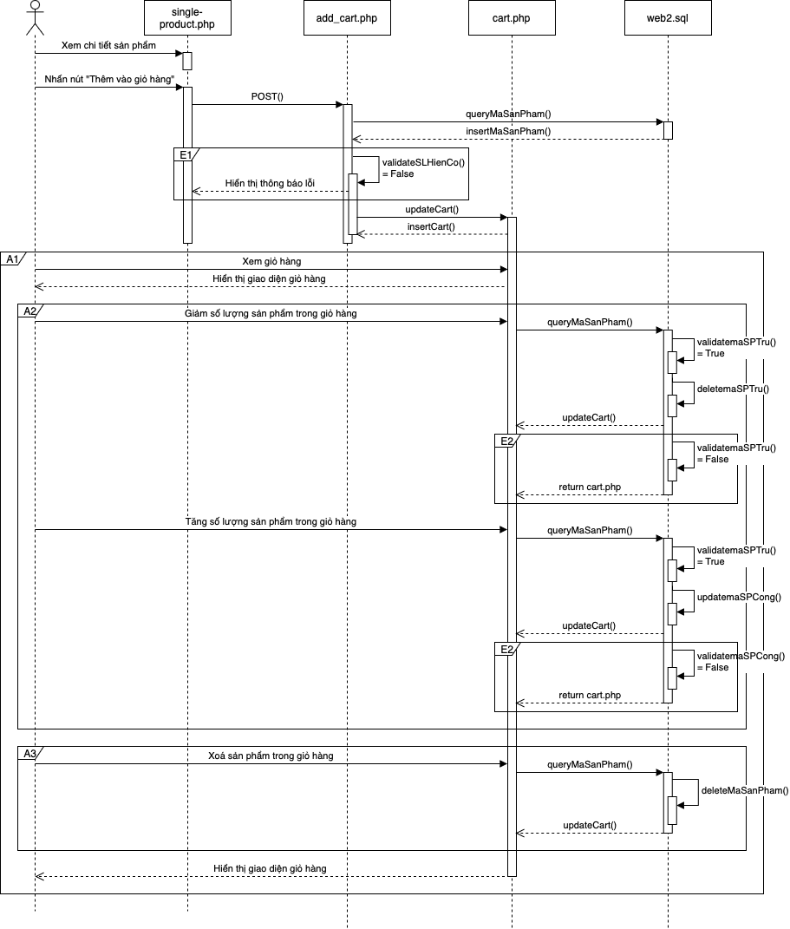
Figure 56: The sequence model of the shopping cart function
As you can see in the figure above, the main interactions between the user and the system are shown through the following steps:
- Stage to view product details and add to cart:
- Users visit the single-product.php page to view product details.
- When the user presses the "Add to Cart" button, the system sends a POST request to file add_cart.php.
- The system checks the number of available products through the validateSLHienCo function. If the quantity is valid, the system adds the product to the cart and calls the insertCart() function.
- Cart view and management phase:
- Users visit the cart.php page to view and manipulate the cart. Operations include:
- Reduce the number of products: The system calls the queryMaSanPham() function to test the product and validate it through validatemaSPTru(). If successful, the system reduces the quantity and updates the cart again using updateCart().
- Increase the number of products: Similar to the reduction operation, the system performs checks and updates via the queryMaSanPham(), validatemaSPCong(), and updateCart() functions.
- Remove product from cart: The system calls queryMaSanPham() to check the product and proceeds to delete it via deleteMaSanPham() before updating the cart again.
- Interact with the database:
- The web2.sql file contains SQL queries that support checking, adding, removing, and updating cart information to the database.

3.4. Unit Testing of the shopping cart management function

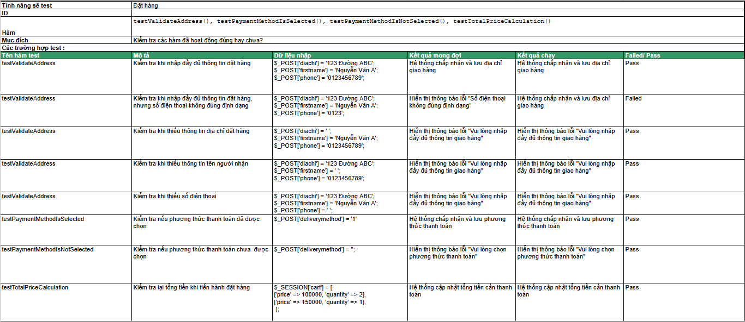
Figure 57: Unit Testing of Cart Management Function

CHAPTER 5: TEST RESULTS

Test Report Test Case
This report aims to summarize the test results carried out on the website system. The content of the report includes: the number of tests performed, the modules tested, and the results classified into groups of pass, fail, untested or not applied. The goal of testing is to evaluate the quality of the software and identify issues that need improvement before the official implementation.
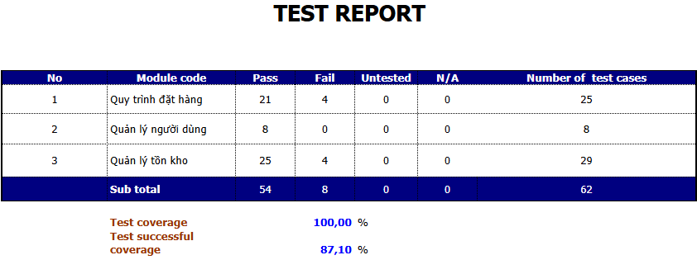
Figure 58: Test report của test case

1.1. Overview of results
- Total number of tests: 62
- Test coverage rate: 100% (all tests have been performed).
- Number of test cases: 54 (success rate 87.10%).
- Number of failed tests: 8 (error rate 12.90%).
All test cases are carried out, ensuring that the critical functions of the system are fully evaluated. However, the success rate is not ideal, especially in modules that have a direct impact on users such as Ordering Process and Inventory Management.

1.2. Results by Module
- Order Process
- Number of test cases: 25
- Pass: 21
- Fail: 4
- Comments: Errors arising in this module may be related to critical processes such as product selection, payment processing, or order confirmation. Processing should be prioritized to ensure an uninterrupted user experience.
- User Management
- Number of test cases: 8
- Pass: 8
- Fail: 0
- Comments: This module works stably with a 100% success rate. The basic features have been tested and work reliably.
- Inventory Management
- Number of test cases: 29
- Pass: 25
- Fail: 4
- Remarks: Errors arising in this module may affect the updating and synchronization of inventory quantities, causing discrepancies in product information.
From the analysis results, it can be seen that the majority of functions have been operating stably with a high success rate. However, errors in the ordering process and inventory management are notable problems and need to be fixed in a timely manner.

1.3. Comments and suggestions

1.3.1. Overview Comments
According to Figure 58, we can see that the test coverage has reached 100%, ensuring that all tests have been carried out as planned.
The success rate of 87.10% shows that the software system is operating relatively stably. However, there is still a need to improve some important functions in the modules.

1.3.2. Suggestions for improvement
Quickly analyze and fix errors in the order process module, with a particular focus on the payment and order confirmation processes, as these are functions that have a direct impact on the user.
Handle issues in the inventory management module to ensure that the quantity of goods is always accurate and synchronized in real time.
Perform regression testing after fixing errors to ensure that old errors do not reappear or cause new errors.
Build more detailed tests in subsequent test sessions, especially with margin cases and special situations, to detect more potential errors.

Test Report Unit Testing
The table below is the results after the unit testing process in software development. The test module includes "Shopping Cart Search", "Shopping Cart Management", "Ordering", "User Management". The purpose of this report is to provide detailed information about the results of testing source code units (such as functions, classes, modules) to ensure they work correctly as required.

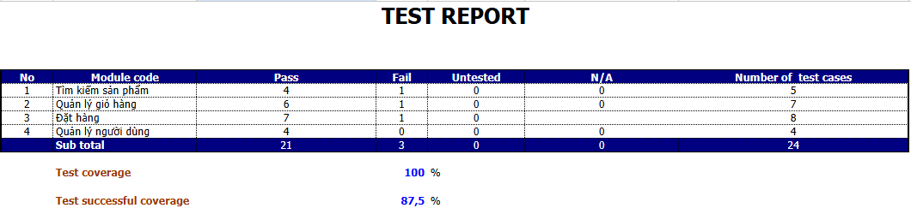
Figure 59: Test report of unit test

2.1. Overview of results
- Total number of tests: 24
- Test coverage rate: 100% (all tests have been performed).
- Number of successful tests: 21 (87.5% success rate).
- Number of failed tests: 3 (error rate 12.5%).
All test cases are carried out, ensuring that the critical functions of the system are fully evaluated. However, the success rate is not ideal, especially in modules that directly affect users such as product search and cart management.

2.2. Results by Module
Total number of tests: 24
- Product Search
- Number of test cases: 5
- Number of cases: 4
- Number of failed cases: 1
Comments: An error occurred when searching for the product by description.
- Product Management:
- Number of test cases: 6
- Number of cases: 6
- Number of failed cases: 0
Remarks: This module works stably.
- Place an order:
- Number of test cases: 7
- Number of cases: 7
- Number of failed cases: 1
Remarks: An error occurred during the ordering process.

- User Management:
- Number of test cases: 4
- Number of cases: 4
- Number of failed cases: 0
Remarks: This module works stably.

2.3. Comments
The system has not recognized the phone number in the wrong format.
From the above results, we can see that the functions are quite stable, but there are still errors in the "Product Search" and "Order" functions that need to be fixed.

Defect List
The table below is a list of defects detected during software testing, focusing on operations such as adding, editing, and managing data. Each bug is recorded in detail with information such as: bug description, steps to reproduce the bug, actual result, expected result, priority, severity and ID of the corresponding test case (Testcase ID).
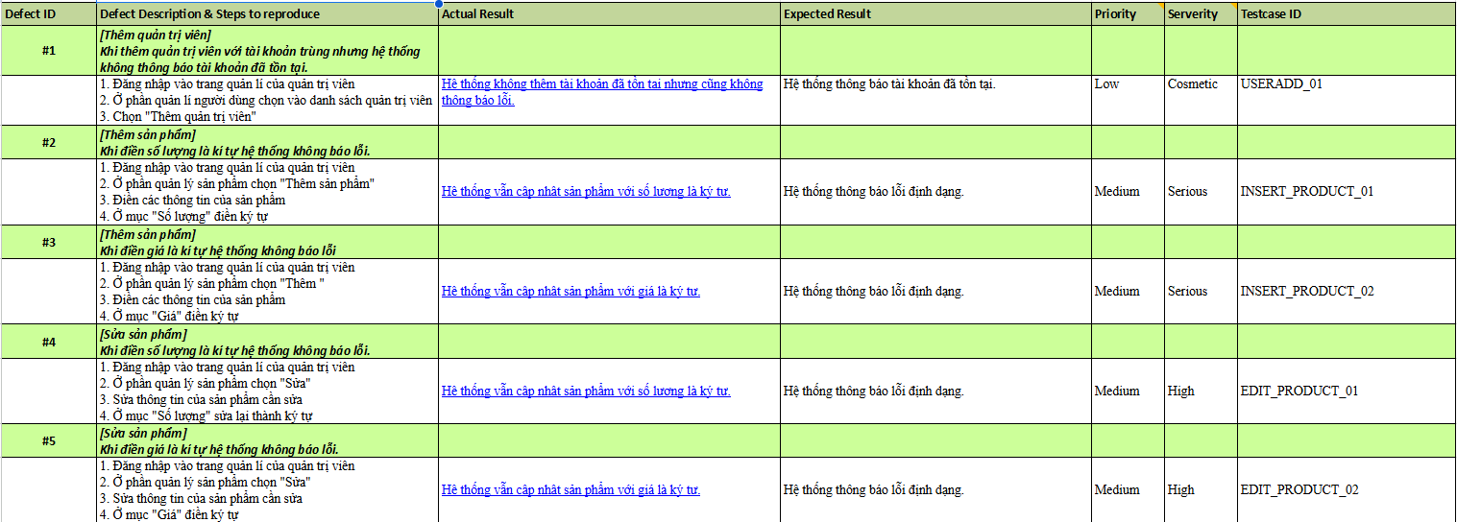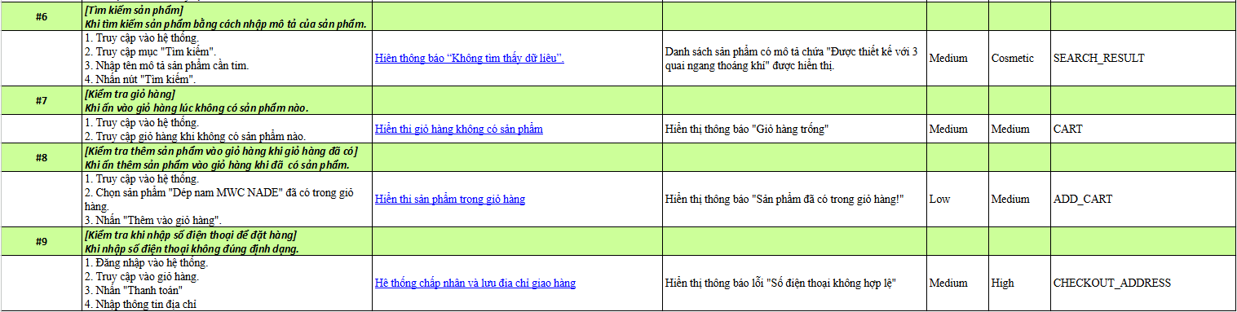
Figure 60: Defect list in the system
As shown in Figure 60, we can see that the details of the current bugs in the system have been clearly shown, giving the software development team a basis to fix and improve the quality of the product. Errors with high severity need to be prioritized to ensure the best user satisfaction and experience.

CHAPTER 6: CONCLUSION

Advantage
My group's MWC slippers website has the following advantages:
- User-friendly interface: The interface of the website is simple and easy to understand, making it easy for customers to browse products and perform necessary operations.
- Product Classification and Search Features: The website offers slipper sorting and keyword search features, making it easy for customers to find the products they want.
- Complete basic features: The website fully supports basic functions such as searching for products, adding to carts, checkout, and has a management page for admins to track orders and manage products.

Shortcoming
Besides the advantages, the website still has some disadvantages that need improvement:
- Errors during testing: There are still some errors that arise during testing, which affects the user experience.
- Lack of password forgetting: An important feature like forgetting passwords is not yet available, making it difficult for users to have problems with passwords.

Development direction
After testing the website for selling sandals, the group made suggestions for website development as follows:
- Add a forgotten password feature: This feature will make it easy for customers to recover their accounts when they forget their passwords.
- Product review feature: After receiving the product, customers can review the product, which helps increase the transparency and reliability of the products on the website.
- Online customer consultation support: Integrating the online support feature makes it possible for customers to receive quick advice from support agents.
- Develop on multiple platforms: Extending a website on platforms other than computers, like mobile phones and tablets, makes it easy for users to access from multiple devices.
- Promotions: Create more promotions, discounts, or special offers to attract customers and motivate them to shop.

