Software

Design

Specification

Version 1.0

July, 2024

Table of Contents

**1.** **INTRODUCTION** 5

**1.1** **Document Description** 5

**1.2** **Abstract:** 5

**1.3** **Purpose** 5

**1.4** **Scope** 5

**1.5** **References:** 6

**1.6** **Definitions, Acronyms and Abbreviations** 6

**2.** **SYSTEM OVERVIEW** 6

**2.1** **System Context** 6

**2.2** **Objectives** 6

**3.** **ARCHITECTURAL DESIGN** 6

**3.1** **Architecture Diagram** 6

**3.2** **Interfaces** 7

**4.** **DETAILED DESIGN** 7

**4.1** **Class Diagrams** 7

**4.2** **Sequence Diagrams** 7

**4.3** **Loan Stock Issuance** 7

**4.4** **Loan Stock Return** 8

**4.5** **Data Models** 8

**5.** **USER INTERFACE DESIGN** 8

**5.1** **Wireframes** 8

**5.2** **User Interaction** 9

**6.** **NON-FUNCTIONAL REQUIREMENTS** 10

**6.1** **Performance** 10

**6.2** **Scalability** 10

**6.3** **Security** 10

**6.4** **Usability** 10

**7.** **IMPLEMENTATION CONSIDERATIONS** 10

**7.1** **Technology Stack** 10

**7.2** **Coding Standards** 10

**8.** **TESTING STRATEGY** 10

**8.1** **Testing Types** 10

**8.2** **Test Cases** 10

**9.** **GLOSSARY** 10

**10.** **BIBLIOGRAPHY** 10

**11.** **CONCLUSION** 11

# Table of Images

Figure 1: Architecture diagram 6

Figure 2: UML Class Diagram for Loan Stocks Management System 7

Figure 3: Sequence diagram loan stock issuance processes 8

Figure 4: Sequence diagram loan stock return processes 8

Figure 5: Wireframes Loan Stock Issuance 9

Figure 6: Wireframes Loan Stock Return 9

# **INTRODUCTION**

This is an attempt to put together a comprehensive template for the specification of software designs, with guidelines on how to structure the contents of various sections and subsections of the document.

The template has been created using suggestions from various SEI reports and even IEEE documentation standards for software designs and software requirements.

We believe that a completed software design specification document should meet the following criteria:

* It should be able to serve as training material for new project members, giving them enough information and understanding about the project implementation.
* It should serve as “objective evidence” that the designers and/or implementers are following through on their commitment to implement the functionality described in the requirements specification.
* It needs to be as detailed as possible, without imposing too much of a burden on the designers and/or implementers and without becoming overly difficult to create or maintain.

## **Document Description**

Title: Software Design Specification for Loan Stocks Management System

Version: 1.0

Status: Final

## **Abstract:**

The Software Design Specification (SDS) document for the Loan Stocks Management System outlines the system’s architecture, design considerations, detailed design and implementation strategies. It serves as a guide for developers and stakeholders to understand the structure and functionality of the system, ensuring efficient and effective management of loan stock items.

## **Purpose**

The purpose of this document is to provide a detailed design specification for the Loan Stocks Management System, which will facilitate the management of loan stock transactions, including issuance, returns and inventory tracking.

The primary purpose of this document is to provide a clear and comprehensive design specification that will facilitate the development and maintenance of the Loan Stocks Management System. This document aims to ensure that all stakeholders have a common understanding of the system’s design and implementation details.

## **Scope**

This document covers all aspects of the design of the Loan Stocks Management System, including the architectural overview, detailed system design, user interface design, implementation considerations and testing strategy. It is intended for use by the development team, project managers, quality assurance team and other stakeholders involved in the project

This system will support the management of loan stock items, tracking their availability, issuance to users and returns. It aims to enhance operational efficiency and ensure accurate record-keeping.

## **References:**

* IEEE Software Design Documentation Standards.
* SEI Reports on Software Architecture.
* Organizational Policies and Standard for Software Development.

## **Definitions, Acronyms and Abbreviations**

* Loan Stock: Items available for temporary borrowing.
* User: Individuals that can borrow loan stock items.
* Inventory: The stock of loan items managed within the system

# **SYSTEM OVERVIEW**

## **System Context**

The Loan Stocks Management System will be integrated with existing inventory management systems and will be accessible via a web interface for users and administrators.

## **Objectives**

* Efficiently track loan stock inventory.
* Facilitate easy issuance and return of loan stock items.
* Provide reports on loan stock usage and availability.

# **ARCHITECTURAL DESIGN**

## **Architecture Diagram**

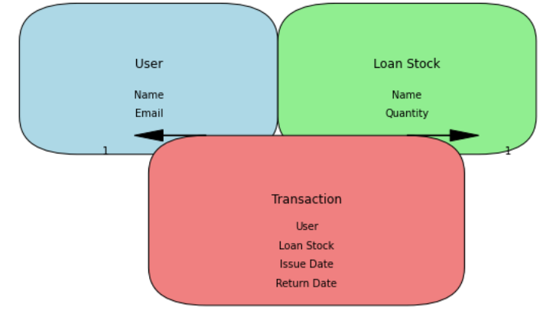

Figure 1: Architecture diagram

The architecture diagram includes the following components:

* User Interface: Web-based interface for users and administrators.
* Business Logic Layer: Handles the processing of loan stock transactions.
* Database: Stores information on loan stock items, users and transaction history.
* Interfaces: RESTful APIs for integration with other systems

## **Interfaces**

* RESTful APIs for integration with other systems.
* Web interface for user interaction.

# **DETAILED DESIGN**

## **Class Diagrams**

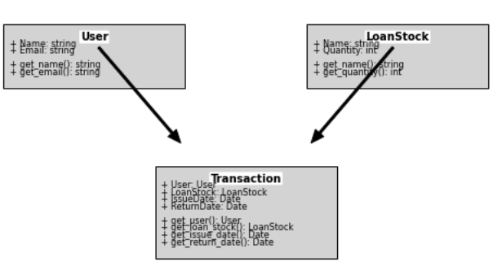

Figure 2: UML Class Diagram for Loan Stocks Management System

## **Sequence Diagrams**

(Insert sequence diagrams illustrating loan stock issuance and return processes)

## **Loan Stock Issuance**

1. User requests to issue a loan stock item.
2. System checks the availability of the item.
3. System records the transaction.
4. User receives confirmation.

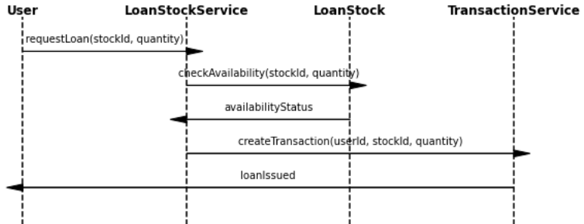

Figure 3: Sequence diagram loan stock issuance processes

## **Loan Stock Return**

1. User returns the loan stock item.
2. System updates the inventory.
3. System records the return transaction.
4. User receives confirmation.

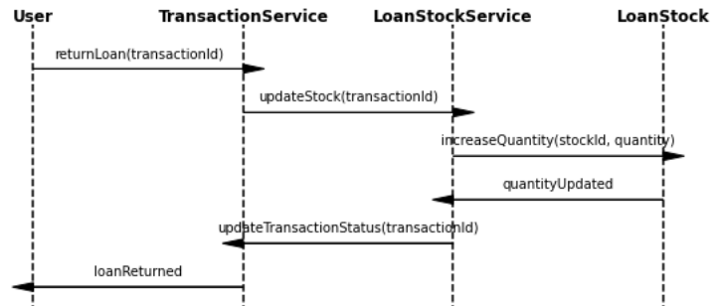

Figure 4: Sequence diagram loan stock return processes

## **Data Models**

Loan Stock: Attributes include id, name, quantity, status, location.

User: Attributes include id, name, email, phone.

Transaction: Attributes include id, loan Stock Id, user Id, issue Date,

# **USER INTERFACE DESIGN**

## **Wireframes**

(Insert wireframes)

Wireframes will illustrate the visual design of the user interface, including screens for viewing loan stock, issuing, returning and generating reports.

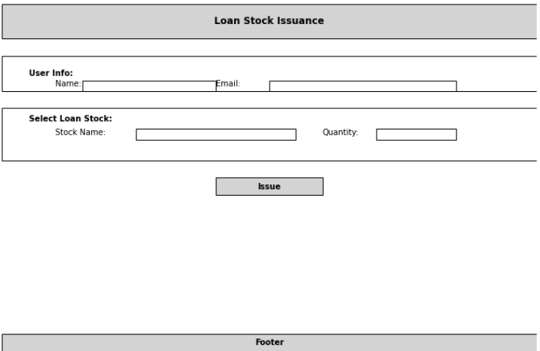

Figure 5: Wireframes Loan Stock Issuance

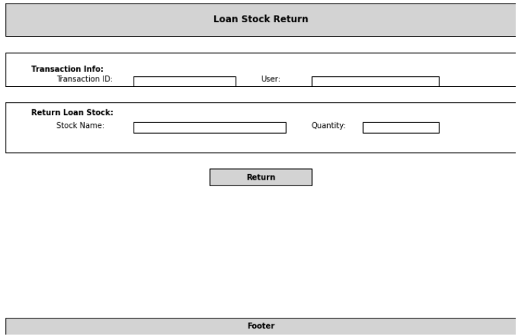

Figure 6: Wireframes Loan Stock Return

## **User Interaction**

Users will navigate through the system to:

* View available loan stocks.
* Issue loan stocks.
* Return loan stocks.
* Generate reports.

# **NON-FUNCTIONAL REQUIREMENTS**

## **Performance**

System should handle up to 100 concurrent users with a response time of under 2 seconds for standard transactions.

## **Scalability**

The system should support scaling horizontally to accommodate increased load.

## **Security**

* User authentication and authorization will be implemented.
* Sensitive data will be encrypted in transit and at rest.

## **Usability**

The interface will be designed to be user-friendly, adhering to accessibility standards.

# **IMPLEMENTATION CONSIDERATIONS**

## **Technology Stack**

## **Coding Standards**

Follow industry best practices for coding standards and documentation.

# **TESTING STRATEGY**

## **Testing Types**

* Unit Testing: Test individual components and functions.
* User Acceptance Testing: Validate the system against user requirements.

## **Test Cases**

* Verify that users can issue a loan stock.
* Verify that users can return a loan stock.
* Check system response when loan stock is out of inventory.

# **GLOSSARY**

* Loan Stock: Items available for temporary borrowing.
* User: Individuals who can borrow loan stock items.
* Inventory: The stock of loan items managed within the system.

# **BIBLIOGRAPHY**

* IEEE Software Design Documentation Standards
* SEI Reports

# **CONCLUSION**

This Software Design Specification outlines the design and implementation details for the Loan Stocks Management System. The system aims to streamline stock management processes while providing robust tracking and reporting capabilities.

The Software Design Specification (SDS) document for the Loan Stocks Management System provides a comprehensive and detailed blueprint for the development and implementation of the system. This document has outlined the architectural framework, design principles, and detailed component descriptions necessary to build a robust, scalable, and efficient loan stock management solution.

Throughout this document, we have meticulously detailed the system's architecture, covering both the high-level overview and the low-level design of individual components. The clear delineation of responsibilities, data flows, and interactions among system modules ensures that developers have a well-defined path to follow during the implementation phase. The inclusion of UML diagrams, sequence diagrams, and wireframes further enhances the clarity and comprehensiveness of the design, providing visual representations that aid in understanding complex interactions and workflows.

The design considerations section has addressed critical aspects such as performance, security, usability, and maintainability, ensuring that the system not only meets current requirements but is also prepared for future challenges and expansions. By adhering to these design principles, the Loan Stocks Management System will deliver a reliable, user-friendly, and secure platform for managing loan stock items.

Moreover, the implementation strategy and testing plans laid out in this document provide a structured approach to building and verifying the system. These plans ensure that each component is developed and tested in alignment with the specified design, minimizing risks and ensuring a high-quality final product.

In conclusion, the SDS for the Loan Stocks Management System serves as a vital document that bridges the gap between requirements and implementation. It provides a clear, detailed, and actionable design plan that guides developers, project managers, and stakeholders through the development process. With this strong foundation, the project is well-positioned to succeed, delivering a system that meets the needs of its users and stands up to the demands of its operational environment.