**PRO192- LAB 5**

Develop School management OOP application with following components and requirements

1. **Create MVC console application in NetBean:**
   1. Define class Student with following attributes and methods:  
      + ID, Name, Average  
      + Constructors, get/set(), toString()   
      Define class School with following attributes and methods:   
      + List of Student to store data for School  
      + Search Student by different criteria  
      + Print any List of Student  
      + Add new Student from console
   2. Develop SchoolManagement class for application  
      + Application menu for application include: Display all Students, Student Search, Add new Student, Student statistical  
      Hint: An abstract Menu class is provided for use in the application. Override method excecute()  
      + Method for searching Student with searching menu

+ Method for sort Student with sort menu

1. **Technical requirements**:  
   + Create package **model** for Student and School class  
   + Create package **view** for Menu and SchoolManagement class.

**+** Perform data validation for attributes when the user enters incorrect data  
+ User interface as sample images below

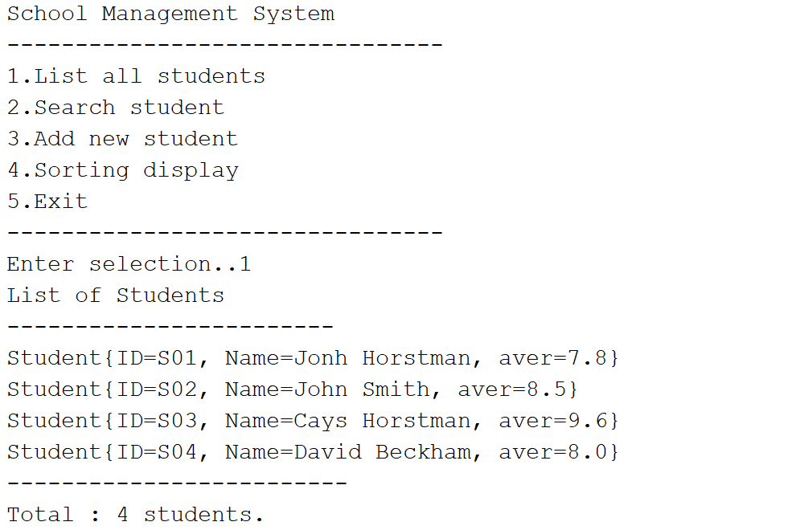

When choose search Student:

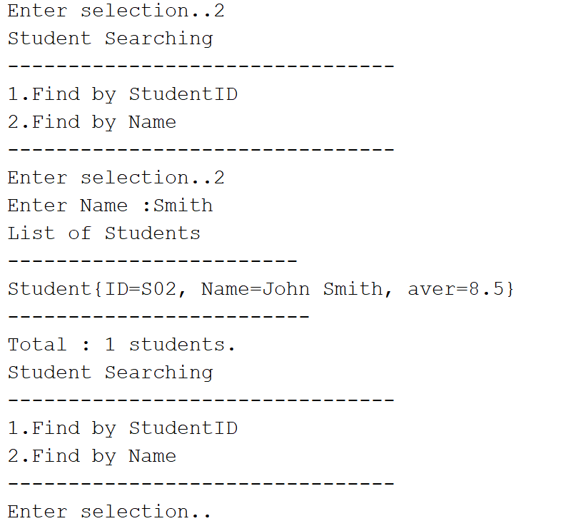

When choose sort Student:

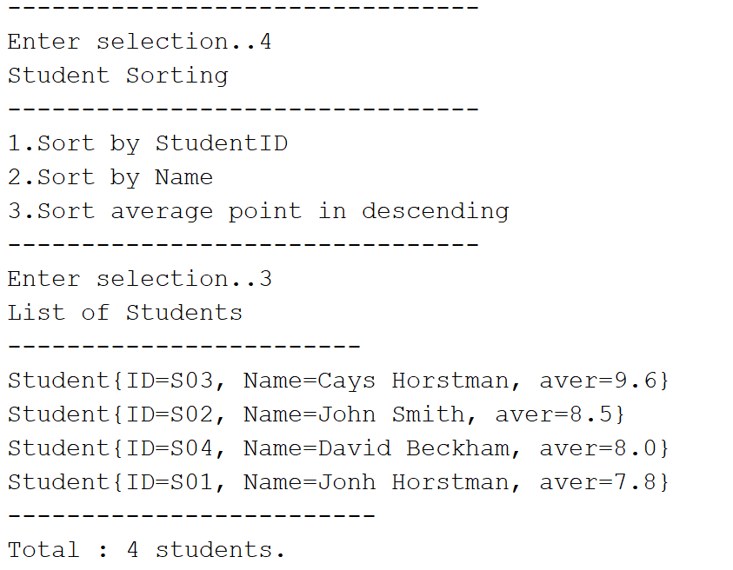

**Notice: Student must strictly follow all requirements as describe above for marking,   
Any modification the requirement detail is not allowed and will get no mark!**