Introduction to Software Engineering

Design Software

Prepared by:
Nguyễn Thái Cường (24127336)
Nguyễn Thanh Tùng (24127583)
Đỗ Trương Khoa (24127423)
K’Vớn (24127593)
Đào Hoàng Phúc (24127496)

Instructor:
Dr. Trần Duy Hoàng
MSc. Trương Phước Lộc
MSc. Phạm Hoàng Hải


Hồ Chí Minh city, July 28, 2026

Software Engineering Department
Faculty of Information and Technology
University of Science

Table of Contents
1 Member Contribution Assessment 2
2 Conceptual Model 3
3. Architectural Design 5
3.1 Architecture Diagram 6
3.1.1.System Decomposition Tree 6
3.1.2.Overall System Architecture 7
3.2 Class Diagram 8
3.3 Class Specifications 9
3.3.1 Superclass: User (Abstract) 9
3.3.2 Subclass : Player 10
3.3.3 Subclass : VenueOwner 11
3.3.4 Class : Venue 12
3.3.5 Class : Field 13
3.3.6 Class : TimeSlot 14
3.3.7 Class : Booking 15
3.3.8 Class : Payment 16
3.3.9 Class : RefereeAssignment 17
3.3.10 Class : Match 18
4. Data Design 19
4.1 Data Diagram 19
4.2 Data Specification 20
4.2.1. Relational Database Tables (PostgreSQL - Logical Schemas) 20
4.2.1.1. Logical Schema: schema_auth 20
4.2.1.2. Logical Schema: schema_venue 23
4.2.1.3. Logical Schema: schema_booking 26
4.2.1.4. Logical Schema: schema_payment 28
4.2.1.5. Logical Schema: schema_referee 29
4.2.1.6. Logical Schema: schema_social 30
4.2.1.7. Logical Schema: schema_review 34
4.2.2.. In-Memory Data Structures (Redis Cache Keys) 35
5 User Interface and User Experience Design 36
5.1. Screen Diagram 36
5.2. Screen Specifications 38
5.2.1. Screen “Booking field homepage” 38
Presentation format 39
5.2.2. Screen “Voice booking” 40
5.2.3 Screen “Football - Dashboard” 42
5.2.4. Screen “Matches - Homepage” 44
5.2.5.Screen “Referee Invites - Manage Bookings” 45
5.2.6. Screen “SPOT | Venue Owner Dashboard (Web)” 46

Software Design

Objectives
This document focus on the following topics:
- Complete the Software Design Document with the following contents:
  - Conceptual Model
  - Architectural Design
  - Data Design
  - User Interface Design
- Understanding the Software Design Document.

Member Contribution Assessment
- Group ID: 09
ID | Name | Assign ticket | Contribution (%)
24127336 | Nguyễn Thái Cường | [#24][#25][#26][#27] | 100 %
24127583 | Nguyễn Thanh Tùng | [#20][#21][#22][#23] | 100 %
24127423 | Đỗ Trương Khoa | [#16][#18][#19] | 100 %
24127593 | K’Vớn | [#24][#25][#26][#27] | 100 %
24127496 | Đào Hoàng Phúc | [#19][#20][#21] | 100 %

Conceptual Model

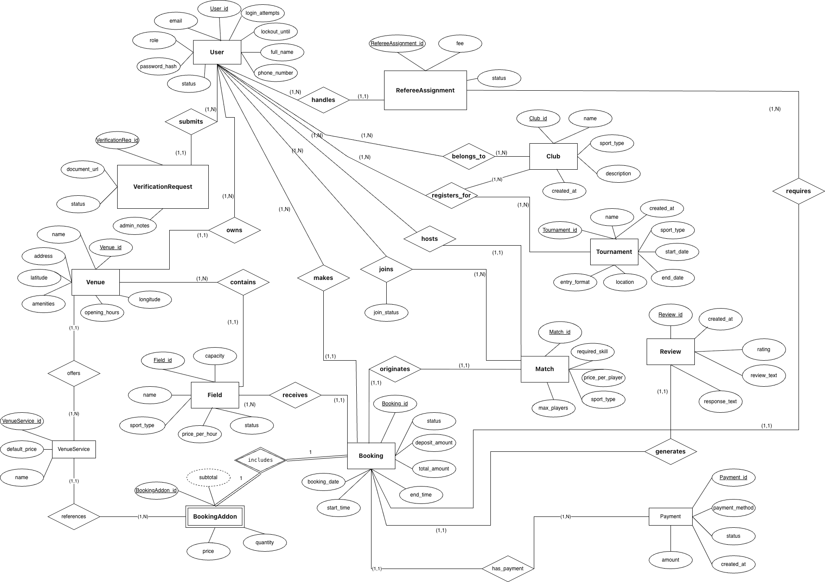

Link ER
Link ER Draw.io

Seq | Entity Name | Description | Relationships
1 | User | Represents a registered account on the platform (Player, Venue Owner, Referee, Admin), storing login credentials, profile data (name, phone number), and status. | Submits VerificationRequests; Owns Venues; Makes Bookings; Receives RefereeAssignments; Joins Matches; Hosts Matches; Registers for Tournaments.
2 | VerificationRequest | Represents a verification request containing business licenses or credentials submitted by a Venue Owner or Referee to the system. | Submitted by a User.
3 | Venue | Represents a sports facility, storing location data (coordinates, address), a list of amenities, and opening hours. | Owned by a User; Contains Fields.
4 | Field | Represents a specific playing field/court within a facility, storing the sport type, name, hourly price, capacity, and status. | Contained within a Venue; Reserved in a Booking.
5 | Booking | Represents a customer's field reservation, tracking the time slot, total amount, deposit amount, and status. | Made by a User; Reserves a Field; Includes BookingAddons; Generates a Review; Handles RefereeAssignments.
6 | BookingAddon | Represents add-on services (e.g., equipment rental, drinks) added to a reservation, tracking the quantity, price, and subtotal. | Included in a Booking.
7 | Review | Represents a customer's feedback after completing a booking, storing the rating and review text. | Generated from a Booking.
8 | Match | Represents a matchmaking session, storing the required skill level, price per player, maximum number of players, and sport type. | Hosted by a User; Joined by Users.
9 | Tournament | Represents a sports tournament, storing the tournament name, schedule, location, and entry format. | Receives registrations (registers_for) from Users or Clubs.
10 | Club | Represents a sports club or group of players on the platform. | Registers for Tournaments.
11 | RefereeAssignment | Represents the assignment of a referee to a match/booking, storing the fee and acceptance status. | Handled through a Booking; Received by a User (acting as a Referee).
12 | Payment | Represents a payment transaction for a booking, storing the amount, payment method, and status. | Processes payments for a Booking.
13 | VenueService | Represents a catalog of fixed add-on services set up by the venue owner, storing the service name and default price. | Offered by a Venue; Referenced by BookingAddons.

3. Architectural Design

3.1 Architecture Diagram

3.1.1.System Decomposition Tree

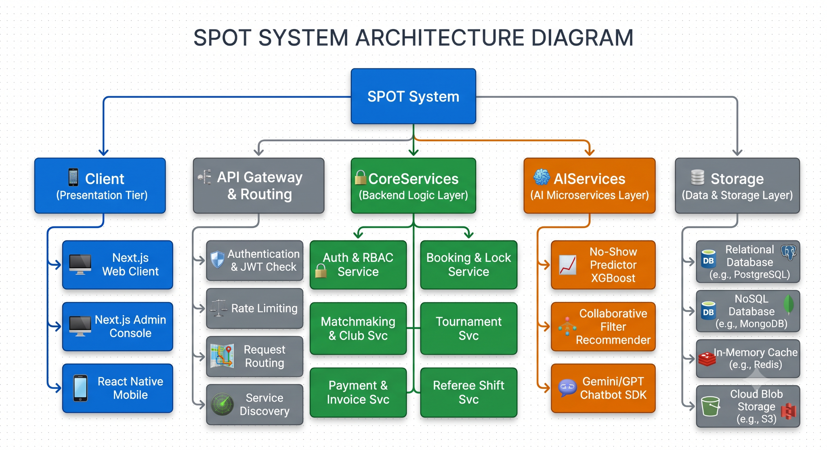

3.1.2.Overall System Architecture
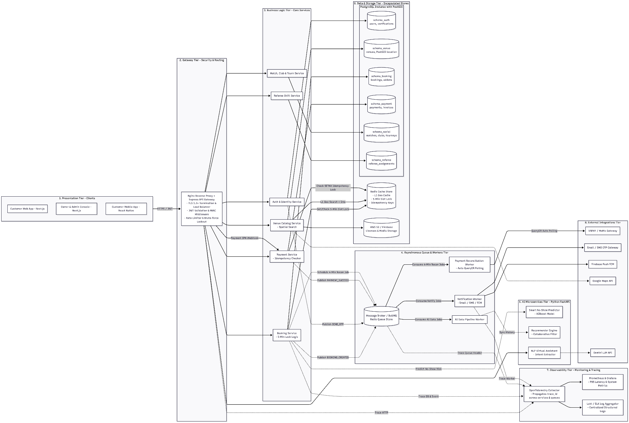

Link Overall System Architecture

3.2 Class Diagram
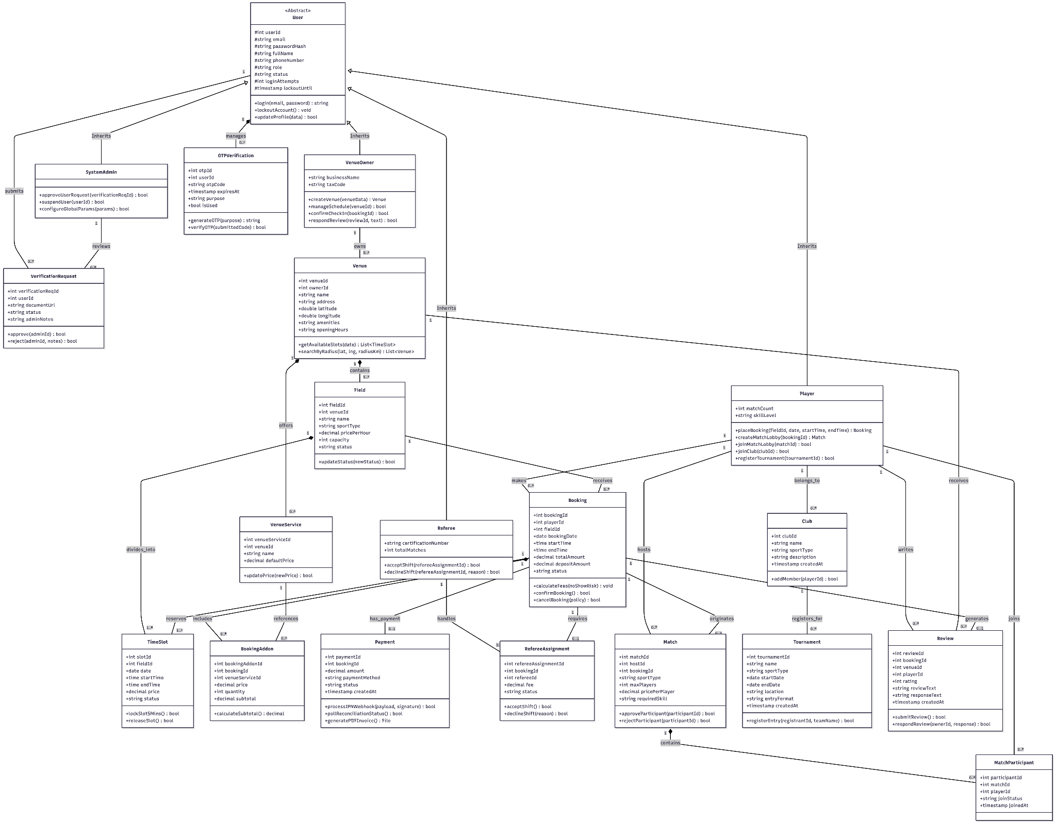
Link Class Diagram

3.3 Class Specifications

3.3.1 Superclass: User (Abstract)
List of Attributes:
Seq | Property | Modifier | Constraint | Description
1 | userId | Protected | Primary Key | Unique user identification code
2 | email | Public | Unique,Valid Email | User account login email
3 | passwordHash | Protected | Argon2 / Bcrypt Hash | Encrypted password string
4 | fullName | Protected | Not Null | User's full legal name
5 | phoneNumber | Protected | Unique,Valid Format | Primary contact phone number
6 | role | Protected | Enum:PLAYER, OWNER, REFEREE, ADMIN | Access control role
7 | status | Protected | Enum:ACTIVE, PENDING, LOCKED | Operational account state
8 | loginAttempts | Protected | Default: 0 | Counter for failed login attempts
8 | lockoutUntil | Protected | Nullable Timestamp | Expiry timestamp for 15-minute lockout

List of Operations:
Seq | Operation | Modifier | Constraint | Description
1 | login(email, pass) |  | Returns JWT Token | Authenticates credentials and issues JWT token
2 | lockoutAccount() |  | Triggered when attempts = 5 | Temporarily locks account for 15 minutes
3 | updateProfile(data) |  | Requires OTP for sensitive fields | Updates personal profile attributes

3.3.2 Subclass : Player
List of Attributes:
Seq | Property | Modifier | Constraint | Description
1 | matchCount | Public | Default: 0 | Total number of completed sessions
2 | skillLevel | Public | Enum: BEGINNER, INTERMEDIATE, ADVANCED | Player's self-assessed skill rating

List of Operations:
Seq | Operation | Modifier | Constraint | Description
1 | placeBooking(fieldId, date, startTime, endTime) | Public | Returns Booking instance | Creates court reservation and locks slots
2 | createMatchLobby(bookingId) | Public | Requires paid booking | Publishes a friendly match session
3 | joinMatchLobby(matchId) | Public | Match status = OPEN | Requests to join an existing match session
4 | joinClub(clubId) | Public | None | Submits a request to join a sports club
5 | registerTournament(tournamentId) | Public | Entry open | Enrolls in a tournament competition

3.3.3 Subclass : VenueOwner
List of Attributes:
Seq | Property | Modifier | Constraint | Description
1 | businessName | Public | Not Null | Registered business entity name
2 | taxCode | Public | Unique String | Official tax identification number

List of Operations:
Seq | Operation | Modifier | Constraint | Description
1 | createVenue(venueData) | Public | Status = APPROVED | Registers a new venue facility
2 | manageSchedule(venueId) | Public | Owner ID matches | Updates field availability and status
3 | confirmCheckIn(bookingId) | Public | Current time >= Booking time | Marks a booking as checked-in or completed

3.3.4 Class : Venue
List of Attributes:
Seq | Property | Modifier | Constraint | Description
1 | venueId | Private | Primary Key | Unique venue identification code
2 | ownerId | Public | Foreign Key -> VenueOwner.userId | Owner account ID
3 | name | Public | Not Null | Venue facility name
4 | address | Public | Not Null | Physical location address string
5 | latitude | Public | Double (-90.0 to 90.0) | Geographic latitude coordinate
6 | longtitude | Public | Double (-180.0 to 180.0) | Geographic longitude coordinate

List of Operations:
Seq | Operation | Modifier | Constraint | Description
1 | getAvailableSlots(date) | Public | Date format | Queries available fields and time slots
2 | searchByRadius(lat,lng,radiusKm) | Public | PostGIS GIST Index | Performs spatial radius search (<20ms)

3.3.5 Class : Field
List of Attributes:
Seq | Property | Modifier | Constraint | Description
1 | fieldId | Private | Primary Key | Unique field identifier
2 | venueId | Public | Foreign Key -> Venue.venueId | Parent venue facility ID
3 | name | Public | Not Null | Court name (e.g., Pitch A, Court 1)
4 | sportType | Public | Not Null | Sport category (Football, Badminton, Tennis)
5 | pricePerHour | Public | Decimal > 0 | Hourly rental price rate
6 | status | Public | Enum: ACTIVE, MAINTENANCE, INACTIVE | Court operational status

List of Operations:
Seq | Operation | Modifier | Constraint | Description
1 | updateStatus(newStatus) | Public | Owner authority | Updates court status (e.g., MAINTENANCE)

3.3.6 Class : TimeSlot
List of Attributes:
Seq | Property | Modifier | Constraint | Description
1 | slotId | Private | Primary Key | Unique time slot identifier
2 | fieldId | Public | Foreign Key -> Field.fieldId | Parent field ID
3 | date | Public | Date | Date of schedule slot
4 | startTime | Public | Time | Slot start time boundary
5 | endTime | Public | Time | Slot end time boundary
6 | status | Public | Enum: AVAILABLE, LOCKED_5M, BOOKED | Current availability state of slot

List of Operations:
Seq | Operation | Modifier | Constraint | Description
1 | lockSlot5Mins() | Public | Redis TTL = 300s | Holds temporary lock on Redis memory
2 | releaseSlot() | Public | Lock exists | Clears lock state if checkout is aborted

3.3.7 Class : Booking
List of Attributes:
Seq | Property | Modifier | Constraint | Description
1 | bookingId | Private | Primary Key | Unique booking ticket number
2 | playerId | Public | Foreign Key -> Player.userId | Customer user ID
3 | fieldId | Public | Foreign Key -> Field.fieldId | Target field ID
4 | bookingDate | Public | Date | Reserved match date
5 | totalAmount | Public | Decimal >= 0 | Total price including add-ons
6 | depositAmount | Public | Decimal >= 0 | Dynamically computed deposit fee
7 | status | Public | Enum:PENDING_PAYMENT,PAID, CHECKED_IN, NO_SHOW, COMPLETED | Booking lifecycle state
List of Operations:
Seq | Operation | Modifier | Constraint | Description
1 | calculateFees(noShowRisk) | Public | Risk 0.0 to 1.0 | Adjusts deposit based on AI No-Show prediction
2 | confirmBooking() | Public | Payment=SUCCESS | Transitions booking state to PAID
3 | cancelBooking(policy) | Public | Check cancellation policy | Cancels reservation

3.3.8 Class : Payment
List of Attributes:
Seq | Property | Modifier | Constraint | Description
1 | paymentId | Private | Primary Key | Unique payment record ID
2 | bookingId | Public | Foreign Key -> Booking.bookingId | Target booking ID
3 | amount | Public | Decimal >= 0 | Processed monetary amount
4 | paymentMethod | Public | Enum:ONLINE, COUNTER | Processed monetary amount
5 | status | Public | Enum: PENDING, SUCCESS, FAILED | Payment method path

List of Operations:
Seq | Operation | Modifier | Constraint | Description
1 | processIPNWebhook(payload, signature) | Public | Redis SETNX lock check | Handles webhooks safely without duplicate crediting
2 | pollReconciliationStatus() | Public | 4-minute delay | Polling QueryDR API if IPN is dropped
3 | generatePDFInvoice() | Public | Returns PDF Stream | Generates printable PDF receipt

3.3.9 Class : RefereeAssignment
List of Attributes:
Seq | Property | Modifier | Constraint | Description
1 | refereeAssignmentId | Private | Primary Key | Unique shift assignment ID
2 | bookingId | Public | Foreign Key -> Booking.bookingId | Target booking ID
3 | refereeId | Public | Foreign Key -> Referee.userId | Assigned referee ID
4 | fee | Public | Decimal >= 0 | Officiating fee for the shift
5 | status | Public | Enum: PENDING, ACCEPTED, DECLINED | Shift acceptance status

List of Operations:
Seq | Operation | Modifier | Constraint | Description
1 | acceptShift() | Public | Status = PENDING | Accepts officiating assignment
2 | declineShift(reason) | Public | Status = PENDING | Declines assignment with reason

3.3.10 Class : Match
List of Attributes:
Seq | Property | Modifier | Constraint | Description
1 | matchId | Private | Primary Key | Unique match lobby ID
2 | hostId | Public | Foreign Key -> Player.userId | Match host player ID
3 | bookingId | Public | Foreign Key -> Booking.bookingId | Associated confirmed booking ID
4 | sportType | Public | Not Null | Sport category
5 | maxPlayers | Public | Integer > 0 | Maximum player capacity
6 | pricePerPlayer | Public | Decimal >= 0 | Cost share per joining player
7 | requiredSkill | Public | Enum: BEGINNER, INTERMEDIATE, ADVANCED | Required skill level

List of Operations:
Seq | Operation | Modifier | Constraint | Description
1 | approveParticipant(participantId) | Public | Host authority | Approves a player's join request
2 | rejectParticipant(participantId) | Public | Host authority | Rejects a player's join request

4. Data Design

4.1 Data Diagram
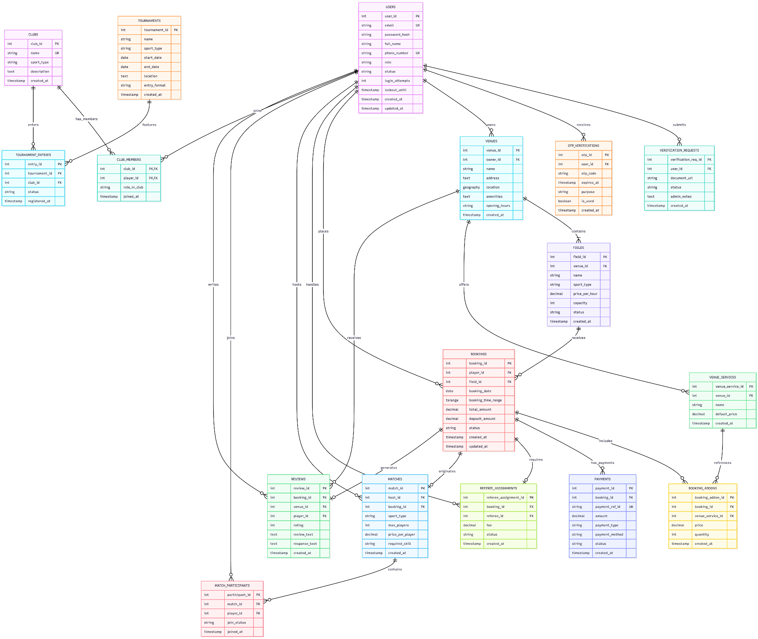
Link Data Diagram

4.2 Data Specification

4.2.1. Relational Database Tables (PostgreSQL - Logical Schemas)

4.2.1.1. Logical Schema: schema_auth
Table 1.1: schema_auth.users
Description: Stores user identity accounts, hashed credentials, security lockout counters, and RBAC roles

Attribute | Data Type | Constraint | Description
user_id | SERIAL | Primary Key | Unique user identification number
email | VARCHAR(150) | UNIQUE, NOT NULL | Account login email address
password_hash | VARCHAR(255) | NOT NULL | Argon2 / Bcrypt encrypted password hash
full_name | VARCHAR(100) | NOT NULL | User's full legal name
phone_number | VARCHAR(15) | UNIQUE, NOT NULL | Primary contact phone number
role | VARCHAR(20) | ENUM('PLAYER','OWNER','REFEREE','ADMIN') | RBAC access control role
status | VARCHAR(20) | ENUM('ACTIVE','PENDING','LOCKED') | Operational account state
login_attempts | INT | DEFAULT 0 | Counter for failed consecutive login attempts
lockout_until | TIMESTAMP | NULLABLE | Expiry timestamp for 15-minute lockout
created_at | TIMESTAMP | DEFAULT CURRENT_TIMESTAMP | Account creation timestamp
updated_at | TIMESTAMP | DEFAULT CURRENT_TIMESTAMP | Account profile update timestamp

Table 1.2: schema_auth.verification_requests
Description: Stores legal business licenses and referee credentials queued for Admin review.
Attribute | Data Type | Constraint | Description
verification_req_id | SERIAL | Primary Key | Unique verification request ID
user_id | INT | FK->schema_auth.users(user_id) | Applicant user ID
document_url | VARCHAR(255) | NOT NULL | S3/Firebase URL to attached credential document
status | VARCHAR(20) | ENUM('PENDING','APPROVED','REJECTED') | Admin review status
admin_notes | TEXT | NULLABLE | Administrative review notes or rejection reason
created_at | TIMESTAMP | DEFAULT CURRENT_TIMESTAMP | Submission timestamp

Table 1.3: schema_auth.otp_verifications
Description: Stores 6-digit one-time password hashes with 5-minute TTL for sensitive actions.
Attribute | Data Type | Constraint | Description
otp_id | SERIAL | Primary Key | Unique OTP record ID
user_id | INT | FK->schema_auth.users(user_id) | Target recipient user ID
otp_code | VARCHAR(10) | NOT NULL | Hashed 6-digit verification code
expires_at | TIMESTAMP | NOT NULL | Expiration timestamp (5 minutes TTL)
purpose | VARCHAR(50) | NOT NULL | Reason for issuance (e.g., FORGOT_PASSWORD)
is_used | BOOLEAN | DEFAULT FALSE | Flag indicating if code has been consumed
created_at | TIMESTAMP | DEFAULT CURRENT_TIMESTAMP | OTP generation timestamp

4.2.1.2. Logical Schema: schema_venue
Table 2.1: schema_venue.venues (PostGIS Extension Enabled)
Description: Stores sports complex center metadata and PostGIS geographic spatial coordinates.
Attribute | Data Type | Constraint | Description
venue_id | SERIAL | Primary Key | Unique venue facility code
owner_id | INT | FK-> schema_auth.users(user_id) | Linked Venue Owner user ID
name | VARCHAR(150) | NOT NULL | Venue facility name
address | TEXT | NOT NULL | Physical address string
location | GEOGRAPHY(Point, 4326) | GIST Spatial Index | Longitude & Latitude point for ST_DWithin radius search
amenities | TEXT | NULLABLE | Available amenities (Wifi, Parking, Locker rooms)
opening_hours | VARCHAR(100) | NULLABLE | Operating daily time window
created_at | TIMESTAMP | DEFAULT CURRENT_TIMESTAMP | Record creation timestamp
updated_at | TIMESTAMP | DEFAULT CURRENT_TIMESTAMP | Record update timestamp

Table 2.2: schema_venue.venue_services
Description: Add-on services offered at a specific venue (e.g., referee hiring, drink crates, equipment rental).
Attribute | Data Type | Constraint | Description
venue_service_id | SERIAL | Primary Key | Unique venue service identification code.
venue_id | INT | FK->schema_venue.venues(venue_id) | Parent venue facility ID
name | VARCHAR(100) | NOT NULL | Add-on service title
default_price | DECIMAL(10,2) | NOT NULL, >= 0 | Default unit price for rental/purchase
created_at | TIMESTAMP | DEFAULT CURRENT_TIMESTAMP | Record creation timestamp

Table 2.3: schema_venue.fields
Description: Individual court or pitch within a venue facility.
Attribute | Data Type | Constraint | Description
field_id | SERIAL | Primary Key | Unique field identifier
venue_id | INT | FK->schema_venue.venues(venue_id) | Parent venue facility ID
name | VARCHAR(100) | NOT NULL | Court name (Pitch A, Court 1)
sport_type | VARCHAR(50) | NOT NULL | Sport category (Football, Badminton, Tennis)
price_per_hour | DECIMAL(10,2) | NOT NULL, > 0 | Hourly rental rate
capacity | INT | DEFAULT 10 | Maximum player capacity
status | VARCHAR(20) | ENUM('ACTIVE','MAINTENANCE'  ,'INACTIVE') | Court operational status
created_at | TIMESTAMP | DEFAULT CURRENT_TIMESTAMP | Record creation timestamp

4.2.1.3. Logical Schema: schema_booking
Table 3.1: schema_booking.bookings (Physical STRANGE Overlap Constraint)
Description: Stores reservation ticket transactions with PostgreSQL TSRANGE time bounds to eliminate double-booking at the physical DB level.
Attribute | Data Type | Constraint | Description
booking_id | SERIAL | Primary Key | Unique booking ticket number
player_id | INT | FK->schema_auth.users(user_id) | Reserving customer user ID
field_id | INT | FK->schema_venue.fields(field_id) | Target court ID
booking_date | DATE | NOT NULL | Reserved match date
booking_time_range | TSRANGE | NOT NULL, EXCLUDE GIST | Timestamp range representing start_time and end_time
total_amount | DECIMAL(10,2) | NOT NULL, >= 0 | Total payable price including add-ons.
deposit_amount | DECIMAL(10,2) | NOT NULL, >= 0 | Dynamically computed deposit fee
status | VARCHAR(30) | ENUM('PENDING_PAYMENT','PAID','CHECKED_IN','NO_SHOW','COMPLETED') | Booking lifecycle status
created_at | TIMESTAMP | DEFAULT CURRENT_TIMESTAMP | Reservation creation timestamp
updated_at | TIMESTAMP | DEFAULT CURRENT_TIMESTAMP | Reservation status update timestamp

Table 3.2: schema_booking.booking_addons (Weak Entity)
Description: Stores add-on items attached to a specific booking ticket.
Attribute | Data Type | Constraint | Description
booking_addon_id | SERIAL | Primary Key | Unique add-on item record ID
booking_id | INT | FK->schema_booking.bookings(booking_id) | Parent booking ID
venue_service_id | INT | FK->schema_venue.venue_services(venue_service_id) | Referenced venue service ID
price | DECIMAL(10,2) | NOT NULL, >= 0 | Unit price at time of booking
quantity | INT | DEFAULT 1, > 0 | Quantity ordered
created_at | TIMESTAMP | DEFAULT CURRENT_TIMESTAMP | Item addition timestamp

4.2.1.4. Logical Schema: schema_payment
Table 4.1: schema_payment.payments (Multi-Payment Support)
Description: Stores individual payment transactions supporting online deposits and counter remaining balances
Attribute | Data Type | Constraint | Description
payment_id | SERIAL | Primary Key | Unique payment record ID
booking_id | INT | FK->schema_booking.bookings(booking_id) | Associated booking ID
payment_ref_id | VARCHAR(100) | UNIQUE, NULLABLE | Gateway reference transaction code
amount | DECIMAL(10,2) | NOT NULL, > 0 | Processed monetary amount
payment_type | VARCHAR(20) | ENUM('DEPOSIT', 'REMAINING', 'FULL') | Payment installment type
payment_method | VARCHAR(20) | ENUM('ONLINE', 'COUNTER') | Chosen payment path
status | VARCHAR(20) | ENUM('PENDING', 'SUCCESS', 'FAILED') | Payment settlement status
created_at | TIMESTAMP | DEFAULT CURRENT_TIMESTAMP | Transaction timestamp
updated_at | TIMESTAMP | DEFAULT CURRENT_TIMESTAMP | Status update timestamp

4.2.1.5. Logical Schema: schema_referee
Table 5.1: schema_referee.referee_assignments
Description: Officiating shift assignments for booked matches.

Attribute | Data Type | Constraint | Description
referee_assignment_id | SERIAL | Primary Key | Unique shift assignment ID
booking_id | INT | FK -> schema_booking.bookings(booking_id) | Target booking ID
referee_id | INT | FK -> schema_auth.users(user_id) | Assigned referee ID
fee | DECIMAL(10,2) | NOT NULL, >= 0 | Officiating fee for the shift
status | VARCHAR(20) | ENUM('PENDING', 'ACCEPTED', 'DECLINED') | Shift acceptance status
created_at | TIMESTAMP | DEFAULT CURRENT_TIMESTAMP | Assignment creation timestamp

4.2.1.6. Logical Schema: schema_social
Table 6.1: schema_social.matches
Description: Friendly match lobbies created by hosts seeking extra players.
Attribute | Data Type | Constraint | Description
match_id | SERIAL | Primary Key | Unique match lobby ID
host_id | INT | FK -> schema_auth.users(user_id) | Match host player ID
booking_id | INT | FK -> schema_booking.bookings(booking_id) | Associated confirmed booking ID
sport_type | VARCHAR(50) | NOT NULL | Sport category
max_players | INT | NOT NULL, > 0 | Maximum player capacity
price_per_player | DECIMAL(10,2) | DEFAULT 0.00 | Cost share per joining player
required_skill | VARCHAR(20) | ENUM('BEGINNER','INTERMEDIATE','ADVANCED') | Required skill level
created_at | TIMESTAMP | DEFAULT CURRENT_TIMESTAMP | Lobby creation timestamp

Table 6.2: schema_social.match_participants (Association Table)
Description: Participant join requests and approval status for match lobbies.
Attribute | Data Type | Constraint | Description
participant_id | SERIAL | Primary Key | Unique participant record ID
match_id | INT | FK->schema_social.matches(match_id) | Target match session ID
player_id | INT | FK->schema_auth.users(user_id) | Requesting player ID
join_status | VARCHAR(20) | ENUM('PENDING','APPROVED','REJECTED','KICKED') | Host approval status
joined_at | TIMESTAMP | DEFAULT CURRENT_TIMESTAMP | Request timestamp

Table 6.3: schema_social.clubs
Description: Sports clubs and group rosters.
Attribute | Data Type | Constraint | Description
club_id | SERIAL | Primary Key | Unique club identifier
name | VARCHAR(100) | UNIQUE, NOT NULL | Club name
sport_type | VARCHAR(50) | NOT NULL | Primary sport activity
description | TEXT | NULLABLE | Club guidelines and description
created_at | TIMESTAMP | DEFAULT CURRENT_TIMESTAMP | Foundation timestamp

Table 6.4: schema_social.club_members (M:N Junction Table)
Description: Junction table connecting Users to multiple Clubs with club roles.
Attribute | Data Type | Constraint | Description
club_id | INT | PK,FK->schema_social.clubs(club_id) | Target club ID
player_id | INT | PK,FK-> schema_auth.users(user_id) | Member player ID
role_in_club | VARCHAR(20) | ENUM('CAPTAIN', 'MEMBER') | Role within the club
joined_at | TIMESTAMP | DEFAULT CURRENT_TIMESTAMP | Membership join timestamp

Table 6.5: schema_social.tournaments
Description: Tournament events and competition details.
Attribute | Data Type | Constraint | Description
tournament_id | SERIAL | Primary Key | Unique tournament ID
name | VARCHAR(150) | NOT NULL | Tournament title
sport_type | VARCHAR(50) | NOT NULL | Sport category
start_date | DATE | NOT NULL | Tournament opening date
end_date | DATE | NOT NULL | Tournament conclusion date
location | TEXT | NOT NULL | Venue address or facility name
entry_format | VARCHAR(20) | ENUM('SINGLES', 'DOUBLES', 'TEAMS') | Competition entry format
created_at | TIMESTAMP | DEFAULT CURRENT_TIMESTAMP | Creation timestamp

Table 6.6: schema_social.tournament_entries (M:N Junction Table)
Description: Junction table registering Clubs for Tournaments.
Attribute | Data Type | Constraint | Description
entry_id | SERIAL | Primary Key | Unique entry record ID
tournament_id | INT | FK->schema_social.tournaments(tournament_id) | Target tournament ID
club_id | INT | FK->schema_social.clubs(club_id) | Enrolled club ID
status | VARCHAR(20) | ENUM('PENDING', 'CONFIRMED', 'REJECTED') | Entry approval status.
registered_at | TIMESTAMP | DEFAULT CURRENT_TIMESTAMP | Registration timestamp

4.2.1.7. Logical Schema: schema_review
Table 7.1: schema_review.reviews
Description: Stores post-booking reviews, ratings, and owner responses.
Attribute | Data Type | Constraint | Description
review_id | SERIAL | Primary Key | Unique review ID
booking_id | INT | UNIQUE,FK->schema_booking.bookings(booking_id) | Related completed booking ID
venue_id | INT | FK->schema_venue.venues(venue_id) | Target venue ID
player_id | INT | FK -> schema_auth.users(user_id) | Author player ID
rating | INT | CHECK(rating BETWEEN 1 AND 5) | Star rating (1 to 5 stars)
review_text | TEXT | NULLABLE | Review comment text
response_text | TEXT | NULLABLE | Venue owner's response text
created_at | TIMESTAMP | DEFAULT CURRENT_TIMESTAMP | Submission timestamp

4.2.2.. In-Memory Data Structures (Redis Cache Keys)
Key Pattern | Data Structure | TTL | Description / Purpose
lock:slot:{field_id}:{date}:{start_time} | String (user_id) | 300 seconds | 5-Minute Ephemeral Slot Lock: Holds slot temporarily during checkout to guarantee 0% double-booking and < 50ms latency
geo:venues:{sport_type} | Redis GeoSet | Infinite | L1 Geo Search Cache: Stores venue geographic points for instant GEOSEARCH radius queries (< 5ms)
lock:ipn:{payment_ref_id} | String (SETNX) | 30 seconds | Payment Idempotency Lock: Prevents duplicate VNPAY/MoMo IPN webhook executions
sess:user:{user_id} | Hash | 86400 seconds | Active Session Cache: Stores active user token claims and role permissions for fast JWT validation

5 User Interface and User Experience Design

5.1. Screen Diagram
Screen Diagram for Player/Host Match Link: Access Link Here
UI/UX Screen Link: Access Link Here
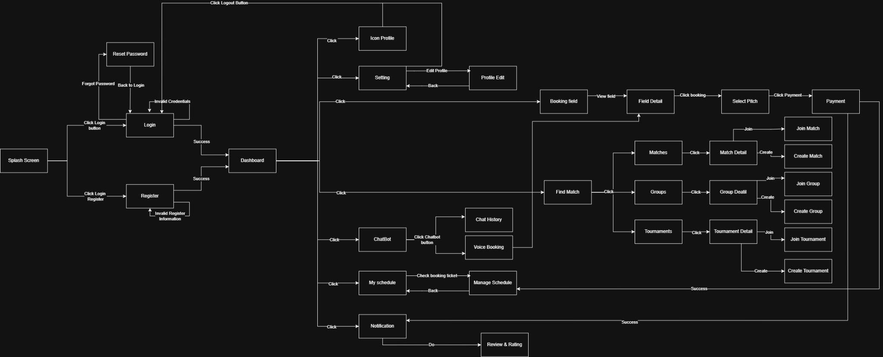

Seq | Screen | Description
1 | Splash Screen | The initial launch screen, branching to Login or Register.
2 | Login | Login screen. Receives flow from Splash Screen or Back to Login from Reset Password. Proceeds to Dashboard upon Success.
3 | Register | Registration screen. Receives flow from Splash Screen. Proceeds to Dashboard upon Success.
4 | Reset Password | Password recovery screen. Accessed via the "Forgot Password" branch from Login.
5 | Dashboard | The main navigation hub, connecting to all core features of the app.
6 | Icon Profile | Accessed from Dashboard. Contains a Logout Button that routes the user straight back to Login.
7 | Setting | Accessed from Dashboard. Navigates to the Profile Edit screen.
8 | Profile Edit | Edit personal information. Accessed from Setting (Edit Profile) and allows returning via a Back flow.
9 | Booking field | Venue list screen. Accessed from Dashboard or Voice Booking. Navigates to Field Detail.
10 | Field Detail | Venue details. Accessed from Booking field (View field). Navigates to Select Pitch.
11 | Select Pitch | Choose pitch and time. Accessed from Field Detail (Click booking). Navigates to Payment.
12 | Payment | Checkout screen (Click Payment from Select Pitch). A Success event routes back to Dashboard and sends a flow to Notification.
13 | Find Match | Main matchmaking screen, accessed from Dashboard. Branches into Matches, Groups, and Tournaments.
14 | Matches | List of drop-in matches. Accessed from Find Match, navigates to Match Detail.
15 | Match Detail | Match specifics. Branches into Join Match or Create Match screens.
16 | Join Match | Screen to join an existing match.
17 | Create Match | Screen to host a new match.
18 | Groups | List of communities/groups. Accessed from Find Match, navigates to Group Deatial.
19 | Group Detail | Group specifics. Branches into Join Group or Create Group screens.
20 | Join Group | Screen to join an existing group.
21 | Create Group | Screen to form a new group.
22 | Tournaments | List of tournaments. Accessed from Find Match, navigates to Tournament Detail.
23 | Tournament Detail | Tournament specifics. Branches into Join Tournament or Create Tournament screens.
24 | Join Tournament | Screen to register for an ongoing tournament.
25 | Create Tournament | Screen to organize a new tournament.
26 | ChatBot | AI assistant feature, accessed from Dashboard.
27 | Chat History | View past conversations, accessed via the ChatBot button branch.
28 | Voice Booking | Voice-activated booking. Accessed via ChatBot button and routes directly to the Booking field.
29 | My schedule | Itinerary screen, accessed from Dashboard.
30 | Manage Schedule | Schedule management, accessed from My schedule (Check booking ticket) and allows returning via a Back flow.
31 | Notification | Notification center, accessed from Dashboard or receives a Success trigger from Payment.
32 | Review & Rating | Feedback screen, initiated via a "Do" action from Notification.

5.2. Screen Specifications

5.2.1. Screen “Booking field homepage”
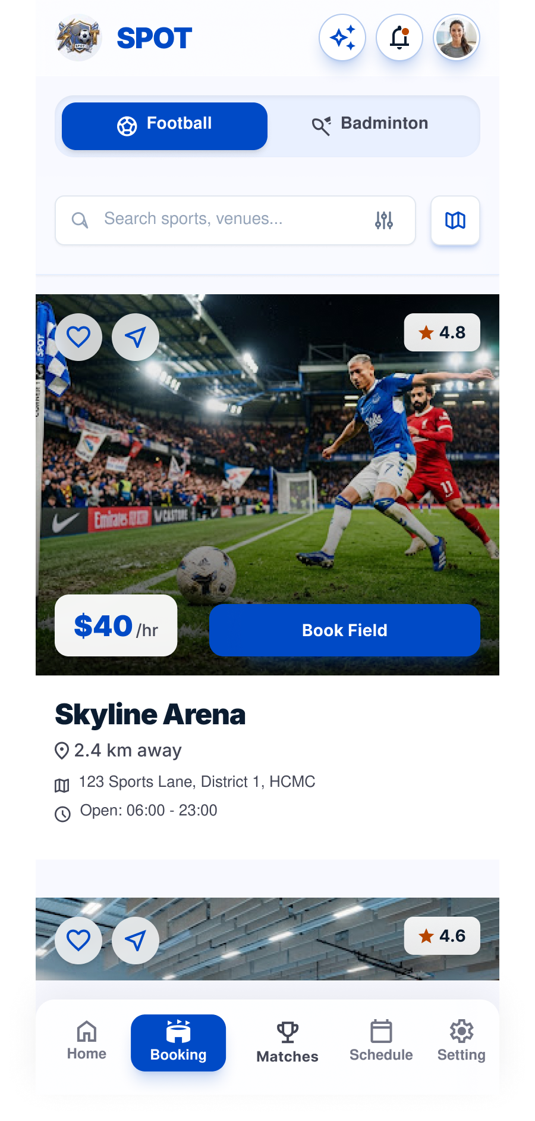

Presentation format
- Top Navigation Bar: Located at the top, displaying the SPOT logo, an AI assistant icon, a notification bell icon, and the user profile avatar.
- Sport Category Switcher: Two prominent toggle buttons allowing users to switch between "Football" (active) and "Badminton".
- Search and Filter Bar: A search input field integrated with a filter icon and a map view toggle icon.
- Venues List: A vertically scrollable list of available sports facilities (e.g., Skyline Arena, Metro Futsal Hub) featuring:
  - High-quality venue images.
  - Rating badge (e.g., 4.8 stars).
  - Hourly rental price overlay.
  - Detailed information: Distance, address, and operating hours.
  - Secondary Interaction Buttons: A favorite (heart) button and a share button overlaid on each venue's image.
  - Main Action Button: A prominent blue "Book Field" button for each listing.
- Bottom Navigation Bar: Fixed at the bottom containing five primary tabs: Home, Booking (active), Matches, Schedule, and Setting.
Event handling
- Click "Football" / "Badminton" tab: Action: Switches the active sport category and filters the venue list accordingly.
- Click Search input / Filter / Map icon: Action: Activates text entry, opens advanced filtering parameters, or switches the list view to a map layout.
- Click "Book Field" on a specific venue: Action: Opens the time slot selection and booking confirmation interface for that specific venue.
- Click Favorite (Heart) icon: Action: Saves the venue to the user's favorites list; the icon toggles its state (e.g., filled/outlined).
- Click Share icon: Action: Opens the system sharing dialog for the venue.
- Click AI assistant, Notification, or Profile avatar: Action: Navigates to the respective AI chat, notifications panel, or user profile view.
- Click Bottom Navigation items: Action: Navigates the user to other main sections of the application.

5.2.2. Screen “Voice booking”
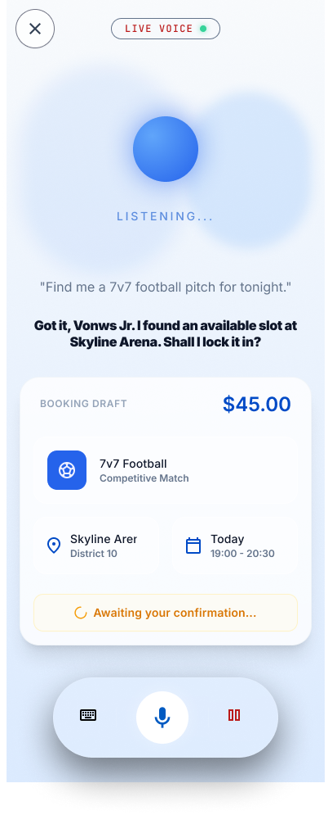
Presentation format
- Top Bar: Features a close ('X') button on the left and an active status indicator displaying a "LIVE VOICE" label with a green dot on the top center.
- Voice Animation Area: Shows a glowing blue sphere and the text "LISTENING..." to indicate active audio reception.
- Transcript Text: Displays the user's speech input (e.g., "Find me a 7v7 football pitch for tonight.") and the AI's conversational response ("Got it, Vonws Jr. I found an available slot at Skyline Arena. Shall I lock it in?").
- Booking Draft Card: A pre-filled summary card created by the AI containing:
  - Estimated total cost in the top right (e.g., $45.00).
  - Match type details (e.g., 7v7 Football, Competitive Match).
  - Venue location (e.g., Skyline Arer, District 10).
  - Date and time (e.g., Today, 19:00 - 20:30).
  - A status indicator banner stating "Awaiting your confirmation...".
- Bottom Toolbar: A floating pill-shaped container holding a keyboard switch button, a glowing active microphone icon in the center, and a pause/stop bars icon.
Event handling
- Click the Close ('X') button: Action: Exits the live voice assistant interface and returns the user to the previous screen.
- Click the Keyboard icon: Action: Switches the input mode from live voice conversation to manual text typing.
- Click the Microphone icon: Action: Toggles the microphone state (mutes or resumes voice input).
- Click the Pause button: Action: Pauses the current listening state or session of the AI assistant.

5.2.3 Screen “Football - Dashboard”
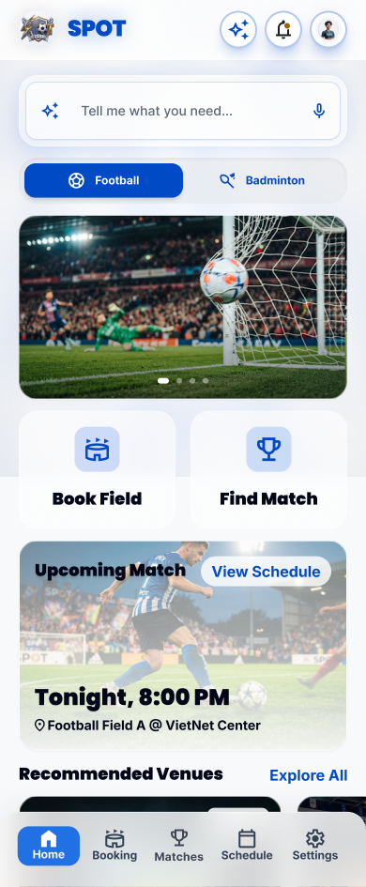
Presentation format
- Search Bar: A versatile search bar featuring a microphone icon for voice input.
- Sport Tabs: Quick toggle buttons to switch between different sports (e.g., Football, Badminton).
- Main Action Buttons: Two prominent, large buttons for primary actions: "Book Field" and "Find Match".
- "Upcoming Match" Card: Displays the user's next scheduled match, including date, time, and venue name/address.
- "Recommended Venues" List: A horizontally scrollable list of suggested venues. Each card includes a cover image, hourly rate, distance (in km), and a rating score.
- Bottom Navigation Bar: Contains navigation tabs: Home, Booking, Matches, Schedule, Settings.
Event handling
- Click Microphone Icon (Voice Search):
  - Action: Activates the AI voice assistant and navigates the user to the "Voice booking" screen.
- Click "Book Field" button:
  - Action: Navigates the user to the venue listing screen ("Football - Dashboard").
- Click "Find Match" button:
  - Action: Navigates the user to the match discovery screen ("Matches - Homepage").

5.2.4. Screen “Matches - Homepage”
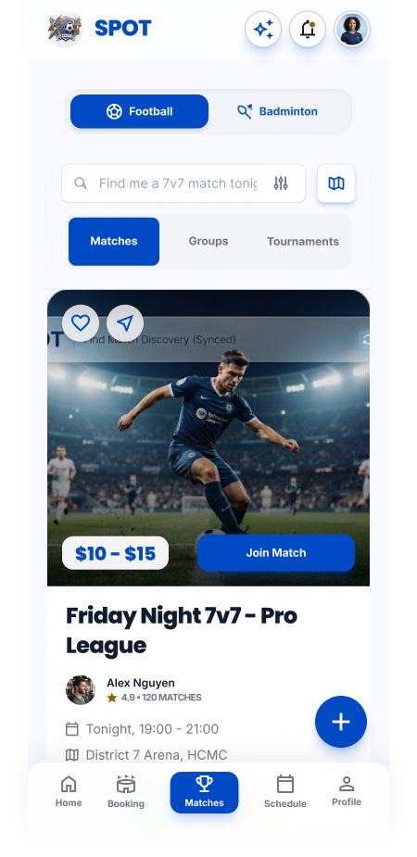
Presentation format
- Content Tabs: Navigation tabs to switch between "Matches", "Groups", and "Tournaments".
- Match List: Displays active matches looking for players (e.g., Friday Night 7v7, Advanced Singles Smash) with the following details:
  - Host avatar and name.
  - Date, time, venue, and distance.
  - Required skill level range (e.g., Amateur -> Semi-pro).
  - Availability status (e.g., "10 spots left") alongside avatars of joined players.
  - Entry fee.
- Action Button: A distinct blue "Join Match" button.
- Floating Action Button (FAB): A floating "+" button located at the bottom right corner.
Event handling
- Click "Join Match" button:
  - Action: Submits a request to join the match or redirects the user to the payment screen for the entry fee.
- Click "+" FAB:
  - Action: Opens a form for the user to create and host a new match.

5.2.5.Screen “Referee Invites - Manage Bookings”
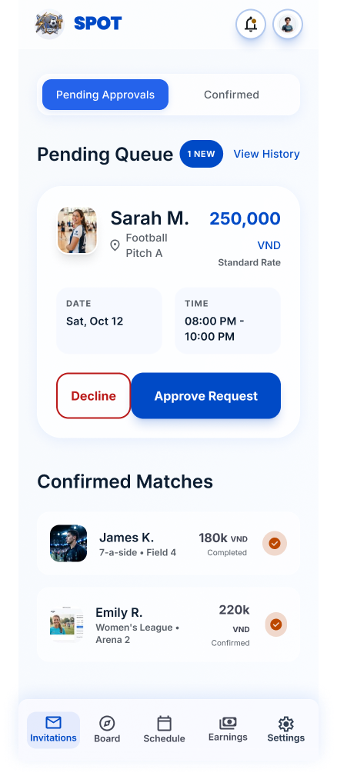
Presentation format
- Status Tabs: Two main tabs for managing requests: "Pending Approvals" and "Confirmed".
- Pending Queue Section: A list of incoming booking or referee requests awaiting action, displaying:
  - Requester's details (Avatar, Name, Venue).
  - Offered compensation/rate (e.g., 250,000 VND - Standard Rate).
  - Specific Date and Time.
  - Two parallel action buttons: "Decline" (red outline) and "Approve Request" (solid blue).
- Confirmed Matches Section: A list of previously approved matches showing completion status or upcoming schedule.
Event handling
- Click "Approve Request" button:
  - Action: Accepts the request. The item is moved to the "Confirmed" tab, and a notification is sent to the requester.
- Click "Decline" button:
  - Action: Rejects the request. The item is removed from the "Pending Queue".

5.2.6. Screen “SPOT | Venue Owner Dashboard (Web)”
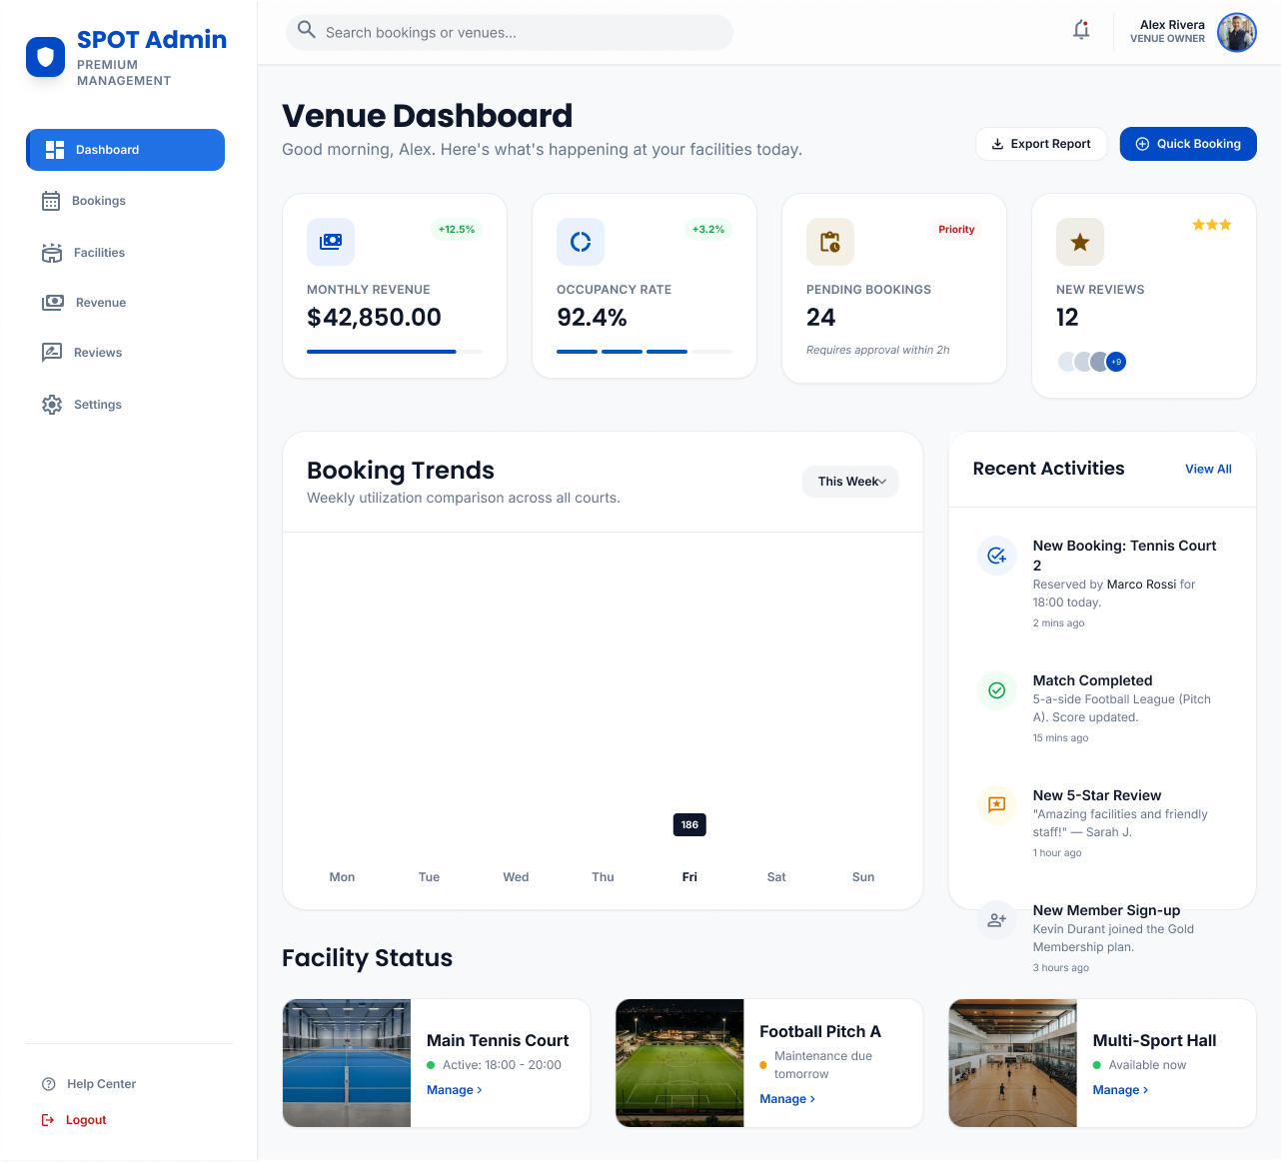

Presentation format
- Sidebar Navigation: A left-hand menu containing management modules: Dashboard, Bookings, Facilities, Revenue, Reviews, Settings.
- Top Statistics Cards: Four summary cards highlighting key performance indicators (KPIs): Monthly Revenue, Occupancy Rate, Pending Bookings (with priority tags), and New Reviews.
- Booking Trends Chart: A bar chart visualizing booking volume trends over the days of the week.
- Recent Activities Panel: A feed displaying the latest system events (e.g., new bookings, completed matches, new reviews).
- Facility Status Section: Quick-glance cards for individual courts/fields (e.g., Main Tennis Court, Football Pitch A) showing their current operational status (Active, Maintenance, Available now) and a "Manage >" link.
- Top Right Action Buttons: "Export Report" and "Quick Booking" buttons.
Event handling
- Click "Quick Booking" button:
  - Action: Opens a modal form allowing the venue owner or staff to manually enter a booking (useful for walk-in or phone reservations).
- Click "Manage >" on a Facility card:
  - Action: Redirects to a detailed settings and schedule management page specific to that individual facility.

