ECG Classifier Project Report
Shravani Kuchi, Agata Marchi, Thanigaiarasu Shanmugam, Monika Shrivastava, Abhay Soni

1. Business/Application Understanding

1.1 Application Scenario
The electrocardiogram (ECG) is a medical test that records the electrical activity of the heart through electrodes placed on the skin and is a standard, non-invasive tool for detecting heart disease. Each heartbeat produces a characteristic waveform, changes in its shape or timing can be an indicator of early signs of heart diseases so it is important for doctors to identify these anomalies. To find them, a patient usually wears a Holter monitor that records the ECG for 24 to 48 hours. However, at around 70 beats per minute this is roughly 100,000 beats per day, which is far too many beats for a doctor to check them by hand. In recent years, health monitoring is moving from the clinic to the patient thanks to small wearable devices that can record the ECG continuously during daily life. The embedding of software that labels each beat into these small wearable devices can point doctors to the few beats that actually need a closer look.
The goal of this project is to develop a model able to classify heartbeats from an electrocardiogram and that is small enough to run on a wearable device instead of on a computer or a server. Running the model on the device (Edge-AI) itself has some clear advantages. The raw ECG does not have to leave the device, which is better for privacy. Sending a few labels uses much less radio power and data than streaming the full signal all day so the battery lasts longer. The device also keeps working when there is no internet connection.
The main users would be doctors and nurses who review the flagged beats, the patients who wear the monitor and companies that develop these health monitoring wearables.
Our project only covers the ECG part of such a system, so no motion-sensor data is used. It is a course project and not a medical device, and we do not claim that our model is clinically validated.

1.2 Data-Mining Objective
Input: for each heartbeat the model gets two things:
- The beat itself: a window of 128 samples from ECG lead MLII at 180 Hz (0.71 s), with 48 samples before the R-peak and 80 samples after it.
- Three RR intervals: the time since the previous beat, the time until the next beat, and the median of the last four gaps, which shows the patient’s recent normal rhythm.
We include the RR intervals because an S beat often looks almost the same as a normal beat. The main difference is that it comes too early, which is easy to see when the time since the previous beat is compared with the recent median.
Output: one of the four classes in Table 1. These have been grouped in the same way as in de Chazal et al. (2004). The model gives a score for each class and the class with the highest score is the final prediction.
Class | Name | Description
N | Normal-type beat | Normal beats, plus bundle branch block beats and atrial or nodal escape beats
S | Supraventricular ectopic beat | Premature beats that start above the ventricles (in the atria or the AV node)
V | Ventricular ectopic beat | Beats that start in the ventricles, mostly premature ventricular contractions (the class also includes 106 ventricular escape beats)
F | Fusion beat | A ventricular beat and a normal beat that happen at the same time and merge
Table 1. The four heartbeat classes
Type of task: supervised multiclass classification with four classes and one label per beat.

1.3 Project Objectives
Our main aim is to develop a compact model that can tell N, S, V and F beats apart in patients it has not seen before and that works on the edge device MAX78002.
Our technical objectives are:
- Classify each heartbeat as N, S, V or F.
- Generalize to new, unseen patients. We train and select models only on DS1 and test once on DS2, and we always split by recording, never by individual beats.
- Detect the rare classes S and F reasonably well, not only the majority class N.
- Be robust to real ECG noise from the MIT-BIH Noise Stress Test Database (Moody et al., 1984).
- Keep the model compact and use only layer types the MAX78002 supports, such as 1D convolution, pooling, ReLU and a small fully connected output layer.
- Quantize the model to INT8 with only a small loss in performance.
- Get the model through the Analog Devices ai8x-training and ai8x-synthesis tools (Analog Devices, n.d.) and generate C code for the MAX78002.
- Compare it with a simple baseline, to check if the neural network is worth the extra size.
- Keep everything reproducible with one config file and a fixed random seed.

1.4 Success Criteria
We will not judge the model on accuracy alone because of the class imbalance of the dataset. On the DS2 test dataset, a model that always predicts N would already get about 89% accuracy. Instead we use macro-F1 (the average F1 score of the four classes) and recall for the rare classes. All targets are measured on DS2 with the final INT8 model unless the table says otherwise. Table 2 provides a summary of the evaluation criteria we will use in the project.
Area | Criterion
Predictive performance | Macro-F1 of at least 0.55, and better than the baseline
Minority classes | Recall of at least 0.60 for S and at least 0.80 for V. F is reported without a fixed target, because 362 of the 388 F beats in DS2 (93%) come from one patient (record 213).
Noise robustness | At 12 dB macro-F1 stays at least 90% of the clean result, and at 6 dB at least 75%. 0 dB is only reported.
Quantization | INT8 macro-F1 is at most 0.03 lower than FP32, and S and V recall drop by at most 5 percentage points.
Model complexity | INT8 weights of at most 2 MB. We aim for fewer than 100,000 parameters.
MAX78002 compatibility | Model accepted by the toolchain, quantization completed, synthesis completed and C files generated.

Table 2. Evaluation and success criteria

1.5 Constraints
Limited memory. The model must fit within 2 MB, so we use a small 1D CNN with a short input. Downsampling to 180 Hz helps since the 0.71 s window is 128 samples long instead of the 256 samples at the original 360 Hz.
INT8 computation. The CNN accelerator on the MAX78002 works with low-precision integers (we use 8-bit) instead of 32-bit floating-point numbers, so the model must be quantized. Clipping the input to ±4 keeps the value range small, and if quantization costs too much performance, we can try quantization-aware training.
Class imbalance. In our prepared dataset N makes up 89.5% of all beats, V 7.0%, S 2.8% and F only 0.8%, so the model sees very few examples of the rare classes. We plan to use a class-weighted loss for this (Section 3.6).
Few subjects. The database has 48 recordings from only 47 people (Moody and Mark, 2001), and after removing the paced records just 22 recordings are left for training and validation. Records 201 (DS1) and 202 (DS2) come from the same person, but since 201 is in our validation set, the model never trains on that person.
Noise. MIT-BIH recordings are fairly clean compared with what a wearable records in daily life, where baseline wander, muscle noise and electrode motion are common. We filter the signal (Section 3.4) and test the model with added real noise (Section 5.4).
Real-time use. A device working on a live signal only has past samples, so our filters are causal (Section 3.4). Because the input includes the time until the next beat, each beat can only be classified once the next beat has arrived. In our data the median gap between beats is 0.74 s, so this delay is small enough for monitoring.
Computational resources. In a course project the time for training and trying out models is limited, so we keep the models small and the number of experiments manageable.
No MAX78002 board. Without the hardware we cannot measure inference time, power use or the real accuracy on the chip, so we can only verify the model in software (Section 6.4).
1.6 Risks and Challenges
These risks follow directly from the data-preparation work in Section 3, each one is something we measured in this dataset, not a generic list.
Risk | Why it is important | Proposed mitigation
Severe, patient-concentrated class imbalance. F is 0.8 % of all beats overall, and one record supplies ~90–95 % of it in both the development set (208) and the test set (213) (3.6, 3.8). | A model can reach high overall accuracy while rarely predicting F or S correctly. Because F is concentrated in one or two patients, good F performance may reflect the model learning one person's ECG rather than the fusion-beat class in general, and would not be visible if we only looked at accuracy. | Report macro-F1 and per-class precision/recall/F1 rather than accuracy (Section 5); use a class-weighted loss set from the training split only (3.6); treat validation-F (only 21 beats, 3.1) as a coarse pass/fail alarm rather than a metric to optimise; run patient-level error analysis on DS2 (5.5).
S beats look like normal beats and are only separable by when they arrive. | S beats are premature beats that start above the ventricles, so their waveform is almost the same as a normal beat. The main cue is that they come too early. A model that relies on the waveform alone will mistake S for N, and because N is 89.5 % of all beats while S is only 2.8 % (Section 1.5), these errors barely change accuracy but cost S recall. The timing cue is also fragile: it depends on the neighbouring R-peaks being detected correctly, and it is undefined for the first and last beat of a record, which are dropped. | Give the model the three RR intervals (previous, next and the median of the last four gaps) together with the beat window (Section 1.2), so that an early beat can be compared with the patient's recent rhythm. Compare waveform-only against waveform + RR to show that the timing information is what separates S from N. Report per-class S recall and the S to N confusion rather than accuracy (Section 5), use the class-weighted loss (3.6), and include S beats in the patient-level error analysis on DS2 (5.5).
Data leakage from patient-correlated morphology if beats were split randomly rather than by record. | Consecutive beats from the same patient share electrode placement, baseline noise and individual anatomy. A random beat-level split would let the model see near-duplicate waveforms in both training and test, inflating reported performance far above what a genuinely unseen patient would give. | Strict inter-patient DS1/DS2 partition, with the internal train/validation split inside DS1 also performed by record, never by beat (3.1). DS2 stays untouched until final evaluation; no hyperparameter tuning is done against it.
FP32 → INT8 quantisation may hurt minority classes more than the aggregate accuracy figure suggests. | Quantisation error behaves like added noise. Classes with narrower decision margins (S, F) are more likely to flip near a quantisation boundary than the majority N class, so a small aggregate accuracy drop could hide a much larger relative loss on the classes this project cares about clinically. | Report FP32 vs INT8 per-class metrics side by side, not only the aggregate (Sections 5.1–5.3); keep quantisation-aware training available if the drop is large; constrain the architecture early to operations the MAX78002 accelerator supports, leaving headroom before synthesis is attempted.
Gap between MIT-BIH recording conditions and real ambulatory wearable use. | MIT-BIH recordings are calmer than a wearable will encounter in daily use. A model that scores well on clean MIT-BIH beats could still fail in the field, and reporting only clean-test numbers would overstate real-world readiness. | Explicit noise-robustness protocol (clean / 12 dB / 6 dB / 0 dB) using disjoint train/test halves and channels of the MIT-BIH Noise Stress Test Database, so the robustness numbers cannot be leaked or memorised (3.7).
No physical MAX78002 development kit is available for this project. | Without hardware in hand, real inference latency, power/energy draw and true on-device INT8 accuracy cannot be measured. Treating a successful software toolchain pass as equivalent to a hardware-verified result would overstate deployment readiness. | Keep a clear PASS/FAIL software-verification table (toolchain acceptance, quantisation, synthesis, generated files) separate from any hardware claim (Sections 6.3–6.4), and document what could not be tested with a proposed hardware validation plan rather than estimating numbers we cannot measure.

2. Data Understanding

2.1 Dataset Description
We use the MIT-BIH Arrhythmia Database, version 1.0.0, available from PhysioNet (Moody and Mark, 2001). The complete database contains 48 approximately half-hour ECG recordings from 47 people. Each recording contains two ECG channels sampled at 360 Hz.
Parameter | Complete Source Database | DS1 Analysis
Database Name | MIT-BIH Arrhythmia Database, version 1.0.0 | DS 1 Subset
Number of records | 48 | 22
Number of subjects | 47 | 22
Number of channels | 2 per record | 2(44 channel traces examined)
Sampling Frequency | 360 Hz per channel | 360 Hz per channel
Recording duration | 30.093 minutes | 30.093 minutes per recording
Annotation type | Expert-reviewed beat, rhythm, signal-quality and other event annotations in .atr files | Same annotations, restricted to DS1
ECG Leads available | MLII, V1, V2, V4, V5 | MLII, V1, V4 and V5 observed

The .dat files contain the ECG measurements, .hea files describe recording properties, and .atr files contain the reference annotations. Sampling frequency, channel names and recording duration were obtained from the DS1 headers. Class counts were calculated from the DS1 annotation files.
The analysed DS1 records were:
101, 106, 108, 109, 112, 114, 115, 116, 118, 119, 122, 124, 201, 203, 205, 207, 208, 209, 215, 220, 223 and 230.
The supplied DS1/DS2 membership was retained. All 48 recordings were checked for file availability, while waveform and annotation analysis was restricted to DS1. The results below describe raw data before model preparation.

2.2 Target Class
Final Class | Original Annotations included | Number of beats | Percentage (%)
N | “N,L,R” | 45834 | 89.85
S | “A,a,J,S,e,j” | 976 | 1.91
V | “V,E” | 3788 | 7.425
F | “F” | 415 | 0.813

Annotations outside these four classes were excluded from target-class counts. Eight unclassifiable beats marked Q were excluded because they have no reliable label among the required classes. A further 1,515 annotations described other events rather than N/S/V/F heartbeat targets. These remained available for rhythm and quality inspection.
Symbol | Category | Meaning | Count
+ | Non-beat annotation | Rhythm change | 616
! | Non-beat annotation | Ventricular flutter wave | 472
~ | Non-beat annotation | Signal-quality change | 289
| | Non-beat annotation | Isolated QRS-like artifact | 66
x | Non-beat annotation | Blocked P-wave | 58
Q | Excluded Beat | Unclassifiable beat | 8
[ | Non-beat annotation | Start of Ventricular flutter/fibrillation | 6
] | Non-beat annotation | End of Ventricular flutter/fibrillation | 6
“ | Non-beat annotation | Comment | 2

The supplied protocol excludes paced recordings 102, 104, 107 and 217. Paced-beat symbols / and f also fall outside the selected mapping. So, neither was observed in the analysed DS1 annotations. These are class-definition exclusions.

2.3 Exploratory Data Analysis
2.3.1 ECG Signal and Noise Example
The below figure shows reference-annotated clean, noisy and unreadable MLII intervals from recordings 101, 108 and 208. The clean interval has clearly distinguishable repeating beats. The noisy interval has an unstable baseline and additional fluctuations, while the unreadable interval shows substantial drift and poorly distinguishable beats.
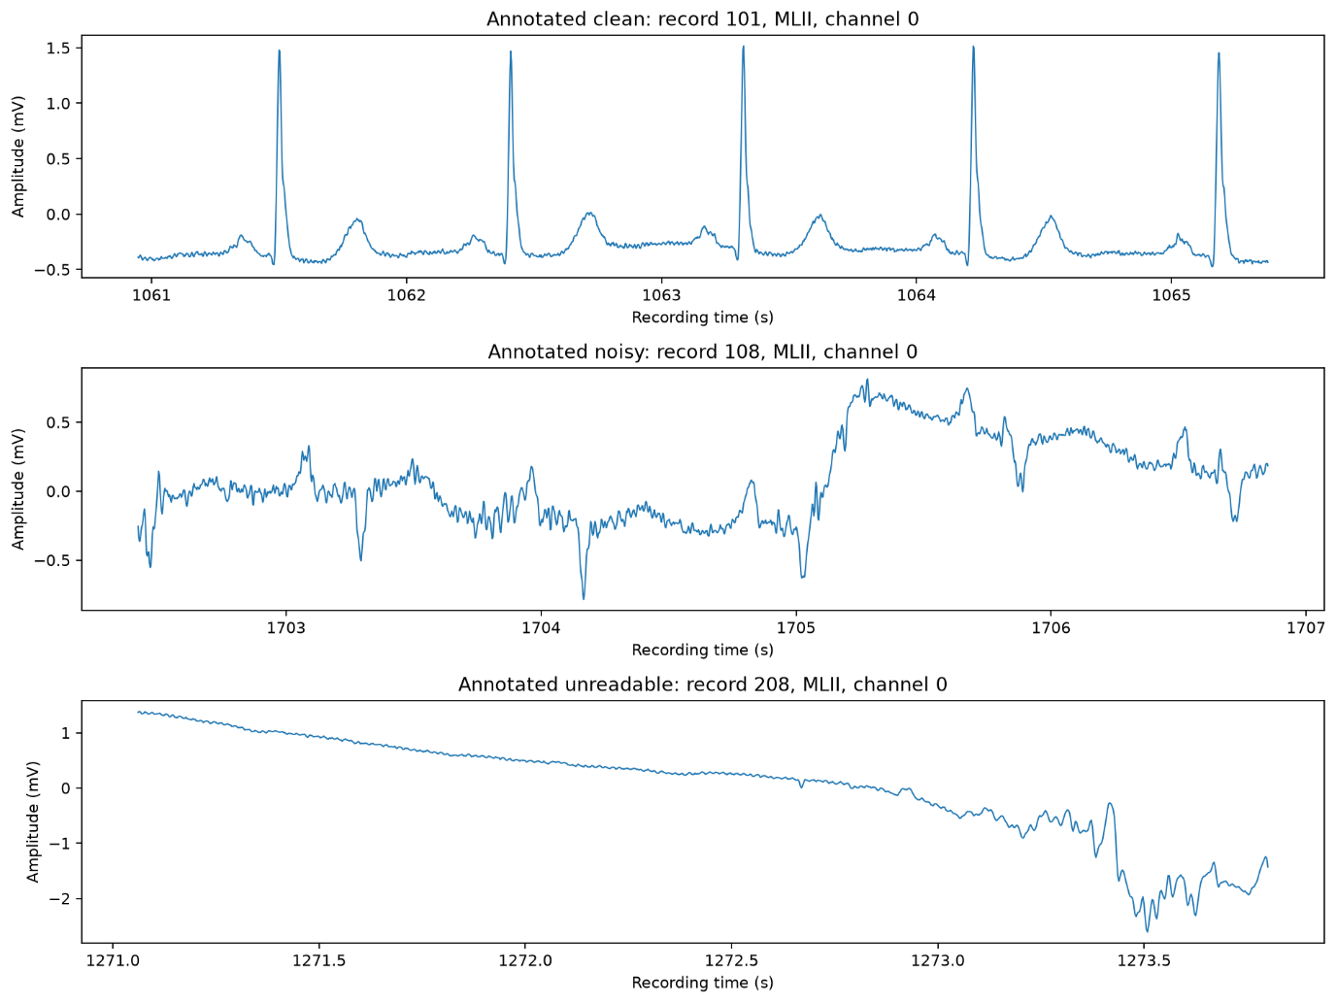
2.3.2 Example Heartbeat from each class:

Below figure shows one annotated example from each target class: N and S from recording 101, V from 106, and F from 108. MLII was selected by its header name to provide a consistent measurement view.
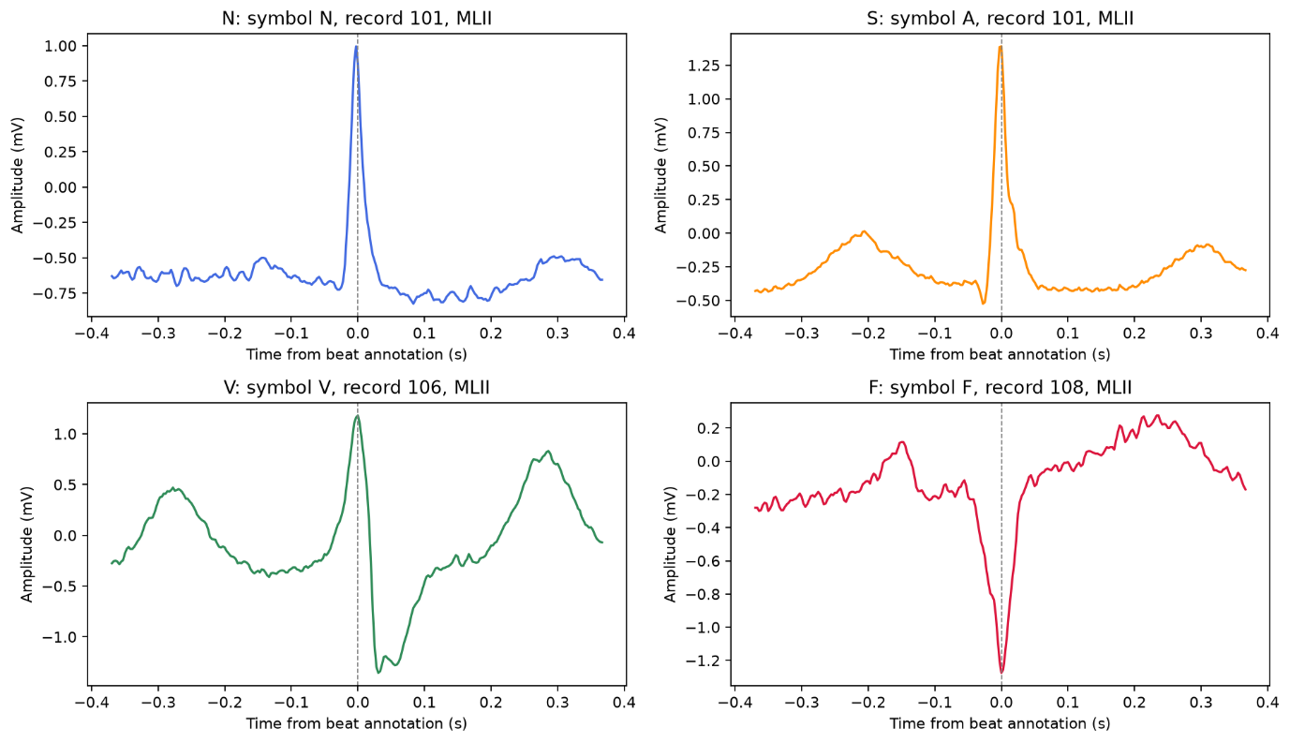

2.3.3 Class Distribution:
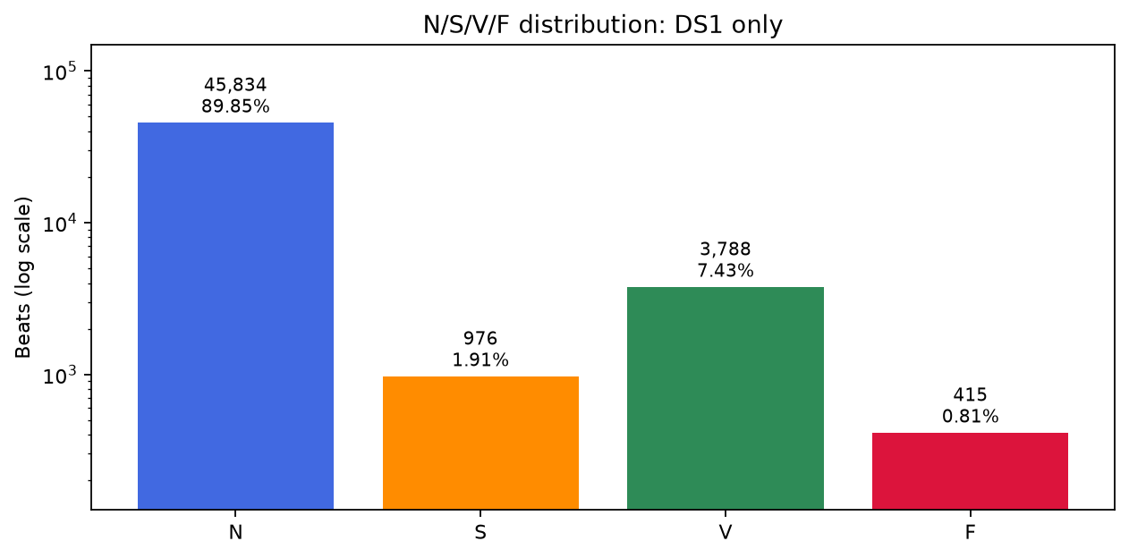

2.3.4 Subject/Record Distribution:
The below figure shows different numbers of retained beats across the approximately equal-duration recordings. Counts range from 1,619 in recording 124 to 3,363 in recording 215.
The record and subject distributions match within DS1 because each analysed recording belong to a different person. Subject key 201_202 identifies the person whose second recording lies in DS2 and only record 201 contributes to these DS1 statistics.
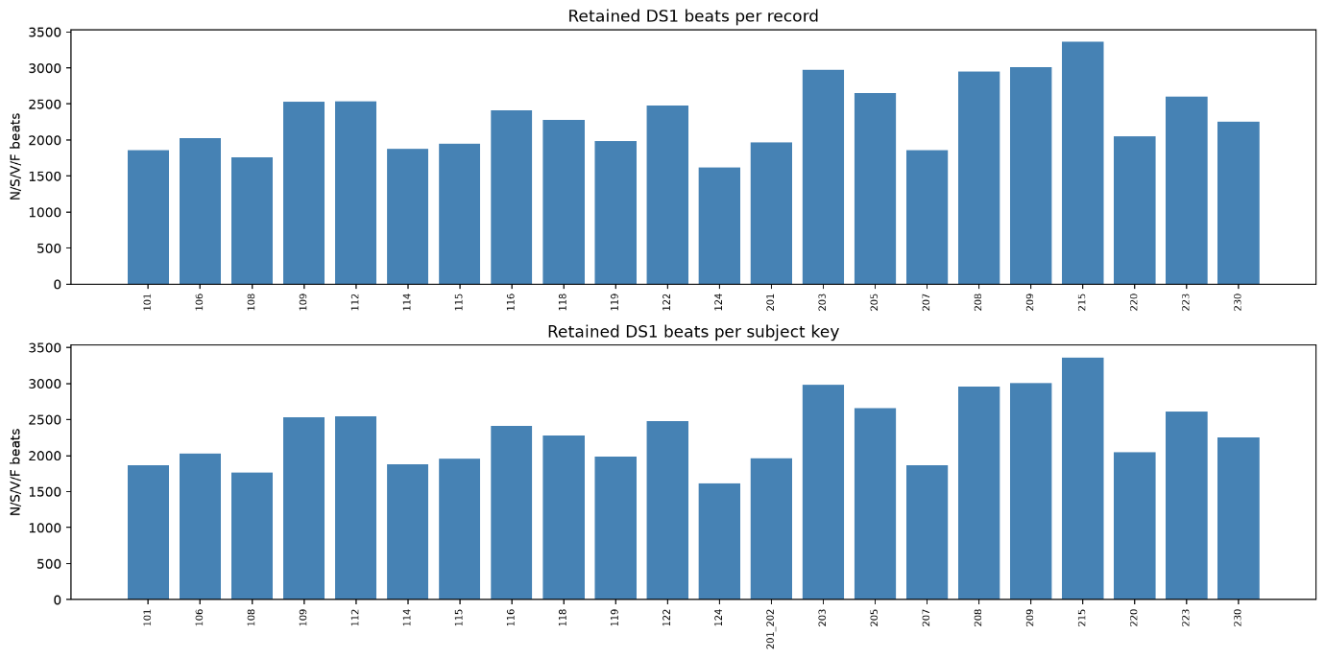
Below figure shows that class availability also varies between recordings
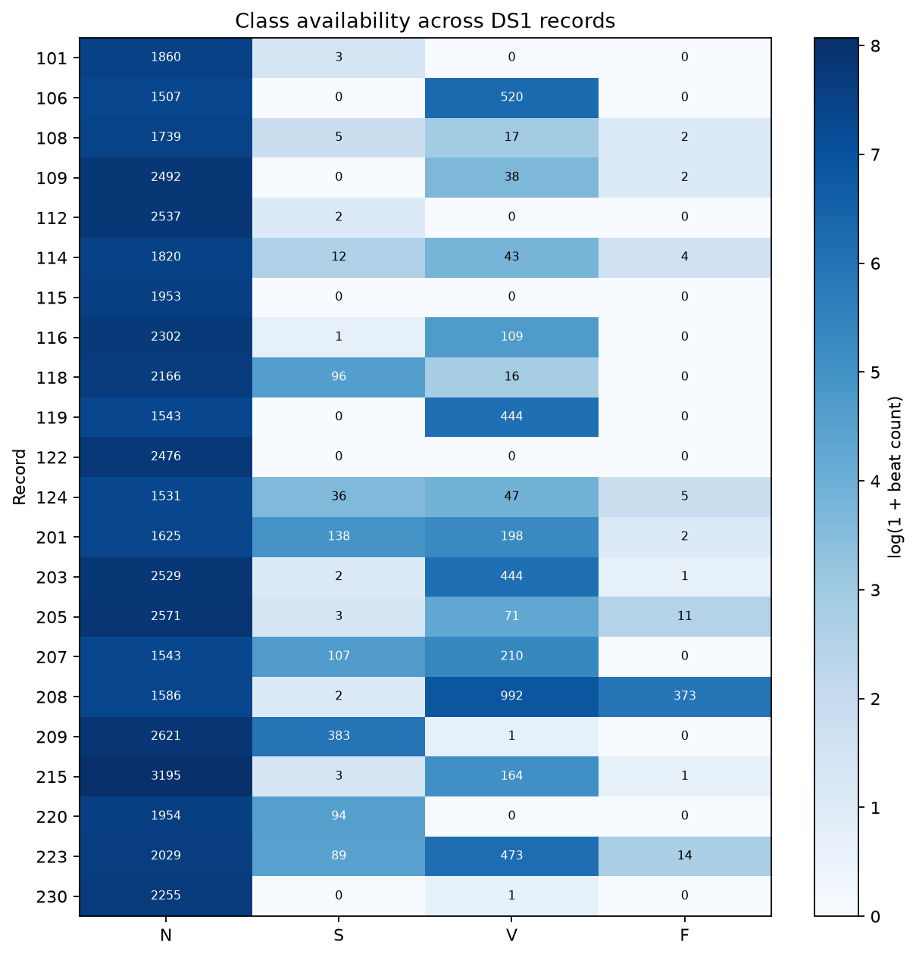

2.3.5 Signal Amplitude Distribution
Below figure displays amplitude histograms for the observed leads. We sampled 5,000 values from each record/channel using random seed 42, giving 220,000 plotted measurements. Histogram widths were calculated using the data-dependent Freedman–Diaconis rule.
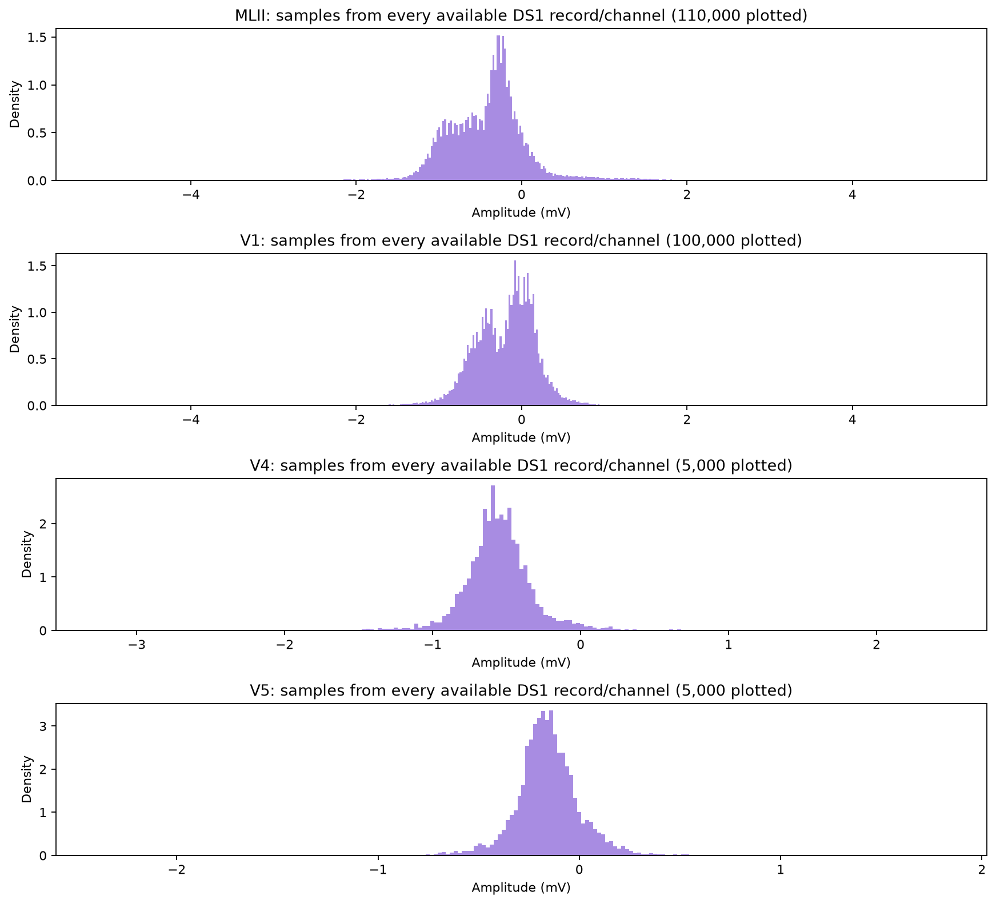

2.3.6 Examples of Noisy ECG
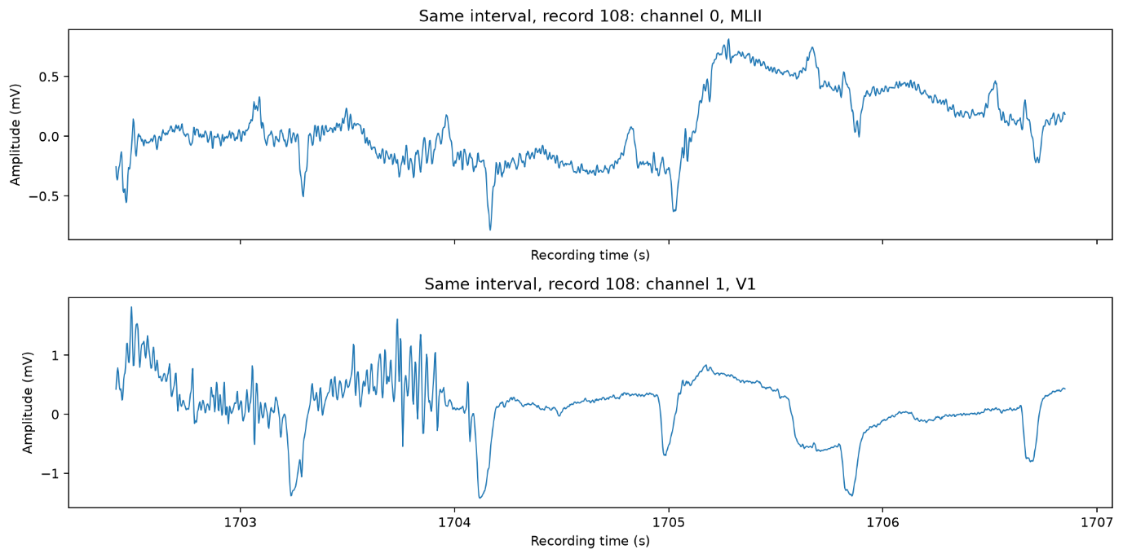

2.4 Data Quality
Quality Check | Result
Successfully read DS1 recordings | 22
Channel traces examined | 44
Signal Read errors | 0
Missing values represented by NaN | 0
Infinite sample values | 0
Header checksum mismatch | 0
Samples at or beyond computed ADC limits | 1635
Out of range annotation positions(DS1) | 0
Out of order Annotations (DS1) | 0
Duplicate beat positions (DS1) | 0

Extreme Amplitudes and potentially corrupt segments:
Observed amplitudes ranged from −5.120 to 5.115 mV. These extrema occurred in MLII from recording 116 and V1 from recording 223.
The 1,635 samples flagged at possible ADC limits identify candidate clipping regions. No channel had an exact constant digital run lasting at least 0.7389 seconds. Large jumps and constant digital runs were also measured. Recording-limit values, sudden changes and repeated samples are quality indicators, and do not independently prove signal corruption. No automatic deletion was based on these checks.
Class Imbalance:
‘N’ represents 89.85% of retained DS1 beats. A rule that assigns every retained DS1 beat to N would therefore match 89.85% of the labels while identifying none of the minority classes. This supports the use of macro-F1 and per-class recall described in Section 1. The concentration of F beats in recording 208 additionally limits the range of subjects represented by that class.
Difference between recordings and channels:
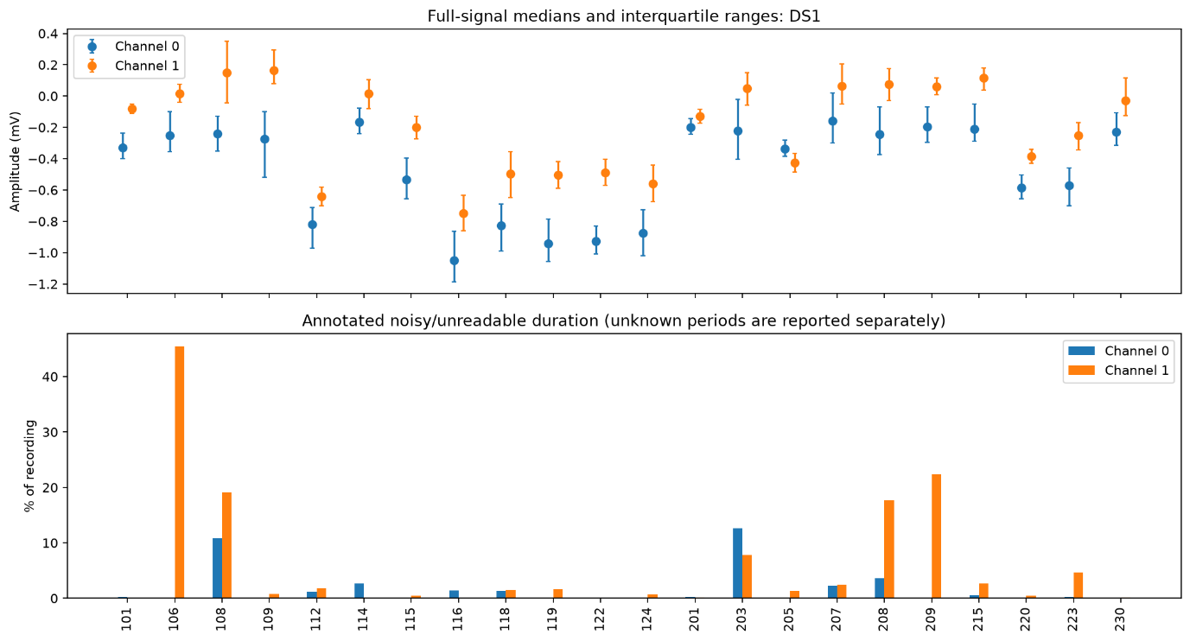
The above figure compares median amplitudes, the middle 50% of sample values and annotated noisy/unreadable duration for each channel. Median offsets, amplitude spread and quality coverage vary between recordings and between their two channels.
For example, recording 106 has a much larger annotated noisy/unreadable fraction in channel 1 than in channel 0.

2.5 Leakage Analysis
Randomly splitting individual heartbeats from the same person between training and testing can produce misleading results. These beats share characteristics of that person’s ECG and recording conditions. Neighbouring beats can also be highly similar, and extracted windows may share signal samples. A model can therefore exploit familiar patterns in the test group, making its performance appear better than its performance on previously unseen people. Multiple beats from one person are not equivalent to the same number of independent people.
Our evaluation design follows the supplied whole-record DS1/DS2 partition. DS1 is used for development, and DS2 is reserved for final testing. All heartbeats from a recording belong to its assigned group instead of being randomly distributed between development and testing. This prevents the same recording from supplying beats to both groups. The development design also separates training and validation by recording, the EDA notebook itself does not create these model-training splits.
Leakage could also arise from using test data to select model or preprocessing settings, fitting normalisation on combined training and test data, or distributing original and augmented versions of a beat across groups. The EDA does not perform fitted normalisation, training augmentation or model training.
The supplied DS1/DS2 partition nevertheless contains one documented subject overlap: recordings 201 and 202 belong to the same person, with 201 assigned to DS1 and 202 to DS2. A model trained on 201 and evaluated on 202 would therefore encounter a familiar person despite receiving a different recording. The supplied partition separates recordings but is not fully subject-independent. Our current analysis identifies this limitation, restricting access to DS2 alone does not eliminate it.
3. Data Preparation
3.1 Record Selection
We follow the standard inter-patient partition (de Chazal et al., 2004) required by the project rather than a random beat-level split. Splitting by record guarantees that no validation or test beat comes from a patient whose beats also appear in training.
DS1- development set (22 records), used for training and validation: 101, 106, 108, 109, 112, 114, 115, 116, 118, 119, 122, 124, 201, 203, 205, 207, 208, 209, 215, 220, 223, 230.
DS2- final test set (22 records), never used for training, validation or model selection: 100, 103, 105, 111, 113, 117, 121, 123, 200, 202, 210, 212, 213, 214, 219, 221, 222, 228, 231, 232, 233, 234.
Records 102, 104, 107 and 217 do not appear in either list. All four are paced recordings, which the project permits us to exclude, de Chazal's original partition excludes them for the same clinical reason, and keeping them out preserves comparability with the literature this partition comes from.
Within DS1 we set aside five records as an internal validation set, again split by record rather than by beat, per configs/prep.yaml: 106, 112, 124, 201, 223. The remaining 17 DS1 records form the training set: 101, 108, 109, 114, 115, 116, 118, 119, 122, 203, 205, 207, 208, 209, 215, 220, 230.
This split is not accidental for the minority classes. Between them, the five validation records hold 234 of DS1's 944 S beats (25 %) and 21 of its 415 F beats (5 %), so validation can detect a model that fails on S or F outright. The F-heavy record 208 (372 F beats, 90 % of DS1's F beats) stays in training rather than validation, since its beats are far more useful for the network to learn from than to be held back for a validation set they would otherwise dominate. Section 3.8 returns to the consequence: with only 21 F beats, validation F is read as a coarse alarm rather than a trustworthy estimate.
3.2 ECG Channel Selection
We use one channel throughout the modified limb lead MLII. Three things decided it. It appears in all 44 records of the inter-patient partition, so we lose no patient. Its QRS Complex is large and mostly positive, which is makes the R-Peak the clearest landmark in the signal and every window in 3.3 is placed relative to that pea. And it is the channel used in the literature that defines this partition, so our numbers stay comparable with published ones. Sticking to one channel also halves preprocessing cost and input memory on the device. Which matters here a single-lead wearable is what this model would actually run on.
We pick the lead by name from the record header, never by channel number. This matters more than it looks. Channel order is not consistent across the database: record 114 stores its channels as V5 | MLII, the reverse of the usual arrangement. Had we simply read channel 0, that one patient would have been trained on V5 while the other 43 supplied MLII — an error that produces no warning and would be very hard to find later. If MLII were missing we fall back through V5, V2, V1, V4 and log the substitution, though across our 44 records the fallback never fired (results/lead_audit.csv). Records 102 and 104 carry no MLII at all, but both are paced and already excluded on clinical grounds.
3.3 Beat Extraction
We take R-peak positions from the reference .atr annotations that ship with the database, placed and verified by cardiologists. We do not run an automatic QRS detector. As a real wearable has no cardiologist, and its own detector would make mistakes that feed straight into both the window position and the RR intervals we derive from it. Before any of this we strip the non-beat markers — rhythm (+), signal quality (~) and artefact (|). There are 2,991 of them across the 44 records, and treating them as heartbeats would inflate every class total we report
Each window takes 48 samples before the R-peak (266.7 ms) and 80 after it (444.4 ms), 128 samples in total, covering 711 ms at our working rate of 180 Hz. The asymmetry is deliberate. Ahead of the R-peak the only thing we need is the P wave, which sits roughly 200 ms earlier, while repolarisation behind it runs on much longer. A symmetric window of the same length would have to either cut off the T wave or waste samples on flat baseline. Choosing 128 also keeps every intermediate tensor inside the per-layer dimension limits of the MAX78002.
One complication follows from filtering causally: it delays the signal, so the annotated positions no longer line up with the waveform we have processed. We measured the delay rather than calculating it, which turned out to matter our own filter chain accounts for only about 3 samples, and the rest comes from the anti-aliasing filter hidden inside the decimation step. The total is 8 samples at 360 Hz, or 22.2 ms. We shift the annotations by that amount before cutting. Left uncorrected the R-peak settles at index 52 rather than 48; corrected, it sits at 48. We checked this across twelve records (scripts/verify_alignment.py).
We drop a beat if it sits too close to the start or end of a recording, or if it has no neighbour on one side and so no measurable RR interval. In practice only the second case happens, the first and last beat of each record, 88 altogether, or 0.087 % of the data.
3.4 Signal Preprocessing
We apply the following operations in this order. Every parameter comes from configs/prep.yaml — nothing is hard-coded, so changing a cutoff means editing one file rather than hunting through the source.
# | Operation | Parameters | Why it is necessary
1 | Lead selection | MLII, by name | Same physical lead for every patient (3.2)
2 | Causal filtering | Butterworth order 3; high-pass 0.5 Hz, notch 60 Hz, low-pass 40 Hz | Removes baseline wander, mains interference and muscle noise, none of which carry cardiac information.
3 | Decimation | 360 to 180 Hz, anti-aliased | Halves input length and on-device data memory; content above 40 Hz is already removed, so nothing diagnostic is lost.
4 | Normalisation | Per record: subtract median, divide by the 99.5th percentile of absolute deviation | Removes per-patient sensor gain while preserving relative amplitude within a patient, which is a real cue.
5 | Clipping | +/- 4 | Bounds the range so rare artefacts cannot dominate the INT8 quantisation scale.
6 | Delay Compensation | +8 samples, measured | Realigns annotations with the filtered signal (3.3).
7 | Segmentation | 48 before, 80 after, 128 total | Produces the fixed-size network input (3.3).

• Causality. Our filters run in one direction only. We could have used zero-phase filtering most of the ECG literature does but it passes over the signal forwards and then backwards, which means it needs samples from the future. A device classifying a live signal does not have them. Reporting results obtained that way would mean reporting something the hardware could never reproduce. The price we pay is the group delay measured in 3.3.
• Cutoffs. The 0.5 Hz high-pass clears the slow drift caused by breathing, while staying low enough to leave the ST segment alone. The notch sits at 60 Hz rather than 50 Hz because these recordings were made in the United States. The 40 Hz low-pass removes muscle artefact and conveniently doubles as the anti-aliasing filter for step 3.
• Decimation, not simply dropping samples. Keeping every second sample would fold any content above 90 Hz back into our signal band, and that cannot be undone afterwards. We stop at 180 Hz rather than going lower because QRS width is what separates normal beats from ventricular ones, and decimating too far blunts exactly that.
• Choice of scale. We normalise per record rather than per beat, because how much taller one beat is than its neighbours is itself a clue and per-beat scaling would erase it. Our first attempt used the median absolute deviation and had to be abandoned: the flat baseline dominates that statistic, so R-peaks ended up anywhere between 6 and 23 scale units depending on the patient, and any clip low enough to be useful would have sliced through the QRS. Scaling by the 99.5th percentile instead puts them between 0.46 and 1.01 on every record, and the clip at 4 is never reached the largest value across all 100,630 beats is 2.25.
• RR features. Besides the waveform we store three timing values for every beat: rr_prev, the gap to the previous beat; rr_next, the gap to the next; and rr_local, the median of the previous four gaps, which stands for the patient’s current rhythm. All three are in seconds and are computed from the annotation positions at 360 Hz, before resampling, so decimation cannot shift them. They matter because an S beat is defined by arriving early rather than by looking different, and a 128-sample window centred on a single beat cannot express that. One detail decides whether they are correct: the gaps are measured with every annotated beat still present, including the paced and unclassifiable beats that are excluded later. Removing a beat first would merge two gaps into one and invent an interval twice as long as anything the heart produced. All three values are stored per beat alongside the waveform in data/processed/beats.npz.
3.5 Label Preparation
Beat-level annotations use the raw MIT-BIH symbol set. Section 3.3 already removes annotations that are not beats at all - rhythm (+), signal-quality (~) and artefact (|) markers, 2,991 of them across the 44 records. What remains is mapped onto the four AAMI EC57 classes (AAMI, 2012) required by the brief, following the same grouping used by de Chazal et al. (2004):
Final class | Original MIT-BIH symbol(s) | AAMI EC57 rationale | Beats (44 records)
N | N, L, R, e, j | Normal beats plus bundle-branch-block conduction (L, R) and escape beats (e, j): morphologically distinct but not ectopic | 90,125
S | A, a, J, S | Supraventricular ectopic beats: atrial/nodal premature and aberrated beats | 2,781
V | V, E | Ventricular ectopic and escape beats | 7,009
F | F | Fusion of a ventricular and a normal beat | 803
excluded (Q) | /, f, Q | Paced beats and beats the original annotators could not classify; not part of the 4-class task | 15
src/io_utils.py implements this mapping as a single dictionary (AAMI_MAP) rather than scattering it through the pipeline, so the class definition has one place to audit. src/data_audit.py checks every beat symbol that appears in the 44 records against it; the result (results/audit_summary.txt) is that none fall outside the table above - there is no 'unmapped' bucket left over. The 15 excluded Q beats are counted, not silently dropped, so the exclusion is documented rather than assumed.
A further 88 beats (0.087 % of the 100,718 N/S/V/F beats) are dropped later, in 3.3, because they are the first or last beat of a recording and so have no measurable RR interval, that drop happens after labelling and is independent of it (Section 3.8).
3.6 Class Imbalance
Section 3.8 reports the full split table and the headline numbers are that F is 0.8 % of the whole dataset and S is 2.8 %, against 89.5 % for N. This is heartbeat-database imbalance, not an artefact of our pipeline, de Chazal's own inter-patient partition has the same shape, and the alternative (a balanced sample) would no longer be representative of what an ambulatory monitor actually records.
The imbalance is also concentrated by patient rather than spread out: one record (208 in development, 213 in test) supplies roughly 90–95 % of that split's F beats (3.8), and the test split's S share (3.70 %) does not match the training split's (1.76 %) because the published DS1/DS2 partition was fixed by record, not by class balance.
We do not correct this at the data-preparation stage. Three options were considered and rejected for the reasons already given in 3.7: SMOTE-style interpolation invents waveforms for a class held by one or two patients; random undersampling of N would shrink an already small (100k-beat) dataset and is unnecessary since the model will be judged on macro-F1 and per-class metrics rather than accuracy; and duplicating minority beats verbatim would let the network memorise a handful of individual waveforms rather than learn the class. What we defer to the Modeling stage (Submission 2, Section 4) is: (i) a class-weighted loss, with weights set from the training split's inverse class frequency only, so DS2 and the validation records never influence it; (ii) evaluating with macro-F1 and per-class precision/recall/F1 rather than accuracy, so a model that only predicts N is not rewarded; and (iii) treating validation-F, which has only 21 beats (3.1), as a coarse pass/fail alarm rather than a metric to optimise against. The augmentation policy in 3.7 is applied per beat regardless of class, so it increases how many distinct-looking versions of a minority beat the network sees per epoch without inventing new ones - a mild, indirect form of oversampling we consider acceptable where SMOTE is not. We also considered balanced-batch sampling and focal loss as alternatives to a plain class-weighted loss; both stay on the table for model selection in Submission 2 (Section 4.4), compared against class weighting on the same validation split.
3.7 Data Augmentation
We augment the training split only. Validation and test data are left untouched — augmenting them would quietly change the thing we are trying to measure.
Transformation | Range | Why it is realistic
Amplitude scaling | X0.9 to x1.1 | Variation in electrode contact and sensor gain between wearing sessions.
Temporal jitter | +/- 4 samples | The localisation error an on-device QRS detector makes against an expert annotation.
Additive real ECG noise | SNR 6 to 20 dB | The noise actually present in ambulatory recording.

The noise comes from the MIT-BIH Noise Stress Test Database, which provides baseline wander, muscle artefact and electrode motion as separate recordings. We use real noise rather than synthetic Gaussian noise because ECG noise has structure: baseline wander is slow drift, electrode motion is a series of abrupt jumps. Gaussian noise looks like neither, and a model trained on it would be ready for neither.
The noise we train on and the noise we test on must not overlap. We split each noise recording so training draws one half and one channel while evaluation gets the other. Skip this and a model can simply memorise the particular noise waveform it saw, which makes the resulting robustness figure worthless. For the same reason we do not evaluate on the twelve ready-made noisy records that come with the database: all twelve are built from records 118 and 119, and both are training records in our partition.
We deliberately leave out three things. Time warping, because it changes the RR relationships the S class is defined by. Synthetic minority oversampling, because interpolating between beats of a class held by one or two patients invents waveforms that belong to nobody. And reflection or sign inversion, because the result is not an ECG any heart could produce.
3.8 Final Dataset
Split | Records | N | S | V | F | Total | F%
Train | 17 | 36574 | 709 | 2550 | 393 | 40226 | 0.98
Validation | 5 | 9250 | 234 | 1238 | 21 | 10743 | 0.20
Test (DS2) | 22 | 44218 | 1836 | 3219 | 388 | 49661 | 0.78
Total | 44 | 90042 | 2779 | 7007 | 802 | 100630 | 0.80
These totals come directly from the run described in 3.9 (scripts/run_prepare.py, 0 reconciliation mismatches) and match the record lists fixed in 3.1.
Of the 100,718 beats belonging to our four target classes we extracted 100,630 and dropped 88, which is 0.087 %. All 88 are the first and last beat of a recording; none was lost to a window running off the end. A further 15 had already been excluded as paced or unclassifiable. Every beat keeps its record number, so the data can be re-split later without running preprocessing again.
- Validation holds just 21 F beats. That is enough to notice if the model fails on F completely, but nowhere near enough for an F1 score we would trust, so we plan to select models on the other three classes and read validation F only as a rough alarm.
- Class F is not simply rare, it is concentrated in one person. Record 208 supplies 372 of the development set's 414 F beats; the next largest contributor supplies 14. Whatever we learn about F, we largely learn from one patient.
- The test split is not composed like the development split, S makes up 3.70 % of it against 1.76 % of training. That is a property of the published partition rather than a mistake on our side, and it is one more reason we report per-class metrics instead of accuracy.
3.9 Reproducibility
Everything needed to regenerate the dataset from scratch is pinned in requirements.txt and configs/prep.yaml, so the process does not depend on remembering versions or parameters. We ran the pipeline under Python 3.14.7 with PyYAML 6.0.3, NumPy 2.5.2, pandas 3.0.5, SciPy 1.18.1 and wfdb 4.3.1 (matplotlib 3.11.1 and torch 2.14.0 are pinned for later stages but unused by data preparation).
A single seed, 20260924 (configs/prep.yaml → reproducibility.seed), is defined for the whole project. Data preparation itself is deterministic - filtering, decimation, normalisation, segmentation and the AAMI mapping involve no randomness, so the seed does not change any number in this report; it exists so that the data augmentation (3.7) and model training (Submission 2) that consume this dataset are themselves reproducible.
Every parameter used in 3.2–3.8, sampling rate (360 → 180 Hz), filter cutoffs and order, normalisation percentile and clip, the +8-sample delay compensation, the 48/80-sample window and the record lists themselves is read from configs/prep.yaml at run time rather than hard-coded (3.4), so this file is the single source of truth for reproducing the exact dataset reported here. The network input this produces is a single fixed-size vector: 128 samples (48 pre-R, 80 post-R) from one lead (MLII) at 180 Hz, per beat (3.3).
To reproduce, create the environment from requirements.txt, then run scripts/run_prepare.py from the project root (or ./run.sh, which does the same). The script downloads the 44 records once via src/io_utils.py's ensure_database() (wfdb.dl_database) into data/mitdb/, marked complete with a .complete file, so repeated runs read from that local cache instead of streaming from PhysioNet every time. We do not submit that folder, the README explains how to regenerate it locally.
The run is checked, not just executed: src/data_audit.py cross-checks every mapped beat against the published de Chazal counts before preparation (results/audit_summary.txt - 0 mismatches, 0 unmapped symbols), scripts/run_prepare.py reconciles kept + dropped beats against that audit for all 44 records after preparation (0 mismatches, Section 3.8), and scripts/verify_alignment.py independently checks the R-peak delay compensation from 3.3 on twelve records. All three passed on the run this report is based on (results/dataset_stats.csv, results/split_stats.csv).

4. Modelling

4.1 Baseline
Multinomial Logistic Regression is chosen as a simple baseline model to compare with the CNN. Both models started with the same single-lead ECG windows of 256 samples at 180 Hz. The baseline used the sample values directly to predict N, S, V or F.
We trained on 40,223 beats from 17 DS1 records and used the other five records (10,743 beats) for validation. We used the training set to standardize each sample position and calculate the class weights. The rarer classes are given more weight based on their inverse frequencies and capped the largest weight at 20 times the smallest.
We tried four values of C (0.01, 0.1, 1 and 10) to adjust the L2 penalty on the model’s weights. Like CNN, we used macro-F1 across N, S and V to pick the best setting because the validation set had only 21 F beats. We chose C = 10, which gave us the highest score (0.4781) and 82.19% validation accuracy.
The saved model is tested on 49,656 beats from 22 DS2 records without adding noise. It reached 74.28% accuracy, with a macro-F1 of 0.4433 for N/S/V and 0.3429 for all four classes. The model correctly identified 40 of the 1,836 S beats and labelled 1,746 of them as N.
Then added the electrode-motion noise to the raw DS2 Recordings at a signal-to-noise ratio (SNR) of 0 DB before preprocessing and on these noisy beats, the same fitted model’s accuracy fell to 64.50%. Its macro-F1 dropped to 0.3921 for N/S/V and 0.3031 for all the four classes.

4.2 Proposed Edge Model
The classifier is a four block 1D convolutional network taking a single lead ECG window of 256 samples at 180 Hz - 1.42 seconds and producing four logits, one per AAMI class. Section 4.4 reports the comparison that selected this input length; the architecture itself is identical across every variant tested, so that comparison isolates the input representation.
# | Input | Operation | Output | Parameters
1 | 1 × 256 | Conv1d 1→16, k=5, pad 2 → ReLU | 16 × 256 | 96
2 | 16 × 256 | MaxPool 2 → Conv1d 16→32, k=5, pad 2 → ReLU | 32 × 128 | 2,592
3 | 32 × 128 | MaxPool 2 → Conv1d 32→64, k=5, pad 2 → ReLU | 64 × 64 | 10,304
4 | 64 × 64 | MaxPool 2 → Conv1d 64→64, k=5, pad 2 → ReLU | 64 × 32 | 20,544
5 | 64 × 32 | MaxPool 4 → Flatten → Linear 512→4 | 4 | 2,052
 |  | Total |  | 35,588
Table 4.1. Layer by layer specification of the selected model.
Why this architecture suits Edge-AI deployment
- Memory. 35,588 INT8 weights occupy 35 KiB of the MAX78002’s 2,340 KiB weight memory 1.5 % of the budget, and well inside the 100,000-parameter ceiling set in section 1.4. The largest intermediate tensor holds 4,096 values, comfortably inside the 1,280 KiB data memory.
- Every operation is in the accelerator’s supported set. Conv1d with kernel 5, max pooling, ReLU and a single fully-connected layer. No batch normalisation, no residual connections, no activation other than ReLU.
- Convolution stride is fixed at 1 on this hardware, so every reduction in sequence length is performed by a pooling layer. The pooling precedes the convolution in each block, matching the FusedMaxPoolConv1dReLU primitive that the ai8x synthesis toolchain expects; the reverse order is rejected at synthesis.
- The flattened vector entering the classifier is 512 values, against a hard limit of 1024 - 50 % headroom. Section 4.4 explains why this margin was treated as a selection criterion rather than a convenience.
- There is no softmax layer. CrossEntropyLoss applies it internally during training, and the device predicts with argmax over the raw logits, so an explicit softmax would add a layer that changes nothing at inference.
One inference costs approximately 1.66 million multiply accumulate operations. These constraints are asserted in code: src/model.py raises an error rather than constructing a network whose kernel exceeds 9 or whose flattened width exceeds 1024, so a configuration that cannot be synthesised fails immediately instead of after training.

4.3 Training Configuration
Every value below is read from configs at run time, none is hard-coded. Each training run writes the complete configuration it used alongside its results, so any figure in this report can be traced to the settings that produced it.
Setting | Value
Optimizer | Adam
Learning rate | 0.001, cosine annealing over the epoch budget
Batch size | 256
Epoch budget | 100 maximum
Early stopping | patience 15 on validation macro-F1(N/S/V); the selected model stopped after 60 epochs on average, with its best epoch between 27 and 58
Loss function | Cross-entropy weighted by inverse class frequency
Class weighting | N 0.072 · S 1.446 · V 1.037 · F 1.446 (max:min ratio capped at 20)
Augmentation | training split only: amplitude scaling in [0.9, 1.1] and temporal shift of ±4 samples, each applied with probability 0.5
Random seeds | 20260906, 20260907, 20260908, 20260909, 20260910
Environment | Python 3.14.2, PyTorch 2.14.0 (Paszke et al., 2019), Apple MPS backend
Table 4.2. Training configuration. All five seeds are run for every reported result; figures are given as mean+/- standard deviation across them.
Class weighting.
Inverse-frequency weighting alone gives class F a weight 93 times that of class N, because F accounts for 0.8 % of the training beats. At that ratio a few hundred F beats dominate every gradient step. The maximin ratio is therefore capped at 20 before the weights are normalised to mean 1 - capping after normalisation has no effect, which is a mistake the implementation explicitly guards against.
Augmentation.
The temporal shift simulates the alignment error an on-device QRS detector would make relative to the reference annotations used here. Because beats.npz stores a 256-sample window, a shifted window still consists of recorded signal rather than zero padding. Augmentation is applied to the training split only; the implementation raises an error if it is requested for validation or test data.
Model selection metric.
Models are selected on macro-F1 over N, S and V only. The validation split contains 21 F beats, far too few for a stable F1: across the five seeds of the selected model, the number identified correctly was 0 in four runs and 1 in the fifth. Including F would therefore make selection follow noise rather than signal. F is reported in every results table and is evaluated properly on DS2, where 388 F beats are available.
Reproducibility.
All reported runs are deterministic. The complete experiment was executed independently in two separate working copies and produced bit-identical results the same macro-F1 at full precision and the same confusion matrices, cell for cell. The test split is never loaded during training.

4.4 Model Selection
Models tried.
An S beat is defined by prematurity it arrives earlier than the patient’s prevailing rhythm and prematurity is a property of the interval between beats, not of the waveform. A window containing a single beat therefore cannot, in principle, contain the evidence needed to identify one. Four input representations were compared to test this directly, using one architecture, one dataset and one set of seeds, so that only the input differs.
Arm | Input | What it tests
A | 1 × 128 | Control. The beat alone: morphology only, rhythm-blind by construction.
B | 1 × 256 | A longer window, in which prematurity appears as geometry the network can learn.
B2 | 1 × 256 | Arm B with one additional pooling stage, reducing the flattened width from 1024 to 512.
C | 5 × 128 | The beat plus four RR-interval ratios supplied as explicit constant input channels.
Table 4.3. The four input representations compared.
Hyperparameters varied.
The input representation and the random seed were varied across all four arms. Two further hyperparameters were swept on the selected arm: the class-weight cap and, post hoc, the decision threshold for class S. Architectural hyperparameters kernel size, channel widths, block count were deliberately held fixed, because varying them simultaneously with the input would have confounded the comparison the experiment was designed to make.
Results.
Arm | Macro-F1 (N/S/V) | S recall | S F1 | Accuracy | Parameters | Flatten
A | 0.615 ± 0.031 | 0.091 | 0.129 | 0.911 | 35,588 | 512
B | 0.721 ± 0.011 | 0.277 | 0.309 | 0.950 | 37,636 | 1024
B2 | 0.717 ± 0.015 | 0.275 | 0.278 | 0.951 | 35,588 | 512
C | 0.670 ± 0.008 | 0.440 | 0.210 | 0.906 | 35,908 | 512
Table 4.4. Validation results, mean +/- standard deviation over five seeds. Flatten is the width of the vector entering the classifier; the MAX78002 limit is 1024.
Arm A confirms the hypothesis. With only a single beat it identifies 9 % of S beats, and it reaches its best validation score at epoch 16 at the latest within ten epochs in four of the five runs, and at epoch 2 in one then improves no further through the remaining epochs. It is not undertrained; there is no further information in the window for it to extract. Both arms that add rhythm information roughly triple that figure.
Arm C was expected to perform best, since it is supplied with the RR ratios directly rather than being required to learn them. It did not. Its higher S recall is obtained by predicting S 3.2 times more often than S occurs, which flags 539 normal beats per run and reduces S precision to 0.138. Shifting arm B2’s decision threshold reproduces arm C’s operating point almost exactly at a threshold offset of 3.0, arm B2 yields S recall 0.448 and precision 0.141 against arm C’s 0.440 and 0.138. Arm C therefore lies on arm B2’s own precision–recall curve rather than above it: the hand-computed RR features add no information that the longer window does not already contain.
Class-weight cap.
Cap | Macro-F1 (N/S/V) | S recall | S precision
20 | 0.7317 | 0.274 | 0.344
40 | 0.7064 | 0.244 | 0.250
60 | 0.7036 | 0.256 | 0.235
93 (uncapped) | 0.6854 | 0.192 | 0.196
Table 4.5. Class-weight cap swept on arm B2, seed 20260906. Raising the cap degrades every measure.
Raising the cap was expected to increase S recall and did the opposite. The cap bounds the ratio between the largest and smallest class weight, and the smallest class is F, not S; raising it therefore transfers weight to F and, after normalisation, reduces the weight on S from 1.45 to 1.29. The configured value of 20 is retained as a measured choice rather than an assumption.
Why arm B2 was selected.
Arm B obtains the highest macro-F1 and arm B2 the second highest, but the two are not distinguishable: a paired t-test across matched seeds gives t = 0.818, p = 0.46, and arm B’s own seed-to-seed standard deviation is 2.3 times the gap between the arms. The pre-registered selection metric therefore does not separate them.
The tie is broken by a constraint stated in section 1.5 before any model was trained. Arm B’s flattened width is 1024 exactly the MAX78002 fully connected input limit, with no margin. Arm B2 achieves the same performance at 512, with 2,048 fewer parameters. Selecting on the hardware constraint when the performance metric is indifferent is not a change of criterion after the fact; it is the constraint the project was defined around. Arm B2 is the selected model.
Cross-validated estimate.
The validation split rests on five patients, so the selected arm was additionally evaluated by five-fold cross-validation inside DS1, with folds balanced first by record count and then by S-beat count. Every DS1 record takes a turn as validation data and every beat receives one prediction from a model that never saw it. DS2 was not used. Pooled over all 943 DS1 S beats, S recall is 0.455 +/- 0.029. Restricted to the seven patients with 30 or more S beats the only patients for whom recall is meaningful it is 0.266 +/- 0.294, which is statistically indistinguishable from the 0.275 obtained on the single split.
Record | S beats | Cross-validated S recall
209 | 383 | 0.786 +/- 0.062
201 | 128 | 0.302 +/- 0.013
207 | 106 | 0.000 +/- 0.000
118 | 96 | 0.115 +/- 0.098
220 | 94 | 0.613 +/- 0.057
223 | 73 | 0.000 +/- 0.000
124 | 31 | 0.043 +/- 0.015
Table 4.6. Cross-validated S recall per patient, for the seven DS1 records holding 30 or more S beats. Mean of three seeds.
The spread in Table 4.6 is the substantive finding. Performance on S is not uniformly moderate; it is near-complete on some patients and absent on others. Two records holding 106 and 73 S beats are missed entirely, in every seed. Aggregate S recall is consequently governed by which patients happen to contribute the beats record 209 alone supplies 41 % of DS1’s S beats, and record 232 supplies 75 % of DS2’s.

4.5 Quantization
Two INT8 models exist in this project and they answer different questions. This section refers to software results from PyTorch’s CPU quantizer. The model deployed to the MAX78002 (Section 6) comes from a separate training run in the Analog Devices framework with quantization-aware training (QAT) and has different weights, so it is not the model compared here.
Method.
PyTorch’s static eager-mode quantizer was used, in four steps and without retraining. Each Conv1d and the ReLU are fused into one layer and finally. the layers are converted: weights become signed 8-bit integers and activations unsigned 8-bit integers. Only training beats were used for calibration, so neither the validation split nor DS2 influenced the quantizer. The quantized layers run on the CPU (ARM backend, qnnpack). The output logits are 8-bit as well, with a step of about 0.26 logit units for the first model.
 | FP32 | INT8 (PTQ)
Parameters | 35,588 | 35,588
Weight precision | 32-bit float | 8-bit integer
Saved weights | 143 KiB | 43 KiB
Calibration | none | 20 training batches
Validation macro-F1 | 0.539 ± 0.012 | 0.539 ± 0.013
Validation beats with a changed class | - | 29 of 10,743 (0.27 %)
Table 4.7. FP32 versus INT8 (post-training quantization) for the five trained models of arm B2
PTQ is used here because it isolates the cost of rounding on models trained in the normal way and it answers the question whether rounding costs anything for this network at all.

5. Evaluation

5.1 Clean Test Results
We tested the final models on DS2, which contains 22 patients and 49,656 beats. None of these beats were used for training, model selection or calibration, and the test was run only once, after arm B2 had been selected in Section 4.4. As in the rest of the report, each value is the mean ± standard deviation over the five trained models (seeds 20260906–20260910). The INT8 model is the quantized version of each FP32 model from Section 5.3. Macro-F1 is the average F1 score over all four classes, as defined in Section 1.4. All numbers come from src/evaluate.py, which also saves them to results/metrics.csv and results/confusion_matrix.csv.
Metric | Baseline | FP32 Edge Model | Quantized Model (INT8)
Accuracy | 0.743 | 0.863 ± 0.024 | 0.867 ± 0.024
Macro F1 | 0.343 | 0.468 ± 0.027 | 0.470 ± 0.028
Macro F1 (N/S/V) | 0.443 | 0.614 ± 0.039 | 0.616 ± 0.039
Model parameters | 1,028 | 35,588 | 35,588
Saved weights | n/a | 143 KiB | 43 KiB
Table 5.5. Clean results on DS2. FP32 and INT8 are the mean ± sd over five models; the baseline is the single logistic regression model from Section 4.1.
Accuracy alone is not very informative here. 89.0 % of the beats in DS2 are normal (44,213 of 49,656), so a model that always predicts N would reach 89 % accuracy but only 0.236 macro-F1. Our model reaches 0.86 accuracy and 0.47 macro-F1, so it does much better than always predicting N. However, it also classifies some normal beats as abnormal, which is why its accuracy is slightly lower than 89 %. It is still clearly better than the logistic regression baseline from Section 4.1, which reaches 0.743 accuracy and 0.343 macro-F1.
A bigger concern is the drop in performance from validation to test. On the five validation patients the models reach a macro-F1 of 0.539 (Section 5.3), while on DS2 they reach 0.468. The models are the same in both cases; only the patients are different. This shows how much performance drops when the model is used on people it has not seen before. FP32 and INT8 give almost the same results, as already shown in Section 5.3.
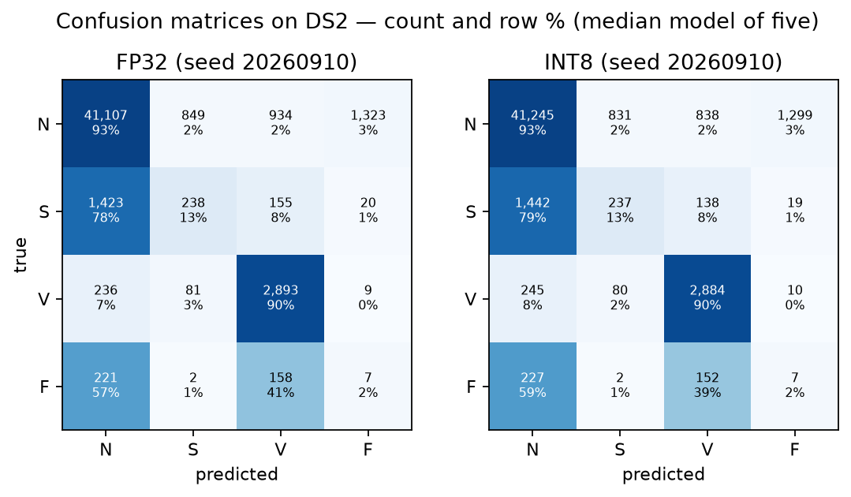
Figure 5.5. Confusion matrices on DS2 for the model with the median macro-F1 of the five, shown as counts and as a percentage of each true class. Rows are the true class.

5.2 Per-Class Performance
Class | Precision | Sensitivity/Recall | F1
N | 0.958 ± 0.002 | 0.902 ± 0.025 | 0.929 ± 0.013
S | 0.185 ± 0.042 | 0.155 ± 0.036 | 0.166 ± 0.035
V | 0.663 ± 0.104 | 0.884 ± 0.024 | 0.754 ± 0.079
F | 0.017 ± 0.010 | 0.097 ± 0.063 | 0.029 ± 0.017
Table 5.6. Per-class results of the INT8 model on DS2, mean ± sd over five models. The FP32 values differ by about 0.01 or less in every cell.
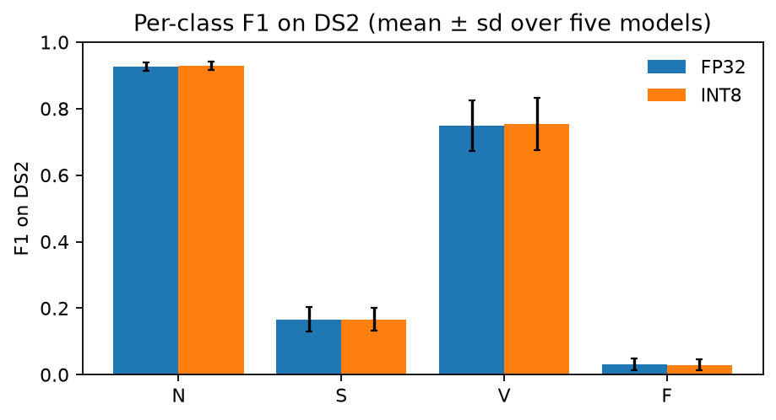
Figure 5.6. F1 score of each class on DS2 for FP32 and INT8, mean ± sd over five models.
N. The model correctly finds 90 % of the normal beats, and 96 % of the beats it predicts as N are actually normal.
V. Most V beats are detected (recall 0.88), but only about two out of three beats predicted as V are actually V. Many of these false V predictions come from one patient: in the model shown in Figure 5.5, 344 of the 838 normal beats predicted as V belong to record 111. This patient has left bundle branch block. These beats are counted as N in the AAMI classes, but their QRS complex is wide and looks similar to a ventricular beat.
S. S is the weakest of the main classes. Recall is only 0.155, and in the model shown in Figure 5.5, 79 % of the S beats are predicted as N. Most of these errors come from a single patient. Record 232 contains 1,381 of the 1,836 S beats in DS2 (75 %), and the model detects only 2.9 % of them. This patient has a very slow heart rhythm with long pauses, so the S beats are not clearly premature compared with the surrounding beats. Prematurity is the main feature the model uses to detect S (Section 4.4). When record 232 is excluded, S recall on the other 15 DS2 patients is 0.54. This means the model does detect S beats in many patients, but the overall result is dominated by one unusual patient.
F. F beats are almost never detected (F1 0.03). There are two main reasons. First, 362 of the 388 F beats in DS2 come from one patient (record 213), so the F result mainly reflects one person. Second, a fusion beat is a mix of a normal and a ventricular beat, and the model treats it that way: in Figure 5.5, 59 % of the F beats are predicted as N and 39 % as V. The same model also predicts about 1,300 normal beats as F, mostly from records 117 and 233. With only 393 F beats in the training data, coming from a few patients, the model cannot learn this class well. This is also why no target was set for F in Section 1.4.

5.3 Quantization Analysis
The FP32 models and their INT8 copies were compared on the validation split and on DS2 for all five trained models. Each model is compared with its own INT8 copy on identical beats.
Split | FP32 macro-F1 | INT8 macro-F1 | Difference | FP32 accuracy | INT8 accuracy | Beats changed
Validation | 0.539 ± 0.012 | 0.539 ± 0.013 | −0.0001 | 0.951 ± 0.004 | 0.951 ± 0.003 | 0.27 %
DS2 | 0.468 ± 0.027 | 0.470 ± 0.028 | +0.0016 | 0.863 ± 0.024 | 0.867 ± 0.024 | 0.69 %
Table 5.1. FP32 versus INT8 (PTQ) on clean data. “Beats changed” is the share of beats that the INT8 copy assigns to a different class than its FP32 original.
Effect of quantization.
Quantization barely changed the model’s performance. Only 0.27 % of validation beats (29 of 10,743 on average) and 0.69 % of DS2 beats (about 340 of 49,656) receive a different class from the INT8 copy; these are presumably beats close to a decision boundary. The stored weights shrank from 143 KiB to 43 KiB.
The largest per-class change on DS2 is in class F, whose recall falls from 0.107 to 0.097, which is about four of its 388 beats on average. Recall of N rises from 0.897 to 0.902, recall of S falls from 0.158 to 0.155 and recall of V is unchanged at 0.884. No class is systematically lost.
The INT8 results are software results from PyTorch’s CPU quantizer; nothing was measured on the MAX78002 (See section 6.3 for that)

5.4 Noise Robustness
Method
Noise was taken from the MIT-BIH Noise Stress Test Database (NSTDB; Moody et al., 1984), which provides three 30-minute recordings of real ECG noise at 360 Hz: baseline wander (BW), electrode motion artifact (EM) and muscle artifact (MA, electromyographic activity). Each was added to the raw 360 Hz DS2 records at signal-to-noise ratios of 12, 6 and 0 dB, where the SNR is the variance of the clean record divided by the variance of the added noise. At 0 dB the noise has as much power as the ECG. The noisy signal then passes through exactly the same preprocessing as the clean data.
To prevent leakage, the test noise comes only from the second half of each NSTDB recording (channel noise2, 903 s). The first half was reserved for potential noise augmentation in training. The models however were not trained with noise and the INT8 copies were calibrated on clean training beats, so no model has seen noise of any kind. Because half a recording is shorter than a record (903 s against 1,805 s), the noise is repeated to cover the record
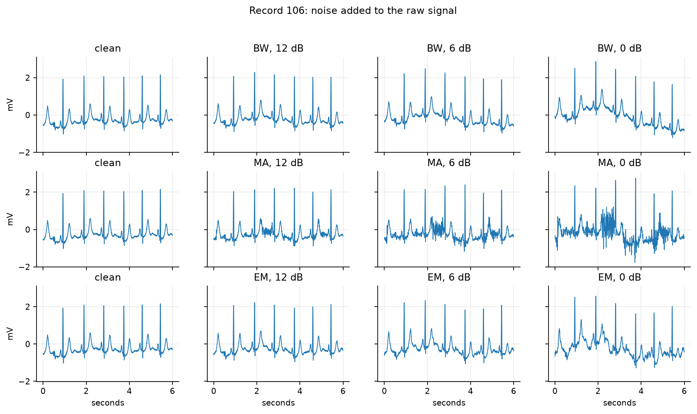
Figure 5.1. Record 106 with each noise type added at 12, 6 and 0 dB (raw 360 Hz signal, 6 s).
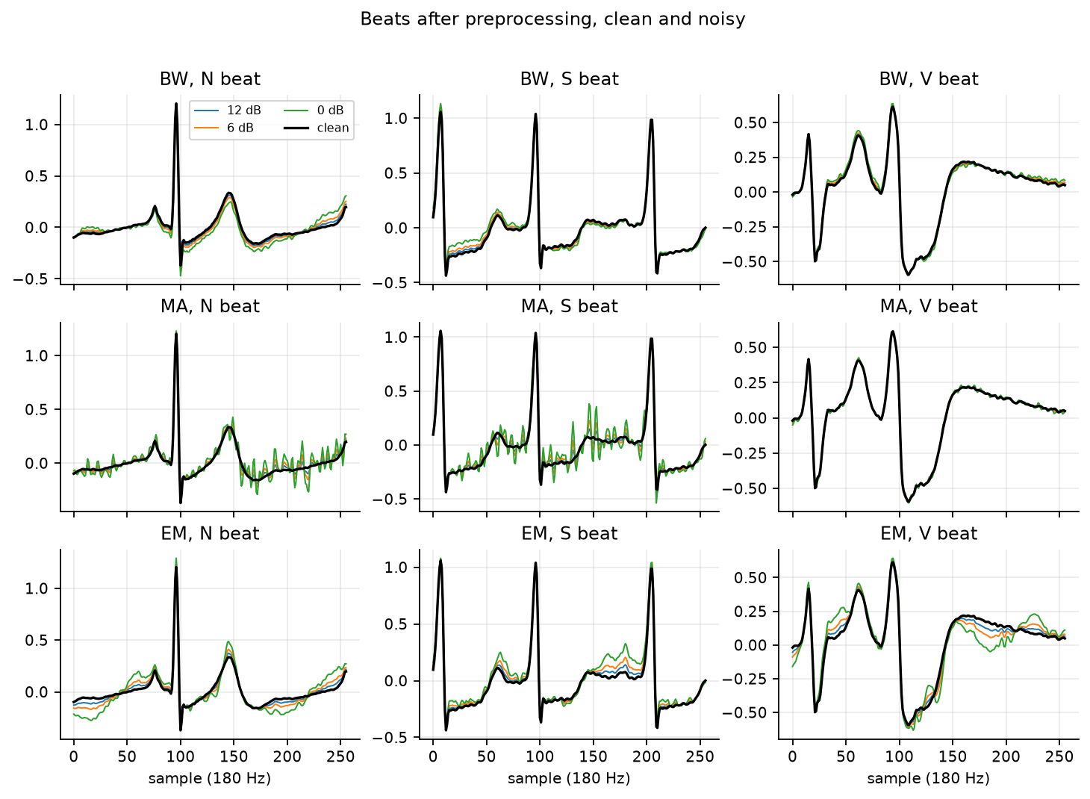
Figure 5.2. The same N, S and V beats after preprocessing, clean (black) and with each noise type at 12, 6 and 0 dB.
Results.
Table 5.2 gives the results on DS2 test set. Each value is the mean over the three noise types and the five trained models, with the standard deviation over the models.
Condition | FP32 accuracy | FP32 macro-F1 | INT8 accuracy | INT8 macro-F1
Clean | 0.863 ± 0.024 | 0.468 ± 0.027 | 0.867 ± 0.024 | 0.470 ± 0.028
12 dB | 0.860 ± 0.023 | 0.465 ± 0.026 | 0.863 ± 0.023 | 0.466 ± 0.026
6 dB | 0.851 ± 0.023 | 0.456 ± 0.024 | 0.855 ± 0.023 | 0.457 ± 0.024
0 dB | 0.837 ± 0.022 | 0.436 ± 0.020 | 0.841 ± 0.022 | 0.437 ± 0.020
Table 5.2. Noise robustness on DS2
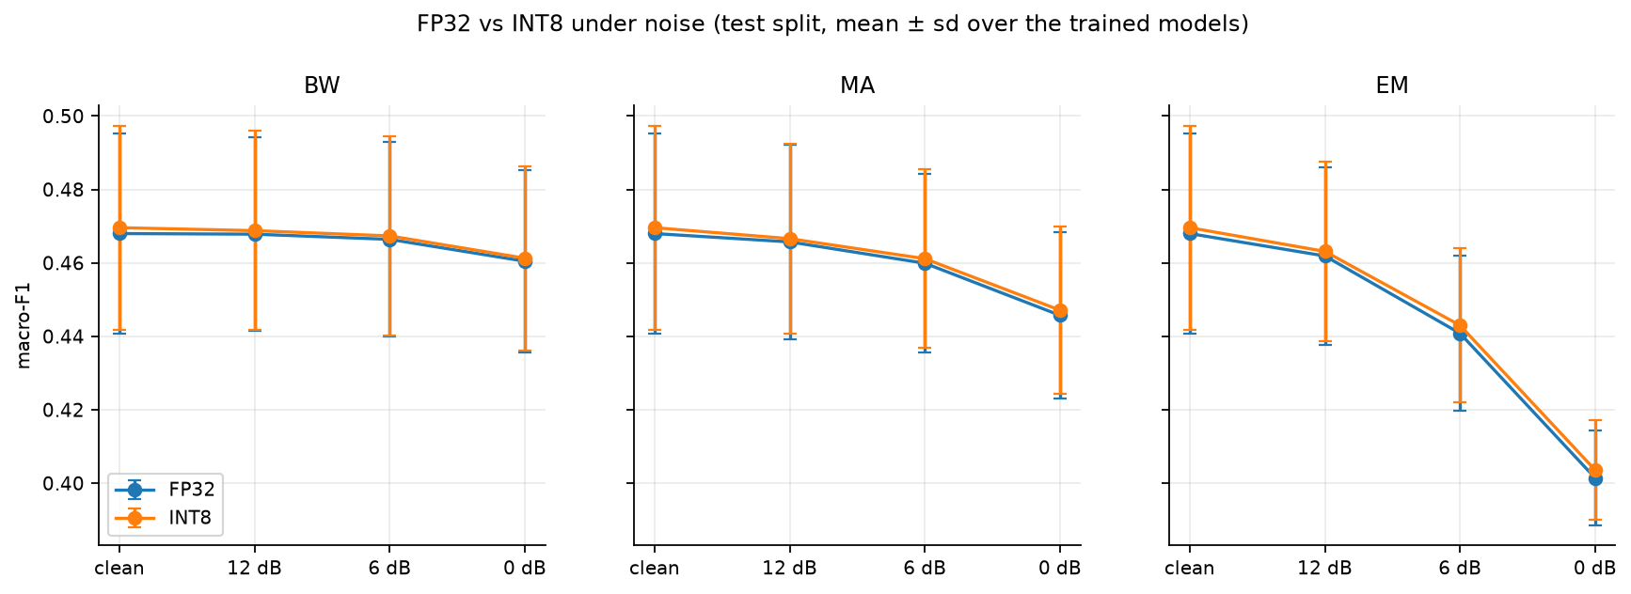
Figure 5.3. Macro-F1 against noise level on DS2 for each noise type, FP32 and INT8. Error bars are the standard deviation over the five models. The clean point is the same in all three panels.
Performance falls steadily but no condition causes a collapse. On DS2 the FP32 macro-F1 falls from 0.468 to 0.465, 0.456 and 0.436 at 12, 6 and 0 dB, so each step costs more than the one before it. At 0 dB, where the noise has as much power as the ECG, the models keep 93 % of their clean macro-F1 and 97 % of their clean accuracy.
Model | Condition | Recall N | Recall S | Recall V | Recall F
FP32 | Clean | 0.897 ± 0.026 | 0.158 ± 0.040 | 0.884 ± 0.026 | 0.107 ± 0.071
FP32 | 12 dB | 0.894 ± 0.025 | 0.157 ± 0.042 | 0.885 ± 0.023 | 0.102 ± 0.062
FP32 | 6 dB | 0.885 ± 0.025 | 0.151 ± 0.043 | 0.883 ± 0.020 | 0.095 ± 0.055
FP32 | 0 dB | 0.870 ± 0.024 | 0.136 ± 0.044 | 0.866 ± 0.018 | 0.084 ± 0.043
INT8 | Clean | 0.902 ± 0.025 | 0.155 ± 0.036 | 0.884 ± 0.024 | 0.097 ± 0.063
INT8 | 12 dB | 0.898 ± 0.025 | 0.152 ± 0.036 | 0.884 ± 0.022 | 0.093 ± 0.057
INT8 | 6 dB | 0.889 ± 0.025 | 0.147 ± 0.039 | 0.882 ± 0.019 | 0.086 ± 0.053
INT8 | 0 dB | 0.875 ± 0.024 | 0.132 ± 0.039 | 0.864 ± 0.017 | 0.077 ± 0.039
Table 5.4. Recall of each class on DS2 under noise, mean over the three noise types and the five models, ± standard deviation over the models.
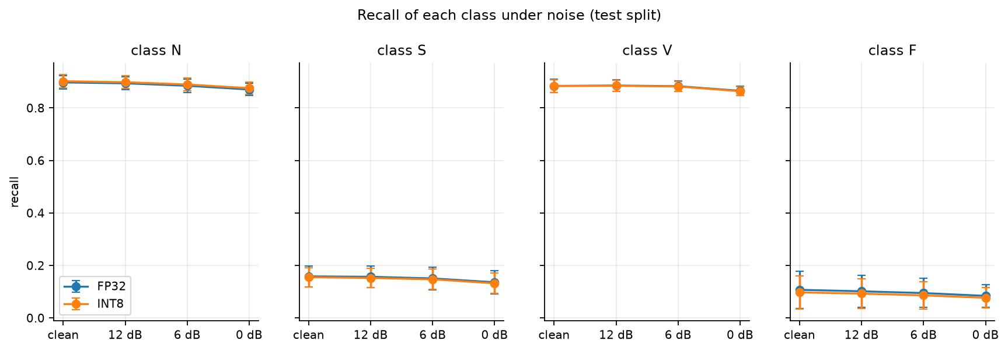
Figure 5.4. Recall of each class against noise level on DS2, FP32 and INT8, averaged over the three noise types.
The rare classes lose the largest share of their recall. On DS2 (FP32), recall of S falls from 0.158 to 0.136 (14 % lower) and recall of F from 0.107 to 0.084 (21 % lower), while recall of N falls from 0.897 to 0.870 (3 %) and recall of V from 0.884 to 0.866 (2 %). In absolute terms the four classes lose a similar two to three points, but S and F start from a recall that is already low, so noise removes a large part of what the model could detect. INT8 shows the same pattern as FP32. The INT8 copies follow the FP32 models at every noise level. The macro-F1 difference on DS2 is between +0.001 and +0.002 in all conditions, and on the validation split between −0.0002 and +0.0013. The share of beats on which INT8 and FP32 disagree grows slightly with noise on the validation split (0.27 % clean, 0.66 % at 0 dB) and hardly at all on DS2 (0.69 % to 0.77 %).
To improve robustness, a noise augmentation strategy could be applied. training on beats with noise from the first half of the NSTDB recordings at 6 to 20 dB, which is already reserved in the configuration, and repeating this test with the second half.
Overall, the model is only moderately sensitive to ECG noise. At 0 dB, where the noise has the same power as the ECG, DS2 macro-F1 fell from 0.468 to 0.436 (7 % lower) and accuracy from 0.863 to 0.837 (3 % lower); at 12 dB the loss is 0.003. The rare classes were affected most in relative terms (S recall 14 % lower and F recall 21 % lower at 0 dB), and INT8 behaved like FP32 at every level. Noise therefore sharpens an existing weakness and does not create a new one.

5.5 Error Analysis
We looked at four errors made by the logistic regression baseline on DS2. For each error type, we chose a case near the median predicted-class score. In Figure 5.7, 0ms marks the annotated beat.
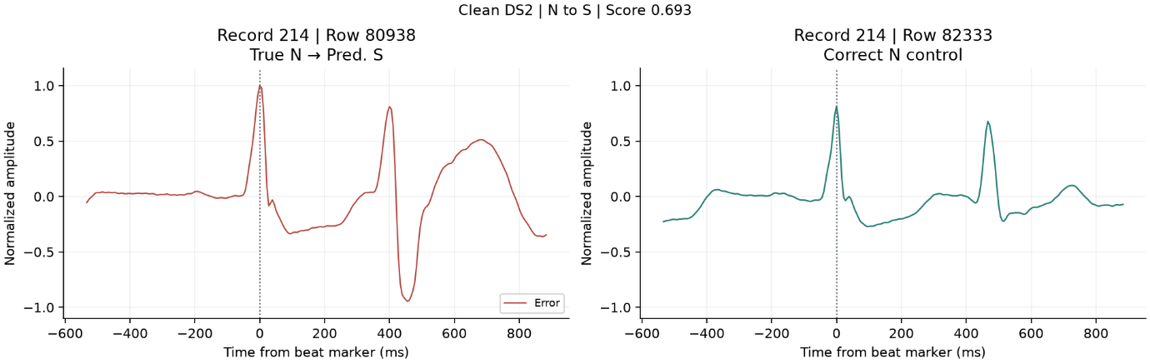
Figure 5.7(a). N beat classified as S on clean DS2 (record 214, row 80938, left) and a correctly classified N beat from the same record (row 82333, right).

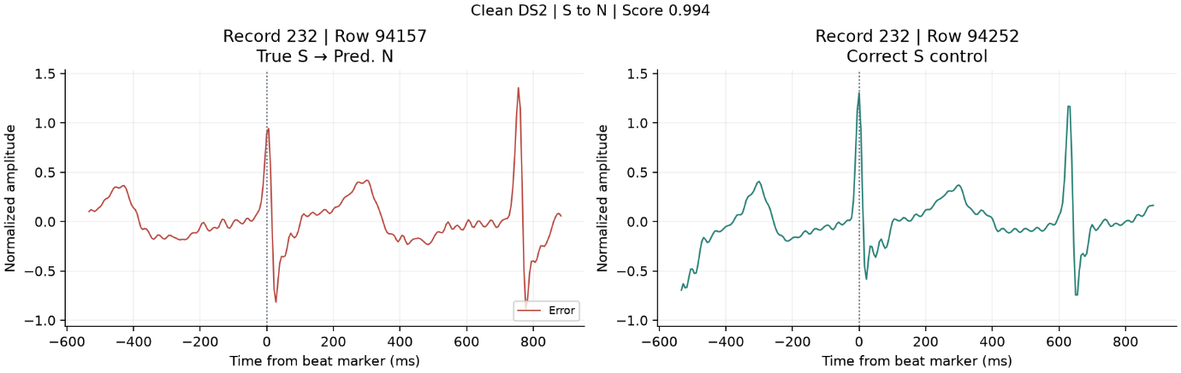
Figure 5.7(b). S beat classified as N on clean DS2 (record 232, row 94157, left) and a correctly classified S beat from the same record (row 94252, right).

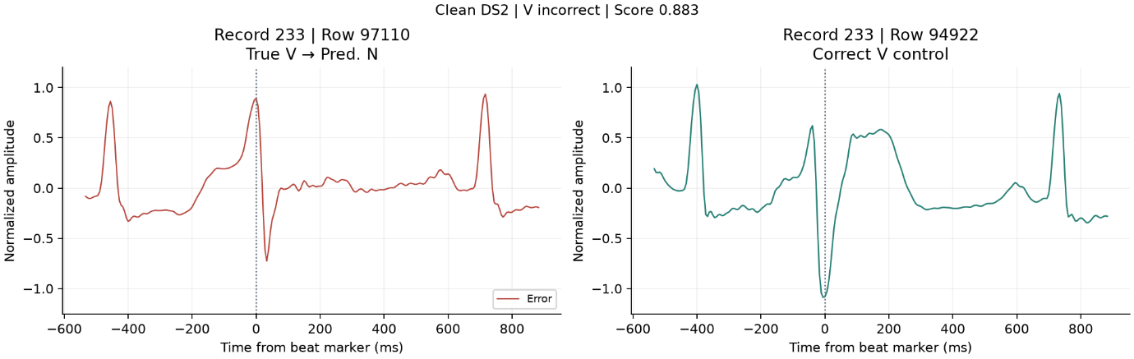
Figure 5.7(c). V beat classified as N on clean DS2 (record 233, row 97110, left) and a correctly classified V beat from the same record (row 94922, right).

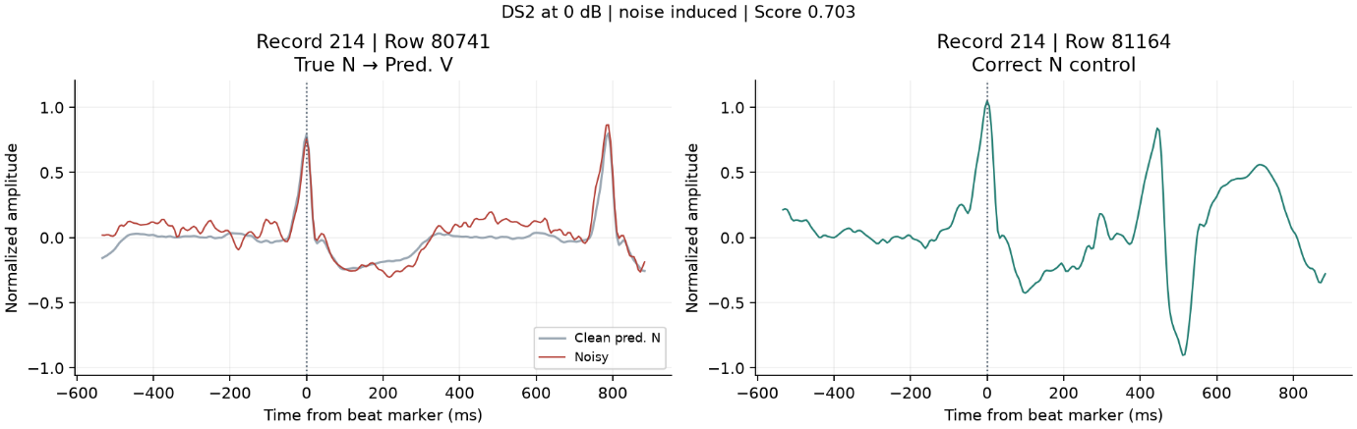
Figure 5.7(d). Clean and noisy versions of an N beat from record 214, row 80741 (left). The prediction changed from N to V after adding electrode-motion noise at 0 dB SNR. A correctly classified N beat is shown on the right for comparison.
(a) N classified as S. In record 214, the peak at the beat marker looks similar in both traces. In the misclassified window, the next peak at about 400 ms is followed by a much deeper dip than in the correctly classified example. Since the baseline uses the whole window, the shape of the next beat may have influenced the S prediction.
(b) S classified as N. In record 232, both S beats have a narrow upright peak followed by a dip at the beat marker. The next peak appears about 750 ms after the marker in the misclassified example and about 630 ms after it in the correctly classified example. The two beats look similar around the marker, with a clearer difference in the timing of the following beat.
(c) V classified as N. The missed V beat in record 233 has a tall upright peak that looks similar to the other peaks in its window. In the correctly classified V example, the dip near the marker is deeper and is followed by a broad upward wave.
(d) Error under strong noise. For the N beat in record 214, the baseline predicted N on the clean input and V after adding electrode-motion noise at 0 dB SNR. The main peak near 0 ms is still visible in both traces. The noisy trace rises higher just before the next beat, changing the shape of the signal around the marked beat.
On clean DS2, the INT8 CNN averaged 15.5% recall for S and 88.4% for V. The baseline reached 2.2% and 67.8%, respectively. Both models still missed most S beats in record 232, which accounted for 75% of the S beats in DS2 (Section 5.2).

5.6 Success-Criteria Review
Table 5.7 compares our results with the success criteria defined in Section 1.4. As stated there, all criteria are measured on DS2 with the INT8 model unless noted otherwise.
Area | Criterion (Section 1.4) | Result | Verdict
Predictive performance | Macro-F1 ≥ 0.55 and better than the baseline | Macro-F1 0.470 ± 0.028; baseline 0.343 | Partially achieved
Minority classes | Recall S ≥ 0.60 and V ≥ 0.80 (F only reported) | S 0.155, V 0.884, F 0.097 | Partially achieved
Noise robustness | Macro-F1 at 12 dB ≥ 90 % and at 6 dB ≥ 75 % of clean | 12 dB: 99.3 %, 6 dB: 97.4 % (0 dB: 93.1 %) | Achieved
Quantization | INT8 macro-F1 at most 0.03 lower than FP32; S and V recall at most 5 points lower | Macro-F1 +0.002; S recall −0.3 points; V unchanged | Achieved
Model complexity | INT8 weights ≤ 2 MB; fewer than 100,000 parameters | 35,588 parameters; 35 KB on the MAX78002 | Achieved
MAX78002 compatibility | Model accepted, quantized, synthesized and C files generated | All steps passed (Section 6.3) | Achieved (software only)
Table 5.7. Success criteria from Section 1.4 and whether they were achieved.
Predictive performance. Partially achieved. Our model clearly beats the logistic regression baseline (0.470 against 0.343 macro-F1), but 0.470 is still below our target of 0.55. When we set this target, we did not know how much performance would drop on new patients. On the validation patients the models reach 0.539, which is close to the target.
Minority classes. Partially achieved. V meets its target (0.884 vs. 0.80), but S is far below it (0.155 vs. 0.60). As shown in Section 5.2, the main reason is record 232. Without this patient, S recall is 0.54, which is closer to the target but still below it.
Noise robustness. Achieved. Based on the results in Section 5.4, the INT8 model keeps 99 % of its clean macro-F1 at 12 dB and 97 % at 6 dB, which is well above the required 90 % and 75 %.
Quantization. Achieved. The INT8 model performs as well as the FP32 model, and the small differences are within the variation between seeds (Section 5.3).
Model complexity. Achieved. The model uses about 1.5 % of the MAX78002 weight memory and about one third of the 100,000-parameter limit we set.
MAX78002 compatibility. Achieved, but only at software level. The full Analog Devices toolchain ran successfully and generated C code (Section 6). However, no physical board was used. Also, the synthesized model is a separate quantization-aware model that was only tested on the validation records (Section 6.3). The DS2 results in this table come from the PyTorch INT8 models, which we use as the closest estimate.
Overall, four criteria are achieved and two are partially achieved. The model meets all requirements related to the hardware, model size, quantization and noise, but it does not reach the performance targets on new patients. The per-class and per-patient results suggest that the main reason is the small number of patients with S and F beats, not the size of the model.

6. Deployment
In this course, deployment means software-level preparation of the selected model (arm B2, Section 4.4) for the Analog Devices MAX78002. No development kit was available, so every result in this section is software verified. Nothing here is a measurement taken on hardware (see 6.4). All files referred to are in the max78002/ folder of the repository, and the whole flow is reproduced by max78002/run_toolchain.sh.

6.1 MAX78002 Compatibility
The architecture was designed against the MAX78002 CNN accelerator rules from the start (Section 4.2), and src/model.py refuses to build a model that breaks them. To run on the accelerator, the model was re-expressed with Analog Devices' ai8x layer classes, which model the hardware's fused pooling, clipping and rounding. The re-expressed model (ai87ecgnet) has the same layer structure and the same 35,588 parameters as B2; this was checked tensor by tensor (6.3).
HW layer | ai8x operation | Input | Output | Parameters
0 | FusedConv1dReLU 1→16, k=5, pad=2 | 1 × 256 | 16 × 256 | 96
1 | FusedMaxPoolConv1dReLU (pool 2) 16→32, k=5 | 16 × 256 | 32 × 128 | 2,592
2 | FusedMaxPoolConv1dReLU (pool 2) 32→64, k=5 | 32 × 128 | 64 × 64 | 10,304
3 | FusedMaxPoolConv1dReLU (pool 2) 64→64, k=5 | 64 × 64 | 64 × 32 | 20,544
4 | MaxPool1d 4 (pass-through layer) | 64 × 32 | 64 × 8 | 0
5 | Flatten + Linear 512→4, 32-bit output | 512 | 4 logits | 2,052
 | Total |  |  | 35,588
Table 6.1. Hardware layer map of the deployed model.
Why it fits the accelerator:
- Only supported operations are used: 1D convolution (kernel 5 is within the 1-9 limit, padding 2 within 0-2, stride 1), max pooling, ReLU and one fully connected layer. There is no batch normalisation, no residual connection and no unsupported custom operation.
- Pooling always precedes convolution, so each pooling stage is fused into the following convolution (FusedMaxPoolConv1dReLU) and does not cost an extra layer.
- The final MaxPool4 is a separate pass-through layer, because the MAX78002 cannot pool and flatten in the same layer. The network therefore uses 6 hardware layers, against a limit of 128.
- The flattened vector is 64 × 8 = 512, within the 1,024 input fully connected limit; H × W = 8 ≤ 256.
- Input: a fixed 1 × 256 window (1.42 s at 180 Hz), one channel, 8-bit signed. Output: 4 logits (N, S, V, F) as 32-bit values; the class is the argmax. A software softmax is generated only for display.
- Parameter count: 35,588, i.e. 35,588 bytes at 8 bits, about 1.5 % of the weight memory.

6.2 MAX78002 Toolchain
Both Analog Devices frameworks were used: ai8x-training and ai8x-synthesis. They ran in WSL2 Ubuntu 24.04 on a laptop with an NVIDIA RTX A3000, using PyTorch 2.3.1 with CUDA 12.1. The officially supported setup is Ubuntu 20.04/22.04 with Python 3.11; we used Python 3.12. The only consequence is that torch.compile is unavailable on 3.12, so training ran with --compiler-mode none, which affects speed but not results. Before any of our own work, the toolchain was tested by synthesising Analog Devices' pretrained MAX78002 keyword-spotting network (also Conv1d-based) into C code.
The steps were:
- Model and data. models/ai87ecgnet.py (Table 6.1) and datasets/ecg.py were added to ai8x-training. The data loader reads the same data/processed/beats.npz as our own pipeline, keeps the same five validation records (106, 112, 124, 201, 223) and the same capped class weights (0.072, 1.446, 1.037, 1.446), and augments only the training records (amplitude ×0.9-1.1, shift ±4 samples). Inputs are divided by 4, which maps the normalised range [-4, 4] onto the accelerator's 8-bit input range [-128, 127]. DS2 can be loaded for evaluation only; the loader raises an error if DS2 is requested for training. ai8x's default random beat-level validation split was replaced with the record-level split, so no patient appears in both training and validation.
- Quantization-aware training (QAT). Adam, learning rate 0.001, batch 256, 100 epochs, weighted cross-entropy. The first 60 epochs train in floating point; at epoch 60 ai8x collects activation statistics and switches to 8-bit QAT for the remaining 40 epochs. The learning rate is multiplied by 0.2 at epochs 60 and 85. The run took about 5 minutes on the GPU.
- Checkpoint selection. ai8x keeps the best QAT epoch by validation accuracy, whereas our protocol selects on macro-F1 over N/S/V (Section 4.4). We recomputed macro-F1(N/S/V) for every epoch from the logged confusion matrices: epoch 83 is best by both criteria, so there was no conflict.
- Quantization. quantize.py --device MAX78002 converted the QAT checkpoint to 8-bit integer weights and biases (quantization_output/ai87-ecg-b2-qat8-q.pth.tar).
- Evaluation of the quantized model. train.py --evaluate -8 simulates 8-bit hardware arithmetic on the validation records. DS2 was not used.
- Synthesis. ai8xize.py --device MAX78002 combined the quantized checkpoint, the network description (model_configuration/ecg-b2.yaml) and one validation beat as a known-answer sample, and generated the device project in synthesis_output/ecg_b2/.

6.3 Deployment Evidence
Requirement | Result | Evidence
Model accepted by MAX78002 toolchain | PASS | quantization_output/training_log/
Quantization completed | PASS | quantization_output/quantize.log
Synthesis completed | PASS | synthesis_output/ecg_b2/log.txt
C/device files generated | PASS | cnn.c, cnn.h, weights.h, main.c, sampledata.h, sampleoutput.h, softmax.c, Makefile
Weight-memory requirement | 35,408 B of 2,396,160 B (1.5 %) | log.txt
Bias-memory requirement | 180 B of 8,192 B (2.2 %) | log.txt
Data-memory requirement | ≈ 8 KiB peak of 1,280 KiB | computed from the layer layout in log.txt: the largest input + output pair is 2 × 4,096 B
Compute per beat | 1,660,928 MACs | log.txt
Table 6.2. MAX78002 deployment evidence (software verified).
Validation results of the deployed (quantized) model, on the five validation records:
Class | Precision | Recall | F1 | Support
N | 0.971 | 0.985 | 0.978 | 9,250
S | 0.210 | 0.244 | 0.226 | 234
V | 0.902 | 0.786 | 0.840 | 1,238
F | 0.000 | 0.000 | 0.000 | 21
Accuracy 0.944 | Macro-F1 (N/S/V) 0.681 | Macro-F1 (all) 0.511
Table 6.3. Simulated 8-bit results on validation records 106, 112, 124, 201, 223. DS2 results are reported in Section 5.
We did not rely on the tools' own pass messages alone. An independent script (max78002/verify_toolchain.py; output in synthesis_output/verification.txt) checked 11 properties, and all passed:
- the ai8x model has the same parameter tensors as B2 in src/model.py;
- the ai8x loader gives exactly the same validation beats, labels and records as src/dataset.py (difference 0), keeps train and validation records disjoint, contains no DS2 beats, and augments training records only;
- every weight and bias in the quantized checkpoint is an 8-bit integer;
- an independent reload of the quantized model reproduces train.py's 8-bit confusion matrix exactly;
- the synthesizer's own simulation of the generated network (the expected output written into sampleoutput.h) is bit-exact with the PyTorch 8-bit logits for 40 validation beats, 10 of each class, apart from a fixed output scale of 1/16. Since the synthesizer builds its simulation from our network description, this confirms the description matches the trained model. The generated C code compares the chip's output against that same expected output (check_output() in main.c).
No architecture changes were needed for synthesis to succeed. The one hardware-driven change, splitting the final pooling into its own layer, was made in advance from the documented limits.

6.4 Hardware Limitations
No MAX78002 board was used, so the following were not measured and are not claimed: inference latency, power, energy per inference, accuracy on the real chip, and real-time behaviour. The figures are separated as follows.
Software verified | Not verified (needs hardware)
Toolchain accepts, quantizes and synthesizes the model | Inference latency
Memory use: weights, bias, activations (from the synthesizer) | Power and energy per inference
Operation count (1.66 M MACs per beat) | Accuracy measured on the chip
8-bit simulation accuracy on validation records | Real-time streaming behaviour
Synthesizer simulation bit-exact with PyTorch 8-bit model | Known-answer test executed on the device
Table 6.4. Software-verified versus hardware-verified results.
The operation count and memory figures describe the workload, not its speed. Execution time and energy depend on the clock configuration, data loading and the microcontroller code around the accelerator, and can only be established on a board.

6.5 Proposed Hardware Validation
With a MAX78002 evaluation kit, validation would proceed in this order:
- Load the generated model. Build synthesis_output/ecg_b2 with the Analog Devices MSDK (Arm GCC, make) and flash it. The generated main.c runs the known-answer test: it loads the stored validation beat, runs the accelerator, compares all four output words with sampleoutput.h and prints PASS or FAIL. This checks weight loading, layer configuration and memory layout in one step.
- Supply identical ECG inputs. Replace the single stored sample with a loop that streams the 8-bit validation beats over UART (later the DS2 beats, in the final evaluation only) into the accelerator input memory through load_input(), and returns the four 32-bit logits per beat.
- Compare Python and hardware outputs. Compare each beat's logits with the PyTorch 8-bit simulation (verify_toolchain.py). The synthesizer simulation is bit-exact with PyTorch, so the expected result is identical logits and an identical confusion matrix. Any difference points to an input-format or configuration error, not to quantization.
- Check intermediate outputs. If outputs differ, regenerate the code with --stop-after N and --log-intermediate to dump each layer's activations, and compare layer by layer against the synthesizer log to find the first layer that diverges.
- Measure inference time. Regenerate with --timer 0 (already set) so cnn.c reports the accelerator time per inference. Separately time the input load and the unload, and repeat over many beats.
- Measure energy. Regenerate with --energy, which runs 100 inferences back to back, and read the energy per inference from the kit's on-board power monitor (MAX34417). Compare the default pipelined clock with --no-pipeline.
- Real-time check. Confirm that inference plus data transfer fits easily within one heartbeat interval: the shortest RR interval in the prepared dataset is 0.25 s.

7. Final Discussion

7.1 What did we learn from the data?
The biggest lesson was that differences between patients matter more than the total number of beats. We expected the class imbalance, but we did not expect how much a few people would decide the results. In the training set, four of the 17 records give 96 % of all S beats, and five records have no S beats at all. On DS2 it is the same: record 232 decides most of the S result, and record 213 is almost the whole F class. We also learned that an S beat is recognised by when it arrives, not by its shape. A window with only one heartbeat cannot show that timing, so with that input the model found only 9 % of S beats and stopped improving after about ten epochs. Giving the network a longer window, so it could see the beats around it, worked better than adding hand-made RR features.

7.2 What was the largest source of error?
The largest source of error was S beats being predicted as N. This happens about 1,300 times per model, and 89 % of these errors come from one patient, record 232. The cross-validation in Table 4.6 shows the same problem: S recall goes from 0.000 to 0.786 between patients with a similar number of S beats. The model is not too small, since it still has plenty of parameters and memory left. The real problem is that it has seen too few different people with S beats. This also means that one overall S recall number mostly describes a few patients, because 75 % of the S beats in DS2 belong to record 232.

7.3 Was the highest-accuracy model also the best Edge-AI model?
No. Normal beats make up 89 % of DS2, so a model can get high accuracy and still miss most S and F beats. For a heart monitor, finding those rare beats matters more than overall accuracy. Even when we used macro-F1, the top-scoring model was not the one we chose. The highest-scoring version (arm B) used all 1,024 inputs that the MAX78002 allows for the fully connected layer, with no margin left. Arm B2 scored the same, within seed noise, while using only half of the classifier width. Since quantization and synthesis were still ahead, we chose B2. The score could not tell the two models apart, so the hardware limit made the decision for us (see Section 4.4).

7.4 How much performance was lost after quantization?
Almost nothing. Macro-F1 was 0.468 for the FP32 model and 0.470 for the INT8 model, and accuracy was 0.863 and 0.867. These small differences are well within the variation between seeds. The two versions also make the same kinds of mistakes, so the 8-bit model can be used without losing performance (Section 5.3).

7.5 How sensitive was the system to ECG noise?
Not very sensitive. We added real noise from the MIT-BIH Noise Stress Test Database at 12, 6 and 0 dB. The model kept about 99 % of its clean macro-F1 at 12 dB and 97 % at 6 dB. Even at 0 dB, where the noise is as strong as the ECG signal, it still kept 93 %. The INT8 model reacted to noise in the same way as the FP32 model (Section 5.4).

7.6 What compromises were necessary because of hardware constraints?
The chip shaped almost every design choice. The convolution stride is fixed at 1, so all downsampling has to be done with pooling layers. ReLU is the only activation we could use and there is no batch normalisation, so we could not use the usual tricks to keep training stable. The fully connected layer takes at most 1,024 inputs, which limits how much of the signal reaches the classifier, and this was the main reason we picked B2 over B. The filtering also had to be causal, because a device reading a live signal cannot look at future samples. This adds a delay of 8 samples, which we corrected before cutting the windows. Finally, we did not have a MAX78002 board, so everything was tested in software only. This means we have no results for speed, energy use or accuracy on the real chip (see Sections 4.2 and 6.1).

7.7 What would we change with more time?
Most of our problems came from having too few patients with S beats, not from the model itself, so we would mainly work on the data. First, we would add more S and F patients from other ECG databases, even though this means moving away from the standard DS1/DS2 split. Second, we would try a longer input window of about three seconds, so the model can compare each beat with several earlier ones. Going from 128 to 256 samples already tripled S recall, so there is probably more to gain. Third, we would set the S target per patient, or report the spread across patients, instead of one average number, because an average hides how differently the model works for each person. Finally, we would test the synthesized model on DS2 and run it on a real MAX78002 board to measure speed, energy and on-chip accuracy.

8. Limitations
Limited dataset size. MIT-BIH contains 48 recordings from 47 people. After removing the four paced recordings we have 44, and only 17 of them are used for training (5 for validation and 22 for testing). That is not many people to learn rare beat types from, and it is one of the main reasons why the results differ so much between patients.
Class imbalance. Normal beats make up 89.5 % of all beats, V 7.0 %, S 2.8 % and F only 0.8 %. The training set has only 709 S beats and 393 F beats, and the validation set has just 21 F beats, which is too few to use F for model selection. Class weights helped, but they are no replacement for more real examples.
Differences between patients. The rare beats are concentrated in a few people. Four training patients supply 96 % of the S beats in training, and five training patients have no S beats at all. On DS2, S recall ranges from 0.03 (record 232) to 0.67 (record 100) among patients with at least 30 S beats, so one average number does not tell us much about how the model would work for a new person.
Use of historical ECG datasets. MIT-BIH was recorded between 1975 and 1979 at Beth Israel Hospital in Boston, mostly from hospital patients and on analogue Holter tapes. Recording equipment and patient groups are different today. Some beats, such as fusion beats, are also hard to label, even for cardiologists.
Absence of prospective clinical testing. All our results come from a fixed public database. The model has never been used on new patients in real time or checked by a doctor, and it is not a medical device.
Absence of hardware testing. Everything related to the MAX78002 was checked in software only. We did not measure inference time, energy use or accuracy on a real chip. In addition, the synthesized model was only tested on the validation records, not on DS2.
Possible domain shift to wearable ECG devices. We used lead MLII from clinical recordings. A wearable device usually records a different lead, uses dry electrodes and has much more movement noise. Our noise test adds real noise to clean recordings, which is not quite the same thing. We also used the R-peak positions from the annotations, while a real device would need its own beat detector. The ±4-sample shift we use in training only partly simulates its errors.

9. Final Submission Package
All code, results and MAX78002 files are in our GitHub repository: https://github.com/ThaniJames/Group17_ECG_Project. The repository follows the folder structure from the brief. The raw PhysioNet data is not included, and README.md explains how run.sh downloads it.

References
AAMI. (2012). ANSI/AAMI EC57:2012 Testing and reporting performance results of cardiac rhythm and ST segment measurement algorithms. Association for the Advancement of Medical Instrumentation.
Analog Devices. (n.d.). ai8x-training and ai8x-synthesis: Model training, quantization and synthesis for the MAX78000 and MAX78002 Edge AI devices [Computer software]. GitHub. https://github.com/analogdevicesinc/ai8x-training and https://github.com/analogdevicesinc/ai8x-synthesis
de Chazal, P., O'Dwyer, M., & Reilly, R. B. (2004). Automatic classification of heartbeats using ECG morphology and heartbeat interval features. IEEE Transactions on Biomedical Engineering, 51(7), 1196–1206. https://doi.org/10.1109/TBME.2004.827359
Moody, G. B., & Mark, R. G. (2001). The impact of the MIT-BIH Arrhythmia Database. IEEE Engineering in Medicine and Biology Magazine, 20(3), 45–50. https://doi.org/10.1109/51.932724
Moody, G. B., Muldrow, W. E., & Mark, R. G. (1984). A noise stress test for arrhythmia detectors. Computers in Cardiology, 11, 381–384.
Paszke, A., et al. (2019). PyTorch: An imperative style, high-performance deep learning library. In Advances in Neural Information Processing Systems 32 (pp. 8024–8035). Curran Associates.

