5.1 Clean Test Results
We tested the final models on DS2, which contains 22 patients and 49,656 beats. None of these beats were used for training, model selection or calibration, and the test was run only once, after arm B2 had been selected in Section 4.4. As in the rest of the report, each value is the mean ± standard deviation over the five trained models (seeds 20260906–20260910). The INT8 model is the quantized version of each FP32 model from Section 5.3. Macro-F1 is the average F1 score over all four classes, as defined in Section 1.4. All numbers come from src/evaluate.py, which also saves them to results/metrics.csv and results/confusion_matrix.csv.
Metric | Baseline | FP32 Edge Model | Quantized Model (INT8)
Accuracy | 0.743 | 0.863 ± 0.024 | 0.867 ± 0.024
Macro F1 | 0.343 | 0.468 ± 0.027 | 0.470 ± 0.028
Macro F1 (N/S/V) | 0.443 | 0.614 ± 0.039 | 0.616 ± 0.039
Model parameters | 1,028 | 35,588 | 35,588
Saved weights | n/a | 143 KiB | 43 KiB
Table 5.5. Clean results on DS2. FP32 and INT8 are the mean ± sd over five models; the baseline is the single logistic regression model from Section 4.1.
Accuracy alone is not very informative here. 89.0 % of the beats in DS2 are normal (44,213 of 49,656), so a model that always predicts N would reach 89 % accuracy but only 0.236 macro-F1. Our model reaches 0.86 accuracy and 0.47 macro-F1, so it does much better than always predicting N. However, it also classifies some normal beats as abnormal, which is why its accuracy is slightly lower than 89 %. It is still clearly better than the logistic regression baseline from Section 4.1, which reaches 0.743 accuracy and 0.343 macro-F1.
A bigger concern is the drop in performance from validation to test. On the five validation patients the models reach a macro-F1 of 0.539 (Section 5.3), while on DS2 they reach 0.468. The models are the same in both cases; only the patients are different. This shows how much performance drops when the model is used on people it has not seen before. FP32 and INT8 give almost the same results, as already shown in Section 5.3.
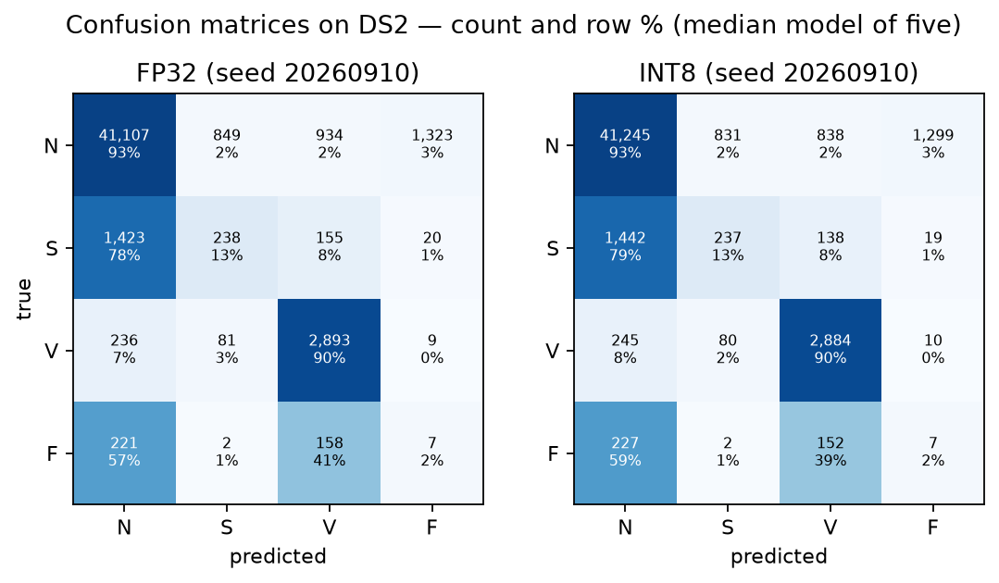
Figure 5.5. Confusion matrices on DS2 for the model with the median macro-F1 of the five, shown as counts and as a percentage of each true class. Rows are the true class.

5.2 Per-Class Performance
Class | Precision | Sensitivity/Recall | F1
N | 0.958 ± 0.002 | 0.902 ± 0.025 | 0.929 ± 0.013
S | 0.185 ± 0.042 | 0.155 ± 0.036 | 0.166 ± 0.035
V | 0.663 ± 0.104 | 0.884 ± 0.024 | 0.754 ± 0.079
F | 0.017 ± 0.010 | 0.097 ± 0.063 | 0.029 ± 0.017
Table 5.6. Per-class results of the INT8 model on DS2, mean ± sd over five models. The FP32 values differ by about 0.01 or less in every cell.
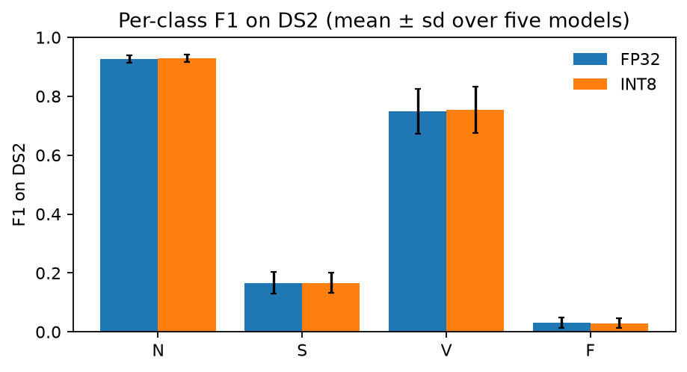
Figure 5.6. F1 score of each class on DS2 for FP32 and INT8, mean ± sd over five models.
N. The model correctly finds 90 % of the normal beats, and 96 % of the beats it predicts as N are actually normal.
V. Most V beats are detected (recall 0.88), but only about two out of three beats predicted as V are actually V. Many of these false V predictions come from one patient: in the model shown in Figure 5.5, 344 of the 838 normal beats predicted as V belong to record 111. This patient has left bundle branch block. These beats are counted as N in the AAMI classes, but their QRS complex is wide and looks similar to a ventricular beat.
S. S is the weakest of the main classes. Recall is only 0.155, and in the model shown in Figure 5.5, 79 % of the S beats are predicted as N. Most of these errors come from a single patient. Record 232 contains 1,381 of the 1,836 S beats in DS2 (75 %), and the model detects only 2.9 % of them. This patient has a very slow heart rhythm with long pauses, so the S beats are not clearly premature compared with the surrounding beats. Prematurity is the main feature the model uses to detect S (Section 4.4). When record 232 is excluded, S recall on the other 15 DS2 patients is 0.54. This means the model does detect S beats in many patients, but the overall result is dominated by one unusual patient.
F. F beats are almost never detected (F1 0.03). There are two main reasons. First, 362 of the 388 F beats in DS2 come from one patient (record 213), so the F result mainly reflects one person. Second, a fusion beat is a mix of a normal and a ventricular beat, and the model treats it that way: in Figure 5.5, 59 % of the F beats are predicted as N and 39 % as V. The same model also predicts about 1,300 normal beats as F, mostly from records 117 and 233. With only 393 F beats in the training data, coming from a few patients, the model cannot learn this class well. This is also why no target was set for F in Section 1.4.

5.5 Error Analysis
We looked at four errors made by the logistic regression baseline on DS2. For each error type, we chose a case near the median predicted-class score. In Figure 5.7, 0ms marks the annotated beat.
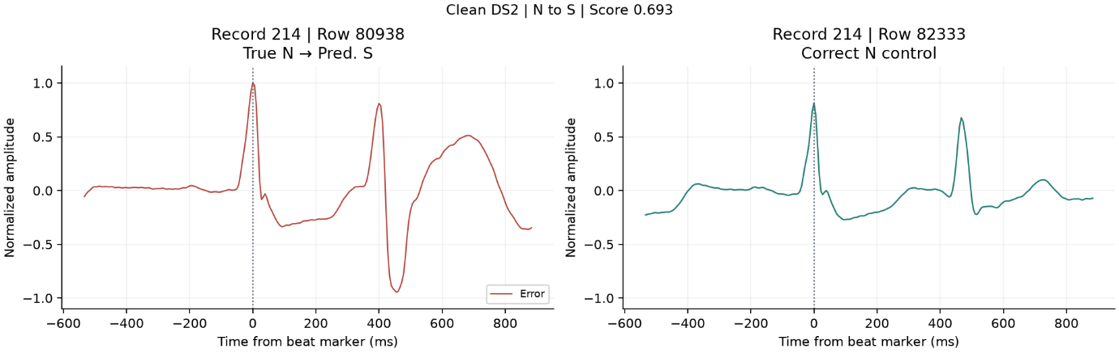
Figure 5.7(a). N beat classified as S on clean DS2 (record 214, row 80938, left) and a correctly classified N beat from the same record (row 82333, right).

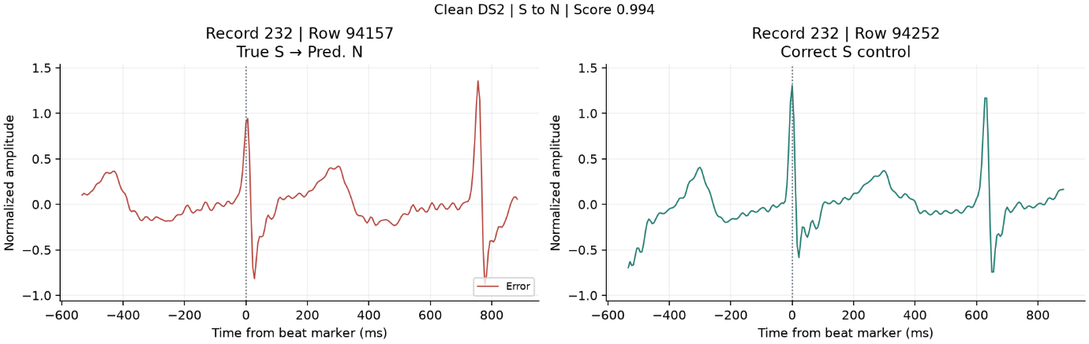
Figure 5.7(b). S beat classified as N on clean DS2 (record 232, row 94157, left) and a correctly classified S beat from the same record (row 94252, right).

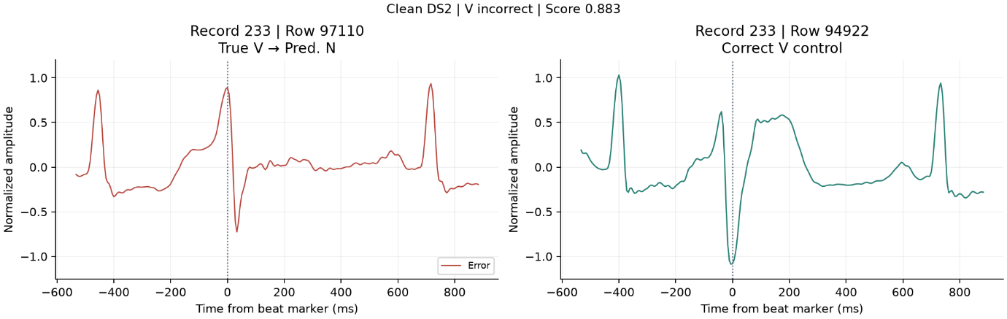
Figure 5.7(c). V beat classified as N on clean DS2 (record 233, row 97110, left) and a correctly classified V beat from the same record (row 94922, right).

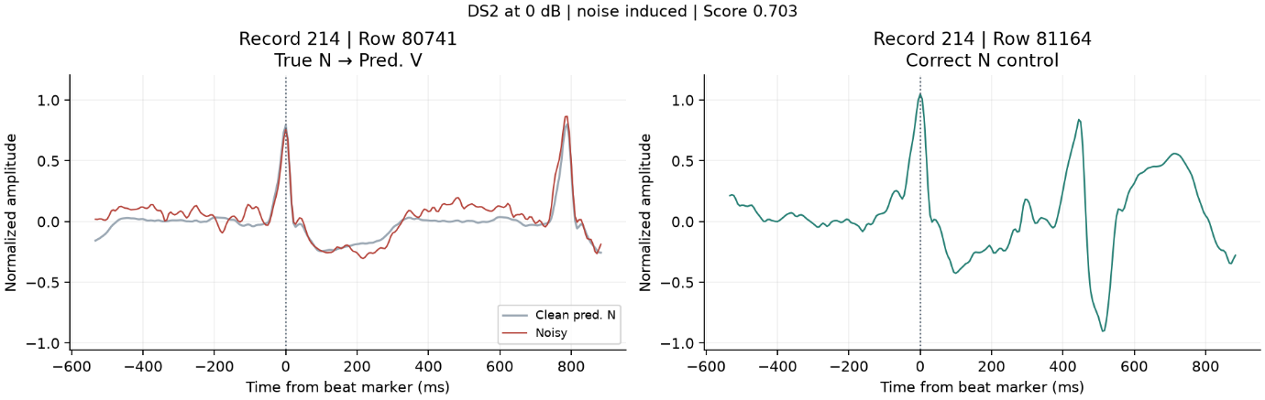
Figure 5.7(d). Clean and noisy versions of an N beat from record 214, row 80741 (left). The prediction changed from N to V after adding electrode-motion noise at 0 dB SNR. A correctly classified N beat is shown on the right for comparison.

(a) N classified as S. In record 214, the peak at the beat marker looks similar in both traces. In the misclassified window, the next peak at about 400 ms is followed by a much deeper dip than in the correctly classified example. Since the baseline uses the whole window, the shape of the next beat may have influenced the S prediction.
(b) S classified as N. In record 232, both S beats have a narrow upright peak followed by a dip at the beat marker. The next peak appears about 750 ms after the marker in the misclassified example and about 630 ms after it in the correctly classified example. The two beats look similar around the marker, with a clearer difference in the timing of the following beat.
(c) V classified as N. The missed V beat in record 233 has a tall upright peak that looks similar to the other peaks in its window. In the correctly classified V example, the dip near the marker is deeper and is followed by a broad upward wave.
(d) Error under strong noise. For the N beat in record 214, the baseline predicted N on the clean input and V after adding electrode-motion noise at 0 dB SNR. The main peak near 0 ms is still visible in both traces. The noisy trace rises higher just before the next beat, changing the shape of the signal around the marked beat.
On clean DS2, the INT8 CNN averaged 15.5% recall for S and 88.4% for V. The baseline reached 2.2% and 67.8%, respectively. Both models still missed most S beats in record 232, which accounted for 75% of the S beats in DS2 (Section 5.2).

5.6 Success-Criteria Review
Table 5.7 compares our results with the success criteria defined in Section 1.4. As stated there, all criteria are measured on DS2 with the INT8 model unless noted otherwise.
Area | Criterion (Section 1.4) | Result | Verdict
Predictive performance | Macro-F1 ≥ 0.55 and better than the baseline | Macro-F1 0.470 ± 0.028; baseline 0.343 | Partially achieved
Minority classes | Recall S ≥ 0.60 and V ≥ 0.80 (F only reported) | S 0.155, V 0.884, F 0.097 | Partially achieved
Noise robustness | Macro-F1 at 12 dB ≥ 90 % and at 6 dB ≥ 75 % of clean | 12 dB: 99.3 %, 6 dB: 97.4 % (0 dB: 93.1 %) | Achieved
Quantization | INT8 macro-F1 at most 0.03 lower than FP32; S and V recall at most 5 points lower | Macro-F1 +0.002; S recall −0.3 points; V unchanged | Achieved
Model complexity | INT8 weights ≤ 2 MB; fewer than 100,000 parameters | 35,588 parameters; 35 KB on the MAX78002 | Achieved
MAX78002 compatibility | Model accepted, quantized, synthesized and C files generated | All steps passed (Section 6.3) | Achieved (software only)
Table 5.7. Success criteria from Section 1.4 and whether they were achieved.
Predictive performance. Partially achieved. Our model clearly beats the logistic regression baseline (0.470 against 0.343 macro-F1), but 0.470 is still below our target of 0.55. When we set this target, we did not know how much performance would drop on new patients. On the validation patients the models reach 0.539, which is close to the target.
Minority classes. Partially achieved. V meets its target (0.884 vs. 0.80), but S is far below it (0.155 vs. 0.60). As shown in Section 5.2, the main reason is record 232. Without this patient, S recall is 0.54, which is closer to the target but still below it.
Noise robustness. Achieved. Based on the results in Section 5.4, the INT8 model keeps 99 % of its clean macro-F1 at 12 dB and 97 % at 6 dB, which is well above the required 90 % and 75 %.
Quantization. Achieved. The INT8 model performs as well as the FP32 model, and the small differences are within the variation between seeds (Section 5.3).
Model complexity. Achieved. The model uses about 1.5 % of the MAX78002 weight memory and about one third of the 100,000-parameter limit we set.
MAX78002 compatibility. Achieved, but only at software level. The full Analog Devices toolchain ran successfully and generated C code (Section 6). However, no physical board was used. Also, the synthesized model is a separate quantization-aware model that was only tested on the validation records (Section 6.3). The DS2 results in this table come from the PyTorch INT8 models, which we use as the closest estimate.
Overall, four criteria are achieved and two are partially achieved. The model meets all requirements related to the hardware, model size, quantization and noise, but it does not reach the performance targets on new patients. The per-class and per-patient results suggest that the main reason is the small number of patients with S and F beats, not the size of the model.

