Quantization
Two INT8 models exist in this project and they answer different questions. This section refers to software results from PyTorch’s CPU quantizer. The model deployed to the MAX78002 (Section 6) comes from a separate training run in the Analog Devices framework with quantization-aware training (QAT) and has different weights, so it is not the model compared here.
Method.
PyTorch’s static eager-mode quantizer was used, in four steps and without retraining. Each Conv1d and the ReLU are fused into one layer and finally. the layers are converted: weights become signed 8-bit integers and activations unsigned 8-bit integers. Only training beats were used for calibration, so neither the validation split nor DS2 influenced the quantizer. The quantized layers run on the CPU (ARM backend, qnnpack). The output logits are 8-bit as well, with a step of about 0.26 logit units for the first model.
 | FP32 | INT8 (PTQ)
Parameters | 35,588 | 35,588
Weight precision | 32-bit float | 8-bit integer
Saved weights | 143 KiB | 43 KiB
Calibration | none | 20 training batches
Validation macro-F1 | 0.539 ± 0.012 | 0.539 ± 0.013
Validation beats with a changed class | - | 29 of 10,743 (0.27 %)
Table 4.7. FP32 versus INT8 (post-training quantization) for the five trained models of arm B2
PTQ is used here because it isolates the cost of rounding on models trained in the normal way and it answers the question whether rounding costs anything for this network at all.
Analysis
The FP32 models and their INT8 copies were compared on the validation split and on DS2 for all five trained models. Each model is compared with its own INT8 copy on identical beats.
Split | FP32 macro-F1 | INT8 macro-F1 | Difference | FP32 accuracy | INT8 accuracy | Beats changed
Validation | 0.539 ± 0.012 | 0.539 ± 0.013 | −0.0001 | 0.951 ± 0.004 | 0.951 ± 0.003 | 0.27 %
DS2 | 0.468 ± 0.027 | 0.470 ± 0.028 | +0.0016 | 0.863 ± 0.024 | 0.867 ± 0.024 | 0.69 %
Table 5.1. FP32 versus INT8 (PTQ) on clean data. “Beats changed” is the share of beats that the INT8 copy assigns to a different class than its FP32 original.
Effect of quantization.
Quantization barely changed the model’s performance. Only 0.27 % of validation beats (29 of 10,743 on average) and 0.69 % of DS2 beats (about 340 of 49,656) receive a different class from the INT8 copy; these are presumably beats close to a decision boundary. The stored weights shrank from 143 KiB to 43 KiB.
The largest per-class change on DS2 is in class F, whose recall falls from 0.107 to 0.097, which is about four of its 388 beats on average. Recall of N rises from 0.897 to 0.902, recall of S falls from 0.158 to 0.155 and recall of V is unchanged at 0.884. No class is systematically lost.
The INT8 results are software results from PyTorch’s CPU quantizer; nothing was measured on the MAX78002 (See section 6.3 for that)

5.4 Noise Robustness
Method
Noise was taken from the MIT-BIH Noise Stress Test Database (NSTDB), which provides three 30-minute recordings of real ECG noise at 360 Hz: baseline wander (BW), electrode motion artifact (EM) and muscle artifact (MA, electromyographic activity). Each was added to the raw 360 Hz DS2 records at signal-to-noise ratios of 12, 6 and 0 dB, where the SNR is the variance of the clean record divided by the variance of the added noise. At 0 dB the noise has as much power as the ECG. The noisy signal then passes through exactly the same preprocessing as the clean data.
To prevent leakage, the test noise comes only from the second half of each NSTDB recording (channel noise2, 903 s). The first half was reserved for potential noise augmentation in training. The models however were not trained with noise and the INT8 copies were calibrated on clean training beats, so no model has seen noise of any kind. Because half a recording is shorter than a record (903 s against 1,805 s), the noise is repeated to cover the record
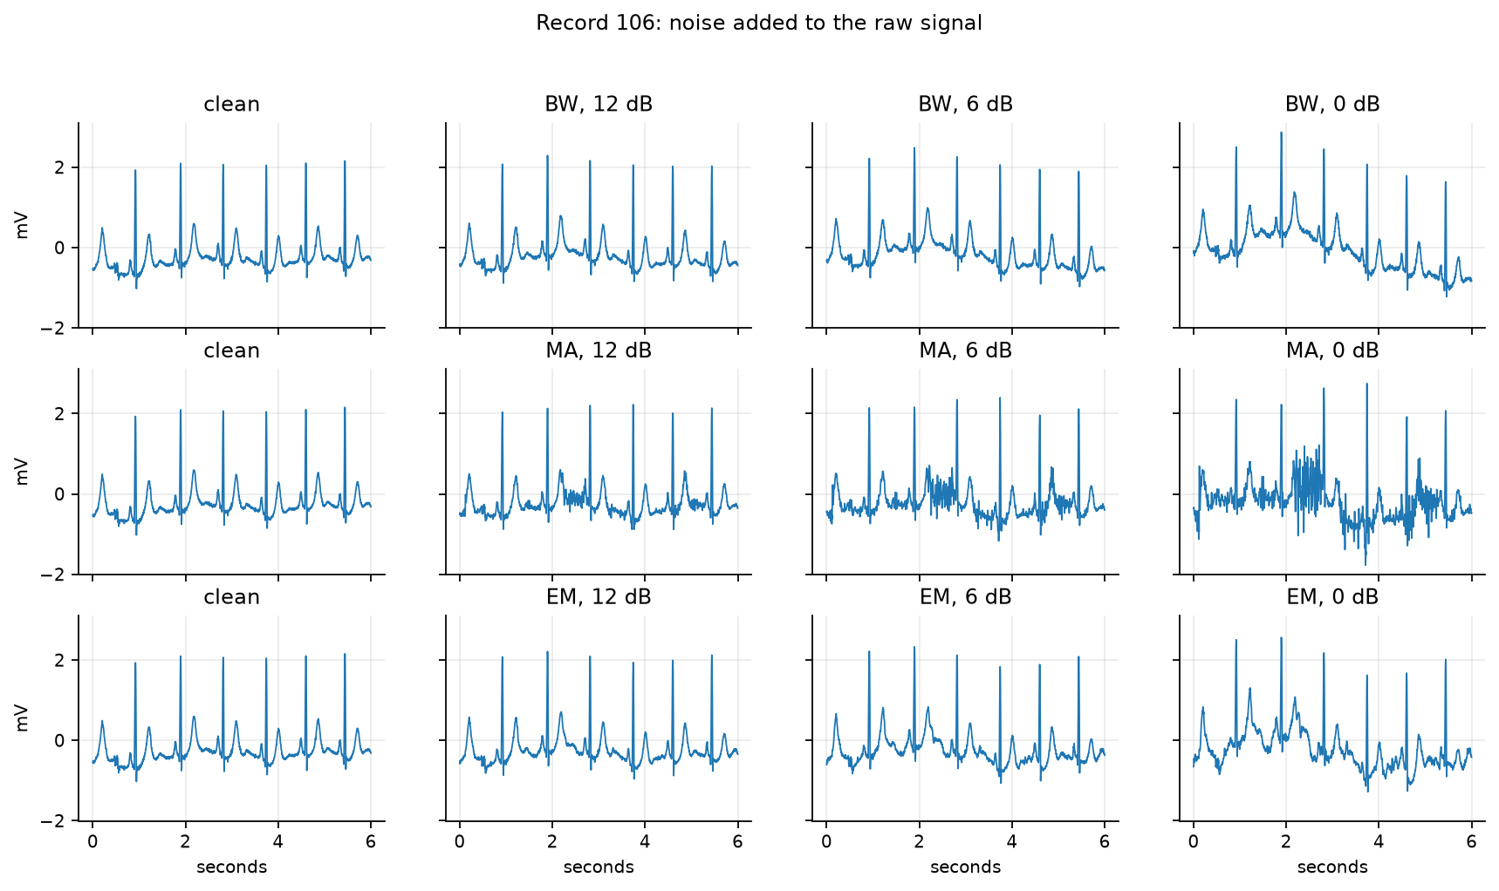
Figure 5.1. Record 106 with each noise type added at 12, 6 and 0 dB (raw 360 Hz signal, 6 s).
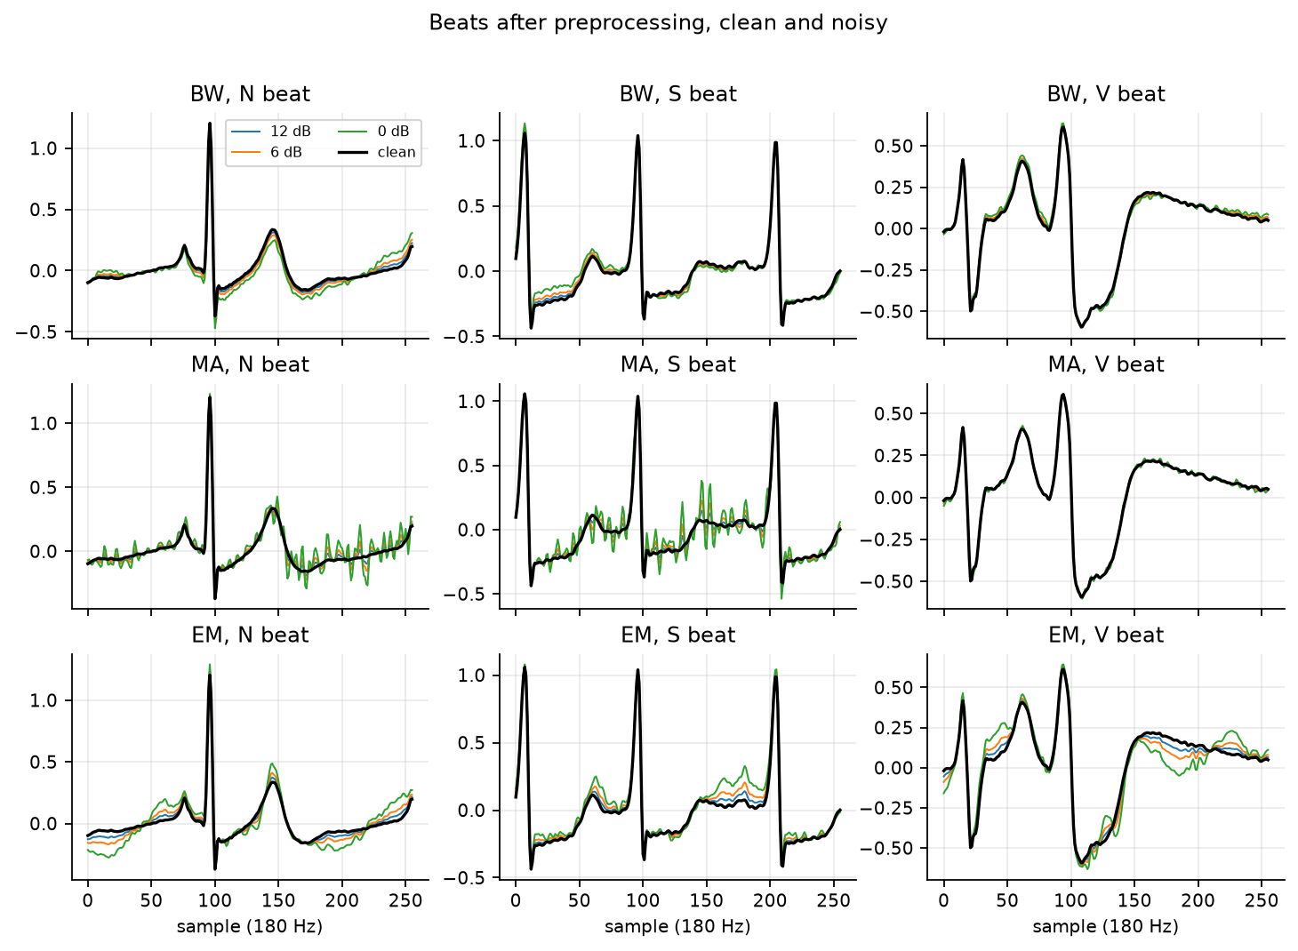
Figure 5.2. The same N, S and V beats after preprocessing, clean (black) and with each noise type at 12, 6 and 0 dB.
Results.
Table 5.2 gives the results on DS2 test set. Each value is the mean over the three noise types and the five trained models, with the standard deviation over the models.
Condition | FP32 accuracy | FP32 macro-F1 | INT8 accuracy | INT8 macro-F1
Clean | 0.863 ± 0.024 | 0.468 ± 0.027 | 0.867 ± 0.024 | 0.470 ± 0.028
12 dB | 0.860 ± 0.023 | 0.465 ± 0.026 | 0.863 ± 0.023 | 0.466 ± 0.026
6 dB | 0.851 ± 0.023 | 0.456 ± 0.024 | 0.855 ± 0.023 | 0.457 ± 0.024
0 dB | 0.837 ± 0.022 | 0.436 ± 0.020 | 0.841 ± 0.022 | 0.437 ± 0.020
Table 5.2. Noise robustness on DS2
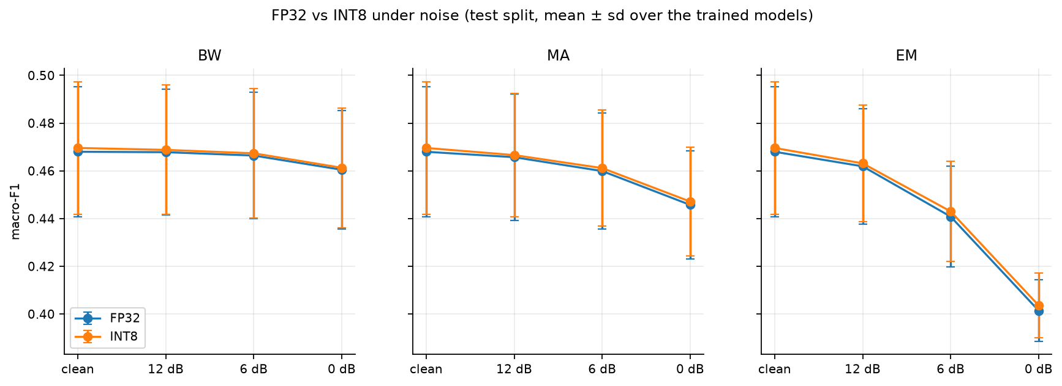
Figure 5.3. Macro-F1 against noise level on DS2 for each noise type, FP32 and INT8. Error bars are the standard deviation over the five models. The clean point is the same in all three panels.
Performance falls steadily but no condition causes a collapse. On DS2 the FP32 macro-F1 falls from 0.468 to 0.465, 0.456 and 0.436 at 12, 6 and 0 dB, so each step costs more than the one before it. At 0 dB, where the noise has as much power as the ECG, the models keep 93 % of their clean macro-F1 and 97 % of their clean accuracy.
Model | Condition | Recall N | Recall S | Recall V | Recall F
FP32 | Clean | 0.897 ± 0.026 | 0.158 ± 0.040 | 0.884 ± 0.026 | 0.107 ± 0.071
FP32 | 12 dB | 0.894 ± 0.025 | 0.157 ± 0.042 | 0.885 ± 0.023 | 0.102 ± 0.062
FP32 | 6 dB | 0.885 ± 0.025 | 0.151 ± 0.043 | 0.883 ± 0.020 | 0.095 ± 0.055
FP32 | 0 dB | 0.870 ± 0.024 | 0.136 ± 0.044 | 0.866 ± 0.018 | 0.084 ± 0.043
INT8 | Clean | 0.902 ± 0.025 | 0.155 ± 0.036 | 0.884 ± 0.024 | 0.097 ± 0.063
INT8 | 12 dB | 0.898 ± 0.025 | 0.152 ± 0.036 | 0.884 ± 0.022 | 0.093 ± 0.057
INT8 | 6 dB | 0.889 ± 0.025 | 0.147 ± 0.039 | 0.882 ± 0.019 | 0.086 ± 0.053
INT8 | 0 dB | 0.875 ± 0.024 | 0.132 ± 0.039 | 0.864 ± 0.017 | 0.077 ± 0.039
Table 5.4. Recall of each class on DS2 under noise, mean over the three noise types and the five models, ± standard deviation over the models.
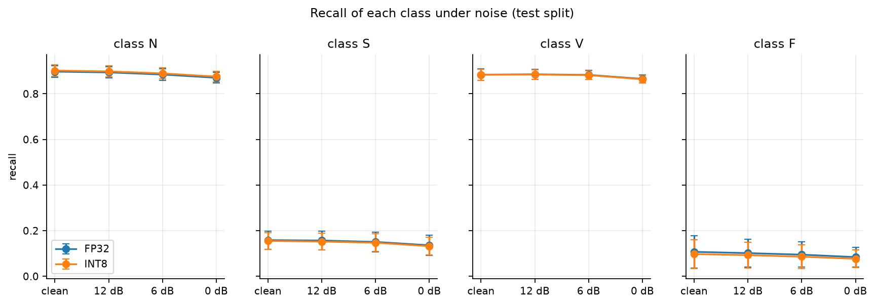
Figure 5.4. Recall of each class against noise level on DS2, FP32 and INT8, averaged over the three noise types.
The rare classes lose the largest share of their recall. On DS2 (FP32), recall of S falls from 0.158 to 0.136 (14 % lower) and recall of F from 0.107 to 0.084 (21 % lower), while recall of N falls from 0.897 to 0.870 (3 %) and recall of V from 0.884 to 0.866 (2 %). In absolute terms the four classes lose a similar two to three points, but S and F start from a recall that is already low, so noise removes a large part of what the model could detect. INT8 shows the same pattern as FP32. The INT8 copies follow the FP32 models at every noise level. The macro-F1 difference on DS2 is between +0.001 and +0.002 in all conditions, and on the validation split between −0.0002 and +0.0013. The share of beats on which INT8 and FP32 disagree grows slightly with noise on the validation split (0.27 % clean, 0.66 % at 0 dB) and hardly at all on DS2 (0.69 % to 0.77 %).
To improve robustness, a noise augmentation strategy could be applied. training on beats with noise from the first half of the NSTDB recordings at 6 to 20 dB, which is already reserved in the configuration, and repeating this test with the second half.
Overall, the model is only moderately sensitive to ECG noise. At 0 dB, where the noise has the same power as the ECG, DS2 macro-F1 fell from 0.468 to 0.436 (7 % lower) and accuracy from 0.863 to 0.837 (3 % lower); at 12 dB the loss is 0.003. The rare classes were affected most in relative terms (S recall 14 % lower and F recall 21 % lower at 0 dB), and INT8 behaved like FP32 at every level. Noise therefore sharpens an existing weakness and does not create a new one.

