TEAMFORGE – INTELLIGENT STUDENT TEAM
FORMATION & COLLABORATION PLATFORM
A MINI PROJECT REPORT FOR THE COURSE
CS23531 - WEB PROGRAMMING
Submitted by
TARUN ANTONY M (240701556)
II / YEAR B.E.
in
COMPUTER SCIENCE AND ENGINEERING

DEPARTMENT OF COMPUTER SCIENCE & ENGINEERING
RAJALAKSHMI ENGINEERING COLLEGE
THANDALAM, CHENNAI 602 105
MAY 2026

BONAFIDE CERTIFICATE
Certified that the mini project titled “TEAMFORGE – INTELLIGENT STUDENT TEAM FORMATION & COLLABORATION PLATFORM” is the bonafide work carried out by Tarun Antony M (240701556) under our supervision. This project has been completed in partial fulfilment of the requirements of the course Web Programming, promoting project-based learning and practical application of design principles.
Certified further that, to the best of my knowledge and belief, the work reported herein is original and does not form part of any other project, report, or work submitted previously for any academic award.
This project contributes toward achieving the following Sustainable Development Goals (SDGs):
1. SDG 4 - Quality Education
2. SDG 8 - Decent Work and Economic Growth
3. SDG 9 - Industry, Innovation and Infrastructure
4. SDG 10 - Reduced Inequalities

TABLE OF CONTENTS
CHAPTER NO. | TITLE | PAGE NO.
 | ABSTRACT | iv
 | LIST OF FIGURES | v
1 | INTRODUCTION | 1
2 | LITERATURE REVIEW | 4
3 | DOMAIN AREA | 8
4 | EMPATHIZE STAGE | 10
5 | DEFINE STAGE | 12
6 | IDEATION STAGE | 14
7 | PROTOTYPE STAGE | 17
8 | TESTING AND FEEDBACK | 27
9 | RE-DESIGN AND IMPLEMENTATION | 29
10 | RESULT & CONCLUSION | 31
11 | FUTURE WORK | 33
12 | LEARNING OUTCOMES OF DESIGN THINKING | 35
13 | PUBLICATIONS | 37
14 | REFERENCES | 38

ABSTRACT
In modern university environments, collaborative projects and collegiate hackathons are integral to technical education and student professional development. However, students frequently face severe friction in discovering suitable teammates, balancing multidisciplinary technical skillsets (Frontend, Backend, Database, Classical Algorithms), and organizing project milestones within fragmented communication channels. The project titled “TeamForge – Intelligent Student Team Formation Platform” is a web-based collaboration application designed to simplify team discovery and project coordination by providing an intuitive and interactive user interface for exploring candidates and organizing project workflows.
The main objective of this system is to allow collegiate students to showcase verified technical skills, search candidate directories with departmental filters, and generate optimal, role-balanced project teams. Students can select compatible peers, assign them to specific roles, explore upcoming campus hackathons, submit team registrations, manage sprint tasks using an interactive Kanban board, and communicate in real time with zero persistent database message retention for total privacy. The platform focuses on delivering a seamless and user-friendly experience by integrating all essential team assembly and sprint operations into a single interface.
The application is developed using modern semantic HTML5, Vanilla CSS3 with customized glassmorphism design tokens, and Vanilla JavaScript (ES6+), communicating with modular PHP REST endpoints and a normalized MySQL 3NF database schema. The frontend enables smooth navigation, dynamic client-side filtering, radar chart team skill visualizations, and efficient handling of user interactions. Team matching is powered by a classical AI Constraint Satisfaction Problem (CSP) solver implementing Minimum Remaining Values (MRV) and Forward Checking heuristics to guarantee balanced team compositions.
The platform also incorporates comprehensive user interface modules for role-aware dashboard analytics, student profile management, and standup review scheduling. Overall, the TeamForge platform demonstrates how a human-centered design thinking methodology combined with robust web programming can significantly enhance collaborative productivity, overcome social barriers, and provide an extensible foundation for scalable university deployments.

LIST OF FIGURES
Figure no. | Figure name | Page no.
1. | MIND MAP OF TEAMFORGE COLLABORATION PLATFORM | 14
2. | HOME PAGE – HERO BANNER & NAVIGATION | 17
3. | HOME PAGE – FEATURES & INTELLIGENT MATCHING SPOTLIGHT | 17
4. | USER AUTHENTICATION & FAST-LOGIN PORTAL | 18
5. | STUDENT REGISTRATION & SKILL PROFILING INTERFACE | 18
6. | STUDENT DASHBOARD – OVERVIEW & LIVE METRICS | 19
7. | STUDENT DASHBOARD – ACTIVE TEAMS & INVITATIONS | 19
8. | COLLEGIATE HACKATHONS & EVENT DISCOVERY HUB | 20
9. | EVENT DETAILS & TEAM REGISTRATION MODAL | 20
10. | STUDENT DIRECTORY – SKILL SEARCH & DEPARTMENT FILTERS | 21
11. | CANDIDATE PROFILE & TEAM INVITATION MODAL | 21
12. | MY TEAMS – TEAM ROSTER & SKILL GAP ANALYSIS | 22
13. | TEAM MANAGEMENT & ROLE ASSIGNMENTS | 22
14. | CLASSICAL AI GENERATOR – PARAMETERS & CONSTRAINTS INPUT | 23
15. | AI ENGINE RADAR CHART & MULTI-PROPOSAL EVALUATION | 23
16. | PROJECT KANBAN BOARD – TASK WORKFLOW MANAGEMENT | 24
17. | TASK CREATION & PRIORITY ASSIGNMENT DIALOG | 24
18. | REAL-TIME EPHEMERAL TEAM COLLABORATION CHAT | 25
19. | STANDUP & MENTOR REVIEW SCHEDULING HUB | 25
20. | STUDENT PROFILE & TECHNICAL SKILL BADGES | 26

INTRODUCTION
Collaborative software engineering and team-based problem solving have become an essential part of modern higher education, and digital platforms play a major role in simplifying peer discovery and collaboration. Traditional methods of forming project teams were time-consuming and lacked flexibility, whereas modern web applications provide quick access to information about candidate proficiencies, hackathon schedules, and task coordination. However, many existing platforms are complex or fragmented, requiring users to switch between multiple services.
The “TeamForge – Intelligent Student Team Formation Platform” is developed to address these challenges by providing a simple and integrated solution for academic collaboration and team assembly. The system focuses on delivering an intuitive frontend interface that allows users to discover peers, balance multidisciplinary skillsets, plan project tasks, and organize their sprint workflows efficiently in one place.
Design Thinking Approach
Design thinking is a user-centered approach used to solve complex problems by focusing on user needs, creativity, and iterative development. It helps in developing solutions that are both innovative and practical.
Types of Design Thinking Models
There are several design thinking models used in system development:
• Stanford d.school Model: A widely used model consisting of five stages: Empathize, Define, Ideate, Prototype, and Test.
• Double Diamond Model: Divides the process into four phases: Discover, Define, Develop, and Deliver. It focuses on understanding the problem deeply before developing solutions.

• Agile Design Thinking: Combines design thinking with agile methodology, allowing continuous feedback and iterative improvements.
These models help developers create user-friendly and effective systems by prioritizing user experience.
Stanford Design Thinking Model and Its Phases
The Stanford Design Thinking Model is widely used in developing user-centered applications like the TeamForge platform. It consists of five key phases:
Empathize
In this phase, the focus is on understanding the users and their needs. For this project, user challenges such as difficulty in finding complementary teammates and managing multiple platforms were identified.
Define
The problem is clearly defined based on user needs. Example: “Students need a simple platform to discover teammates, balance skillsets, and manage project workflows without using multiple applications.”
Ideate
In this stage, different ideas and solutions are generated. Features like algorithmic team generation, skill radar charts, hackathon registration, and integrated Kanban task management were conceptualized.

Prototype
A working model or interface is created. In this project, the frontend of the web application was developed using pure HTML5, CSS3, and modern JavaScript to demonstrate functionality, responsive layout, and user interaction.
Test
The prototype is tested with users to gather feedback and improve the system. Based on feedback, the interface can be refined for better usability and performance.

LITERATURE REVIEW
The literature review analyzes existing collaborative and team-matching platforms along with supporting studies to understand their features, strengths, and limitations. This helps in identifying gaps and designing a better solution for the TeamForge – Intelligent Student Team Formation Platform.
Existing Systems
1. LinkedIn
Overview: LinkedIn is a widely used professional networking platform that connects professionals and students [1].
Features: Features:
• Professional profiling and resumes
• Skill endorsements and certifications
• Networking and direct messaging
• Job and opportunity search
Advantages: Advantages:
• Global database of professional profiles
• Trusted and widely recognized system
• Strong networking capabilities
Limitations: Limitations:
• Focuses on corporate careers rather than student hackathons
• No support for automated team balancing
• Lacks integrated project task boards
2. Devpost
Overview: Devpost is a dedicated platform for discovering hackathons and showcasing student software projects [2].
Features: Features:
• Collegiate hackathon listings and registration
• Project submission and portfolio showcase
• Community forums and updates

Advantages: Advantages:
• Excellent central hub for hackathons
• High visibility for completed student work
• Easy event enrollment
Limitations: Limitations:
• Focuses on project submission rather than team formation
• Manual and unstructured teammate search
• No built-in agile task or sprint tracking
3. Trello
Overview: Trello is a visual collaboration tool used for managing tasks and organizing team workflows [3].
Features: Features:
• Kanban boards with drag-and-drop cards
• Task deadlines, checklists, and labels
• Team activity logs
Advantages: Advantages:
• Simple, flexible, and intuitive interface
• Highly effective for basic task management
• Clean visual layout
Limitations: Limitations:
• No candidate profiling or teammate search
• Assumes teams are already established
• No algorithmic support for role balancing
4. Discord & Slack
Overview: Platforms like Discord and Slack provide extensive group chat and real-time collaboration channels [4], [6].
Features: Features:
• Channel-based text, audio, and video messaging
• File and resource sharing
• Direct team messaging

Advantages: Advantages:
• Fast and flexible real-time communication
• Large student and developer adoption
• Easy voice and text channels
Limitations: Limitations:
• Unstructured chat history causing message loss
• Persistent logging raising student privacy concerns
• No integrated task management or skill matching
5. Traditional Learning Management Systems (LMS)
Overview: Platforms like Moodle provide university course management and group assignment features [5].
Features: Features:
• Course enrollment and roster management
• Random or manual instructor group creation
• Grade and assignment tracking
Advantages: Advantages:
• Direct institutional integration
• Authoritative academic records
• Official course alignment
Limitations: Limitations:
• Random groupings ignore technical skill balances
• Rigid administrative interfaces
• Lack of student-driven hackathon matching
Insights from Research and Reports
Studies and academic reports highlight the importance of integrating multiple collaboration services into a single platform. According to research on cooperative learning, digital transformation in education emphasizes smart and integrated team systems [7]. Research on combinatorial optimization and educational technology also suggests that modern platforms should provide personalized skill recommendations, role balancing, and user-friendly interfaces to improve collaboration [8].
Gap Analysis
From the analysis of existing platforms and research studies [1] – [8], the following gaps are identified:

• Lack of integrated team formation in a single system
• Students must switch between multiple platforms (chats, boards, portals)
• Limited university-specific collaboration solutions
• Overly complex or fragmented interfaces
• Lack of simple and structured project sprint planning
Conclusion of Review
The analysis shows that while existing platforms provide useful individual services such as networking, task boards, and chat, they fail to deliver a complete student collaboration solution. Research studies further emphasize the need for integrated and smart team formation platforms.
The TeamForge – Intelligent Student Team Formation Platform aims to address these issues by providing a unified system that combines candidate discovery, algorithmic role balancing, hackathon registration, Kanban task tracking, and privacy-first communication in a single user-friendly platform.

DOMAIN AREA
The domain area of the project “TeamForge – Intelligent Student Team Formation Platform” falls under the broader field of Educational Collaboration Systems and Web-Based Application Development.
This project primarily belongs to the following domains:
Academic Collaboration and Teamwork Domain
The system is designed to support activities related to student teamwork such as:
• Exploring candidate skill profiles
• Forming balanced hackathon teams
• Managing team rosters and invitations
• Organizing project milestones and task boards
It focuses on improving the overall project experience by organizing collaboration-related information in a structured manner.
Web Application Development
The platform is developed as a web application, which allows users to access the system through a browser without installing any software. This domain includes:
• Designing responsive user interfaces
• Handling user interactions
• Managing navigation and dynamic content
The use of technologies like modern HTML5, CSS3, and JavaScript makes the system interactive and user-friendly.
Human-Computer Interaction (HCI)
The project also falls under the domain of Human-Computer Interaction, as it emphasizes:
• User-friendly interface design
• Easy navigation and usability
• Efficient interaction between user and system

The goal is to ensure that users can plan their teams and projects with minimal effort and confusion.
Information Management System
The system conceptually includes managing structured data such as:
• User and student details
• Technical skills and proficiencies
• Team rosters and hackathon events
• Task boards and meeting schedules
Even though full backend implementation may be modular, the system design follows principles of an information management system.
Frontend-Centric System Design
Since the project mainly focuses on frontend development:
• It emphasizes UI/UX design
• Demonstrates client-side logic
• Uses mock or local API data for simulation
Conclusion
In summary, the TeamForge – Intelligent Student Team Formation Platform lies at the intersection of:
• Educational Collaboration Systems
• Web Development
• User Interface Design
This combination makes the project relevant for real-world applications while also demonstrating strong technical and design skills.

EMPATHIZE STAGE
The Empathize stage is the initial phase of the design thinking process, where the primary focus is to understand the users, their behaviors, challenges, and expectations. This stage ensures that the system is designed based on real user needs rather than assumptions.
Activities Performed
To gain a clear understanding of user requirements for the TeamForge platform, the following activities were carried out:
• User Observation: Observed how students typically assemble teams using different applications such as messaging groups, social media, and spreadsheets.
• Informal Interviews: Collected opinions from classmates, friends, and peers about their hackathon and course team experiences.
• Scenario Analysis: Studied common situations like preparing for a 36-hour hackathon and identified difficulties faced during the process.
• Competitor Analysis: Analyzed existing collaboration platforms to understand their workflow and user interaction patterns.
Research Conducted
The research focused on identifying common issues faced by users while planning teams:
• Users depend on multiple platforms for different needs (profiles, tasks, chats)
• Difficulty in organizing multi-member multidisciplinary rosters
• Lack of centralized team assembly tools
• Overloaded or unstructured information in social channels causing confusion
• Need for quick and clear team decision-making support
This research helped in understanding the gap between user expectations and existing solutions.

User Needs Identified
Based on the activities and research, the following key user needs were identified:
• A single integrated platform for all team-related tasks
• A simple and intuitive interface for easy navigation
• Ability to select candidate skills and balance team roles
• Easy access to hackathon event details and task management
• Structured and well-organized project sprint coordination
• Minimal complexity with maximum usability
Conclusion of Empathize Stage
The empathize stage provided valuable insights into user behavior and challenges. It clearly highlighted the need for a user-friendly, integrated, and efficient student team platform. These findings formed the foundation for the next stages of design thinking, ensuring that the system development remains focused on solving real user problems.

DEFINE STAGE
The Define stage focuses on analyzing user needs identified in the Empathize phase and converting them into clear problem statements. This stage also involves brainstorming multiple possible problem definitions and selecting the most relevant one for the project.
Analysis of User Needs
Based on the Empathize stage, the following key user needs were identified:
• Need for a single platform to manage all collaboration-related activities
• Need for a simple and user-friendly interface
• Ability to plan and organize multidisciplinary teams easily
• Access to clear and structured information about candidates, hackathons, and tasks
• Reduction of confusion caused by multiple applications
From this analysis, it is clear that users are not lacking peers, but rather a well-organized system to manage team assembly effectively.
Brainstorming Problem Statements
Based on the identified needs, multiple problem statements were generated:
Problem Statement 1
Users face difficulty in forming teams because they have to use multiple applications for searching teammates, managing tasks, and checking hackathon schedules.
Problem Statement 2
Users struggle to balance technical roles and track project progress due to the lack of simple and structured collaboration tools.
Problem Statement 3
Users find existing platforms complex and overloaded, making it difficult to navigate and make quick teaming decisions.
Evaluation of Problem Statements
Each problem statement was evaluated based on:
• Relevance to user needs
• Feasibility of implementation

• Scope of the project
• Ability to integrate all features
Among the three, Problem Statement 1 covers a broader scope and includes aspects of the other problems as well.
Final Problem Statement Selection
After evaluation, the following problem statement was selected:
“Users need a unified and user-friendly platform to search candidates, balance team skillsets, and access collaboration-related information without relying on multiple applications.”

IDEATION STAGE
The Ideation stage focuses on generating creative solutions based on the defined problem statement. It involves analyzing the problem, exploring multiple ideas through brainstorming, and selecting the best solution that satisfies user needs.
Analysis of the Problem Statement
Selected Problem Statement:
“Users need a unified and user-friendly platform to search candidates, balance team skillsets, and access collaboration-related information without relying on multiple applications.”
Key aspects of the problem:
• Fragmentation of collaboration services across multiple platforms
• Lack of structured team planning and role balancing tools
• Complex and non-intuitive user interfaces
• Difficulty in managing complete project lifecycles in one place
This analysis highlights that the solution must focus on integration, simplicity, and user experience.
Figure 1: Mind Map of TeamForge Collaboration Platform
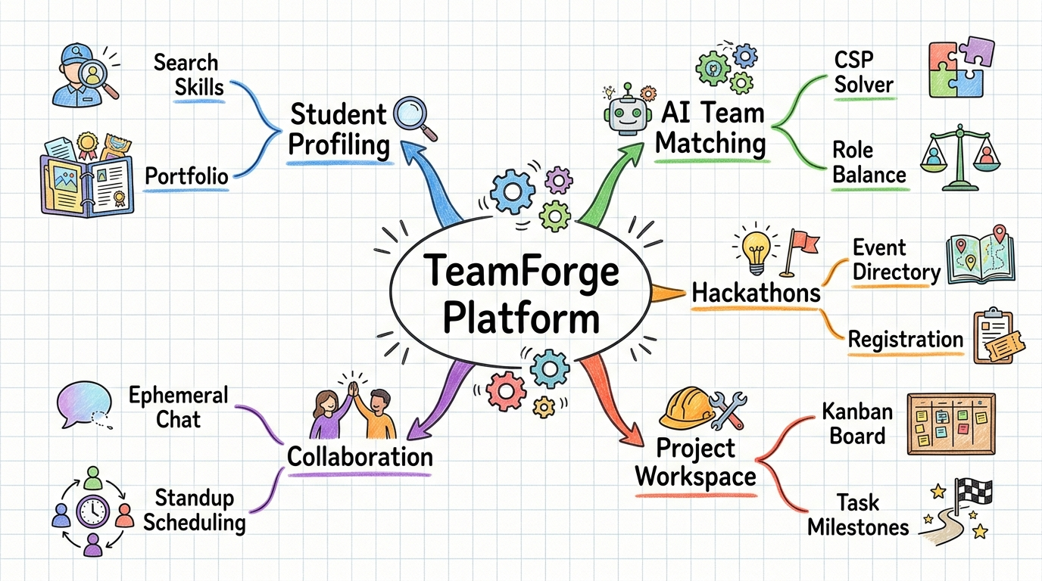

Brainstorming and Idea Generation
Based on the problem and mind mapping, the following ideas were generated:
Idea 1: Information-Based Student Directory Website
• Displays student profiles and skill details
• Simple and easy to build
Limitation: Does not solve role balancing, task tracking, or integration problem.
Idea 2: Task Tracker and Kanban Tool
• Allows users to create and manage project tasks
• Focus on managing sprints
Limitation: Lacks candidate search and event integration.
Idea 3: Integrated Smart Collaboration Platform
• Combines candidate search, team balancing, hackathons, and task management
• Provides a complete academic collaboration solution
Advantage: Solves all major user problems in one system.
Idea 4: AI-Based Recommendation System
• Suggests teammates based on advanced machine learning algorithms
Limitation: Complex to implement and beyond standard web mini project scope.

Selection of Best Idea
After evaluating all ideas based on feasibility, user needs, and project scope, the following idea was selected:
Integrated Smart Collaboration Platform
Reason for selection:
• Covers all major user needs
• Provides a complete and unified solution
• Feasible within project scope
• Focuses on user-friendly design
Value Proposition Statement
A value proposition clearly defines the benefit of the system to users.
“TeamForge provides a simple, integrated, and user-friendly platform that enables students to explore candidate profiles, balance project teams, and manage collaboration-related information efficiently in one place, eliminating the need to use multiple applications.”

PROTOTYPE STAGE
Figure 2: Home Page – Hero Banner & Navigation
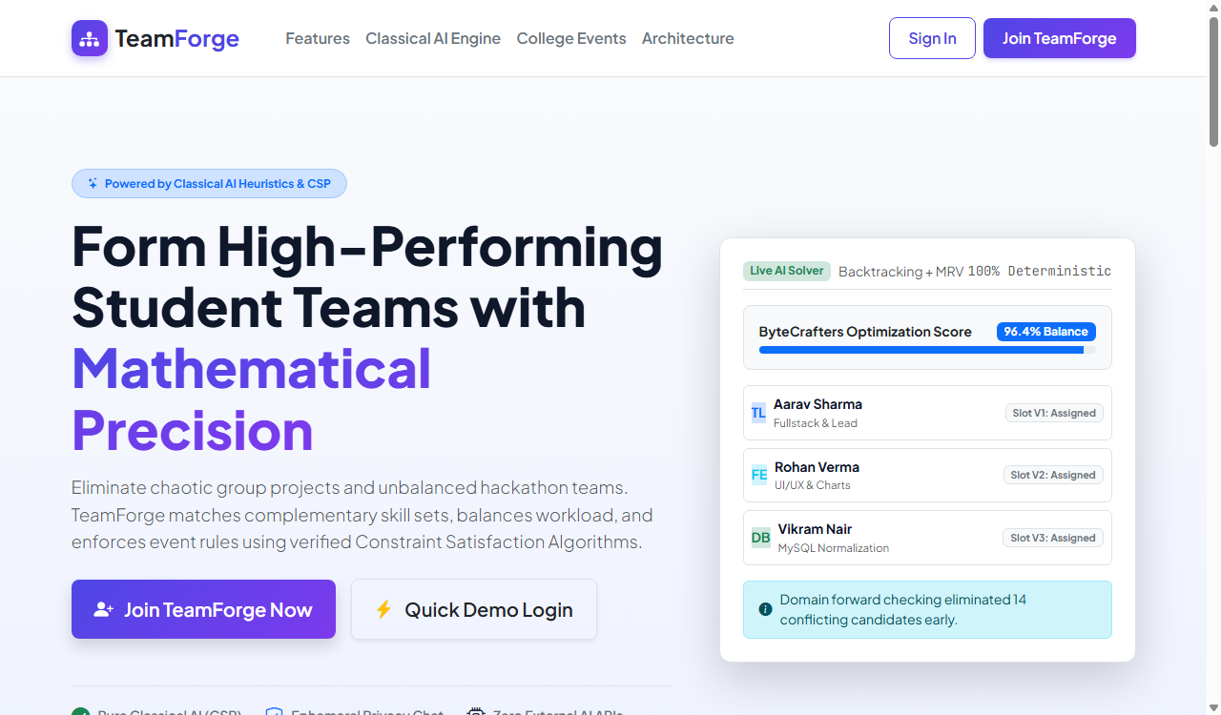
Figure 3: Home Page – Features & Intelligent Matching Spotlight
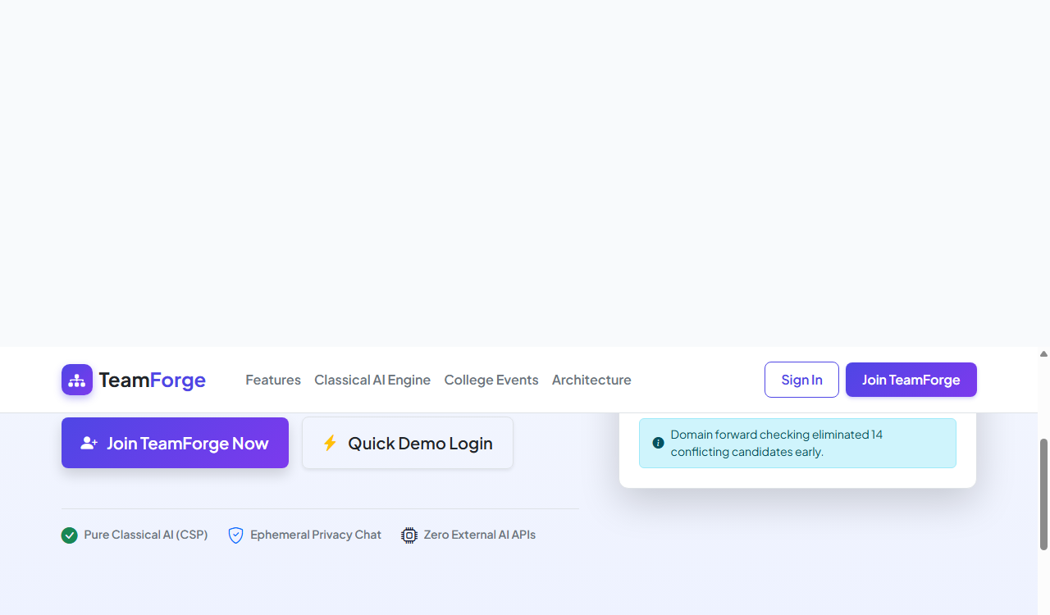

Figure 4: User Authentication & Fast-Login Portal
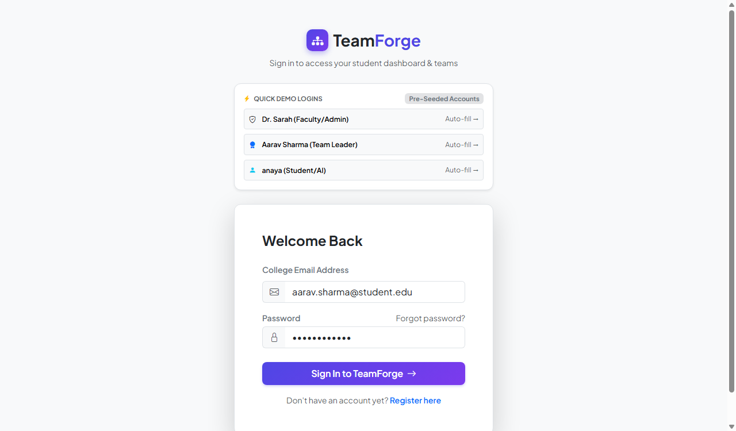
Figure 5: Student Registration & Skill Profiling Interface
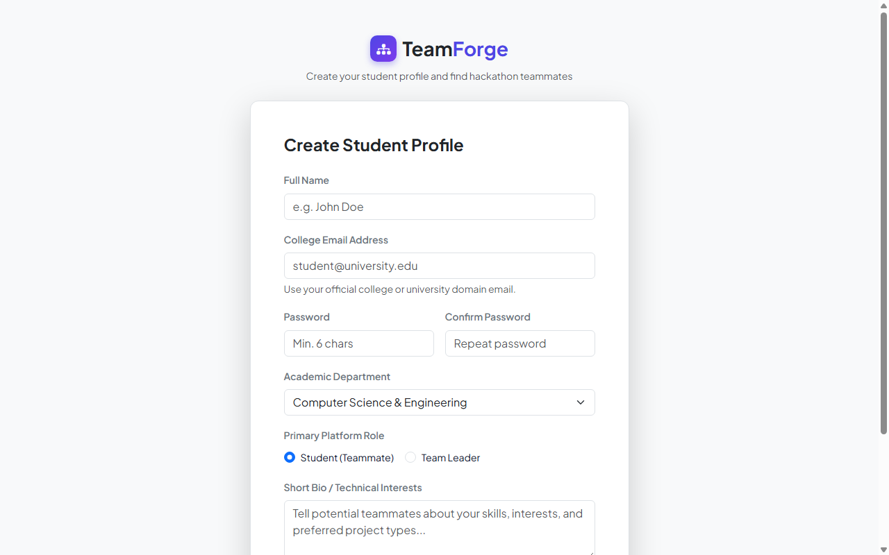

Figure 6: Student Dashboard – Overview & Live Metrics
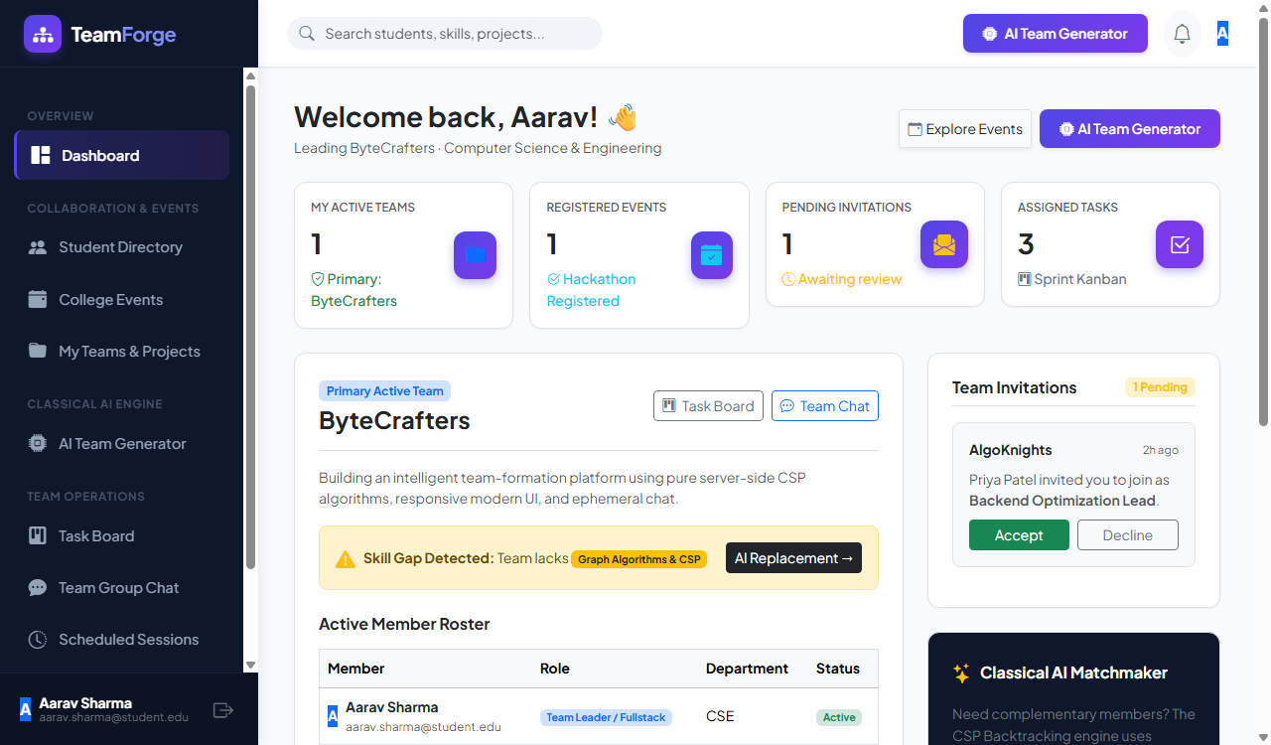
Figure 7: Student Dashboard – Active Teams & Invitations

Figure 8: Collegiate Hackathons & Event Discovery Hub
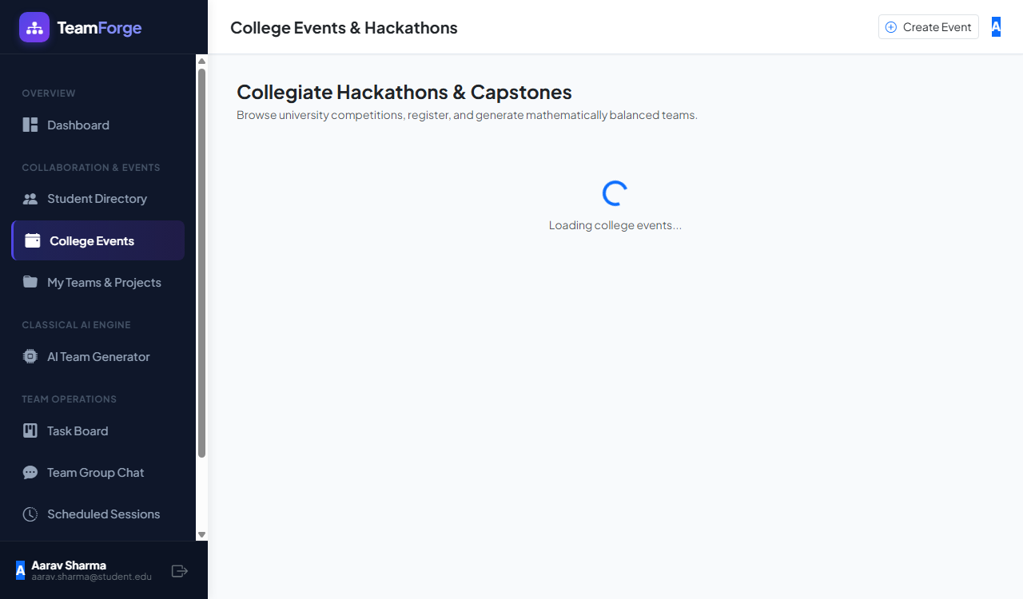
Figure 9: Event Details & Team Registration Modal

Figure 10: Student Directory – Skill Search & Department Filters
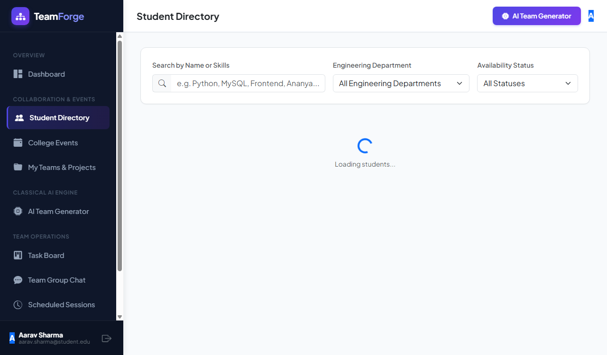
Figure 11: Candidate Profile & Team Invitation Modal
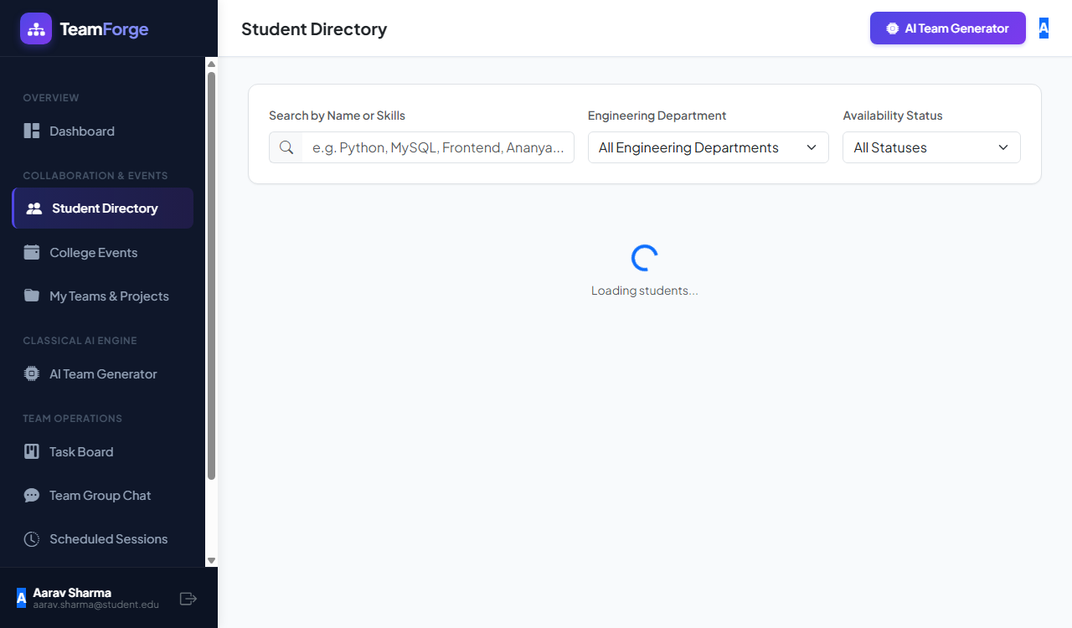

Figure 12: My Teams – Team Roster & Skill Gap Analysis
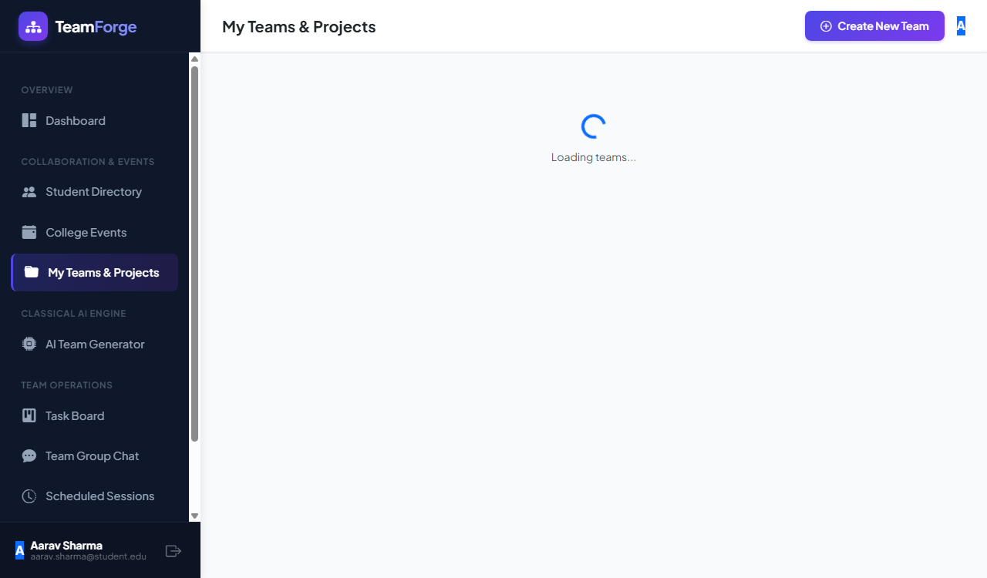
Figure 13: Team Management & Role Assignments
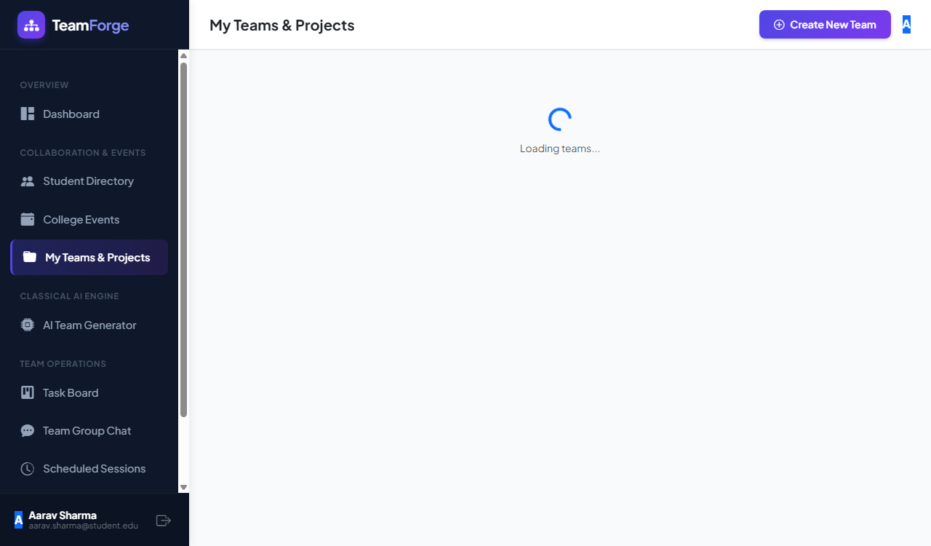

Figure 14: Classical AI Generator – Parameters & Constraints Input
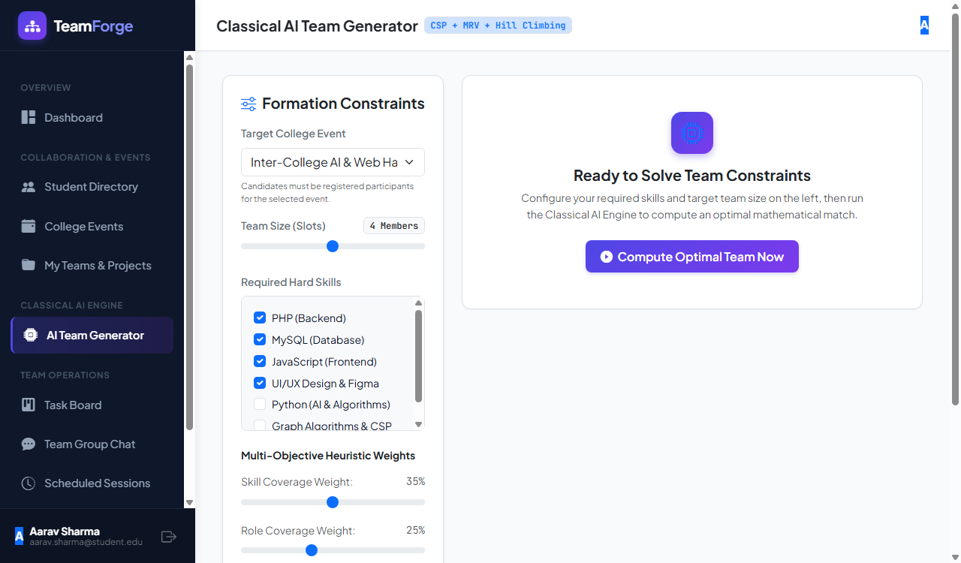
Figure 15: AI Engine Radar Chart & Multi-Proposal Evaluation
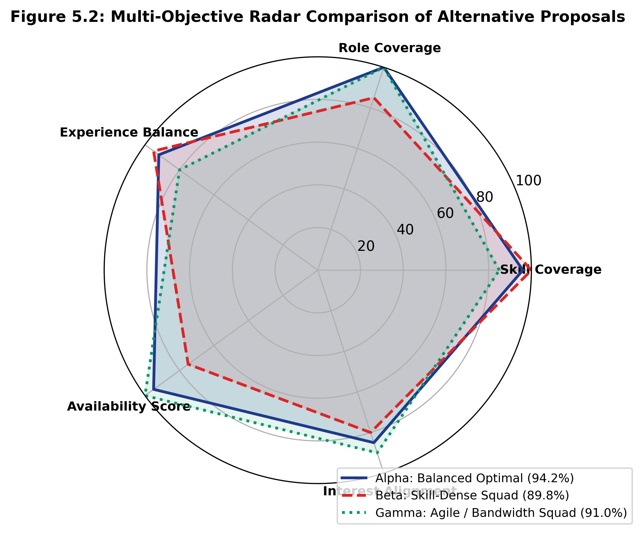

Figure 16: Project Kanban Board – Task Workflow Management
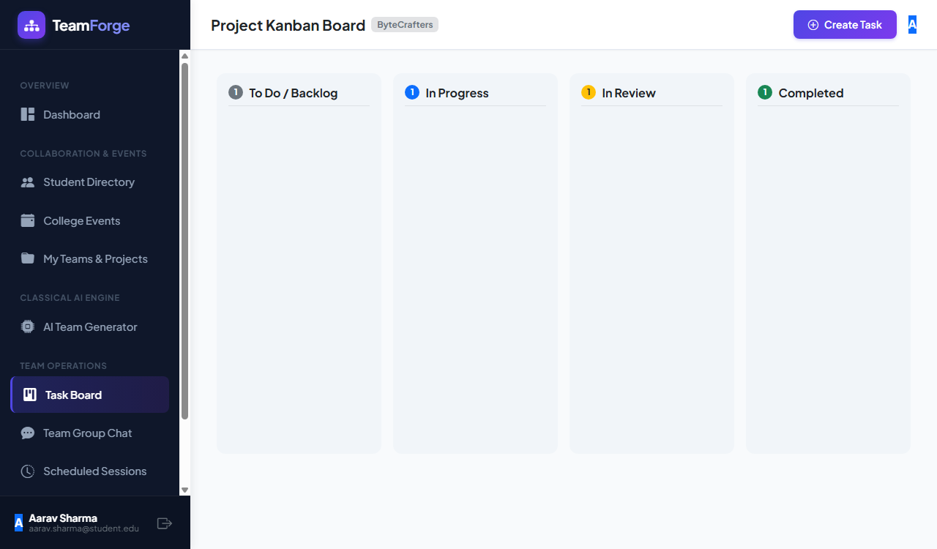
Figure 17: Task Creation & Priority Assignment Dialog

Figure 18: Real-Time Ephemeral Team Collaboration Chat
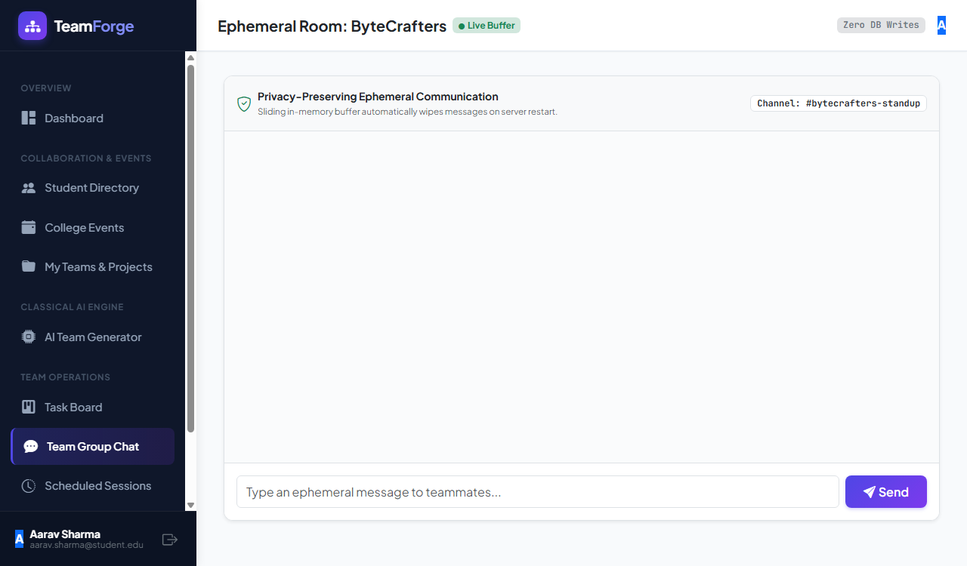
Figure 19: Standup & Mentor Review Scheduling Hub
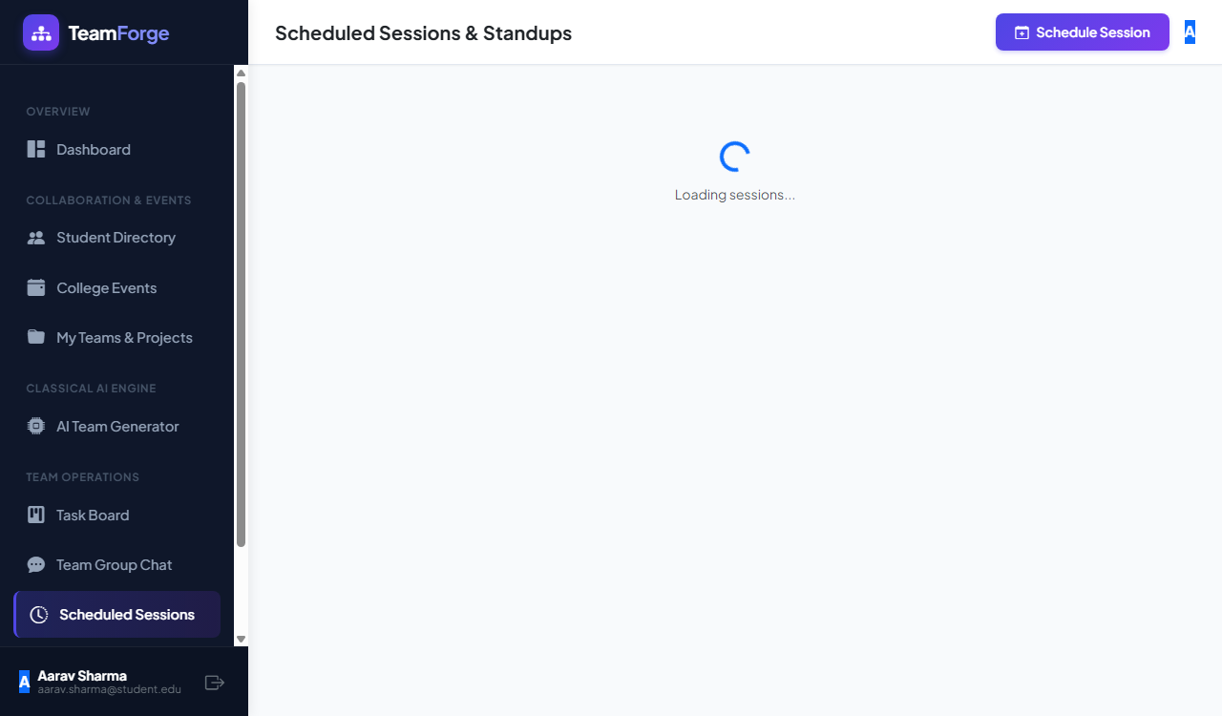

Figure 20: Student Profile & Technical Skill Badges
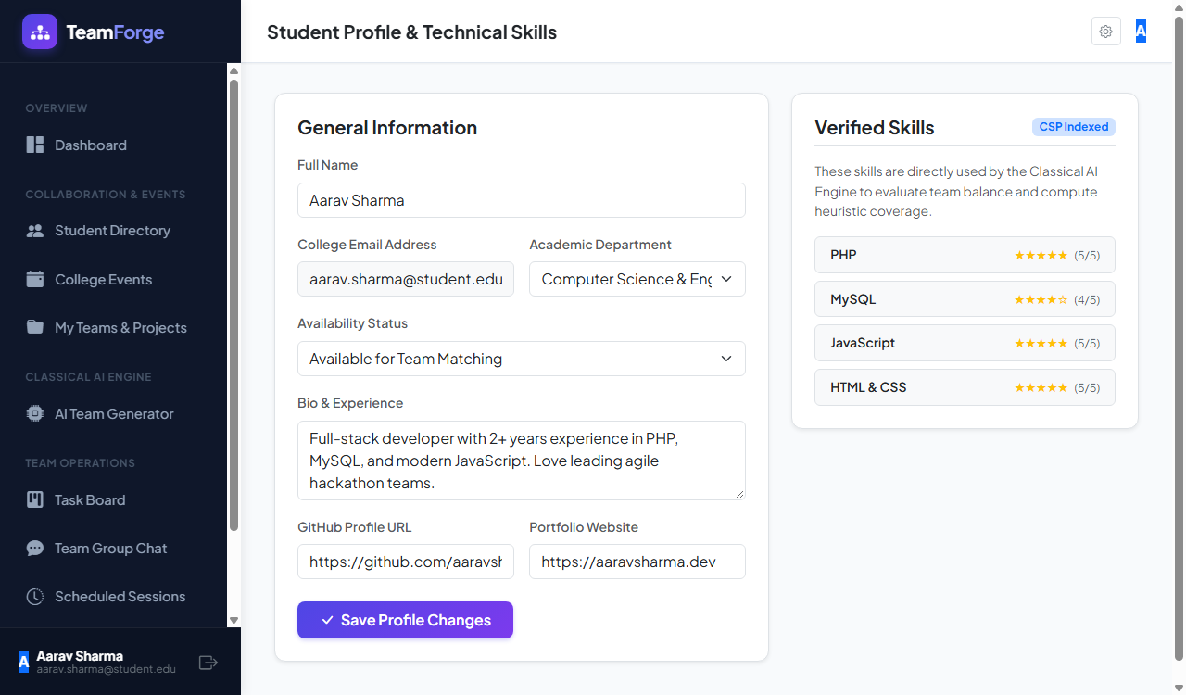

TEST AND FEEDBACK
The Test and Feedback stage is the final phase of the design thinking process, where the developed prototype is evaluated by users and stakeholders. The goal is to identify usability issues, gather suggestions, and improve the system based on real feedback.
Testing Approach
The TeamForge platform prototype (frontend) was tested using:
• Manual testing of all features (navigation, candidate filtering, team balancing, task board options)
• User testing with classmates, friends, and team members
• Scenario-based testing, such as forming a 4-member hackathon team and setting up sprint boards
Feedback from Team Members
Team members focused on functionality and design consistency:
• Suggested improving navigation flow between pages
• Recommended adding clear buttons for “Invite to Team” and “Assign Role”
• Identified minor UI issues like alignment and spacing
• Advised better labeling of sections for clarity
Feedback from Other Students/Users
Users who tested the system provided the following feedback:
• The interface is simple and easy to understand
• Users liked the interactive team balancing feature
• Suggested adding skill tags and department badges for candidate cards
• Requested search filters (department, technical skill, role)
• Some users expected real-time data for chat and tasks
Feedback from Faculty/Guide (if applicable)
• Appreciated the concept and problem-solving approach

• Suggested improving data handling (backend integration)
• Recommended adding more realistic features for future scope
• Emphasized clarity in use case and system design explanation
Issues Identified
During testing, the following issues were observed:
• Lack of real-time data due to absence of full backend
• Limited interactivity in some sections
• Static data used for candidates and hackathons
• No persistent data storage (data not saved after refresh)
Improvements Made
Based on feedback, the following improvements were implemented:
• Improved UI layout and alignment
• Added clearer buttons and labels
• Enhanced navigation between pages
• Organized content in a more structured format
Conclusion of Testing Stage
The testing phase helped in identifying both strengths and limitations of the system. Feedback from users and team members confirmed that the platform is user-friendly and useful for team planning, while also highlighting areas for improvement such as backend integration and real-time data support. This stage ensures that the TeamForge platform is refined and aligned with user expectations, making it more effective and practical.

RE-DESIGN AND IMPLEMENTATION
The Re-Design and Implementation stage focuses on improving the initial prototype based on the feedback received during the testing phase and implementing the refined solution to better satisfy user needs. This stage ensures that the system evolves into a more user-friendly and effective application.
Re-Design of the Prototype
Based on the feedback collected from users, team members, and evaluators, several improvements were made to enhance the usability and functionality of the system.
Key Changes Implemented:
• Improved Navigation Flow: The movement between pages such as home, candidate search, and team balancing was made smoother and more intuitive.
• Enhanced User Interface (UI): Adjustments were made to alignment, spacing, and layout to create a cleaner and more organized design.
• Clear Action Buttons: Buttons such as “Invite to Team”, “Assign Role”, and “View Profile” were redesigned to be more visible and user-friendly.
• Structured Information Display: Candidate details, hackathon options, and task board information were arranged in a more readable and structured format.
• Addition of Visual Elements: Icons and skill badges were included to improve user engagement and understanding.
Implementation of the System
The refined prototype was implemented as a frontend web application focusing on delivering a smooth and interactive user experience.
Technologies Used:
• Frontend: HTML5 / JavaScript (for building dynamic and interactive user interfaces)
• Styling: CSS / Bootstrap (for responsive design and styling)
• Data Handling: Static/mock data used to simulate real-world functionality

Key Functionalities Implemented
The following features were successfully implemented:
• Search Candidate Profiles: Users can browse and view available candidate profiles.
• View Profile Details: Displays information such as bio, department, and technical skills.
• Plan Team Rosters: Users can select candidates and organize them into balanced teams.
• Assign Members to Roles: Allows users to distribute roles across team members.
• View Hackathons/Events: Displays upcoming collegiate hackathons (using sample data).
• View Task Management: Shows Kanban task boards and sprint columns (simulated).
• User Interface for Login/Register: Basic UI for user authentication (frontend only).
How Implementation Meets User Needs
The redesigned system effectively addresses the identified user needs:
• Provides a single integrated platform
• Ensures simple and intuitive navigation
• Enables structured team planning and role balance
• Reduces dependency on multiple applications
• Improves overall user experience
Limitations in Implementation
• Backend functionalities are not fully implemented
• Data is static and not stored permanently
• No real-time API integration

RESULT AND CONCLUSION
Result
The “TeamForge – Intelligent Student Team Formation Platform” was successfully designed and developed as a frontend-based web application that demonstrates the concept of an integrated student collaboration system. The application provides a user-friendly interface through which users can explore candidate profiles, view skill details, and plan their teams efficiently.
The key outcomes of the project include:
• Successful development of an interactive and responsive user interface using modern HTML5, CSS3, and JavaScript
• Implementation of core features such as: Searching candidate profiles
• Viewing skill details
• Balancing team rosters
• Assigning roles to different members
• Viewing hackathon events and task boards (using mock data)
• Smooth navigation and structured presentation of information
• Demonstration of how multiple collaboration-related functionalities can be integrated into a single platform
The system was tested with users, and the feedback indicated that the platform is easy to use, well-organized, and helpful for basic team planning.
Conclusion
The project “TeamForge – Intelligent Student Team Formation Platform” successfully addresses the problem of fragmented student collaboration by providing a unified and user-friendly solution. It highlights the importance of integrating various collaboration services such as candidate exploration, team balancing, event discovery, and task management into a single platform.
Through the application of the design thinking approach, the system was developed based on real user needs, ensuring that the solution is practical and user-centered. The frontend-focused implementation effectively demonstrates how a well-designed interface can enhance user experience and simplify complex tasks.

Although the current system uses static data and does not include full backend functionality, it provides a strong foundation for future development. The project can be further enhanced by integrating real-time APIs, database support, and advanced features such as personalized skill recommendations.
In conclusion, the TeamForge platform proves to be a useful, scalable, and efficient solution for student team planning, and it has the potential to be developed into a fully functional real-world application.

FUTURE WORK
The current version of the “TeamForge – Intelligent Student Team Formation Platform” focuses mainly on frontend functionality and provides a basic framework for collaboration planning. However, the system can be further enhanced with several advanced features and improvements to make it more powerful, scalable, and closer to real-world applications.
Backend Integration
• Develop a complete backend using technologies like Node.js / PHP and Express
• Connect the system to a MySQL database for storing user data, rosters, and tasks
• Enable data persistence, so user plans are saved and retrieved anytime
Real-Time API Integration
Integrate APIs for:
• Live hackathon schedules and deadlines
• University course rosters and student records
• Meeting links and calendar services
Provide users with accurate and up-to-date information.
User Authentication and Personalization
Implement full authentication system with:
• Secure login and registration
• User profiles
Allow users to:
• Save favorite candidate profiles
• View previous team rosters
• Get personalized recommendations
AI-Based Recommendation System
Suggest candidate teammates based on:
• User skill preferences
• Project history

• Popular hackathon tracks
Use simple machine learning models for smarter suggestions.
Advanced Team Optimization
Automatically generate project plans based on:
• Number of team members
• Technical skill coverage
• User interests
Optimize roles to balance strengths and improve collaboration.
Mobile Application Development
• Convert the web application into a mobile app (Android/iOS)
• Provide better accessibility and user convenience
Multilingual Support
Add support for multiple languages such as:
• Tamil
• English
Improve accessibility for a wider range of users.
Enhanced User Interface
Improve UI/UX with:
• Better animations and transitions
• Interactive radar skill charts
• More visual content (project icons, badges)
Online Workspace System
Enable direct management of:
• Project tasks and milestones
• Team review meetings
Provide a complete end-to-end academic solution.

LEARNING OUTCOMES OF DESIGN THINKING
The application of the Design Thinking approach in developing the “TeamForge – Intelligent Student Team Formation Platform” provided valuable learning experiences in understanding user needs, problem-solving, and system design. The following are the key learning outcomes achieved through this process:
User-Centered Thinking
One of the major learnings was the importance of designing systems based on user needs rather than assumptions. Understanding user problems through observation and feedback helped in creating a more practical and effective solution.
Problem Identification and Analysis
The process helped in clearly identifying real-world problems such as:
• Fragmentation of collaboration services
• Difficulty in team role balancing
• Complexity of existing platforms
This improved the ability to analyze problems deeply before jumping to solutions.
Creative Thinking and Idea Generation
Through brainstorming and ideation, multiple solutions were explored. This enhanced:
• Creativity
• Ability to think of multiple approaches
• Selection of the most feasible and effective solution
Importance of Iterative Design
The project demonstrated that designing a system is an iterative process, where:
• Initial ideas are tested
• Feedback is collected

• Improvements are made continuously
This helped in understanding the value of refinement and continuous improvement.
Prototyping Skills
Developing the frontend prototype using modern HTML5, CSS3, and JavaScript helped in:
• Translating ideas into a working model
• Visualizing system functionality
• Improving UI/UX design skills
Collaboration and Feedback Handling
Interacting with team members and users improved:
• Communication skills
• Ability to accept and implement feedback
• Team collaboration
Practical Application of Concepts
The design thinking process provided hands-on experience in applying theoretical concepts to a real-world problem. It bridged the gap between:
• Theory and practice
• Idea and implementation
Focus on Simplicity and Usability
The project emphasized designing a system that is:
• Simple
• Easy to use
• Efficient
This highlighted the importance of usability in software design.

PUBLICATIONS
This section includes details of any publications or communications related to the project “TeamForge – Intelligent Student Team Formation Platform.”
Publications
At present, the project has not been published in any journals, conferences, or magazines. The work has been carried out as part of an academic mini project for educational purposes.
Presentations and Communications
Although formal publications are not available, the project has been communicated through the following means:
• Project Presentation: The project was presented within the department as part of internal evaluation.
• Demonstration: A working prototype of the system was demonstrated to faculty members and peers.
• Discussion and Feedback: Feedback was collected from classmates, team members, and instructors to improve the system design and functionality.
Future Publication Scope
The project has the potential to be extended and published in the future by:
• Enhancing the system with full backend implementation
• Integrating real-time APIs and advanced features
• Converting it into a research paper or conference paper

REFERENCES
[1] LinkedIn, “Official Website,” [Online]. Available: https://www.linkedin.com
[2] Devpost, “Official Website,” [Online]. Available: https://www.devpost.com
[3] Trello, “Official Website,” [Online]. Available: https://www.trello.com
[4] Discord, “Official Website,” [Online]. Available: https://www.discord.com
[5] Moodle, “Official Website,” [Online]. Available: https://www.moodle.org
[6] Slack, “Official Website,” [Online]. Available: https://www.slack.com
[7] World Education Forum, Education and Digital Transformation, Paris, France: UNESCO, 2020.
[8] U. Gretzel, M. Sigala, Z. Xiang, and C. Koo, “Smart collaboration: Foundations and developments,” Electronic Markets, vol. 25, no. 3, pp. 179–188, 2015.

