**Embedded Prograaming Assignment**

**Processor : ESP32**

**Pin Layout**

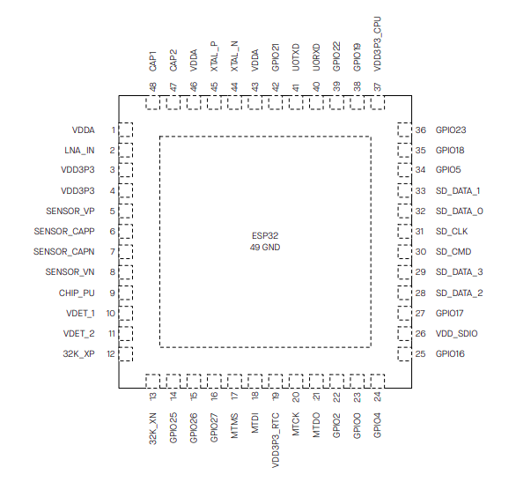

**Features**

### **Dual-Core Processor**

* Dual-core 32-bit: The ESP32 has a dual-core architecture, with two Tensilica Xtensa LX6 microprocessor cores running at up to 240 MHz.
* Multi-threading: It supports multi-threading, enabling efficient execution of multiple tasks simultaneously.

### **Wi-Fi and Bluetooth Connectivity**

* Wi-Fi: The ESP32 supports 802.11 b/g/n Wi-Fi standards with a wide range of features, such as:
  + WPA/WPA2 security
  + SoftAP mode (Access Point)
  + Station mode
* Bluetooth: It supports both Bluetooth Classic and Bluetooth Low Energy (BLE), making it suitable for Bluetooth communication as well as IoT devices.

### **Low Power Consumption**

* The ESP32 offers several low-power modes, including deep sleep and light sleep, to extend battery life for portable and battery-operated devices.
* It can achieve low standby power consumption with its Ultra-Low Power (ULP) co-processor, which allows certain tasks to continue even in deep sleep mode.

### **Multiple GPIOs (General Purpose Input/Output)**

* 34 GPIO pins (depending on the specific model) are available, capable of functioning as digital input/output, analog inputs, PWM, and more.
* Many pins are configurable for specialized tasks such as SPI, UART, I2C, etc.

### **High-Resolution ADC (Analog-to-Digital Converter)**

* 12-bit ADC resolution (some models support 8-bit and 10-bit as well) with up to 18 channels for reading analog sensors.
* Internal temperature sensor for measuring temperature in certain models.
* DAC (Digital-to-Analog Converter) for generating analog signals.

### **Integrated Peripherals**

* SPI (Serial Peripheral Interface): Supports communication with SPI devices.
* I2C (Inter-Integrated Circuit): Enables easy connection with sensors, displays, and other devices.
* UART (Universal Asynchronous Receiver-Transmitter): For serial communication with other devices.
* PWM (Pulse Width Modulation): For controlling motors, LED brightness, etc.
* I2S (Inter-IC Sound): For audio applications like microphones and speakers.
* CAN: Controller Area Network interface for automotive or industrial applications.

### **Security Features**

* Secure Boot: Ensures that only authorized firmware is executed.
* Flash Encryption: Protects sensitive data stored in the flash memory.
* Cryptographic Hardware Acceleration: Includes hardware support for encryption algorithms such as AES, SHA, and RSA, to enhance security in IoT applications.

### **Flash Memory and RAM**

* The ESP32 typically comes with 4MB of Flash memory (but can vary depending on the specific model) and up to 520KB of SRAM for program execution and data storage.

### **Integrated Wi-Fi/Bluetooth Antennas**

* Integrated antennas for both Wi-Fi and Bluetooth communication.
* External antenna support: Some versions of the ESP32 support an external antenna through an external connector.

### **Real-Time Clock (RTC)**

* The ESP32 includes an RTC (Real-Time Clock), which allows accurate timekeeping and scheduling even during low-power states.

### **Peripheral Interface (SD Card, SPI Flash)**

* Supports connecting to an SD card for file storage, commonly used for logging data or saving configuration files.
* The SPI flash interface allows communication with external flash memory, typically used for program storage and data.

### **Integrated Hall Sensor**

* The ESP32 has an integrated hall effect sensor, which can be used for detecting magnetic fields.

### **Ethernet (Optional)**

* Some variants of the ESP32 offer Ethernet connectivity through an external PHY (Physical Layer) module, making it suitable for wired applications.

### **Hardware PWM**

* Up to 16 channels of PWM can be used for controlling motors, LEDs, and other actuators.

### **FreeRTOS Support**

* ESP32 uses FreeRTOS, an open-source real-time operating system, providing multitasking support and better scheduling for time-sensitive tasks.

### **Development Platform Support**

* Arduino IDE: The ESP32 can be programmed using the popular Arduino IDE, with the help of the ESP32 core.
* PlatformIO: Another popular platform for ESP32 development, providing a more professional IDE and additional tools.
* Espressif IDE: ESP32 is supported natively by the Espressif IDF (Espressif Development Framework), which allows for advanced features and optimizations.
* MicroPython: The ESP32 also supports MicroPython, a lightweight Python interpreter designed for microcontrollers.

### **Multiple I/O Voltage Support**

* The ESP32 operates with a 3.3V logic level, but it can communicate with 5V logic devices with proper level shifting.

### **Operating Temperature Range**

* The ESP32 can operate within a wide temperature range (usually from -40°C to +125°C for industrial versions).

### **Easy Connectivity to Cloud Services**

* With built-in Wi-Fi and Bluetooth support, the ESP32 can connect to various cloud services such as AWS IoT, Google Firebase, ThingSpeak, etc.

**Applications**

With low power consumption, ESP32 is an ideal choice for IoT devices in the following areas:

• Smart Home

• Industrial Automation

• Health Care

• Consumer Electronics

• Smart Agriculture

• POS machines

• Service robot

• Audio Devices

• Generic Low-power IoT Sensor Hubs

• Generic Low-power IoT Data Loggers

• Cameras for Video Streaming

• Speech Recognition

• Image Recognition

• SDIO Wi-Fi + Bluetooth Networking Card

• Touch and Proximity Sensing