Tạ Thanh Vũ
ITITIU21352
Task 1:
Output:
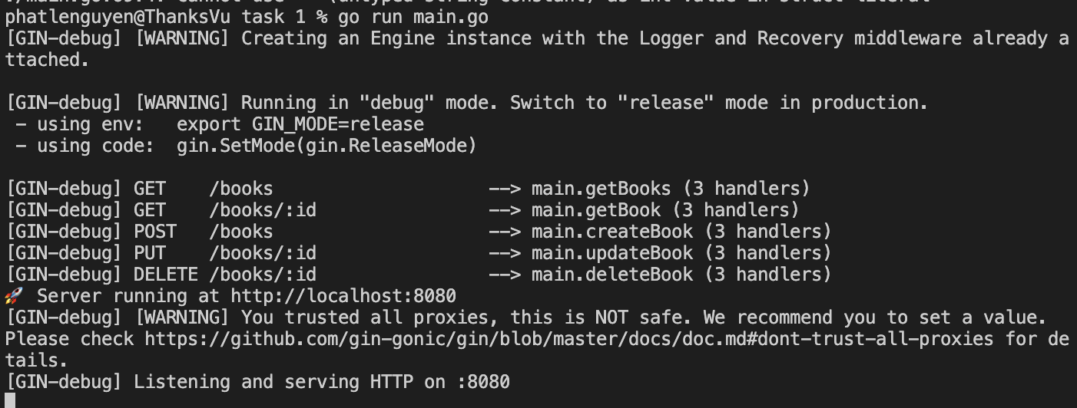
Task 2:
Output:
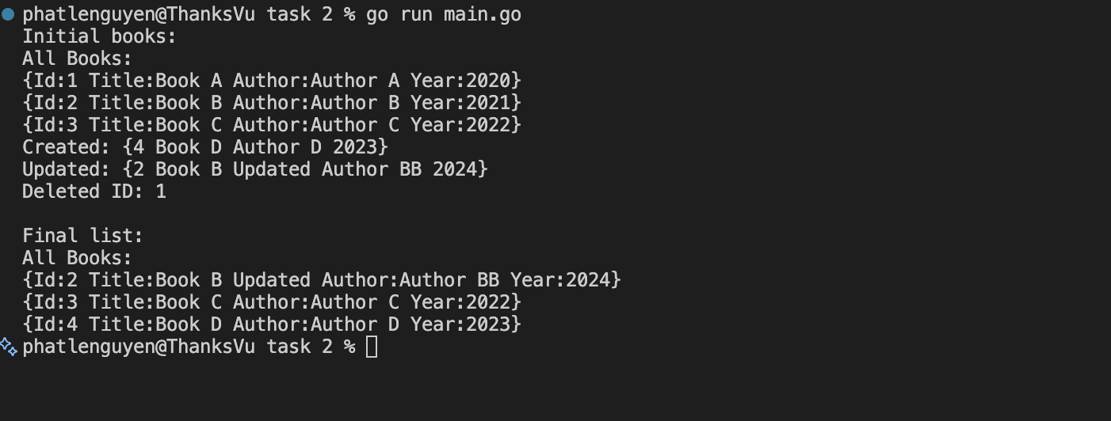

Task 3:
Output:
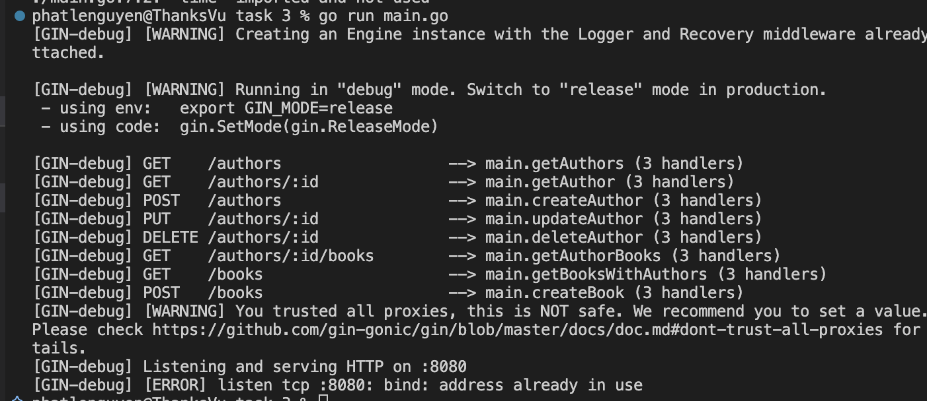
Task 4:
Output:
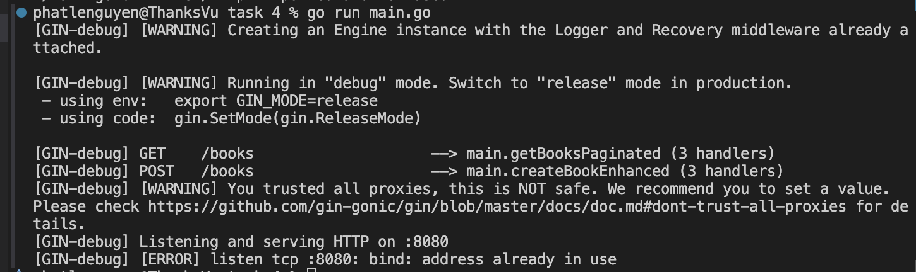

Task 5:
Output:
