Tạ Thanh Vũ - ITITIU21352
Lab 7 – Net Centric

Task 3:
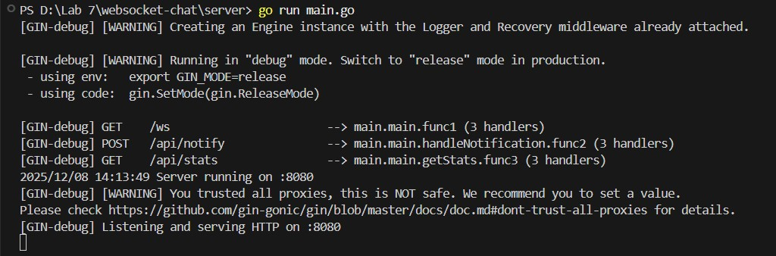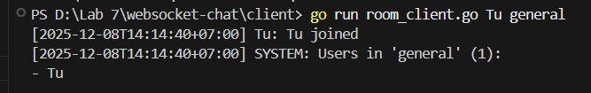
Create a username in a general room. (Tu)
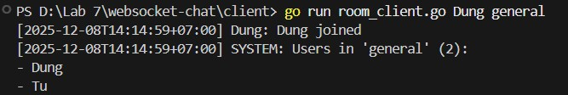
Dung is a second username that has joined the general room. (Dung)
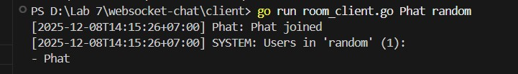
Create a new username randomly. This username is not in the general room, and it cannot see any messages from the room.
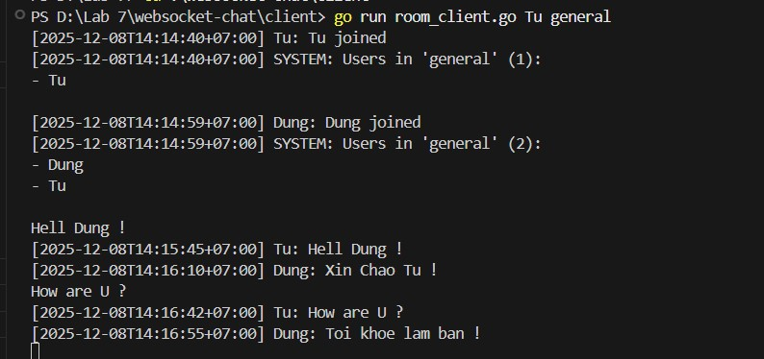
This is the communication between Tu and Dung. (This picture from the terminal of Tu)
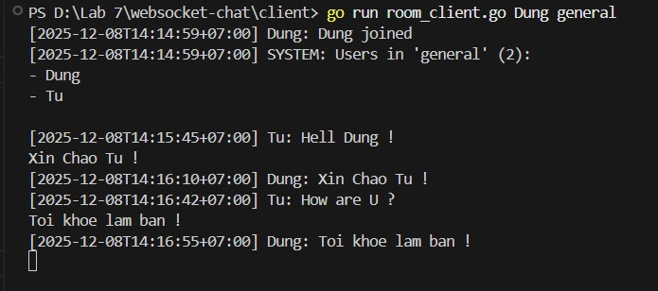
(This picture from the terminal of Dung)
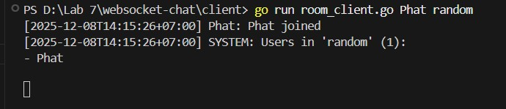
The user(Phat) cannot receive any messages, because he is not in the general room.
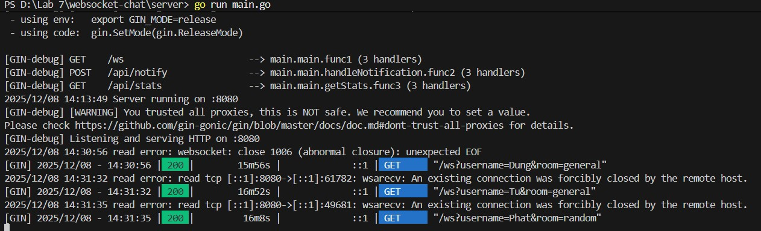
Task 4:
Check that users are attending the room.
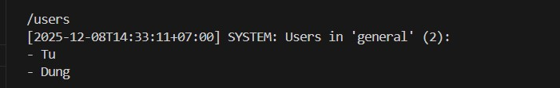
Tu’s check.
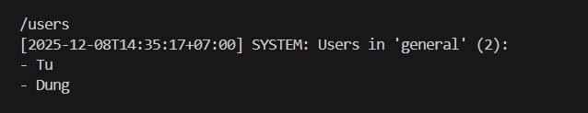
Dung’s check.
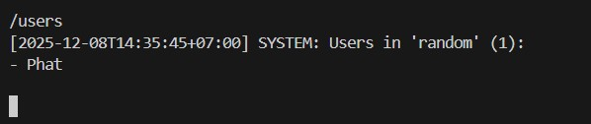
Phat’s check. Only one username is Phat, because in the random room, just has himself.

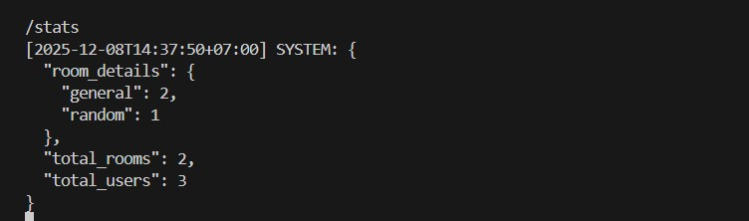
Check how many users and rooms.
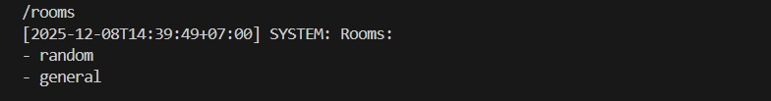
Check rooms, and we received that we have 2 rooms.
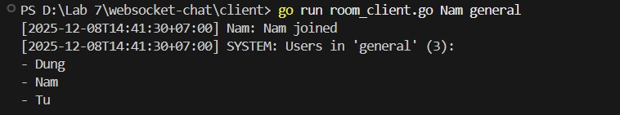
We can see that Nam has joined the general room.
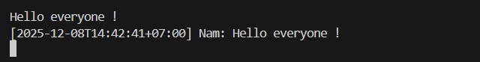
He sent a message.

After Dung’s terminal stop, it will show “Dung left.” And in the room, only Nam and Tu.

Task 5:
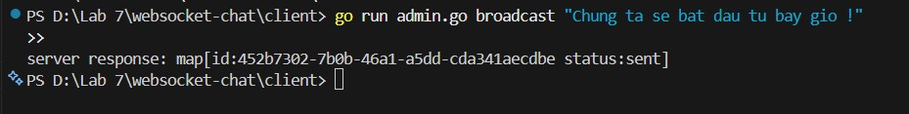
Admin sent a message “ Chung ta se bat dau tu bay gio !”.
And everyone in the server will receive this announcement.
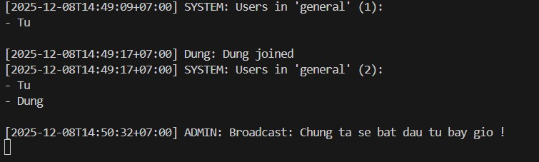
Tu received.
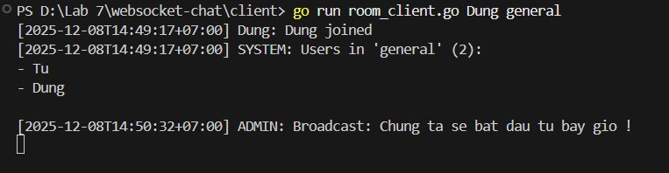
Dung received.
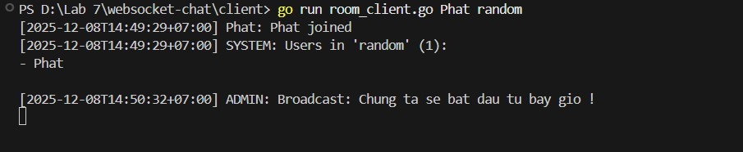
Phat received, too.

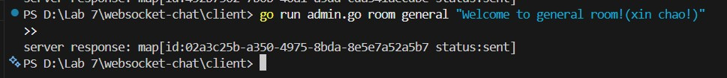
Admin sent a message to the general room. And only Dung and Tu will receive it.
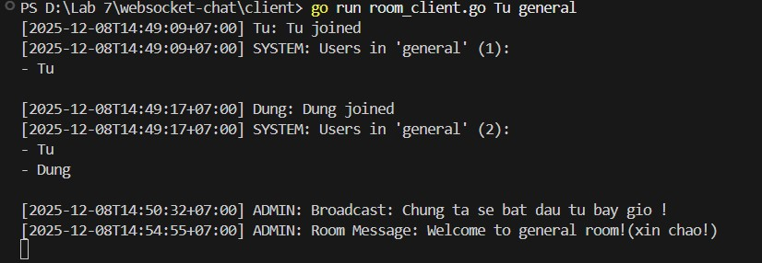
Tu received.
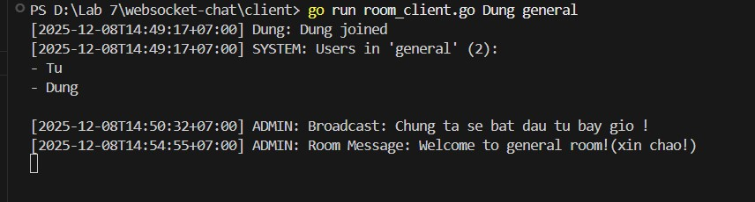
Dung received.
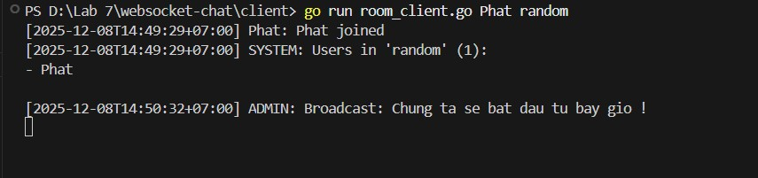
Phat cannot receive because he is not in the general room.
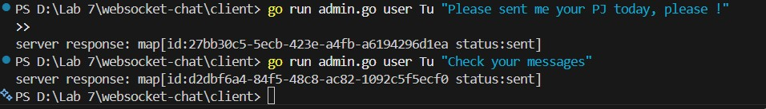
Admin sent a message to Tu, and only Tu can receive this message.
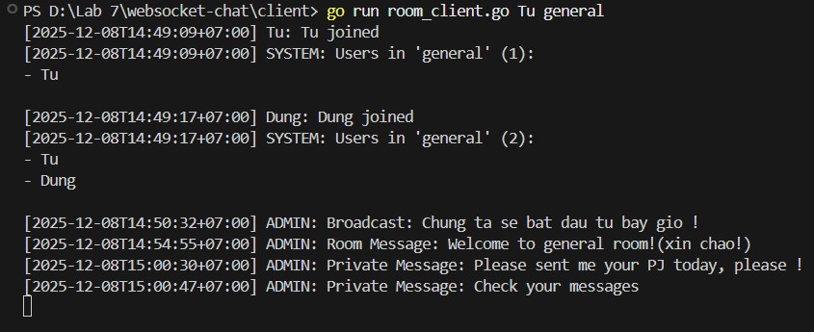
Tu received.

Admin sent an announcement to everyone.
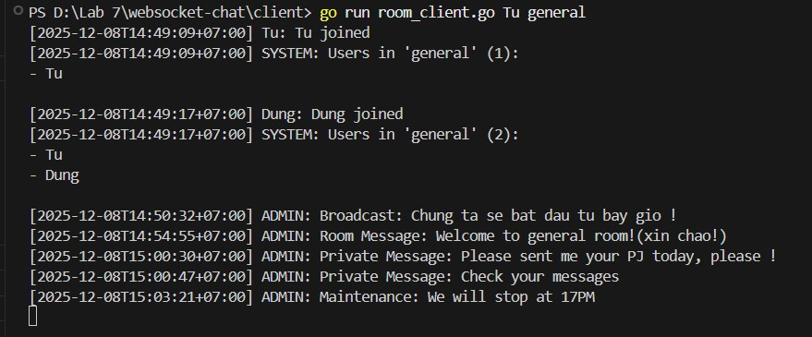
Tu received.
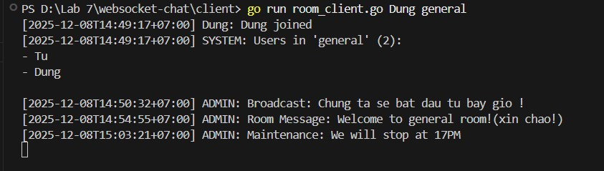
Dung received.
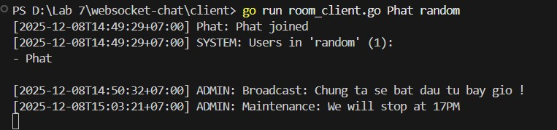
Phat also received.

