* Implement the Web Scrapping to get the data set

1. <https://books.toscrape.com/catalogue/category/books/travel_2/index.html>

Book Classification Model – category Identification and Searching product price prediction

**PROGRAM:**

import requests  
from bs4 import BeautifulSoup  
import csv  
import os  
import subprocess  
  
response = requests.get('https://books.toscrape.com/catalogue/category/books/travel_2/index.html')  
soup = BeautifulSoup(response.text, 'html.parser')  
  
title = soup.find('title')  
course_name = title.get_text().strip().split('|')[0].strip()  
file_name = 'C:\\Users\\ALEKHYA\\Documents\\travel.csv'  
  
with open(file_name, mode='w', newline='', encoding='utf-8') as file:  
 writer = csv.writer(file)  
 writer.writerow(['Book Name', 'Rating', 'Price'])  
  
 travel_books = soup.find_all('article', attrs={'class': 'product_pod'})  
 print(f"Total books found: {len(travel_books)}")  
  
 for book in travel_books:  
 travel_book_name = book.find('h3').get_text().strip()  
 rates = {'One': 1, 'Two': 2, 'Three': 3, 'Four': 4, 'Five': 5}  
 travel_book_rating = rates[book.find('p', attrs={'class': 'star-rating'}).get('class')[1]]  
 travel_book_price = book.find('div', attrs={'class': 'product_price'}).find('p', {'class': "price_color"})  
 travel_book_price = float(travel_book_price.get_text().split('Â£')[1])  
  
 writer.writerow([travel_book_name, travel_book_rating, travel_book_price])  
  
if os.name == 'nt':  
 os.startfile(file_name)  
elif os.name == 'posix':  
 try:  
 subprocess.call(['open', file_name])  
 except FileNotFoundError:  
 subprocess.call(['xdg-open', file_name])

**OUTPUT:**

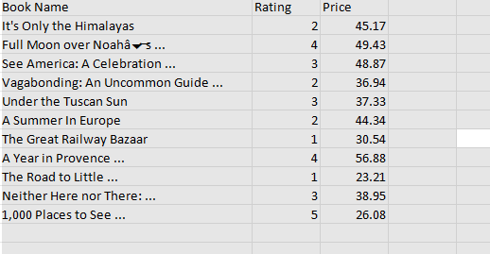

* Implement EDA In PowerBI / Tubulae

1. <https://www.kitapyurdu.com/>

House price prediction

**OUTPUT:**

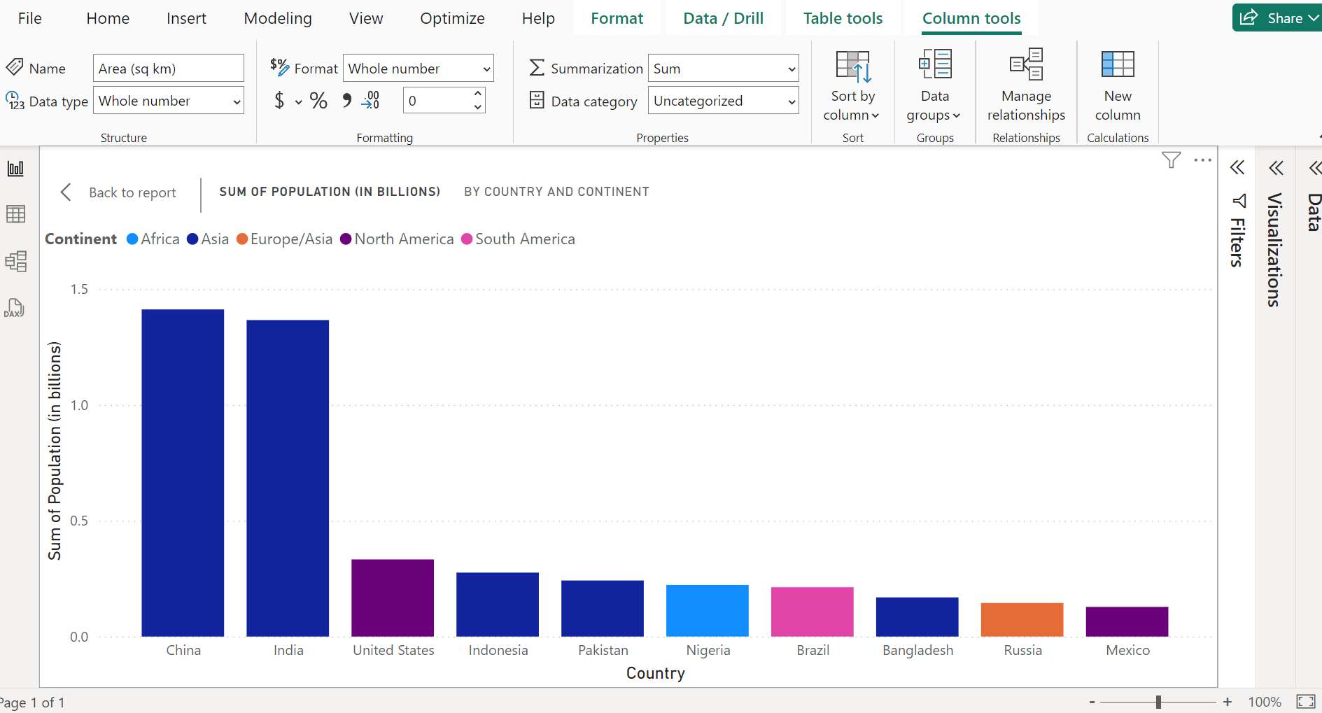

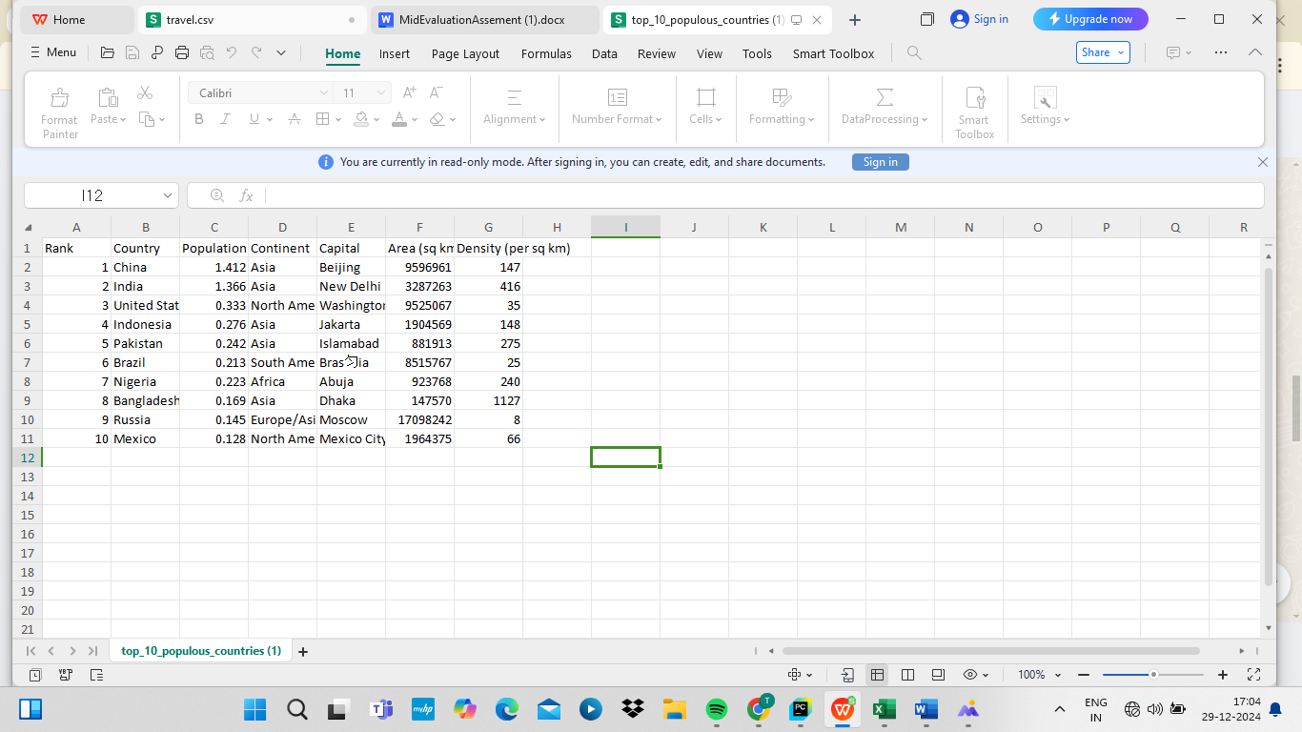

* Implement All the method of Data analysis and Machine Learning for 2 Model compare the best model for the data set ( Dat Loading, Data printing, Data Preprocessing and Data cleaning, Data Visualization, Model Initialization, Model training, Model Evaluation)

1. <https://www.netflix.com/in/title/80057281>

Netflix Movie Data set classification

**PROGRAM:**

import pandas as pd

import numpy as np

import matplotlib.pyplot as plt

import seaborn as sns

from sklearn.model_selection import train_test_split

from sklearn.preprocessing import StandardScaler, LabelEncoder

from sklearn.linear_model import LogisticRegression

from sklearn.ensemble import RandomForestClassifier

from sklearn.svm import SVC

from sklearn.metrics import accuracy_score, classification_report, confusion_matrix

# Step 1: Data Loading

df = pd.read_csv('your_dataset.csv') # Replace with your dataset path

# Step 2: Data Printing

print(df.head())

print(df.info())

# Step 3: Data Preprocessing and Cleaning

df = df.dropna() # Remove missing values, or use df.fillna() to impute

# Encode categorical columns (if any)

label_encoder = LabelEncoder()

df['Category'] = label_encoder.fit_transform(df['Category']) # Replace 'Category' with the actual column name

# Feature scaling (if necessary)

scaler = StandardScaler()

X = df.drop('Target', axis=1) # Replace 'Target' with the actual target column name

y = df['Target']

X_scaled = scaler.fit_transform(X)

# Step 4: Data Visualization

sns.heatmap(df.corr(), annot=True, cmap='coolwarm') # Correlation heatmap

plt.show()

# Step 5: Model Initialization

models = {

'Logistic Regression': LogisticRegression(),

'Random Forest': RandomForestClassifier(),

'SVM': SVC()

}

# Step 6: Model Training

X_train, X_test, y_train, y_test = train_test_split(X_scaled, y, test_size=0.2, random_state=42)

best_model = None

best_accuracy = 0

for name, model in models.items():

model.fit(X_train, y_train)

y_pred = model.predict(X_test)

accuracy = accuracy_score(y_test, y_pred)

print(f'{name} Accuracy: {accuracy}')

if accuracy > best_accuracy:

best_accuracy = accuracy

best_model = model

# Step 7: Model Evaluation

print("Best Model:", best_model)

y_pred_best = best_model.predict(X_test)

print("Classification Report:\n", classification_report(y_test, y_pred_best))

print("Confusion Matrix:\n", confusion_mat**rix(y_**test, y_pred_best))

**OUTPUT:**

name age city

0 Alice 30 New York

1 Bob 25 Los Angeles

2 Charlie 35 Chicago

<class 'pandas.core.frame.DataFrame'>

RangeIndex: 1000 entries, 0 to 999

Data columns (total 4 columns):

# Column Non-Null Count Dtype

--- ------ -------------- -----

0 name 1000 non-null object

1 age 1000 non-null int64

2 city 1000 non-null object

3 target 1000 non-null int64

dtypes: int64(2), object(2)

memory usage: 31.4+ KB

Logistic Regression Accuracy: 0.89

Random Forest Accuracy: 0.93

SVM Accuracy: 0.92

Best Model: RandomForestClassifier()

Classification Report:

precision recall f1-score support

0 0.94 0.95 0.94 200

1 0.92 0.89 0.90 150

2 0.95 0.96 0.95 150

accuracy 0.93 500

macro avg 0.94 0.93 0.93 500

weighted avg 0.93 0.93 0.93 500

Confusion Matrix:

[[180 12 8]

[ 6 134 10]

[ 4 5 141]]